Attachment (attached in addition to the thematic report)
A table containing information and photographs of Azerbaijani children (aged 0–18) who were taken hostage and subsequently went missing is attached as an annex to the report.
Note: The information and photographs relating to the hostage children were obtained from open sources. Their legal heirs do not object to the disclosure of such information. Nevertheless, the annex is submitted as a separate file accompanying the Report. If the Committee considers it ethically inappropriate for the photographs of children (who were minors at the time of being taken hostage) to be made publicly available, the annex may be provided exclusively to the members of the Committee.
The information was provided by the State Commission on Prisoners of War, Hostages and Missing Persons.
Last updated: 4 May 2026.
Total: 71 persons (46 boys, 25 girls)
№ | FULL NAME | GENDER | DATE and PLACE OF BIRTH | PLACE and DATE OF CAPTURE (or DİSAPPEARANCE) | REMARKS | PHOTOGRAPH
 | Abishov Chingiz Nazim | male | 26.01.1986,  Khojaly city | 26.02.1992  Khojaly city |  | 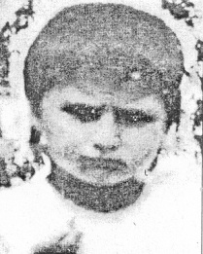
 | Abishova Chinarə Nazim | female | 24.06.1982  Khojaly city | 26.02.1992  Khojaly city |  | 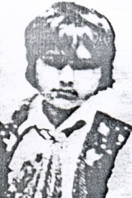
 | Aghayrov Nabi Isaq | male | 12.09.1981  Khojaly city | 26.02.1992  Khojaly district, Katik forest (near the Abdal-Gulabli village cemetery) |  | 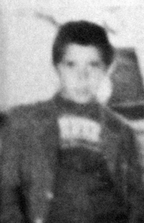
 | Aghayrov Roman Isaq | male | 06.06.1986  Khojaly city | 26.02.1992  Khojaly district, Katik forest (near the Abdal-Gulabli village cemetery) |  | No photograph available
 | Aghayrova Sevinc Isaq | female | 06.02.1985  Khojaly city | 26.02.1992  Khojaly district, Katik forest (near the Abdal-Gulabli village cemetery) |  | No photograph available
 | Aghayev Aftandil Shirali | male | 05.06.1977  Aghdam district, Seyidli village | 15.08.1993  Qubadli city |  | 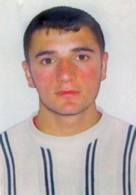
 | Aghayev Allahverdi (Vusal) Sattar | male | 22.01.1982  Aghdam district, Guzanli village | 26.02.1992  Khojaly district, Katik forest (near the Abdal-Gulabli village cemetery) |  | 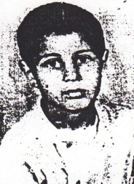
 | Alishova Vesila Jafar | female | 01.06.1980  Aghdam district, Shikhlar village | 31.03.1993  Kalbajar district, Qamishli village (tunnel) |  | 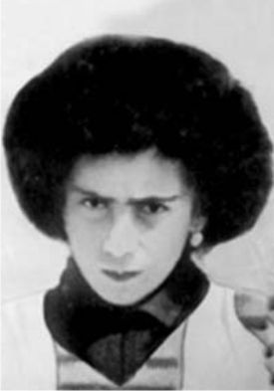
 | Allahverdiyev Mahir Novruz | male | 08.05.1975  Aghdam district, Seyidli village | 26.02.1992  Khojaly city |  | 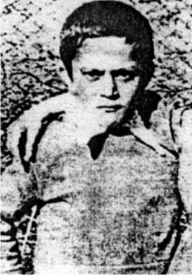
 | Aslanova Elnare Tofiq | female | 01.06.1978  Khojaly city | 26.02.1992  Khojaly district, Katik forest |  | 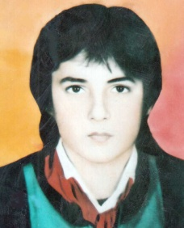
 | Bayramova Natavan Panah | female | 22.06.1988  Shusha city | 26.02.1992  Khojaly city |  | 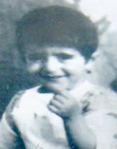
 | Bandaliyev Khayal Elburus | male | 15.01.1986  Mingachevir city | 31.03.1993  Kalbajar district, Qamishli village (tunnel) |  | 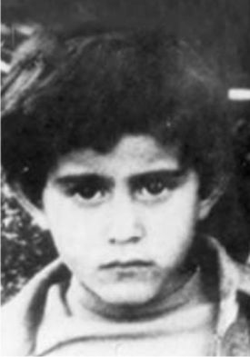
 | Jafarov Anar (Nusrat) Fazil | male | 05.04.1975  Khojaly city | 26.02.1992  Khojaly city |  | 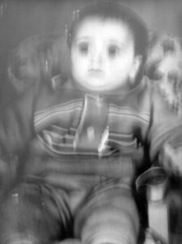
 | Jafarov Samir Tacir | male | 01.06.1987  Khankendi city | 26.02.1992  Khojaly city |  | 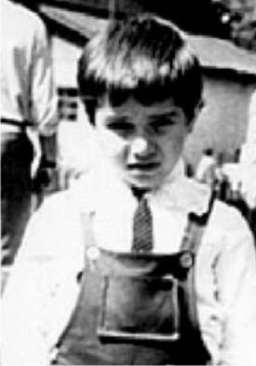
 | Dadashov Ugur Eldar | male | 02.05.1975  Khojavend district, Garadaghli village | 17.02.1992  Khojavend district, Garadaghli village | Identified on 07.06.2024, the remains of the body were handed over to the next of kin, and on 12.07.2024, they were buried in Garadaghli village, Khojavend district. | 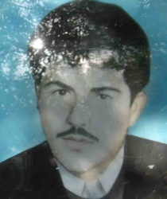
 | Dadashova Shamama Lala | female | 01.06.1978  Kalbajar district, Zar village | 02.04.1993  Kalbajar district, Lev village |  | 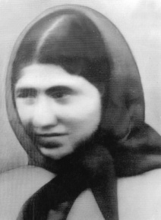
 | Aliyev Sabuhi Jahangir | male | 13.01.1981  Khankendi city | 26.02.1992  Khojaly district, Katik forest |  | 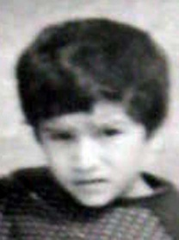
 | Aliyev Salim Jahangir | male | 15.01.1988  Khankendi city | 26.02.1992  Khojaly district, Katik forest |  | 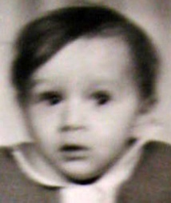
 | Aliyev Elgiz Firdovsi | male | 01.01.1984  Khojaly city | 26.02.1992  Khojaly city |  | 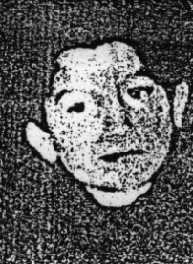
 | Aliyev Elchin Firdovsi | male | 01.06.1982  Khojaly city | 26.02.1992  Khojaly city |  | 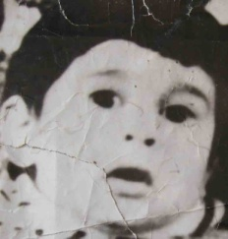
 | Aliyev Tural Nadir | male | 01.06.1982  Lachin district, Garabayli village | 31.03.1993  Kalbajar district, Qamishli village (tunnel) |  | 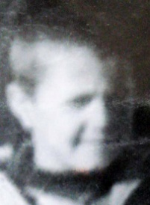
 | Aliyev Khalig Maharram | male | 01.08.1975  Khojavend district, Garadaghli village | 17.02.1992  Khojavend district, Garadaghli village |  | 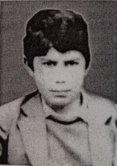
 | Hasanova Latifat Hasan | female | 01.01.1976  Khojaly city | 26.02.1992  Khojaly district, Dahraz village |  | 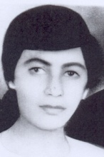
 | Humbatova Simuzar Jalil | female | 18.12.1976  Shusha city | 26.02.1992  Khojaly city |  | 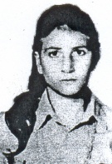
 | Huseynov Abulfat Mekhman | male | 01.07.1975  Khojavend district, Garadaghli village | 17.02.1992  Khojavend district, Garadaghli village |  | 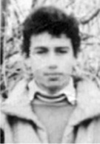
 | Huseynov Makhsar Elkhan | male | 02.02.1991  Khojaly city | 26.02.1992  Khojaly city |  | 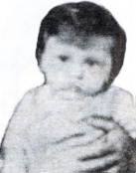
 | Huseynov Rajab Elkhan | male | 27.01.1985  Khojaly city | 26.02.1992  Khojaly city |  | 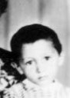
 | Huseynov Emin Aleksandr | male | 26.02.1975  Khojaly city | 26.02.1992  Khojaly city |  | 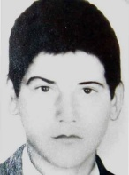
 | Huseynov Ibish Habib | male | 16.06.1977  Khojavend district, Garadaghli village | 17.02.1992  Khojavend district, Garadaghli village |  | 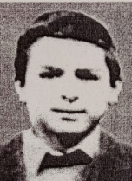
 | Huseynov Niftali Bakir | male | 01.06.1975  Khojavend district, Garadaghli village. | 17.02.1992  Khojavend district, Garadaghli village |  | 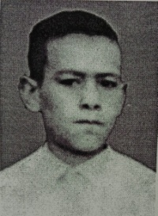
 | Huseynova Nasiba (Emma) Huseyn | female | 01.06.1983  Asgaran district, Dashbulag village | 26.02.1992  Khojaly city |  | 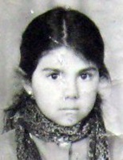
 | Huseynova Shabnam (Sabina) Elkhan | female | 15.06.1986  Khojaly city | 26.02.1992  Khojaly city |  | 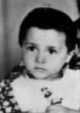
 | Huseynova Atrabe Jabrayil | female | 01.06.1978  Armenian SSR, Azizbeyov district, Sarvan village | 26.02.1992  Khojaly district, Katik forest |  | No photograph available
 | Isgandarov Rasim Yolchu | male | 26.07.1976  Jabrayil district, Boyuk Marjanli village | 23.10.1993  between Gazakhlar and Ahmadalilar villages, Fuzuli district (near the Araz River) |  | 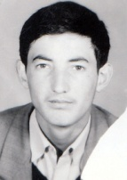
 | Kochariyev Cahid Zahid | male | 03.01.1991  Aghdara district, Bash Guneypaya village | 12.03.1992  Aghdara district, Bash Guneypaya village |  | No photograph available
 | Majnunova Gulafa Izzat | female | 01.06.1979  Qubadli district, Chaytumas village | 30.08.1993  Qubadli district, Chaytumas village |  | 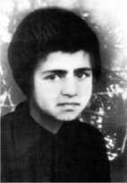
 | Majnunova Sakina Izzat | female | 01.06.1983  Qubadli district, Chaytumas village | 30.08.1993  Qubadli district, Chaytumas village |  | 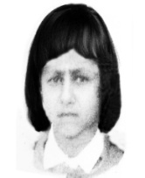
 | Mamishov Taleh Alaskar | male | 06.06.1985  Kalbajar district, Gunashli village | 31.03.1993  Kalbajar district, Qamishli village (tunnel) |  | 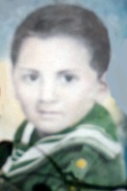
 | Mammadov Ceyhun Vagif | male | 01.06.1975  Khojaly city | 26.02.1992  Khojaly city |  | 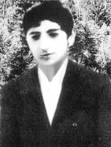
 | Mammadov Mohlet Mammad | male | 01.06.1976  Armenian SSR, Basarkechar (Vardenis) district | 26.02.1992  Khojaly city |  | 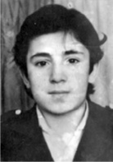
 | Mammadov Niyamaddin Vaqif | male | 01.06.1978  Khojaly city | 26.02.1992  Khojaly city |  | 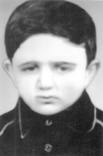
 | Mammadov Sohbat Mammad | male | 01.06.1975  Armenian SSR, Basarkechar (Vardenis) district | 26.02.1992  Khojaly city |  | 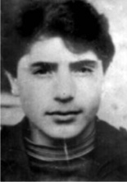
 | Mammadov Rafig Volodya | male | 19.11.1981  Shusha city | 08.05.1992  Shusha city |  | No photograph available
 | Mammadov Vidadi Volodya | male | 10.06.1984  Shusha city | 08.05.1992  Shusha city |  | No photograph available
 | Mammadova Sadagat Volodya | female | 08.07.1986  Shusha city | 08.05.1992  Shusha city |  | No photograph available
 | Mammadova Samira Volodya | female | 29.06.1988  Shusha city | 08.05.1992  Shusha city |  | No photograph available
 | Nagiyev Aftandil Khanlar | male | 22.08.1977  Khojavend district, Garadaghli village | 17.02.1992  Khojavend district, Garadaghli village |  | 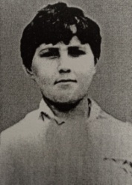
 | Orucov Cavan (Khagani) Canan | male | 13.05.1976  Khojaly city | 26.02.1992  Khojaly district, Nakhchivanli village |  | 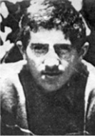
 | Gafarov Ixtiyar Mashallah | male | 29.01.1991  Qubadli district, Ashaghi Mollu village | 30.08.1993  Qubadli district, Ashaghi Mollu village |  | 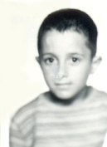
 | Gasimova Rasmiyya Agha | female | 01.06.1981  Khojaly city | 26.02.1992  Khojaly city |  | No photograph available
 | Gambarov Emil Safar | male | 01.06.1987  Khankendi city | 26.02.1992  Khojaly city |  | 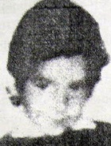
 | Gambarova Esmira Safar | female | 01.06.1985  Khankendi city | 26.02.1992  Khojaly city |  | 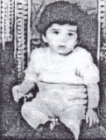
 | Guliyev Ceyhun Mehdiqulu | male | 01.06.1981  Jabrayil district, Niyazgullar village | 23.10.1993  Fuzuli district, Horadiz settlement |  | 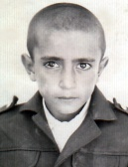
 | Guliyev Mazahir Gara | male | 05.04.1983  Kalbajar district, Chorman village | 31.03.1993  Kalbajar district, Qamishli village (tunnel) |  | 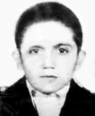
 | Guliyev Mikayil Zahid | male | 16.11.1975  Lachin district, Khachinali village | 26.02.1992  Khojaly district (between Khojaly and Aghdam districts) |  | 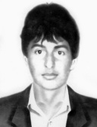
 | Guliyev Khurram Mehdiqulu | male | 01.06.1983  Jabrayil district, Niyazgullar village | 23.10.1993  Fuzuli district, Horadiz settlement |  | 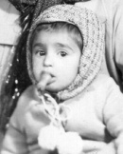
 | Guliyev Shukur Garyagdi | male | 06.04.1985  Khojaly city | 26.02.1992  Khojaly district, Katik forest (near the Abdal-Gulabli village cemetery) |  | 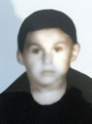
 | Guliyev Yashar Gara | male | 10.11.1981  Kalbajar district, Chorman village | 31.03.1993  Kalbajar district, Qamishli village (tunnel) |  | 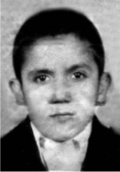
 | Guliyeva Aygun Gara | female | 22.03.1990  Kalbajar district, Chorman village | 31.03.1993  Kalbajar district, Qamishli village (tunnel) |  | No photograph available
 | Guliyeva Ceyhuna Mehdigulu | female | 01.06.1987  Jabrayil district, Niyazgullar village | 23.10.1993  Fuzuli district, Horadiz settlement |  | 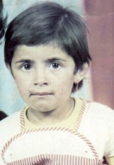
 | Guliyeva Nurane Garyagdi | female | 13.09.1981  Khojaly city | 26.02.1992  Khojaly district, Katik forest (near the Abdal-Gulabli village cemetery) |  | 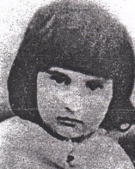
 | Guliyeva Ravane Garyagdi | female | 18.07.1979  Khojaly city | 26.02.1992  Khojaly district, Katik forest (near the Abdal-Gulabli village cemetery) |  | No photograph available
 | Guliyeva Shahnaz Mammad | female | 29.04.1981  Kalbajar district, Kilsali village | 31.03.1993  Kalbajar district, Qamishli village (tunnel) |  | 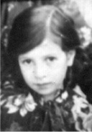
 | Rahimov Vagif Sadri | male | 01.06.1980  Saatli district, Orta Mughan village (Garayevkend) | 23.10.1993  Fuzuli district, Horadiz settlement |  | 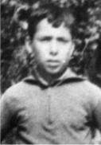
 | Taghiyev Mazahir Hasan | male | 01.06.1976  Kalbajar district, Dalqilincli village | 02.04.1993  Kalbajar district, Qamishli village (tunnel) |  | 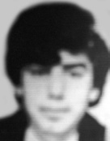
 | Tahirov Huseyn Zakir | male | 22.04.1975  Fuzuli district, Yukhari Veysalli village | 22.02.1992  Fuzuli district, Yukhari Veysalli village |  | 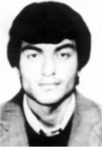
 | Veliyeva Guldana Zakir | female | 12.06.1989  Shusha city | 26.02.1992  Khojaly city |  | No photograph available
 | Zeynalov Fariz Davud | male | 08.03.1984  Kalbajar district, Chobangarakmez village | 31.03.1993  Kalbajar district, Qamishli village (tunnel) |  | 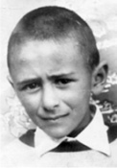
 | Allahverdiyev Bahram Hidayat | male | 1977  Armenian SSR, Basarkechar (Vardenis) district, Garagoyun village | 26.02.1992  Khojaly city |  | 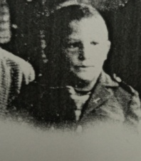
 | Orujova Natavan Nabi | female | 01.06.1989  Shusha city | 26.02.1992  Khojaly city |  | No photograph available
 | Ahmadova Zovgiyya Binnat | female | 1981  Kalbajar district, Bashlibel village | 18.04.1993  Kalbajar district, Bashlibel village | Identified in 2022, the remains of the body were handed over to the next of kin and were buried in Bashlibel village, Kalbajar district. | No photograph available

