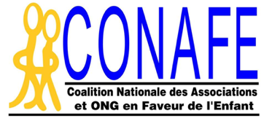

REPORT ON THE CONVENTION ON THE RIGHTS OF THE CHILD

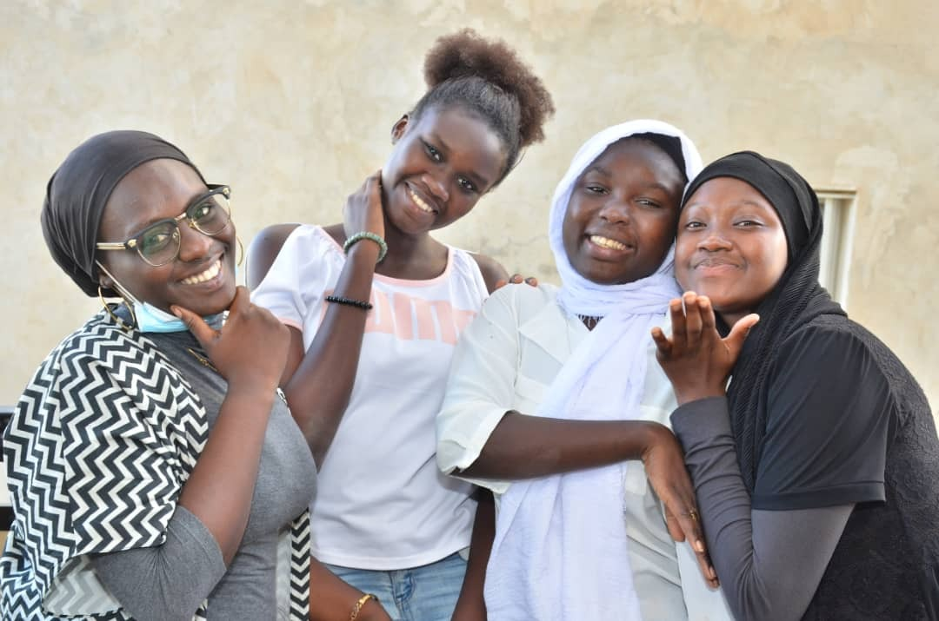
PREPARED BY CHILDREN FROM SENEGAL

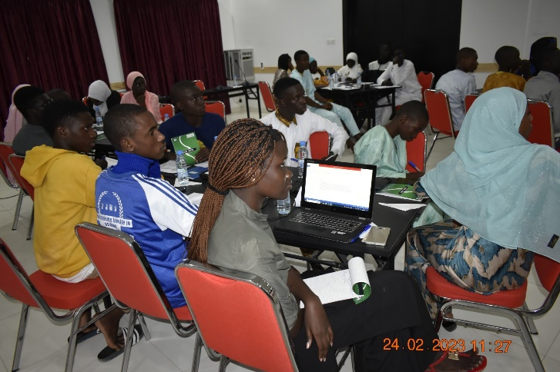

YEAR 2023

WHO ARE WE?

We are children and teenagers from Senegal, aged between 12 and 18. We come from the 14 administrative regions of Senegal.

In our different communities, we have organized ourselves in Children and Youth Departmental Advisory Councils throughout the 45 departments of the country. In our respective municipalities, many of us are also members of Children Municipal Councils (CMCs).

With the ongoing support of the National Coalition of Associations and NGOs for Children in Senegal (CONAFE SN), we have gained these two organizational experiences, and many others, which are recognized by the State, civil society and technical and financial partners working for the promotion and protection of Children's Rights.

Considering that children's participation is one of the fundamental principles enshrined in the Convention on the Rights of the Child (CRC), we took this opportunity to produce our own report. And as the name suggests, our "complementary" report, which takes into account our views and those of the people we met.

As a reminder, we participated in the development of CONAFE Senegal complementary reports on the Convention on the Rights of the Child (CRC), the African Charter on the Rights and Welfare of the Child (ACRWC), the Universal Periodic Review (UPR). From 2006 to 2017, children's views were included in the civil society report.

With support from Save the Child International (SCI), CONAFE Senegal has provided us with several capacity building activities that have allowed us to develop greater self-reliance in our reflections and activities as activists committed to the fulfillment of our rights.

In 2018, we produced our first report on the ACRWC which was submitted and presented to the African Committee of Experts on the Rights and Welfare of the Child by five (05) of our peers.

Building on this experience, we have embarked on a second report to be submitted to the United Nations Committee on the Rights of the Child.

This time, we are fortunate and very pleased, again thanks to CONAFE Senegal and its partners (SCI and UNICEF), to be able to prepare and write our own report in complement to that of the State of Senegal and the Civil society, the first of its kind.

HOW DID WE carry out our report writing process?

With the support of a facilitator at our disposal, we carried out three preparatory activities (preparatory phase): a training session on the handbooks for children: "My Pocket Guide to CRC Reporting" and "the UPR and me" including a conference call, due to the Covid 19 pandemic restrictions, and an in-person methodology guidance workshop.

During the training session, we shared these inspirational children's guides and worked to adapt them to our national and local context and to what we wanted to achieve.
The online meeting brought together children and adolescents and our coaches in the different regions.
Also, we learned to understand what a report is, a complementary report, the cycle of preparing the children’s report, how to structure it in several parts, how to collect information, how to consolidate it and how to use it.

We also had a lot of discussion about the key elements and words, often used in research or report writing, taking advantage of our facilitator's insights to take ownership of them.

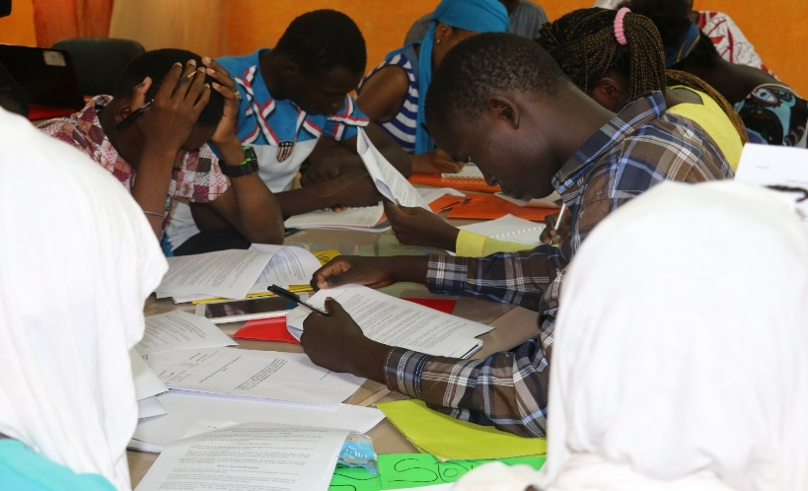
The methodology workshop was held in Dakar. Each region sent a delegation of children and adolescents designated democratically by their peers.

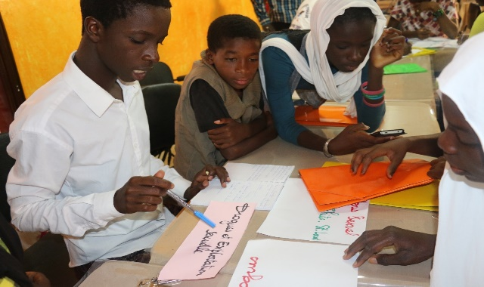
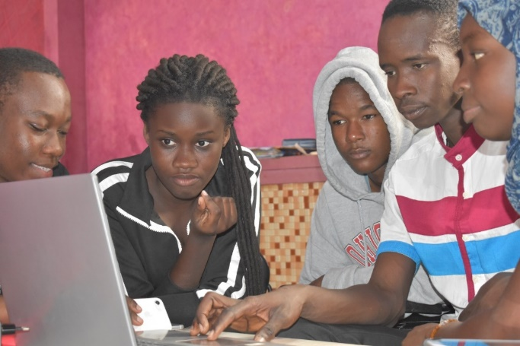

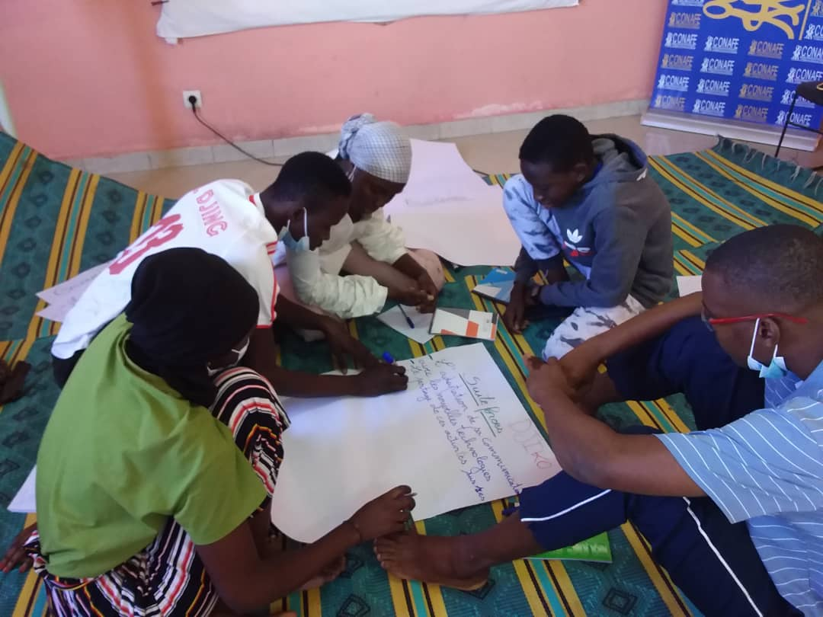

This workshop was very practical. For three days we learned about technical methods and tools for collecting and analyzing information; how to develop an interview guide, a questionnaire? How to conduct an interview? How to get an appointment with an official? We revisited the Concluding Observations of the Committee on the Rights of the Child, looked at the State report among other examples.

We then discussed the choice of targets and host sites for the data collection, along with a plan of action for the field visit to carry out our investigations in the communities based on assumptions. These assumptions, which we have defined based on our daily experience, each one in their own place of life, in the form of topics that raise questions or are obstacles to the fulfillment of children's rights.

Each regional delegation was able to choose three topics. The pooling led us to select ten (10) topics which are: birth registration, violence against children, child labor, child begging, children dropping out of school, children's participation, child health, drug abuse and use, child trafficking, abduction and smuggling, children's rights and the environment. We have focused on the obstacles that weaken the children's rights fulfillment in Senegal.
At the end of the workshop, the participating children formed a "WITNESS" group of five children from different regions to work with our facilitator and facilitate learning about the follow-up process.
With our action plan, we went to discuss it with the population at grassroots level (information gathering phase).
Prior to this, upon returning to our different departments, the children's representatives who participated in the methodological orientation workshop made a restitution to our peers in our CCDEJs through a session to share the results of the workshop. The presentations focused on the conduct of the process, the themes selected, the methods, techniques and collection tools produced, and the instructions for gathering the views of our targets together.
This exercise allowed us to collect the point of view of our peers, to divide the groups and to encourage the participants to appropriate interview techniques for the collection of information, to identify the people to be consulted in order to meet them.

In fact, we met with administrative authorities, traditional and religious leaders, departmental technical services, leaders of civil society organizations, parents, heads of schools and training/learning centers, local elected officials, and our peers, children and adolescents, through mixed groups.
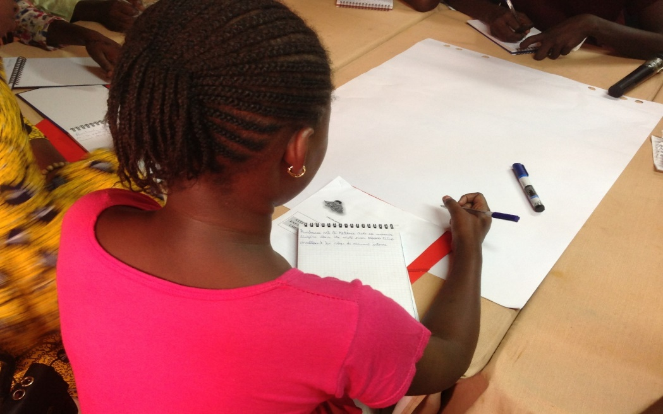

In the absence of available statistics at the local or even national level, we focused on the information and views most widely shared by our respondents by summarizing them in notes.
After the collection of information in the field, the "WITNESS" group met at CONAFE headquarters for two days face-to-face with the facilitator, for the exploitation of the opinions and information collected from the targeted persons, followed by a validation workshop of our report.

ACCORDING TO THE PEOPLE WE CONSULTED: WHAT ARE THE MAIN BARRIERS TO THE EFFECTIVE FULFILLMENT OF CHILDREN'S RIGHTS IN SENEGAL?

Generally speaking, the main obstacles to the fulfillment of children's rights in Senegal, as identified by respondents, both individually and collectively through interviews or focus groups, are as follows.

- Religious and socio-cultural barriers

The persistence of religious and socio-cultural barriers continues to be a serious cause of children's rights violations: begging, economic exploitation, child marriage, female genital mutilation and abuse are still phenomena of which many of our peers are victims. No region of the country is spared and the number of children affected is increasing year after year.

The state does not do much and many people are simply observing these issues, if they are not party to this by for example giving money to a child beggar knowing that the money is meant for the person who is exploiting them.

Similarly, child marriage and genital mutilation continue to be justified either by religion or by custom.
- A gap in law enforcement

The issue of child victims without justice is common. Indeed, children have little access to justice. The facts may occur while they are in a situation of family break-up, negotiations between relatives or neighbors may prevent a perpetrator of child rights violations from being held accountable before a court.
Justice itself, when cases are brought to it, is not as quick in applying the laws to protect our peer victims or at least to discourage those who would be tempted to commit the same abuse on children: this is the case of early marriage, genital mutilation, abusing child beggars....

- Negligence by some parents/ignorance by others...

The fulfillment of children's rights continues to suffer from either parental neglect, ignorance or the inaccessibility of the registry office.

The most illustrative example is that of the declaration of births at the civil registry office. In many localities, including Dakar, children with problems of civil status in order to sit for exams is a recurrent fact.

The child's rights fulfillment continues to be hindered by the negligence of parents, their ignorance, or the inaccessibility of the civil registry service.
The most illustrative example is that of the birth registration process. In many places, including Dakar, children having problems with their birth registration in order to sit for exams is a recurrent issue.

There are several reasons for this issue: it may be due to the negligence of parents who do not give particular importance to birth registration; they may be unaware of this importance, which is a child's right. In remote areas, because of poverty, the geographical or financial inaccessibility of the civil registry service may also be a problem.
In all cases, it is the child's right to birth registration that is violated.

- Low community ownership of children's rights

The low level of ownership of children's rights by community actors represents a major obstacle to their fulfillment. This situation justifies the reluctance and persistence of practices, beliefs and resistance that slow down the country's progress towards respecting and effectively taking into account the rights of the child. As for the participation in the decision-making process, for example, there is a clear lack of interest among child protection actors and activists.

For many people at grassroots level, the rights of the child are imported from the West and do not fit with their understanding of what the place of the child in society should be. As long as this perception is not removed from the communities, fulfilling the rights of the child in general, and their participation and representation in decision-making bodies in particular, in order to take into account our views and aspirations, will remain a major challenge.
Another obstacle to participation is the fact that the National Children's Parliament (PNE) has not been renewed. Although it has been set up, it is still not functioning as children would like it to.

- Insufficient budget for children's rights

In recent years, the State of Senegal has made many efforts in terms of budgeting to ensure that children have the best possible living conditions, education and health, among others. But this remains insufficient.

In schools, despite the dedicated curriculum, there are still thousands of classrooms that are temporary shelters, made from easily damaged materials, such as fences and straw, and some others, although under construction, have reached the end of their life cycle and are waiting to be rebuilt.

In the field of health, as in education, in addition to geographical access and financial constraints, for many children, there are also quality issues: low technical standards, lack of qualified staff, lack of facilities and appropriate teaching materials, especially for children with special needs such as those with physical, visual or hearing disabilities...
In addition, many children who have the right to adapted care do not have access to it. All those who have the right to go to school do not. Others manage to get into school but don't stay there for long....

- Early school drop-out and lack of educational or vocational training alternatives

Many causes lead children to drop out of school, sometimes too early: parents' poverty, forced to work before the age of majority (gold mining, cashew nuts, fields), health problems, lack of appropriate educational services: The case of the disabled, which highlights the difficulties of making the education system inclusive. Remoteness, marriages, early pregnancies, sexual abuse and violence, problems of birth registration, the fact that school is not compulsory, the parental decision, the limited intake capacity, which imposes a system for assessing selective learning and therefore by elimination...

In some places, early school drop-out affects girls more severely than boys (Kolda, Sédhiou, Matam, Diourbel, etc.)

When dropout occurs, alternative educational opportunities exist, but they are insufficient and unevenly distributed in the country, with a great disparity between urban and rural areas.

- Environment - Wandering children - Insecurity

If every child has the right to live and evolve in a healthy environment, this is not the case for children on the street. In fact, in our cities and suburbs, it is common to see children, sometimes very young, permanently roaming the streets, particularly in the capital city and in the large cities inside the country.
Some are foreigners from countries bordering Senegal. Those among them who have any connection at all are with a Koranic master who leaves them begging. But not all of them are Koranic school pupils.

Their area of development is problematic. They are left alone and live in the street without any family ties. Generally, if they have a shelter, it is usually a building under construction on the outskirts of the neighbourhoods.

They spend time in unhealthy and unsafe places, with all the risks and dangers: disease, violence, abuse, trafficking, sexual abuse, and can easily be drawn into petty crime before turning to serious crime.

In addition, the use of the Internet and social media by children raises the whole issue of insecurity. Many children and teenagers have become addicted to the internet, which has consequences for their health, they are exposed to abuse and sexual manipulation online, they are sometimes not focused on their studies and are involved in violence.

The environment today poses a serious threat to well-being and affects children's rights. Today we children see many problems such as climate change, floods, deforestation, diseases related to mining operations, child trafficking or abduction etc.

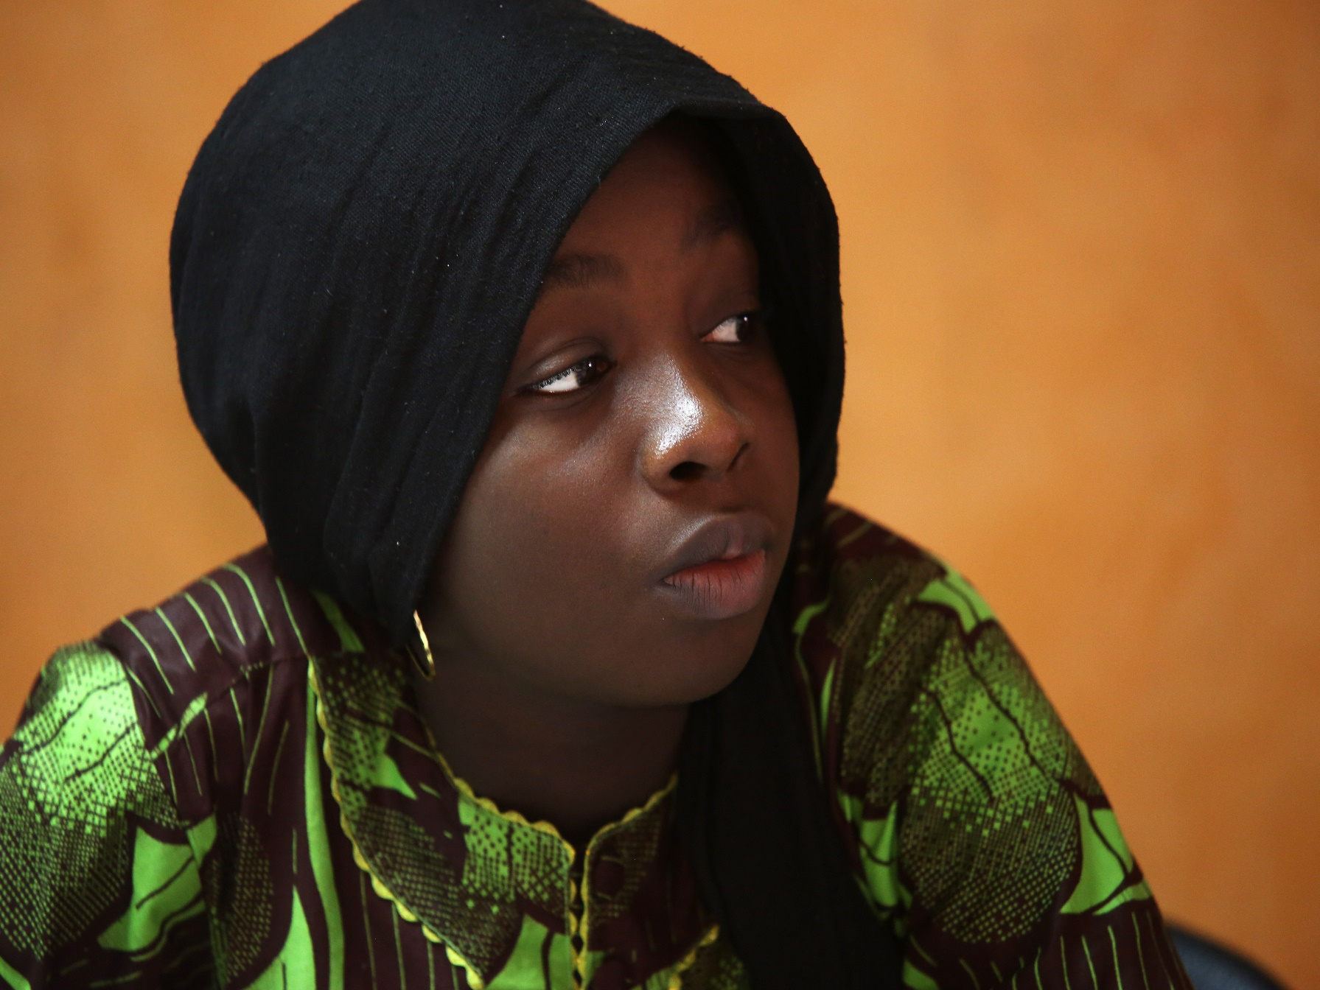
OUR RECOMMENDATIONS?

In order to improve the pace of our country's progress towards a more satisfactory and progressive fulfilment of children's rights, we recommend the following:

- The persistence of religious and socio-cultural constraints requires the adoption and implementation of an inclusive national information, education and communication strategy to support communities towards a positive social change and perception of the rights of the child. The State should engage in this process, together with civil society and technical and financial partners and ourselves, children and youth. When people understand more about why it is important to protect children, they will be more aware of their rights and thus it will be easier to get them to make the desired changes in their behaviour and attitudes towards us.
- It is true that the legal provisions set out by the State and the international community (CRC-ACRWC) for the protection of children's rights are scattered in several laws, codes and conventions, making them more complex to understand and use. They can be enforced to the fullest extent, which is not the case. Jurisdictions should enforce them without fail. This will help to deter and prevent violations, abuses and unaccountable abuses.

The State must commit to this without delay.

- In view of the worrying situation, at least for us, of the rights of the child in our country, we call on the State to mobilize even more resources to be dedicated to the fulfilment of the rights of the child, which must be effective, and to pay greater attention to inclusive education, to health, especially adolescent reproductive health, to the safety and well-being of all children in Senegal, and to the protection of children against abuse and exploitation, including online abuse.

- Considering the very high number of children who drop out of school at a very early age, we request the State to increase the number of children in school, to diversify the offer of alternative educational services and vocational training so as to give every Senegalese child the chance to study or follow a training course of their choice, whatever their level, because it is under these conditions that they will be able to become a responsible citizen.

  - Convinced that it is possible to guarantee the dignity, health and safety of every child living in Senegal in a family setting, we invite the State to seriously study the issue of street children, to determine the responsibilities of all parties involved and to find a definitive solution to their situation.

- We express the wish to see the State settle the issue of birth registration, by regulating the situation of all children who are deprived of it, by making birth registration services more accessible, and by ensuring that archives are kept and computerized; if necessary, withdrawing these services from the municipalities, by creating a real administration for birth registration.

- The draft Children's Code remains for us a priority that we share with civil society actors. We hope that it will be adopted and that it will be in line with the provisions of the CRC and the ACRWC ratified by Senegal.

- Considering the importance of our right to participate in the decision-making process, we call for the Children's Parliament to be reactivated, renewed and institutionalized, with an operating budget like all other institutions of the Republic.
- Among our peers and young brothers, many of whom follow a Koranic education in daaras (koranic school), we call on the State to take more interest in their living and studying conditions and to ensure that, in addition to learning the Koran, this activity is associated with a professional apprenticeship to prepare for their future integration into working life.

- Finally, considering that poverty, which makes families vulnerable, is one of the main obstacles to the fulfilment of the children's rights in our communities, we urge the State to strengthen public policies to combat poverty and promote economic and social development

ACKNOWLEDGEMENTS

We have been able to complete this activity with the help and support of people and organizations who kindly supported us. We would like to express our deepest gratitude to them.
In particular, we would like to thank:

- CONAFE Board members
- CONAFE Executive Secretary
- CONAFE regional coordinators
- CONAFE partners: UNICEF and Save the Children
- Child Rights Connect and the Committee on the Rights of the Child for the guides produced for us
- Our facilitator
- Local administrative authorities, Prefects and Sub-Prefects
- Customary and religious leaders
- Heads of technical services
- leaders of civil society organizations we met
- our peers, children, adolescents and youth
- People of the host sites
- Our parents who allowed us to participate in this process

TO ALL OF YOU, A BIG THANK YOU !



