


REPUBLIC OF MOLDOVA
ISSUES RELATED TO HEALTH CARE IN THE PENITENTIARY SYSTEM

SUGGESTED LIST OF ISSUES PRIOR TO REPORTING
Joint Submission to the UN HUMAN RIGHTS COMMITTEE
138th session (26 June - 28 July 2023)

Submitted on: 2 May 2023
Authors of the joint submission:
- Promo-LEX
The “Promo-LEX” Association is a civil society organization with special consultative status with the UN (ECOSOC) based in Chisinau, whose purpose is to advance democracy in the Republic of Moldova through promoting and defending human rights and monitoring democratic processes. Promo-LEX was founded in 2002 and is based in Chisinau. Promo-LEX works through the Human Rights Program and the Monitoring Democratic Processes Program.

- EPLN (EUROPEAN PRISON LITIGATION NETWORK)
The European Prison Litigation Network (EPLN) is an international non-governmental organization (INGO) granted participative status with the Council of Europe. EPLN was founded in 2013 by a network of NGOs, jurists, lawyers, and researchers from different countries, active in the penitentiary field. The Network aims to strengthen the judicial protection of prisoners' fundamental rights in the Member States of the Council of Europe.

INTRODUCTION
- The Human Rights Committee (hereinafter, “the Committee”) will adopt its List of issues prior to reporting (hereinafter, “LoiPR”) concerning the Republic of Moldova on its 138th session, to be held from 26 June to 28 July 2023, in the framework of the examination of the State party’s periodic report.
- This alternative report is submitted by the Promo-LEX Association (hereinafter “Promo-LEX”) and European Prison Litigation Network (hereinafter ”EPLN”). It aims to provide a review of the main obstacles in implementing the Republic of Moldova’s obligations under the International Covenant on Civil and Political Rights (hereinafter, “the Covenant”), in particular, concerning the areas of adequate healthcare in the prison system. The alternative report analyses the Republic of Moldova’s compliance with its obligations concerning this issue.
- Reference is made in particular to Moldova’s obligations pursuant to Articles 6, 7, and 10 of the Covenant. For each subject covered concrete questions and recommendation for the LoiPR are suggested.
- The UN Human Rights Committee (the CCPR), the independent expert body which monitors state compliance with the obligations under the International Covenant on Civil and Political Rights, has stated that although there is no specific right to health provision within the Covenant, questions of health in detention could be raised under the right to life (Article 6), prohibition of torture (Article 7) and the right to humane treatment (Article 10).
- The health care services in the Moldovan penitentiaries were constantly in the sight of national, regional, and international human rights mechanisms. Recommendations on improving access of inmates to medical, mental health, and psychosocial services were addressed previously to the Moldovan Government during the second and third UPR cycles (2016 and 2021 respectively), by the Council of Europe's human rights mechanisms, such as the ECtHR and the European Committee for the Prevention of Torture (CPT), as well as by the UN Committee against Torture and by the National Preventive Mechanism.

Recommendations made by the States during the Third UPR cycle (2021):

- Improve access to inclusive medical psychosocial and mental health services for all persons in detention, especially for those belonging to vulnerable groups (127.98 Austria);
- Improve conditions in prisons and take effective measures against overcrowding in line with international standards, including with the Nelson Mandela Rules (127.91 Germany);
- Implement the United Nations Standard Minimum Rules for the Treatment of Prisoners (the Nelson Mandela Rules) to improve conditions of detention (127.92 Fiji);
- Accelerate reforms to tackle the issues of overcrowding, adequate sanitation and access to health care in prisons and detention centers (127.97 Czechia).

The UN Committee against Torture (CAT)
- The Committee was concerned about reports that health care in penitentiary facilities is insufficient, that unqualified staff provide medical services to inmates, that inmates are not permitted to obtain private medical assistance or referred to outside specialists when necessary, that the needs of inmates with disabilities and those who require mental health and psychosocial services cannot be adequately accommodated. The Committee was also concerned at reports concerning particularly poor material conditions, the inadequate quality of medical services, and disciplinary sanctions against patients at the penitentiary hospital (Penitentiary No. 16), and at the fact that medical staff in the penitentiary system are not independent of the prison management (arts. 2, 10 and 11 of the UN Convention against Torture). The Committee recommended the State party to:
- transfer responsibility for penitentiary medical units from the Department of Penitentiary Institutions to the Ministry of Health, Labour and Social Protection; ensure that the penitentiary hospital is affiliated with the Ministry of Health;
- intensify its efforts to improve health care in penitentiary facilities, including by hiring adequate numbers of qualified medical staff and providing them with training on the Istanbul Protocol;
- establish and ensure the implementation of rules to facilitate requests from inmates for private medical assistance and referrals to outside specialist services and to accommodate the needs of inmates with disabilities in the penitentiary environment;
- take measures to reduce overcrowding; improve material conditions, including by renovating and equipping patients’ rooms; provide adequate food and medicines; and ensure individualized treatment plans and medicines for psychoneurological patients, including anti-psychotic drugs.
- intensify its efforts to bring the conditions of detention in places of deprivation of liberty into line with international standards such as the United Nations Standard Minimum Rules for the Treatment of Prisoners (the Nelson Mandela Rules), by, inter alia, ensuring that detainees are provided with adequate material and hygienic conditions, including: health care.
Council of Europe’s human rights mechanisms (ECtHR and Committee of Ministers)
- The systemic issues concerning the medical care in the prisons also was recently highlighted by the European Court of Human Rights (ECtHR) in the case of Cosovan v. Moldova on March 22, 2022. The problems underlying the violation are both systemic and structural in nature and remain unresolved despite the increasing number of recommendations by international and national human rights bodies. The ECtHR in the Cosovan case addressed the critical structural and systemic problems of medical care in the penitentiary system of the Republic of Moldova, which require urgent general measures.
- The lack of medical care. As regards the quality of the medical care and service provided, the Court notes first that Prison hospital no.16, in which the applicant received a significant part of his treatment, was not officially accredited as a medical institution. The medical personnel didn't respect the scheme of treatment. Adjustment of the dosage and number of medicines with various drugs wasn't made by a specialist. The Court noted that specific medical procedures were prescribed and not thoroughly followed through.
- The lack of independence of prison doctors from the prison administration. The prison administration had to organize the transportation and guarding of each detainee treated in public hospitals, which created its own logistical and perhaps financial complications. In addition, medical services to detainees were provided on a contractual basis (which results from the fact that the general medical insurance scheme does not cover detainees). However, this again implied additional costs for the prison. The prison administration thus had incentives to limit detainees' treatment outside the prison, and this situation potentially created a conflict of interests for the prison doctors, which should not be the case. In this respect, it is noted that the UN Committee against Torture urged the Moldovan Government to transfer responsibility for doctors working with detainees from the Department of Penitentiary Institutions to the Ministry of Health. In addition, the National Committee Against Torture expressly noted the absence of independence of prison doctors from the prison administration as a problem.
- On 22 of September 2022, the Committee of Ministers decided to distinguish the supervision of the execution of this and other judgments concerning prison medicine from those concerning the material conditions of detention. The Committee of Ministers decided to supervise the execution of Cosovan under the enhanced procedure as a separate leading judgment, in order to intensify its implementation and to carry out steps to address the underlying systemic/structural problems identified in this case. The systematic shortcomings highlighted by the Court in the Cosovan case require complex general measures. It should be noted that in Cosovan case the Court found a violation of Article 3 of the ECHR in its substantive limb, on account of inadequate medical treatment dispensed to the applicant with a serious illness in its terminal stage during his detention. In arriving to this conclusion, the Court emphasized serious shortcomings in medical care in detention. In particular, it referred to:
- the lack of official accreditation of the prison hospital (Penitentiary No. 16 - Pruncul) as a health institution;
- absence of certain medical specialists in the prison hospital and the fact that a treatment can be denied or only partially carried out simply because it is unavailable in prison or because the resources are too scarce;
- logistical and financial complications for guarding detainees transferred to civilian hospitals;
- lack of access of detainees to the general medical insurance scheme;
- subordination of prison doctors to the penitentiary administration, and
- unavailability of humanitarian release of seriously ill persons detained pending trial.

National preventive mechanism (the Council for the Prevention of Torture Moldova (CpPT))
- Serious problems were found by the Council for the Prevention of Torture Moldova (CpPT) together with health experts in July 2019. The CpPT confirmed these severe findings in 2022 following the monitoring visit carried out at Penitentiary no. 16-Pruncul:
- Penitentiary no. 16 - Pruncul. It does not have a health authorization and is not accredited as a medical institution. As a result, the provision of medical services for detainees in this institution is outside the legal provisions in force.
- Although repair and reconstruction activities are currently being carried out in many rooms, doctors' offices, and patient rooms, there are serious violations of the sanitary and epidemiological standards.
- The most common illnesses encountered in detainees are mental and behavioral disorders. The CpPT is concerned about the high rate of suicides, which is the most common cause of death among detainees, after cardiovascular disease.
- The CpPT is concerned about the lack of psychiatrists and the mental health strategy in the penitentiary system. Prison environment requires complex medical and psychological interventions to rule out suffering of the ill prisoners, as well as to ensure the authorities' compliance with their positive obligation to provide the persons in detention with medical monitoring and the prescribed treatment.
- The health care provided does not meet the quality standards. The quality of the medical services provided in the penitentiary hospital is not systematically verified by the competent institutions subordinated to the Ministry of Health.
- Detainees' right to health is violated due to inadequate treatment, lack of medical staff, and non-compliance with national treatment protocols and standards.
- Access to medical assistance is limited because of inadequate infrastructure and policies, insufficient human and financial resources, and other impediments. The continuing problems regarding the lack of access to adequate medical care in the Republic of Moldova and the need for a much stronger commitment of the authorities to effectively protect the right of detainees to health protection, which requires a massive reform plan.

THE EMERGING ISSUES

RELEVANT ICCPR ARTICLES: Article 6 (the right to life), Article 7 (prohibition of torture), Article 10 (the rights of persons deprived of their liberty)

- The main issues regarding the inadequate health care in penitentiary institutions are the following:
- Structural difficulties of the medical system in the penitentiary institutions
- Organizational failure of the medical system in the penitentiary institutions
- The shortage of health care staff in the prisons, overburdening of medical staff and lack of motivation mechanisms to attract and retain them in the penitentiary system
- Improper handling of medical records in prisons
- The failure of the Government to comply with the principle of equivalence of treatment in and outside prisons
- High rate of chronic illnesses and poor access to specialized health care
- A high level of mortality
- The lack of consistent health care policy in prison accentuates the system's difficulties

- The right to medical care of persons in detention is guaranteed under the Covenant. The CCPR, has indicated that ‘‘the right to ... health of all detained persons’’ is engaged under Articles 6 (the right to life) and 7 (prohibition of torture) of the Covenant, and the obligation to ‘‘provide appropriate medical care to detainees’’ is engaged under Article 10 (prohibition of inhuman or degrading treatment). As a result, the CCPR has affirmed that State responsibilities under the Covenant include ‘‘the provision of adequate medical care during detention’’. It has specified that State obligations to provide medical care to prisoners ‘‘extends to persons under the sentence of death’’. Given that even those persons under the most severe penal sanction retain a fundamental right to medical care, it follows that all persons under sentence, or held without charge or in pre-trial detention, must also retain this right. The Committee has been critical of poor standards of prison medical care in a number of its Concluding Observations reviewing the compliance of states with the obligations stemming from the Covenant.
- The right to medical care in prisons is guaranteed as an element of the right to life. According to the CCPR, ‘‘the State party by arresting and detaining individuals takes the responsibility to care for their life’’. Given that ‘‘the State party remains responsible for the life and well-being of its detainees’’, it is therefore ‘‘incumbent on States to ensure the right of life of detainees, and not incumbent on the latter to request protection’’. This therefore demands the provision of adequate and pro-active medical care. The CCPR has considered several individual complaints about prisoners’ medical care under the right to life.
- The Committee found that the failure of the authorities to provide a ‘‘properly functioning medical service’’ to diagnose and treat the prisoners’ medical conditions violated their right to life.
- Indeed, the right to life, prohibition of torture, and the right to humane treatment impose positive obligations upon countries that have ratified the treaty to protect the lives and/or well-being of persons in custody, which has often been interpreted to require government authorities to take action to safeguard the health of prisoners. As will be explored below, civil and political rights mechanisms within the UN and regional human rights systems provide important protections for the health of persons in detention.
- The failure to develop mechanisms capable of ensuring the necessary medical care in detention to prevent the deterioration of the prisoner's health conditions leads to the violation of the absolute right not to be subjected to ill-treatment.

- EMERGING ISSUE: organisational failure of the medical system in the penitentiary institutions

Organisational failure of the medical system in the penitentiary institutions

- Access to medical assistance is limited and doesn't comply with the principle of equivalence of treatment in and outside prisons because of inadequate infrastructure and policies, critical insufficiency of human resources, and other impediments.
- One of the most serious problems in this area is the poor organisation of healthcare in the penitentiary system, which is incapable of providing adequate health care. There are two parallel medical systems in Moldova:
- the public accredited medical system
- the non-accredited medical services of the penitentiary system

- The medical service of the Penitentiary Administration System comprises:
- Outpatient medical assistance:
- 16 outpatient medical wards in penitentiaries. Of these 16 medical departments in the prison, 13 recently received accreditation (for five years).
- Inpatient medical assistance:
- One penitentiary hospital – Penitentiary no. 16 - Pruncul. This institution functions without sanitary authorisation and accreditation of medical services. As a result, the provision of medical services for detainees in this institution is outside the applicable legal requirements.
- According to the National Penitentiary Administration data, two types of inpatient medical assistance are available in the penitentiary system:
- At penitentiary hospital no. P16 – Pruncul, which does not have anaesthesia and intensive care units or palliative care unit, although patients in need of these types of treatment are held in this penitentiary hospital.
- At the public medical system (civilian) hospitals. The Ministry of Justice contracts medical services from these public medical institutions. This causes logistical deficiencies: insufficient security staff, discrimination and stigmatisation of detainees in public medical institutions, and refusals to provide medical assistance. The financing of the medical assistance is made by the Ministry of Justice and the National Administration of Penitentiaries from the public budget, as well as from other sources allowed under the domestic law (donations, material aid, grants). Detainees do not have the status of an insured person in the compulsory health insurance system. Prisoners can receive treatment only at the limited number of public health institutions contracted by the Ministry of Justice and only to a limited extent, defined by the contracts. Acording to the ECtHR’s finding in the Cosovan case, the prison administration had to organise the transportation and guarding of each detainee treated in public hospitals, which created its own logistical and perhaps financial complications. In addition, medical services to detainees were provided on a contractual basis (which results from the fact that the general medical insurance scheme does not cover detainees). However, this again implies additional costs for the prison. The prison administration thus had incentives to limit detainees' treatment outside the prison, and this situation potentially created a conflict of interests for the prison doctors, which should not be the case.

- Difficulties and challenges identified by the National Penitentiary Administration:
- The acute shortage of medical personnel, guards, and transportation means.
- Overworked and unmotivated medical staff.
- Insufficient implementation of National Clinical Protocols.
- Insufficient implementation of illness prevention, screening, monitoring, and dispensary measures.
- Penitentiary-hospitals’ lack of sanitary authorisations and medical accreditations.
- Incomplete implementation of quality-management system.
- Deficient interaction between public medical institutions and the Ministry of Health.
- Insufficient access of detainees to dental treatment.

- The shortage of health care staff in the prisons, overburdening of medical staff and lack of motivation mechanisms to attract and retain them in the penitentiary system

- Effective prisons provide health care to a standard equivalent to that available in the community. This can only be achieved when prison management and staff understand and promote health and health care within a "healthy prisons" approach. Good health in prisons cannot flourish without an environment of safe custody and good order and without prisoners and staff feeling safe. Only then can all staff working together produce the kind of setting that protects and promotes health. A prison is a place where detainees live and staff work. Prison in the Republic of Moldova is a stressful and hazardous place to work. High vacancy rates, and staff turnover, are indicators of a poorly functioning workplace. Successful prison systems rely on managing these factors through modern and enlightened employment practices: reward and recognition schemes, opportunities for career progression and occupational health services are necessary components to address stress and poor working conditions.
- Insufficient provision for medical staff influences detainees' access to medical services. The medical staff of the penitentiary hospital comprises two categories:
- officers and agents who are civil servants with special status
- contracted staff
- Thus, the medical staff of the penitentiary institutions in the Republic of Moldova is subordinated to the Director of prisons, which entails their “double loyalty” when making medical decisions. Such “double loyalty” may be defined as a clinical role conflict between professional duties towards a patient and obligations, explicit or implied, to the interests of a third party (such as an employer, an insurer, or the State).
- The first category of the staff (officers and agents with special status) includes the heads of sections / laboratories / pharmacies, who hold the rank of justice commissioners, as well as certain specialists (dermatovenerologists, psychiatrists, duty doctors, laboratory assistants, surgeons, dentists, physiologists) who have the level of chief inspector of justice.
- In the Republic of Moldova, prison medical staff are discriminated against public medical personnel in terms of salary and work conditions. Hence the lack of prison medical staff and the negative impact it causes on the prison medicine. Despite the similarity of the functional duties and responsibilities, civil servants with special status and the contracted staff are remunerated differently, which additionally demotivates the employees. Contract staff are paid under Annex 9 of Law no. 270 of 23/11/2018 on the Unitary salary system, and civil servants with special status are remunerated according to Annex 6 of the same law (salary difference can amount to 2000-2500 lei (400-500 euros)). Contracted staff work 7 hours a day, against 8-hour working day of the civil servants with special status, who are also prohibited from performing any other paid work / combining functions within one institution.
- Officers and agents (prison doctors) do not have individual employment contracts, and are not remunerated for 24-hour continuous on-call work. However, they are provided only with additional days off.
- The understaffing in medical wards becomes even more critical when after a 24-hour shift the only doctor takes a day off. As a result of the overloading of the staff, the essential activity, the performance of the duties by the medical personnel, and the quality of medical services suffer considerably. This situation negatively affects the treatment of detainees in the penitentiary system.
- On July 12, 2021, the Ministry of Finance, at the request of the Ministry of Justice, clarified that the difference between the work conditions of civil servants and public health system personnel persists because, according to the legislation, penitentiary institutions are not part of the medical institutions, and their medical staff cannot benefit from the respective guarantees provided to the public health system personnel.
- On September 14, 2021, the Council for the Prevention and Elimination of Discrimination and Ensuring Equality registered a collective complaint regarding the discrimination of the staff of medical departments within penitentiary institutions. The authors referred, in particular, to the lack of the 30% increase to salaries (similar to those in the public system) and the salary increase provided for by Art. 17 (c) of Law no. 270/2018 on the Unitary salary system in the budget sector. The Council found that: "the less favourable differential treatment applied to medical staff from penitentiary institutions who are in a comparable situation to medical staff from public medical institutions is direct discrimination based on job criteria when determining remuneration.” In this context, the Council recommended the Ministry of Finance, together with other responsible institutions, revise the normative acts in the field of salaries to exclude this discrimination, which directly affects the problem of medical staff in prisons. To date, the responsible authorities have not implemented the Council's recommendation.
- The CPT pointed out the insufficient guarantees provided to the prison health care staff during its most recent visit to Moldova (in 2020), which continues to be one of the serious problems in the penitentiary system.
- According to official information provided by the National Penitentiary Administration the insufficient number of medical staff in relation to the number of sick detainees who require medical assistance continues to be a severe problem. The national and institutional clinical protocols and medical treatment standards are insufficiently implemented due to the shortage of medical staff in prisons and the overload of the medical staff working there.
- They identified the main factors that generate the deficit of medical staff:
- The absence of standards for providing medical staff for the medical wards of the penitentiary administration system (SAP) in view of the workload. In the last ten years, 75.25% medical staff positions have been reduced.
- The professional independence of the medical staff in the penitentiary system remains a sensitive subject, which frequently influences the clinical decisions of doctors and leads to the turnover of the healthcare personnel.
- Lack of an insurance strategy for the medical staff of penitentiary system.
- The absence of actions for the penitentiary system in the Action Plan of the strategy for the development of human resources in the field of health for 2016-2025.
- Isolation of the departmental medical system and its insufficient integration into the national health system; only civilian medical personnel can combine functions in a medical institution;
- The lack of a mechanism for assigning young medical specialists by the Ministry of Health to the penitentiary system.
- The practice of bringing court actions by the Ministry of Health against young medical specialists, for the recovery of education expenses, in case a graduate has started to work in the penitentiary system.
- Reduced prestige of the medical service in the penitentiary system.
- Specific activity, institutional climate, working conditions, insufficient financial motivation, non-payment of overtime, involvement in activities other than medical ones, limitation on professional decision-making, increased professional burnout, and relationships with patients were found to be demotivating.

- As a result of the CPT visit from January - February 2020, the Committee's experts also found a number of problems: in the Chisinau and Taraclia prisons, the delegation met with several detainees who appeared to have mental health problems or thoughts of self-mutilation, including suicide attempts, and who had been detained in solitary confinement for months or even years. The Committee recommended that all detainees with mental health problems incarcerated in Chisinau and Taraclia penitentiaries be evaluated by a psychiatrist. They should be transferred and treated in a suitable environment, with sufficient qualified medical staff to provide the necessary care.

- Improper handling of medical records in prisons

- Although according to the legislation, the medical record of the patient is an official document drawn up by the medical staff, in which the information related to the diagnosis of the disease (trauma), the dynamic development of the pathological process, and the applied treatment is recorded. The medical record serves as a source of information for medico-legal expert assessment, especially in cases of trauma or problems related to the quality of the patient's medical assistance. If the information contained in the Medical Records is brief and does not fully reflect the volume of assistance provided, the medical staff and experts would not be able to assess the correctness and completeness of the medical care. The correctly completed medical record, including all stages of the treatment, can also protect doctors from an unfounded accusation related to their activity. According to the legal framework, corrections, changes, and additions to the information already recorded are not allowed.

Improper handling of medical records in prisons, leads to the problem to collection of evidence of ill-treatment/ torture.

- Improper handling of medical records in prisons creates significant challenges in gathering evidence of ill-treatment or torture. When medical records are not managed appropriately, crucial information about instances of mistreatment or abuse can be lost, tampered with, or deliberately concealed. This poses a serious obstacle to conducting thorough investigations and holding perpetrators accountable for their actions. Medical records play a crucial role in documenting the physical and psychological well-being of prisoners, as well as any signs of mistreatment or torture they may have experienced. These records serve as vital evidence in legal proceedings, human rights investigations, and efforts to ensure the well-being of incarcerated individuals.
- However, when there are flaws in the handling of medical records within prisons, several problems can arise. Records may be incomplete, inaccurately recorded, or deliberately manipulated to hide evidence of abuse. In some cases, medical staff may face pressure or intimidation to alter records or refrain from documenting instances of ill-treatment. Such actions hinder the collection of evidence and undermine the ability to address human rights violations effectively. The improper handling of medical records not only obstructs justice but also undermines the trust between prisoners and medical staff. When individuals perceive that their medical records are mishandled or manipulated, they may hesitate to seek medical assistance or disclose instances of mistreatment, fearing retaliation or a lack of credibility.
- Addressing this issue requires implementing strict protocols and safeguards for the management of medical records within the prison system. This includes ensuring the confidentiality and integrity of records, providing comprehensive training to medical staff on proper documentation procedures, and establishing independent oversight mechanisms to monitor the handling of medical records. By promoting transparency, accountability, and adherence to professional ethical standards, it becomes possible to improve the collection of evidence related to ill-treatment and torture, enhance the overall healthcare provision within prisons, and protect the rights and well-being of incarcerated individuals.
- However, as a result of the monitoring carried out by the Promo-LEX Association, it has been found that the medical records in prisons are often filled in improperly:
- The completion is not digitized
- The prescribed treatment scheme is not clearly indicated.
- Medical records are illegible.
- The description of the dynamic monitoring of the patient is lacking.
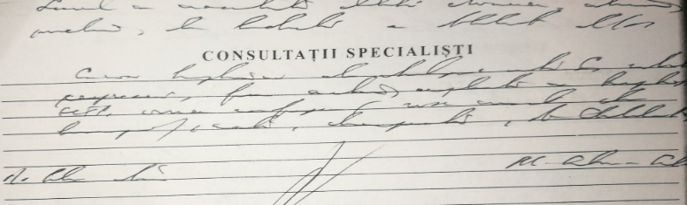
An excerpt from a medical record from the penitentiary system

- EMERGING ISSUE: the failure of the Government to comply with the principle of equivalence of treatment in and outside prisons.

- Detainees have the same right to healthcare as everyone else in society. Prisoners have much higher medical assistance needs than the general population, being diagnosed much more frequently with infectious pathologies, chronic pathologies, mental health issues, drug and tobacco addiction, self-mutilation and suicide inclinations. The realisation of the right to health in places of detention depends on several interrelated and essential elements related to access, availability, acceptability, quality, and equivalence (equity) of health care.
- Access provides for the availability of health services for all prisoners, available for free, upon any request. Availability implies adequate infrastructure for providing health care, sufficient medicaments, reagents, diagnostic equipment, and well-trained personnel, sufficient in number and capable of providing health services, including screening, counseling, primary care, and mental health services. Acceptability provides for providing medical services with respect and dignity, without discrimination based on sex, age, culture, language, and HIV status, respecting ethics, and protecting confidentiality. Quality means that all medical care is appropriate and of good quality, provided by trained medical staff, provided when needed and in a safe manner, centered on the person's needs, and that basic medicines and products meet quality standards. Equivalence (equity) arises from the fact that prisoners cannot take care of themselves while in detention. It is the state's responsibility to provide health services and a healthy environment (at least equivalent to that available to the outside population). Arising from the vulnerability for prisoners, the needs for medical and psychosocial services in detention are much greater than in the community and require appropriate investment.

- High rate of chronic illnesses and poor access to specialised health care

- Many people with chronic illnesses and complex medical needs are held in places of detention (more than 40% of the prison population, according to estimates by the National Administration of Penitentiaries). As a result, incarcerated people face high levels of chronic diseases. Detainees do not benefit from medical assistance from CNAM funds and do not have insurance. Prophylaxis, screening, and dispensary examination is not sufficiently implemented due to the overload and insufficiency of the medical staff.
- In 2021, ANP approved Order No. 129 of March 10, 2021, "On the quality assurance of the medical services provided," which approved the composition of the Quality Council and its activity regulations. In the same year, the National Administration of Penitentiaries (ANP) conducted the first internal medical audit in 6 medical departments out of 6 prisons for the first time. As a result of this internal medical audit, 29 violations were identified, and 60 recommendations were made to eliminate the shortcomings.
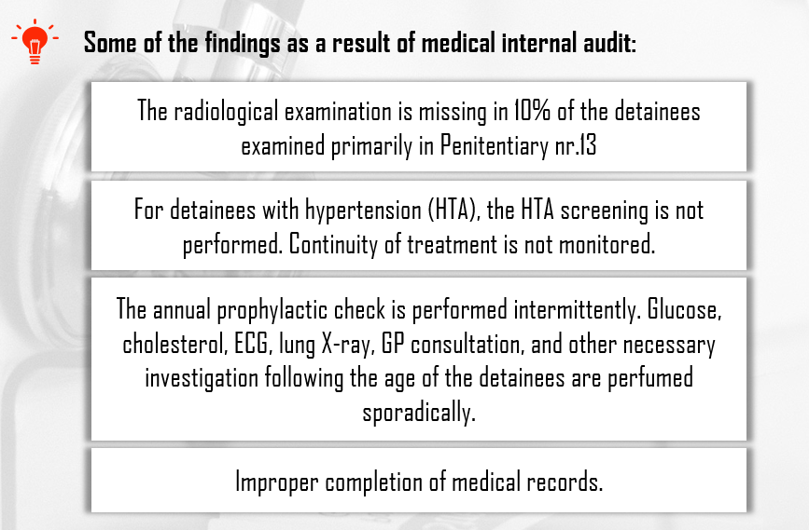
- In 2022, 123 violations and 54 observations were identified, 269 recommendations were made for eliminating shortcomings. As a result of the audit, general recommendations were formulated regarding the liquidation of shortcomings from the medical system of prisons regarding:
- Increasing the qualitative completion of medical documentation, digitalising of the documentation, proper implementation of prescribed medical indications and monitoring of the continuous administration of systemic medical treatment.
- Taking measures to ensure the confidentiality of personal medical data.
- Identification of prisoners from cardiovascular risk groups to reduce morbidity and mortality from cardiovascular pathologies.
- Effective management of primary and concurrent diagnoses to improve the medical treatment.

- The general morbidity in the penitentiary system:
- In 2021 - 16,498 detainees with illnesses, (3,542 more cases than in 2020).
- In 2022 – 15,321 detainees with illnesses, (1,177 cases less than in 2021).

- In 2020-2021, mental and behavioral disorders were the most widespread diseases in the overall morbidity, followed by diseases of the digestive system, and diseases of respiratory system.

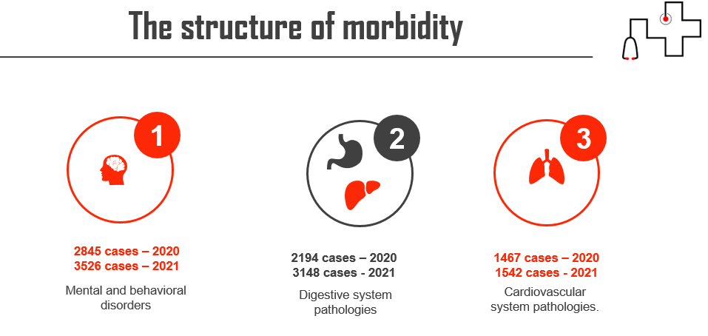
- In 2022, the most prevalent were diseases of the digestive system, followed by mental and behavioural disorders, and the infectious pathologies.

A high level of mortality

- Deaths in the penitentiary system are another problem that becomes more serious every year. The mortality rate from medical causes, as well, remains high. Compared to previous years, the number of deaths in the penitentiary system in 2018 has an increasing trend, according to the statistical data of the National Administration of Penitentiaries of Moldova. Although the number of deaths in 2021 decreased by 15 cases, a high death rate in the prison system remains. Moreover, according to reports of the Ombudsman and the Council for the Prevention of Torture, concerns about improving access to medical, psychosocial and mental health services for all detainees, especially those belonging to vulnerable groups, remain valid in 2021.
- In 2022, the death rate decreased to 23 deaths in the penitentiary system. However, we cannot claim that this decrease was due to the improvement of medical care and not in view of the reduction in the number of prisoners during this period.

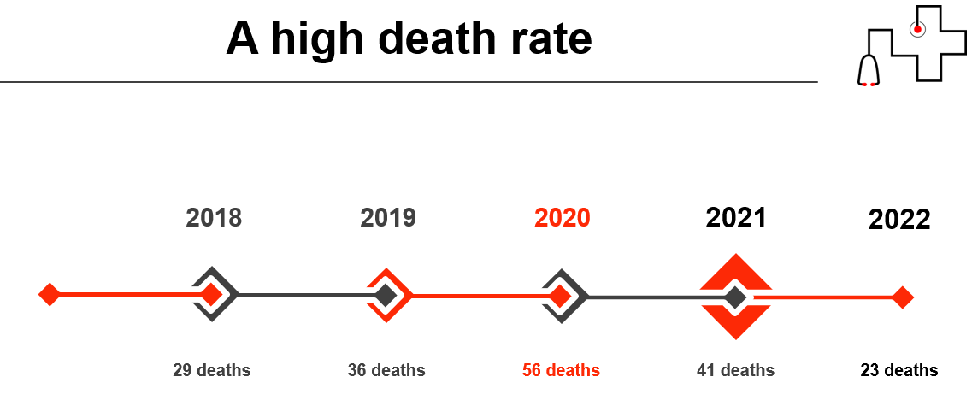

- In 2021, the prevailing cause of death in custody was diseases of the cardiovascular system and tumors (22 cases), followed by 6 cases of diseases of the digestive system and suicide.
- In 2022, the main cause of death was diseases of the digestive system with 7 cases, followed by 5 cases of the cardiovascular system, suicide, and cancer (4 cases each).
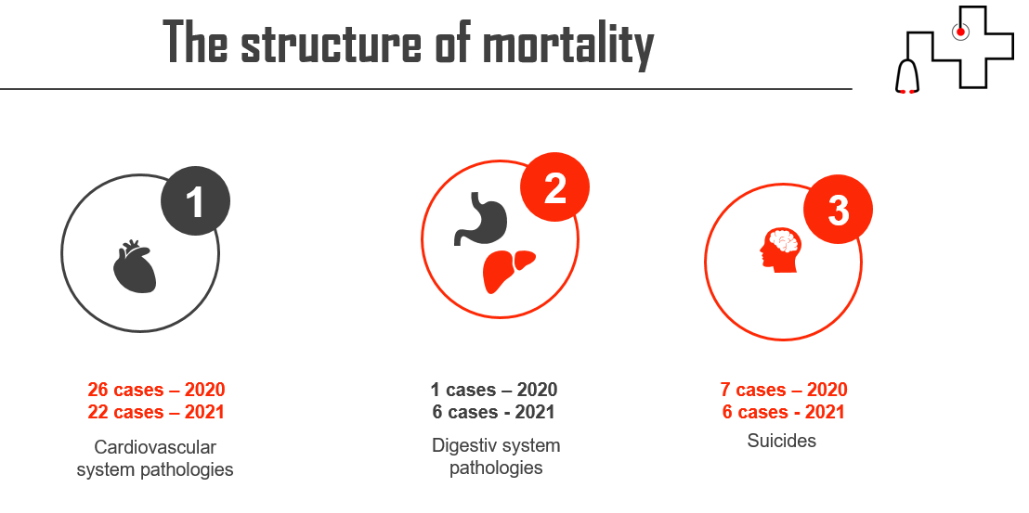

- In 2021, several cases of death had come to attention of People's Advocate, which aroused suspicions regarding the quality of medical services provided by the penitentiary system:
- Death of V.B.V., a detainee, born in 1964, who, although suffering from a severe illness for a long time, did not benefit, within a reasonable time, from the humanitarian mechanism provided for in Article 95 of the Criminal Code. Release on medical grounds was delayed and failed to take effect, as the detainee's death had occurred. In this case, the People's Advocate inquired whether the medical arrangements in Hospital-Penitentiary No. 16 Pruncul had been able to improve the detainee’s health and if it had been necessary to provide qualified medical services in an oncology institution. There were also questions about whether the failure to transfer the patient to a specialized medical institution would have prevented the disease from progressing to a stage of irreversibility. In connection with this case, the People's Advocate urged the penitentiary authorities to delegate the medical competencies to logistically and medically adapted structures whenever the detainees complained of health problems.
- Death of P.G.A., resulting from liver cirrhosis, which was treated in Hospital-Penitentiary no. 16 – Pruncul: in this case, the People's Advocate made serious findings regarding the quality of the medical service provided. Thus, it was noted that:
    - The institution's services did not meet the standards of medical efficiency and could not provide adequate treatment. Moreover, the medical personnel were directly responsible for the deterioration of the detainees' health. The medical reports produced by the personnel of the penitentiary institution (Hospital-Penitentiary no. 16 Pruncul) were inaccurate. There were no data on the intervention of medical specialists, frequency of treatment, or type of medication used. Moreover, some medical reports from the penitentiary institution presented contradictory data. The People's Advocate considered the selective provision of information as a method of concealing the circumstances of the detainee’s death. Moreover, such a representation of the incident seemed to reflect the inaction in preventing the evolution of the disease. The nurses of the penitentiary system were only interviewed as witnesses. Their actions were never assessed as a factor contributing to the crisis.
- Suicide of an 18-year-old detainee in Penitentiary no. 13. The People's Advocate expressed his concern regarding the existence of the suicide phenomenon in the penitentiary environment. According to the Special Report of the People's Advocate of February 16, 2021, on suicide by strangulation in penitentiary institution no. 13 - Chisinau, there were still severe problems regarding the conditions of detention and health care in Penitentiary no. 13 in Chisinau: medical and other services did not satisfy the quality requirements, specifically, they did not act prevent some negative consequences.
- A detainee died in prison after a two-month hunger strike. The cause of death was extreme dehydration. The incident took place in September 2021, but it became known on January 14, 2022, after the publication of the Office of the People's Advocate report. The Prison Administration confirmed the information.
- On January 14, 2022, the Office of the People's Advocate published a report on detainees' condition in Moldova prisons. According to it, 40 people have died in Moldovan prisons over the past year (2021). The youngest was 19 years old, and the most senior - was 75. Most of the deaths (16) occurred in prison No. 16 - Prunсul. As a rule, seriously ill prisoners are detained there. Causes of death were: suicide, chronic pneumonia, cancer, intestinal bleeding, extensive dehydration, cirrhosis of the liver, lung abscess.
- It is crucial to note that when the medical treatment in the penitentiary requires specialized medical care outside the prison, the availability of these services becomes a problem. At the same time, in the context of the availability of medical services in the penitentiary system, the CPT experts found that for the transfer of a patient to a healthcare unit outside the prison, which is not available in penitentiaries, it is necessary to organize his/her escorting. Transferring involves a long series of bureaucratic procedures, which delay the timely provision of medical care within the time-frame set by the standards in the civilian hospitals.

EMERGING ISSUE: the lack of consistent health care policy in prison, which accentuates the system’s difficulties

- The UN CAT urged the Moldovan Government to transfer responsibility for doctors working with detainees to the Ministry of Health. In addition, the Council for the Prevention of Torture Moldova expressly noted the absence of independence of prison doctors from the prison administration as a serious issue.
- The key issue from the standpoint of improving medical care for prisoners is the transfer of prison medicine under the authority of the Ministry of Health. This would allow to ensure the independence of carers, a sine qua non for establishing trust between patients and doctors, and to ensure good coordination with civilian hospitals. In this respect, the reorganisation of the health system was defined as a priority of the Prison System Development Strategy 2016-2020 and the Action Plan for its implementation. Still, no essential reforms have been proposed or designed regarding the unification of medical services (the public health care with the penitentiary medicine), as recommended by the UN CAT.
- By achieving objective VI: “Developing qualitative healthcare services for inmates, equivalent to those provided in the public healthcare system”, the State pursue a qualitative medical treatment and reduces morbidity and mortality in prisons.
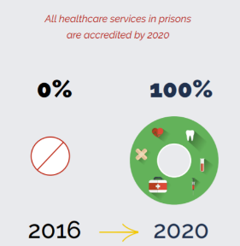
- By 2020, the following results were planned to be fully achieved:
- Accreditation of medical services in prisons;
- Inclusion of certain categories of prisoners in the category of medically insured persons;
- Effective mechanism of interaction with the institutions under the Ministry of Health to facilitate implementation of national health programmes in prisons;
- Creating specialised public medical institutions for healthcare of prisoners.
- The Strategy has considerable delays in implementing healthcare-related actions due to the complexity of interventions and insufficient involvement of the Ministry of Health in developing inter-sector policies. This situation hampers the realization of the recommendations set forth by the Council of Europe concerning health in detention facilities, which reiterates that the management and coordination of activities, and resources involved in prisoners’ health and wellbeing is the responsibility of the State, and the Ministry of Health shall be the responsible party for healthcare services provided in places of detention.
- As a result of the alternative evaluation of the implementation of the Strategy, it was concluded that although all activities planned for the implementation of Objective VI were to be completed by 2020, most of them, including the essential ones, have not been implemented. According to the authority responsible for implementing this Strategy, the main impediments are the insufficiency of financial means, the insufficient number of employees or the need to improve the legislative and normative framework. The analysis of the official data and the information collected from other open sources further demonstrate severe deficiencies in the medical service in the Republic of Moldova penitentiary system due to insufficient and inefficient activities planned in the Strategy. As with all public services, the extent and quality of their provision depend on a political decision. Like any other public policy, the Strategy was to receive financial and legal support following its adoption and the objective planning, which however, were not provided.
- Currently, no public policy envisage the reform of the medical service in the penitentiary system, especially regarding the transfer of prison medicine from the authority of the Ministry of Justice to the subordination of the Ministry of Health.
- Moreover, in national health policies, there are no actions concerning medical assistance in penitentiaries:
- Government Decision no. 886/2007 regarding the approval of the National Health Policy.
- Government Decision no. 452/2016 regarding the approval of the Strategy for the development of human resources in the health system for 2016-2025.
- The 2030 sustainable development agenda in the context of the Republic of Moldova.
- The National Strategy for the Prevention and Control of non-communicable diseases for 2012-2020.
- Government Decision regarding the approval of the National Program for the prevention and control of priority non-communicable diseases in the Republic of Moldova for 2022-2030 and the Action Plan for 2022-2025 implementation.

SUGGESTED QUESTIONS FOR THE GOVERNMENT OF THE REPUBLIC OF MOLDOVA:
- What steps have the Government taken to ensure the implementation of the UN Committee against Torture recommendations concerning transferring of the responsibility for penitentiary medical units from the Ministry of Justice to the Ministry of Health? What is the Government's plan on the integration of the penitentiary medical service into the public health system?
- What are the expected timelines and milestones for implementing a comprehensive policy for prison medical assistance, including the medical service transfer from the Ministry of Justice to the Ministry of Health?
- Are there any plans for research or studies on the current state of medical services in the penitentiary system and public awareness-raising on the development of future policies?
- What are the reasons or considerations behind the absence of actions concerning medical assistance in penitentiaries in national health policies?
- What is the current strategy, if any, for insuring the medical staff in the penitentiary system, and how does the lack of an insurance strategy impact the system?
- What is the reason for the absence of actions for the penitentiary system in the Action Plan of the national strategy for improvement of human resources in the health field?
- What are the restrictions or requirements regarding the combining functions in a medical institution for employed medical personnel in the penitentiary system?
- Is there a sustainable legal mechanism for assigning young medical specialists by the Ministry of Health to the penitentiary system?
- How does the practice of bringing court action against young medical specialists by the Ministry of Health to recover education expenses from them affect the recruitment and retention of medical staff in the penitentiary system?
- How do the Government aim to improve the prestige of the medical service in the penitentiary system?
- Has there been any improvement in access to medical, psychosocial, and mental health services for detainees, especially those belonging to vulnerable groups, as recommended by the Ombudsman and the Council for the Prevention of Torture of Moldova? What measures have been taken to address concerns about improving detainees' access to medical, psychosocial, and mental health services?
- How do the Government plan to address the diseases identified as the prevailing causes of death in the penitentiary? Are there any specialized medical services or facilities available within the prison system to address the specific diseases contributing to the high mortality rate?
- What steps have been taken to prevent suicides in the penitentiary, and are there any specific programs or protocols for mental health support?
- Have any initiatives been implemented to provide early detection and treatment of diseases in the penitentiary, particularly for diseases of the cardiovascular system and tumors?
- How do the Government intend to monitor and evaluate the effectiveness of measures implemented to reduce mortality and improve access to medical care in the penitentiary?

Respectfully submitted,

Promo-LEX Association
Contact person: Nicoleta Hriplivii, e-mail: nicoleta.hriplivii@promolex.md, Human Rights Lawyer.

EPLN (EUROPEAN PRISON LITIGATION NETWORK)
Contact person: Dmitry Gurin, e-mail: dmitry.gurin@prisonlitigation.org, Legal Advisor.

https://promolex.md/?lang=ro
https://www.prisonlitigation.org/
Universal Periodic Review - Republic of Moldova https://www.ohchr.org/en/hr-bodies/upr/md-index
Report to the Government of the Republic of Moldova on the visit to the Republic of Moldova carried out by the European Committee for the Prevention of Torture and Inhuman or Degrading Treatment or Punishment (CPT) from 28 January to 7 February 2020 http://ombudsman.md/wp-content/uploads/2020/10/Raportul-CPT_vizita-2020.pdf
Concluding observations on the third periodic report of Republic of Moldova https://tbinternet.ohchr.org/_layouts/15/treatybodyexternal/Download.aspx?symbolno=CAT%2FC%2FMDA%2FCO%2F3&Lang=en
REPORT on the monitoring visit carried out in Penitentiary no. 16 – Pruncul on February 22, 2022, http://ombudsman.md/wp-content/uploads/2022/04/Raport-CpPT_P16_22.02.2022-FINAL_FINAL_pe-site_expediat-autoritatilor.pdf?fbclid=IwAR1slBRP8aW0vzWOMvnKB7QJcdWiSyVovBH30UbsilK6GgZWSZ9jmBIx39s
Universal Periodic Review - Republic of Moldova https://www.ohchr.org/en/hr-bodies/upr/md-index
Concluding observations on the third periodic report of Republic of Moldova https://tbinternet.ohchr.org/_layouts/15/treatybodyexternal/Download.aspx?symbolno=CAT%2FC%2FMDA%2FCO%2F3&Lang=en
Case of Cosovan v. the Republic of Moldova (Application no. 13472/18) https://hudoc.echr.coe.int/eng?i=001-216352
Case Cosovan v the Republic of Moldova, the Decision of the CoE Committee of Ministers https://hudoc.exec.coe.int/ENG#{%22EXECIdentifier%22:[%22DH-DD(2022)894E%22]}
Report on the monitoring visit carried out in Penitentiary no. 16 – Pruncul on July 22-23, 2019 http://ombudsman.md/wp-content/uploads/2020/02/P-16-Pruncul.pdf
Report on the monitoring visit carried out in Penitentiary nor.16 – Pruncul on February 22, 2022 http://ombudsman.md/wp-content/uploads/2022/04/Raport-CpPT_P16_22.02.2022-FINAL_FINAL_pe-site_expediat-autoritatilor.pdf?fbclid=IwAR1slBRP8aW0vzWOMvnKB7QJcdWiSyVovBH30UbsilK6GgZWSZ9jmBIx39s
Law no. 552 of 18.10.2001 About assessment and accreditation in health care system, art. 2, art. 11 (3)(amended in 2020) https://www.legis.md/cautare/getResults?doc_id=122910&lang=ro#
The right to health of prisoners in international human rights law/RICK LINES/International Harm Reduction Association (2008) https://www.hr-dp.org/files/2013/09/22/Right-to-Health-IJPH-2008.pdf
The Ombudsman Report http://ombudsman.md/wp-content/uploads/2020/02/Raport_OAP_Prevenirea_Torturii_2018.pdf
Law no. 552 of 18.10.2001 About assessment and accreditation in health care system, art. 2, art. 11 (3)(amended in 2020) https://www.legis.md/cautare/getResults?doc_id=122910&lang=ro#
Report on the monitoring visit carried out in Penitentiary no. 16 – Pruncul on February 22, 2022, http://ombudsman.md/wp-content/uploads/2022/04/Raport-CpPT_P16_22.02.2022-FINAL_FINAL_pe-site_expediat-autoritatilor.pdf?fbclid=IwAR1slBRP8aW0vzWOMvnKB7QJcdWiSyVovBH30UbsilK6GgZWSZ9jmBIx39s
WHO: Prisons and Health (2014) https://apps.who.int/iris/bitstream/handle/10665/128603/9789289050593-eng.pdf?sequence=3%20%20Image?%20Yes
Promo-LEX monitoring Report 2 | Managing the COVID-19 pandemic in the prison administration system https://promolex.md/wp-content/uploads/2022/04/RAPORT-DE-MONITORIZARE-2-Gestionarea-pandemiei-de-COVID-19-%C3%AEn-sistemul-administra%C8%9Biei-penitenciare.pdf
Report to the Government of the Republic of Moldova on the visit to the Republic of Moldova carried out by the European Committee for the Prevention of Torture and Inhuman or Degrading Treatment or Punishment (CPT) (2020) http://ombudsman.md/wp-content/uploads/2020/10/Raportul-CPT_vizita-2020.pdf
Report of the European Committee for the Prevention of Torture and Inhuman or Degrading Treatment or Punishment (CPT) on the visit between January 28 and February 7, 2020, https://rm.coe.int/16809f8fa8
Instruction on completing the inpatient medical record (F 003/e)
National Penitentiary Administration: Internal medical audit report (2022) https://drive.google.com/file/d/1no48U7O5muf3lDa3quiC0DHHauLRBs2R/view
National Penitentiary Administration Report on the activity of the penitentiary administration system for the year 2021 https://drive.google.com/file/d/1ltu2_qZ8BYQznVTuSEvjVPPfO0j67MOr/view
National Penitentiary Administration Report on the activity of the penitentiary administration system for the year 2022 https://drive.google.com/file/d/1lwPQj2QaMNceE2_xb4LNq1H8qf9CbKH8/view
National Penitentiary Administration Report on the activity of the penitentiary administration system for the year 2022 https://drive.google.com/file/d/1lwPQj2QaMNceE2_xb4LNq1H8qf9CbKH8/view
Report on the observance of human rights and freedoms in the Republic of Moldova in 2019 http://ombudsman.md/wp-content/uploads/2020/03/RAPORTUL2019-FINAL.pdf
Balance sheet report of the activity of the penitentiary administration system for the first semester of 2020 https://drive.google.com/file/d/1ScyOiRlRnYx5KtDNImEfm4PFoHEOPEok/view
REPORT on the situation of human rights in the Republic of Moldova in the 3rd cycle of the U.N. Universal Periodic Review http://ombudsman.md/wp-content/uploads/2021/10/raportUPR2021.pdf
On January 1, 2023, 6,084 people were detained in the penitentiary system compared to 6,396 who were detained in 2021. Thus, there was a decrease in the number of detainees by 312 people (4.88%).
National Penitentiary Administration Report on the activity of the penitentiary administration system for the year 2021 https://drive.google.com/file/d/1ltu2_qZ8BYQznVTuSEvjVPPfO0j67MOr/view
National Penitentiary Administration Report on the activity of the penitentiary administration system for the year 2022 https://drive.google.com/file/d/1lwPQj2QaMNceE2_xb4LNq1H8qf9CbKH8/view
Special Report of the Ombudsman on the Death of a Detainee http://ombudsman.md/wp-content/uploads/2021/10/sesizareoficiu.pdf
Special Report of the Ombudsman on the Death of a Detainee http://ombudsman.md/wp-content/uploads/2021/11/rapport-special02.11.21.pdf
Special Report of the Ombudsman on the Death of a Detainee http://ombudsman.md/wp-content/uploads/2021/08/08-1-22-1337-din-09.08.2021-ANP-Raportul-special-p-d-suicidul-p-n-strangulare-%C3%AEn-P-13.pdf
What happened in Moldovan prisons during the year https://newsmaker.md/rus/novosti/33-popytki-suitsida-i-ezhednevnye-izbieniya-chto-proizoshlo-v-moldavskikh-tyurmakh-za-god/
What happened in Moldovan prisons during the year https://newsmaker.md/rus/novosti/33-popytki-suitsida-i-ezhednevnye-izbieniya-chto-proizoshlo-v-moldavskikh-tyurmakh-za-god/
Prison health care and medical ethics (Council of Europe /2016) https://rm.coe.int/publication-prison-healthcare-rom/16806ab9b4
Concluding observations on the third periodic report of Republic of Moldova https://tbinternet.ohchr.org/_layouts/15/treatybodyexternal/Download.aspx?symbolno=CAT%2FC%2FMDA%2FCO%2F3&Lang=en
REPORT on the monitoring visit carried out in Penitentiary no. 16 – Pruncul on July 22-23, 2019 http://ombudsman.md/wp-content/uploads/2020/02/P-16-Pruncul.pdf
Approved by Government Decision No. 1462 of 30.12.2016
Concluding observations on the third periodic report of the Republic of Moldova: § 10 http://tbinternet.ohchr.org/_layouts/treatybodyexternal/Download.aspx?symbolno=CAT%2fC%2fMDA%2fCO%2f3&Lang=en
Prison system development strategy 2016-2020 http://www.justice.gov.md/public/files/noutati/Strategia_de_dezvoltare_a_sistemului_penitenciar_2016-2020.pdf
The balance sheet of the activity of the penitentiary system in 2018 http://www.justice.gov.md/libview.php?l=ro&idc=4&id=4219

