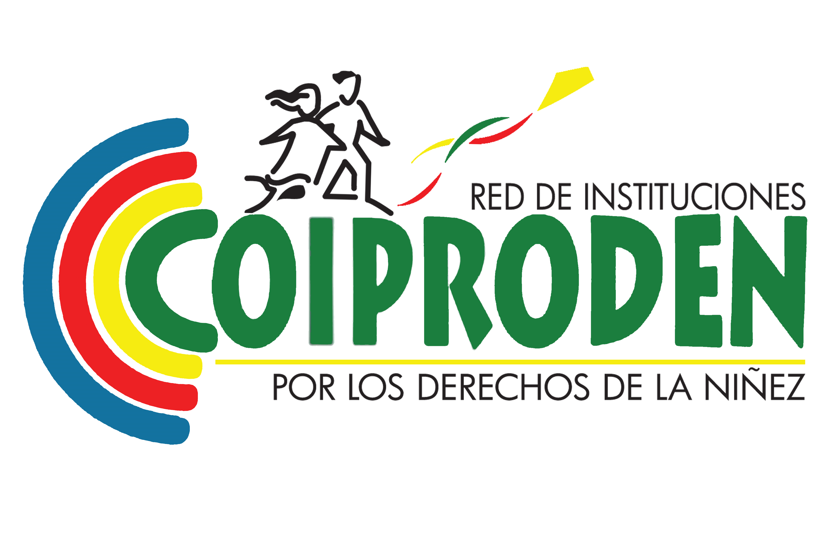
Tegucigalpa, Honduras
October, 2023
Period 2015-2023
To the Observations of the Committee on the Rights of the Child to the State of Honduras on the Optional Protocol on the Sale and Child Pornography and Child Pornography, PASC.
ALTERNATIVE REPORT HONDURAS

- GENERAL ASPECTS.
According to the U.S. Government's 2022 Trafficking Report, Honduras is the fifth country of origin for human trafficking cases, rated Level 2 for failure to meet minimum standards for the elimination of trafficking. The report identifies that many children cross the border alone and others are moved by labor and/or sex trafficking networks.
Between 2014-2022, the Directorate of Children, Adolescents and Family (DINAF, 2023) registered 105,519 Honduran children returned from the United States, Mexico and Guatemala. Between January 1 and February 9, 2023, 762 children under the age of 18 have been returned: 324 are girls, 438 boys. 493 were accompanied by family members or responsible adults and 269 were traveling alone. 300 returned children are between 0 and 6 years old (early childhood), 166 between 7 and 12 years old (childhood) and 296 between 13 and 17 years old.
Mixed migratory flows also grew 973.7% in 2022, compared to 2021. The National Institute of Migration (INM) reports for 2021-2022 that15,914 children crossed through Honduras: 7,219 are girls (45%), most of them from Cuba, Venezuela, Ecuador, Haiti, South America and Africa. There is only one insufficient border shelter, there is a lack of shelter and protection along the entire internal route of the country, increasing the situation of homelessness and begging.
Recommendation
- Strengthen and/or create specialized technical teams in the competent state institutions to provide and/or articulate comprehensive protection services for children and adolescents from international migration, regardless of their migratory status.
- Implement the binational protocol (Honduras-Guatemala) for the safe return of immigrant minors to their countries of origin, evaluating its results to adjust its application.

II. GENERAL REMARKS.
Recommendation: To approve, incorporating the children's approach, and through appropriate consultation processes, the following policies and laws: National Policy for the Guarantee of the Rights of Children and Adolescents; Law on the Purple Alert for the Immediate Search for Missing Women and Girls; the Comprehensive Law on Violence against Women; Shelter Houses Act; DNA Law for Genetic Identification of Children, Penal Code Reforms, others.

DATA COLLECTION
There is a National Information System on Trafficking in Persons (SNITdP) run by the Inter-institutional Commission against Commercial Sexual Exploitation and Trafficking in Persons in Honduras (CICESCT), which compiles reports from justice operators.
The system in question does not include variables on prostitution, child sex tourism, disappearances, irregular adoptions, international abduction, forced labor, forced recruitment, ethnic origin, # of children who have received assistance for their physical and psychological recovery, etc. There is also no centralized registry of sex offenders.
CICESCT 2021 reports that 101 victims of trafficking were rescued, of which 51% are children. Of the total number of victims, 81 are exploited in the national territory and 20 abroad. Data from the Ministry of Public Works report that in 2022 they rescued 208 victims and of 51 complaints of trafficking, 23 cases ended in a prosecutorial request for commercial sexual exploitation, labor, forced begging and recruitment for criminal activities. That year, only 18 convictions were obtained, 10 of them for sex trafficking. In 2019, 34 traffickers were convicted.
Recommendation:
- Strengthen CICEST's SNITdP, especially its role of coordination and centralization of data processing, applying a disaggregated and intersectional approach, including data collection by geographical areas, the different forms of exploitation, children's access to TICs, comprehensive assistance and paid reparations, etc.
- Promote a centralized registry of sex offenders and expedite international judicial and police cooperation.

GENERAL IMPLEMENTING MEASURES
The National Action Plan against ESCNNA 2006-2011 was replaced by the Strategic Plan against Commercial Sexual Exploitation and Trafficking in Persons, 2016-2022, (Executive Agreement 487-2016). Absent or poorly addressed topics were: gender, multiculturalism, intersectionality, responsibility of the private sector (tourism, regulation of access to TICs, etc.).
The executing body of the Strategic Plan is CICESCT, an autonomous institution that is technically and budgetarily attached to the Secretariat for Human Rights. Its operation is through intersectoral coordination and there are 23 Local Committees, one each in the 18 departments of the country, but none with a budget.
Recommendation: Evaluate the 2016-2022 Plan, develop a new comprehensive Action Plan, incorporate all the variables suggested by international organizations; missing topics (responsibilities of the private sector and ongoing evaluation mechanisms); Define your national and local budget.

COORDINATION AND EVALUATION
CICESCT as the body responsible for eradicating ESCNNA in order to avoid dual competencies developed an Intersectoral Protocol to improve the coordination of the Immediate Response Team (ERI). In addition, it approved a Manual to assist victims and Standard Operating Procedures (SOPs) for the identification of victims, their referral to services, and the detection of cases in vulnerable populations.
Recommendation: Evaluate the mechanisms and tools for inter-institutional coordination, care processes, case referral and victim support, with an intersectional approach to vulnerable groups; Adopt best practices.

DISSEMINATION, AWARENESS-RAISING, TRAINING
CICESCT (2021) reports training to authorities, training actions for schooled and out-of-school children, education teachers at the local, national and border levels. Prevention and reporting are paramount in training. In addition, it recognizes its limited capacity to reach more people and other key actors. It exposes budgetary and methodological constraints to address vulnerable sectors locally. Dissemination is generalist and not adapted to age groups.
In March 2023, the Comprehensive Education Law for the Prevention of Teenage Pregnancy was approved, but it was rejected by the "Don't mess with my children" movement and was vetoed by President Castro.
Recommendations:
- The Ministry of Education, with advice from DINAF/SENAF, lead a national education strategy (formal, non-formal and adapted to age groups, including continuous training for educators, parents, judicial operators, etc.); develop campaigns to prevent, eradicate and denounce all forms of ESCNNA and the use of TICs.
- Reach a consensus and approve the Comprehensive Education Law, ensuring that children and adolescents at all levels of education receive sex education adapted to their age.

RESOURCE ALLOCATION
The Anti-Trafficking Law requires that a budget item be allocated for the operation of CICESCT, in addition to the fact that each member institution must allocate a budget for its respective competencies. The Money Laundering Law establishes that 2% of the assets seized are for programs for victims of trafficking and for the Fund for the Attention of Victims of Trafficking in Persons.
In 2023, CICECST's budget increased fivefold to 30,307,772 Lempiras (US$ 1,226,886) for the information system on trafficking, strengthening the ERI, and expanding from 4 to 12 interdisciplinary people.

IV and V. PREVENTION OF THE SALE OF CHILDREN, CHILD PROSTITUTION AND CHILD PORNOGRAPHY.
Pornography and prostitution are not criminalized in the Trafficking Act, but they are in the Penal Code through the crime of Manufacture and use of child pornography, including the sale and distribution to victims under 18 years of age or persons with disabilities. (Article 261).
Justice operators do not report large-scale network dismantling. In 2021, the National Police's Computer Crime Investigation Unit established that child pornography is the most commonly committed cybercrime, with victims ranging from 3 months to 14 years old. In 2022, the Police Unit against Human Trafficking, ESC and Smuggling, prosecuted 30 cases of child pornography. The victims were contacted on social media or online games.

In 2018, an External Audit by CONATEL reported that Honduras is the second Latin American country with the highest consumption of child pornography, however, the limitation of data prevents prevention, protection and care, particularly of children in vulnerable situations. The authorities argue clandestinity and transnationality as limitations to investigate and punish.
In the study "Knowing the internet use habits of children in Honduras" (TIGO, 2020) it revealed that children spend an average of 2.4 hours on internet browsing during school days and 3.6 hours on weekends.
Recommendations:
- Design regulations and/or policies to regulate private internet and cable providers that control, prevent, and punish the exchange and sale of child pornography and other cybercrimes against children. To the State acceding to the Budapest Convention or Convention on Cybercrime.
- Police units give priority to investigating and systematizing data on ESCNNA crimes in street conditions, in domestic service, indigenous, migrant, children in gangs and in drug trafficking and other international crimes.
- The Social Protection Cabinet and the Government's Solidarity Network create a strategic line of protection and financial support for children and adolescents from families susceptible to ESCNNA

USE OF CHILDREN IN SEX TOURISM
According to the Central Bank of Honduras (BCH-2022), tourism is the fourth largest source of foreign exchange. There are no express prohibitions or sanctions on sex tourism. National policies open to tourism especially expose street children and children from indigenous populations. There is an urgent need for risk prevention campaigns and preventive police surveillance mechanisms. The Women's Forum for Life warned that between 2008 and 2019 some 3,300 women had disappeared in Honduras. 23% are girls.
The Honduran Institute of Tourism (IHT) has joined the Regional Action Group of the Americas (GARA). The National Chamber of Tourism of Honduras has promoted, together with the State, the Code of Conduct for the protection of children and adolescents against sexual exploitation in the tourism and travel industry: 453 companies have registered, signed or have renewed.
Recommendations: Define between DINAF/SENAF and IHT a strategy for the business and tourism sector aimed at the protection of children; sanction companies that do not comply with the Code of Conduct or adopt risky practices.

SAW. Observation No. 25.
The new Penal Code (2017) affected the classification of ESCNNA offenses, but in 2021 reforms were introduced to the code to strengthen the classification and penalties. According to CICESCT (2021), the most significant changes to the crime of trafficking are:
- The sentence from 5 to 8 years is increased from 10 to 15 years, equating it with rape.
- Violence, intimidation, deception or abuse of the victim's position of superiority and need constitutes an aggravating circumstance.
- The active subject who carries out the facilitation and promotion is punished.
- The modalities contained in the anti-trafficking law are included.
- Sexual exploitation includes forced and commercial exploitation.
- The offense of money laundering included the proceeds of human trafficking, illegal trafficking in persons, sexual exploitation and child pornography.
- The use of force, fraud or coercion is an aggravating circumstance, rather than an essential element of the offense.

With regard to the Committee's questions:
- The C.P regulates the illicit trafficking of organs and their transfers for profit, with aggravating circumstances in the case of minors under 18 years of age (art. 165 of the Criminal Code). Being a minor is not an essential element of the crime.
- The sale of children for the purpose of sexual exploitation or forced labor is not a criminal offense.
- The crime of Sexual Exploitation does not contemplate the offering, possession, acquisition, or delivery of a child for the purpose of prostitution.
- Prostitution is not an autonomous crime, but a form of sexual exploitation.
- There is no punishment for preparatory acts, nor for attempting to commit any of these offenses.
- The penalties for fraudulent adoption, which is usually used as a way of selling children, are very low.
- When the sentence is low, there is the figure of replacing custodial sentences with other measures.

Recommendation:
- Strengthen the capacity of CISESCT to lead, with the advice of DINAF/SENAF and UNICEF, the new reform of the C.P., for the adequate classification of all crimes related to the optional protocol and other international standards. Ensure penalties commensurate with the severity, including seizure and confiscation.
- Standardize the Anti-Trafficking Act with adjustments to the Penal Code, define the functions of each law; approve LT regulations.

IMPUNITY

According to COIPRODEN (2023), only 32% of traffickers prosecuted between 2019-2022 were convicted.
Specific investigative units have been created in the police and the Public Ministry but all are located in the capital and the city of San Pedro Sula, with limited capacities to operate at the national level or sensitive regions such as borders or cities with the greatest tourist boom. In the interior of the country, action is carried out through investigation units and non-specialized prosecutors' offices.
Prosecution takes place in criminal courts, but the Trafficking Law provides that their crimes will be tried by the national organized crime jurisdiction. CONADEH (2022) reported that courts of national jurisdiction reject cases of trafficking and ESC as minor crimes.
Help through the toll-free 911 line, and the emotional support "offered" on DINAF's 110 line tends to be delayed or non-responsive.
In May 2023, they denounced DINAF for allegedly being linked to an alleged network that took advantage of weaknesses in the adoption and rights restitution processes. The response was the dismissal of the high authorities along with the beginning of an intervention by the police and the MP that continues to this day.

Recommendations:
- Greater territorial presence of specialized research units, in borders, tourist and industrial cities. Raise awareness among justice operators about the seriousness of these crimes. Evaluate and define a plan to strengthen the response of CISECT, ERI, the 911 and 110 lines.
- Generate transparent audit processes for DINAF with emphasis on the May 2023 complaints about irregular procedures in adoptions and protection measures. SENAF to establish protocols and mechanisms for internal complaints and accountability.

LIABILITY OF LEGAL PERSONS
The 2017 Penal Code contained two articles relating to the criminal liability of legal persons in the Crimes of Trafficking in Persons and other degrading forms of human exploitation (Art. 225) and their liability in the crimes of commercial sexual exploitation and child pornography (Art. 263). In both cases, malicious actions were punished. But the business lobby achieved the total repeal of the articles (decree 93-2021).
The only existing regulation is the Code of Conduct for the tourism industry, but it is a voluntary soft regulation.
Recommendation: Enact regulations that regulate the administrative, civil and criminal liability of legal entities (companies, the State, international organizations, others).

EXTRATERRITORIAL JURISDICTION AND EXTRADITION
There is the ultra-territorial application of Honduran criminal law to crimes committed outside the national territory (principle of universal jurisdiction, article 9 of the Criminal Code), which in turn makes it possible to request the extradition of foreigners and Hondurans. It includes the offense of trafficking in persons and sexual exploitation of minors under 18 years of age, as well as those committed abroad.
There is no extradition law, thus generating loopholes on the seizure and confiscation of assets and how they can be used in reparation and compensation processes for vulnerable children.

VII. PROTECTION OF THE RIGHTS OF CHILD VICTIMS
The protection of witnesses and victims is covered by the Witness Protection Act and the Anti-Trafficking in Persons Act.
There is a need to adapt both laws and issue protocols based on the Guidelines on Justice in Matters

Involving Child Victims and Witnesses of Crime.
The protection is usually procedural: confidentiality of identity and personal data, use of Gesell's camera and sometimes physical protection for the duration of the trial, temporary relocation, etc. The program has budgetary limitations, and does not apply a focus on childhood, gender, ethnicity, and intersectionality.
There is no national service of shelters for victims, so support is coordinated with women's shelters that exist in the country and that support receiving victims of ESCNNA. There are risks, for example, of integrating children and adolescents who are victims of ESC in the same place with a case of a woman protected by threats from organized crime.
CISESCT has an outsourcing agreement with one (1) local NGO to provide support to a limited number of victims, mainly from the central area of the country.

RECOVERY AND REINTEGRATION OF VICTIMS
Observation No. 35. There are no integrated multidisciplinary centers of the State for children who are victims of trafficking and/or ESC to receive protection, rehabilitation and comprehensive recovery. Compensation is an issue that is not addressed in any way.
In 2020, the NGO Quality of Life Association stated that of 51 victims of trafficking between 2019 and 2020, none received comprehensive reparation treatment, and in the CICEST 2021 Annual Report it states that out of 101 attentions only "11 victims reached a positive level of social reintegration and emotional stability".
In a 2017 Mapping of Primary, Secondary and Tertiary Prevention Services for Children and Youth in Honduras it was found that of 333 organizations that provide services to children, only 20 have shelter and care services for children in situations of abandonment or poverty. Only 6 organizations had the possibility of providing shelter to child victims of ESC.
DINAF has a limited Program for the Protection and Restitution of Rights of children who are victims of abandonment, abuse, and labor exploitation. These services are limited in scope and quality and are implemented directly or through the outsourcing of services to NGOs, churches and other specialized private actors.
Recommendations:
- Guarantee that services for the protection and restitution of public or private rights, whether outsourced or not, are free, accessible, of high quality, are under permanent supervision of the State, with certified personnel, and are of a comprehensive nature (health, physical and psychological recovery, social reintegration, etc.).
- Invest in shelters or specialized shelters for victims of ESC with a comprehensive approach, aimed at protection, recovery, healing, reintegration and non-repetition.
- Review national legislation in order to incorporate the legal concept of reparation and compensation for victims and their life project.

From 2014 to 2023, Honduras has registered 105,519 children and adolescents (NNA) returned from the United States, Mexico and Guatemala – COIPRODEN Network
20221020-2022-TIP-Report.pdf (state.gov)
Child pornography, the most common cybercrime in Honduras | Your Note
MP prosecutes more than 30 cases of child pornography - Diario La Tribuna
Tigo and UNICEF launch programme to protect children online
Alleged trafficking of minors under the figure of adoption denounced in the DINAF | Your Note
2017 Directory.Casa Alianza de Honduras and Programa Proponte Más/USAID 2017.

