NGO Thematic Report on the Effects Caused to Children Witnessing Violent Government Practices Against Homeless Animals TUNISIA

Failure to comply with the UN Convention on the Rights of the Child

Nov 2020

For further details, contact:

Malcolm Plant, European Link Coalition -
europeanlinkcoalition@europe.com
Anna Mulà, Fondation Franz Weber –
annamula@ffw.ch

Violent Government Homeless Animal Control
Practices Witnessed by Children

Summary

The following report is presented by European Link Coalition and the Fondation Franz Weber. Attention has been drawn to the UN Committee about the existence of activities involving children and adolescents below the age of 18 (hereinafter children) that violate nation’s obligations under the Convention.

The UN Committee has responded to the ‘Harmful Effects’ caused to children witnessing violent animal abuse in bullfighting to advise nations where this takes place to ensure that children are not exposed to these practices. The Committee declared to “Increase efforts to change violent traditions and practices that negatively affect the well-being of children (…)”.

The United Nations Committee on the Rights of the Child has included an express statement regarding the violation of the rights of people under 18 years old in the formulation of the Concluding Observations of the following countries regarding witnessing bullfighting: Portugal (2014 and September 2019), Colombia (February 2015), Mexico (June 2015), Peru (February 2016), France (February 2016), Ecuador (October 2017) and Spain (February 2018), identifying harmful effects to children participating & witnessing violent animal abuse.

Index

1. Violent Government Homeless Animal Control Practices Witnessed by Children: policies, evidence-base information and key concerns
2. Violation of the UN Convention on the Rights of the Child and General comments: articles 3, 6, 19.1 and 27.1.
3. Children’s Right to Be Heard (article 12)
4. Recommendations
5. Academic Study Papers

1. Violent Government Homeless Animal Control Practices Witnessed by Children: policies, evidence-base information and key concerns

In Tunisia the preferred practice of managing homeless animal populations is conducted by shooting the animals.

A subsequent study conducted by Teesside University, UK (Plant et al,2016) explored the effects of violent practices against animals, witnessed by children in societies where homeless animal populations are subjected to management by killing by violent practices. The effects were the same as identified in exposure to bullfighting but on a significantly greater scale exercising this practice in public and witnessed by children (Ladny R.T & Meyer,L (2019). Violent government activity invites a normalisation of violence (Thompson K.L & Gollone. E. (2006) Passivity allows uncontrolled numbers of homeless animal populations with attendant social status diminishment, encouraging societal violence against animals, again witnessed by children.

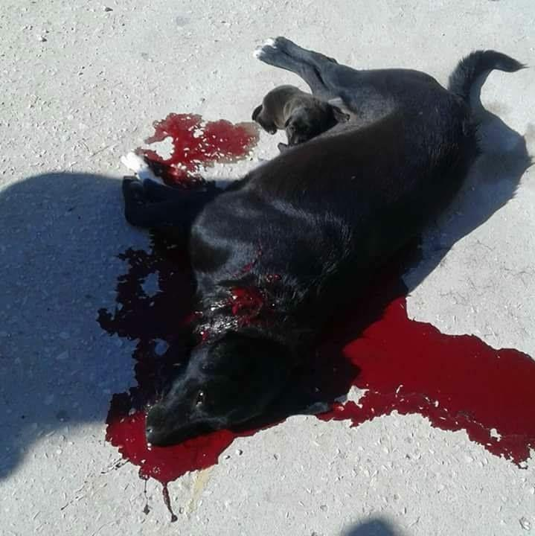
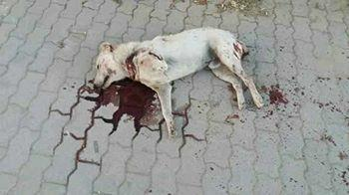

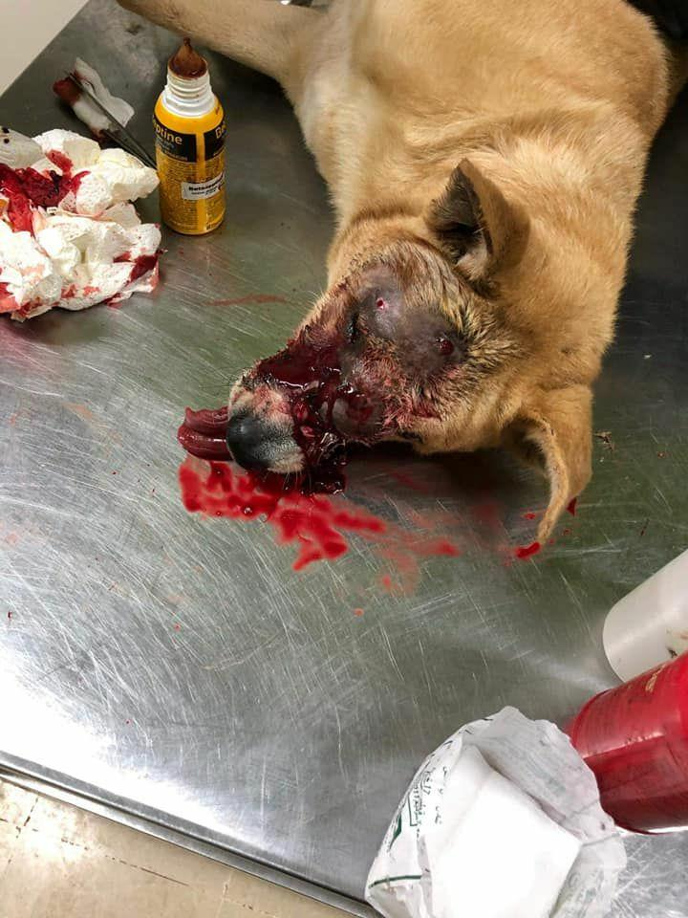
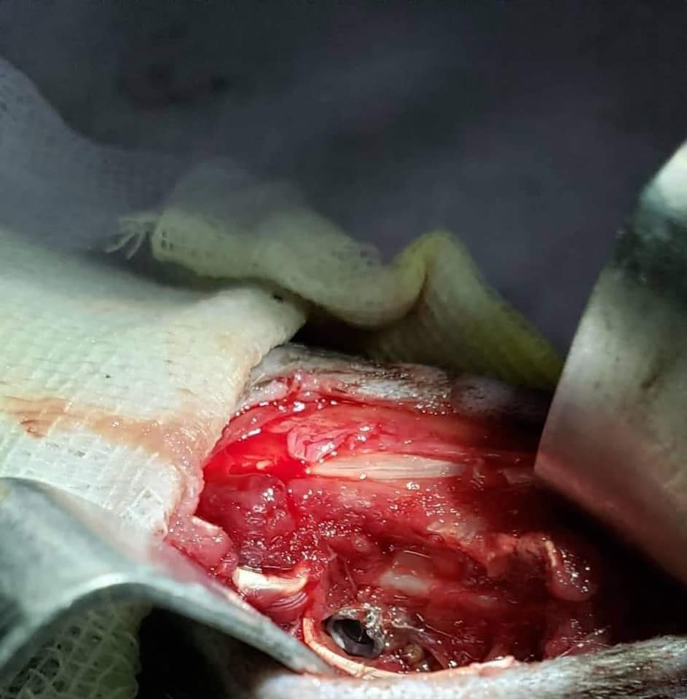

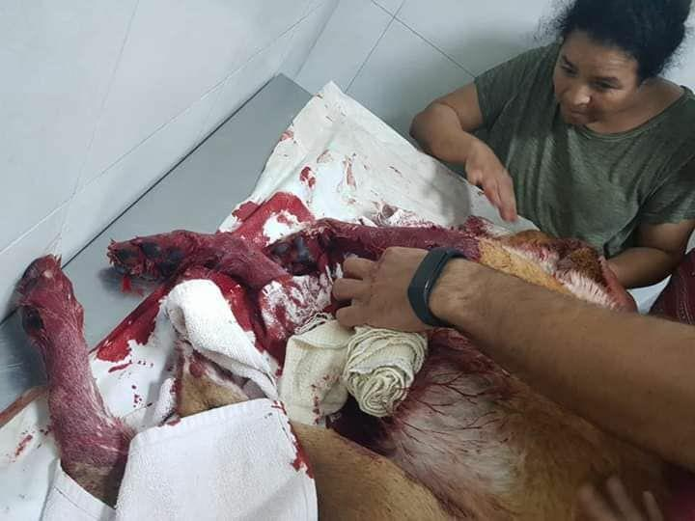

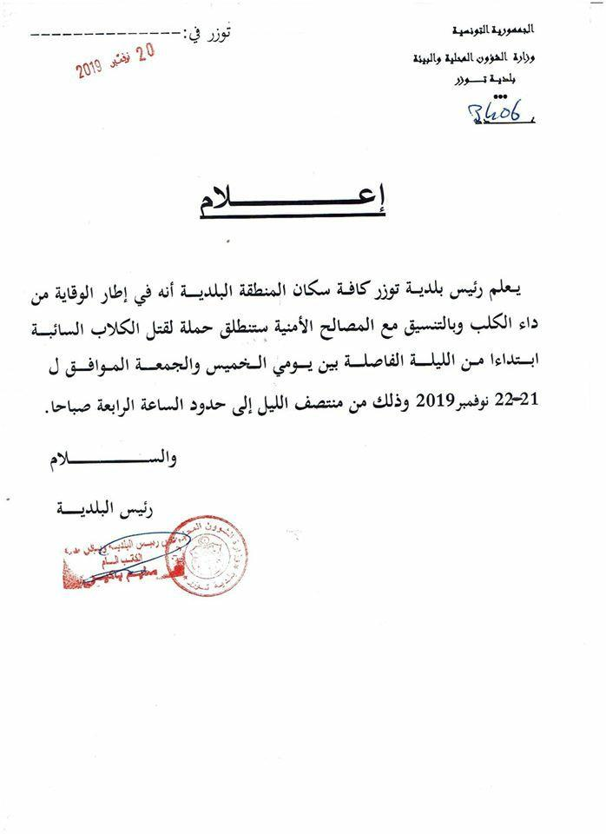

Translation Arabic to English :- ‘The mayor of Tozeur informs all the inhabitants of the town that as part of the prevention of rabies and in coordination with the security services, a campaign to kill stray dogs is launched, from the night of Thursday to Friday, corresponding to November 21 and 22 of the year 2019, from midnight until 4 a.m.’

It should be noted that although on this occasion a nocturnal activity, the children are affected by hearing the sounds of violence, can witness this from their windows & also see animals dying on the streets after only being severely wounded.

It should also be noted that eradication practices promote social stigmatization of the animals which encourages a normalization of violence against animals & which is evidenced to also potentially be enacted in the human domain, typically with domestic violence & child abuse..

This could all be prevented if a national neutering program as recommended by World Animal Health Organisation (OIE) , World Health Organisation (WHO) (as also effective in rabies control)⁹, and Federation of Veterinarians of Europe, (FVE) ¹⁰ as the ONLY effective homeless animal management practice replaced the killing practices.

Judgement of the European Court of Human Rights Georgel and Georgeta Stoicescu v Romania [2011] ECHR 1193 (26 July 2011), is an important judgment that, based on the scope of article 8 of the European Convention on Human Rights, held that Romania violated article 8 of the Convention through failing to take sufficient measures to protect the physical and psychological integrity of the applicant, Ms Georgeta Stoicescu. In October 2000, the applicant was attacked by a pack of stray dogs in front of her home in Bucharest. As a result of the attack, she suffered very serious injuries and became disabled. The large population of stray dogs in Romania has been a public health issue for many years (as Tunisia).

Violent Animal Abuse Practices & the Children – VIDEO: Click on this image to view the video of violent practices experienced by the children in Tunisia
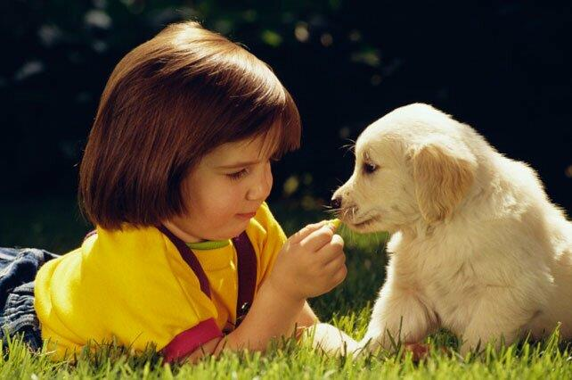

2. Violation of the UN Convention on the Rights of the Child and General comments: articles 3, 6, 12, 19.1 and 27.1.

The situation in Tunisia in relation to children and violent animal abuse practices violate the following articles of the Convention:

- General principles: articles 3 and 6

Protection and care of well-being of children and best interests of the child shall be a primary consideration.

GENERAL COMMENT no. 5 (2003) general measures of implementation of the UN Convention on the Rights of the Child. “Article 3, paragraph 1 -In all actions concerning children the best interests of the child shall be the primary consideration.

According to Concluding observations (2010) of the Committee on the Rights of the Child CRC/C/TUN/CO/3(32), Committee concerns about the views of children not being sufficiently taken into account and respected.

- Civil rights and liberties: article 19.1

State Parties shall take all appropriate legislative, administrative, social and educational measures to protect the child from all forms of physical or mental violence.

The State Party has not taken appropriate steps to protect children from the mental harm of abuse caused by children being exposed to violent homeless animal management practices.

According to Concluding observations (2010) of the Committee on the Rights of the Child CRC/C/TUN/CO/3 (42), the Committee encourages the State party to prioritize the elimination of all forms of violence against children and recommends that the State party pay particular attention to prohibit all forms of violence against children and use the recommendations of the United Nations Study on Violence against Children as a tool for action in partnership with civil society and, in particular, with the involvement of children to ensure that all children are protected from all forms of psychological violence and to gain momentum for concrete and time-bound actions to prevent and respond to such violence and abuse.

- Wellbeing and basic health: article 27.1

Article 27. 1. The State Parties recognize the right of every child to a standard of living adequate for the child's physical, mental, spiritual, moral and social development.

Recognition of the right included in article 27.1 is violated when dealing with public animal killing, as the mental, spiritual and moral development of children is severely compromised by the experience linked to the activity and to traumatic consequences and after-effects of viewing such an event (habituation of violence, traumatic effects, moral desensitization and disturbance of values).

Similarly, the resolution of the General Assembly of the United Nations on "Children's Rights" A/RES/61/146, of 19 December 2006 condemned all forms of violence against children and urges States to take effective legislative and other measures to prevent and eliminate violence in all its forms (physical, mental and psychological).

Thus, the State Party has not adopted the necessary legislative and administrative measures to ensure children such protection and care as is necessary for their wellbeing and to protect against mental abuse in public places.

The physical, mental, spiritual and moral development of children is severely compromised by the danger linked to the activity and to traumatic consequences and after-effects of viewing such events. Witnessing public killing of sentient beings often befriended by the children does not foster the development of those educational values incumbent on the State Parties.

The Committee has already declared its position on the exposure of children to violent animal abuse.

Various psychological studies on violence and animal abuse have shown that witnessing or participating in the violence inherent in bullfights and witnessing public violence against homeless animals can have the following negative impacts on children:

Traumatic effects on children, who cannot freely express their feelings in an environment shaped by adults. A child’s normal reaction to the sight of an animal bleeding as a result of human violence is always, on principle, one of rejection, distress, and fear. Progressive desensitization with an erosion of affective empathy & progressive normalisation of violence from traumatization potentially life-affecting, are among identified results (Merz-Perez, L., Heide, K. M., & Silverman, I. J. (2001).

Habituation to violence if we show them that gratuitous violence can be acceptable and even recommendable. Witnessing the mistreatment of animals perpetuates the cycle of violence by desensitization and imitation of behaviours, especially among people who are at an age when they are learning and being taught.

As a result, significant evidence exists showing that youths who repeatedly witness the mistreatment of animals might be more susceptible to “learning” to use violence in their personal relationships (Wright, J., & Hensley, C. (2003), Murrell, A. R. Merwin, R. M., Christoff, K. A., & Henning, K. R. (2005), Daly, B., & Morton, L. L. (2008), Buka, S. L., Stichick, T. L., Birdthistle, I., & Earls, F. J. (2001).

Confusion of values because the child’s opinion of what is fair and unfair is destabilized. Public Killing of innocent domesticated animals is the negation of what children understand a value to be. Children’s ability to feel empathy is not only limited to human beings; they can also feel it for animals. This is based on the concept of biophilia - the innate emotional bond that humans have towards other living creatures - a predisposition that is particularly strong in children. Killing animals also runs contrary to law - and children know that mistreatment of animals is punishable by law in many countries.

Weakening of the moral compass at a time when children need to find role models to identify with. Children, anxious to preserve the image of their parents and to avoid conflicts of loyalty, have no option but to deny the brutality they have witnessed and to hide all feelings of compassion towards the animal victim. A progressive desensitization process ensues with an erosion of affective empathy and a normalisation of violence which can then be taken into the child' adult world and enacted against people and property. A Cycle of Abuse can be created which results in an increased likelihood of child safeguarding issues and domestic violence. All forms of public violence against animals can cause 'Harmful Effects' to the observing child whether these practices include shooting, poisoning or violent removal for later slaughter.

40 years of research has provided academic resilience to the 'link' between animal abuse & its associations in the human domain. This now informs many authorities including the FBI (USA) and College of Policing (UK).

Children exposed to violent practices suffer sometimes life changing effects.

Effects include empathy erosion & normalisation of violence.

3. Children’s Right to Be Heard

Children Expressing Their Feelings -VIDEO: Click on this image to view the video of children Expressing Their Feelings About Having to See Violent Public Animal Abuse Practices.



4. Recommendations

Violent government homeless animal management practices are both historically proven to be unsuccessful but also unnecessary. WHO, OIE & FVE all advise national neutering programs as the ONLY effective solution.

European Link Coalition makes the following recommendations to Tunisia in order that it meet its obligations pursuant to the Convention on the Rights of the Child:

That Tunisia adopt the appropriate legislative or administrative measures to prevent children from being exposed to the shooting of homeless animals to manage their population.

That Tunisia adopt neutering programs of dogs as being the only proven management practice that could prevent children from being exposed to this kind of violence.

5. Academic Study Papers

Ascione, F. R. (1993). Children who are cruel to animals: A review of research and implications for developmental psychopathology. Anthrozoos, 6(4), 226-247.
Ascione, F. R., Weber, C. V., Thompson, T. M., Heath, J., Maruyama, M., & Hayashi, K. (2007). Battered pets and domestic violence: Animal abuse reported by women experiencing intimate violence and by nonabused women. Violence Against Women, 13(4), 354-373.
Becker, K. D., Stuewig, J., Herrera, V. M., & McCloskey, L. A. (2004). A study of firesetting and animal cruelty in children: Family influences and adolescent outcomes. Journal of the American Academy of Child & Adolescent Psychiatry, 43(7), 905-912.
Buka, S. L., Stichick, T. L., Birdthistle, I., & Earls, F. J. (2001). Youth exposure to violence: prevalence, risks, and consequences. American Journal of Orthopsychiatry, 71(3), 298. Daly, B., & Morton, L. L. (2008). Empathic correlates of witnessing the inhumane killing of an animal: An investigation of single and multiple exposures. Society & Animals, 16(3), 243-255.
DeGue, S., & DiLillo, D. (2009). Is animal cruelty a “red flag” for family violence? Investigating co-occurring violence toward children, partners, and pets. Journal of Interpersonal Violence, 24(6), 1036-1056.
Dutton, D. G. (2000). Witnessing parental violence as a traumatic experience shaping the abusive personality. Journal of Aggression, Maltreatment & Trauma, 3(1), 59-67.
Farrell, A. D., Mehari, K. R., Kramer-Kuhn, A., & Goncy, E. A. (2014). The impact of victimization and witnessing violence on physical aggression among high-risk adolescents. Child Development, 85(4), 1694-1710.
Faver, C. A. (2009). School-based humane education as a strategy to prevent violence: Review and recommendations. Children and Youth Services Review, 32, 365-370.
Flynn, C. P. (1999). Animal abuse in childhood and later support for interpersonal violence in families. Society & Animals, 7(2), 161-172.
Flynn, C. P. (2011). Examining the links between animal abuse and human violence. Crime, Law and Social Change, 55(5), 453-468.
Gullone, E., & Robertson, N. (2008). The relationship between bullying and animal abuse behaviors in adolescents: the importance of witnessing animal abuse. Journal of Applied Developmental Psychology, 29, 371-379.
Henry, B. C. (2004). Exposure to animal abuse and group context: Two factors affecting participation in animal abuse. Anthrozoos, 17(4), 290-305.
Hensley, C., & Tallichet, S. E. (2005). Learning to be cruel?: Exploring the onset and frequency of animal cruelty. International Journal of Offender Therapy and Comparative Criminology, 49(1), 37-47.
Holt, S., Buckley, H., & Whelan, S. (2008). The impact of exposure to domestic violence on children and young people: A review of the literature. Child Abuse & Neglect, 32(8), 797-810.
Kellert, S. R., & Felthous, A. R. (1985). Childhood cruelty toward animals among criminals and noncriminals. Human relations, 38(12), 1113-1129.
Ladny, R.T., Meyer, L. Traumatized Witnesses: Review of Childhood Exposure to Animal Cruelty. Journ Child Adol Trauma (2019). https://doi.org/10.1007/s40653- 019-00277-x Merz-Perez, L., Heide, K. M., & Silverman, I. J. (2001). Childhood cruelty to animals and subsequent violence against humans. International Journal of Offender Therapy and Comparative Criminology, 45(5), 556-573.
Murrell, A. R. Merwin, R. M., Christoff, K. A., & Henning, K. R. (2005). When parents model violence: the relationship between witnessing weapon use as a child and later use as an adult. Behavior and Social Issues, 14, 128-133.
Nicoll, K., Trifone, C., & Samuels, W. E. (2008). An in-class, humane education program can improve young students’ attitudes toward animals. Society & Animals, 16, 45-60.
Plant, M., van Schaik, P., Gullone, E., & Flynn, C. (2016). “It’s a Dog’s Life”: Culture, Empathy, Gender, and Domestic Violence Predict Animal Abuse in Adolescents—Implications for Societal Health. Journal of Interpersonal Violence, 0886260516659655.
Tardif-Williams, C. Y., & Bosacki, S. L. (2015). Evaluating the impact of a humane education summer-camp program on school-aged children’s relationships with companion animals. Anthrozoos, 28(4), 587-600. doi:10.1080/08927936.2015.1070001
Thompson, K. L., & Gullone, E. (2006). An investigation into the association between the witnessing of animal abuse and adolescents’ behavior toward animals. Society & Animals, 14(3), 221-243.
Wright, J., & Hensley, C. (2003). From animal cruelty to serial murder: Applying the graduation hypothesis. International journal of offender therapy and comparative criminology, 47(1), 71-88.

https://tbinternet.ohchr.org/_layouts/15/treatybodyexternal/Download.aspx?symbolno=CRC%2FC%2FPRT%2FCO%2F5-6&Lang=en
http://tbinternet.ohchr.org/_layouts/treatybodyexternal/Download.aspx?symbolno=CRC/C/COL/CO/4-5&Lang=Sp
http://tbinternet.ohchr.org/_layouts/treatybodyexternal/Download.aspx?symbolno=CRC%2FC%2FMEX%2FCO%2F4-5
http://tbinternet.ohchr.org/_layouts/treatybodyexternal/Download.aspx?symbolno=CRC/C/PER/CO/4-5&Lang=En
http://tbinternet.ohchr.org/_layouts/treatybodyexternal/Download.aspx?symbolno=CRC%2FC%2FFRA%2FCO%2F5&Lang=en
http://tbinternet.ohchr.org/_layouts/treatybodyexternal/Download.aspx?symbolno=CRC%2fC%2fECU%2fCO%2f5-6&Lang=en
http://tbinternet.ohchr.org/_layouts/treatybodyexternal/Download.aspx?symbolno=CRC%2FC%2FESP%2FCO%2F5-6&Lang=en
https://www.oie.int/fileadmin/Home/eng/Health_standards/tahc/current/chapitre_aw_stray_dog.pdf ⁹ https:/www.who.int/rabies/animal/dogs/en/ ¹⁰ https://www.fve.org/cms/wp-content/uploads/004-Stray-dogs-position-paper-adopted.pdf

