Consultation with Persons with a Disability

for Civil Society Report on

Implementation of the CRPD
Alliantie VN-verdrag Handicap


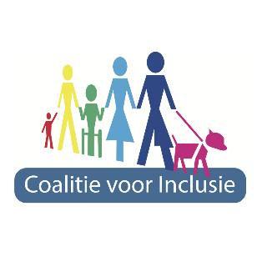


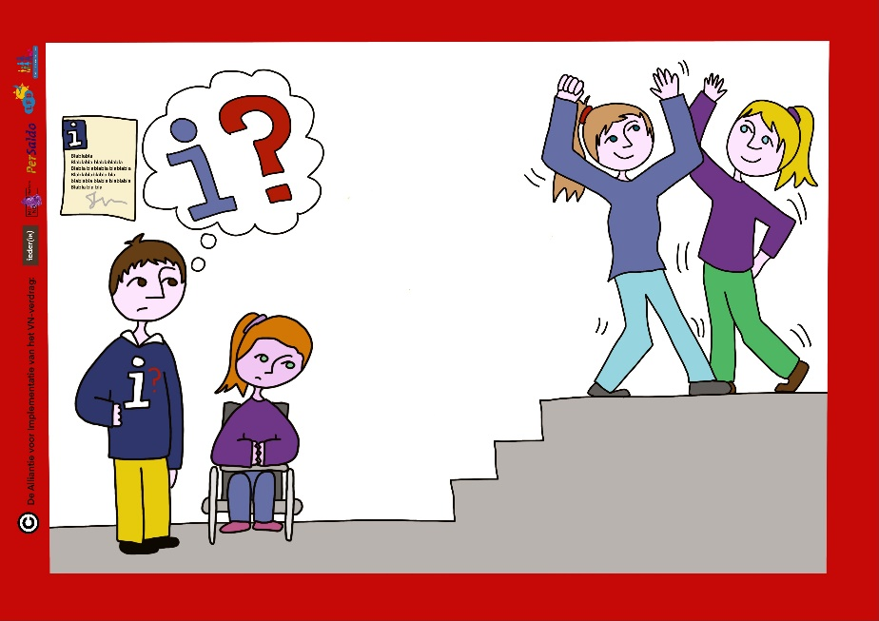
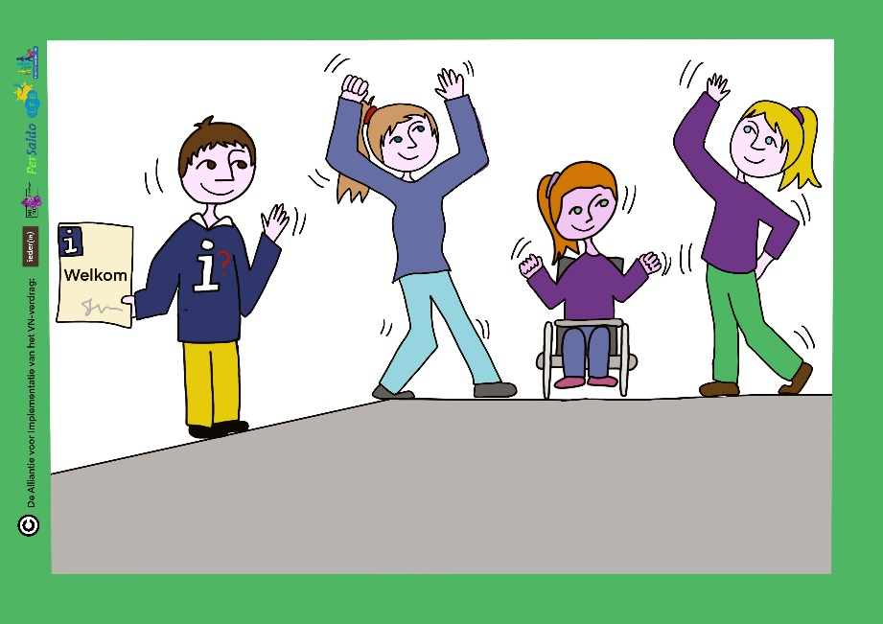
October 2019

Contents
1. Introduction 3
1.1 Purpose 3
1.2 Structure 3
2. The respondents 4
3. Most important themes 5
4. Was a topic missing from the list of topics? 6
5. What should government do to remove barriers? 7
5.1 The importance of listening 7
5.2 Making and enforcing rules 8
5.3 Improvement of legal protection 10
5.4 Work on awareness-raising 10
5.5 More respectful treatment 11
5.6 More monitoring and guidance for implementation of the Convention by municipal government 12
5.7 More individualized support and use of personal care budgets (pgb) 12
5.8 Less bureaucracy 13
5.9 Guarantee access to (inclusive) education 13
5.10 Strengthen the position on the labor market 14
5.11 Facilitate community living 15
5.12 Improve mobility 16
5.13 Poverty prevention 17

Introduction
The CRPD took effect in the Netherlands in July 2016. The Alliance for Implementation of the Treaty (Alliantie voor het VN-verdrag), consisting of DPOs Ieder(in), Mind, Per Saldo, LFB and Coalitie voor Inclusie, has taken on the job of preparing an alternative report on the state of implementation of the Convention in the Netherlands. This report is also called a ‘shadow’ report and is intended for the CRPD Committee in Geneva. This Committee monitors compliance with the implementation of the Convention. The Dutch government submitted its initial report in 2018, two years after ratification, as required by the Convention.
It is important for the shadow report that disabled persons themselves share their experiences and opinions with the writers of the report. This is why the members of the Alliantie organizations are being invited to contribute in a variety of ways to the shadow report. This questionnaire is one of the ways people can contribute to the report.

1.1 Purpose
The purpose of this report is to present the results of the questionnaire which consisted of questions concerning the following:
- The background of the participants;
- The most important topics (selected from a list) for the shadow report;
- Topics that are missing from the list;
- What the government (national, municipal or provincial) can do to remove barriers.
The first issues were addressed with closed questions and the latter with open questions.

1.2 Structure
A total of 623 people completed the questionnaire prepared by Ieder(in). The results are described in four chapters, each chapter focusing on the answers to one of the questions. Many people gave extensive answers to the fourth question (what the government should do). That is why Chapter 5 is by far the longest.

The respondents
The questionnaire was filled in by 623 people. The majority (74%) gave answers based on their own experience with a disability or impairment. The rest of the participants were mostly family members and advocates.
Answer choices | Responses
From personal experience in life with a disability | 74.36%
As a close relative of someone with a disability | 25.47%
From my role as an advocate for people with a disability | 18.29%
Otherwise, namely: | 3.93%
The questionnaire was sent out to members of the organizations making up the Alliantie voor de implementatie van het VN-verdrag. This was done via calls on social media and announcements in DPO newsletters. Ieder(in) also reached out to its constituents via a member panel and that yielded the most responses. Ninety-four percent of the responses came from the Ieder(in) panel.
The overrepresentation of the Ieder(in) panel means that persons with a mental health disability, the constituents of umbrella organization Mind, are relatively poorly represented in this survey. This should be kept in mind when interpreting the results.

Most important themes
People were asked which five topics should absolutely be included in the shadow report. The following three topics were by far the most frequently mentioned:
- Accessibility of the built environment, public transportation and communication (57%),
- Sufficient income to be able to participate in society (46%)
- Discrimination and unequal treatment (35%)
Five other topics followed in frequency of mention (between 28 and 32%):
- Assistive devices,
- Being part of society,
- Independent living,
- Personal mobility,
- Access to care.
The least mentioned topics were: the opportunity to be politically active (2%), violence (3%) and coercion in health care (4%).
Note: The low incidence of mentions of ‘coercion in health care’ likely reflects the underrepresentation of persons with mental health issues among the respondents.
Answer choices | Responses
Accessibility of buildings, environment, public transport and communication | 56.83%
Sufficient income to participate in society | 45.54%
Discrimination and unequal treatment | 35,34%
Personal mobility and health aids | 31.51%
Be part of society | 29.87%
Independent living | 29.69%
Personal mobility (eg regional taxi services) | 29.51%
Access to care | 27.87%
Control over personal support | 24.23%
Sufficient personal support | 21.31%
Willingness of government to work on equal treatment | 20.22%
Access to work | 19.85%
Make your own choices | 19.49%
Access to good education and necessary support in doing so | 16.39%
Safety (on the street or elsewhere) | 14.03%
Derogatory treatment | 13.30%
Possibility to file a complaint or challenge a decision | 13.30%
Support for children with disabilities | 9.65%
Right to family life | 4.92%
Compulsion in care | 3.83%
Violence | 3.10%
Ability to be politically active | 2.37%

Was a topic missing from the list of topics?
More than half of the participants said that nothing was missing by either answering none or skipping the question. Those who answered the question often named problems that came under one of the 22 topics in the list. This is understandable because a number of topics were connected to Convention articles but were abstractly formulated. Some examples:
- Protection from forced medication (= coercion in healthcare)
- Sufficient adapted housing (= being part of society)
- Adapted play grounds (= accessiblity of the built environment)
Topics that were named and not directly linked to a topic from the list are:
- Loneliness (oneliness, difficulty having relationships)
- Sexuality (having mutual relationships, talking about sexuality)
- Bureaucracy
- The increase of electromagnetic fields

What should government do to remove barriers?
The extensive answers given to this question make it clear that participants find that government has a lot to do in many areas. The following reaction sums it up well:
- Make a Delta Plan (a large-scale dike project built in the past century to protect the Netherlands from massive flooding, which required a great investment of human power and money) to remove the obstacles. I was asked to tick five topics, but there are many more I could have ticked off.
The answers to the question about what the government could do vary as to theme and level of abstraction. Some answers present a specific solution to a problem in a personal situation and other answers concern problems at the collective level and are more policy-formulated. And yet certain themes and recommendations recur in many answers.

5.1 The importance of listening
The plea most often given by far is for government to listen better to persons with a disability. ‘Listening’ was named in 62 answers, ‘enter into dialogue with’ 16 times, and ‘speak with’ 14 times. There were also answers given that indicated in other words that government should talk directly to the people concerned and their organizations.
- Think about the consequences for, and even better, talk first with the people in the field. Even if it means taking one or two days, seeing what people actually experience can’t hurt.
- Experiencing things on our level for once, and actually thinking with us instead of at a desk or from behind a drawing board.
- Entering into a discussion with the parties. Supporting the advocacy organizations.
In a number of answers people indicated that listening to proposals was key to coming up with effective solutions at the individual level.
- Entering into discussion with residents/clients/those involved. Hiring self-advocates and persons with a disability or following courses led by dpos.
- Listening to people with a disability. The protocols used by municipalities have become so narrowly defined that individual tailoring isn’t possible anymore and every individual is approached with distrust, as if we’re out to defraud the municipal government. This is such a destructive trend that has an enormous impact on the individual’s trust in government.
- Psychological and/or psychiatric issues need to be taken seriously. Just as seriously as physical disabilities.
- Cut back on budgets only after listening better and providing better treatment, because now the wrong facilities are offered which means they cost twice as much in the end.
The government needs to use the expertise of self-advocates:
- Hire self-advocates. They understand and feel what it means to come up with solutions to problems more quickly.
- Discuss with the people concerned. Be open-minded and think along with and not for others.
Discussion contributes to respectful treatment and dignity:
- Take disabled people seriously, talk with them instead of about them. Provide them with a good, varied day program. Not everyone wants to do crafts or serve sandwiches.
- Observe and keep in mind what a patient or person with a disability really needs (…..) and help people to do their volunteer work in the community and/or to keep up with their hobbies. Don’t force them to be home before dark so that they can go to bed like children.
It is even less a given that people who are deaf or hearing impaired are listened to and heard. This needs attention:
- Every municipality should have someone in service who is at least familiar with the background of deaf and hearing impaired people, can speak Dutch Sign Language or at least use an interpreter, and can actively provide information about the possibilities within a musicality and make effective referrals.

5.2 Making and enforcing rules
It was often mentioned that more needs to be laid down in national rules and regulations. People find that the approach of voluntary compliance leads to little progress. Especially rules related to physical accessibility of the built environment need to be improved:
- Make accessibility guidelines, such as CROW and ITS guidelines, a mandatory part of building regulations. Require full accessibility of public spaces and publicly accessible buildings such as restaurants and hotels, stores, etc.
- Accessibility to buildings needs to be mandated by statute. Amend the Building Decree so that buildings are required to be accessible to disabled people. Require enough disability accessible toilets. Preferably a legal requirement like in Scandinavian countries (where every 500 meters a disability accessible toilet is required).
Next to requiring legal rules, many answers also named enforcement as necessary to making society more accessible. A call for sanctions was made:
- Make work of the issues that have been identified, and if that doesn’t happen, impose fines on the government to force it to take steps. The government always uses money as an excuse for not doing things.
- More regulations, more fines if organizations don’t take action.
- Comply more fully with the Convention, impose sanctions, too much is put off into the future.
- Fine violations of the Convention. There is finally a law, but among others the MKB (Medium and Small Businesses) seem to just ignore it. If it were possible to impose fines they would have to respect the law. A ramp is often too expense for a small or medium business to install. Subsidies as well as fines would literally lower the threshold.
- The government (national/local) must not just say that inclusion is important, but it should have to show that inclusion is the basis of every decision it makes.
You can make accessibility mandatory by including it in concessions and permit requirements:
- Include the CRPD in concessions for public transportation. This does not happen currently. And stimulate municipalities to put the Convention front and center when it makes policy.
- How can it be that we still can’t go to all events and festivals, simply and only because people forget to think about accessibility in the application and permit process?!
- New rules and new policy must be tested against the UN CRPD:
- The government (national/local) must not be allowed to just say they think inclusion is important, but must actually show that inclusion is the basis of every decision they make.
- Include an inclusion paragraph in all administrative agreements, and require it by law.

5.3 Improvement of legal protection
People also find that their individual legal protection needs to be strengthened when Convention rules are violated. In the third citation that follows, a reference is made to Article 1 of the Dutch Constitution, an equality guarantee that fails to name disability as a ground of discrimination.
- The government has to offer concrete ways for us to claim our rights. In practice the Convention seems to be no more than a paper tiger that offers little to an ordinary citizen. I’ve heard a number of stories where support assistance dogs are refused entry and the police say they can’t do anything about it. Then you are repeatedly told to go the College Rechten van de Mens (HRI), but the CRM can only give advice and it takes a lot to make a complaint there. The government should be empowered to issue sanctions quickly for violations of the Convention.
- Ratify the Individual Complaints Protocol.
- Implement the UN Convention and Article 1 of the Dutch Constitution. The government requires the municipalities to do all kinds of things, but no one is there to enforce anything. Nothing is mandatory. The same is true for the Ombudsman and the CRM, their decisions aren’t binding. You can only address the government in The Hague, that doesn’t make binding rules, so the UN Convention is just a soap bubble and a way to provide jobs to nondisabled people and to profit from disabled people.

5.4 Work on awareness-raising
Awareness-raising about the rights of persons with a disability is seen as a responsibility of government. There are various ideas about how this should be done. A number of people had suggestions for improving awareness-raising campaigns:
- Make advertisements that don’t show pathetic disabled people, but people who have a right to participate. That it’s not a question of charity that we exist, but a human right.
- Make TV/radio spots (such as for "nix" – ‘not 18 no alcohol, no smoking’ campaign), that disabled persons can also have a degree in higher education and can order food and beverages themselves in a restaurant, in place of a waiter asking the partner “what would he/she like to order?” Awareness-raising is also about making invisible disabilities visible.
But just as often it was mentioned that acceptance and equality can best be achieved through the participation of persons with a disability in society:
- Let society ‘meet’ its disabled neighbors. Invest in accessibility, so that these people can just! Become visible. Require that buildings be made easily accessible, including for prone toileting care. Reflect the attitude that accessibility is normal. Not unusual and exceptional.
- Discrimination is still a big problem. As long as there is no equality in government, it won’t be reflected in society either. Let’s start to make all people heard and seen.
- Let disabled children take part in society so that children learn that having a disability doesn’t mean that you are different. If you start early with this you can teach society that it’s normal to help another without getting something back in return.

5.5 More respectful treatment
The approach to disabled persons needs to be ‘inclusive’ and free of ús-and-them thinking. Everyone is a human being in the first place and wishes to be treated as a full human being. The government should set a good example in this respect:
- The government acts as if disabled persons are subhuman: as if we cost money and have no added value.
- Work harder to do your best! Why is there a difference between Dutch residents without a disability and with a disability? I’ve never understood this. We shouldn’t have to be talking about this, support people who need it!! In the first place you’re a person!!! Who happens to have a disability.
- People often find it hard to believe how poor the quality of care and assistive devices is. We are second class citizens and have to content ourselves with what we get, we’re not supposed to have anything to say about it.
Patronizing attitudes, insulting behavior and acting as if we are trying to defraud the system, including by governmental agencies. This has to stop:
- Less patronizing behavior by authorities who are there to help disabled persons, such as the WMO (Social Support Act support provided by municipalities) personnel, wheelchair taxi drivers, but also people around you. You are a citizen with capabilities, not a pitiful little bird that needs to be protected and treated like a young child.
- A better social life, and by that I don’t mean Bingo evenings.
- Less control, not everyone is out to rip off the system.
- Training people to be more human. The interrogation I had to go through for three hours of support per week was just plain humiliating.

5.6 More monitoring and guidance for implementation of the Convention by municipal government
National government is responsible for implementation of the Convention and should be setting a good example:
- Set a good example and do what the Convention really requires. Make sure that where sanctions can be imposed, they are imposed.
And the government has to make sure and monitor the municipal governments to correctly implement the Convention:
- The government should be much more demanding of the municipalities, make funding available. People also need to be actively informed about the aims of the Convention; I mean local bureaucrats in particular. The Social Team doesn’t work effectively; often rejects requests for assistance based only on their judgement. The municipality itself is not accessible and hides behind the Social Team. It is important that the municipality backs its residents. The government could send a questionnaire to the residents about this.
- Give the decentral governments sufficient ear-marked funds to carry out their tasks and hold them to binding deadlines.

5.7 More individualized support and use of personal care budgets (pgb)
In providing support to disabled persons, the government has to take account of the differences between people. Besides physical accessibility there must also be attention for visual and auditory accessibility. And the government has to guarantee possibilities for tailoring individual support:
- Allow room for customizing support. Not every disability fits in the same square.
- Provide visual information such as subtitling for TV, film, etc. and information in public transportation. Promote the use of (writing) interpreters in work and educational settings.
- Tailored programs for disabled persons. Combine work/study with care, without erecting a wall to separate the two domains.
- More customizing, don’t shove everything onto the shoulders of nondisabled friends/neighbors/partners so that you can’t function as a family anymore and relationships come under pressure because of the dependency situation created.
The Personal Care Budget (Persoons Gebonden Budget, pgb) is mentioned a number of times as a way to facilitate customized care and personal control:
- Give greater access to pgbs and services and assistive devices that make it possible to live a regular life.
- Stimulate the use of pgb so that people can exercise control over their lives and work toward their own goals.
- Personal control needs to be facilitated on all fronts. Long live the pgb!

5.8 Less bureaucracy
Less administrative red tape and good information provision are needed so that people can get the right support.
- Don’t send parents of children with a problem from one desk to another when they ask for help. (…..) Look beyond the letter of the strict rules. Give diapers for life to children with severe and complex disabilities (emb) who will never be toilet-trained, and don’t require a new application for them every year.
- More transparency (which bureau, when, procedure, etc.) and make it easier to arrange support outside of your own domicile or province. Care is often purchased regionally and care providers who are only aware of what’s available in their own locale/region cannot help with requests for other provinces/municipalities.

5.9 Guarantee access to (inclusive) education
Inclusive education is considered an important prerequisite for social participation. The government has to take action to make this happen:
- Make a plan to implement all the Convention rights and give priority to education. Most children with a disability cannot go to a regular school. Discrimination starts there already. Ensure that all children can go to regular school, then everyone can learn to get along and everyone can see that disabled children want to enjoy the same rights.
- Integrate disabled children in regular education!
- The government had to put the right to education into practice and ensure that good education is possible for every child:
- There needs to be a solution with respect to education. Our daughter receives no education because she doesn’t fit at a medical child daycare center (KDC) nor in special education for children with severe learning difficulties, and they aren’t required to enroll her. But the municipality also has no money to fund a fitting solution for her at home.
- Give children with a disability or illness the right to education, also if they can’t go to class. Now if you report them as ill they end up in Youth care and juvenile incarceration.
- Children with a learning disability (zmlk) should be allowed to stay in school longer, parents of disabled children should be taken more seriously.
- Shorter waiting lists for specialized care and guarantees for appropriate education. Right now there is no authority with a mandate to ensure that a child gets an appropriate education; as the parent of a disabled child you are simply not heard.

5.10 Strengthen the position on the labor market
Several people mention that the measures taken by the government to improve the chances of paid employment for disabled persons. Employers need to be required and/or stimulated to provide employment to people with an employment disability:
- Require, facilitate and monitor businesses to hire persons with a disability.
- Use bonuses or tax incentives to enable employers to hire persons with a disability.
- A really important point is that when hiring a person with a disability that they not have to compete with a nondisabled candidate. More jobs need to be made available for disabled persons at different levels.
Adaptations to positions and workspaces have to be possible and people should be paid a competitive wage:
- Labor market: make the possibilities of employment in small businesses more attractive. Make adaptation of a position possible, and simplify rules for the employer to substitute a sick employee.
- Not wanting us to take part in society and then dumping us by the wayside because we can’t keep up on the open market. And if a group of disabled workers are able to work on the open market, they should be paid a competitive wage instead of at the poverty norm.
If adapted jobs aren’t available, then the government itself has to either provide suitable employment or make unemployment benefits high enough to enable people to participate in society:
- Access to employment is not always available because of significant budget cuts in sheltered employment that was very beneficial to persons with a disability. They had employment, were valued and had a task in society. Really important for these target groups.
- Help people with a disability to find work more easily, instead of requiring them to show that they’ve written 20 application letters (one per day, except the weekend days). Also ensuring that your assistance is raised if you need medication that your insurance doesn’t reimburse. I am speaking from my own experience, live with my father, and have and am confronted with the expense-sharers norm (kostendelersnorm) - from my monthly benefit assistance I can barely pay half of my rent and my health insurance and €38.50 for my deductible. Nothing is left over from my benefits.

5.11 Facilitate community living
The government needs to ensure a sufficient number of accessible dwellings for various population groups: the elderly, youth and for families with a disabled family member:
- Build wheelchair accessible homes, in regular neighborhoods in the community, thus no old folks homes.
- Adapted living with my family (my deepest wish). No one takes account of the possibility that you as mother could become ill and have a family and that other things become necessary. Am shut out everywhere and don’t fit in the squares when it comes to the possibilities for support that are available.
- Make all newly constructed building (whether office buildings or residences) accessible. Attempt to make old public buildings accessible. And then don’t build toilet facilities for disabled persons with an automatic door closer and a 10 cm high threshold.

Innovative living arrangements and citizen’s initiatives must be able to count on government support:
- All areas of life are affected when you have a disabled family member. Getting the right care, finding a suitable residence, etc. should be approached much more intelligently. Such as by combining initiatives in elderly care, disability care and child care. Stimulate and give full support to citizen’s initiatives, elderly initiatives, etc.!
The direct environment has to be participation-friendly and homes need to be affordable:
- More possibilities for making contacts in the direct surroundings. In that way disabled persons become part of society. Facilitate this in education, in sport, adapted playgrounds, etc.
- The ridiculous rent increases need to be rolled back for people with a disability and costs for care (deductibles and co-payments).

5.12 Improve mobility
The government is required to work on accessible public spaces where it is possible for everyone to be:
- The built public environment should be accessible and usable by everyone. No obstacles should block your mobility in getting from A to B.
And the government must ensure that public transportation becomes more accessible:
- Require providers to acquire accessible buses and trains.
- Public transportation should also be accessible for electric wheelchairs. (Refusal based on European regulations.) A wheelchair may not be taller than 1.09 meter.
- Public transportation: train instep level with the platform, or at least require reducing the time for getting assistance to a half hour.
And the quality of supplemental transportation must be improved:
- Also provide transportation to nature areas and other places not having a postcode. The system can’t process this.
- Wmo-provided transportation must be improved. Long waiting times and riding time for wheelchair transportation.
- Fair opportunities to participate in societal events by providing the right assistive devices and transportation.

5.13 Poverty prevention
Many people mentioned that the government has to take steps to limit extra care costs and co-payments. They have difficulties with the accumulation of extra costs and have too little money left over to be able to participate in society:
- More money and attention to care, make sure that care is affordable.
- Tackle with the tax department the compounding of costs for care/medication/assistive devices/co-payment and deductible CAK, etc., as well as the continual reduction of the tax exemption for personal care costs.
- Equal treatment and ensuring that the compounding of care costs disappears. Thank god I have benefits, but my care costs/deductibles/medication use them up completely.
- Get rid of co-payments for home care, we already have so many extra costs.
More attention is needed for providing income support to prevent people from living in poverty:
- Look at income support: care costs are often the cause of poverty.
- Ensure that it’s financially possible to participate in society.
- Raise the income/benefits of persons with chronic illness and/or a disability as that in most cases they cannot lift themselves out of poverty, even when the healthy benefits recipient is able to look for work.

