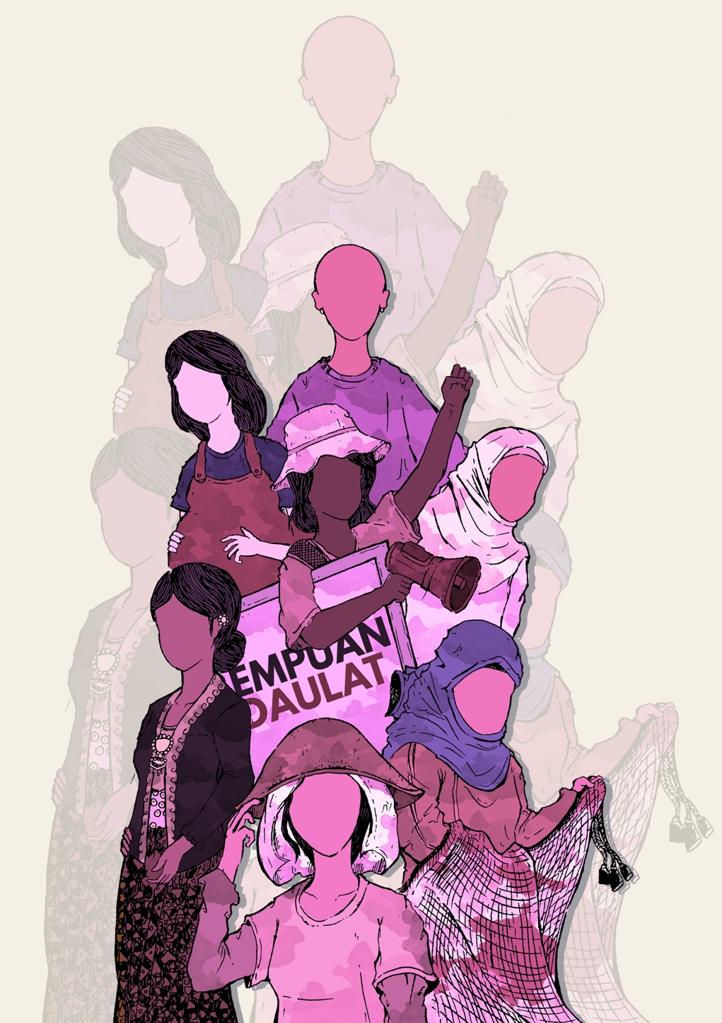
INDONESIAN NGO SHADOW REPORT ON CEDAW
Submitted by Soldiaritas Perempuan

Table of Contents
Acknowledgements 2
Executive Summary 2
Definitions of discrimination against women 2
Constitutional and legislative framework 3
National machinery for the advancement of women 5
Violence against women in conflict 6
Trafficking and exploitation of prostitution 6
Women migrant workers 6
Discrimination against women in rural areas 7
Impact of international trade and investment agreement on women’s rights 7
Women human rights defender 8
Climate Crisis and Disasters 9
Recommendations 10

Acknowledgements
This report was prepared by Solidaritas Perempuan (SP), a feminist organization in Indonesia with individual membership in various issue contexts. Together with its 12 communities: SP Bungoeng Jeumpa Aceh, SP Palembang of South Sumatera, SP Sebay Lampung, SP Jabotabek, SP Kinasih Yogyakarta, SP Mataram and SP Sumbawa of East Nusa Tenggara, SP Anging Mammiri of South Sulawesi, SP Kendari of South-East Sulawesi, SP Palu and SP Sintuwu Raya Poso of Central Sulawesi, and SP Mamut Menteng of Central Kalimantan, SP has spoken to at least 600 women through a series of joint discussions with community activists. Thus this report is prepared based on the real situation experienced by grassroots women in the community.

Herewith we declare our full consent this report for the publishing to public, including for the 80th session of CEDAW.

Executive Summary

Women in Indonesia from various backgrounds, identities, regions and spaces of life have experienced various rights violations, problems of oppression and injustice. Women have experienced a situation where there is injustice in access to and control over resources. In addition, the occurrence of environmental disasters has exacerbated the situation experienced by women. The Covid-19 pandemic disaster also has caused disruption to human life which has resulted in the emergence of crises in various aspects. For women, the pandemic has caused various impacts.

The loss of livelihood has forced women to leave their territory. They looked for alternative sources of economic livelihood elsewhere. In fact, they also become migrant workers abroad by working in vulnerable sectors such as domestic workers. Women are often victims of violence, extortion, exploitation, and human trafficking. Meanwhile, the religious fundamentalism that strengthens and destroys pluralism produces conflicts that have further impacts on women. Religious fundamentalism is included in the socio-political system so manifested to the discriminatory laws.

Definitions of discrimination against women

- Indonesia does not fully incorporate the definition of dicrimination against women in accordane with CEDAW. Inclungdin in the Law No. 39 of 1999 on Human Rights that guaranteed of women’s rights in Indonesia.

- Indonesia Commitment to the 2030 Agenda for the Sustainable Development Goals has been established by the Government of Indonesia through Presidential Regulation No. 59 of 2017. However, the Regulation is only provides technical regulations and eliminates the basic principles of the SDGs agenda, including principles of non-discrimination at all levels. Furthermore, this regulation does not incorporate the definition of discrimination against women as in CEDAW.

Constitutional and legislative framework
- Law No. 6 of 2014 on Village mentioned as a legal framework to guarantee the rights of rural women to be involved in the development process in their village. In fact, SP found that community participation has only been realized through the representation of several people who are considered as figures to be participated at the various level in village. In such conditions, women have to fight with the power of male domination and any domestic burden attached to them.
- Law no. 7 of 2012 concerning Handling Social Conflicts, that has been stated in a National Action Plan for the Protection and Empowerment of Women and Children in Social Conflicts (RAN-P3AKS). However, this RAN P3AKS does not cover the agrarian conflicts that women have to deal with. In fact, the cases of women dealing with agrarian conflicts are increasing, along with the increase in project developments that have confiscated people's land. The experience of SP Palembang in assisting peasant women in dealing with agrarian conflicts since 1983, the handling of agrarian conflicts has always been carried out with an approach of intimidation, violence and criminalization of residents. This situation has caused deep trauma for women. In the efforts to resolve agrarian conflicts, women are not involved in the dialogues.
- Decentralization through Law No. 23 of 2014 concerning Regional Government mandates the formulation of policies for the protection of women. In fact, what happened was opposite. In particular, SP Aceh was reporting women’s rights violations from the Local Law of Aceh No. 6 Year 2014 regarding Criminal Law (Qanun Jinayah) in 2016. Qanun has created a discrimination and criminalized the people who have different interpretation in understanding about and live under islamic law.
Discriminatory laws
- Due to the absence of a legal basis that provides a framework for the definition of discrimination against women, Indonesia actually produces legislation that implements the rules of discrimination against women.

- Law No. 7 of 2016 concerning the Protection and Empowerment of Fishers, Fish Raisers and Salt Farmers, mentioned that women are only as part of the fishermen's household. That makes some women who acts as heads of households or the women who are not married but work as fishers have experienced discrimination in accessing fisher protection and empowerment programs provided by the government. SP Anging Mamiri has recorded the experience a fisherwomen (initial Z) who did not receive the ship distribution program because their husbands were not fishers, instead a pedicab driver. Their households are not recognized as a fisher household, considering that the head of the household is working as a pedicab driver.

- In the Concluding Observations of the CEDAW Committee in 2012 (CEDAW/C/IDN/CO/6-7) and recommendation from the Working Group on the Universal Periodic Review Indonesian government must revoke policies that control women's sexuality, especially those in Aceh. But Indonesia does not implement the recommendations and does not make efforts in accordance with the report it submitted.

- On October 10, 2015, SP conducted a Judicial Review of Qanun Jinayat through the Supreme Court. However, on December 1, 2015, the Supreme Court through its verdict stated that the case was unacceptable (niet ontvankelijke verklaard) without considered the substance of the case and only decided based on administrative considerations.

- The Committee of the Rights of All Migrant Workers and Members of Their Families 2017 concerned to the Minister of Manpower and Transmigration Regulation No. 260 Year 2015 banning the placement of Indonesian migrant workers with individual users in the Middle East prohibits migrant domestic workers from travelling to countries in the Middle East for work (CMW/C/IDN/CO1). However, the Decree of the Minister of Manpower and Transmigration No. 260 of 2015 continues applied.

- The results of the research from SP show that this policy have blocked women's access to the right to work and the right to migrate to their desired country as guaranteed in the Migrant Convention and General Recommendation No. 26 CEDAW.

- After the implementation of this policy, women migrant workers become victims of trafficking and fraud, such as the lure of large salaries, not being placed in the agreed country, not being employed in accordance with the employment contract, and experiencing physical, psychological and sexual violence. For instance, a case happened in 2018. A women migrant worker (initial MT) from Jakarta was persuaded by brokers that she would be hired in Turkey as a restaurant waitress as she wished. After going through the process, MT arrived in Libya without knowing that she would be dispatched to that country. MT is employed as a domestic worker. MT kept refusing to become a domestic worker, and during the process, MT was subjected to violence and unpaid wages.

National machinery for the advancement of women
- Until 2021, the Draft Law on Gender Equality and Justice is not included in the list of priorities for the 2021 National Legislation Program set by the Indonesian parliament Thus, Indonesia did not prioritize this bill to be immediately ratified as a recommendation from the CEDAW Committee (CEDAW/C/IDN/CO/6-7) and the HRC (A/HRC/36/7 - Para. 139). Even in the process, the formulation of this bill is non-transparent and exclusive. The Ministry of Women's Empowerment and Child Protection (KPPA) do not provide open access to documents, so it was difficult for the public to provide critical input.
- Changes in the institutional structure of the KPPPA based on the KPPPA Regulation No. 4 of 2020 has removed the structure of Gender Equality in the Infrastructure and Environment sector. This shows that KPPPA's orientation is no longer prioritizing the protection of women's rights in dealing with infrastructure projects and environmental damage.
- SP noted an increase in cases of violence and rights violations experienced by women along with the increase in infrastructure development in National Strategy Projects (PSN). There is no explicit provision regarding human rights aspects in infrastructure policy and State Owned Enterprises involved in PSN have not explicitly stated their commitment to respecting human rights.
- SP Anging Mamiri documented with the Transnational Institute noted that the development of the PSN Makassar New Port (MNP) prevents fishers from accessing fishing grounds and coastal areas key to local livelihoods. Women are working throughout the value-chain, from harvesting mussels, to washing them and taking them to market. They are also involved in post-harvest activities of the boat-based fishery practiced primarily by men who use traps to catch crabs. Now with the construction of projects like MNP, they have limited access to the raw materials and are left without this important source of income.

Trafficking and exploitation of prostitution
- Cases of trafficking are also experienced by women migrant workers – a situation that then ensnares women in prostitution circles. For example, the case handled by SP, a women migrant worker (initial Sr) who was forced to work abroad was tricked into being hired not according to the contract. She was promised to work at the clinic. However, when he arrived in Johor - Malaysia, she was forced to work as a sex-massage therapist in poor working conditions.

Women migrant workers
- Throughout 2020, SP handled 63 cases of violence, rights violations, exploitation and even trafficking experienced by Women Migrant Workers. In the 63 cases, each women migrant worker experienced more than one type of violence and rights violations. As for the various rights violations experienced by women migrant workers, such as overcharging, trafficking, types of work and placements that are not in accordance with the contract, torture, and so on. The most cases handled by SP are trafficking cases, with 29% are trafficking cases that occurred after the enactment of the Decree of the Minister of Manpower No. 260 of 2015.

- Covid-19 pandemic has also had a specific impact on migrant workers. They are being stigmatized especially when they return to their homes, they are deemed as the vector of the virus. This also prompted by Governor of North Kalimantan and the Consulate General of the Republic of Indonesia (KJRI) in Kota Kinibalu to decide to request a temporary postponement of the deportation to the Government of Sabah rather than build a repatriation mechanism that is in accordance with the Covid-19 health protocol. On the other hand, the Sabah government called the deportation a step to prevent the spread of Covid-19.

- As a result, many Indonesian migrant workers, including women and children, are forced to live in Temporary Detention Centers with inadequate conditions and facilities. SP and the Coalition of Sovereign Migrant Workers formed a fact-finding team regarding the repatriation of 1082 people (June-September 2020 data) from Sabah to Indonesia. Some of the facts obtained include the difficulty of accessing basic needs such as air, food, and health facilities. The women deportant proved that at least she saw 3 women giving birth there with poor maternal and infant health conditions.

Discrimination against women in rural areas
- Government of Indonesia has violated the CEDAW GR No. 34, due to conduct village development without participation of rural women and even displaced women from their living spaces. For instance in the national strategic project of dam construction (Bener Dam) in Central Java Province threatens the Wadas village landscape, including agricultural land, biodiversity and has the potential to pollute the environment including springs. The threat will be felt more heavily and deeply for women because of their gender roles. Moreover, women have never been engaged in the public consultation process that was carried out. Furthermore, no impact analysis on women’s lives was included in the project planning documents.

Impact of international trade and investment agreement on women’s rights
- The current trend of international agreements does not only regulate the elimination of barriers to goods and services, but also extends to cover many essential sectors. The Comprehensive Economic Partnership Agreement (CEPA) although stated for the purpose of trade liberalization, are in fact a significant barrier to the realization of women's human rights.

- In recent years, Indonesia has approved several CEPAs, even in the midst of the pandemic, the Indonesian government is still forcing to process several trade agreements such as the Regional Comprehensive Economic Partnership (RCEP). However, there has never been human rights impact assessment, especially women's rights when trade and investment agreement negotiated and signed. In addition to substances that threaten the lives of the people, the process of formulating these agreements is always in a closed door.

- Regarding land and resource issues, most of the peasant women are managing land and resources in subsistence farming model. Discrimination in a patriarchal system limits women access to and control over agricultural land. In international trade agreements, there is a provision in which the government must treat foreign investors as same as domestic investors or what is known as National Treatment. If this provision is enforced, then peasant women without sufficient ownership documentation can easily loss their land.
Women human rights defender
- Women are very attached to nature and the environment. SP records that women are often at the forefront of protecting the environment. This causes women to face threats of violence, intimidation, criminalization, harassment, rape and even murder.

- The experience of the SP of Palembang in assisting the struggle of peasant women to reclaim their confiscated land, a women leader (initial E) experienced the stigma of being labeled as a bad woman because they are often involved in community meetings at night. This stigma is fueled by the company to weaken the resistance movement.

- However, until now there has been no regulation that specifically regulates how to protect women from these threats. Although in the context of defending the environment, Article 66 of Law No. 32 of 2009 concerning the Protection and Management of the Environment does ensure that environmental defenders cannot be criminalized. However, the interpretation of this article is reduced. This provision is limited only to protect the defenders who takes legal action due to environmental destruction.

Climate Crisis and Disasters
- Indonesia is geographically located in an area that is prone to natural disasters. In September 2021, the National Disaster Management Agency (BNPB) reported that the accumulation of natural disaster events from early January to late August 2021 reached 1,805 events, where wet hydrometeorological disasters still dominate.

- In disasters that occur, women often experience multiple layers of violence. The experience of SP Palu in handling the liquefaction disaster in Central Sulawesi in 2018, showed that many of the women survivors were victims of sexual harassment and domestic violences. Girls are ensnared in early marriage due to poverty after disaster, and many women are ensnared in the seduction of middlemen to become migrant workers abroad because their economic resources are lost due to the disaster.

- The disasters that occurred in Indonesia were exacerbated by the climate crisis. This is closely related to the government's strategy on climate change does not touch the root of the problem. But it is oriented towards climate finance and false solution projects which later result in the loss of people's sources of life.

- As an implementation of the Paris Agreement, the government of Indonesia’s commitment has resulted in another layer of discrimination and violence against women through climate projects. One example is the Kalimantan Forest Climate Partnership (KFCP) project, intended to mitigate climate change; this project instead, is contributing to threatening the women's livelihoods and access to resources. In addition, this project-oriented program has been in conflict within the community.

- As the Lake Poso Hydroelectric Power Plant, which is claimed to be a clean energy project. This development has damaged the forests and rivers of Poso, which are women's living spaces and have social, cultural, economic, political and spiritual significance for women. Women begin to feel fear and lose their sense of security due to the company's operations which often cause quite strong vibrations such as earthquakes, where the vibrations generated can even crack people's houses. These projects have resulted the destruction of women's living spaces and sources of livelihood, as well as deepening the impact of the climate crisis on women.

Recommendations
Based on the explanation above, SP requests the CEDAW Committee to provide recommendations in the Concluding Observations as follows::

- Adopt the definition of discrimination against women as declared in CEDAW articles and must, but also on ensuring substantive equality. Therefore, States must address indirect forms of discrimination where, ostensibly, neutral policy decisions lead to unequal outcomes and widen gender and other inequality gaps. And revoke all discriminatory regulations adopted at all level, including Qanun Jinayat in Aceh province.

- Push forward the enactment of the Bill on Gender Equality and Justice and ensure the upholding of principles on the obligation to recognize, respect, and protect women in respect to CEDAW Convention.

- Ensure the protection of women and children in agrarian conflicts and other natural resource conflicts; with the aim of ensuring the realignment of women's institutional structures - the environment and natural resources in the KPPPA.

- Ensure the protection of rural women’s rights in every step of development by addressing specific problems of women in villages with intersexuality approach.

- Trade and investment agreements should not limit the steps States can adopt or maintain in their efforts to comply with CEDAW. Ensure women's rights impact assessment prior to signing international agreements and the full participation of women in the entire negotiation and decision-making process.

- Implement a comprehensive, gender-responsive and human rights-compliant strategy on the protection of migrant workers and their families based on CMW and GR CEDAW No. 26.

- Ensure the government lifts the ban on migrant domestic workers wishing to travel to countries in the Middle East for work and consider adopting and implementing alternative nondiscriminatory measures to effectively protect the rights of migrant domestic workers.

- Take the necessary steps to ensure that Indonesian migrant workers and their families, especially those who are undocumented, are guaranteed legal proceedings on an equal basis with citizens of the country of employment before the law.

- The state must create a legal umbrella for the protection of human rights defenders with taking into account the special situation of women as human rights defender, and involve civil society with a transparent process.

- Ensure the participation of women and avoid project-based climate change mitigation measures; adopt the enhanced five-year Lima work program on gender and its gender action plan based on Decision 3/CP.25 Conference of Party 25, UNFCCC to the national legislative framework

SP Annual Record 2020: Revealing the Reality and Struggle of Women in the Middle of Patriarchal Politics and Multidimensional Crisis.
See more: https://www.upr-info.org/sites/default/files/document/indonesia/session_27_-_may_2017/sp_upr27_idn_e_main.pdf
Concluding observations Para 18.
A/HRC/21/7 article 109.20
See more: https://tbinternet.ohchr.org/_layouts/15/treatybodyexternal/Download.aspx?symbolno=CEDAW%2fC%2fIDN%2fRQ%2f8&Lang=en
See more: https://putusan3.mahkamahagung.go.id/direktori/putusan/14302d50d3a67a52e51a35aa2c7877de.html
Concluding observation Para 51.
See more: https://www.dpr.go.id/berita/detail/id/32239/t/Paripurna+DPR+Sepakati+33+RUU+Prolegnas+Prioritas+2021
Concluding observations Para 20e.
See more: https://longreads.tni.org/gender-and-fisheries-in-indonesia ¹³ See more: https://magdalene.co/story/tragedi-sigi-dan-kerentanan-petani-di-tengah-pandemi
SP Annual Record 2020.
See more: https://www.solidaritasperempuan.org/sub/wp-content/uploads/2021/01/Report-Koalisi-Buruh-Migran-Berdaulat.pdf
See more: https://www.solidaritasperempuan.org/sub/wp-content/uploads/2021/09/Amicus-Curiae_SP.pdf
See more: https://ftacenter.kemendag.go.id/news-asean-dorong-implementasi-penuh-persetujuan-rcep-awal-2022
See more: https://www.suara.com/news/2021/09/04/232201/bnpb-terjadi-1805-bencana-di-indonesia-selama-januari-agustus-2021
See more: https://www.solidaritasperempuan.org/deklarasi-perempuan-penyintas-bencana-sulawesi-tengah-bangkit-bersolidaritas-dan-pulih-bersama-menuju-perempuan-penyintas-bencana-yang-berdaulat/
See more: https://apwld.org/wp-content/uploads/2014/12/flyer-sp.pdf
SP Annual Record 2020.
FCCC/CP/2019/13/Add.1

