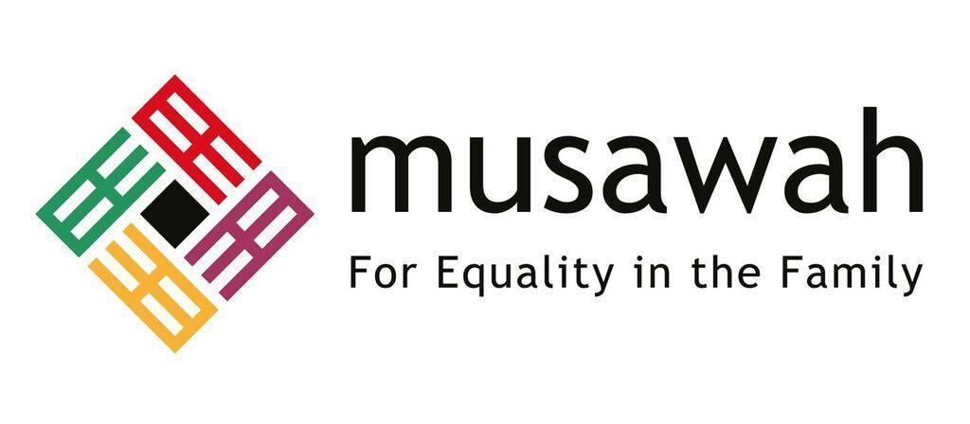
THEMATIC REPORT ON MUSLIM FAMILY LAW AND
MUSLIM WOMEN’S RIGHTS IN
MOROCCO

82nd CEDAW Session
Geneva, Switzerland
June 2022

Musawah

15, Jalan Limau Purut, Bangsar Park, 59000 Kuala Lumpur, Malaysia
Tel: +603 2083 0202 Fax: +603 2202 0303
Email: musawah@musawah.org
Web: www.musawah.org

A. INTRODUCTION

Musawah, the global movement for equality and justice in the Muslim family, submits this Thematic Report on Article 16 and related concerns for consideration by the CEDAW Committee in its review of the Government of Morocco, reporting before the 82nd CEDAW Session in June 2022. In particular, this report examines Morocco’s laws and practices that enforce de jure and de facto discrimination against women in the following areas: child and forced marriage, guardianship and custody, division of property, nationality and inheritance law.

We hope that the CEDAW Committee will utilize this report as a key resource during its Constructive engagement with the State party. In particular, we hope the Committee will use the recommendations, outlined in grey boxes within the text, to identify follow-up issues in its Concluding Observations.

B. background and legal framework

- Country Background: The official religion of Morocco is Islam. More than 99 percent of the population is Sunni Muslim, and less than 0.1 percent is Shia Muslim. Groups together constituting less than 1 percent of the population include Christians, Jews, and Baha’is.

- Equality in the Constitution: According to the Constitution, Islam is the official religion of the State. Morocco’s Constitution provides for equality between men and women in a number of provisions, including:

- The Preamble, which commits the State to prohibit and combat discrimination against anyone on several bases, including sex;
- Article 6, which guarantees equality before the law regardless of gender;
- Article 19, which provides for the equal enjoyment of civil, political, economic, social, cultural and environmental rights and freedoms by both men and women; and
- Article 32, which states that the family is founded on the legal ties of marriages and declares family as the basic unit of society.

- The Family Code (Moudawana): The Family Code (Moudawana) is the primary codified law that governs marriage and family relations of the predominantly Muslim population in Morocco, regardless of their sect. In the absence of codified laws that sufficiently address a particular matter of personal status of Muslims, reference may generally be made to rules of Maliki jurisprudence (fiqh) and to judicial reasoning (ijtihad) that “strive to fulfil and enhance Islamic values, notably, justice, equality and amicable social relations”. The Family Code provides for a marital framework that is based on equality between the two spouses:

- Article 4 defines marriage as a “legal contract”, the purpose of which is “fidelity, virtue and the formation of a stable family under the supervision of both spouses”;
- Article 51 stipulates the mutual rights and duties between spouses, which include: (i) cohabitation, mutual respect, affection and the preservation of the family interest; (ii) both spouses assuming the responsibility of managing and protecting household affairs and the children’s education; (iii) consultation on decisions concerning the management of family affairs;
- Article 52 states that when either spouse continually fails to fulfil his or her obligations in marriage, the other spouse may compel the spouse to execute the obligation or seek divorce for irreconcilable difference.

According to the current family law, the husband is obligated to financially provide for the family while “women can choose to contribute as their abilities allow”.

- Analysis of Legal Framework:

- According to Fatima Sadiqi, the family code “does not adequately address the problems of single women and the non-Moroccan wives of Moroccan men”.
- Many feminist activists report that the Family Code was deemed “revolutionary” in 2004 but is "outdated" in 2021. They point out the inconsistencies and demand a revision of all discriminatory policies and legislations to be in line with the constitution and Morocco's international obligations.

C. KEY ISSUES AND RECOMMENDATIONS

1. Child and Forced Marriages Article 16

Legal Background

The minimum legal age for marriage is 18 for females and males. However, the Family Affairs Judge in charge of marriage may permit girls and boys below 18 to marry “in a well-substantiated decision explaining the reasons justifying the marriage”, after having heard the parents or legal guardian of the minor with the assistance of medical expertise or after having conducted a social enquiry. Such a decree is not subject to appeal.This provision creates a legal loophole preventing the eradication of child marriage in Morocco.

The marriage of a minor is contingent upon the consent of minor’s legal guardian. Should the guardian refuse, the Family Affairs Judge may rule on the matter. The law does not stipulate an absolute minimum age below which a marriage may not be authorised.

Prevalence of Child Marriage:

Despite the increase in the minimum age of marriage in 2004 from 15 to 18 through the enactment of the Family Code, various sources indicate that the prevalence of child marriages in Morocco is relatively high, and authorization by judges of marriages to minors continue to be rampant:

- In Morocco, the Ministry of Justice registered 25,514 child marriage cases in 2018, corresponding to a prevalence rate of 9 percent.
- According to UNICEF’s 2016 State of the World’s Children Report, 16 percent of women aged 20-24 in Morocco were first married by 18 and 3 percent by 15.
- Recent statistics from Morocco’s Ministry of Justice demonstrate that during 2019, out of 32,000 requests for marriage to minors, Moroccan courts issued authorizations for 81 percent or 25,920 cases.
- Nearly 85 percent of such applications filed between 2011 and 2018 were authorized, and involved, in their vast majority, girls (94.8 percent of the total minors married). These statistics do not include informal marriages ("Al-Fatiha", "by Contracts") nor those established through the procedure of recognition of marriage (Article 16 of the Family Code) which alone represent 15 percent of marriages of minors concluded between 2015 and 2019.

Reasons for Prevalence of Child Marriage:

According to reports by the National Human Rights Council of Morocco, the World Bank and civil society groups, as well as academic research, the reasons for the high prevalence of child marriages in Morocco include:
- Entrenched patriarchal attitudes, along with poverty and lack of education;
- High and increasing number of petitions for authorisation of child marriages and high rates of approval, as discussed above;
- Under-implementation of the law:
  - The marriage of minors subject to authorization by a judge after medical examination or social investigation is also under-implemented. In practice, only 12.42 percent of married minors received an investigation by a social worker, while 87.56 percent were only heard by a judge.
  - Judges often issue an authorisation to marry minors based on their own visual examination of the minor girl’s physical appearance and determination that she is capable of assuming “marital responsibilities”, rather than resorting to the required expertise. Reasons provided by judges for authorising underage marriage include saving family honour, avoiding scandal, protecting the girl’s chastity and preventing her from debauchery. Some cite marriage as a solution to poverty. At times judges do not even substantiate their decisions in writing;
  - Alleged corruption among public actors and the ease by which medical certificates attesting to a minor girl’s “maturity” can be obtained.
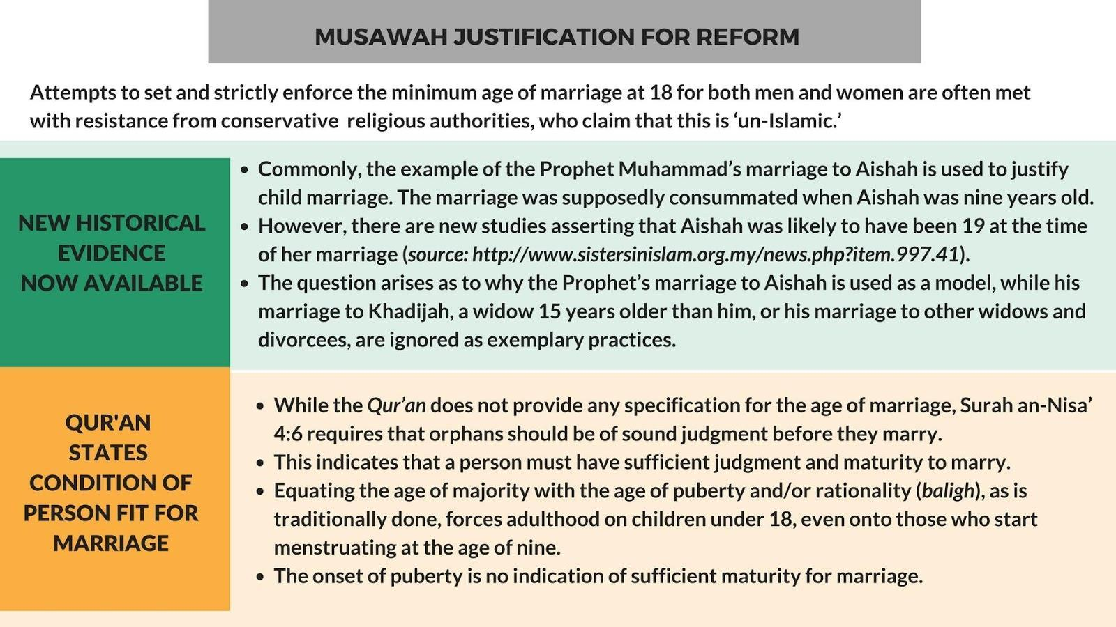

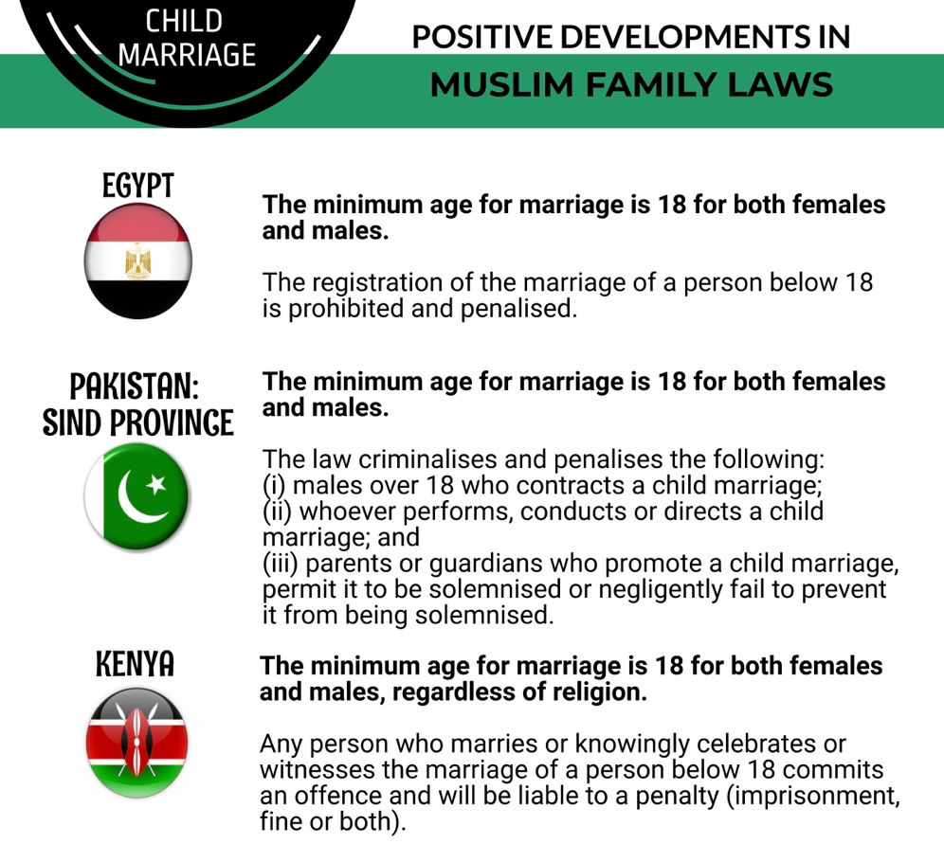

RECOMMENDATIONS

We recommend the CEDAW Committee urge the State Party to:

- Ensure that government passes and enacts legislation to raise the minimum age to 18 without any exception of judicial permission.

- Ensure data collection of the number of cases of child and forced marriages and number of prosecutions and penalties imposed on persons responsible for child and forced marriages; also continue to ensure data collection of the number of exceptions granted by the judiciary in the past five years, as well as the specific criteria considered by the judges when granting such exceptions.

2. Guardianship and Custody of Children Article 16

Legal Background:

Under Moroccan law, the father is the legal guardian of a child, and Moroccan women can only exercise guardianship over their children under restrictive conditions, including death, absence, or loss of capacity. Even though the family code stipulates that “where the father is totally or partially unable to provide for his children, and the mother is well off, she shall pay alimony”, this material responsibility does not give her the right of guardianship over her children.

During the marriage, both parents have custodial rights over their children. Upon a divorce, a mother has priority right of physical custody of her children (followed by the father and then maternal grandmother) until the children reach the age of 15. Thereafter, the child may choose either the mother or father to be his or her custodian.

However, a mother risks losing custody of her child if she remarries, and her new husband is not a close blood relative of the child or the child’s legal representative. No such restriction exists for the father.

Public Opinion:

In 2021, Moroccan human rights advocates and mothers launched a campaign on social media under the slogan “I am a Moroccan mother in 2021” to demand changes to chapters in the Family Code that limit the mother's guardianship of her children. This slogan is backed up by statements including “I am not allowed to make decisions about my children’s education, extracurricular activities, and medical treatment. I'm not allowed to give them a passport, set up a savings account, and go on a trip without permission” and “When I pay for medical consultations, the father is compensated. When I contribute more than 50 percent of the household expenses, it is the father who receives the family compensation.”

Regarding custody, in 2021, the Democratic Association of Moroccan Women (ADFM) stated in materials about revising the family code that depriving the woman of the right of custody after remarrying perpetuates discrimination against women. A number of feminist activists were surveyed and declared that the provision in which a divorced mother loses custody of her child when she remarries does not apply to the father since he "can remarry without fear of losing the custody".

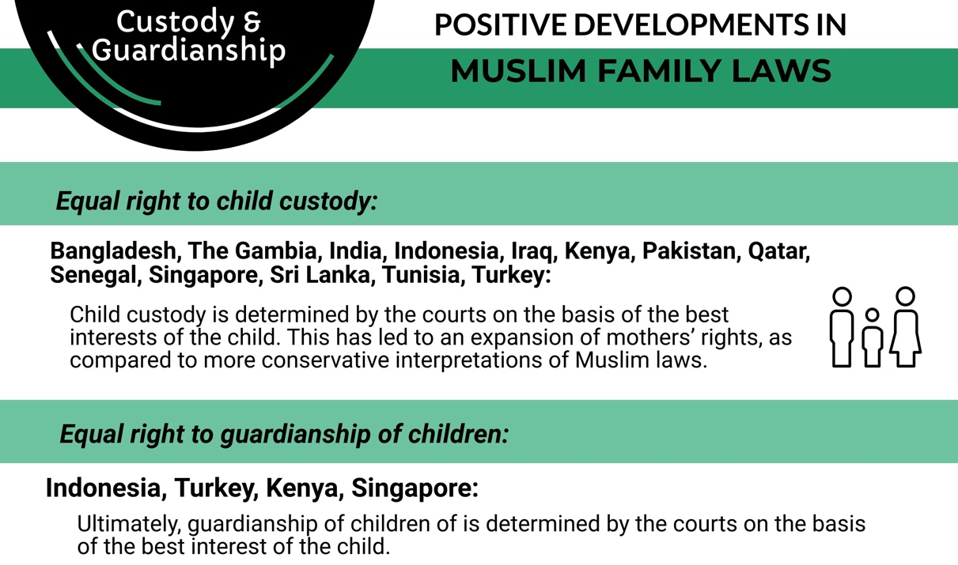

RECOMMENDATIONS

We recommend the CEDAW Committee urge the State Party to:

- Amend Article 175 of the Family Code 2004 to not deprive the woman of the right of custody upon remarriage.

- Amend Article 236 and 238 of the Family Code to grant women the same rights of guardianship of children as men, and to provide for recourse to be made to the best interests of the child in the event of a dispute.

3. Division of Property in a Marriage Article 16

Under Moroccan law, spouses may, through a written document separate from a marriage contract, agree on the investment and distribution of assets acquired during the marriage.

However, in 2019, only 0.25 percent of marriages were accompanied by such a contract due to the lack of information or to the refusal of families to establish such an agreement at the time of marriage.

In the absence of such an agreement, ‘recourse is made to general standards of evidence, taking into consideration the work of each spouse, the efforts made as well as the responsibilities assumed in the development of the family assets’. This ambiguous wording allows the judge to require tangible proof of the wife's financial contribution and, as shown by several decisions of the Court of Cassation, to disregard her contribution through her domestic and care work.

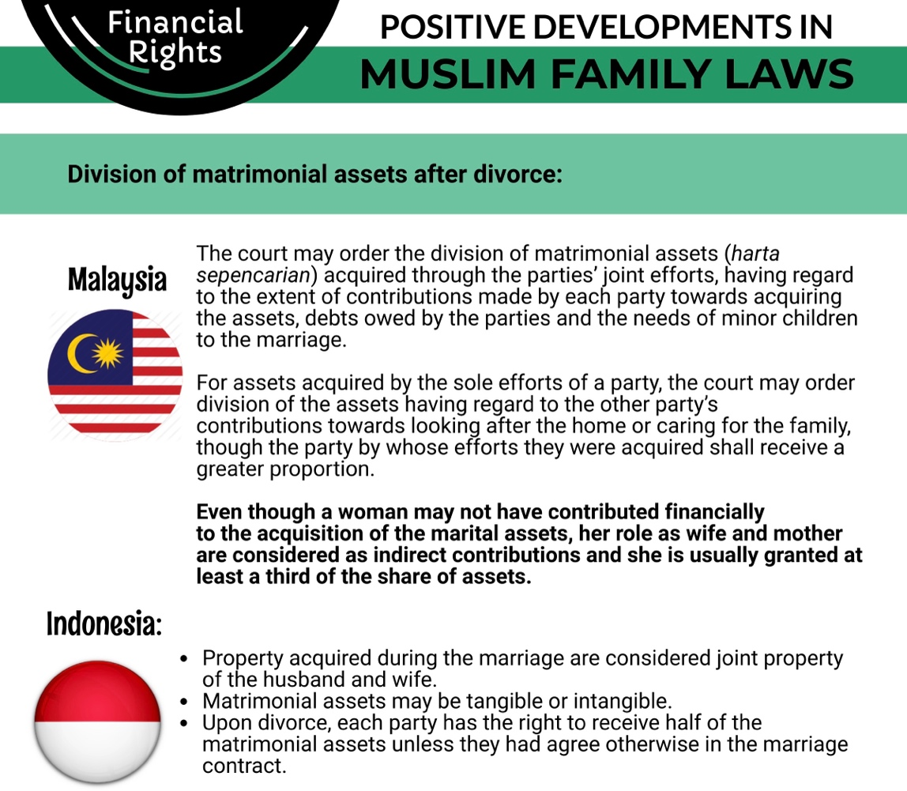

RECOMMENDATIONS

We recommend the CEDAW Committee urge the State Party to:

- Take measures to inform the public on the usage of the written agreement for the division of property and to remove barriers that cause lack of such information, particularly to women from disadvantaged social backgrounds.

- Amend Article 49 of the Family Code to also take into account domestic and care work by courts while adjudicating on the division of marital property upon divorce in the absence of a written agreement.

4. Nationality Law Article 9

While the UN Committee on the Rights of the Child welcomed the 2007 changes in the Nationality Code enabling women to transmit their nationality to their child at birth, it expressed concern that, in 2014, rural women remained unaware of their right to transmit Moroccan nationality to their children, while 14 percent of births were still unregistered.

Discrimination between men and women in relation to transmission of nationality to spouses still remains. Foreign spouses of Moroccan men are automatically entitled to Moroccan citizenship. However, Moroccan women must initiate complicated administrative procedures to pass nationality to their foreign spouses, creating a unique burden on them versus Moroccan men married to non-Moroccan women. Without going through this process, foreign spouses of Moroccan women face obstacles related to residency in Morocco and access to employment and public services.

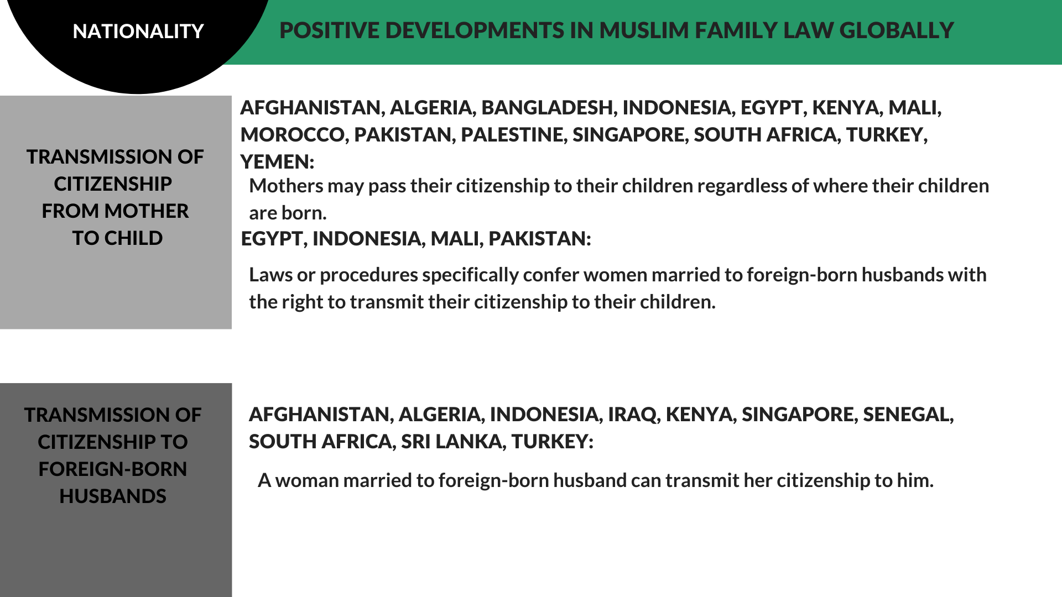

RECOMMENDATIONS

We recommend the CEDAW Committee urge the State Party to:

- Amend the Nationality Code to allow women to transmit nationality to their foreign spouses.

- Take measures to inform the public and create awareness of women’s right to transmit Moroccan nationality to their children.

5. Inheritance Law Article 16

The inheritance law states that women can inherit only half the share of men who have the same degree of relationship to the deceased. In 2004, Morocco removed the inequality between grandchildren who would be excluded from an inheritance of a grandparent because their parent had died; at present, a bequest is obligatory for grandparents in favour of their grandchildren not only via the son, but also via the daughter.

The World Bank reported that “Women's legal inability to inherit equally to men can significantly undermine their economic security and independence, as well as their access to economic opportunity”. The USAID/Morocco Gender Analysis Final Report pointed out that customs and traditions denying women any rights to inheritance may be enforced by violence, with women pressured to renounce their rights or threatened to be evicted from the home.

In December, the Socialist Union of Popular Forces, a political party in Morocco, demanded the repeal of laws that discriminate against women and called for a national debate on the inheritance law. Although their message stirred some controversy, no national or legislative debate ensued. While the Family Code is based on traditional interpretations of inheritance law in Islam, a representative of Mobilizing for Rights Associates, a nongovernmental organization based in Morocco, stated in 2014 that “Islam allows for reinterpretation, and it is time for radical decisions to protect women.” She stated that “this law of inheritance was based on the fact that men were the head of the households, which is not the case anymore as many women are the ones who provide for the family or at least contribute in a significant manner.”

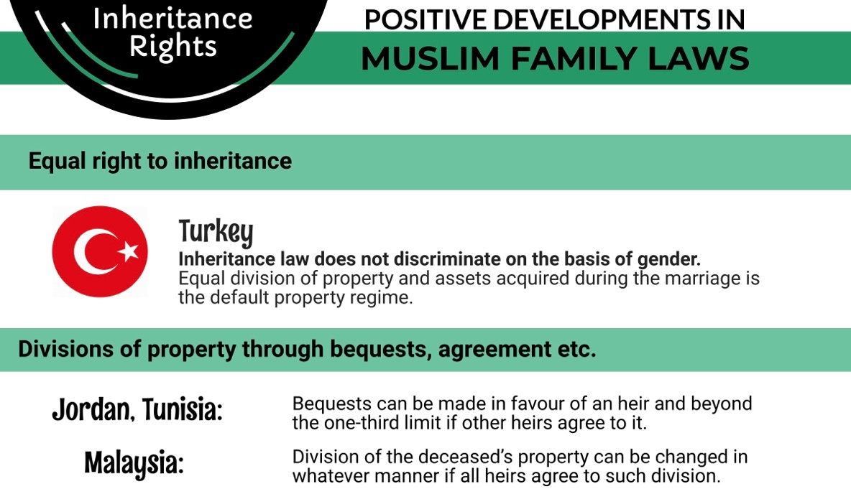

RECOMMENDATIONS

We recommend the CEDAW Committee urge the State Party to:

- Amend the relevant law to grant women the same rights as men in matters of inheritance in conformity with Article 16 of CEDAW.

Musawah would like to acknowledge the inputs provided by the Fédération des Ligues des Droits des Femmes (FLDF) and other national advocates in the preparation of this report.
Morocco’s Constitution of 2011 (hereinafter “Morocco Constitution”), art. 3, https://www.constituteproject.org/constitution/Morocco_2011.pdf?lang=en
Report on International Religious Freedom: Morocco 2019, Office of International Religious Freedom US Department of State, https://www.state.gov/reports/2019-report-on-international-religious-freedom/morocco/
Morocco Family Code (Moudawana) (2004) (hereinafter “Family Code” or “Moudawana”). http://www.hrea.org/wp-content/uploads/2015/02/Moudawana.pdf
Family Code, art. 400.
Family Code, arts. 4, 51, 52.
Lahcen, Achy., “Morocco’s gender equality laws fail to improve situation,” Al-Monitor, April 2013.
Women's Rights in the Middle East and North Africa 2010 - Morocco, Freedom House, 3 March 2010. https://www.refworld.org/docid/4b990120c.html
Sara Ibriz. “Code De La Famille : Voici Des Pistes De Réforme.” Medias24. 8 December 2021. https://medias24.com/2021/12/08/code-de-la-famille-voici-des-pistes-de-reforme/
Statement, “For a comprehensive and urgent reform of the family code”, Democratic Association of Moroccan Women (ADFM), 11 October 2021. https://euromedrights.org/wp-content/uploads/2021/10/communique-10-octobre-2021_.pdf
Family Code, art. 19.
Family Code, art. 20.
Ibid.
Family Code, art. 21.
The Advocates for Human Rights and MRA Mobilising for Rights Associates, “Morocco”, Submission to the Committee on Economic Social and Cultural Rights for the 56th Session, 2015, para. 44, http://www.tanmia.ma/wp-content/uploads/2015/09/AHR-MRA-Morocco-ESC-Shadow-Report-FINAL.pdf
“Child Marriage in the Context of Covid-19”, UNICEF Middle East and North Africa Regional Office UNFPA Arab States Regional Office, June 2021, https://arabstates.unfpa.org/sites/default/files/pub-pdf/child_marriage_in_the_context_of_covid-19-_mena_regional_analysis_high_res_1.pdf.pdf
“The State of the World’s Children 2016”, UNICEF, Table 9, pp. 150-153, https://www.unicef.org/publications/files/UNICEF_SOWC_2016.pdf
“Moroccan Courts Approved 25,920 Child Marriage Requests in 2019”, Morocco World News, 26 January 2020, https://www.moroccoworldnews.com/2020/01/292105/2019-child-marriage-morocco-statistics
Association Démocratique des Femmes du Maroc (ADFM) and the Harmonization Now Dynamic, “Morocco”, Submission for the CEDAW 82nd Session, June 2022, (Hereinafter “ADFM CEDAW Submission 2022”), para. 18, https://tbinternet.ohchr.org/Treaties/CEDAW/Shared%20Documents/MAR/INT_CEDAW_CSS_MAR_48466_E.docx
Ibid.
“Gender Equality and Parity in Morocco”, National Human Rights Council of Morocco, 2015, para. 6, http://www.cndh.org.ma/sites/default/files/cndh_-_r.e_-_web_parite_egalite_uk_-.pdf; Paul Pretitore, “Ten Years After Morocco’s Family Code Reform: Are Gender Gaps Closing?”, World Bank MENA Knowledge and Learning Quick Notes Series, 121, 2014, p. 3, http://siteresources.worldbank.org/INTMENA/Resources/QN121.pdf; “Child Marriages Around the World: Morocco”, Girls Not Brides, http://www.girlsnotbrides.org/child-marriage/morocco/; The Advocates for Human Rights and MRA Mobilising for Rights Associates, “Morocco”, Submission to the Committee on Economic, Social and Cultural Rights for the 56th Session, 2015, paras. 43, 45, http://www.tanmia.ma/wp-content/uploads/2015/09/AHR-MRA-Morocco-ESC-Shadow-Report-FINAL.pdf; Ann M. Eisenberg, “Law on the Books vs. Law in Action: Under-Enforcement of Morocco’s Reformed 2004 Family Law, the Moudawana”, (Cornell International Law Journal, 44, 2011), p. 710, http://www.lawschool.cornell.edu/research/ILJ/upload/Eisenberg-final.pdf
ADFM CEDAW Submission 2022, para. 17.
Family Code, art. 236.
Family Code, art. 238.
Family Code, art. 199.
Family Code, art. 164.
Family Code, art. 166, 171; Leo Buskens, “Sharia and National Law in Morrocco,” in Sharia Incorporated: A Comparative Overview of the Legal Systems of Twelve Muslim Countries in Past and Present, ed. Jan Michiel Otto, (2010), p. 119, https://openaccess.leidenuniv.nl/bitstream/handle/1887/21170/file221087.pdf?sequence=1
Family Code, art. 175.
Guenine, Amal. “Moroccan women demand amendments to the Family Code to recognize the roles of motherhood”, Hespress Newspaper, 31 March 2021, https://bit.ly/39S29ve
Statement, “For a comprehensive and urgent reform of the family code”, Democratic Association of Moroccan Women (ADFM), 11 October 2021. https://euromedrights.org/wp-content/uploads/2021/10/communique-10-octobre-2021_.pdf
“Family Code: Avenues for Reform”, Medias24, 8 December 2021, https://medias24.com/2021/12/08/code-de-la-famille-voici-des-pistes-de-reforme/?fbclid=IwAR0JqP2Nuz0C64XSzDHb-1k2kHtgCnA0o-1FGsvT1P8go7iMy9OW7NnEiSc
Family Code, art. 49.
“Division of Property between Spouses”, LesEco.ma, 5 April 2021, https://leseco.ma/maroc/partage-des-biens-entre-epoux-pourquoi-faut-il-amender-la-loi.html
Family Code, art. 49.
ADFM CEDAW Submission 2022, para. 64.
Moroccan Nationality Code, Ministry of Justice, 1 August 2007, https://learningpartnership.org/sites/default/files/resources/pdfs/Morocco-Nationality-Law-Morocco-2007-French.pdf
Citizenship Rights: Morocco, Citizenship Rights in Africa Initiative, http://citizenshiprightsafrica.org/region/morocco/
”Morocco: Mind the Gap – Empowering Women for a More Open, Inclusive and Prosperous Society”, World Bank, 2015, p. 72, http://documents.worldbank.org/curated/en/798491468000266024/pdf/103907-WP-P144621-PUBLIC-Non-BOARD-VERSION-Morocco-Gender-ENG-3-8-16-web.pdf
Leo Buskens, “Sharia and National Law in Morrocco,” in Sharia Incorporated: A Comparative Overview of the Legal Systems of Twelve Muslim Countries in Past and Present, ed. Jan Michiel Otto (Leiden, The Netherlands: Leiden University Press, 2010), p. 120, https://openaccess.leidenuniv.nl/bitstream/handle/1887/21170/file221087.pdf?sequence=1
Ibid; Family Code, arts. 369-372.
Cited in Snyder, Kathryn, et al., (2020). “Legal Discrimination in Morocco and the United States”. Department of Public Health, Indiana University. PBHL-S 635: Biosocial Approach to Global Health. 27 April 2020, https://international.iupui.edu/doc/partnerships/curriculum-internationalization/turman-class-project-example.pdf
Country Development Cooperation Strategy (CDCS): Morocco, USAID, 15 November 2013 – 31 December 2020, https://www.usaid.gov/sites/default/files/documents/1883/CDCS_Morocco_Dec_2020.pdf
Aida Alami, “Gender Inequality in Morocco Continues, Despite Amendments to Family Law”, The New York Times, 16 March 2014. https://www.nytimes.com/2014/03/17/world/africa/gender-inequality-in-morocco-continues-despite-amendments-to-family-law.html
Ibid.

