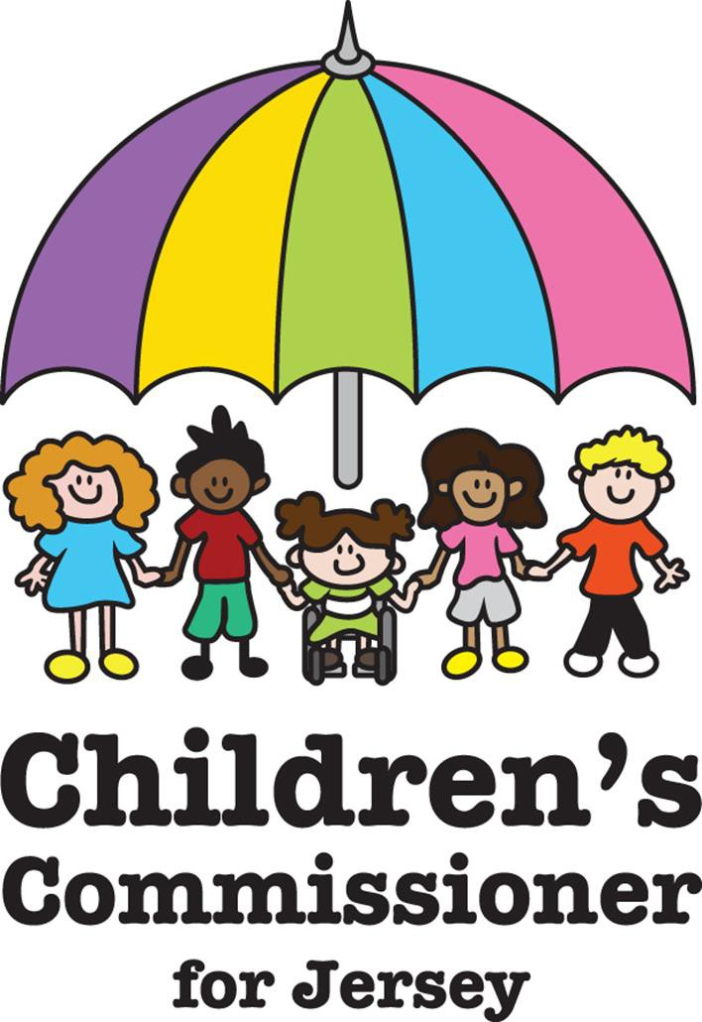

Children’s supplementary periodic report to the UN Committee on the Rights of the Child
1 December 2022

Introduction

This is the supplementary children’s report to be considered alongside the report of Jersey’s Commissioner for Children and Young People. The report has been prepared in the form of a short video for the UN Committee on the Rights of the Child’s examination of the United Kingdom under the United Nations Convention on the Rights of the Child (UNCRC). Accompanying the report is our Life on the Rock report, which is the written accompaniment to the video.

Methodology

The video is based on the words of children who participated in Life on the Rock. The methodology and participation principles underlying that project are set in full in its appendix. The video was filmed in Jersey and features local young people, some of whom are members of the Jersey Commissioner’s Youth Advisory Group. None of them are paid actors and all of them have given full consent for the video to be shared and viewed across all platforms. We have already seen huge engagement at a local level via our office’s TikTok channel, in particular, where this video was first posted on World Children’s Day (20 November 2022). At the time of writing, that post has had more than 40,000 views.

Video link

https://vimeo.com/767838746

Transcript

I’m a child in Jersey,
appreciating the proximity of the sea,
I’ve got ability to be
The kid I wanna be
in easy reach of the beach
that’s life on the rock for me

I’m a child in Jersey,
It’s not as easy as I want it to be
How many times have we moved?
I think like three
We came here last year
And it’s not been a nightmare
But it’s not been a dream
I’m doing alright
Like a mid-table team

I’m a child in Jersey
Appreciating that nothing comes free
Some people live on an Estate
Some people live on the estates
And the states don’t always seem to see
That us kids, we’re people
Who have learned the terms of fair
And equal, do others see them as we do?
And if they don’t hear us
In their Government buildings...
Well... they need to

I’m a teenager in Jersey, I get a bit bored
It’s like what do I do if can’t play ball?
Waterfront? McDonalds, sometimes there’s a fight
We circle Havre Des Pas, just waiting for night
Youth Clubs were alright, until I hit year nine
Now everyone’s on something else
And I feel lost a lot of the time

I’m a teenager in Jersey, it’s kind of like safe
Like open door, unlocked car, nowhere’s too far
You know? Safe. But it’s not always the same
For all of my mates.
Sometimes it’s home, their parents are like
Locked in a cold war, or actual combat
I’m lucky cos I dodged that, but my friend
Never said nothing so how could we stop that?
I guess it’s not all just sunshine and seagull flocks
That’s life on the rock

I’m a teenager in Jersey
I spend my life waiting for the no.1 bus
Coast road, sit at the back
Forget my headphones and still play the track
It’s funny that we hang around Liberation Square
I don’t feel that free
School seems like a trap and unless its detention
Nothing seems targeted at me
Surrounded by the ocean
I’m an island here, in an out go my tides of emotion
I say nothing

I’m a teenager in Jersey
I don’t vote
I think these politicians are sinking ships using money to keep their boat afloat
I see those Yachts in the marina arena
Life all sweet like Ribena
I commit what the court calls
Misdemeanours... Well yeah...
Cos it’s not really fair
They call this place a tax haven
But I ain’t got no savings
We don’t have the same distance
To travel on our climb to the top
That’s life on the rock

We are kids in Jersey
Unique like fingerprints
From bungalow to high rise
No two stories are the same
Each of us flickers with our own flame
This is our life on the rock
We do different things
Lead different lives
We don’t all make the same choice
But one thing that unites us...
We all have a voice.

