

Submission to the Human Rights Committee at its 144th Session

May 2025, Geneva, Switzerland

SPAIN
Submission by:

ADF International
Rue Pré-de-la-Bichette 1
1202 Geneva, Switzerland

Web: www.ADFinternational.org
Email: UN@ADFinternational.org

ECOSOC Special Consultative Status (2010)

Introduction
- ADF International welcomes the opportunity to submit information as part of the Human Rights Committee’s consideration of the seventh periodic report of Spain.
- In particular, this submission sets out concerns regarding the compatibility of Law 4/2023 for Real and Effective Equality for Trans People with Spain’s obligations under the International Covenant on Civil and Political Rights (ICCPR), notably articles 2, 3, 9, 17, and 26. It underscores that the effective enjoyment by all persons of the rights set forth in the Covenant without discrimination of any kind requires adequately protecting the rights of women and girls to equality and non-discrimination on the basis of sex.
- Equality and Non-Discrimination on the Basis of Sex
Background
- Article 14 of the Spanish Constitution recognizes that all Spaniards are equal before the law, and that they may not in any way be discriminated against on account of birth, race, sex, religion, opinion, or any other personal or social condition or circumstance. In this regard, Article 9.2 of the Constitution establishes the obligation of public authorities to promote conditions that ensure the real and effective equality of the individual and the groups into which they are integrated, and to remove obstacles that impede or hinder their full realization.
- Article 3 of Organic Law 3/2007 for the Effective Equality of Women and Men states that the principle of equal treatment between women and men implies the absence of any discrimination, direct or indirect, based on sex. Article 4 of said law states that equality of treatment and opportunities between women and men is an informing principle of the legal system and, as such, will be integrated and observed in the interpretation and application of legal norms.
- Article 6 of the aforementioned law defines discrimination based on sex as encompassing the following:
‘1. Direct discrimination based on sex is the situation in which a person is, has been, or could be treated, based on their sex, less favorably than another person in a comparable situation.
2. Indirect discrimination based on sex is the situation in which an apparently neutral provision, criterion, or practice places persons of one sex at a particular disadvantage compared to persons of the other, unless such provision, criterion, or practice can be objectively justified in light of a legitimate purpose and the means to achieve that purpose are necessary and appropriate.
3. In any case, any order to discriminate directly or indirectly, on the basis of sex, is considered discriminatory.’
- Furthermore, Article 11 of Organic Law 3/2007 states that, in order to implement the constitutional right to equality, public authorities shall adopt specific measures in favor of women to correct situations of de facto inequality with respect to men. Such measures, which shall be applicable as long as such situations persist, must be reasonable and proportionate in relation to the objective pursued in each case.
- In 2022, a new Law for Equal Treatment and Non-Discrimination entered into force, expanding the protected grounds for discrimination already covered under Organic Law 3/2007 to also include sexual orientation and gender identity, among others. Article 2.2 of the same law also recognizes that differential treatment may be established when the criteria for such differentiation are reasonable and objective, and what is being pursued is to achieve a legitimate purpose. Building on this provision, Article 4.2 affirms that differentiated treatment based on any grounds listed in Article 2.1 of this law—including sex—is not considered discrimination if it is objectively justified by a legitimate aim and the means of achieving that aim are appropriate, necessary, and proportionate.
- While Organic Law 1/2004 on Comprehensive Protection Measures against Gender Violence was designed to address violence driven by discrimination, inequality, and male power over women, specifically in the context of intimate relationships, the recent adoption of legislation allowing persons to legally modify their sex on the basis of self-identification has blurred the lines of protection, undermining the very safeguards this and other relevant laws were created to provide for women and girls.
The ‘Ley Trans’
- In March 2023, Spain enacted Law 4/2023 for Real and Effective Equality for Trans People and for the Guarantee of the Rights of LGTBI People, colloquially referred to as ‘Ley Trans’ (lit. ‘Trans Law’).
- Under this law, direct and indirect discrimination are defined as follows:
‘a) Direct discrimination: A situation in which a person or group of persons is, has been, or could be treated less favorably than others in a similar or comparable situation based on sexual orientation, sexual identity, gender expression, or sex characteristics.
b) Indirect discrimination: This occurs when an apparently neutral provision, criterion, or practice causes or may cause one or more persons to be particularly disadvantaged compared to others based on sexual orientation, sexual identity, gender expression, or sex characteristics.’
- According to Article 3(k) of said law, a ‘trans person’ is considered to be ‘a person whose sexual identity does not correspond to their sex assigned at birth.’
- In this regard, the law grants adults and children as young as 12 years old the ability to change their legal sex based on self-identification. It removes all prior requirements established under Law 3/2007 Regulating the Rectification of Registration Statements Regarding the Sex of Individuals, such as the requirement to have a medical diagnosis or judicial authorization in order for a person to legally alter their registered sex.
- Article 46.4 explicitly states that anyone who legally modifies their sex from male to female based on self-identification is entitled to benefit from the positive action measures for women outlined in Article 11 of Organic Law 3/2007 on Effective Equality between Women and Men.
- The legal recognition of sex based on self-identification, provided under the Ley Trans, establishes a presumption of entitlement to access sex-specific spaces and services on this basis. In particular, this enables individuals who are biologically male to enter spaces and access services that were initially designed to protect women, including in contexts where such protections serve as special measures as recognized by domestic and international law.
- Sex-based protections for women, including the protection of female-only spaces, are crucial in ensuring women’s and girls’ rights. Allowing males, irrespective of how they identify, into female-only spaces undermines women’s and girls’ right to privacy and can threaten their safety. In any spaces where women are or may feel vulnerable—such as those involving full or partial nudity, intimate physical contact, sleeping, female group therapy sessions, or female-only networks, both online and offline—there is a legitimate safety and privacy rationale that justifies maintaining single-sex spaces for women and girls. Accordingly, the erosion of sex-based protections for women and girls arising from the enactment of the Ley Trans represents a retrogression in Spain’s implementation of its Covenant obligations.
- Every person has the right to live free from discrimination. Measures aimed at achieving this goal for persons who identify as the opposite sex cannot imply forfeiting the protections that females have a right to on the basis of their female sex.
Cases
- On 20 March 2024, it was reported that six men in Madrid, registered in the Gender-Based Violence System for allegedly committing violence against women, had legally changed their sex from male to female under the Ley Trans. Three of them requested protection against alleged violence under Organic Law 1/2004 on Gender Violence. One of them specifically asked to be placed in the same shelter for female victims of violence where a former partner has been residing since suffering violence from the individual in question.
- One of the most controversial cases reported thus far involves a woman who was drugged and then sexually abused by her former male partner in front of her daughter. When she reported the violence to the authorities, she discovered that her aggressor had previously modified legal sex from male to female based on self-identification. This change prevented her from claiming the protections that would otherwise have applied under Organic Law 1/2004, had her aggressor still been legally recognized as male. This aligns with Article 46 of the Trans Law, which states that anyone who commits a crime will be judged under the registered sex that appeared at the time of the events.
- According to sources from the Autonomous Community of Madrid, implementation of the Ley Trans is having grave consequences—particularly for women with previous experiences of violence and abuse. Women victims of violence, personnel working in shelters for female victims of violence, and the systems designed to protect them have all been undermined.
- On 1 June 2024, the General Secretariat of Penitentiary Institutions, under the Ministry of the Interior in Spain, declared that it was uncertain how many prisoners had requested a change of sex since the Ley Trans came into force. Because of the recently enacted legal framework, cases like the above occur also in the prison system.
- For example, in the same year, M.A.R.P., who is currently serving a 30-year sentence in the Zuera prison for murder, robbery with violence, and arson after beating his neighbor to death in Palma Mallorca and setting fire to her home in 2015, was moved to one of the female modules after opting to identify as a woman, without any consideration for female inmates’ physical integrity, privacy, and safety or other factors.
- Another high-profile case involved a male offender who, after being admitted to Fontcalent prison, declared to self-identify as a woman and as such obtained a transfer to the female unit.
- The adverse human rights consequences of Spain’s sex self-identification regime are also evident in the field of sports. On 31 January 2024, a male runner self-identifying as ‘gender fluid’ participated in the female-only category at the Na’dalt race. While the Na’dalt race is not a professional race, the male athlete's participation and victory in the women’s category resulted in some female participants making complaints.
- Given the vast body of scientific evidence on the biological differences between men and women and their impact on athletic performance, on 31 March 2023, the Royal Spanish Athletics Federation announced that it would join World Athletics in barring males who self-identify as female but underwent relevant interventions after puberty to compete in the female-only category in athletics. While multiple studies have shown that males retain key biological advantages in sports regardless of whether they transition before or after puberty, the decision by the Royal Spanish Athletics Federation represented an important step toward protecting female-only spaces and upholding women's and girl’s sex-based rights.
Incompatibility with Spain’s Obligations under the ICCPR
- As a State Party to International Covenant on Civil and Political Rights (ICCPR), Spain has the obligation to take all necessary steps, including the prohibition of discrimination on the grounds of sex, to end discriminatory actions that impair women's equal enjoyment of rights compared to men in all spheres.
- Article 26 of the ICCPR not only enshrines a general right to equality before the law and, without discrimination, to equal protection of the law but also directly prohibits any discrimination under the law and guarantees to all persons equal and effective protection against discrimination, including sex-based discrimination. As noted by the Human Rights Committee, ‘[T]he right to equality before the law and freedom from discrimination, protected by article 26, requires States to act against discrimination by public and private agencies in all fields.’
- Furthermore, the same Committee has emphasized that, ‘[N]ot every differentiation of treatment will constitute discrimination, if the criteria for such differentiation are reasonable and objective and if the aim is to achieve a purpose which is legitimate under the Covenant.’ This position is reflected in various international human rights instruments, including, inter alia, the Convention Against the Elimination of Discrimination Against Women (CEDAW) and the Declaration on the Elimination of Violence Against Women (DEVAW).
- It is evident from the plain, ordinary meaning of ‘sex’ in the aforementioned provisions that the term refers to the biological categories of male and female. The term 'sex’ itself—derived from Middle French and Latin—relates to the division of something in two. Pursuant to the rules of interpretation of treaties set forth in the Vienna Convention on the Law of Treaties, no additional meaning can be attributed to this term in the absence of explicit agreement or practice by States Parties.
- The ICCPR does not permit any derogation to the prohibition of discrimination on the ground of sex. Where tensions may arise, no international human rights norm or principle endorses an interpretation that allows the obligations to ensure equality and non-discrimination based on sex to be forfeited for the sake of respect for other rights.
- The provision of single-sex spaces and services can constitute a reasonable, objective, and legitimate differentiation that in no way can be deemed to constitute discrimination or a denial of equality under international human rights law. In this context, female-only spaces and services are crucial means to uphold their dignity and realize their rights, including by ensuring their safety and privacy and providing sanctuary from acts or risks of male violence and abuse. In digital contexts, female-only spaces also provide foster mutual support, collaboration, and empowerment for women and girls.
- In this regard, Article 9.1 of the ICCPR recognizes that ‘everyone has the right to liberty and security of person’. As recognized by this Committee under General Comment No. 35:
‘[S]ecurity of person concerns freedom from injury to the body and the mind, or bodily and mental integrity. […] The right to security of person protects individuals against intentional infliction of bodily or mental injury, regardless of whether the victim is detained or non-detained. The right to personal security also obliges States parties […] to protect individuals from foreseeable threats to life or bodily integrity proceeding from any governmental or private actors.’
- In a similar vein, Article 17 of the ICCPR recognizes that no one shall be subjected to arbitrary or unlawful interference with his privacy, and that everyone has the right to the protection of the law against such interference or attacks. Accordingly, the State's failure to ensure that both public and private actors uphold the right to privacy constitutes a breach of its obligations under Article 17 of the ICCPR.
- In accordance with the above provisions, Spain is obligated to prevent and address any circumstances that cause, or threaten to increase the risk of, violence and discrimination against women and girls. Ensuring this protection requires the maintenance of female-only spaces, such as locker rooms, dormitories, showers, and sanitation facilities, and the development and implementation of laws, policies and other measures to re-establish and strengthen sex-based legal safeguards.
- The legal and policy developments outlined in this submission have greatly contributed to the erosion of women and girls' rights to enjoy their human rights without distinction based on sex. Regrettably, these developments reflect a broader pattern of failure by Spain to fulfill its obligations under the Covenant, particularly its Articles 2, 3, 9, 17, and 26.
- Recommendation
- In light of the aforementioned, ADF International wishes to recommend that the Human Rights Committee consider recommending, as part of its Concluding Observations on Spain’s seventh periodic review, to implement all necessary legal and policy measures to restore biological sex as the legal basis for access to sex-specific protections, including female-only spaces and services, including by repeal or amending existing legislation, including Law 4/2023.

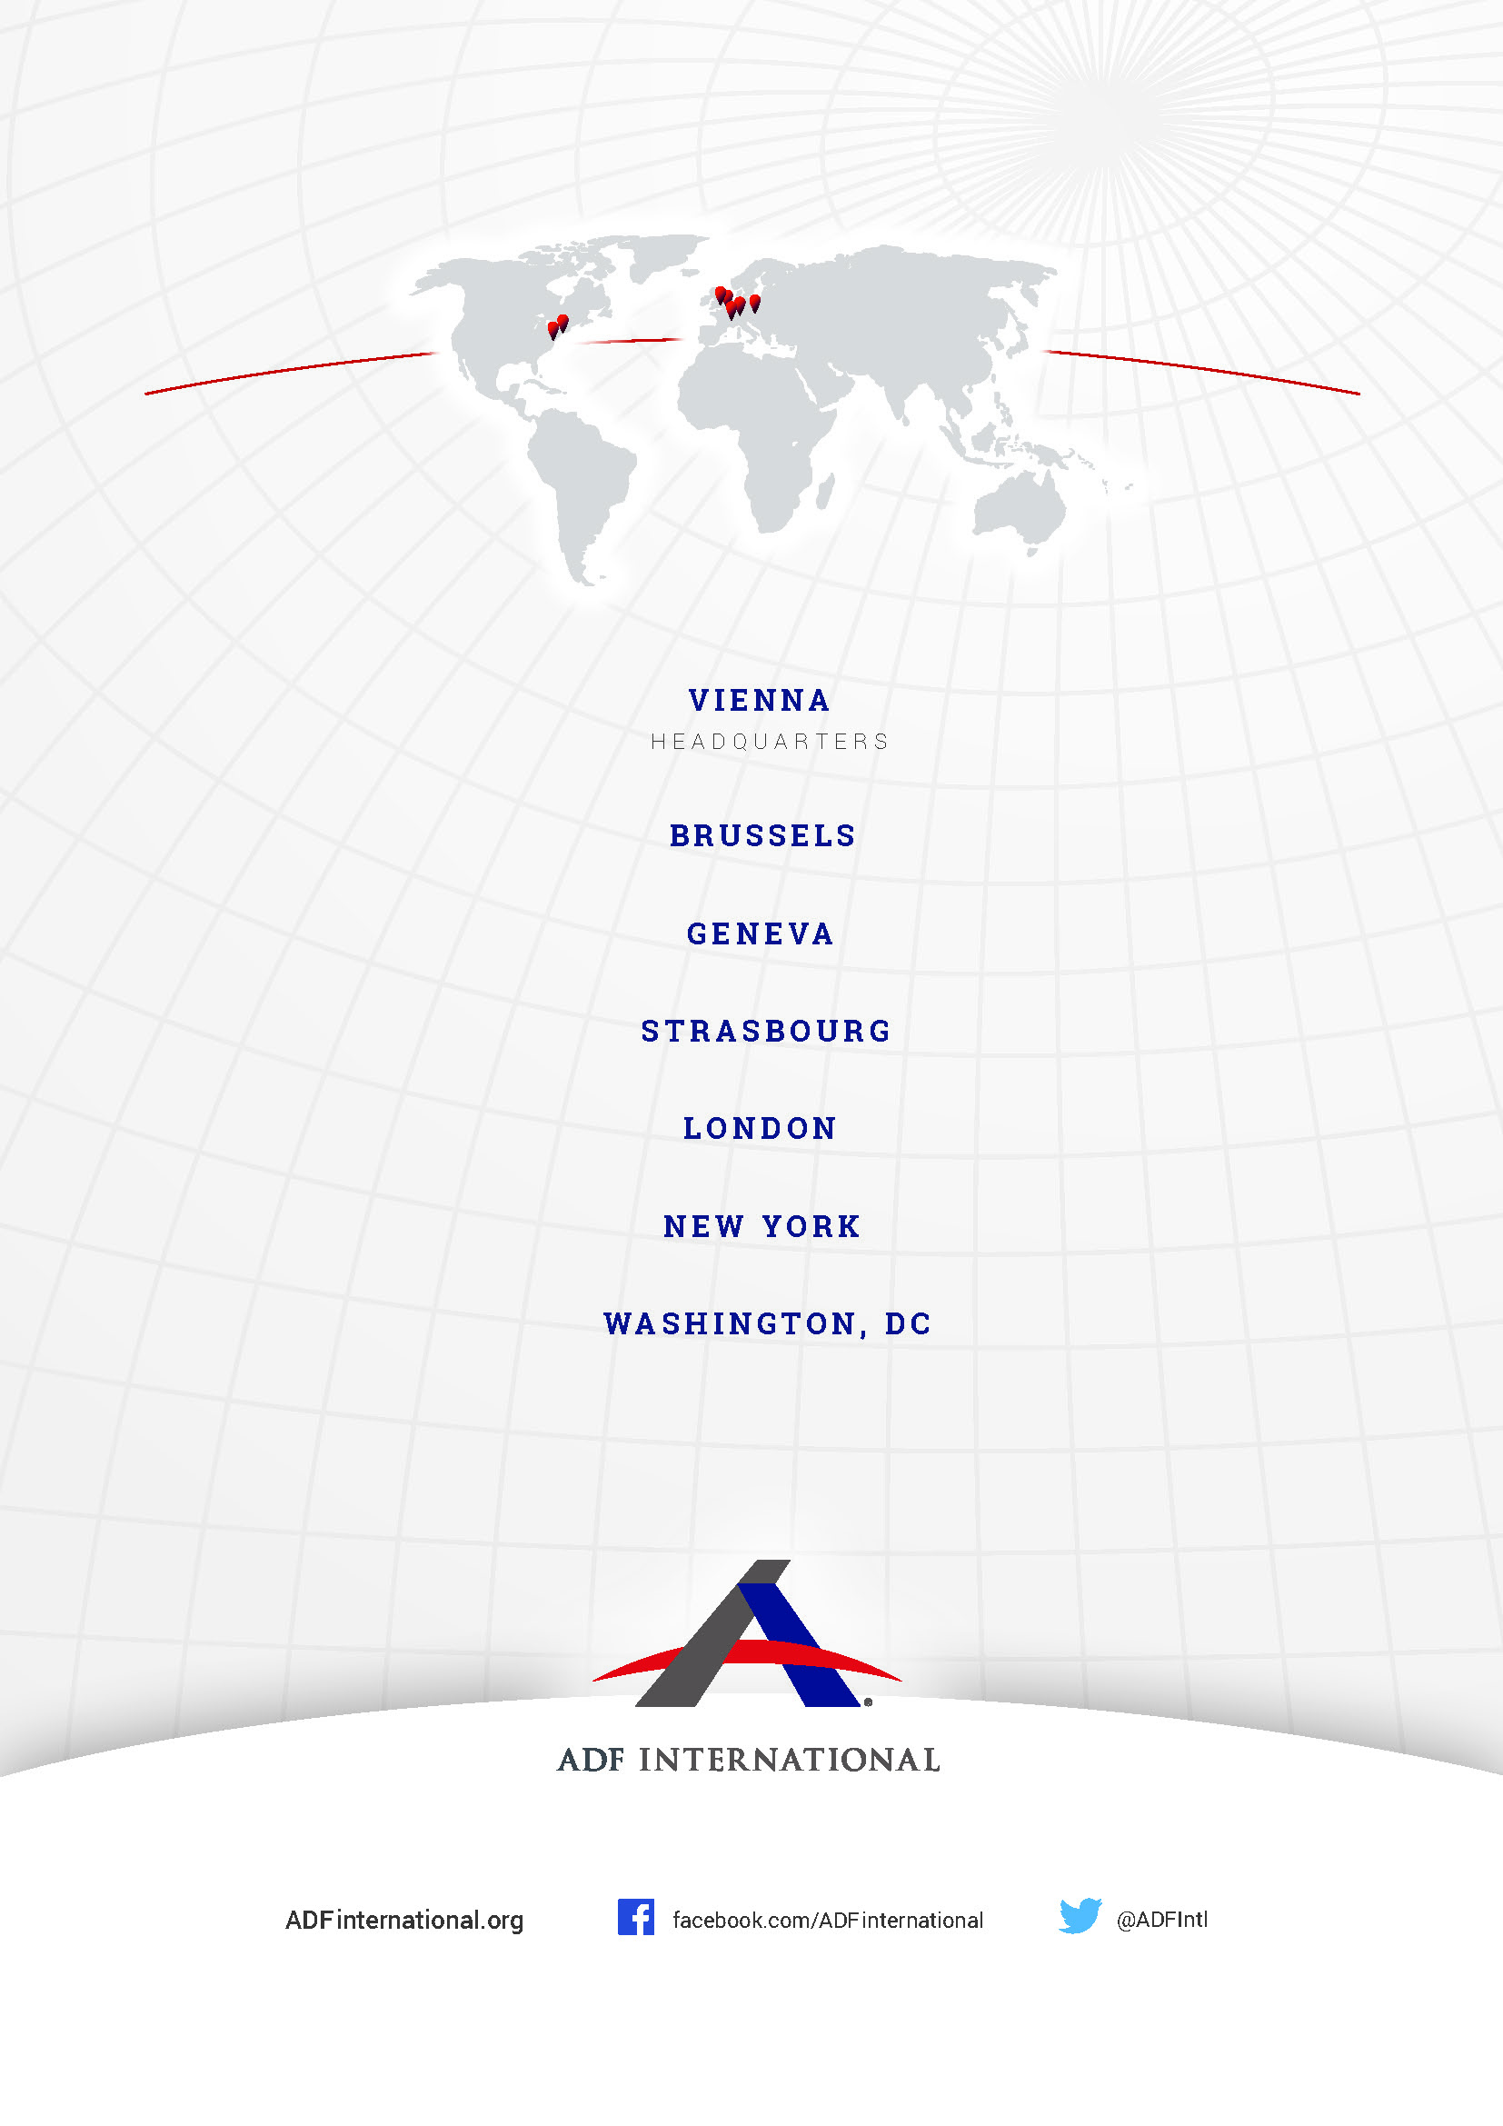

© 2025

State Agency Official Gazette, The Spanish Constitution (Last modified on 19 February 2024) available at https://www.boe.es/biblioteca_juridica/codigos/abrir_pdf.php?fich=158_Constitucion_Espanola_________________The_Spanish_Constitution_.pdf, Article 14.
Id., Article 9.2.
State Agency Official Gazette, Organic Law 3/2007 for the effective equality of women and men (Last modified on 2 August 2024) available at https://www.boe.es/buscar/act.php?id=BOE-A-2007-6115, Article 3.
Id., Article 4.
Id., Article 6.
Id., Article 11.
State Agency Official Gazette, Law for Equal Treatment and Non-Discrimination (13 July 2022) available at https://www.boe.es/buscar/act.php?id=BOE-A-2022-11589, Article 2.1.
Id., Article 2.2.
Id., Article 4.2.
State Agency Official Gazette, Organic Law 1/2004 on Comprehensive Protection Measures against Gender Violence (29 December 2004) available at https://www.boe.es/buscar/act.php?id=BOE-A-2004-21760, Article 1.
State Agency Official Gazette, Law 4/2023, of February 28, for the real and effective equality of trans people and for the guarantee of the rights of LGTBI people (1 March 2023) available at https://www.boe.es/buscar/doc.php?id=BOE-A-2023-5366.
Id., Article 3(a) and Article 3(b).
Id., Article 3(k).
Id., Article 43 and Article 44.
State Agency Official Gazette, Law 3/2007, Regulating the Rectification of Registration Statements Regarding the Sex of Individuals (15 March 2007) available at https://www.boe.es/boe/dias/2007/03/16/pdfs/A11251-11253.pdf, Article 4.
State Agency Official Gazette, Law 4/2023, of February 28, for the real and effective equality of trans people and for the guarantee of the rights of LGTBI people (1 March 2023) available at https://www.boe.es/buscar/doc.php?id=BOE-A-2023-5366, Article 46.4.
Quico Alsedo, Madrid alerta a Igualdad: seis agresores se hacen trans para eludir la Ley de Violencia de Género (20 March 2024) El Mundo, available at https://www.elmundo.es/espana/2024/03/19/65f9d92921efa005218b4587.html.
Id.
State Agency Official Gazette, Law 4/2023, of February 28, for the real and effective equality of trans people and for the guarantee of the rights of LGTBI people (1 March 2023) available at https://www.boe.es/buscar/doc.php?id=BOE-A-2023-5366, Article 46.
Id.
Marcos Ondarra, El Ministerio del Interior ignora cuántos presos se han cambiado de sexo con la 'ley trans' (1 June 2024) The Objective, available at https://theobjective.com/espana/2024-06-01/ministerio-interior-presos-cambio-sexo/.
Id.
A. Garcia, La atleta trans que ganó la carrera femenina: "En mi día a día me siento un hombre, pero en la montaña soy mujer" (31 January 2024), Marca, available at https://www.marca.com/deportes-aventura/2024/01/31/atleta-trans-gano-carrera-femenina-mi-dia-dia-me-siento-hombre-montana-mujer.html.
Gregory A. Brown, White Paper Concerning Male Physiological and Performance Advantages in Athletic Competition and The Effect of Testosterone Suppression on Male Athletic Advantage (14 December 2021) available at https://dm1l19z832j5m.cloudfront.net/public/2022-01/Gregory%20Brown%20Male%20Athletic%20Advantages%20White%20Paper.pdf. Knox, T., L.C. Anderson, et al., Transwomen in elite sport: scientific & ethical considerations, 45 J. Med Ethics 395 (2019) available at https://pubmed.ncbi.nlm.nih.gov/31217230/. Handelsman, D.J. et al., Circulating testosterone as the hormonal basis of sex differences in athletic performance, (Oct 2018) Endocrine Reviews, available at https://academic.oup.com/edrv/article/39/5/803/5052770.
El Diario, La Federación Española se une a la Internacional y prohíbe a las atletas trans competir en pruebas femeninas (23 March 2023) available at https://www.eldiario.es/sociedad/federacion-internacional-atletismo-prohibe-deportistas-trans-competir-pruebas-femeninas_1_10061187.html.
Gregory A. Brown, White Paper Concerning Male Physiological and Performance Advantages in Athletic Competition and The Effect of Testosterone Suppression on Male Athletic Advantage (14 December 2021) available at https://dm1l19z832j5m.cloudfront.net/public/2022-01/Gregory%20Brown%20Male%20Athletic%20Advantages%20White%20Paper.pdf.
International Convention on Civil and Political Rights (adopted 16 December 1966, entered into force 23 March 1976) 999 UNTS 171 (ICCPR), Articles 2 and 3.
Human Rights Committee, General Comment No. 28: Equality of Rights Between Men and Women (Article 3) (29 March 2000) UN Doc CCPR/C/21/Rev.1/Add.10, 31.
Human Rights Committee, General Comment No. 18: Non-discrimination (10 November 1989) UN Doc HRI/GEN/1/Rev.9, 13.
See, inter alia, CEDAW, Arts. 2-4, DEVAW art 4.
See e.g. Chinkin et al (Ed.), the UN Convention on the Elimination of All Forms of Discrimination Against Women: A Commentary, 1992, first edition, p. 15.
Namely, the two biological sexes, male and female. See Oxford English Dictionary <https://www.oed.com/view/Entry/176989?>.
Vienna Convention on the Law of Treaties (opened for signature 23 May 1969, entered into force 27 January 1980) 1155 UNTS 331, art 31.
OHCHR, Special Rapporteur decries Australia’s Federal Court ruling further eroding rights to female-only spaces (04 September 2024) <https://www.ohchr.org/en/press-releases/2024/09/special-rapporteur-decries-australias-federal-court-ruling-further-eroding>.
See e.g., Full Report: Why single-sex services matter: privacy, dignity, safety, and choice, Sex Matters (July 2022) <https://sex-matters.org/wp-content/uploads/2022/07/Single-sex-services-full-report.pdf>.
International Convention on Civil and Political Rights (adopted 16 December 1966, entered into force 23 March 1976) 999 UNTS 171 (ICCPR), Article 9.1.
Human Rights Committee, General Comment No. 35: Liberty and Security of Person (Article 9) (16 December 2014) UN Doc CCPR/C/GC/35, paragraphs 3, 4, and 9.

