PARALLEL REPORT TO THE UNITED NATIONS COMMITTEE ON ECONOMIC, SOCIAL AND CULTURAL RIGHTS

Burundi, 56th Session (21 Sep 2015 - 09 Oct 2015)
________________________________________________________________________

Submitted by:



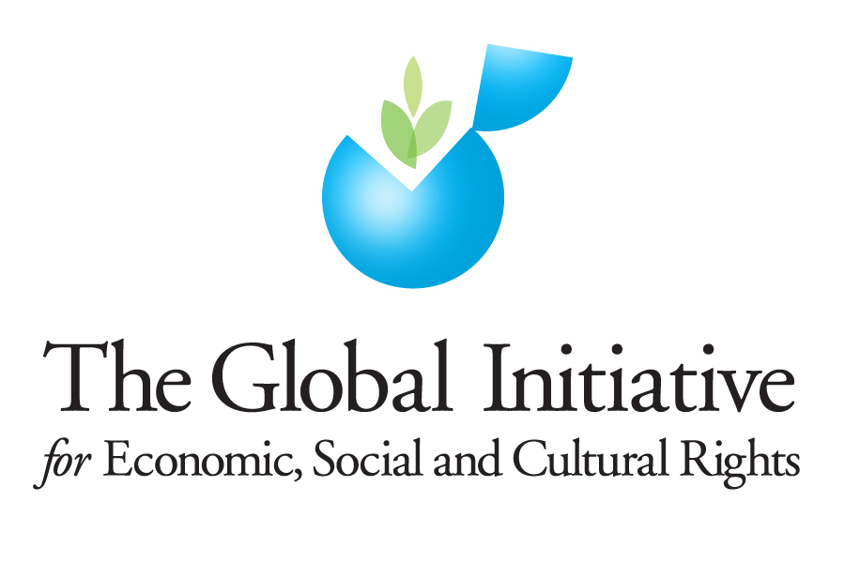
Women’s Land and Property Rights in Burundi
While statutory law in Burundi upholds the notion of gender equality, customary law routinely discriminates against women in relation to land and inheritance rights. Most land holdings in Burundi are acquired by succession. Under customary law, land under intestate succession generally devolves to male members of the paternal line. Alternatively, the woman may have tenure after a will where a particular property is given, but this situation is unfortunately rare.

The State party report acknowledges that “There is no law on inheritance. However, a married woman has a beneficial interest in the possessions of her household… With the exception of land, possessions are divided in equal parts between the sons and daughters of their common parents” (para. 67, emphasis added). It further notes that “At present, it is still case law which determines questions of inheritance and unfortunately, in the absence of statute law on the subject, the outcome is contingent on the view taken by the judge hearing the case” (para. 68).

In its 2008 review of Burundi, the Concluding Observations of the Committee on the Elimination of Discrimination against Women highlighted concerns around violations of women’s rights related to inheritance (UN Doc. CEDAW/C/BDI/CO/4, 8 April 2008):

13. The Committee notes with concern that customary law is still recognized in the State party and has a detrimental impact on the rights of women with regard to inheritance, matrimonial regimes and gifts.

14. The Committee recommends that the State party adopt a uniform family code ensuring de jure and de facto equality for women with regard to inheritance, matrimonial regimes and gifts, and that it ensure its effective implementation, particularly in rural areas. The Committee calls on the State party to organize an awareness-raising campaign in order to educate rural chiefs about the new laws to ensure their effective implementation.

Six years later, in its 2014 review on Burundi the Human Rights Committee issued the following Concluding Observation addressing these same issues (UN Doc. CCPR/C/BDI/CO/2, 21 November 2014):
- The Committee is concerned by the fact that men and women are not treated equally with regard to inheritance, matrimonial regimes and bequests. It also notes that article 88 of the draft Personal and Family Code still provides for different minimum ages of marriage for men and women (arts. 2, 3, 23 and 26).

The State party should amend the Personal and Family Code so that it sets the same minimum age of marriage for men and women, in accordance with international standards. It should adopt the bill on inheritance, matrimonial regimes and bequests and make sure that it is in full compliance with the Covenant. The State should, in addition, conduct public awareness campaigns to help bring about a change in traditional attitudes that hinder women’s ability to exercise their fundamental human rights.

Unfortunately, these issues remain unresolved for women in Burundi. The Social Insitututions and Gender Index (SIGI) of the OECD highlights that while men and women in Burundi have the same legal position in matters related to the conclusion of contracts (Civil Code, Article 336) and the administration of property (Personal Status and Family Code, Article 120), customary law discriminates against women with respect to access to land. As noted in the Family Code section, customary laws provide that women cannot inherit land from their fathers or husbands.

Land is a particularly important issue for women in Burundi, as women play a key role in agriculture yet have few legal rights over the land that they farm. ActionAid Burundi has held various focus groups around Burundi to discuss the status of women’s land and property rights. These focus group discussions have revealed that:

+ In general, women generally only inherit property of small value. Customary laws provide that women cannot inherit land from their fathers or husbands.

+ Married women are considered not to have property; all goods are the property of her husband to dispose of without necessarily having the consent of his wife.

+ Married women generally hold land in usufruct. The woman may farm land, but does not have the right to control land. Land allocation decisions belong to the husband.

+ Widows similarly lack rights to inherit from the estate of their deceased husband, and are sometimes subject to violence at the hands of in-laws in cases of property disputes. Even property acquired by the widow after the death of her husband can become the subject of family dispute.

+ In most cases, men see themselves as sole owners of all family property and make decisions about any income brought in by the wife. Sometimes these claims are pursued with violence, including physical, psychological and economic violence.

Lack of access to remedies
Women in Burundi also highlight that that for issues of land and property, there are inadequate remedies women, and judges are in general not trained to protect women’s rights. There is also lack of gender sensitivity by local actors: most customary leaders discriminate against women in matters related to land because of discriminatory customary norms. Even judges are not immune from this sensitivity, and this is particularly true in rural areas (see also : UN Doc. CEDAW/C/BDI/CO/4, 8 April 2008, at paras. 15 & 16).

The need to adopt a law on inheritance
Although the principle of gender equality and non-discrimination on the grounds of sex is enshrined in the 2005 Constitution, there is no law that specifically provides for equal inheritance rights. This is a major obstacle as inheritance is largely governed by customary laws that discriminate against women. Many negative consequences of the absence of an inheritance law have been expressed, including women’s lack of empowerment and the continuation of violence against women.

The Committee on Economci, Social and Cultural Rights has clearly stated in its General Comment 16 on the equal right of men and women to the enjoyment of all economic, social and cultural rights (art. 3 of the International Covenant on Economic, Social and Cultural Rights) that implementing article 3 of the Covenant, in relation to article 10, “requires States parties, inter alia, ... to ensure that women have equal rights to marital property and inheritance upon their husband’s death” (emphasis added).

Discrimination against women in land registration
While the Land Code allows any owner of a property right to the register (art.380), women rarely register land in their name. Burundian women are subject to multiple discrimination in access to the registration of land ownership, and family land is most often registered in the name of the husband. Men see themselves as sole owners of land, with women a mere ‘manager.’ With regard to property acquired by the woman herself, custom holds that even in this case the woman acquired the property through income which is the property of the husband, leaving that registration must be done at name of the husband, the ‘family head.’ Divorced and unmarried women also face discrimination in the area of registration of land.

Recommendations

The Government of Burundi should be encouraged to:

Draft and adopt a national Succession Act which will protect the equal inheritance rights of women, and address and nullify those aspects of Burundian customary law which discriminate against women.

Require the State to put in place safeguards to secure land tenure rights of women through the registration of land procedure. The results show that in all phases of land registration, the woman suffers from significant discrimination which must be corrected.

Require that the State submit information on steps taken to implement and expressly address the issue of women’s right to land and property, and give details of the actual situation facing women in this regard.

See: http://genderindex.org/country/burundi
Ibid.

