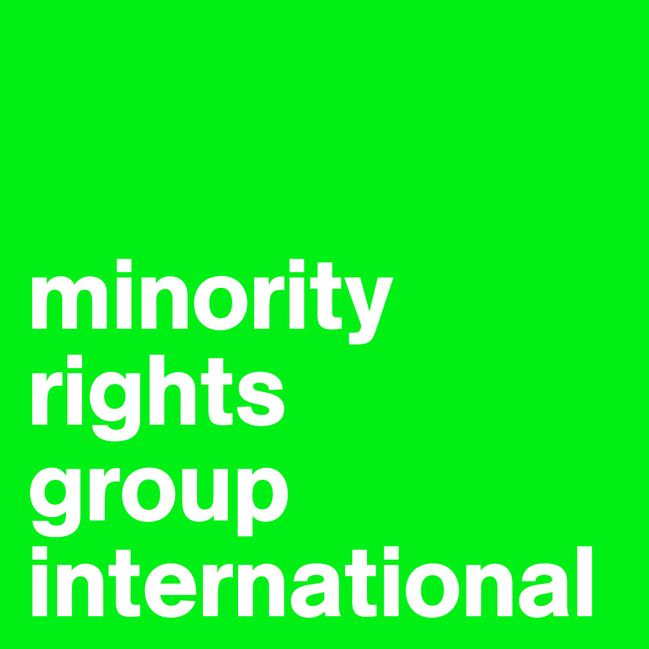
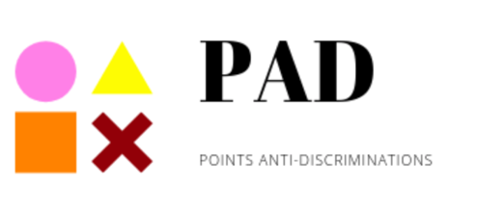

Minority Rights Group International

In partnership with the Anti-Discrimination Points Network:
Association pour la Promotion du Droit à la Différence, Association Tunisienne de Prevention Positive, By Lhwem, Damj, Danseurs Citoyens Sud, Mnemty, Terre d’Asile Tunisie

Review of the combined 4th to 6th Periodic Report of
TUNISIA

Committee on the Rights of the Child
85th Session
Geneva
7 – 25 September 2020
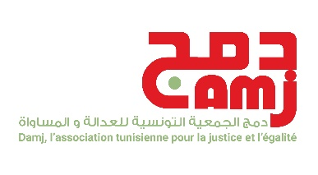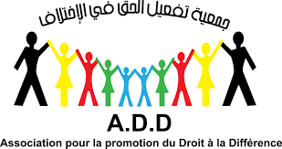
Minority Rights Group Damj pour la Justice et l’Egalité Association pour la Promotion
54 Commercial Street 6 Rue Mohamed Agerbi, du Droit à la Différence (ADD)
London E1 6LT La republique, Tunis, Tunisia 68 rue 2 mars 1934, Centre Tel: +44 2074224200 Damj.association@gmail.com Bouchoucha, D2 Bizerte 7000, Tunisia United Kingdom Tel: +216 72421692
www.minorityrights.org www.droitaladifference.org
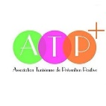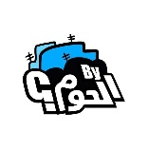
Association Tunisienne de Prevention By Lhwem Danseurs Citoyens Sud
Positive (ATP+) Rue Ibn Hazin el-Andalous Rue Hammam Al-Unf,
9 Rue 7443, Aredh Hrichi, El Manar 1, Bhar Elazraq, La Marsa, Tunisia Bab Bhar, Gabes 6000,
2092 Tunis, Tunisia Tel : +216 50441050 Tunisia
Tel: +216 98795500/506 Tel : +216 53 836 017
www.atpplus.org http://a-dcs.org/

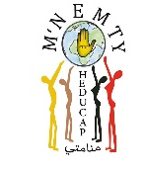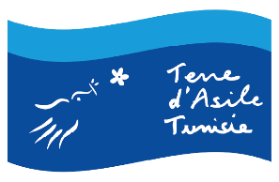
Mnemty Terre d’Asile
1 rue d’Egypte, La Fayette, Tunis, Tunisia Offices in Tunis and Sfax
Tel : +216 53280966 https://maison-migrations.tn/index.php/terre-d-asile-tunisie
https://www.facebook.com/Mnemty/
Minority Rights Group International (MRG) is a non-governmental organization (NGO) working to secure the rights of ethnic, religious and linguistic minorities and indigenous peoples worldwide, and to promote cooperation and understanding between communities. Our activities are focused on international advocacy, training, publishing and outreach. We are guided by the needs expressed by our worldwide partner network of organizations, which represent minority and indigenous peoples. MRG works with over 150 organizations in nearly 50 countries. MRG has consultative status with the United Nations Economic and Social Council (ECOSOC), and observer status with the African Commission on Human and Peoples’ Rights (ACHPR).
The Anti-Discrimination Points Network (PAD) was established in January 2019 through a project led by Minority Rights Group in partnership with Damj in Tunisia. It aims at documenting cases of discrimination on the ground of ethnicity, nationality, and/or sexual orientation or gender identity and expression. The network is composed of : Association pour la Promotion du Droit à la Différence, Association Tunisienne pour la Prevention Positive, By Lhwem, Damj, Danseurs Citoyens Sud, Mnemty, and Terre d’Asile Tunisie. In 2019 more than 300 cases of discrimination were documented in 9 governorates and documentation for the year 2020 is ongoing.
L’Association pour la Promotion du Droit a la Difference (ADD) is a non-governmental and nonprofit
organization established in 2011 with the primary aim of defending universal human rights and democracy in Tunisia.
L’Association Tunisienne de Prevention Positive (ATP+), created in 2014, is a young organization which fights and militates for the rights of people living with HIV as well as key and vulnerable populations.
By Lhwem is a cultural and artistic social association officially created in 2017. It Is based on the experience of Tunisian artistic movements that emerged after the 2011 popular uprising.
Danseurs Citoyens Sud is a non-profit, non-governmental association created in 2015 in Tunisia to promote alternative culture and help establish a culture of citizenship based on the principles of human
rights.
Damj pour la Justice et l’Egalité is a non-governmental and non-profit organization established in 2011 working for the inclusion and the defence of minorities and marginalized groups including the LGBT community.
Mnemty is a Tunisian association, registered since 2013, concerned with the fight against all forms of racial discrimination. Its work contributed to the establishment of a legal framework for the protection of black Tunisian men and women.
Terre d’Asile Tunisie was established in 2014 to provide direct legal and social assistance to migrant communities in Tunisia and it is open to all foreigners regardless of their status, nationality, and reason for stay.
I. Introduction
- This submission to the Committee on the Rights of the Child (hereafter the Committee) ahead of the examination of the combined fourth to sixth periodic reports of Tunisia at the 85th session is based on information gathered through the Anti-Discrimination Points established in 2019 in a number of governorates throughout Tunisia, and gathering 8 Tunisian civil society organisations, complemented by research conducted by Minority Rights Group International (MRG). It provides information on the rights of children belonging to vulnerable groups in Tunisia, including children belonging to ethnic or religious minorities, indigenous children, migrant and asylum-seeking children, children living with HIV, and Lesbian, Gay, Bisexual, Trans, Queer+ (LGBTQ+) children.

II. Legal framework
- Tunisia is a party to the Convention of the Rights of the Child (CRC), as well as to its optional protocols on the involvement of children in armed conflicts and on the sale of children, child prostitution and pornography. Tunisia is also a party to the International Covenant on Economic, Social and Cultural Rights (ICESCR). The lifting of the reservations to the CEDAW in 2014 is favourable to the protection of the rights of girl children and adolescents. Tunisia also ratified in 2019 the Council of Europe Lanzarote Convention for the prevention of sexual violence against children.
- The Tunisian Constitution provides that all children on the territory should be afforded protection by the state without discrimination. Article 47 states that “it is the responsibility of parents and the State to guarantee the child dignity, health care, education and instruction. The state must ensure all forms of protection to all children, without any distinction, in accordance with the best interest of the child”.
- The Child Protection Code, adopted in 1995 and amended in 2006, and law no. 2010-40 modifying article 319 of the Criminal Code, prohibit any form of corporal punishment, including at home. Those texts apply to Tunisian and non-Tunisian children residing in the country alike, however this report highlights how, in practice, migrant children and LGBTQ+ children are often left in a situation of extreme vulnerability.

III. Analysis
General principles – non-discrimination (article 2)
- Tunisian laws that protect children apply in principle to all children, irrespective of their origins, ethnicity, religion, language, nationality or other status. The organic law n° 50 adopted on 23 October 2018, related to elimination of all forms of racial discrimination, imposes that the sentence be doubled in case of racial discrimination against a child. However, so far only three cases have led to a final judgement based on this law and none of the concerned victims are a minor.
- Patterns of discrimination and violence against black children have been documented in schools, where pupils are discriminated against by their fellow students, by parents of other students and/or by teachers. Discrimination and violence can take the form of verbal abuse and segregation of black children. In particular, the human rights NGO Mnemty has documented several cases of marginalisation of black children in Southern Tunisia where there is a high concentration of black population (in villages such as Midou, Kahbya, Mareth, Tchani in the governorate of Gabes and Gosba and Darej in the governorate of Mednine). Mnemty has documented a pattern of regions, with high proportions of black students, being less endowed in terms of cultural facilities, as well as social and health care providers. They have also documented more frequent absences schools in those Southern related to child labour during school time. Those factors contribute to disproportionately high dropout rates among black children and absence of hope and aspirations among black children.
- Migrant children are supposed to benefit from the protection of the Tunisian law. Indeed, the Child Protection Code and other relevant laws apply equally to all children on the territory and all minors in need are entitled to the protection of the Child Protection Office. However, the preventive framework is not adapted to the specific situation of migrant children and the needs of accompanied and unaccompanied foreign minors. In practice, a series of barriers prevent protection, therefore causing indirect discrimination, as explained below.
- A sizeable number of migrant children in Tunisia are survivors of torture, children previously involved in armed conflicts, and victims of abuse. They are also vulnerable to economic exploitation (domestic work, begging) and trafficking. Organic law n° 016-61 adopted on the 3rd of August 2016, on the prevention and the fight against trafficking in human beings, expressly address the situation of children victims of trafficking. This law prohibits forced child labour and economic exploitation and provides that cases of trafficking involving minors should be more severely punished. The law also specifies in art.4 that migrant children are subject to the articles of the Child Protection Code which prohibits child labour. This is in contradiction with the Tunisian Labour Code which allows children to work after they turn 14. Moreover, many unaccompanied foreign minors are victims of trafficking, suffering economic exploitation (such as begging and being recruited in criminal networks) and sexual exploitation. Moreover, language is an important obstacle for migrant children who do not speak Arabic in accessing education, health care and other services, including the asylum-seeking procedure, as detailed below. Language is also a barrier for migrant children from other Arabic-speaking countries as French is widely used in the Tunisian education system.
- As for LGBTQI+ children, they are facing discrimination in the family, in society and in their relations with state agents and public institutions. The continuous existence of laws criminalising homosexuality as well as the spread of homophobia and transphobia within the Tunisian society expose LGBTQI+ minors to abuses within their families, at school, in hospitals and other public institutions. They also foster an environment of tolerance and impunity for discrimination and violence against LGBTQ+ children. LGBTQI+ minors are often rejected by their families (with some living in the streets and looking for support through networks of civil society organisations) and often drop out from school. This means that they will be less likely to find a job and to find opportunities to live a life of their own choosing during their adult age.
- When it comes to HIV-positive children, some of their rights are hindered by law no.71 of 1992 concerning sexually transmitted diseases. For instance, in the case of a child victim of rape, the consent of his parents or legal guardian is required to test for HIV and to administer therapy in the early hours of the rape to prevent contamination, which can delay the administration of the treatment and make this act of no use as one must intervene in the first hours. Moreover, HIV-positive children face high level of discrimination and stigmatization in schools, kindergartens, and public health establishments.
Recommendations to the Government
- Raising awareness on racial discrimination and how it impacts children’s access to all human rights. Training judges, police officers and all public employees working with children on law no.50/2018 in case of minors victim of racial discrimination.
- The newly created National Commission for the Fight Against Racial Discrimination should liaise with bodies under the Ministry of Education and the Ministry of Women, Family, Children and Seniors to implement policies to fight racial discrimination in schools.
- Implementing a regional strategy to identify the link between the socio-economic disparities, inequalities in the childcare system and race and working on eradicating these inequalities and break the link between the socio-economic status and race. This strategy needs measurable commitments to be reported annually.
- Include special measures of protection for migrant children within the future migration strategy, in line with human rights standards
- Harmonize the law on Human Trafficking, the Code of Labour and the various international commitment such as the Convention of the International Labour Organization n°182 related to the abolition of the worst form of child labour, and n° 138 related to the minimum age for admission to employment. to prevent child labour and economic exploitation, particularly of foreign children.
- Enabling children of the LGBTQI community to enjoy their rights to health and education without discrimination, and ensure violations of their rights are duly punished and remedied.

Birth registration, name and nationality (art. 7)
- Registration of birth is a fundamental step to access a whole range of rights for the child. For this to happen a certificate of birth must be delivered to the parents in the hospital where the child is born. In practice, hospitals sometimes fail to deliver birth certificates to parents when they are migrants. Migrant parents, because of a lack of information and of the language barrier, are not always made aware that they must register their childbirth at the municipality within ten days from birth. If this time-limit is not complied with, it is mandatory to initiate a judicial rather than an administrative appeal in order to register birth. Such a process requires the assistance of a legal counsel, and migrants face financial and other barriers that make it difficult for them to secure legal aid.
- In addition, some children have not been registered because their parents’ identity documents were either lost or expired. We have documented occurrences of children who could not access their rights (including education) as they could not prove their identity because of lack of birth registration documents. Mnemty has also documented instances of children being denied identification document due to the absence of the embassies of the countries of origin of their parents from which they could obtain identity documents. .
- The Tunisian Nationality Code, in its article 23 prohibits naturalisation of foreign minors. Once a foreign child turns 18, the Tunisian Nationality Code states in its article 20 that a foreigner can ask to be naturalised if s/he can justify that s/he has been residing in Tunisia for the past five years before his/her request. In order to prove continuous residence, a residency card is fundamental. In case a minor born in Tunisia from a foreign couple (whether their situation on the territory is regular or irregular), does not hold a residency card, s/he will have to pay penalties in order to initiate a naturalisation process. Furthermore, residence cards allow children to access most public services, as these cards are often requested in practice to perform administrative tasks, despite the fact that they are not mandatory by law.
- On 16 July 2020, the Ministry of Local Affairs announced the abrogation of Circular n°85 from 1965 prohibiting the registration of new-borns under an Amazigh name or other any non-Arabic name in civil registration books. Several cases of refusal were documented prior to this abrogation where decisions were being made on an ad hoc basis, at the discretion of the public servant in charge of the registration. This was the case for instance in Sfax in May 2018, where the registration of a baby with the Amazigh name “Massina” was refused by the municipality and the father decided to bring the case before the courts, that ruled in his favour in August 2018, thereby allowing for the registration three months after the baby’s birth.

Recommendations to the Government
- Remove barriers to access to education, health and services for foreign children, including by ensuring access to essential services is not made conditional to a residency card, in law and in practice.
- Inform all municipalities of the abolition of circular no.85 of 1965 to ensure that Amazigh parents can register their children with traditional indigenous names

Preservation of identity (art. 8)
- The Tunisian Constitution of 2014 in its Article 39 guarantees the right to free public education, but it adds that ‘[The State] shall also work to consolidate the Arab-Muslim identity in the young generations’. The lack of information in school curricula on the different religions and ethnicities, as well as on the Amazigh roots of the Tunisian society, has been highlighted by most minority respondents in interviews conducted by MRG as a major issue and as a factor that has contributed to the fact that the country’s diversity has been made invisible over the years. Along the same lines, the Child Protection Code in its art.1(2) affirms that one of its objectives is “to raise the child in the pride of his national identity […] at the national, Maghrebi, Arab and Islamic level”, without any mention of the other identities co-existing within the society.
- The status of the Amazighs in Tunisia has gone from a phase of marginalisation and systematic cultural assimilation to a legal rejection that has enshrined Arabic as the only official language recognised in the constitution. This has historically led to the exclusion of the Tamazight language from education, from primary school to university level, an absence of the language in the public media and the failure to teach Amazigh history to the youngest generations. Amazigh children suffer from a lack of recognition of their history, language, customs and traditions. Tamazight of Tunisia is recognised as a severely endangered language by UNESCO with approximately 10,000 speakers left in six areas of Southern Tunisia: Tamazret, Taoujout, Djerba, Zraoua, Douiret and Chenini/Tataouine. Taoujout is the only village where Tamazight is spoken by the entirety of the population. The children in Taoujout only speak Tamazight until they start the only elementary school available in the village, that uses Arabic, and from the first day they are faced with a language they do not understand. Private classes of Tamazight are organised by a number of Civil Society Organisations, but lack institutional and financial support.
Recommendations to the Government
- Halt the process of cultural assimilation and language endangerment caused by state policies and recognise the country’s diversity in school curricula and in the public discourse
- Provide support for the teaching and revitalisation of the Tamazight language to allow Amazigh children to maintain their linguistic and cultural identity

Freedom of thought, of consciousness and religion (art. 14)
- It is estimated that around 6,000 Tunisians identify as Christians. There is a very limited number of Tunisian families of Christian origins, and most Tunisian Christians are of Muslim background recently converted to Christianity (of different denominations). This means that the number of Christian children born into the religion is very low. Christian children in public schools attend religion classes that are based purely on Islamic teaching as every other child and therefore learn about their own religion only privately at home or by attending masses with their family. There are private Catholic schools in Tunisia that follow the national education system and also include teaching of Islam as a religion. As for Jewish children, most of those residing on the island of Djerba (where the majority of the remaining members of the community are living), attend the public Jewish schools that are attempting to accommodate the traditional Jewish teaching into the national education system.
- Since 2012, Tunisian Bahai’s have attempted to register their presence officially under the registration of an association named ‘Baha’i Association of Tunisia’. Their request was rejected in 2012 by the Prime Minister, and they appealed the decision. In March 2020, the community received a positive judgement on the first verdict from the administrative tribunal. Yet the decision could be appealed by the Presidency of Government. This means that as of the time of writing Baha’is are not able to conduct community activities legally/openly, including religion teaching for the children of their community.
- In addition to those legal barriers, minors who convert from Islam to another religion, as well as converted couples and their offspring, are faced with societal stigmatisation and discrimination, and sometimes perceived as apostates and treated accordingly.
Recommendations to the Government
- Provide information about the different religions existing in Tunisia in public school curricula to avoid marginalisation and stigmatisation of children of religious minorities

Protection of private life and reputation (art. 16)
- Art.6 of Child Protection Code guarantees the respect for children’s private life while considering rights and duties of their parents or carers according to the law.
- We have documented several cases of LGBTQ+ minors whose private belongings (phones, laptops etc) are searched by their families (parents or older siblings) when suspected of having a non-normative sexuality, gender identity or expression. Unveiling these elements of children’s private life often leads to instances of domestic violence, either physical or psychological, or to the minor being expelled from home or disowned by the family.
- We also documented accounts of police officers stopping and searching private belonging of LGBTQ+ minors when suspected of having a non-normative sexuality, gender identity or expression.
- LGBTQ+ minors do not learn about the diversity of sexual orientations and gender identities in school, which leads not only to at-risk sexual behaviours, but also to isolation, rejection and stigmatisation from their classmates with instances of forced outing and bullying.
Recommendations to the Government
- Raising awareness among children about the diversity of sexual orientations and gender identities and the need to respect that diversity and raise awareness among the broader society to prevent abuses of LGBTQ+ children from parents, families and security officers.
- create a healthy and a tolerant environment for children to develop irrespective of their sexual orientation or gender identity through access to non-discriminatory, unbiased and science-based comprehensive sexuality education in both public and private schools.

Violence against LGBTQI+ Children
- Based on the cases documented by the Anti-Discrimination Points, we noticed that the highest number of aggressions against the LGBTQI+ community in all groups of age happen in the family environment. The violence can be verbal and/or physical when there is a suspicion or “proof” (through confiscation of private communication devices, by checking text messages, pictures, historic of websites visited etc.) of homosexuality or non-normative gender identity. Sometimes the physical violence can reach the level of sexual abuse from family members, used as a way to “teach a lesson” or “correct” a minor’s sexuality. There are also instances of forced marriages, especially for lesbian girls. As for the non-familial environment, violence takes the form of threats of forced “outing” on social media, for instance by friend circles and acquaintances.
- Violence against LGBTQI+ minors has also an important psychological element. It takes the form of exclusion and neglect of these persons in social groups like groups of friends or peers at school and sports clubs, which affects negatively the psychological integrity and mental health of minors. LGBTQI+ children tend to have a higher risk of committing suicide attempts or to have suicidal thoughts.
Recommendations to the Government
- Actively fight all forms of violence and ill-treatment against children (as per law no. 2010-40 prohibiting corporal punishment, including within the family) and take specific measures to prevent and punish family and societal violence against LGBTQI+ minors
- Ensure respect for the physical integrity of intersex children by banning any unnecessary surgical intervention even with the consent of the parent and restrict it to those over 18, unless there are serious deficiencies preventing life functions

Right to health
- Children born out of poor families and in marginalised regions of Tunisia tend not to have access to the same quality of services as children born out of wealthy families or living in main cities where most facilities are available.
- When it comes to children born HIV positive, Tunisia suffers from a general shortage in terms of supplies of relevant medications to treat HIV-AIDS in public healthcare centers. As a consequence, children with HIV tend to have irregular access to appropriate medecine, depending on its availability. This situation creates disparities, as the situation is also dependent on the socio-economic nackground of the family, as wealthy families can privately purchase imported medications, that can be expensive and therefore are not affordable to all families. Civil society organisations therefore intervene to fill the gaps in terms of healthcare left by state services and provide support to HIV-positive children and families by distributing medication and by paying fees for private consultations.
- Moreover, the announcement of a diagnosis of HIV-AIDS can be a traumatic event for children. Because no psychological support is provided for HIV-positive children and because they are exposed to strong societal stigmatisation, families tend to keep the HIV status of their children secret.
- When it comes to migrant children, they face a number of obstacles in terms of access to health care and social security because of lack of residency cards and language barriers, which means in practice that they are often excluded. These challenges are especially acute for children in an irregular situation. Lack of access to health can jeopardise their lives and health, especially in the context of the COVID-19 pandemic, and represents a sanitary risk for the whole population in the case of infectious diseases.
Recommendations to the Government
- Increase the supply of free, good quality medications and provide services, including psychological ones, for children living with HIV and for children of HIV-positive parents
- Children should receive therapeutic education which will reassure them of their prognosis or the prognosis of their parents, taking into consideration that children of a certain age can suffer heavy consequences linked to fear of abandonment or being left alone after the death of their parents. Providing psychologic support is necessary for children in those situations, regardless of whether it is individual or familial support.
- Allow all children to access basic free public health care, including migrant children, regardless of their immigration status

Education, leisure and cultural activities (articles 28–30)
- As mentioned in previous sections of this report, children from certain marginalised groups, such as children living with HIV, LGBTQI+ minors and black children, can be victims of stigmatisation and violence within the education system. LGBTQI+ minors do not have access to comprehensive sexuality education at school and do not have access to testing for STDs, without parental consent, according to Tunisian law.
- When it comes to Amazigh children, they do not have access to education in their mother tongue in the public system and not even to learn their language at school as a subject. The Amazigh language is not recognised in Tunisia and there is no public school or institution providing Amazigh language classes. This creates a paradoxical situation where Tunisian children can opt to learn a number of foreign languages in school (French, English, Italian, Spanish and others), but there is no possibility to learn an indigenous language for the indigenous children or for other interested children. The only very limited existing Amazigh courses are delivered through private initiatives of civil society organisations. None of these private initiatives receives public funding. All this has repercussions on the level of endangerment of Amazigh language and associated cultural rights of Amazigh children as mentioned in previous sections.
- Just as access to health, access to quality education is not the same for all children and it is dependent on factors such as the governorate of residence. Marginalised regions and villages tend not to have the same amount of quality education facilities and personnel. As there is a high concentration of Amazigh children and black Tunisian children in Southern Tunisia, where most marginalised regions are located, Amazigh and black Tunisian children often do not have access to the same quality of education.
- Moreover, as systemic racism and racial discrimination exists in the Tunisian society, as in all societies, black children often find themselves lacking role models to aspire to. They almost never see black Tunisian persons in public administrations, as judges, lawyers, doctors and in other socially valued positions. Black children are often told by their own teachers that they will not be able to succeed. We have also documented accounts of black parents who do not encourage their children to pursue their studies in order to “protect them from failure”.
- As for migrant children, 80% of Libyan children living in Tunisia are not attending school. Their integration into the education system is very complicated, especially for unaccompanied foreign minors, mainly due to the language barrier. The Tunisian education system is often based on a mix of Arabic and French teaching (the extent of use of one or the other depends on the region), which puts migrants children who are either Arabic-speaking only or French-speaking only, or who do not speak any of these languages, in a difficult situation where they have difficulties to understand teachers, schoolmates and educational material. Moreover, sometimes unaccompanied foreign minors have been out of the education system for several years and there is a discrepancy in their level of education in comparison with peers of the same age. There are no special classes or education programmes currently in place to allow those children to catch up, adapt and ultimately access education. In addition to this, many migrant parents in an irregular situation decide not to send their children to school out of fear of being reported. Migrant children, including those who would need psychological support because of tranmatic experiences lived in their country of origin or during the migration process, are very rarely afforded psychological support and playful activities that are necessary during the time the child is developing his/her personality.
Recommendations to the Government
- Ensure the right of Amazigh children to learn their language in school by providing Amazigh language classes starting with primary schools in regions where there is a high concentration of Amazigh-speaking children. This will require training of teachers and the preparation of appropriate language curricula. In the meantime, state support should be provided to civil society organisations who are taking up the role of providing Amazigh language teaching, to avoid the complete disappearance of the language and to ensure respect of cultural rights of minority and indigenous children.
- Take urgent measures to guarantee the respect of the right to education for all children without exception, including migrant children regardless of their parents’ legal status.
- Provide similar opportunities for quality education in all regions, including socio-cultural facilities, and ensure that children from minority and indigenous groups are not further marginalized.
- Proactively fight systemic racism not just in its blatant manifestations but also through encouraging black children to seek the same opportunities in terms of education as all Tunisian children.
- Families should be made aware of any incident of racial discrimination that may happen to their child and this should be dealt with efficiently and through psychological support where needed.
- Educational staff should be appropriately trained and human rights education in schools should be promoted to avoid incidents of stigmatization and violence against children belonging to any marginalized groups, including black children, migrant children, LGBTQI+ children and children living with HIV.

Special protection measures (articles 22, 30, 32)
- Although Tunisia has modified several laws to improve the rights of children in various areas, there is still a lack of harmonisation between different laws and difficulties with application of certain legal provisions, in the absence of implementation mechanisms and procedures. The Child Protection Office is lacking human, material and financial resources to be able to take care of children in need in accordance with the law, and is facing difficulties in terms of coordination and synergy with other state structures.
- The achievement of lasting solutions for migrant children (return to the country of origin, settlement in Tunisia or resettlement in a third country) remains complex with long procedures (several months to several years). During this period of time, the child often experiences insufficient assistance in terms of psychological support or access to education.
- While the Child Protection Code is largely aligned with international standards and is tasked to taking into consideration the best interest of the child in any circumstance, the law concerning foreigners is also applied to migrant minors. If they are in an irregular situation, they must pay penalties and are henceforth subject to arrest and deportation (law n° 1968-0007 of 8 March 1968 relating to the foreigners in Tunisia). The International Convention on the Rights of all Migrants Workers and Members of Their Families (1990) has not been ratified by Tunisia, and the draft bill on asylum has still not been adopted.
- In addition to this, there has been a substantial increase in the number of migrant children, including those who are unaccompanied, between 2014 and 2019. They are minors in transit, children seeking economic and educational opportunities, or who are seeking asylum. Between January and November 2019, UNHCR registered 226 children on the move in Zarzis and 34 in Tunis. Among them are asylum seekers and refugees, and many have been victims of trafficking. State agents and international agencies involved in their protection are facing difficulties in ensuring assistance in accordance to the law.
- In terms of housing, there is no dedicated center for migrant children. Minors under 15 years old are usually placed in Children Protection Center, whereas those between 15 and 18 are placed in Centre for social guidance and training (CEOS) which are also open for vulnerable adults (single mothers, homeless persons…). However foreign minors’ conditions of living are difficult in these centers as they are not designed to welcome them, with difficulties related to language barriers, to the lack of means to address psychological trauma, and staff that is not trained to anti-discrimination and to the care of migrant children. Associations supporting migrant children are compelled to look for alternative accommodation solutions, on a case-to-case basis, without sustainable financial guarantee.
- The current legal guardian mechanism makes access to protection complex, in particular when it concerns access to shelter and school integration. Indeed, the role of the legal guardian, in the case of foreign unaccompanied minors, is limited by law to certain persons (the juvenile court judge, the governor, or in certain cases the director of the institution in which the minor is dwelling). Yet it is necessary that the legal guardian provides the minor daily support accompanying him/her in all legal procedures.
Recommendations to the Government
- Examine, revise and harmonise the national legal system of child protection in compliance with the Constitution and the Convention, including to better secure the rights of migrant children.
- To provide protection services and effective support so that migrant children have equal access to social protection mechanisms.
- Train staff in protection centers and other facilities welcoming migrant children on anti-discrimination and on how to deal with foreign children victims of displacement, and provide necessary services, including to address psychological trauma, interpretation services etc.
- Ratify the International Convention on the Rights of all Migrants Workers and Members of Their Families
- Adopt a law on asylum that pays particular attention to children in situation of vulnerability.

Mosley, C. (d), Atlas of the World’s Languages in Danger, UNESCO, 2010.
https://rowaq.cihrs.org/religion-identity-and-ethnicity-the-quest-of-tunisian-religious-minorities-for-full-citizenship/?lang=en&ct=t&fbclid=IwAR0JaEv6qnfISD_sMvcwBEynITeIgkwfvKGmrpcyrQ2ecZzG319pThwTKVs

