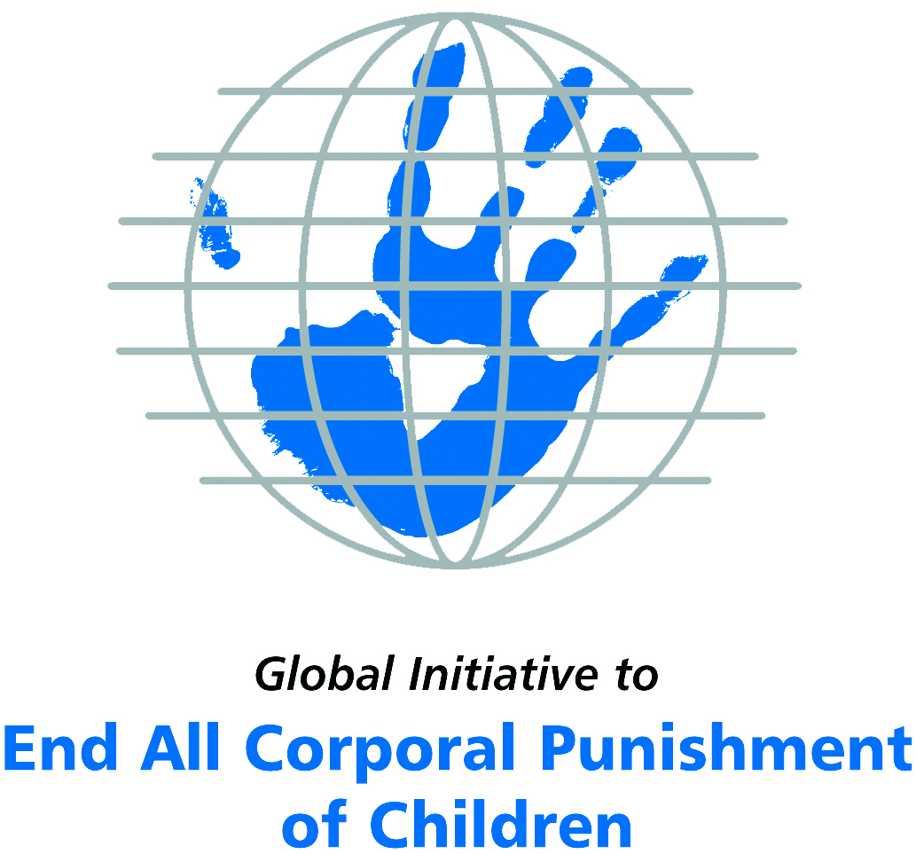
Briefing on Morocco for the Committee on the Rights of Persons with Disabilities, 18th Session, August 2017
From the Global Initiative to End All Corporal Punishment
of Children, July 2017

(a) About the Global Initiative to End All Corporal Punishment of Children
1. The Global Initiative (www.endcorporalpunishment.org) promotes universal prohibition and elimination of corporal punishment in fulfilment of states’ obligations under the UN Convention on the Rights of the Child and other international treaties. Our aims are supported by UNICEF, UNESCO, human rights institutions and international and national NGOs. Since 2002, the Global Initiative has regularly briefed the Committee on the Rights of the Child on this issue, and since 2004 has similarly briefed the Committee Against Torture, the Committee on the Elimination of Discrimination Against Women, the Committee on Economic, Social and Cultural Rights, the Human Rights Committee and the Human Rights Council; we have briefed the Committee on the Rights of Persons with Disabilities since the beginning of its work.

(b) Summary
2. Corporal punishment of children in Morocco is unlawful in the penal system, but it is not yet prohibited in the home, in alternative care and day care settings, and in schools, in violation of the fundamental right of all children to protection from corporal punishment and other cruel or degrading forms of punishment.
3. With reference to articles 7, 15, 16 and 17 of the Convention on the Rights of Persons with Disabilities, and in light of the particular vulnerability of children with disabilities to corporal punishment by adults, the jurisprudence of the UN treaty bodies, the emphasis on eradicating this form of violence given by the UN Secretary General’s Study on Violence against Children and the importance of the issue to achieving target 16.2 on ending violence against children in the 2030 Sustainable Development Goals, we hope the Committee on the Rights of Persons with Disabilities will:
- recommend to the Government of Morocco, in the Committee’s concluding observations on the initial report, that “legislation is drafted and enacted to explicitly prohibit corporal punishment of all children in all settings – including the home, schools and in all alternative care and day care settings – and that measures are put in place to ensure the law is properly implemented”.

(c) Detailed briefing
The right of children with disabilities not to be subjected to corporal punishment
4. The Convention on the Rights of Persons with Disabilities confirms that children with disabilities should enjoy all human rights and fundamental freedoms on an equal basis with other children (art. 7). The Convention also states that all persons have the rights to freedom from torture or cruel, inhuman or degrading treatment or punishment (art. 15), to freedom from exploitation, violence and abuse within and outside the home (art. 16) and to respect for their physical and mental integrity (art. 17). The jurisprudence of treaty monitoring bodies, led by the Committee on the Rights of the Child monitoring the Convention on the Rights of the Child, is clear that these rights put an obligation on states parties to prohibit and eliminate all corporal punishment of children, including within the family. However, the issue is not addressed in Morocco’s initial state party report.
5. As confirmed in the UN Secretary General’s Study on Violence against Children, children with disabilities are particularly vulnerable to violence, including corporal punishment, and corporal punishment is a significant cause of impairment among children. Yet the obligation to prohibit corporal punishment is frequently ignored or evaded by governments. The near universal acceptance of violence in childrearing together with deeply held views that parents and other adults have a “right” to physically punish children can challenge efforts to achieve prohibition. It also means that corporal punishment – at least to some degree – is not readily perceived as violence in the same way as, for example, sexual and other socially unacceptable forms of violence.
6. The newly adopted Sustainable Development Goals under the 2030 Agenda include target 16.2 on ending all forms of violence against children. Violent punishment is the most common form of violence against children: ending it through the adoption and implementation of legislation prohibiting it in all settings including the home is critical.

The legality of corporal punishment of children with disabilities in Morocco
7. Corporal punishment of children in Morocco is unlawful in the penal system, but children with disabilities may lawfully be subjected to physical punishment in the home, in alternative care settings, in day care settings, and in schools.
8. Corporal punishment is lawful in the home. Provisions against violence and abuse in the Criminal Code and the Family Code 2004 are not interpreted as prohibiting corporal punishment of children. Article 22 of the Constitution 2011 protects every person from cruel treatment: “The physical or moral integrity of anyone may not be infringed, in whatever circumstance that may be and by any person that may be, public or private. No one may inflict on others, under whatever pretext there may be, cruel, inhuman, [or] degrading treatments or infringements of [their] dignity. The practice of torture, under any of its forms and by anyone, is a crime punishable by the law.” This is not interpreted as protecting children from all corporal punishment.
9. Corporal punishment is lawful in alternative care settings. There is no explicit prohibition of corporal punishment in the law on foster care for abandoned children 2002. In reporting to the Committee on the Rights of the Child in 2014, the Government stated that measures had been taken to implement Law No. 14.05 establishing child care quality standards in institutions but did not indicate whether these prohibit all corporal punishment.
10. Corporal punishment is lawful in early childhood care and in day care for older children, including for children with disabilities. There is no explicit prohibition of corporal punishment in early childhood care or in day care for older children.
11. Corporal punishment is lawful in schools. A Ministerial directive in 2000 stated that corporal punishment should not be used in schools, but there is no explicit prohibition in law.
12. Corporal punishment is unlawful as a disciplinary measure in penal institutions. It is not among the permitted disciplinary penalties in the Prisons Act No. 23-98, adopted in 1999.
13. Corporal punishment is unlawful as a sentence for crime under the Code of Criminal Procedure 2002.
14. Opportunities for law reform. The Government signalled its commitment to prohibition by clearly accepting recommendations to prohibit corporal punishment in all settings including the home made during the Universal Periodic Review of Morocco in 2012. The Government adopted a policy on the comprehensive protection of children in 2016 – we do not know if this includes prohibition of corporal punishment. A Domestic Violence Bill has been under discussion since 2013, but there appear to have been no proposals to include prohibition of corporal punishment of children. As at July 2017, the Bill had not been passed into law. The Government reported in 2017 that the Code of Criminal Procedure and the Criminal Code were being revised. A Bill on combatting violence against women is being discussed in Parliament.

Recommendations by human rights treaty monitoring bodies and during the UPR
15. The Committee on the Rights of the Child has three times expressed concern at corporal punishment of children in Morocco and recommended it be explicitly prohibited in the home – in its concluding observations on the state party’s initial report in 1996, on the second report in 2003 and on the third/fourth report in 2014.
16. In 2011, the Committee Against Torture recommended to Morocco that corporal punishment of children be prohibited by law in the home, schools and centres that provide child protection services.
17. During the Universal Periodic Review of Morocco in 2012, the Government accepted recommendations to prohibit corporal punishment in all settings, including the home and schools. Recommendations to prohibit were extended to Morocco in 2017, but the Government has yet to respond.

Briefing prepared by the Global Initiative to End All Corporal Punishment of Children
www.endcorporalpunishment.org; info@endcorporalpunishment.org

Pinheiro, P. S. (2006), World Report on Violence against Children, Geneva: United Nations. See also Krug E. G. et al (eds) (2002), World Report on Violence and Health, Geneva: World Health Organisation
17 July 2014, CRC/C/MAR/Q/3-4/Add.1, Reply to list of issues, para. 86
6 July 2012, A/HRC/21/3, Report of the working group, paras. 129(62) and 129(65)
20 February 2017, A/HRC/WG.6/27/MAR/1, National report, paras. 16 and 94
30 October 1996, CRC/C/15/Add.60, Concluding observations on initial report, paras. 15 and 27
10 July 2003, CRC/C/15/Add.211, Concluding observations on second report, paras. 42 and 43
19 September 2014, CRC/C/MAR/CO/3-4 Advance Unedited Version, Concluding observations on third/fourth report, paras. 36 and 37
21 December 2011, CAT/C/MAR/CO/4, Concluding observations on fourth report, para. 24
6 July 2012, A/HRC/21/3, Report of the working group, paras. 129(62) and 129(65)

