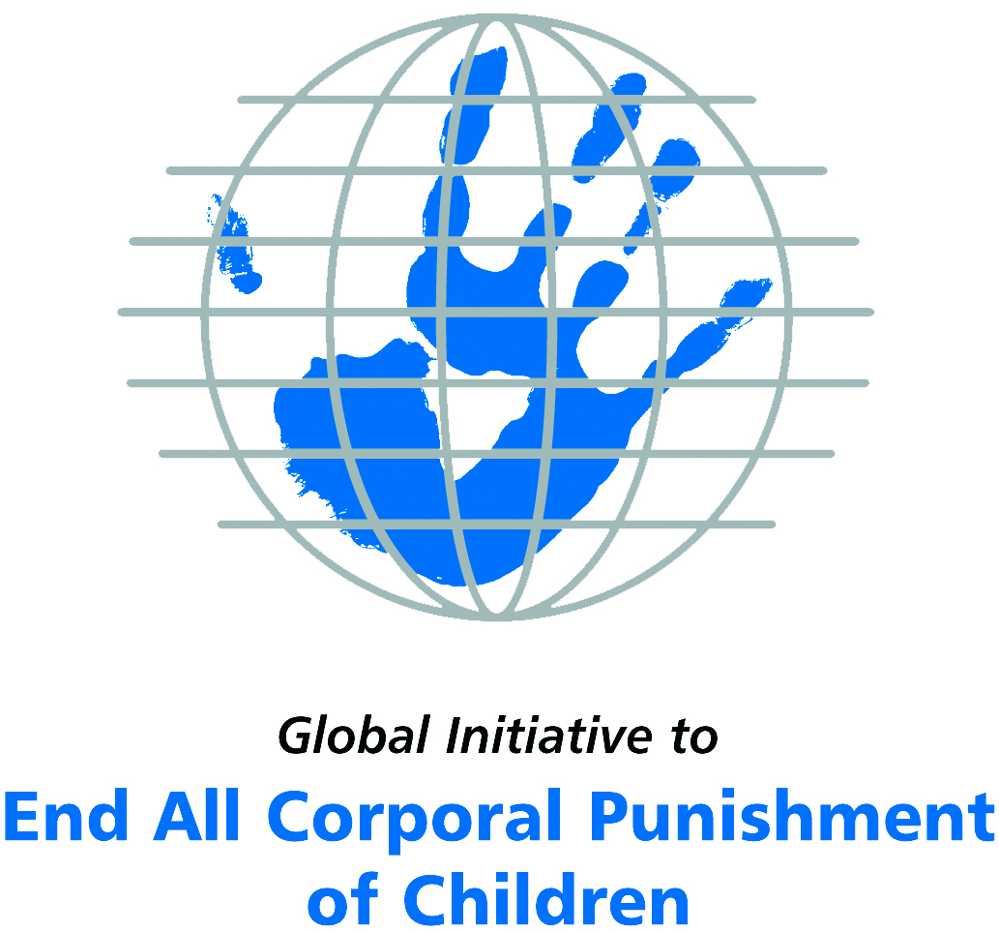
Briefing on Panama for the Committee on the Rights of Persons with Disabilities, 17th session, March/April 2017
From the Global Initiative to End All Corporal Punishment
of Children, February 2017

(a) About the Global Initiative to End All Corporal Punishment of Children
1. The Global Initiative (www.endcorporalpunishment.org) promotes universal prohibition and elimination of corporal punishment in fulfilment of states’ obligations under the UN Convention on the Rights of the Child and other international treaties. Our aims are supported by UNICEF, UNESCO, human rights institutions and international and national NGOs. Since 2002, the Global Initiative has regularly briefed the Committee on the Rights of the Child on this issue, and since 2004 has similarly briefed the Committee Against Torture, the Committee on the Elimination of Discrimination Against Women, the Committee on Economic, Social and Cultural Rights, the Human Rights Committee and the Human Rights Council; we have briefed the Committee on the Rights of Persons with Disabilities since the beginning of its work.

(b) Summary
2. Corporal punishment of children in Panama is unlawful in the penal system, but it is not yet prohibited in the home, alternative care settings, day care and schools, in violation of the fundamental right of all children to protection from corporal punishment and other cruel or degrading forms of punishment.
3. With reference to articles 7, 15, 16 and 17 of the Convention on the Rights of Persons with Disabilities, and in light of the particular vulnerability of children with disabilities to corporal punishment by adults, the jurisprudence of the UN treaty bodies, the emphasis on eradicating this form of violence given by the UN Secretary General’s Study on Violence against Children and the importance of the issue to achieving target 16.2 on ending violence against children in the 2030 Sustainable Development Goals, we hope the Committee on the Rights of Persons with Disabilities will:
- include the issue of corporal punishment in its List of Issues for Panama, in particular asking: “what steps have been taken to ensure that national legislation in Panama fully protects children with disabilities from all violent punishment and that corporal punishment is explicitly prohibited in all settings, including the home, and what progress has been made towards explicitly repealing the right of correction”;
- recommend to the Government of Panama, in the Committee’s concluding observations on the initial report, that “legislation is drafted and enacted to explicitly prohibit corporal punishment of all children in all settings – including the home, schools and in all alternative care and day care settings – and that measures are put in place to ensure the law is properly implemented”.

(c) Detailed briefing
The right of children with disabilities not to be subjected to corporal punishment
4. The Convention on the Rights of Persons with Disabilities confirms that children with disabilities should enjoy all human rights and fundamental freedoms on an equal basis with other children (art. 7). The Convention also states that all persons have the rights to freedom from torture or cruel, inhuman or degrading treatment or punishment (art. 15), to freedom from exploitation, violence and abuse within and outside the home (art. 16) and to respect for their physical and mental integrity (art. 17). The jurisprudence of treaty monitoring bodies, led by the Committee on the Rights of the Child monitoring the Convention on the Rights of the Child, is clear that these rights put an obligation on states parties to prohibit and eliminate all corporal punishment of children, including within the family. However, the issue is not addressed in Panama’s initial state party report.
5. As confirmed in the UN Secretary General’s Study on Violence against Children, children with disabilities are particularly vulnerable to violence, including corporal punishment, and corporal punishment is a significant cause of impairment among children. Yet the obligation to prohibit corporal punishment is frequently ignored or evaded by governments. The near universal acceptance of violence in childrearing together with deeply held views that parents and other adults have a “right” to physically punish children can challenge efforts to achieve prohibition. It also means that corporal punishment – at least to some degree – is not readily perceived as violence in the same way as, for example, sexual and other socially unacceptable forms of violence.
6. The newly adopted Sustainable Development Goals under the 2030 Agenda include target 16.2 on ending all forms of violence against children. Violent punishment is the most common form of violence against children: ending it through the adoption and implementation of legislation prohibiting it in all settings including the home is critical.

The legality of corporal punishment of children with disabilities in Panama
7. Corporal punishment of children in Panama is unlawful in the penal system, but children with disabilities may lawfully be subjected to physical punishment in the home, alternative care settings, day care and possibly schools.
8. Corporal punishment is lawful in the home. Under article 319 of the Family Code 1994 those with parental authority over children have a duty and power “to reasonably and moderately correct them”, and there is a similar provision in article 443 in relation to guardians/tutors. The Family Code 1994 (art. 501) and the Criminal Code 2007 (art. 198) protect children from corporal punishment which causes physical injury but do not prohibit all corporal punishment. These provisions undermine other legal provisions against violence and abuse of children by providing a legal defence for the use of corporal punishment in childrearing, for hitting and hurting children with disabilities in the guise of “discipline”.
9. Corporal punishment is lawful in alternative care settings. As for parents, those responsible for the care of children and others with parental responsibility may physically punish children with disabilities under the right of correction in articles 319 and 443 of the Family Code 1994.
10. Corporal punishment is lawful in early childhood care and in day care for older children, including for children with disabilities. The right to “correct” in articles 319 and 443 of the Family Code 1994 is applicable in these settings.
11. Corporal punishment is possibly lawful in schools. The right of persons with parental authority to correct children contained in articles 319 and 443 of the Family Code may apply to school settings.
12. Corporal punishment is unlawful as a disciplinary measure in penal institutions. It is explicitly prohibited in article 144 of Law No. 40 on the Special regime of criminal responsibility regarding adolescents. Law No. 55 2003 provides for respect of human rights within the penitentiary system.
13. Corporal punishment is unlawful as a sentence for crime. The Criminal Code 2007 and Law No. 40 on the special regime of criminal responsibility regarding adolescents 1999 state that corporal punishment cannot be handed out as a sentence for a crime.
14. Opportunities for law reform. In 2007 a project for a comprehensive law on children’s rights was submitted to Congress but as at October 2011 it had not been approved. A draft law on the promotion and integral protection of the family is under discussion. The Government signalled its commitment to prohibition by accepting recommendations made during the Universal Periodic Review of Panama in 2010 to prohibit all forms of corporal punishment of children. At the second cycle UPR in 2015, the Government again accepted a recommendation to prohibit in all settings, and to repeal the power to correct in the Family and Civil Codes. In September 2015, the Government reported to the Human Rights Council that a high-level inter-institutional commission had been established to draft a comprehensive law for the protection of children.

Recommendations by human rights treaty monitoring bodies and during the UPR
15. The Committee on the Rights of the Child recommended on three occasions that corporal punishment of children be explicitly prohibited in all settings. In 2011, the Committee specifically called for articles 319 and 443 of the Family Code 1994 and article 188 of the Civil Code to be revised to repeal the right of correction.
16. In the Universal Periodic Review of Panama in 2010 and 2015, the Government accepted the recommendations made to explicitly prohibit all forms of corporal punishment, including in the home and family, but misleadingly indicated that existing law already achieves this.

Briefing prepared by the Global Initiative to End All Corporal Punishment of Children
www.endcorporalpunishment.org; info@endcorporalpunishment.org

Pinheiro, P. S. (2006), World Report on Violence against Children, Geneva: United Nations. See also Krug E. G. et al (eds) (2002), World Report on Violence and Health, Geneva: World Health Organisation
24 January 1997, CRC/C/15/Add.68, Concluding observations on initial report, paras. 16 and 30, 30 June 2004, CRC/C/15/Add.233, Concluding observations on second report, paras. 33, 34 and 40, 21 December 2011, CRC/C/PAN/CO/3-4, Concluding observations on third/fourth report, paras. 45 and 46
4 January 2011, A/HRC/16/6, Report of the working group, paras. 70(15) and 70(16), 17 February 2011, A/HRC/16/6/Add.1, Report of the working group: Addendum, 8 July 2015, A/HRC/30/7, Report of the working group, para. 90(75)

