Forced Disappearance in Mexico

Human Rights Data

The Human Rights Measurement Initiative (HRMI) produces data tools that track how well a country is respecting human rights. Our physical integrity measurements, or ‘safety from the state’ data, could be very helpful in preparation for the upcoming committee review on Mexico. All of our data are freely available on the Rights Tracker.

To measure safety from the state, we use a peer-reviewed survey methodology of human rights experts in each country and use Bayesian statistical techniques to produce a country score out of 10.

Summary Score

HRMI measures a collection of 5 civil and political rights that foster people’s physical integrity, including the rights to freedom from:
- arbitrary arrest,
- forced disappearance,
- the death penalty,
- extrajudicial execution, and
- torture and ill-treatment.

On the right to be safe from the state, Mexico currently scores 3.1 out of 10, which falls in the ‘very bad’ range. This score suggests that many people in Mexico are not safe from violations of their physical integrity rights. Compared to other countries in our sample, Mexico is performing worse than average on the right to be safe from the state.
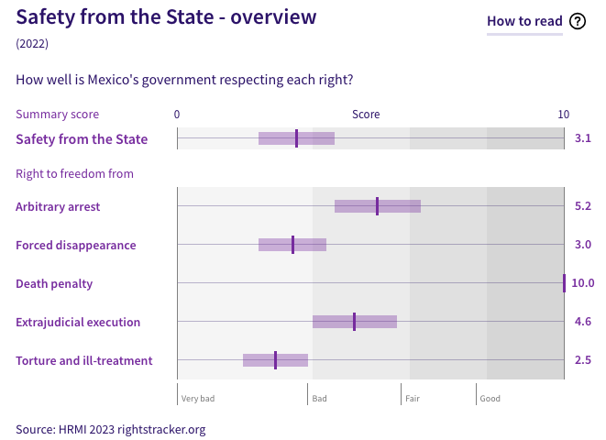
Freedom from Forced Disappearance

For the right to freedom from forced disappearance, Mexico currently scores 3.0 out of 10, which falls in the ‘very bad’ range. This means that many people within Mexico are at risk of forced disappearance.

When compared to 30 nations worldwide, Mexico scores among the lowest for the right to freedom from forced disappearance, below Mozambique, Saudi Arabia, and Venezuela
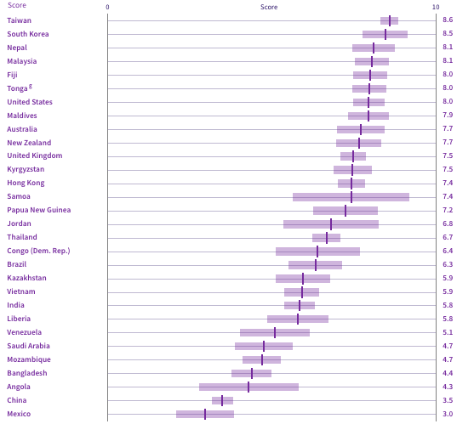

We asked human rights experts in Mexico which people are especially at risk of forced disappearance. 67% of human rights experts said all people are at risk of disappearance in Mexico. Experts also identified human rights advocates, migrants and/or immigrants, detainees, Indigenous people, and many more, as being particularly at risk.
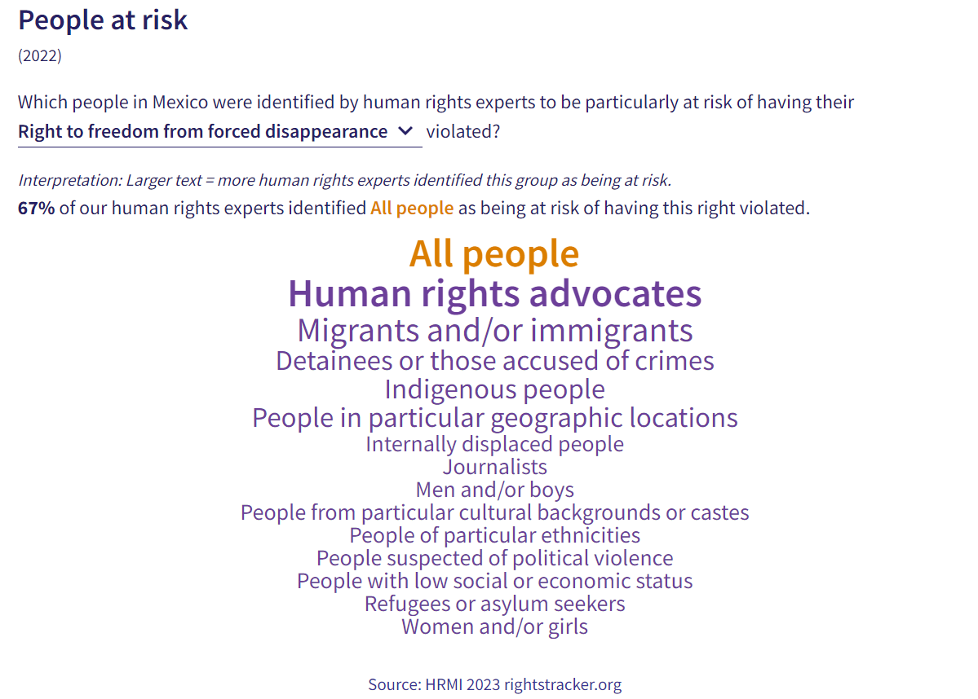

Over Time

We also track Mexico’s performance over time on the right to freedom from forced disappearance. Our data show that there have been no significant changes in freedom from forced disappearance since 2017, suggesting the Mexican government is not taking effective measures to prevent forced disappearance.
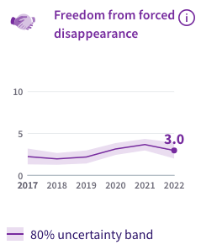

For additional information regarding Mexico’s performance on civil and political rights, please refer to the Rights Tracker, or contact us at HRMI (Thalia Kehoe Rowden - Thalia.KehoeRowden@hrmi.ngo). We are always happy to help you use Rights Tracker data in your work!

