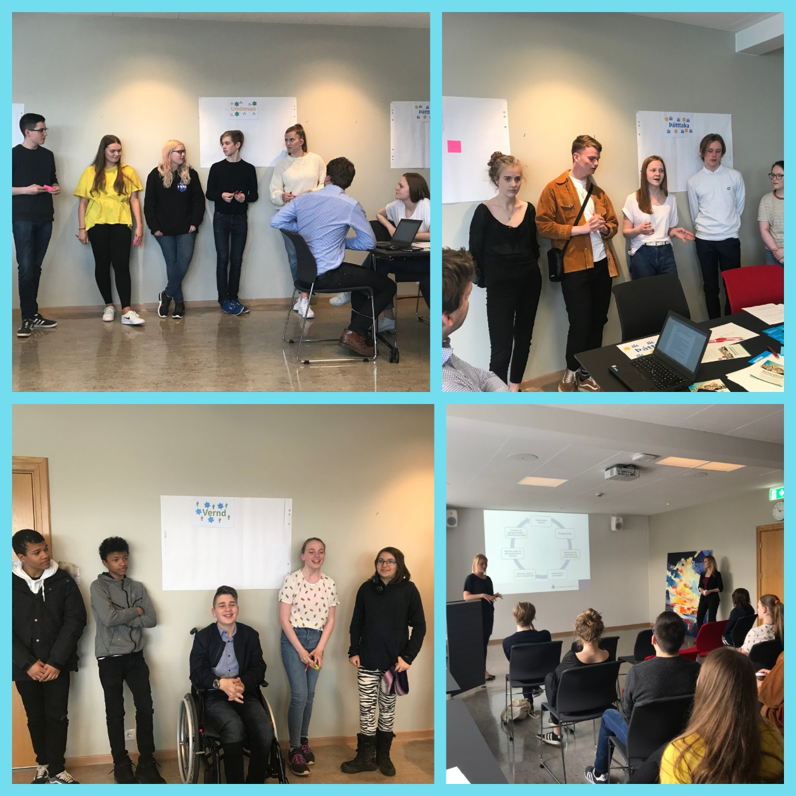

Children and the Convention on
the Rights of the Child
Consultation with Children on the Report from Iceland on the UN Convention on the Rights of the Child

October 2018
Table of contents

Introduction 3
The Consultation Meeting 4
Questions for children on the Convention on the Rights of the Child 5
What is the status of the Convention on the Rights of the Child in Iceland? 5
The right to protection 7
The right to provision 10
The right to participation 13
Other messages to the government 15
Word cloud 16
Conclusion 19
Annex I - Meeting invitation 20
Annex II - The agenda and arrangement of the meeting 21
Annex III – Questionnaire for children and young people 22
Annex IV – A list of parties that sent their representatives to the meeting 23
Annex V - Follow up after the meeting 24

Introduction

In April 2018, a working group with representatives from several ministries was appointed to draft a report on the implementation of the UN Convention on the Rights of the Child (CRC) in Iceland. The working group considered a broad consultation to be important in the making of the report, especially with children. Therefore, it was decided to hold a meeting with children for the purpose of hearing their voices regarding how their rights are protected in Iceland.
In order to reach a larger number of children around the country, a questionnaire was sent to all municipalities in the country with the request that representatives of youth councils or other children in the municipality would complete it electronically.
A total of 74 children and young people completed the questionnaire and 19 children attended a consultation meeting. Almost 100 children and young people were therefore given a chance to promote their views and their experiences of the Icelandic community. This report is meant to promote the voices of these children, as well as describing the consultation.

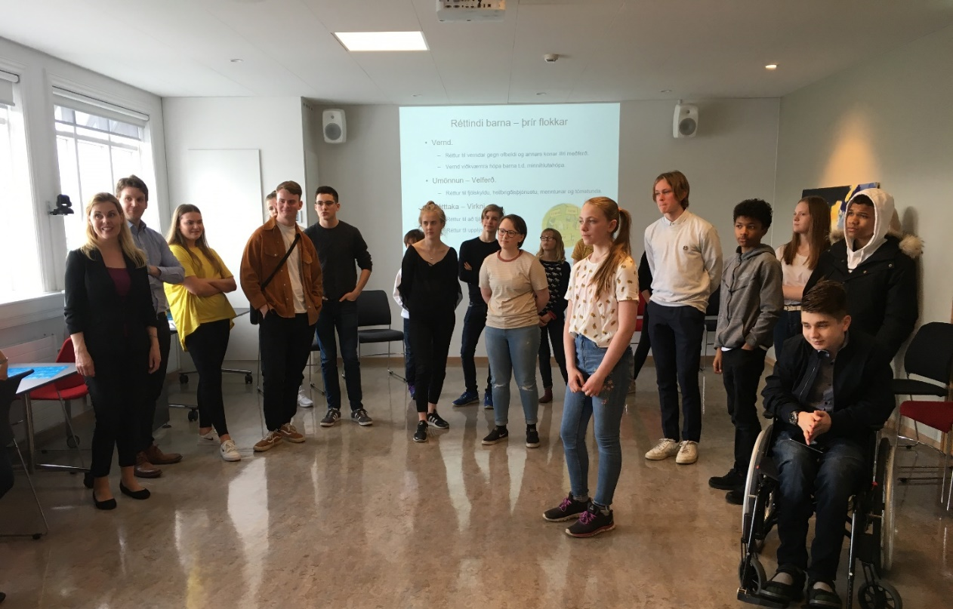

The Consultation Meeting

The working group contacted Nílsína Larsen Einarsdóttir, an expert in leisure and social issues and got her to assist the group in ensuring the participation of children in the drafting Iceland’s Periodic Report on the Convention on the Rights of the Child. Two preparatory meetings were held where representatives of the working group described the consultation and its purpose, and the information that was requested from the children. The decision was made to hold a consultation meeting with children as well as sending a questionnaire to youth councils and other children in Iceland.

A meeting invitation was prepared and a list of organisations and schools from which it was considered appropriate to request representatives was compiled. The list reflected a certain diversity and a special effort was made to get representatives of children from vulnerable or marginalised groups. The meeting invitation was sent out and representatives. 19 children, aged 10 - 18, attended the meeting, in addition to the Ministerial working group.
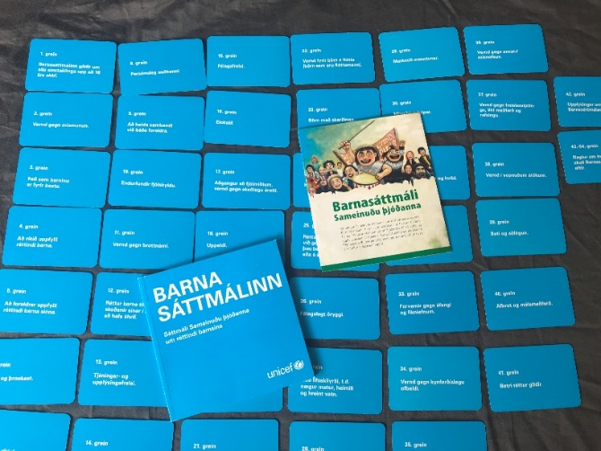
The meeting was held in a meeting room at the Ministry of Education, Science and Culture, where chairs were arranged for a presentation from the Ministerial working group. The presentation covered the method of the drafting of the report to the Committee on the Rights of the Child, the composition of the working group and the purpose of the meeting.

The presentation was followed by team building games and then the representatives were divided into discussion groups. The representatives were divided into four groups with the youngest representatives in one group. Due to their age participants in the youngest group only attended the first half of the meeting, but still discussed the whole questionnaire. This was because the meeting was held after school and sitting through long meetings can be difficult for young children.

Following icebreakers and team building games, discussion tables were arranged in three places in the room and on the tables were questions from the project group along with the Convention on the Rights of the Child. All the articles of the CRC lay on the tables and the tables were divided according to the subjects of the meeting, which were: Protection, provision and participation.
Members of the working group joined as inobtrusive secretaries, noting down information from the discussions as well as providing special assistance to the youngest group.
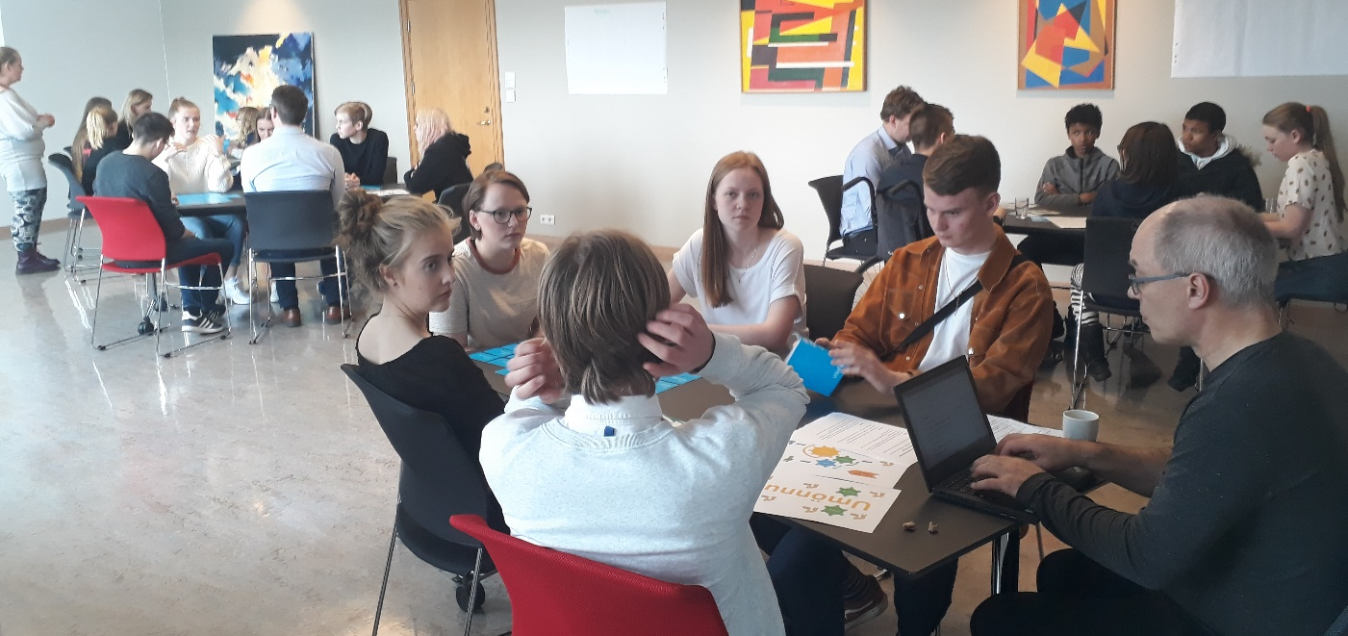
Following the meeting, an e-mail was sent to all the participants informing them of how the information gathered at the meeting will be processed.

Questions for children on the Convention on the Rights of the Child

What is the status of the Convention on the Rights of the Child in Iceland?
1. Do you think that children and adults are familiar with the Convention on the Rights of the Child? Has it been promoted well enough?
The discussion revealed that the younger and older representatives had different knowledge of the CRC. The younger representatives came from compulsory schools which have worked systematically towards implementing the CRC and which are so-called UNICEF Rights Respecting Schools. Those representatives had received a good introduction and education on the convention and what it entails. The older said they had just started to get educated about the convention, “on the brink of 18”, and they felt there was a great lack of promoting and educating children on their rights and the contents of the CRC.
“People know it exists but don’t know the contents well enough. We could do better when it comes to education on the Convention “

“Everyone has heard about it but don’t necessarily know what is says “

It is important that rights education is diverse, entertaining, interactive, practical, and that it takes place at school and across subjects. It is not enough to educate children and young people on their rights, adults also need to know and respect the rights of children.

A total of 74 children and young people answered this question on the electronic questionnaire and it became apparent that most of them know little about the CRC. Most of them say that it needs to be promoted much better. Only five persons thought that the convention had been sufficiently promoted within their schools. It was also mentioned repeatedly that even though the convention is introduced to children, adults are not necessarily aware of the rights of children.
“No, not at all. My friends (age 16 to 18) could not tell you the purpose of the Convention”

“The School Curriculum says that kids should learn about the Convention in schools but not nearly all schools teach kids about it and even if they do they usually only learn what the Convention is and the main purpose of it, but nothing deeper than that”

2. What is good about being a child (0-18 years old) in Iceland? What could be better?
It was revealed, both at the meeting itself and in the replies to the electronic questionnaire, that children and young people generally enjoy a high level of security and freedom. It was mentioned that living in Iceland carried with it a certain risk of natural disasters such as volcanic eruptions and extreme weather. But compared to other countries, it is undoubtedly best to live in Iceland. All children get to go to school here, they have access to healthcare, and there are support systems in place, such as child protection and laws on child labour.
“It matters that children have rights. It makes our lives. I have the right to be looked after by adults and to receive health care”
“I have all the rights I need”

It was also frequently mentioned that children in Iceland generally enjoy good conditions at school and in leisure activities and have plenty of opportunities for participating in sports. They are, nevertheless, aware that not all children enjoy the same opportunities and that the adults need to make sure that everyone gets equal opportunities, especially children with certain disabilities. Some also mentioned that children get bullied at school, which is a concern to them.
There was also talk of how much the parents need to work, leaving them with little time to spend with their children. It was also mentioned that in general, narcotics are easily available. It was mentioned quite often in the children’s replies, that they feel that there is little respect for their views and ideas.
“There are many upsides of being a child in Iceland, but there are many things that could be improved, teaching, rules, obligations and respect for children”

It was also revealed that there is a difference in the definition of the age limits for “a child”, primarily regarding pricing of public transport, swimming pools and the age for paying taxes. Many pointed out that all children needed to be empowered to express their views and take initiative, and children need more room to do things on their own. It is as if their ideas and views have no value until they reach the age for upper secondary education. They feel that no one listens to what they have to say.
“We do not need to be afraid of the army and explosions here because there are no wars”
“Free and safe schools. But not enough support for disabled children”

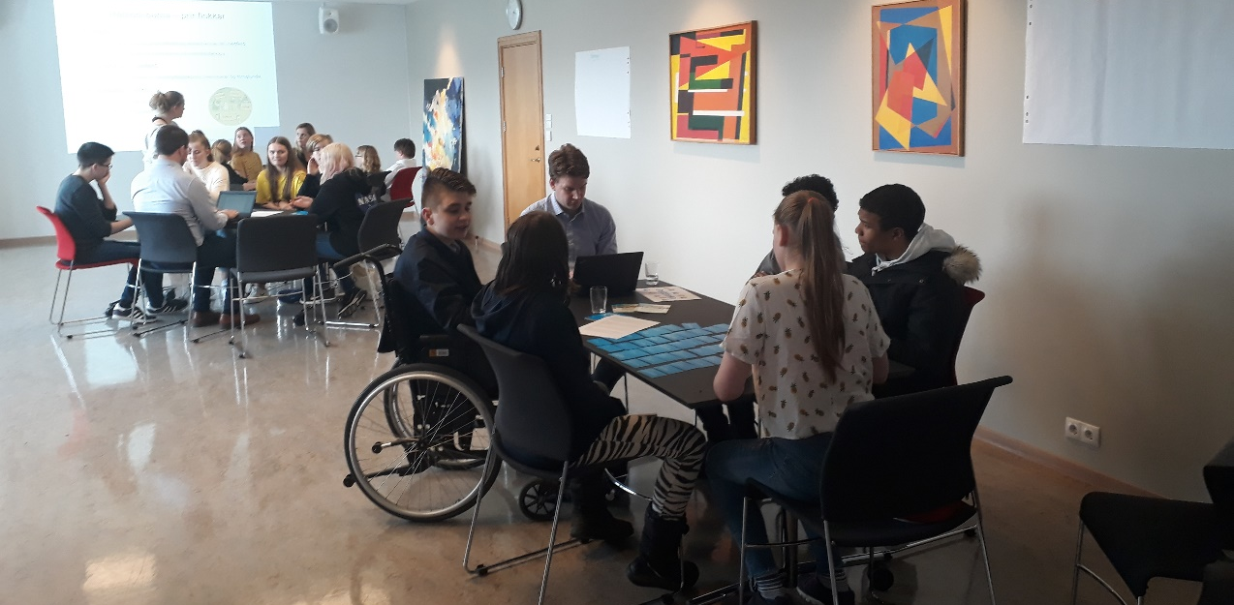
The right to protection
3. Children with disabilities, children of foreign origin, LGBTQIA+ children and other children of minorities - What is the status in Iceland? What is good, what could be better?
Children generally feel that children who seek international protection are well taken care of, but they call for increased support for learning Icelandic and say it is the key to better and earlier integration, i.e. that everyone receives a suitable education. It is also important to enrol them in leisure and/or sport activities and make them socially active.
“The status of “other children” is not good enough”

They generally find that accessibility for children in wheelchairs, for example, is rather good, but the authorities could do more to support all children. They mentioned that all children get to go to school but there should be more education in schools on different disabilities in order to reduce prejudice towards children with disabilities.

Some mentioned the position of LGBTQIA+ children and the prejudice they face at school. Also, that education is important to combat bullying and prejudice.

The respondents are generally very concerned about inequality and that not everyone gets to blossom in the school environment.
“There needs to be greater effort in these matters, e.g. children with disabilities need good accessibility in schools and youth centres. It is also important that children with disabilities are not discriminated against, e.g. socially. As for children of foreign origin, it is important for them to join a group and enter into social activities, sports, leisure activities and such. There also needs to be a plan in place before the children arrive in this country, to prepare children of their age, teachers and others who will be around them and to welcome them into our community.”

“I feel like some do not have the right to get what they need”

“We need a better support network for child refugees”

“The school system has a hard time taking queer kids into account”

4. Child protection, protection against violence and abuse - What is good, what could be better in your opinion?
Most of them think that children in general are very safe in Iceland, but what they see regarding child protection in the media is very negative, and therefore many children might be scared of requesting help from child protection authorities.
“It is not good how the justice system treats former offenders. They can take part in all parts of society and even get elected to power and receive vindication if they know the right people”

It was also mentioned that the silence surrounding violence against children is bad and that it can be difficult to live in small communities and ask for help.
It was mentioned both at the meeting and in the answers to the questionnaire, that there is a need for more education regarding child protection and the work of child protection committees. The children and young people do believe, however, that it is good and important to have such resources in their communities. Opinions differ, however, as to whether child protection steps in too late or too leniently or even with too much force. There is a clear indication that children and young people need more education on the work of the child protection authorities and where they can ask for help when needed. Many respondents claim to know little about child protection, but that they want to know more. They also think it is necessary to be able to receive assistance in the school concerning child protection affairs.
It was pointed out that children face violence in more places than their homes and schools, since violence also takes place on the Internet and especially through social media.
“Parents need help to become better parents “

“Children’s House is doing good work but we need better information for children who are victims of abuse. Where should they go? It is difficult in smaller communities – there kids may not talk to the people that can respond and help them “

“It depends on schools. In some schools teachers are well informed and do everything they can but unfortunately, not all schools are like that“

“A lot of violence online “

The right to provision
5. Healthcare - What is good, what could be better in your opinion?
“The health care system is drying up from neglect. We Icelanders need to improve the health care service all over the country. People need to be able to depend on it. The health care professionals are good, but we need to make sure that they flourish and are able to respond quickly and that they are not understaffed or completely overwhelmed “

There is a clear call from children for improved mental healthcare and increased access. They are worried about how long it takes to get treatment due to waiting lists and how expensive it is. They talk a lot about how it is more difficult for children outside the capitol area to get such healthcare. The analytical procedures are too long, the therapeutic treatments last for short periods, there isn’t enough prevention and it isn’t sufficiently varied. The Children’s and Young Persons’ Psychiatric Department (BUGL) is at its limits and too many children face social isolation, dysphoria and complex mental challenges.
The shortening of the general upper secondary education from four to three years is said to affect young people, that the stress is too much and that there is an increased risk of dropout.
“It is good that there are nurses in all schools. But it is kind of a joke because they never seem to be available, since it is only a part-time position”

The children want increased and more diverse services within the school system so that it is equally accessible to all. They mention that school nurses work in all compulsory schools, but their employment ratio is so low that they are almost never on site when they need their assistance. Many point out that it is necessary to have psychologists working at every school, free of charge.
Children are said to have access to good general dental care, but not when it comes to orthodontics. Icelandic children in general enjoy good conditions in the healthcare system when it comes to physical issues, compared to many other countries.
“The pressure in secondary school has increased after the terms were reduced. Students give up their hobbies to keep up with their school work and have friends. Some drop out “

“It is very strange that therapy is not free! We should get the same service whether it is a physical wound or an emotional pain“

“We need free psychological counselling for all kids aged 0-18!!“

6. Family - What is good, what could be better in your opinion?
Looking back, it would have helped to explain this question a bit better, since many of those who responded to the electronic questionnaire did not realise the meaning and context of the question, or thought that it referred to their own families. It was, however, revealed that parents work too much and therefore do not have enough time to spend with their children. Furthermore, it was pointed out that children also live in poverty in Iceland and that care must be taken to give all children an equal opportunity to leisure and participation in society.

“There are more poor children than we think, a lot of discrimination when it comes to participation in sports and leisure “

„

It was also mentioned that Icelandic families are becoming more diverse, which is a good thing. Having divorced parents is not an issue, for example, but greater consideration could be taken to the wishes of children when deciding on custody, access or residence.
Many children do, however, face prejudice towards them over the actions of other family members, especially children of prisoners or addicts. They need more protection and support to face the prejudice against them.

“Icelandic families are not very close, they should spend more time together, but it is difficult because of long work hours “

“Children should be able to demand joint custody “

“But what if an older sibling does something? Is maybe an addict and then you are all of a sudden part of a family of addiction!? You are your own person and should not have to endure what others do“

7. Education and leisure - What is good, what could be better in your opinion?
“Electives are important. Because the school is not in tune with the future. We may already know what we want to do in the future, what direction we want to go in. But that is not what they teach you at school. We want to be able to choose to learn what we want“

The changes that have been made to the education system in recent years were discussed, such as one year shortening of the upper secondary education and changes to the grading system in compulsory schools. Children clearly have strong opinions on these changes. Especially since the children and young people most affected were not consulted. The authorities ignored the Convention on the Rights of the Child when taking these decisions and the answers reflect a disappointment with that.
The importance of variation in teaching techniques was mentioned as well as the importance of variation when it comes to electives.
Art education outside compulsory and secondary schools is said to be varied but expensive, and therefore not as available for children in poverty.
There was talk of boys not getting enough stimulation in the school environment, and that ways to help them fare better at school need to be examined in order to avoid them dropping out.
Speculations about a shortage of teachers were put forth and it was also pointed out that technical and vocational education needed promoting.
“Boys don’t get enough encouragement in schools” “

“The Education is mostly fine, but we need more attention on the environment and mental health”

“Children that are poor do not have access to the leisure activities they are interested in”
“Instead of the changes made to the Secondary school term, the whole school system should have been re-evaluated from pre-school to university”

The right to participation
8. The right of children to have an impact in society, take part in democracy, express themselves, receive information - What is the status? What is good, what could be better in your opinion?
“Youth councils are a good example. But most children in Iceland do not have an opportunity to have an impact on society”

Many say that children are getting increased opportunities to express their opinions and that youth councils have more weight in the municipalities. Nonetheless, most are of the opinion that even while children get to express themselves, their views may not necessarily be taken into account. Also, not all children in Iceland get the opportunity of joining a youth council and not all municipalities have youth councils. There is, therefore, a call for more education on the possibilities for children and young people to promote their opinions. Access to information is also lacking, in their opinion, especially regarding politics.
Even when youth councils are in place, they are not always consulted and many decisions on matters that affect children and young people directly are made without consulting them. There should also be more education available on the role of youth councils.
“It is good that children can to express themselves but not good that they often do not have an impact. Sometimes they do not even get heard at all “

It is apparent from the answers that information is not systematically sought from children and young people on their welfare, opinions or other ideas. When that is done, a reasonable account is not taken of their contribution and therefore their participation tends to be symbolic and their experience of their participation is therefore loaded with pointlessness. It was also mentioned that children and young people do not have good access to information, and they wonder how they can participate if they do not get information that is understandable to them.
“It is getting a lot better. This questionnaire is an example of this – young people are being asked for their opinion! It is also great that youth councils are becoming more active and that young people have the courage to make themselves heard!”

“We need to increase education on how you can impact society, increase the interest in voting. Get young people to vote when they reach the voting age”

“When children search for information it is not always accessible, like the website of the parliament. It is difficult to understand where the proposals stand unless you are a lawyer. We need child friendly information”

9. The right of children to control their own lives and make decisions. Are children listened to? What is good, what could be better in your opinion?
It differs from one family to the next how much say children and young people have in decisions on their own lives. Most think that children could and should have more influence and that greater consideration should be taken of their views. This especially applies to children of foreign descent. They need to face greater understanding of the fact that Icelandic is not their native language and they need to be able to express themselves in their own language and retain their culture. Some, however, think that children are sufficiently able to control their own lives.
“Children are often not taken seriously and youth councils are sometimes only for show”
“Children should be sought after when decisions about children are being made”
It was clearly stated that children aren’t sufficiently listened to, whether in the family, at school or municipalities. Some say that participation is often symbolic and that is not good enough. It was stated that Iceland is doing well in getting children to voice their opinions, but could, nonetheless, be doing even better. It also seems to be a tendency for letting children express themselves when they reach their upper teens and that the opinions of younger children are not listened to as much.
It was mentioned that many children in Iceland are in poverty and enjoy very little security when it comes to housing. Renting is expensive, and children often have to move due to family situations. Those children are less able to control their own lives as they are dependent on their families. Many parents work multiple jobs to be able to provide stability in the life of the family. Under those conditions it becomes obvious how powerless children and young people are, and what little control they have over their circumstances.
“I am not born in Iceland and sometimes I like better speaking English and then I get told off. People of foreign origin need to speak Icelandic instead of their own language“

“The status in Iceland is good compared to other countries but it could be better“

“It is sad how many children are poor and don‘t have a safe home. Some parents need to work three jobs or even need to move to get cheaper housing“

Other messages to the government
10. Is there anything else that is important to bring to the government’s attention?
Several issues get mentioned, mostly the discrimination against those in need of assistance, for example that children with disabilities receive different levels of service by municipalities.
Children of foreign descent need more support with integrating into society and learning the language. They need special care since they don’t always get the same opportunities as other children.
There are strong indications that children need more opportunities to participate and their views and ideas need to be given reasonable consideration. They have much to say and wish to be listened to. That way, they’re likelier to become active members of society.
“Listen to young people because we also have important opinions”

It was clearly stated that education on mental problems needs to be improved and access to mental health services needs to be increased, especially psychologists within the school system. The Icelandic government should be able to create a society where everyone has equal opportunities of participation and equitable access to all services - irrespective of residence.
“I think the most important thing is that all children enjoy themselves and feel like they belong“
“Fix roads, ensure better internet and mobile connection all over the country, increase awareness about the environment in schools, support technical subjects and increase mental health education and access to psychologists“

“We should listen to children and give them a voice when it comes to decision-making“

Word cloud
Word clouds were used to give the voices of participants a graphical representation, which can be seen on screen shots below. The goal is to reflect the speculations of children in an interactive manner as they type in the answers and they appear instantly on the screen.
The word cloud asks why children’s rights are important. The answers reflect the values of the children participating. They point out that as children they are the future (Framtíðin), they want freedom (Frelsi) and are vulnerable and need more protection than adults (Vernd barna). They are the next generation and as a community we must respect the law that has been put in place and safeguard the rights of children to protection, participation, well-being and freedom. That is the vision for society that they think needs to be in place so that they can participate as members of society and enjoy the rights contained in the Convention on the Rights of the Child.
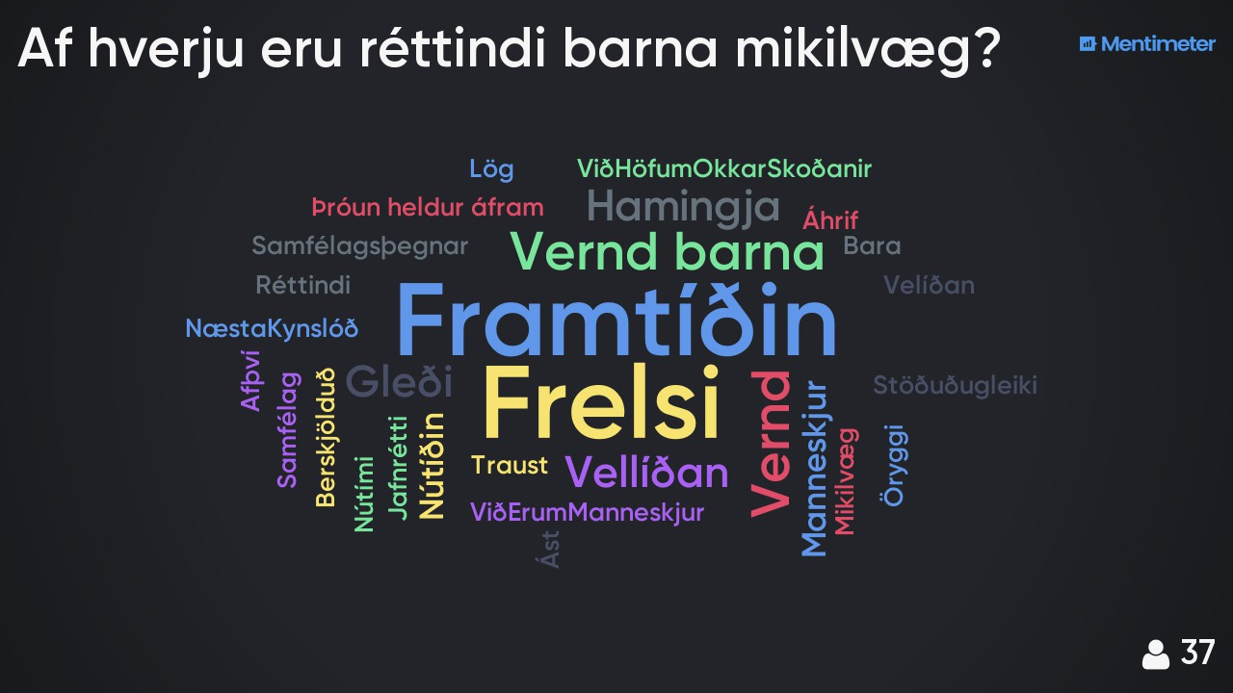
The following images show how the representatives at the meeting prefer to participate in the society they live in. Many ways are suggested here, and it is obvious that the children find both purpose and importance in their participation. Society should do more of consulting with children as they often have good information and ideas, which are valuable for society as a whole.

When the participants were asked to explain how they would like to take part in society there was no shortage of answers, as there was a clear call to those in power for increased consultation. Requests were made for a platform for communicating on issues relating to children and young people, direct access to those in power without multiple intermediaries and that youth councils must be in place. The strongest call, however, is for education and information for children and young people on ways to promote their opinions and on ways to participate in democracy.
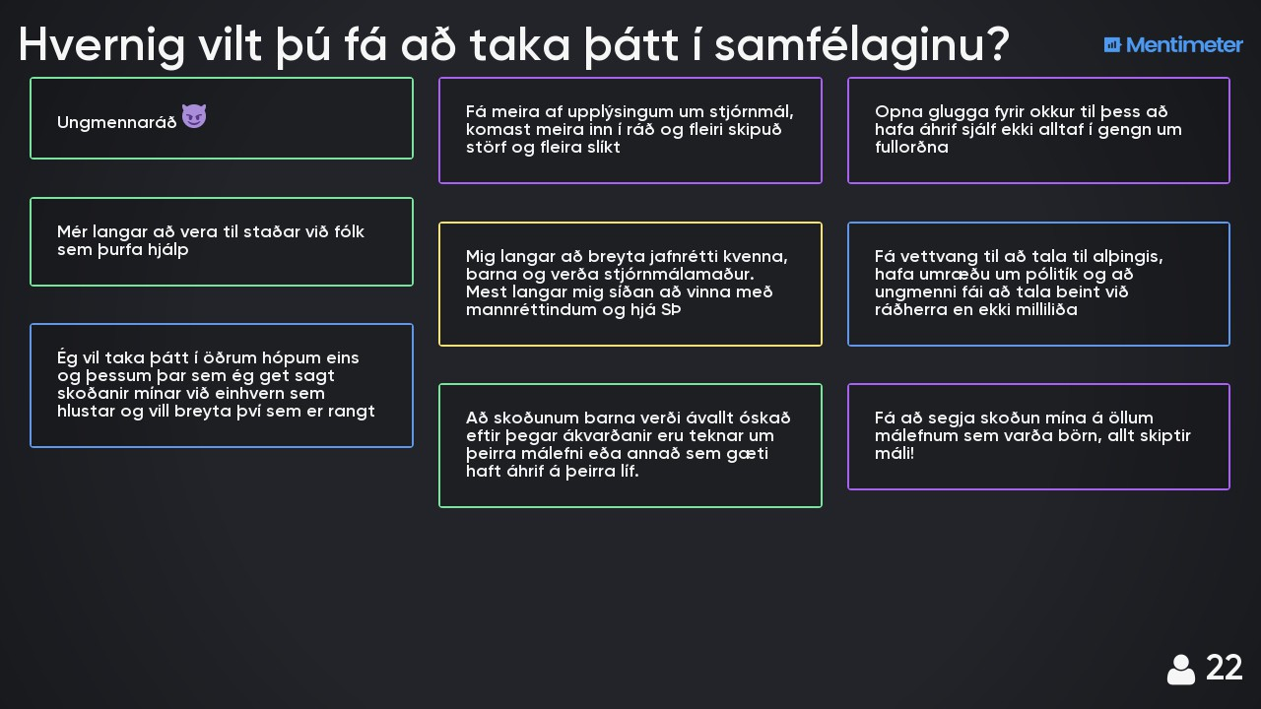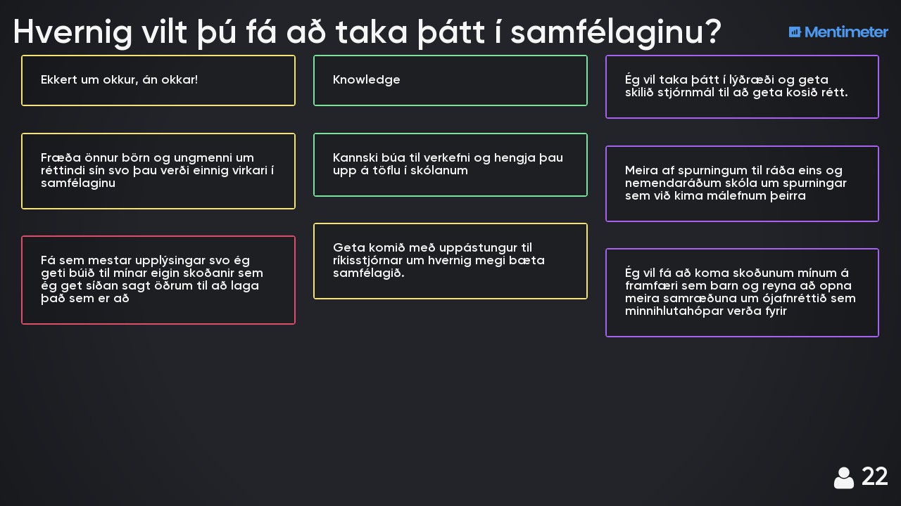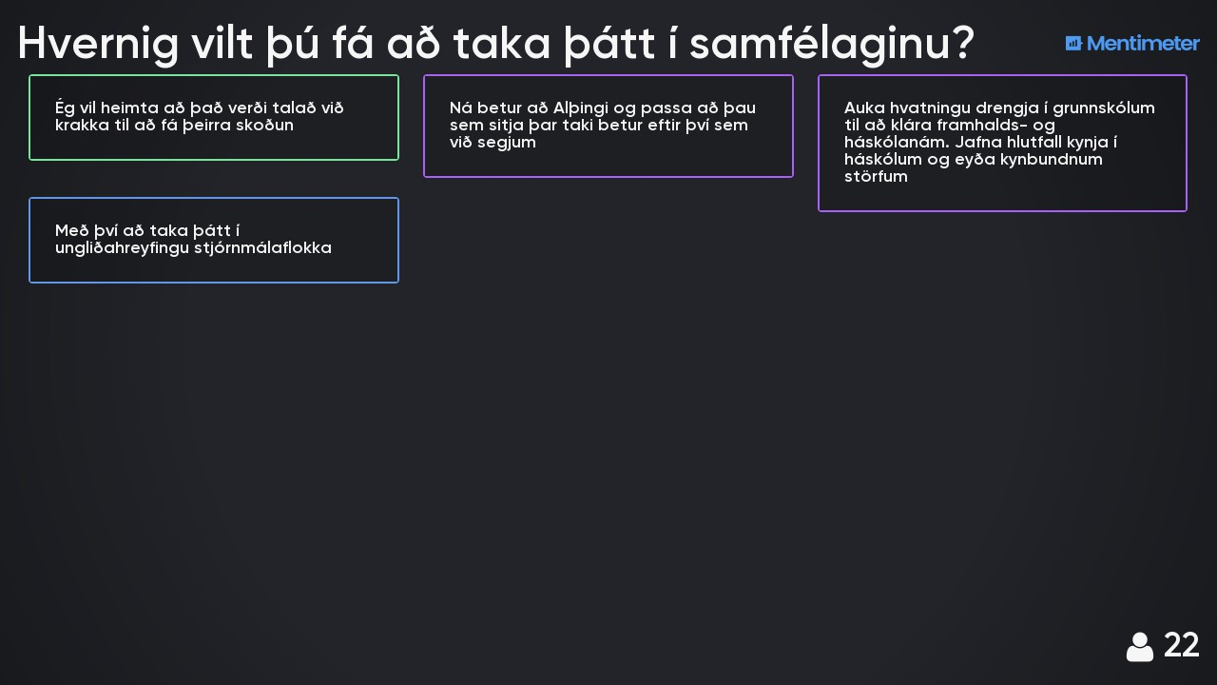
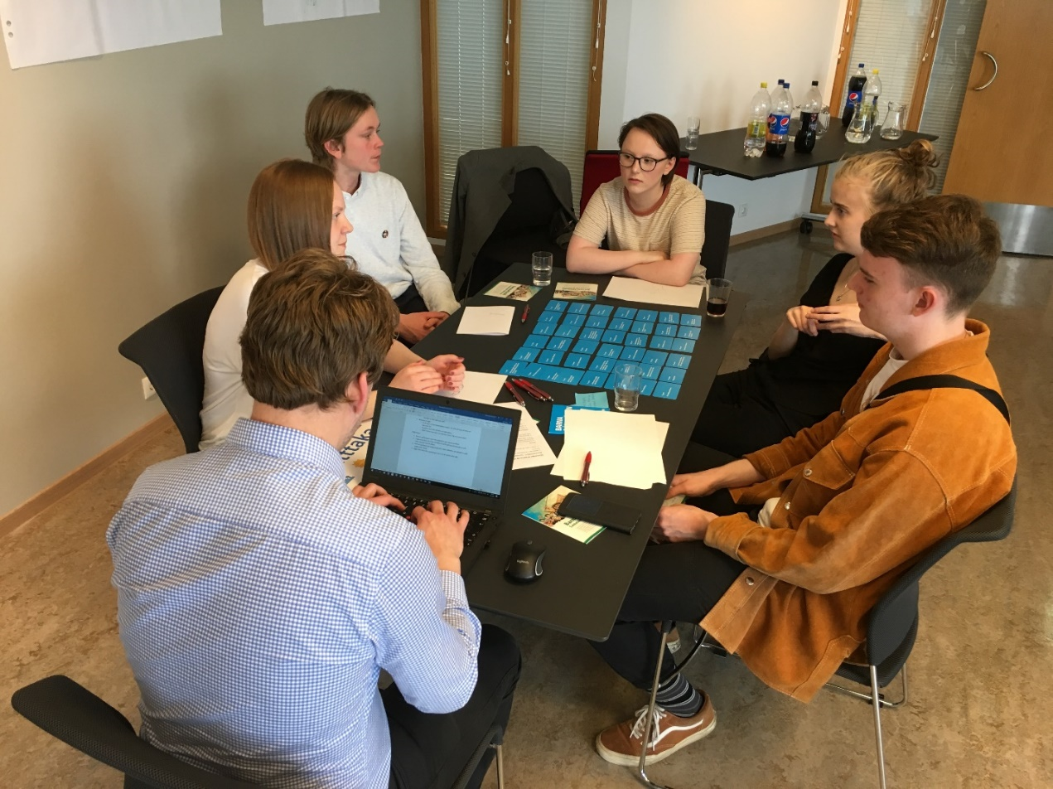

Conclusion

It can truly be said that the children that took part in the consultation meeting and those that completed the electronic questionnaire have much to say. Many things are being done well when it comes to the rights of children in Iceland, but there are also many areas for improvement.

The Convention on the Rights of the Child was ratified in Iceland in 1992. By ratifying the convention, the Icelandic government acknowledges that children are a vulnerable and highly varied group in society that needs special care, protection and support beyond adults.

The Icelandic government has, however, gone a step further than many nations within the UN and legalised the Convention on the Rights of the Child in 2013 with Act No. 19/2013. Since the convention became part of Icelandic law, children’s knowledge of their rights has increased, but there is a need for increased education on children’s rights for both children and adults.

Therefore, it is very important to create a platform for children of all ages to become active in their own lives. This needs to happen by creating opportunities in the school system, the health system and widely around society. It is also important to change the attitude of adults in society towards children. As a society we must acknowledge that the attitudes, voices and experience of children contain great value. By systematically and regularly seeking out their voices, we can empower them to become active participants in society with strong citizen awareness much sooner than we do today.

Children aren’t “just” young people that are future citizens of our society. They are also the present. They are not waiting to become adults, because they are valid individuals with independent, legalised rights. Adults therefore need to be systematically educated about the Convention on the Rights of the Child and its contents, and likewise, children and young people need to be taught to put the convention into the context of their daily lives. In order to exercise their rights, children and young people must know about them.

That way, we empower children and young people to take a bigger part in society, to have a reasonable impact on their surroundings and gain equal access to opportunities.

Annex I - Meeting invitation
Consultation meeting with Children on the Report from Iceland on Implementing the UN Convention on the Rights of the Child.
A working group was recently appointed, with representatives from the Ministry of Justice, the Ministry of Education, Science and Culture, the Ministry of Welfare, the Ministry of Transport and Local Government and the Ministry for Foreign Affairs, whose role it is to draft a report on behalf of Iceland on implementing the UN Convention on the Rights of the Child. The last report from Iceland was written in 2008, and discussed by the Committee on the Rights of the Child in 2011.
The working group wishes to have a broad consultation in drafting the report, with both children and those who work on promoting the rights and interests of children. It has therefore been decided to hold a consultation meeting with children on Tuesday, May 29th, between 14:30 and 18:00 at the Ministry of Education, Science and Culture, 4th floor meeting room, Sölvhólsgata 4.
The working group therefore wishes to invite two representatives of children from (various schools, youth councils and organisations) aged 13-18. This refers to the date of birth of the representatives, i.e. children born after May 29th, 2000. Where possible, the representatives should be of different genders.
The number of representatives is limited. If you are not able to appoint two representatives, you need to notify us as soon as possible, so that other arrangements can be made. Please send information (full name and age) about the appointed representatives to the e-mail address elisabet.gisladottir@dmr.is.
The meeting will have the format of a world café and the participants will be divided into groups by age to discuss the content of the Convention on the Rights of the Child and its implementation in Iceland. The purpose is to hear the voices of children and young people on their rights in Icelandic society. The working group will summarise the results of the meeting and utilise them when preparing the report of the government to the Committee on the Rights of the Child. Refreshments will be available.
Best regards,
on behalf of the working group,
Elísabet

Annex II - The agenda and arrangement of the meeting

Agenda:
14.30 – 14.45 Reception - Project group
14.45 – 15.00 A short introduction on the purpose of the meeting - Project group
15.00– 15.10 Icebreaker and name games - Nilla
15.10– 15.20 An introduction of the Convention of the Rights of the Child and the subjects of the discussion – Protection – Care – Participation - Project group
15.20 – 15.40 Group work 1 PROTECTION – Each group gets a secretary from the project group
15.40 – 16.10 Group work 2 CARE – Each group gets a secretary from the project group

15.20 – 16.10 The younger group discusses all categories – A secretary from the project group is with them the whole time

16.10 – 16.40 Meal break – The younger group leaves at the end of the break

16.40 – 17.00 Group work 3 PARTICIPATION – Each group gets a secretary from the project group
17.00 – 17.30 The groups present their results, a conversation, possible prioritisation of results using Post-It notes - Everyone
17.30 – 18.00 Summary and discussions on the next steps - Project group

Annex III – Questionnaire for children and young people

Questions for young people regarding the Convention on the Rights of the Child
The Convention on the Rights of the Child - what is the status of the Convention on the Rights of the Child in Iceland?
1. Do you think that children and adults are familiar with the Convention on the Rights of the Child? Has it been promoted well enough?
2. What is good about being a child (0-18 years old) in Iceland? What could be better?

Protection
3. Children with disabilities, children of foreign origin, LGBTQIA+ children and other children of minorities - What is the status in Iceland in your opinion? What is good, what could be better?
4. Child protection, protection against violence and abuse - What is good, what could be better in your opinion?

Care
5. Healthcare - What is good, what could be better in your opinion?
6. Family - What is good, what could be better in your opinion?
7. Education and leisure - What is good, what could be better in your opinion?

Participation
8. The right of children to have an impact in society, take part in democracy, express themselves, receive information - What is the status? What is good, what could be better in your opinion?
9. The right of children to control their own lives and make decisions. Are children listened to? What is good, what could be better in your opinion?
10. Is there anything else that is important to bring to the government’s attention?

Annex IV – A list of parties that sent their representatives to the meeting

The following parties sent their representatives to participate in the meeting:

Women of Multicultural Ethnicity Network in Iceland
UNICEF Iceland
The Icelandic Youth Association (UMFÍ)
Flataskóli elementary school
Samfés (Youth Work Iceland)
Laugarnesskóli elementary school
The Organisation of Disabled in Iceland - ODI
An advisory group for the Ombudsman for Children
Youth Council for the Global Goals of the United Nations
Samtökin ´78 (LGBTQIA+ organisation)
The Youth Council for Iceland

Annex V - Follow up after the meeting

  - 1. What working group is this?
  - The working group was appointed to draft a report on the Convention on the Rights of the Child in Iceland. The group is also tasked with following up the report with the Committee on the Rights of the Child and the observations we receive from it.
  - Please contact us if you have any questions or further observations.
  - • In the working group are:
  - - Elísabet Gísladóttir, from the Ministry of Justice – elisabet.gisladottir@dmr.is
  - - Guðni Olgeirsson, from the Ministry of Education, Science and Culture – gudni.olgeirsson@mrn.is
  - - Ingibjörg Sveinsdóttir, from the Ministry of Welfare (Minister of Health) – ingibjorg.sveinsdottir@vel.is.
  - - Ívar Már Ottason, from the Ministry of Welfare (Minister of Social Affairs) – ivar.ottason@vel.is
  - - Gústav Aron Gústavsson, from the Ministry of Transport and Local Government – gustav.a.gustavsson@srn.is.
  - - Davíð Logi Sigurðsson, from the Ministry for Foreign Affairs (unable to attend) – david.sigurdsson@utn.is.

  - 2. Consultation with children
  - Nílsína Larsen Einarsdóttir (Nilla), expert in leisure and social issues, helped the working group to plan the consultation meeting on May 29th – nilsinalarsen@gmail.com
  - • In addition to the consultation meeting, a questionnaire was sent out to municipal youth councils.
  - • Other youth councils are welcome to complete the questionnaire, which can be found here: https://www.surveymonkey.com/r/D7NFPN8 (answers need to be handed by end of day on June 6th 2018).

  - 3. What will be done with the messages from the children?
  - The working group will take the findings of the meeting into account when drafting the report.
  - • Also, a special summary with messages from the children will accompany the report to the Committee on the Rights of the Child.

  - 4. The process:
  - Iceland ratified the Convention on the Rights of the Child in 1992, which means that we have entered into an agreement to ensure that children enjoy the rights in the convention (protection, provision and participation).
  - • Iceland has to submit a report to the Committee on the Rights of the Child every ten years, explaining the situation in Iceland – are we really ensuring the rights of children. The last report was submitted in 2008 and we are therefore due to submit the next one.
  - • The working group will draft a report – taking into account the opinions of children.
  - • The participants of the consultation meeting will be notified when the draft is read and has been published – observations can then be made.
  - • The report will then be submitted to the Committee on the Rights of the Child.
  - • Those who work towards the interest of children, such as the Ombudsman for Children and various organisations, then submit reports on how they see the situation (shadow reports).
  - • The Committee reviews the reports and sends us questions.
  - • The Committee then holds a meeting discussing the rights of the child in Iceland.
  - • Following that, we will receive observations from the Committee that we can hopefully use to increase the right of the child in Iceland.
  - • The observations will be well published when they arrive, which may not be until two years from now.

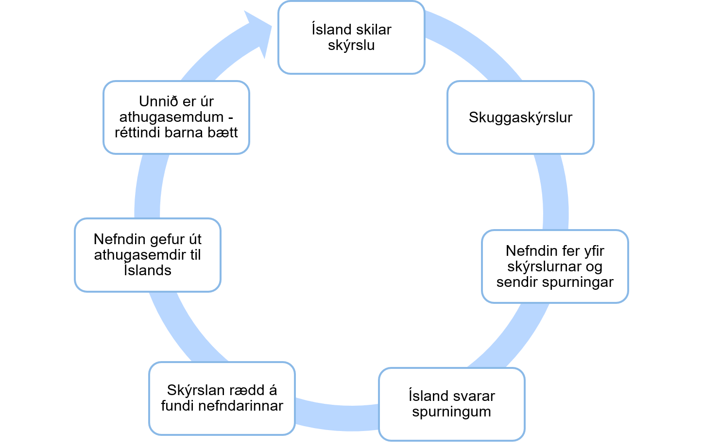

The questionnaire can be viewed in Annex III.
Annex IV contains the parties who sent representatives to the meeting.
The meeting invitation and the agenda are available in Annexes I and II.
The e-mail can be viewed in Annex V.

