BRIEFING ON SERBIA FOR THE COMMITTEE AGAINST TORTURE, SESSION 72- Nov/Dec 2021
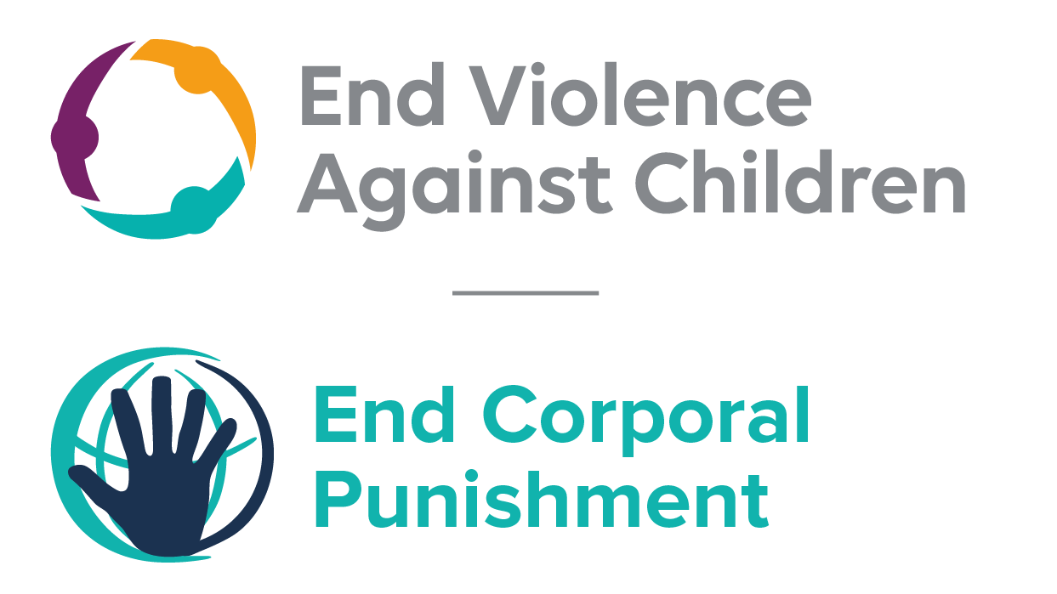
The Global Partnership to End Violence Against Children, October 2021

This briefing describes the legality of corporal punishment of children in Serbia. In light of the obligation under international human rights law to prohibit all corporal punishment of children, the recommendation of the UN Secretary General’s Study on Violence against Children, the repeated recommendations to prohibit all corporal punishment made to Serbia by the Committee Against Torture, the Committee on the Rights of the Child and the European Committee of Social Rights and during the Universal Periodic Review in 2008, 2013 and 2018 (which the Government supported), as well as the global commitment to ending all violence against children in the context of the 2030 Agenda for Sustainable Development, we hope the Committee will:
• in its concluding observations on the third report of Serbia, ask what progress is being made towards adopting the Law on Amendments to the Family Law which aims to explicitly prohibit corporal punishment of children, in all settings including the home.

Serbia’s commitment to prohibiting corporal punishment
Serbia expressed its commitment to prohibiting all corporal punishment of children by accepting the recommendation to do so made during the Universal Periodic Review of Serbia in 2008. The commitment was reaffirmed through accepting similar recommendations in 2013 and again in 2018.

Summary of necessary legal reform to achieve full prohibition
Prohibition is still to be achieved in the home, alternative care settings and some day care settings.
There is no defence for the use of corporal punishment enshrined in legislation but there is no explicit prohibition. In theory, the prohibition of “humiliating actions and punishments which insult the child’s human dignity” in article 69 of the Serbian Family Act 2005 would prohibit corporal punishment by parents, which invariably violates a child’s dignity, but the law is not interpreted in this way – and the potential for such an interpretation is undermined by the near universal social acceptance and use of corporal punishment in childrearing. Realisation of children’s rights to equal protection from assault under the law and to protection from all forms of violence requires clarity in law that no degree or form of corporal punishment is acceptable or lawful, without exception. Prohibition should be enacted of all corporal punishment and other humiliating and degrading treatment, in the home and all other settings where adults exercise authority over children.
Alternative care settings – Prohibition of corporal punishment should be enacted in legislation relating to all alternative care settings (foster care, institutions, places of safety, emergency care, etc).
Day Care – Corporal punishment is considered unlawful in day care which forms part of the education system. Legislation should now be enacted which prohibits it in all early childhood care (nurseries, creches, family centres, etc.) and all day care for older children (day centres, childminding, etc.).

- The report of Serbia to the Committee Against Torture
  - The third periodic report of Serbia states that a provision to prohibit physical punishment of children had been incorporated in the draft Law on the Amendments to the Family Law. The report notes that the adoption of the law was due to place in 2019. We have no further information.

- The legality of corporal punishment in Serbia
  - Summary: Corporal punishment of children in Serbia is unlawful in schools, in penal institutions and as a sentence for a crime. It is not fully prohibited in the home, in alternative care and day care settings.

  - Home: Corporal punishment is lawful in the home. Provisions against violence and abuse in the Criminal Code 2005, the Misdemeanours Act 2007, the Law on the Prevention of Domestic Violence 2016 and the Constitution 2006 are not interpreted as prohibiting all corporal punishment in childrearing. The Serbian Family Law 2005 states (art. 69(2)): “Parents may not subject the child to humiliating actions and punishments which insult the child’s human dignity and have the duty to protect the child from such actions taken by other persons.” But there is no explicit prohibition of all corporal punishment.
  - The Government stated its commitment to prohibition in 2007. In 2008, the Ministry of Social Policy and the Council for Child Rights adopted a National Strategy for the Prevention and Protection of Children Against Violence which included the aim of abolishing corporal punishment of children; plans were made for drafting amendments to the Family Law, and Minister for Education Mr Zarko Obradovic signed the Council of Europe petition against all corporal punishment of children. In accepting the recommendations at the Universal Periodic Review (UPR) in the same year, the Government again stated its intention to prohibit corporal punishment of children. In 2010, the Action Plan for the implementation of the National Strategy was adopted and in 2011, a Working Party developed a Draft Law on the Rights of the Child which includes provisions to prohibit all corporal punishment. In reporting to the second UPR in 2013, the Government confirmed that the Draft Law would prohibit corporal punishment in all settings. The Government accepted the recommendations to prohibit all corporal punishment made during the review. The Government reported to the Committee Against Torture in 2014 that the draft law would be presented in the National Assembly by the Ombudsman. However, the draft law was subsequently dropped and in response to a question about prohibition from the Committee on Economic, Social and Cultural Rights in 2014, the Government drew attention to the Criminal Code and stated that current law “completely prohibits and sanctions every type of violence against the child”. In December 2014, the Government reported to the Committee on the Rights of the Child that a preliminary law on child rights had been drafted which would prohibit corporal punishment in all settings. The Serbia delegation reported to the Committee on the Rights of the Child in January 2017 that the drafting process would resume within the year; however it later appeared the process might not be finalised before 2020. In November 2017, a working group was reportedly established by the Ministry of Social Welfare to draft the new Law on the Rights of the Child; but Serbia’s national report to the UPR also reported that the Ministry for family protection did not think it “necessary to adopt a special law on the rights of the child”. In June 2019, a consultative process was organised around the draft Law on the Rights of the Child and the Ombudsman for Children which reportedly includes explicit prohibition of corporal punishment.

  - A new Civil Code is being drafted. The draft Civil Code which was issued for consultation and public debate in 2015, included protection for children from physical punishment but offered two versions of the relevant article – one prohibiting child abuse “especially physical punishment”, the other prohibiting child abuse but only “inappropriate” physical punishment (art. 2218). Earlier in 2017, the draft Civil Code was still being consulted upon, and as of April 2019 it has not yet been introduced to Parliament as the Commission on Drafting the Civil Code is still finalising the text. It seems responses to the consultation were mainly favourable to a complete prohibition of all physical punishment and that the final version of the relevant article prohibits all corporal punishment.

  - Amendments to the Family Law are under discussion: we have yet to see the proposed amendments, but in February 2016 the Government confirmed to the Committee on the Rights of Persons with Disabilities that the draft Law on Amendments to the Family Law “will contain explicit prohibition of physical punishment of minors and use of physical force as a tool for correcting behaviour”. A similar statement was made to the Human Rights Committee in January 2017. It appears the governmental delegation to the Committee on the Rights of the Child reported that the amendments were expected to be adopted by June 2017. However the process has been delayed following the April 2017 presidential elections. In November 2017, it was reported that the Ministry in charge of family protection had started work on a draft Bill amending the Family Law “which, among other things, provides for a ban on corporal punishment of children and on the use of physical force as a means of upbringing the child”. In June 2018, the Government accepted recommendations to explicitly prohibit corporal punishment of children in all settings. In March 2019, the Government reported that amending the Family Law was underway and that one of the amendments would regulate “chastisement i.e. corporal punishment of a child” and define “the rule that parents are not allowed to chastise the child, or to subject it to degrading treatment and punishment that are offensive for the human dignity and integrity of the child”. In October 2019, a Working Group on amending the Family Law had been established and proposed amendments reportedly included explicit prohibition of corporal punishment. We have no further information.

  - Alternative care settings: There is no explicit prohibition of corporal punishment in alternative care settings, where it is lawful as for parents (see under “Home”). A 2011 law on social protection reportedly bans violence against beneficiaries of social protection services but there is no indication that it explicitly prohibits all corporal punishment.

  - Day care: Corporal punishment is considered unlawful in all day care which forms part of the education system under education law (see under “Schools”), including nurseries, kindergartens, preschools, after school care, workshops and additional education activities. But it is lawful in other day care, such as childminding etc. A regulation reportedly prohibits corporal punishment in care facilities: we are seeking to verify this information.

  - Schools: Corporal punishment was first explicitly prohibited in schools in article 67 of the Law on Public Schools 1929 (Yugoslavia). It is now unlawful under the Law on Secondary Schools 1992, the Law on Elementary Schools 1992 and the Law on the Foundations of Education and Upbringing 2003/2009.

  - Penal institutions: Corporal punishment is unlawful as a disciplinary measure in penal institutions. It is not among permitted disciplinary measures against juveniles in detention in the Law on Enforcement of Penal Sanctions, but this Law does not explicitly prohibit it. The Law on Juvenile Criminal Offenders and Criminal Protection of Juveniles does not include corporal punishment among permitted disciplinary measures and states that force may only be used exceptionally and to prevent a physical attack on others or self-injury (art. 132). A draft new Law on Juvenile Offenders and Protection of Juveniles in Criminal Proceedings was under discussion in February 2016. The Serbia delegation to the Committee on the Rights of the Child reported in January 2017 that the new juvenile justice law was expected to be adopted within the year.

  - Sentence for crime: Corporal punishment as a sentence for crime was abolished in 1873. It is not a permitted sentence for crime under the Criminal Code or the Law on Juvenile Criminal Offenders and Criminal Protection of Juveniles 2005.

Recommendations by human rights treaty bodies and during the UPR
  - CAT: In its 2009 concluding observations on the state party’s initial report, the Committee Against Torture recommended that legislation be enacted to explicitly prohibit corporal punishment in all settings.
  - CRC: On two occasions, the Committee on the Rights of the Child has recommended to Serbia that legislation be enacted to explicitly prohibit corporal punishment in all settings: in its concluding observations on the state party’s initial report in 2008 on the second report in 2004, and on the second-third report in 2014.

  - ECSR: On two occasions, the European Committee on Social Rights recommended that the Government prohibit corporal punishment in all settings: in January 2016 (Conclusions 2015) and in March 2020 (Conclusions 2019).
3.4 UPR: At the first cycle of the Universal Periodic Review of Serbia in 2008, recommendations to adopt legislation explicitly prohibiting corporal punishment were issued and accepted by the Government. Recommendations to prohibit all corporal punishment made in the second cycle UPR in 2013 and third cycle UPR in 2018 were also accepted.

9 November 2009, A/HRC/10/29, Report of the Human Rights Council on its tenth session, para. 519
8 November 2012, A/HRC/WG.6/15/SRB/1, National report to the UPR, para. 73
22 March 2013, A/HRC/23/15, Report of the working group, paras. 144(27), 144(28) and 144(29)
13 February 2014, CAT/C/SRB/2, Second state party report, para. 154
6 May 2014, E/C.12/SRB/Q/2/Add.1, Reply to list of issues, para. 242
[December 2014], CRC/C/SRB/2-3 Unedited Version, Second/third state party report, para. 74
30 January 2017, CRC/C/SR.2176, Summary records of the 2176th meeting, para. 28
Information provided to the Global Initiative, May 2017
Information provided by the Coalition for Monitoring Child Rights, November 2017
13 November 2017, A/HRC/WG.6/29/SRB/1, National report, para. 95
Information provided by the Child Rights Centre, October 2019
http://www.mpravde.gov.rs/sekcija/53/radne-verzije-propisa.php, accessed 29 February 2016
30 January 2017, CRC/C/SR.2176, Summary records of the 2176th meeting, para. 9
Website of the National Assembly of Serbia, http://www.parlament.gov.rs, accessed 24 April 2019
See http://www.novosti.rs/vesti/naslovna/drustvo/aktuelno.290.html:754977-IZRADA-GRADjANSKOG-ZAKONIKA-Koja-prava-dobijaju-gej-osobe, accessed 31 October 2018
See https://aks.org.rs/sr_lat/nacrt-gradanskog-zakonika/, accessed 23 November 2017
Information provided to the Global Initiative, October 2019
16 February 2016, CRPD/C/SRB/Q/1/Add.1, Reply to list of issues, para. 69
17 January 2017, CCPR/C/SRB/Q/3/Add.1, Reply to the list of issues, paras. 76 and 77
3 February 2017, CRC/C/SRB/CO/2-3, Concluding observations on second-third report, Advance unedited version, paras. 36 and 37
Communication with the Office of the Ombudsperson, June 2017
13 November 2017, A/HRC/WG.6/29/SRB/1, National report, para. 96; see also 18 April 2018, A/HRC/38/17, Report of the working group, para. 23
8 June 2018, A/HRC/38/17/Add.1 Advance unedited version, Report of the working group: Addendum
8 March 2019, RAP/RCha/SRB/8(2019), National report to the European Committee of Social Rights, page 60
Communication with MODS, October 2019
Nataša Jović, Assistant Secretary General, Protector of Citizens (Ombudsman), correspondence with the Global Initiative, February 2016
Nataša Jović, Assistant Secretary General, Protector of Citizens (Ombudsman), correspondence with the Global Initiative, February 2016
30 January 2017, CRC/C/SR.2177, Summary records of 2177th meeting, para. 35
19 January 2009, CAT/C/SRB/CO/1, Concluding observations on initial report, para. 20
20 June 2008, CRC/C/SRB/CO/1, Concluding observations on initial report, paras. 46 and 47
3 November 2004, CRC/C/15/Add.244, Concluding observations on second report, paras. 37, 38, 43, 44, 45 and 46
7 July 2014, CRC/C/KGZ/CO/3-4, Concluding observations on third/fourth report, paras. 32 and 33
8 January 2009, A/HRC/10/78, Report of the working group, para. 57(11)
22 March 2013, A/HRC/23/15, Report of the working group, paras. 144(27), 144(28) and 144(29)
8 June 2018, A/HRC/38/17/Add.1 Advance unedited version, Report of the working group: Addendum

