SITUATION OF CHILDREN WITH ALBINISM IN SOUTH AFRICA

Submission to the Committee on the Rights of the Child
February 2021 Pre-sessional Working Group

Submission by:

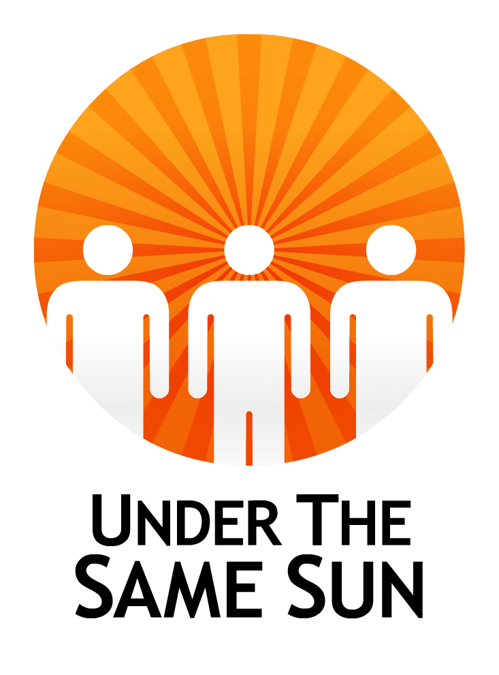

CONTACT
Peter Ash
Founder/CEO
Email: info@underthesamesun.com
Web: www.underthesamesun.com
Tel: +1(604)336-8868

TABLE OF CONTENTS
Questions to the government of South Africa…………………………… | Page 3
Situation in South Africa……………………………………………………. | Page 3
Article 2: Non-Discrimination………………………………………………. | Page 5
Article 6 & 25: Survival and Development; Sale, trafficking, and abduction……………………………………………………………………….. | Page 5
Article 17, 18, & 27: Parental responsibilities, protection from abuse and neglect, and growing up free from poverty…………………………. | Page 6
Article 24: Health and health services…………………………………….. | Page 6
Article 28 & 29: Education…………………………………………………… | Page 7
Recommendations to the government of South Africa………………… | Page 7

This report was prepared by Under the Same Sun (UTSS). It is based on UTSS’s own internal research, firsthand information and experience from partner organizations, credible media reports, as well information from the reports of the Independent Expert on the enjoyment of human rights by persons with albinism.
The report centers on the issues and challenges that surround children with albinism (CWA) in South Africa.
Questions for the Government of South Africa
- What intensified efforts has the government taken to protect children with albinism from violence and discrimination particularly in remote areas from violence?
- What measures has the government taken correct the names used for persons with albinism in national languages?
- What is the government doing to ensure that the public gets well educated about the condition of albinism?
- To what extent does the State budget cater for promoting the welfare of CWA regarding protection from harmful practices, provision of low-vision assistive devices, as well as skin cancer prevention?
- Can statistics of CWA be collected so that their actual number gets established?
Situation in South Africa
- The exact number of persons with albinism (PWA) in South Africa is unknown. However, prevalence of albinism among school children has been estimated to be about 1 in 2000 to 4000. This absence of significant data and statistics on PWA has been a major challenge.
- Existing myths and superstitions about albinism especially the belief that body parts of PWA possess magical powers place them in grave danger of violent acts including murder and mutilation of body parts. It has been noted that children are most vulnerable to such violence because of a belief that the innocence of the victim increases the potency of the body parts used to make witchcraft potions and amulets.
- The government of South Africa has made notable efforts to promote enjoyment of rights by children with albinism (CWA). These include: adoption of the 2013 Ekurhuleni Declaration on the Rights of Persons with Albinism. Among other things, the declaration calls for equality for PWA, children’s rights in education, and the correction of erroneous beliefs, myths and superstitions. It therefore, prompted dialogue and awareness in the country, for instance a round table on albinism hosted in 2018. It also promotes support of programmatic initiatives on albinism at the provincial level.
- The Government has added sunscreen lotions to its list of essential medicines, making the product available and free of charge to persons with albinism.
- The Government has also designated September as albinism awareness month, and also facilitates the national commemoration of International Albinism Awareness Day (IAAD) on June 13. These promote public education and awareness raising about albinism.
- South Africa has a number of legislation promoting rights of PWA. These include: The Constitution of 1996 prohibiting discrimination on the basis of disability and color; The Promotion of Equality and Prevention of Unfair Discrimination Act 2000 and the Employment Equality Act 1998 both aimed at promoting equality and eliminating discrimination; and the Criminal Procedure Act (1977), the Legal Aid Act (2014), and the Prevention and Combating of Trafficking in Persons Act (2013) promoting protection of PWA against ritual killings and trafficking.
While commending the efforts made by the Government of the Republic of South Africa, some challenges are also noted as follows:
COMPLIANCE WITH THE PROVISIONS OF THE CONVENTION ON THE RIGHTS OF THE CHILD
Article 2: Non-Discrimination
Names used by people in referring to PWA, for instance isishawa, meaning a curse, and inkawu, meaning monkey, highly contribute to them being discriminated and stigmatized. “If you are being referred to as a monkey, then your rights will not be easily protected since animals cannot have human rights. These names need to be eliminated as quickly as the word kaffir was for black South Africans”.
Discrimination also entails myths that body parts of PWA can be used in witchcraft-related rituals to generate wealth and fortune; daily taunting, stares and harassment. For children with albinism, this mostly challenges them when at school. Nombuso Cele, a young lady with albinism from Durban-South Africa testifies to this as she says:
“When I was in primary school, other kids stayed away from me because I was different from them and it affected my self-esteem. I was called different names and some would call me “white spooky”, and others would always tease me and call me ugly”.
Article 6 & 35: Survival and Development; Sale, Trafficking, and Abduction
Children with albinism are subjected to harmful practices because of beliefs that their body parts can bring wealth and fortune. The practices include violent attacks including abduction, murder, and mutilation of body parts.
For instance in January 28, 2018, a 14 year-old girl with albinism from Hlalanikahle Township, Witbank Mpumalanga was abducted and murdered. The assailants also took her 15-month old nephew, who did not have albinism but was allegedly mistaken for another child with albinism from the same household. The girl’s body was found 3 decapitated weeks later with her arms and private parts removed. In rural South Africa there is still a very strong suspicion, based on anecdotal reports, that babies with albinism are strangled at birth or left to die.
In June 28, 2016, a 12-year-old boy with albinism was abducted for ritual purposes in the little town of eManguzi in Northern KwaZulu-Natal, South Africa. A woman was arrested while attempting to sell the boy for R 100,000 (6548 USD), the boy was reunited with his family. Also, in June 21, 2016, a 4 year old boy with albinism was abducted and is still missing from Port Dunford in the north of the KwaZulu-Natal province.
Such reports are not many in South Africa compared to other African countries, but it has been noted that many go unreported and undocumented due to a culture of secrecy and vulnerability of the targeted people.
Article 17, 18 & 27: Parental Responsibilities, Protection from Abuse and Neglect, and Growing up Free from Poverty
Mothers of children with albinism are often blamed for their child’s condition, accused of infidelity with white people, carriers or spirits.Thus many children with albinism are raised without the support of one or both parents, creating financial difficulties and an inability to afford health care or education for their child. Sometimes this can lead to tragic consequences such as infanticide.
Article 24: Health and Health Services
Albinism is characterized by a skin pigmentation disorder which puts all PWA at great risk of developing skin cancer on sun-exposed skin. PWA in sub-Saharan Africa are at about a 1000-fold higher risk of developing skin cancer than the general population. This can be managed by taking precautions against sunlight exposure including: minimizing of outdoor activities during peak sunlight hours, the wearing of protective clothing to cover as much of the skin as possible, and the use of sunscreen for exposed skin. The lack of skin pigmentation also results into PWA being visually impaired.
Though South Africa has a national cancer strategy, there are still concerns about quality, consistency in availability and accessibility of sunscreen lotions – particularly in rural areas and where people have to travel distances to reach supply points. Moreover, dermatologists do not have enough training about albinism, and some have been biased against clients with albinism. There is also a lack of ophthalmologists and optometrists trained in low vision. These challenges have been reported to have been aggravated by the COVID-19 pandemic.
Article 28 & 29: Education
Reasonable accommodation measures in schools for children with albinism, including provision of assistive devices, sitting at the front of the class, permission to adjust uniforms and to wear wide-brimmed hats for sun protection, accommodation in outdoor activities, and extra time on tests and exams, often lack in mainstream schools. Social discrimination causes the children to be bullied in school while others in some families are considered to be entirely not worth educating.
Recommendations to the Government of South Africa
National Action Plan
- The government should not relent in every effort to ensure that a national action plan, mirroring the regional action plan, to end attacks and related human rights violations including discrimination in health and education, is put in place in South Africa.
- The national action plan should include, at least, the following measures
Public Awareness Raising:
- The Government should work on changing the discriminatory names used for persons with albinism
- The Government should embark on ongoing long-term nationwide public awareness raising campaigns to debunk false myths about albinism particularly in rural areas.
Education:
- Teachers and educators should be trained on reasonable accommodation of children with albinism.
- The government ensure reasonable accommodation in terms of health goods needed for students including sunscreen lotions, wide brimmed hats and magnifying lenses.
- Parents should be sensitized on the ability of children with albinism to do well in school just like those without albinism.
Data
- Information on albinism including surveys and situational analysis should be carried out to ensure their protection and access to goods and services.
Protection:
- Local authorities should actively protect children with albinism residing within their areas particularly in rural areas. Communities should be sensitized on raising alarm and immediately reporting attacks to the police. Security and anonymity of whistleblowers should be ensured.
Redress:
- Victims of actual and attempted mutilation of body parts and dependents of murdered victims should be provided with redress including full medical care for injuries sustained, psychiatric counseling, monetary compensation, and where necessary, reallocation to safer areas of residence – in consultation with the victim and their family members.
Healthcare:
- Adequate, accessible and affordable diagnostic, preventative and curative skin cancer treatment should be provided to all children with albinism.
- The Government should subsidize costs for accessing skin care and low vision health services for children with albinism, as well as remove barriers to access to dermatologists and optometrists.
- Nurses and midwives should be trained on albinism and provision of counseling to parents where babies with albinism are born. This will reduce chances of rejection and abandonment of mothers and the children.
Cooperation with Special Procedures:
- The Government should continue to cooperate with The United Nations Independent Expert on the Enjoyment of Rights of people with albinism by consulting and updating her on issues pertaining to human rights of persons with albinism.

Action on Albinism, “South Africa: Overall Situation”, https://actiononalbinism.org/page/x6mnst2lnvzmmmvg827c766r; Franklin, A., Lund, P., et al. “Children with albinism in African regions: their rights to ‘being’ and ‘doing’, BMC Int Health Hum Rights 18, 2 (2018). https://doi.org/10.1186/s12914-018-0144-8
Report of the Independent Expert on the enjoyment of human rights by persons with albinism on her mission to South Africa, A/HRC/43/42/Add.1, January 2020, at para 32 to 34.
The South African, “Why are Albinos Being Murdered in South Africa?”, https://www.thesouthafrican.com/news/albinos-murders-south-africa-why/ ; Maureen Mswela, "Violent Attacks against Persons with Albinism in South Africa: A Human Rights Perspective" (2017) 17:1 African Human Rights LJ 114, at 127.
Report of the Independent Expert on the enjoyment of human rights by persons with albinism: a preliminary survey on the root causes of attacks and discrimination against persons with albinism, A/71/255, July 2016, at para 40.
Report of the Independent Expert on the enjoyment of human rights by persons with albinism on her mission to South Africa, A/HRC/43/42/Add.1, January 2020, at para 25.
Ibid, at para 48.
Ibid, at para 27.
Ibid, at para 16 to 18.
Ibid, at para 43.
Ibid.
Ibid, at para 45.
Al-Jazeera, “Living with Albinism in South Africa” (2016), https://www.aljazeera.com/amp/features/2016/6/13/living-with-albinism-in-south-africa#aoh=16048429794244&referrer=https%3A%2F%2Fwww.google.com&_tf=From%20%251%24s
Under the Same Sun, “Reported Attacks”, https://underthesamesun.com/sites/default/files/Attacks%20of%20PWA%20-%20extended%20version_0.pdf.
Report of the Independent Expert on the enjoyment of human rights by persons with albinism on her mission to South Africa, A/HRC/43/42/Add.1, January 2020, at para 89.
Maureen Mswela, "Violent Attacks against Persons with Albinism in South Africa: A Human Rights Perspective" (2017) 17:1 African Human Rights LJ 114, at 116 and 117.
Franklin, A., Lund, P., et al. “Children with albinism in African regions: their rights to ‘being’ and ‘doing’, BMC Int Health Hum Rights 18, 2 (2018), at page 4. https://doi.org/10.1186/s12914-018-0144-8
Report of the Independent Expert on the enjoyment of human rights by persons with albinism on her mission to South Africa, A/HRC/43/42/Add.1, January 2020, at para 88.
P. T. Lekalakala et al, “Oculocutaneous Albinism and Squamous Cell Carcinoma of the Skin of the Head and Neck in Sub-Saharan Africa”, Journal of Skin Cancer, (July 2015), at page 1.
Ibid.
Ibid, at 3.
Zungu Z, Mashige KP. Utilisation of eye and skin care, and social services among persons with albinism in Ulundi, KwaZulu-Natal, South Africa. Afr Vision Eye Health. 2019; 78 (1), a484, https://doi.org/10.4102/aveh.v78i1.484.
Report of the Independent Expert on the enjoyment of human rights by persons with albinism on her mission to South Africa, A/HRC/43/42/Add.1, January 2020, at para 48.
Ibid, at 49.
Amnesty International, “Southern Africa: Persons with albinism especially vulnerable in the face of COVID-19”, https://www.amnesty.org/en/latest/news/2020/06/southern-africa-persons-with-albinism-especially-vulnerable-in-the-face-of-covid19
Report of the Independent Expert on the enjoyment of human rights by persons with albinism on her mission to South Africa, A/HRC/43/42/Add.1, January 2020, at para 54.
Ibid, at para 57; Franklin, A., Lund, P., Bradbury-Jones, C. et al. Children with albinism in African regions: their rights to ‘being’ and ‘doing’. BMC Int Health Hum Rights 18, 2 (2018), at page 6. https://doi.org/10.1186/s12914-018-0144-8

