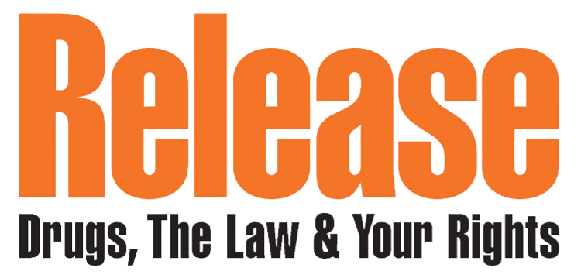
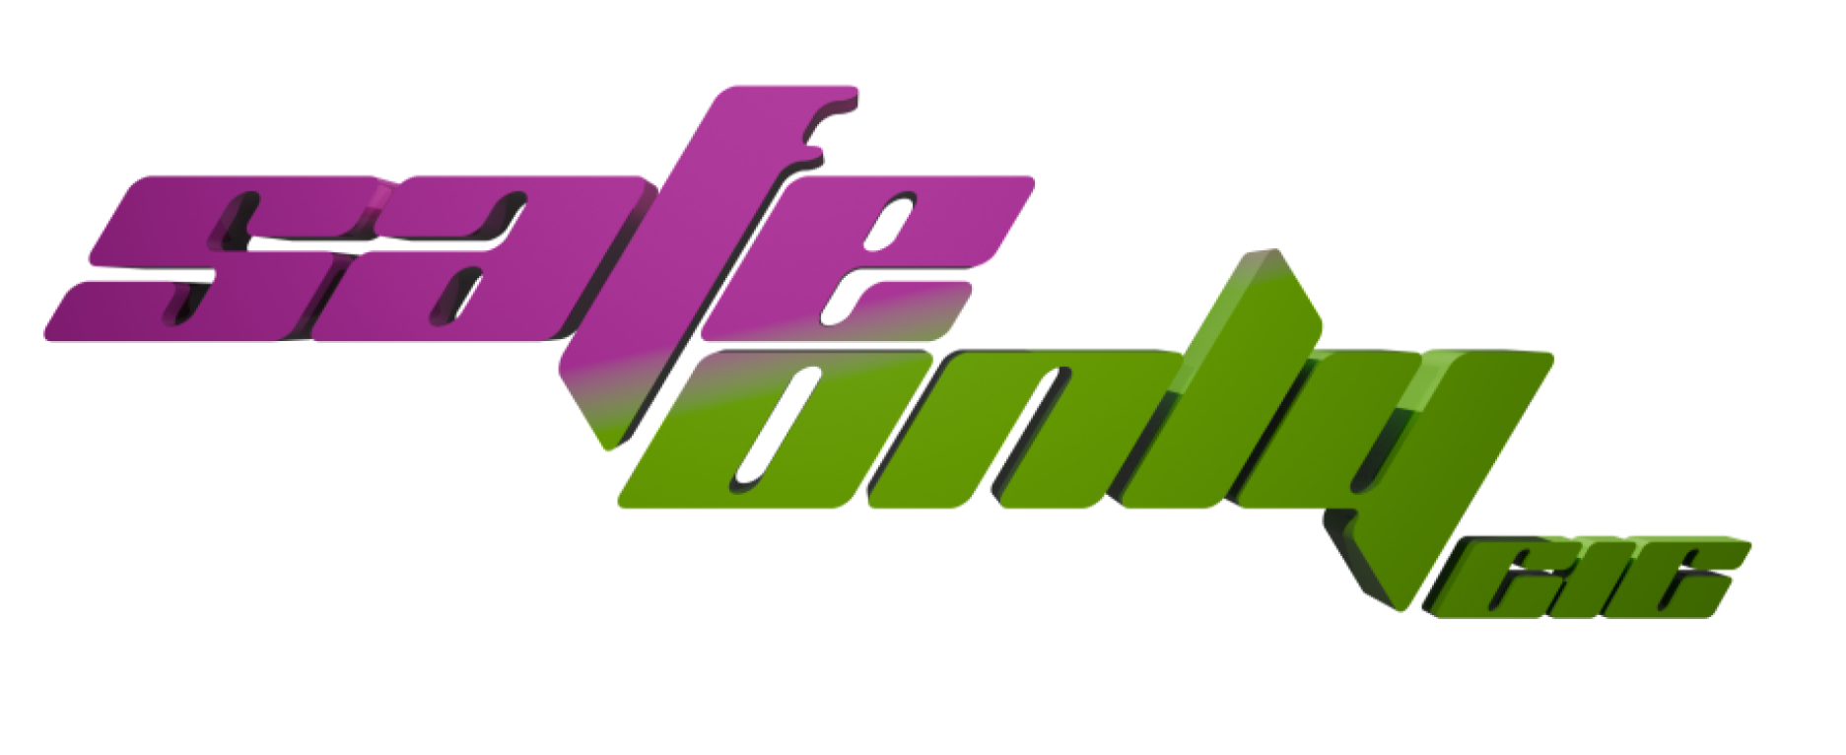
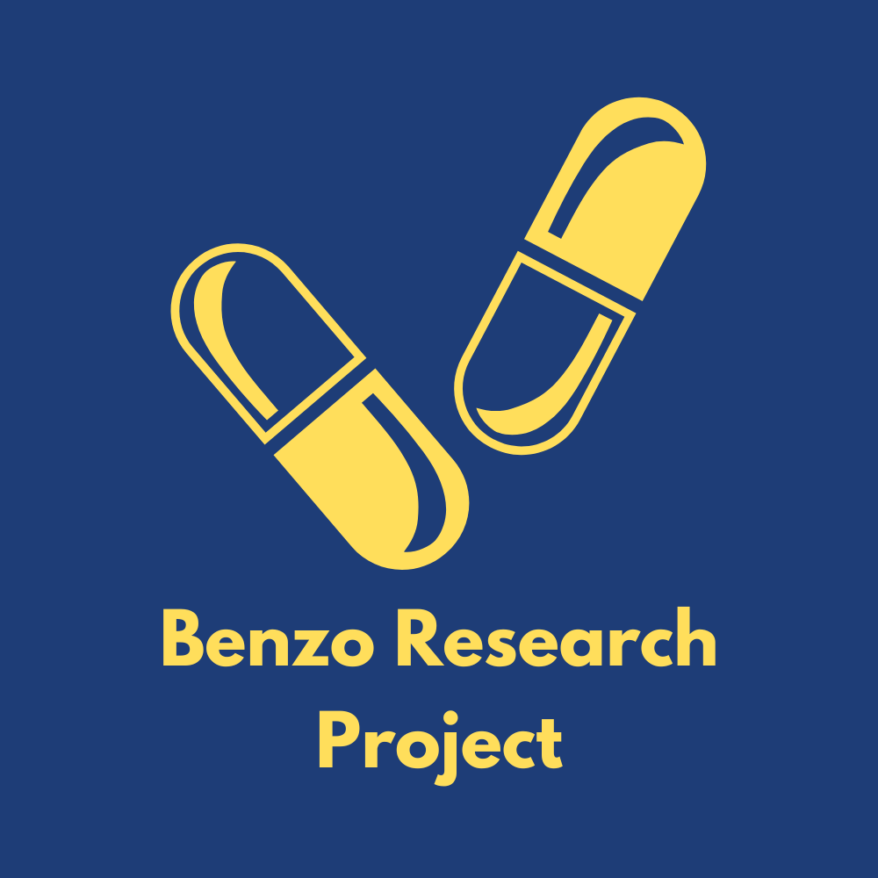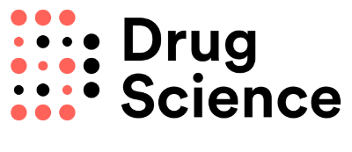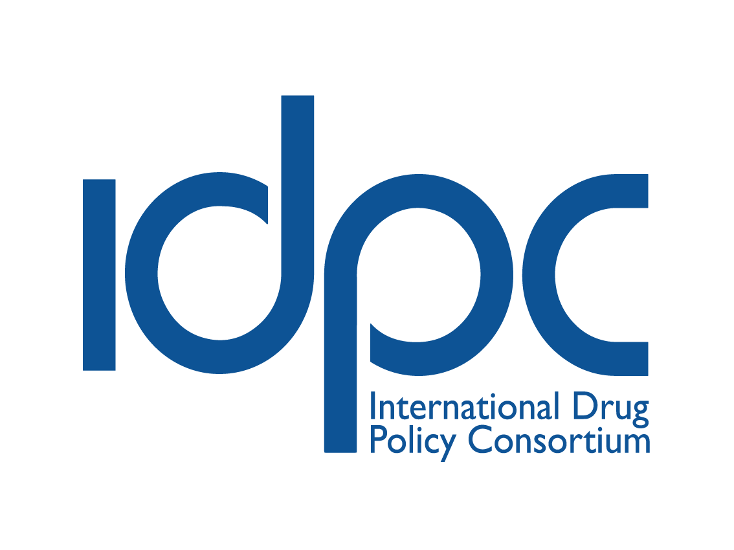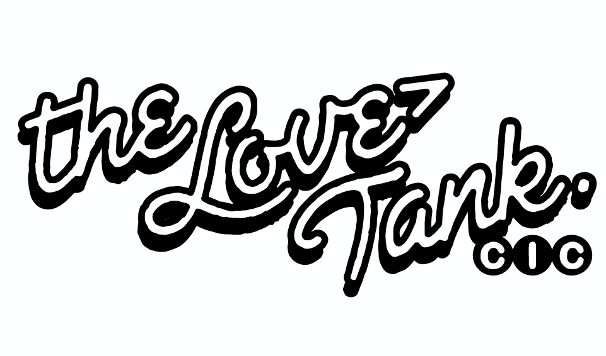
Joint submission to the United Nations Committee on Economic, Social and Cultural Rights (CESCR)
77th session — Review of the United Kingdom of Great Britain and Northern Ireland (UK)’s compliance with the International Covenant on Economic, Social and Cultural Rights.

Submitting Organisations and Contacts:
RATS — ‘radical acts to survive’, is a drug user union resisting the violence and neglect of the ‘war on drugs’ and organising for harm reduction and collective liberation. Contact: londonharmreduxrats@gmail.com
Drug Science works to provide evidence base free from political or commercial influence, creating the foundation for sensible and effective drug laws, and equipping the public, media and policy makers with the knowledge and resources to enact positive change. Contact: info@drugscience.org.uk
The Benzo Research Project is a young people-led non-profit which seeks to understand and improve the lives of young people who use benzodiazepines non-medically across the UK through research, policy advocacy, and advancing harm reduction education and support provision. Contact: hello@brp.org.uk
The International Drug Policy Consortium is a global network of NGOs that come together to promote drug policies grounded in social justice and human rights. Contact: contact@idpc.net
The Love Tank CIC is a London based non-profit community organisation that seeks to promote the health and well-being of under-served communities. Contact: hello@thelovetank.info
Release is the UK’s centre of expertise on drugs and drug laws, providing free and confidential legal and drug services to people who use drugs and/or those caught up in the criminal justice system. The organisation campaigns for evidence-based drugs policies and for reform of the UK’s current drug policy, with a specific call for the end of criminal sanctions for possession offences— Contact: ask@release.org.uk
Safe Only CIC is a peer-led, LGBTQI+ non-profit which works with the queer community in nightlife and cultural settings, providing SIA security, and in-situ and supplementary harm reduction support.

Individual contributors:
Dr Gillian W Shorter, Queen’s University Belfast
Prof Magdalena Harris, London School of Hygiene & Tropical Medicine
Dr Giulia F Zampini, University of Greenwich

Introduction

The submitting organisations are grateful to provide this report to inform the 7th review of the United Kingdom of Great Britain and Northern Ireland (UK) by the UN Committee on Economic, Social and Cultural Rights (CESCR), assessing compliance with the International Covenant on Economic, Social and Cultural Rights.

This submission concerns the worsening public health emergency reflected in soaring drug-related deaths in the UK, and the lack of an appropriate response by the UK authorities in line with their obligations under Article 12 of the International Covenant on Economic, Social, and Cultural Rights. The UK has consistently recorded the highest number of drug-related deaths in Europe for several years. If it were still part of the European Union, it would currently account for approximately 40% of all drug-related deaths within the bloc. Despite this, government responses have remained focused on punitive measures that harm people who use drugs, with limited funding, support, or outright prohibition of essential harm reduction services.

This submission focuses on the need for the UK authorities to remove the existing legal barriers for the opening of safer consumption sites, an essential harm reduction intervention to prevent drug-related deaths, reduce disease transmission through riskier drug use practices, and connect people in situations of marginalisation with systems of care and support.

Radical Acts To Survive (RATS), the drug user union that leads this submission, advocates for the opening of the first safer consumption site in London — including as part of the London Harm Reduction Collective (LHRC), a coalition of civil society and grassroots groups. While the UK experiences one of the highest rates of drug-related deaths in Europe and the world, and the highest number of deaths in the region, there are no safer consumption sites operating in England, Wales or Northern Ireland, partly due to the legal risks associated with setting them up. Following years of advocacy, the first sanctioned facility in Scotland will open in January 2025 but the UK government has no plans to roll them out more widely. This is in spite of clear and compelling scientific evidence for the effectiveness of safer consumption sites in preventing drug-related deaths and reaching out to highly marginalised communities, and clear support by international experts and authorities such as the UN Special Rapporteur on the Right to Health, and the EU Drugs Agency (EUDA).
- This submission is complementary to the joint contribution led by Release, which also addresses the drug deaths emergency in the UK, the importance of supplementary harm reduction funding, and the centrality of legal reform to address harmful punitive policies and their disproportionate impacts on marginalised groups.

The scale of a rapidly deteriorating public health emergency
- The United Kingdom is experiencing a worsening public health emergency reflected in soaring drug-related deaths. This crisis has reached unprecedented levels, with 2023 totalling the highest number of ‘drug poisoning’ deaths registered yearly since records began in 1993: 6,947 lives lost across the United Kingdom (5,448 in England and Wales, 1,330 in Scotland, and 169 in Northern Ireland).

Most drug deaths involve people at risk of criminalisation
- A subset of these fatalities are categorised as ‘drug misuse deaths’ due to the involvement of controlled substances. Despite country-level methodological differences in the production of these statistics, which makes direct comparisons challenging, preliminary numbers paint a bleak picture, with 3,618 deaths in England and Wales, 1,172 in Scotland, and 135 in Northern Ireland. As such, ‘drug misuse’ death registrations in the United Kingdom exceeded 4,925 in 2023, and accounted for at least 70% of all drug poisoning deaths.

However, figures on ‘drug misuse’ deaths are acknowledged to be an underestimate, as the statistics for England and Wales, and Northern Ireland, are developed on the basis of death certificates, which often lack information about the substance/s involved. For England and Wales, this lack of information concerned almost one in every four drug poisoning deaths in 2023, and that proportion is on the rise, undermining adequate and evidence-based responses to a rapidly deteriorating situation.
- In cases where information about the substances involved is available, the most commonly mentioned ones are opioids (primarily heroin and methadone), benzodiazepines, and cocaine. Cocaine-related deaths have risen sharply, with a nationwide increase of 30% from 2022 to 2023, and a cumulative tenfold increase over the past decade. There is an urgent need to scale up service provision, access, and funding; increase investments in outreach; and improve drug services’ training.
The surge of synthetic opioids in street drug markets should be cause for alarm and urgency

The rise of nitazenes in criminalised drug markets is also deeply concerning. These highly potent synthetic opioids have been found in the street supply of opioids and benzodiazepines, and were linked to at least 75 drug-related deaths registered nationwide in 2023. However, due to significant delays in death registrations, the number of deaths in 2023 is likely much higher. In England and Wales, for instance, 64% of deaths registered in 2023 actually occurred in 2022.

The scale of nitazene-related fatalities is further obscured by the lack of toxicological data in some UK death registrations and limited testing for newer psychoactive substances. Even with these challenges, government analysis show deaths involving nitazenes are sharply on the rise in Britain. Similar increases have been identified elsewhere in Europe and Oceania, for instance.

While nitazenes currently represent a small share of the unregulated drug market and associated deaths in Britain, their rapid spread echoes the transformation of street opioid markets in North America. Indeed, in some areas of the continent, synthetic opioids, like fentanyl, have almost entirely displaced other opioids, such as heroin. This has contributed to a shocking increase in drug overdose deaths, with over 100,000 reported in 2023 in the US alone. The urgency to act is compounded by ongoing global disruptions in the heroin supply and associated adulteration, fuelled by plummeting production following Afghanistan's opium ban.

In 2023, the age-standardised mortality rate for 'drug misuse' deaths in England and Wales was 61.8 deaths per million people. This rate is nearly four times higher than when records began in 1993 and has more than doubled since 2012. In Northern Ireland, ‘drug misuse’ death rates stand at around 89 deaths per million people, experiencing a slight de-acceleration since 2020 (the highest rate recorded, at 98.8 deaths per million), but remain intolerably high. Scotland experiences a highly disproportionate burden of drug-related mortality, with age-standardised mortality rates for ‘drug misuse’ standing at 224 per million in 2023 — almost quadrupling since 2000.
UK drug deaths far outpace Europe and are now comparable to North America’s catastrophe

Both in absolute and relative terms, the situation of drug-related mortality in the UK is out of control. Comparisons with other regions, including those experiencing high drug-related mortality rates, are striking.

The European Union, for instance, reports an estimated 6,392 ‘drug-induced’ deaths across the regional bloc for 2022, with an overdose death rate of 22.5 deaths per million. Notwithstanding comparability challenges, including the United Kingdom’s withdrawal from the European Union and its impact on data and reporting harmonisation, the disparity is striking. Were the United Kingdom still a member of the European Union, it would account for 15% of its population yet around 40% of the region’s drug-related deaths, exceeding the bloc’s average death rate by nearly threefold.

In parts of the UK, drug death rates are comparable to those in North America, where a catastrophic drug-related mortality crisis that has claimed hundreds of thousands of lives since intensifying in the 2010s.

A deeply unequal crisis

Within the UK, the drug deaths crisis is characterised by stark disparities between territories and populations, alongside lines of class, gender, and race. While greater data disaggregation is needed to shed light on these dynamics, proxy measures make them apparent.

There is a clear link between economic deprivation and drug-related fatalities, for instance. Lower-income regions like Scotland, Wales, and Northern Ireland have higher death rates than higher-income England. This dynamic is also replicated within each UK nation. In England, the poorest North East region has the highest rates of ‘drug misuse’ deaths, recording 108.5 deaths per million in 2023 — more than doubling the most economically advantaged region, London, at 41.0 per million. In Scotland – which faces some of the highest drug death rates in the world – people in the most deprived areas are over fifteen times more likely to die from ‘drug misuse’ compared to people in the least deprived areas. Northern Ireland has some of the highest drug-related deaths amongst younger adults aged 18–34 in Europe.

Deindustrialisation and austerity policies have contributed to the systemic neglect of marginalised groups from drug services, undermining the UK’s core obligations in relation to the right to health and fuelling drug-related mortality. Funding from the Department of Health and Social Care (DHSC) for adult substance use treatment to local authorities, for instance, fell by 40% between 2014–22. Additionally, 42 unitary authorities in England saw a funding drop of 50% or more during this period.

Drug-related harms are also deeply gendered. While most ‘drug misuse’ deaths occur among men — broadly reflecting higher prevalence of drug use — across the UK, drug-related fatalities are increasing at a faster pace for women than for men. Beyond changing drug use patterns and co-morbidities among women, governmental authorities have pointed out how socio-structural factors, such as patriarchal gender roles and their impact on traumatic state practices — particularly child removals, must be carefully considered. Likewise, while data on drug-related harms and mortality among LGBTQ+ people are sparse, a combination of factors — including higher prevalence rates, minority stress and the related reduced likelihood of engaging with drug services — push this population into higher risk of drug-related harm.

Racialised communities face specific challenges, experiencing higher rates of drug dependence and exposure to drug enforcement due to systemic racism in healthcare and the justice system. Punitive drug laws disproportionately target racialised individuals, particularly Black people, amplifying their vulnerability to state violence and neglect. Black people are subjected to disproportionately high rates of drug-related stop-and-search, arrests, prosecution and imprisonment, with tremendously negative impacts, as referenced by the submission made to the Committee by Release.

This systemic discrimination has ramifications in welfare, healthcare, education and other systems of social protection. They are exemplified by the case of the strip-search of Child Q — a Black 15 year old girl strip-searched on her period, without the presence of her guardian, on the false premise that she was carrying cannabis. The punishment-first approach of the ‘war on drugs’ denies Black people, and other ethnic minorities, the very presumption of innocence, perpetuating harm even for people who do not have any relationship with drugs.

While drug-related mortality rates are lower among Black and other racialised communities in the UK compared to white populations, rising drug dependence rates among Black people, coupled with systemic barriers to accessing relevant health and harm reduction services, highlight the urgent need for intervention.

To address these disparities, harm reduction interventions must be inclusive, accessible, and culturally responsive. Harm reduction initiatives, such as safer consumption sites, particularly mobile and community-led models, can function as adaptable, low-threshold, proximity interventions offering pathways to health services while fostering connection and community empowerment. These spaces can address the alienation and despair that underpin drug-related harm, offering proactive solutions to systemic neglect.

Despite recent positive developments, such as pilot drug-checking programmes, the partial restitution of drug service budgets slashed by austerity policies in the 2010s, and expanded naloxone access, the UK’s response remains woefully insufficient, as demonstrated by soaring drug-related mortalities.

We recommend that the CESCR urges the UK government to move away from punitive models and invest in non-coercive, inclusive systems of care that address the diverse needs of people who use drugs, and particularly those experiencing multiple forms of marginalisation.

A radical reimagining of drug policy, grounded in harm reduction and community empowerment — as was recently recommended by the UN Special Rapporteur on the right to health, is essential to prevent further loss of life and build a society where all people can enjoy the highest attainable standard of health.

Scientific evidence for the effectiveness of safer consumption sites

To respond to this crisis, RATS, the drug user union that leads on this submission, has been advocating for the opening of a safer consumption site in London in partnership with the fifteen grassroots and civil society organisations that integrate the London Harm Reduction Collective. Despite the soaring rate of drug-related deaths across the entire United Kingdom, the government has authorised the opening of only one safer consumption site, in the city of Glasgow (Scotland), which took place in January 2025. There have been no announcements regarding the authorisation of additional sites, which places the lives of drug users in other regions of the country at risk.

As defined by the European Union Drug Agency, safer consumption sites (also known as overdose prevention centres, safer use sites, or drug consumption rooms) are healthcare facilities that provide a safer space for people to use pre-obtained drugs under the supervision of trained staff.

Legally-sanctioned safer consumption sites have been operating since the 1980s. More than one hundred legal sites are now in operation, distributed in at least 19 countries including Australia, Belgium, Canada, Colombia, Denmark, France, Germany, Greece, Ireland, Luxembourg, the Netherlands, Norway, Portugal, Scotland (in the UK), Spain, Switzerland, and the United States.

In many cases, the establishment of state-sanctioned safer consumption sites has been preceded by their informal operation by the community and peers in acts of collective care and civil disobedience. Many such sites continue in operation, either formalised in legislation, as is the possibility in Canada, or inhabiting legally grey areas and outright prohibition, as is the case with facilities in Mexico and the United States.

These experiences have resulted in significant and compelling scientific evidence on the positive impacts of safer consumption sites. Researchers have found that safer consumption sites can reduce and reverse overdoses, reduce injecting risk behaviours, and increase the uptake of drug treatment and health and welfare services. They have also invariably concluded that safer consumption sites are particularly impactful for people experiencing situations of marginalisation and vulnerability.

In summary, this means that safer consumption sites are an appropriate and necessary response to the ongoing drug-related death emergency in the UK, as they primarily address the risks of drug-related deaths amongst populations most at risk.

A proof-of-concept, unsanctioned service which operated in Glasgow in 2020–21 successfully intervened in nine overdoses, and successfully supervised 894 injecting events providing support and safety to its clients.

A 2021 review of 22 studies found that safer consumption sites are linked to ‘significant reductions in opioid overdose morbidity and mortality, significant improvements in injection behaviors and harm reduction, as well as access to drug treatment programs’.

A 2023 evidence review of 570 publications on safer consumption sites found a high willingness amongst people who use drugs to make use of safer consumption sites, particularly amongst people in vulnerable situations and at highest risk of experiencing drug use harms. They summarised evidence that such sites help manage and reverse overdoses, lead to safer use practices, and facilitate access to wider healthcare and social services.

A 2024 review of 391 publications found that safer consumption sites ‘enable people who live with structural violence and vulnerability to develop feelings of safety and trust that help them stay alive and to build longer term trajectories of social inclusion’.

Support for safer consumption sites amongst relevant international expert bodies

In addition to the available evidence, international health and human rights bodies have also shown support for safe consumption sites as harm reduction interventions engaging highly marginalised people who use drugs, enhancing safer drug use practices and reducing drug-related deaths. As such, this is an intervention that is especially suited for the ongoing emergency in the UK.

In 2016, UNAIDS noted that safer consumption sites ‘may deliver important benefits to the most marginalised and severely dependent people who inject drugs’ and recommended that Member States ‘explore’ their use.

In 2018, the EU Drugs Agency (EUDA) recognised safer injection sites as interventions that aim to reduce the acute risks of disease transmission through unhygienic injecting, prevent overdose deaths and connect high-risk drug users with services. The Agency has later noted that ‘the existing evidence is suggestive of a beneficial effect for drug consumption rooms on a number of outcomes’, including improving access to healthcare and harm reduction services for hard-to-reach target populations, reducing drug-related deaths, and reducing injecting risk behaviours.

In her 2024 report on drug use, harm reduction and the right to health, the UN Special Rapporteur on the right to health included safer consumption sites within the list of practical harm reduction measures that Member States may adopt to protect the right to health of people who use drugs, and recommended law enforcement bodies do not target them.

Support for peer-led interventions amongst international authorities

International human rights and health authorities have also recommended that States support and invest in harm reduction services that are peer or community led — organised by people who use drugs themselves — as a measure to ensure that services are acceptable and respond to the needs of people who use drugs.

The 2016 United Nations Political Declaration on Ending AIDS recognises the important leadership roles played by community organisations and commits Member States to ensure that at least 30% of all service delivery is community-led by 2030.

The UNAIDS Global AIDS Strategy 2021–26 sets a 2025 target that 80% of HIV prevention programmes, including harm reduction services, for key populations should be delivered by community-led organisations. Such programmes were cited as ‘among the most effective’.

In 2023, the UN High Commissioner for Human Rights, Volker Turk, recommended that Member States ‘incorporate and fund harm reduction services, and support community-led advocacy and harm reduction services’.

In 2024, the UN Special Rapporteur on the right to health, Dr. Tlaleng Mofokeng, recommended that States ‘ensure that peer-led initiatives remain at the forefront, with political and policy support and stable and sufficient resourcing and funding’.

Scientific evidence points in the same direction. A 2021 rapid evidence review on the impact of involving people who use drugs in harm reduction services found that these led to a reduction in HIV prevalence, an increase in the quality, acceptability, and access to drug services, and reduced stigma and discrimination. A review of 46 papers concerning the role of peer support in overdose prevention services found that ‘peers play a pivotal role in overdose prevention interventions for people who use controlled drugs and are essential to the acceptability and feasibility of such services’.

Legal liabilities for the operation of safer consumption sites and other harm reduction measures in the UK

Health-related harms for people who use drugs in the UK are exacerbated by existing drug policies. These policies often keep individuals from approaching existing services due to fear of criminalisation, and create legal liabilities which make the operation of various harm reduction services unviable or incredibly administratively difficult, for instance, in the case of drug checking, which is explained below.

Operating a safer consumption site under current UK law could subject staff and service users to criminalisation, yet many liabilities can be managed without substantive legislative change, as is the case already with existing needle and syringe programmes around the country.

In Scotland, a safer consumption site has opened as of the 10th of January 2025, after the Scottish Lord Advocate provided protections from prosecution for drug possession, stating that it ‘would not be in the public interest to prosecute users of that facility.’ The greatest legal liability faced by people within safer consumption sites is that the possession of controlled drugs is criminalised. Whilst this would and should be best resolved through the decriminalisation of possession for personal use, as recommended by the UN system, it could also be addressed through arrangements with local level police or prosecution authorities.

As noted in the CESCR submission authored by our partners at Release, despite significant evidence that safer consumption sites can reduce health harms and save lives, the current and previous UK governments’ have continuously refused to allow the establishment of these facilities, citing that they are unlawful.

Safer consumption sites are not the only harm reduction measures which are restricted by the UK’s drug laws at present. Drug checking services in the UK must obtain a licence that authorises the possession of such substances in order to avoid violating the Misuse of Drugs Act 1971. The cost of such a licence is £3,133, which presents a substantial barrier to entry and can result in lengthy waiting periods for approval.
- UK drug laws also prevent the provision of safer smoking equipment, such as pipes, for stimulant use under Section 9A of the Misuse of Drugs Act 1971. This limits harm reduction efforts, especially for marginalised groups like women, sex workers, and racialised drug users, who are already underserved by drugs services. Without legal access to safer inhalation equipment, these individuals face increased risks, including respiratory health issues and fatal overdose.

For existing UK harm reduction services such as needle exchange programmes, the legal liabilities for staff and service users are addressed through existing guidance from the Crown Prosecution Service (CPS). The CPS has stated that it is generally not in the public interest to prosecute individuals for: retaining used needles, possessing sterile needles, and operating bona fide needle exchange schemes. The need to prevent the spread of serious infections is considered to outweigh the typical prosecutorial requirements.

The CPS could remove the current risk of criminalising supervised consumption sites by providing similar advice as that provided in relation to needle and syringe programmes. There are several other potential offences which can be completely avoided through appropriate standard operating procedures of a safe consumption site.

Conclusion & recommendations

In conclusion, the UK’s escalating drug-related death crisis demands urgent and comprehensive action. The disproportionate impact of drug-related deaths on marginalised communities, coupled with the ineffectiveness of current punitive approaches, underscores the urgent need for drug policy reform.

International evidence clearly demonstrates that harm reduction strategies, including safer consumption sites and peer-led initiatives, are essential tools in addressing this public health emergency and saving lives. The UK government must prioritise the expansion of these services and ensure that they are accessible to all individuals, regardless of their socio-economic background, gender, or race.

Furthermore, the legal framework must be reformed to remove barriers to the implementation of these life-saving measures, with a particular focus on decriminalisation and the elimination of legal liabilities that deter service provision.

The UK’s response to this crisis should be rooted in the fundamental human rights of people who use drugs, ensuring their access to health services, safety, and dignity.

The United Nations Committee on Economic, Social, and Cultural Rights has a critical role to play in holding the UK accountable and ensuring that the country’s drug policies align with its international obligations to protect and promote the right to health for all its citizens.

In particular, we recommend that the Committee considers including the following recommendations in its concluding report to the UK government:

Establish and support the development of safer consumption sites, a harm reduction measure to address soaring rates of drug-related mortality and connect people at risk with systems of care and support, following the example of peer countries..

Prioritise and adequately fund community-led initiatives that facilitate the empowerment of people who use drugs to make autonomous decisions on their health and wellbeing, ensuring the involvement of people with lived and living experience in the design and delivery and continued evolution of these initiatives.

Additionally, we recommend the following:

Adopt a broad range of comprehensive high-quality harm reduction programmes (including safer consumption sites as well as drug checking services, heroin-assisted treatment, the distribution of safer use equipment, etc.), dedicating adequate funding to ensure their acceptability and availability..

Review nationwide and country-level legal frameworks to decriminalise drug possession for personal use — and related ancillary activities (ex., possession of safer drug use equipment, including safer inhalation kits) — to ensure that people who use drugs are not subject to punitive measures that impede effective access to healthcare, social services and all systems of care and support that facilitate the right to health.

Improve data collection, disaggregation and reporting on drug-related matters — including by addressing the current gaps and delays in identifying and publishing data on drug-related deaths — ensuring privacy and the participation of affected communities, to inform policies and programmes that serve those most at risk of drug-related mortality, including people living in poverty and homeless, racialised communities, women, young people, LGBTQ+ people, disabled people, sex workers, and migrants.

Notes and references:

European Union Drugs Agency, ‘European Drug Report 2024: Trends and Developments’. (2024) https://www.euda.europa.eu/publications/european-drug-report/2024_en
London Harm Reduction Collective, 'About'. (2024) https://www.londonhrc.org.uk/about [Accessed 7 January 2025]
33 reviews are summarised in this rapid evidence review - Gillian W Shorter et al.l, ‘Overdose prevention centres, safe consumption sites, and drug consumption rooms: A rapid evidence review.’ Drug Science. (2023) https://www.drugscience.org.uk/overdose-prevention-centres-safe-consumption-sites-and-drug-consumption-rooms-a-rapid-evidence-re
Office for National Statistics, ‘Deaths Related to Drug Poisoning in England and Wales: 2023 Registrations’ (2024) https://www.ons.gov.uk/peoplepopulationandcommunity/birthsdeathsandmarriages/deaths/bulletins/deathsrelatedtodrugpoisoninginenglandandwales/2023registrations
National Records of Scotland, ‘Drug-Related Deaths 2023: Extra Tables’ (2024) https://www.nrscotland.gov.uk/media/srfn1zaz/drug-related-deaths-23-extra-tables.xlsx
Northern Ireland Statistics and Research Agency, ‘Registrar General Annual Report 2023: Cause of Death’ (2024) https://www.nisra.gov.uk/publications/registrar-general-annual-report-2023-cause-death
Office for National Statistics, ‘Deaths Related to Drug Poisoning in England and Wales: 2023 Registrations’
National Records of Scotland, ‘Drug-Related Deaths in Scotland in 2023’ (2024) https://www.nrscotland.gov.uk/publications/drug-related-deaths-in-scotland-in-2023
The full bulletin of drug-related deaths statistics for 2023 is expected to be published in late January 2025. Preliminary figures are available at: https://www.nisra.gov.uk/publications/registrar-general-annual-report-2023-cause-death
Office for National Statistics, ‘Deaths Related to Drug Poisoning in England and Wales: 2023 Registrations’
Ibid.
ONS, NRS, and NISRA.
Edinburgh Alcohol and Drugs Partnership and Change Grow Live, ‘Cocaine and Crack Cocaine Conference and Draft Action Plan’ (2024) https://www.edinburghadp.co.uk/wp-content/uploads/2024/07/Cocaine-and-crack-cocaine-conference-and-draft-action-plan.pdf
Benzo Research Project, ‘Using the Freedom of Information Act to investigate local drug education and support in England and Wales’, unpublished manuscript delivered at the event ‘Local and national approaches to young people’s drug use’ (Imperial College London, 12 June 2024). https://www.youtube.com/watch?v=6HVdCEu05vw
Welsh Emerging Drugs and Identification of Novel Substances (WEDINOS), ‘Philtre April 2023 – March 2024’ (2024). https://www.wedinos.org/resources/downloads/WEDINOS_Annual_Report_2023_2024_English.pdf
Adam Holland et al.,. ‘Nitazenes—heralding a second wave for the UK drug-related death crisis?’. The Lancet Public Health, 9:2 (2024), E71–E72. doi:10.1016/S2468-2667(24)00001-X
UK Government, 'Deaths Linked to Potent Synthetic Opioids', Research and Analysis, (2024) https://www.gov.uk/government/publications/deaths-linked-to-potent-synthetic-opioids/deaths-linked-to-potent-synthetic-opioids.
Isabelle Giraudon et al., ‘Nitazenes represent a growing threat to public health in Europe’. The Lancet Public Health, 9:4 (2024), E216. doi:10.1016/S2468-2667(24)00024-0
Monica Richards (Benzo Research Project), statement delivered orally at the UN Commission on Narcotic Drugs, 4th meeting of CND Thematic Discussions, Health and regulatory challenges posed by synthetic opioids and non-medical use of prescription drugs, 2023, available at: https://cndblog.org/2023/12/cnd-thematic-session-session-9-adverse-health-consequences-associated-with-new-psychoactive-substances/
Joseph Friedman, Daniel Ciccarone, 'The Public Health Risks of Counterfeit Pills', The Lancet Public Health, 10:1 (2025),E58–E62. doi: 10.1016/S2468-2667(24)00273-1
Ashley Larnder et al., ‘Variability in the unregulated opioid market in the context of extreme rates of overdose’. Drug and Alcohol Dependence, 235:109427 (2022). doi:10.1016/j.drugalcdep.2022.109427
Beau Kilmer et al., ‘Rapid changes in illegally manufactured fentanyl products and prices in the United States’, Addiction, 117:10, 2745–2749 (2022). doi:10.1111/add.15942
CDC National Center for Health Statistics. ‘Drug Overdose Deaths in the United States, 2003–2023’. NCHS Data Brief No. 522 (2024). https://www.cdc.gov/nchs/products/databriefs/db522.htm
United Nations Office on Drugs and Crime (UNODC), ‘World Drug Report 2024’. (2024) https://www.unodc.org/unodc/en/data-and-analysis/world-drug-report-2024.html
National Records of Scotland (NRS), ‘Drug-Related Deaths in Scotland in 2023’. (2024) https://www.nrscotland.gov.uk/publications/drug-related-deaths-in-scotland-in-2023/
European Union Drugs Agency, ‘European Drug Report 2024: Trends and Developments’. (2024) https://www.euda.europa.eu/publications/european-drug-report/2024_en
The Lancet E, 'Public Health Approaches to Drug Policy: A Global Perspective', The Lancet Public Health, 7:3 (2022), E195. doi:10.1016/S2468-2667(22)00043-3
National Records of Scotland (NRS), ‘Drug-Related Deaths in Scotland in 2023’. (2024) https://www.nrscotland.gov.uk/publications/drug-related-deaths-in-scotland-in-2023/
Anne Campbell et al., ‘Drug Overdoses and Drug-Related Deaths: A Synthesis of NISRA, ED Admissions and Ambulance Service Data’. (2023) https://pure.ulster.ac.uk/ws/portalfiles/portal/128449366/8370_NIada_Drug_Overdoses_and_Drug_Related_Deaths_in_NI.pdf
Jane Parkinson et al., ‘Drug-related deaths in Scotland 1979–2013: evidence of a vulnerable cohort of young men living in deprived areas’. BMC Public Health, 18:357 (2018) doi:10.1186/s12889-018-5267-2
Rocco Friebel, Katelyn Jison Yoo, Laia Maynou, ‘Opioid abuse and austerity: evidence on health service use and mortality in England’. Social Science & Medicine, 298:114511 (2022). doi:10.1016/j.socscimed.2021.114511
Committee on Economic, Social and Cultural Rights, General Comment No. 14, UN Doc. E/C.12/2000/4 (2000)
National Audit Office, ‘Reducing the Harm from Illegal Drugs’. HC 1864 (2023), pp. 17.
Ibid., pp. 17.
See, for ex., Scottish Government, ‘Why are drug-related deaths among women increasing in Scotland?’ (2018) https://www.gov.scot/binaries/content/documents/govscot/publications/research-and-analysis/2018/06/drug-related-deaths-women-increasing-scotland-9781787810129/documents/00537548-pdf/00537548-pdf/govscot%3Adocument/00537548.pdf
Chaka L. Bachmann, Becca Gooch , ‘LGBT Health in Britain — Health Report’. Stonewall, (2018) https://www.stonewall.org.uk/resources/lgbt-britain-health-2018
Pinto et al. 'Non-Opiate and Cannabis Drug Use in Minority Ethnic Groups'. National Centre for Social Research, (2024). https://natcen.ac.uk/publications/non-opiate-and-cannabis-drug-use-minority-ethnic-groups
Shiner et al., ‘The Colour of Injustice: 'Race', Drugs and Law Enforcement in England and Wales’. Release, (2018). https://www.release.org.uk/publications/ColourOfInjustice
Andrew Williams, Brian Webb, and Richard Gale, ‘Racism and the Uneven Geography of Welfare Sanctioning in England’, Transactions of the Institute of British Geographers, 49.1 (2024) https://doi.org/10.1111/tran.12677.
Gareth Iacobucci, ‘Most Black People in UK Face Discrimination from Healthcare Staff, Survey Finds’, BMJ, 378 (2022), o2337 https://doi.org/10.1136/bmj.o2337
Northern Police Monitoring Project, No More Exclusions, National Survivor User Network, INQUEST, Kids of Colour, Art Against Knives, JENGbA, and Maslaha, Holding Our Own: A Guide to Non-Policing Solutions to Serious Youth Violence (London: Liberty, 2023) https://www.libertyhumanrights.org.uk/wp-content/uploads/2023/04/HoldingOurOwn_Digital-DoubleSpreads.pdf
United Nations Working Group of Experts on People of African Descent, ‘Visit to the United Kingdom of Great Britain and Northern Ireland: Report of the Working Group of Experts on People of African Descent’. (2024). https://documents.un.org/doc/undoc/gen/g23/204/71/pdf/g2320471.pdf
Lewer et al. 'Causes of Death among People Who Used Illicit Opioids in England, 2001–18: A Matched Cohort Study', The Lancet Public Health, 7.2 (2021) doi:10.1016/S2468-2667(21)00254-1
Collective Voice. ‘Drug Use in Ethnic Minority Groups: Submission to the Advisory Council on the Misuse of Drugs Call for Evidence’. (2021). https://www.collectivevoice.org.uk/cv-response/response-to-acmd-race-and-ethnicity/.
University of Liverpool, 'The UK’s First Regular Drug Checking Service Launches in Bristol', University of Liverpool News, 26 January 2024, https://news.liverpool.ac.uk/2024/01/26/the-uks-first-regular-drug-checking-service-launches-in-bristol
Carol Black, Independent review of drugs: phase one and phase two reports available https://www.gov.uk/government/collections/independent-review-of-drugs-by-professor-dame-carol-black
United Nations General Assembly, Human Rights Council Fifty-sixth session, 18 June–12 July 2024, Agenda item 3: Promotion and protection of all human rights, civil, political, economic, social and cultural rights, including the right to development, A/HRC/56/52, 30 April 2024, Drug use, harm reduction and the right to health: Report of the Special Rapporteur on the right of everyone to the enjoyment of the highest attainable standard of physical and mental health, Tlaleng Mofokeng, available at: https://undocs.org/A/HRC/56/52
London Harm Reduction Collective, 'About', 2025 https://www.londonhrc.org.uk/about
European Monitoring Centre for Drugs and Drug Addiction, ‘Drug consumption rooms: an overview of provision and evidence’. EMCDDA (2018) https://www.euda.europa.eu/publications/pods/drug-consumption-rooms_en
Leo Beletsky et al., ‘The Global Health and Equity Imperative for Safe Consumption Facilities’. The Lancet, 392.10147 (2018), 553–54. doi:10.1016/S0140-6736(18)31469-7
Thomas Kerr, Sanjana Mitra, Mary Clare Kennedy, and Ryan McNeil, ‘Supervised Injection Facilities in Canada: Past, Present, and Future’, Harm Reduction Journal, 14 (2017), 28 https://doi.org/10.1186/s12954-017-0163-6
Simon Kratholm Ankjærgaard et al., ‘From Civil Disobedience to Drug Users’ Well-Being: Grass-Roots Activity and the Establishment of Drug Consumption Rooms in Denmark’. Drugs and Alcohol Today, 15.3 (2015), 134–43 doi:10.1108/DAT-12-2014-0050
Canadian Drug Policy Coalition, Provincial/Territorial Class Exemptions for Supervised Consumption Site Operators, 2020, available at: https://www.drugpolicy.ca/resources/class-exemption-for-supervised-consumption-sites
David Goodman-Meza et al., ‘Behavior Change After Fentanyl Testing at a Safe Consumption Space for Women in Northern Mexico: A Pilot Study’, International Journal of Drug Policy, 106 (2022), 103745 https://doi.org/10.1016/j.drugpo.2022.103745
Leslie W. Suen et al., ‘Effect of an Unsanctioned Safe Consumption Site in the United States on Syringe Sharing, Rushed Injections, and Isolated Injection Drug Use: A Longitudinal Cohort Analysis’, JAIDS Journal of Acquired Immune Deficiency Syndromes, 89.2 (2022), 172–77 https://doi.org/10.1097/QAI.0000000000002849
Alex Stevens et al., ‘Overdose prevention centres as spaces of safety, trust and inclusion: a causal pathway based on a realist review’. Drug and Alcohol Review, 43:6 (2024), 1573-91. doi:10.1111/dar.13908
Gillian W Shorter et al., ‘The United Kingdom's first unsanctioned overdose prevention site; A proof-of-concept evaluation’. International Journal of Drug Policy. 104:103670 (2022). doi:10.1016/j.drugpo.2022.103670
Timothy W Levengood et al., ‘Supervised injection facilities as harm reduction: a systematic review’. American Journal of Preventive Medicine. 2021;61(5):738-49. doi:10.1016/j.amepre.2021.04.017
Gillian W Shorter et al., ‘Overdose prevention centres, safe consumption sites, and drug consumption rooms: A rapid evidence review’. Drug Science. (2023). https://www.drugscience.org.uk/overdose-prevention-centres-safe-consumption-sites-and-drug-consumption-rooms-a-rapid-evidence-re
Alex Stevens et al., ‘Overdose prevention centres as spaces of safety, trust and inclusion: a causal pathway based on a realist review’. Drug and Alcohol Review, 43:6 (2024),1573-91. doi:10.1111/dar.13908
UNAIDS, ‘Do no harm - Health, human rights, and people who use drugs’. (2016) https://www.unaids.org/sites/default/files/media_asset/donoharm_en.pdf
EUDA, ‘Drug consumption rooms: an overview of provision and evidence’. (2018). EUDA, https://www.euda.europa.eu/publications/pods/drug-consumption-rooms_en
EUDA, ‘Health and social responses: drug consumption rooms’. (2024). EUDA, https://www.euda.europa.eu/publications/mini-guides/health-and-social-responses-drug-consumption-rooms_en
UN. A/HRC/56/52: Drug use, harm reduction and the right to health - Report of the Special Rapporteur on the right of everyone to the enjoyment of the highest attainable standard of physical and mental health, Tlaleng Mofokeng. 2024: UNdocuments.un.org/doc/undoc/gen/g24/069/12/pdf/g2406912.pdf, para. 63.
UN. A/HRC/56/52: Drug use, harm reduction and the right to health - Report of the Special Rapporteur on the right of everyone to the enjoyment of the highest attainable standard of physical and mental health, Tlaleng Mofokeng. 2024: UN https://documents.un.org/doc/undoc/gen/g24/069/12/pdf/g2406912.pdf, para. 85(p)
United Nations General Assembly. A/RES/70/266: ‘Political Declaration on HIV and AIDS: On the Fast Track to Accelerating the Fight against HIV and to Ending the AIDS Epidemic by 2030’. (2016), UNAIDS https://www.unaids.org/sites/default/files/media_asset/2016-political-declaration-HIV-AIDS_en.pdf, para. 60 (d).
UNAIDS, ‘End Inequalities. End AIDS. Global AIDS Strategy 2021-2026’. (2021), UNAIDS https://www.unaids.org/en/Global-AIDS-Strategy-2021-2026, page 41.
Office of the High Commissioner for Human Rights. A/HRC/54/53: Human rights challenges in addressing and countering all aspects of the world drug problem — Report of the Office of the United Nations High Commissioner for Human Rights, 2023: UN. https://documents.un.org/doc/undoc/gen/g23/156/03/pdf/g2315603.pdf, para. 68(l).
UN. A/HRC/56/52: Drug use, harm reduction and the right to health - Report of the Special Rapporteur on the right of everyone to the enjoyment of the highest attainable standard of physical and mental health, Tlaleng Mofokeng. 2024: UN. https://documents.un.org/doc/undoc/gen/g24/069/12/pdf/g2406912.pdf, para. 85(h).
Judy Chang et al., ‘Peer driven or driven peers? A rapid review of peer involvement of people who use drugs in HIV and harm reduction services in low- and middle-income countries’. Harm Reduction Journal, 18:15 (2021). doi:10.1186/s12954-021-00461-z
Fiona Mercer et al., ‘Peer support and overdose prevention responses: a systematic ‘state-of-the-art’ review’. International Journal of Environmental Research and Public Health,18:22 (2021), 12073. doi:10.3390/ijerph182212073
Independent Working Group on Consumption Rooms. ‘The report of the Independent Working Group on Drug Consumption Rooms’. York: Joseph Rowntree Foundation, (2007). https://www.drugsandalcohol.ie/6313/
Andy Guise et al., "Stigma is stopping an evidence-based response to drug overdose deaths in the UK," BMJ, 382 (2023) https://doi.org/10.1136/bmj-2023-074934
Crown Office and Procurator Fiscal Service, ‘Prosecution Policy on Glasgow Drug Consumption Facility,’ 10 January 2025, https://www.copfs.gov.uk/about-copfs/news/prosecution-policy-on-glasgow-drug-consumption-facility/
United Nations, United Nations System Common Position Supporting the Implementation of the International Drug Control Policy Through Effective Inter-Agency Collaboration, United Nations, 2023, https://unsceb.org/united-nations-system-common-position-supporting-implementation-international-drug-control-policy
Misuse of Drugs (Licence Fees) Regulations 2010. https://www.legislation.gov.uk/uksi/2010/2497/made
Home Office, Controlled Drugs, 22 October 2024, https://www.gov.uk/government/publications/controlled-drugs
Misuse of Drugs Act 1971, s. 9A. Available at: https://www.legislation.gov.uk/ukpga/1971/38
Crown Prosecution Service, ‘Drug Offences’. CPS, (2023). https://www.cps.gov.uk/legal-guidance/drug-offences
Gillian W Shorter et al., ‘Overdose prevention centres, safe consumption sites, and drug consumption rooms: A rapid evidence review’. Drug Science (2023) https://www.drugscience.org.uk/overdose-prevention-centres-safe-consumption-sites-and-drug-consumption-rooms-a-rapid-evidence-re, pp. 106–111.

