Breach of Articles 1, 2, 12 and 16 of the International Covenant on the Elimination of Discrimination Against Women, occasioned by long-term exposure of the community in Arica to hazardous industrial waste

Contribution to the List of Issues Prior to Reporting: Chile

Committee on the Elimination of Discrimination Against Women
Pre-Sessional Working Group, 80th Session
1st – 5th March, 2021

Report submitted by:
Rodrigo Pino Vargas - Community Leader and coordinator, Arica, Chile; and Chilean Impact Producer, ARICA IMPACT
Ellie Smith – International Impact Producer, ARICA IMPACT (initial point of contact ellie@radiofilm.co.uk)

ARICA IMPACT is honoured to submit the following issues to the Committee on the Elimination of Discrimination Against Women.

Introduction
Between 1984 and 1985, the Swedish mining company Boliden shipped 19,139 tonnes of toxic waste, containing arsenic, mercury, cadmium and lead, from its smelter in Rönnskärsverken in Skellefteå, Sweden, to Arica, in northern Chile.
Boliden exported the sludge for processing and arsenic extraction to a subcontractor, Promel S.A., a Chilean mining company. Promel processed just 120 of the 19,139 tonnes. The remainder of the waste was left outdoors and uncovered, at a site known as Sitio F, 250 metres from Sica Sica, a neighbourhood of low-income family housing. The location of the storage site is indicated on the attached map. It remained there for 14 years.
The surrounding community was not advised that the material was toxic, and families used some of the abandoned material to build or extend patio areas for their houses. The waste pile also became a playground for local children.
In 1997, toxicology samples taken from the site revealed high levels of arsenic (including weapons-grade arsenic), mercury, lead, cadmium, zinc and copper, amongst other heavy metals. In Spring 1998, the State relocated the waste pile from Sitio F to a location known as Quebrada Encantada, to the east of Arica and approximately 650 metres away from the neighbourhood of Cerro Chuño. The site is marked on the map and remains the location of the waste today.
In 2007, the Chilean Supreme Court ordered Promel to restore the site. However, Promel had become bankrupt during the course of the legal proceedings, and restoration of the site was not undertaken.
In 2009 the Chilean government introduced a program that included the destruction of 1,880 homes, restoration of the contaminated areas and an assessment of the scale of existing health problems. A law was also enacted (Law 20,590) to provide specific assistance to victims in the areas of health, environment, education and housing. In practice, however, these rights have not materialized, and the State is in breach of its obligations under the law, and under Articles 12 and 16 of the International Covenant on the Elimination of Discrimination Against Women.

A number of residents have been rehoused, although not all properties within the contaminated areas have been demolished. Many residents are still living in properties that are either contaminated by the toxic waste or are threatened by exposure due to the current storage conditions of the waste materials.
The health consequences of exposure:
In 1998, the Chilean government estimated that approximately 5,000 people had been exposed to dangerous toxins, and in 2009 it identified an array of illnesses and health conditions within the community, which include cancers, pains in the joints and bones, chronic cough and respiratory difficulties, allergies and anemia.
Contrary to Article 1, the health burden of the exposure to toxic materials has fallen heavily on women in the area, impacting upon the ability of women to realise economic, social and cultural rights (the right to health). Many of the women who played on the waste pile as children have been unable to conceive. They experience high rates of miscarriage, and also suffer significant birth defects in their children, including neurological disorders, hydrocephalus and spina bifida.
Women have also disproportionately become the carers for family members who have become sick as a result of exposure to the toxic materials, affecting their ability to work.

Obligation to Protect
Article 2

- As mentioned, between 1984 and 1985, the Swedish mining conglomerate Boliden shipped 19,139 tonnes of toxic waste, containing arsenic, mercury, cadmium and lead, from its smelter in Rönnskärsverken in Skellefteå, Sweden, to Arica.
- The people in Arica were never advised that the material that was dumped in the area they had been living in was toxic, and families used some of the abandoned material to build or extend patio areas for their houses.
- As a consequence of leaving the waste outdoors and uncovered, the health and environmental consequences of the waste have been catastrophic. In 1998, the Chilean government estimated that approximately 5,000 people had been exposed to dangerous toxins. Moreover, in 2009 the Chilean government also acknowledged that the area was heavily contaminated by toxic heavy metals.
- The current site of the waste is accessible to the public and largely exposed to the elements, including the heavy rains that have recently begun to fall in Arica.
- The environment remains contaminated in many sectors, and so continues to represent a threat to the health of all inhabitants.

Questions for the State:

- What measures have been adopted by the State to effectively protect the economic, social and cultural rights, and in particular, the right to health, of women living in the affected area, including measures to prevent further infringements in the context of business activities including those activities with an extraterritorial dimension?
- What are the concrete actions taken by the State to look for cooperation and assistance with third States concerned by abuses within the context of business activities?
- What efforts or actions is the State carrying out to address possible legal and policy gaps concerning similar cases of violations of women’s economic, social and cultural rights guaranteed by CEDAW involving third parties such as third States and foreign business enterprises?
- What measures or policies are in place to ensure that the waste pile, currently stored at Quebrada Encantada, Arica, does not continue to pose a risk to the health of the neighbouring communities?

Non-discrimination in the field of healthcare, including access to healthcare; Right to decide freely and responsibly on the number and spacing of children; access to the means to exercise that right
Articles 12 and 16(1)(e)

- Contrary to Article 16, the harm suffered by girls and women living in the affected areas has affected the ability of women to decide the number and spacing of their children, and to access the necessary means to realise this right.
- Contrary to Article 12, and in breach of Chilean Law 20,590, the State has failed to provide the necessary medical treatment to the people of Arica, or to create the conditions that would assure accessible services. In particular, there are no toxicology specialists and not enough maternity professionals to treat the victims. There is no monitoring of diseases within the community, and the State has also failed to perform biological sampling on residents to determine levels of chromium, mercury or cadmium.

Questions for the State
- What measures have been adopted by the State to guarantee the health of women currently or previously living in the neighbourhoods of Sica Sica and Cerro Chuño, Arica, together with those who lived in proximity to Sitio F and Quebrada Encantada, storage sites for toxic waste?
- To what extent are existing measures applied and enforced in these areas?
- What policies are in place or will be enacted to ensure adequate access to medical treatment for girls and women in Arica affected by exposure to toxic waste, including the provision of medical specialists and maternity service?

Map of Arica, Chile, indicating original and current
storage sites for the waste

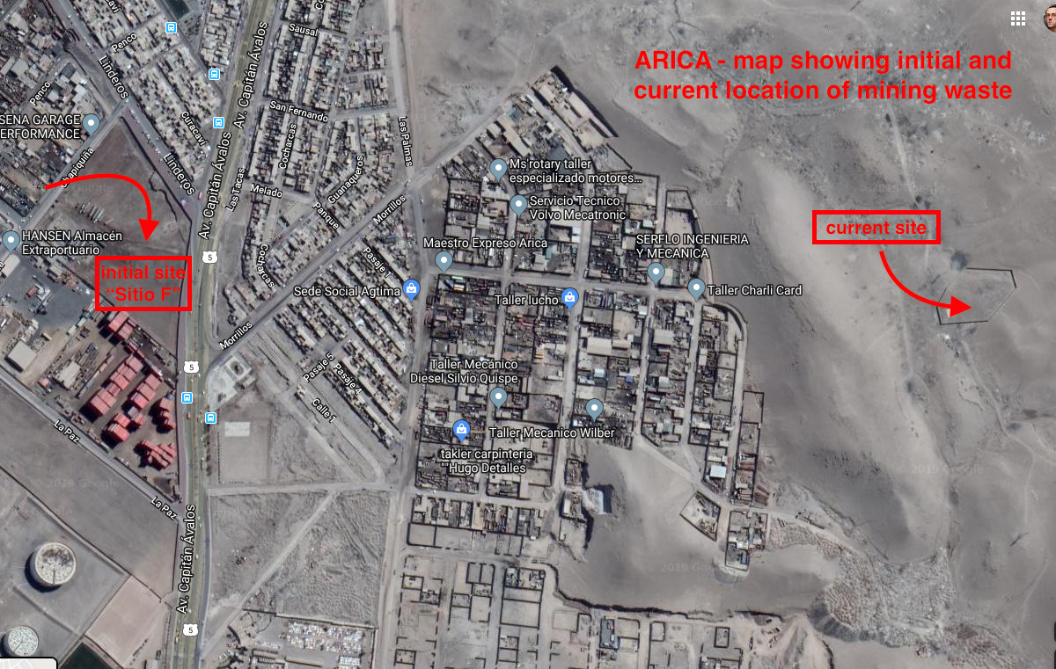

http://www.serviu15.cl/opensite_20130822152329.aspx
https://ejatlas.org/conflict/contaminacion-plomo-arica
http://www.serviu15.cl/opensite_20130822152329.aspx

