Assessment of Economic and Social Rights Fulfilment in Albania
Submission from the Human Rights Measurement Initiative to the United Nations Committee on Economic, Social and Cultural Rights for the 76th Pre-Sessional Working Group Geneva, August 2024.
I. Reporting Organisation
1. The Human Rights Measurement Initiative (HRMI) measures the human rights performance of countries, including Albania. HRMI is an independent, not-for-profit NGO with a primary base of operations in New Zealand, and a second base in the United States at the University of Georgia’s Center for the Study of Global Issues (GLOBIS).
II. Assessment Methodology
2. HRMI uses the award-winning and peer-reviewed SERF Index methodology to measure the fulfilment of economic and social rights (ESR).
3. This methodology uses bellwether indicator data from international organisations—such as the World Health Organization and UNICEF—and compares each country’s achievement to what other countries at the same level of income have achieved. In this way, HRMI measures progressive realisation of economic and social rights (ESRs) as defined in the International Covenant on Economic, Social, and Cultural Rights (ICESCR). A country’s income-adjusted HRMI score is a measure of how well its government is converting its resources into good human rights outcomes for its people.
4. HRMI supplements these scores with qualitative information sourced by a confidential survey of on-the-ground human rights experts, such as NGO researchers, journalists, and human rights lawyers and advocates. For more details on HRMI’s methodology, please refer to the resources on our website.
5. All HRMI’s data are published annually on the Rights Tracker and are freely available for non-commercial use under a Creative Commons License. HRMI’s Rights Tracker is a certified Digital Public Good with the Digital Public Good Alliance.

III. Overview of Economic and Social Rights Fulfilment in Albania
6. HRMI’s most recent ESR scores for Albania measures its achievement as of 2021 and show significant room for improvement. They are shown in the graph below.
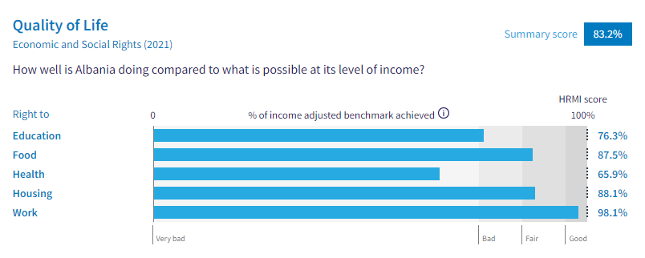
7. Albania’s scores for 2021 are as follows:
▪ Overall Quality of Life score = 83.2%
▪ Right to education = 76.3%
▪ Right to food = 87.5%
▪ Right to health = 65.9%
▪ Right to housing = 88.1%
▪ Right to work = 98.1%

8. Most of these scores fall between the ‘very bad’ and ‘fair’ ranges, with only the right to work reaching the ‘good’ range.
9. Albania scores 83.2% on Quality of Life when scored against the 'Income adjusted' benchmark. This score takes into account Albania's resources and how well it is using them to make sure its people's Quality of Life rights are fulfilled.
10. This score tells us that Albania is only doing 83.2% of what should be possible right now with the resources it has. This score may seem positive, however, since anything less than 100% indicates that a country is not meeting its current duty under international human rights law, our assessment is that Albania has a long way to go to meet its immediate economic and social rights duty.
11. Compared with other countries in Europe, Albania is performing lower than average on Quality of Life rights.
IV. Right to Education
12. HRMI defines the right to education in accordance with ICESCR Article 13 and CESCR General Comments 11 and 13. In the case of low- and middle-income countries, such as Albania, HRMI further breaks down the right to education into three areas of measurement: primary school enrolment, secondary school enrolment, and quality of education. Our scores show significant challenges in all three areas, as the scores lie between the ‘very bad’ and ‘fair’ ranges.
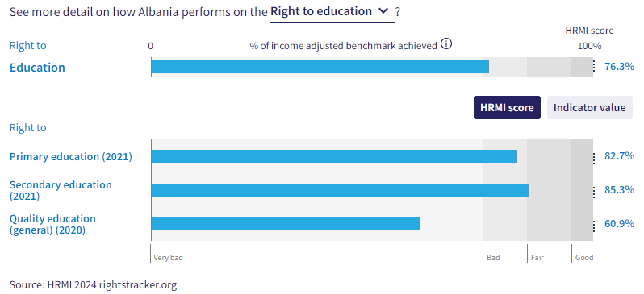
13. Albania’s score for primary school education (adjusted for income) has had a steady decline since 2010. Albania’s right to primary education score dropped from 99.7% to 82.7% across the period of 2010-2021. The score draws on indicator data from UNESCO showing that 93.8% of primary school-aged children were enrolled in school in 2021. Albania is currently ranked tenth from the bottom out of 42 countries in Europe.
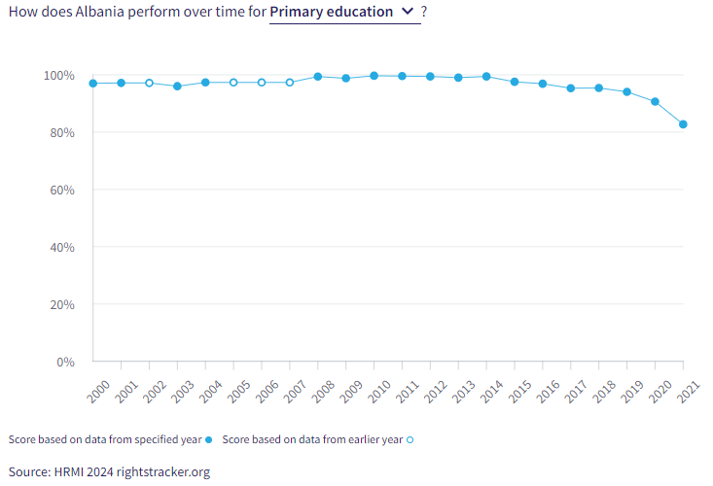
14. Secondary education is also faring very poorly, as 86.8% of children were enrolled in secondary education in 2021. There has been a decline in HRMI scores for the right to secondary education from 89.1% down to 82.8% across the 2014-2020 period. However, some recovery has been made in 2021, with a score of 85.3%, reaching into the ‘fair’ range. Albania is currently ranked 18th from the bottom for secondary education when compared to other countries in Europe.
15. The quality of education score is also in the ‘very bad’ range. Albania is achieving only 60.9% of what we calculate ought to be possible in terms of quality education. Among all countries in Europe, Albania’s score is 8th from the bottom.
V. Right to Food
16. HRMI defines the right to food in accordance with ICESCR Article 11 and CESCR General Comment 12. For low- and middle-income countries, such as Albania, HRMI first uses a bellwether indicator of how many children are growing well (are not stunted). Albania’s score for the right to food is 87.5% and falls in the ‘fair’ range. This means that Albania is doing 87.5% of what ought to be possible to ensure the right to food for its people. This score draws on indicator data on child stunting rates published by the UNICEF-WHO-World Bank: Joint child malnutrition (JME) database.
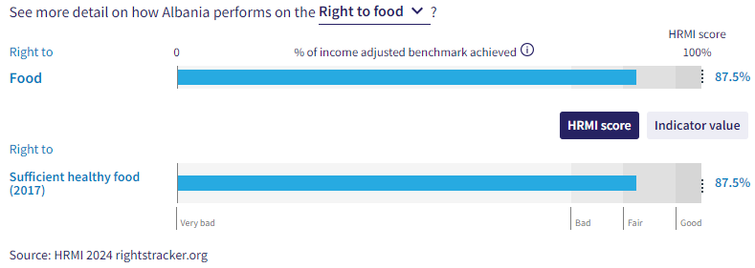
17. We have a supplemental HRMI score of 69.9% on the right to food security, placing Albania within the ‘very bad’ range. Albania is ranked 2nd from the bottom when compared to other countries in Europe.
18. In 2017, 88.7% of children were not stunted, contributing to a HRMI score of 87.5% for the right to food. Albania is currently ranked at the bottom regarding this right when compared to other nations within Europe. However, there has been significant improvement over the 2005-2021 period. In 2005, Albania achieved a HRMI score of only 67.3%, demonstrating encouraging progress. Albania still has a very long way to go, but it is headed in a positive direction.
VI. Right to Health

19. HRMI defines the right to health in accordance with ICESCR Article 12.1 and CESCR General Comment 14. In the case of low- and middle-income countries, such as Albania, HRMI uses three indicators to measure the country’s achievement in child health, adult health, and reproductive health. Albania has an overall HRMI score of 65.9% and is ranked at the bottom within the region of Europe. The right to health for Albania has been in decline since 2008, dropping from 75.9% to 65.9% across the 2008-2021 period.

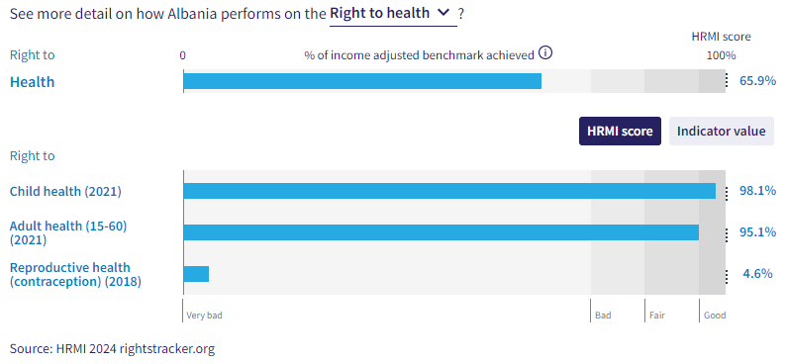
20. Child health across low- and middle-income countries is measured by survival to the age of five. Within Albania, child health has been improving steadily over the 200-2014 period, reaching a peak HRMI score of 98.7% in 2014. The current score of 98.1% places Albania 14th from the bottom within Europe.
21. Adult health has been declining over recent years, reaching a peak HRMI score of 99.9% in 2019, now sitting at 95.1% in 2021.
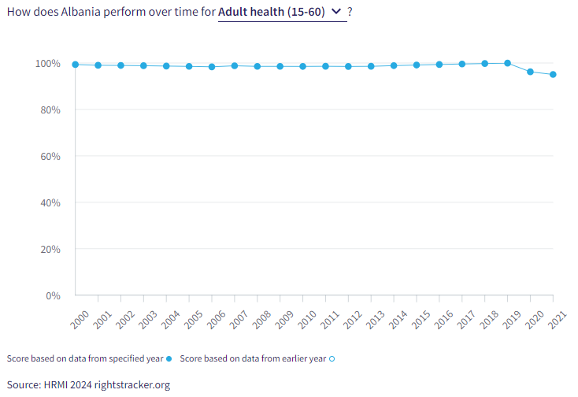
22. The right to reproductive health is measured by the rate of modern contraceptive use. In 2018, there was a rate of 3.7% for modern contraceptive use. This contributed to a concerning HRMI score of only 4.6%, placing Albania in the low end of the ‘very bad’ range and second from the bottom when compared to 142 other countries. Many more people in Albania would have access to these necessities if Albania were using its maximum available resources towards progressive realisation of these rights.
VII. Right to Housing
23. HRMI defines the right to housing in accordance with ICESCR Article 11.1 and CESCR General Comment 4. In the case of low- and middle-income countries, such as Albania, HRMI uses an assessment standard that measures the right to water on premises and ‘basic’ sanitation (each household having its own improved toilet facilities). For basic sanitation, Albania has a score within the ‘good’ range, and for water, the score is within the ‘bad’ range. The overall HRMI score for the right to housing is 88.1%, falling within the ‘fair’ range.

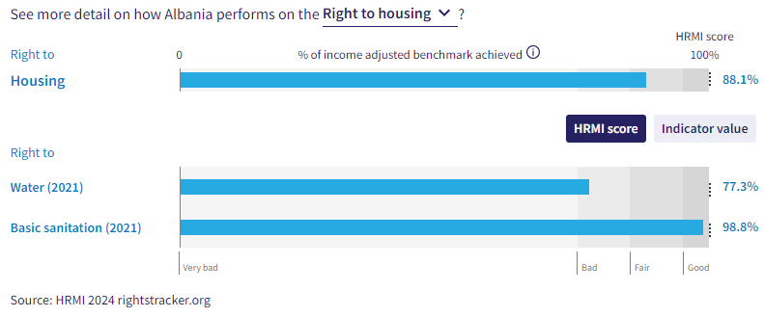

24. In Albania, 80.8% of households have water on premises. Given what other countries with the same level of income have shown to be possible, these statistics lead to a HRMI score of 77.3% for the right to water. The HRMI score has not been improving significantly over the past two decades, plateauing around 76-78%. However, there was a drop from 78% to 77.3% over the 2020-2021 period.

25. There have been significant improvements regarding basic sanitation over the past two decades, as Albania was doing 88.4% of what was possible in 2000, but that score has now risen to 98.8% in 2021. While Albania is still not achieving 100% of what is possible, Albania’s progress in the realm of right to basic sanitation is a step in the right direction.

VIII. Right to Work and Social Security

26. HRMI measures the right to work in accordance with ICESCR Articles 6 and 7. For low and middle-income countries, such as Albania, HRMI measures the right to work and social security using a subsistence income indicator. According to the World Bank PovcalNet, in Albania, the percentage of people who are not absolutely poor is 98.5%, leading to a HRMI score of 98.1%.
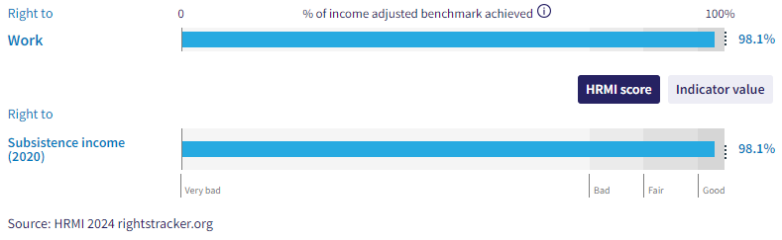
27. The HRMI score is residing within the ‘good’ range. Over the course of the last two decades, Albania has had several rises and falls regarding this right. The first large decrease occurred in 2002, dropping from 100% to 91.5%. However, the largest decrease occurred in 2014, dropping to 88.4%. Albania is gradually recovering, as progress has been made over the 2014-2021 period. If Albania continues to make progress, they will be able to reach 100% again.
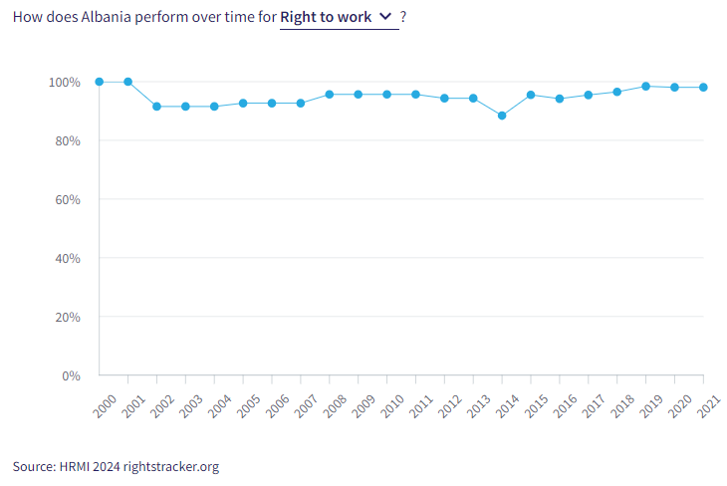

X. Concluding Remarks

28. HRMI respectfully submits its data and findings on the fulfilment of economic and social rights in Albania. We hope that this Submission will serve as a useful resource to the Committee on Economic, Social and Cultural Rights for drafting specific and meaningful questions to Honduras during the CESCR’s 76th Pre-Sessional Working Group.

sw

Visit HRMI’s website to learn more about our mission and work, https://humanrightsmeasurement.org/.
This content represents the opinions of the Human Rights Measurements Initiative. It carries no endorsement of the University of Georgia.
See HRMI’s methodology for measuring economic and social rights: https://humanrightsmeasurement.org/methodology and https://rightstracker.org/page/methodology.
Ibid
Ibid
HRMI 2024 Rights Tracker, https://rightstracker.org/
See Human Rights Measurement Initiative (HRMI) Digital Public Good Certificate, https://app.digitalpublicgoods.net/a/11781 The Digital Public Goods Alliance is endorsed by the UN Secretary General’s “Roadmap for Digital Cooperation,” https://www.un.org/en/content/digital-cooperationroadmap/assets/pdf/Roadmap_for_Digital_Cooperation_EN.pdf. It defines digital public goods as: “open source software, open data, open AI models, open standards and open content that adhere to privacy and other applicable laws and best practices, do no harm, and help attain the SDGs,” https://digitalpublicgoods.net/standard/.
HRMI 2024 Rights Tracker, https://rightstracker.org/country/ALB?qolFdScore=hrmi&as=core&tab=report-esr
The labels on the country charts of good, fair, bad, and very bad are used to give a general indication of how to understand the scores. HRMI’s income adjusted Quality of Life scores can be broadly interpreted as showing the percentage of the country’s obligation it has met, compared to what the best performing countries have achieved at each income level. A country scoring below 75% with a label of “Very bad” is failing to put in place the kinds of structures and policies that help people claim the right concerned, but the structures and policies in place most likely prevent many people from claiming their rights. See HRMI’s methodology for measuring human rights, https://rightstracker.org/page/methodology.
HRMI 2024 Rights Tracker, https://rightstracker.org/country/ALB?qolFdScore=hrmi&as=core&tab=report-esr
HRMI 2024 Rights Tracker, https://rightstracker.org/metric/esr?tab=report-esr&sort=name&subregion=europe
HRMI 2024 Rights Tracker, https://rightstracker.org/metric/education.
HRMI 2024 Rights Tracker, https://rightstracker.org/country/ALB?qolFdScore=hrmi&as=core&tab=report-esr
HRMI 2024 Rights Tracker, https://rightstracker.org/metric/tot-net-primary?tab=report-esr&sort=name&subregion=europe
HRMI 2024 Rights Tracker, https://rightstracker.org/metric/tot-sec-enrol?tab=report-esr&sort=name&subregion=europe
HRMI 2024 Rights Tracker, https://rightstracker.org/metric/educqual?tab=report-esr&sort=score&subregion=europe
HRMI 2024 Rights Tracker, https://rightstracker.org/country/ALB?qolFdScore=hrmi&as=core&tab=report-esr
HRMI 2023 Rights Tracker, https://rightstracker.org/metric/not-stunted.
HRMI 2024 Rights Tracker, https://rightstracker.org/metric/food-security?tab=report-esr&sort=score&subregion=europe
HRMI 2024 Rights Tracker, https://rightstracker.org/country/ALB?qolFdScore=hrmi&as=core&tab=report-esr
HRMI 2024 Rights Tracker, https://rightstracker.org/country/ALB?qolFdScore=hrmi&as=core&tab=report-esr
HRMI 2024 Rights Tracker, https://rightstracker.org/metric/under-5-survival?tab=report-esr&sort=score&subregion=europe
HRMI 2024 Rights Tracker, https://rightstracker.org/metric/contraception?tab=report-esr&sort=score
HRMI 2024 Rights Tracker, https://rightstracker.org/country/ALB?qolFdScore=hrmi&as=core&tab=report-esr
Ibid
HRMI 2024 Rights Tracker, https://rightstracker.org/country/ALB?qolFdScore=hrmi&as=core&tab=report-esr

