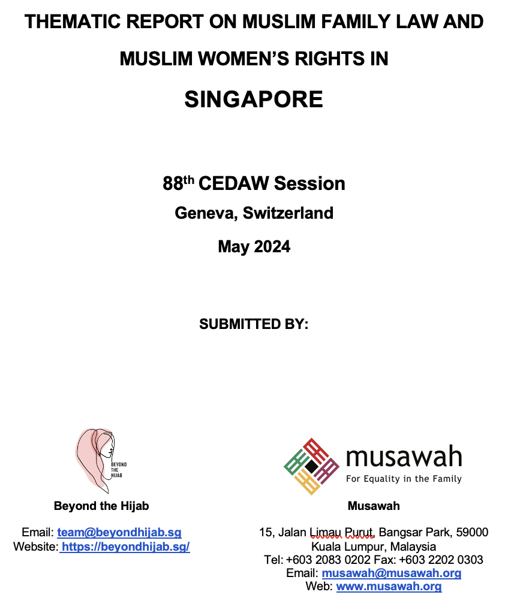
Table of Contents

A. INTRODUCTION 3
B. BACKGROUND, LEGAL FRAMEWORK AND CONTEXT 3
C. KEY ISSUES AND RECOMMENDATIONS 4
1. Comprehensive Reform of Muslim Family Law 4
2. Women’s Consent and Capacity to Enter into Marriages 6
3. Early and Child Marriages 7
4. Polygamy 8
5. Divorce Rights 11
6. Inheritance Rights 14

A. INTRODUCTION

This shadow report is jointly submitted by Beyond the Hijab, an online platform sharing personal stories and perspectives of Singaporean Muslim women, and Musawah, the global movement for equality and justice in the Muslim family, for consideration by the CEDAW Committee in its review of the Government of Singapore, reporting before the 88th Session of the CEDAW Committee in May 2024.

B. BACKGROUND, LEGAL FRAMEWORK AND CONTEXT

Muslims in Singapore constitute 15% of the total population. The majority of Muslims in Singapore are Sunni Muslims of the Shafi’i school of law. Article 12 of the Singaporean Constitution guarantees equal protection of all before and of the law and non-discrimination on the basis of religion, race, descent or place of birth.
Article 12(3) of the Constitution allows for different personal laws based on religious belief. As a multi-religious society, Singapore has two legal regimes that govern marriage and divorce - civil law (Women’s Charter) and Muslim law via the Administration of Muslim Law Act (AMLA). Muslims may marry non-Muslims; the marital union is a civil marriage and falls under the purview of the Women’s Charter. With regard to the CEDAW Convention, Singapore has reservations to Articles 2(a)-(f), 16(1)(a), 16(1)(c), 16(1)(h), 16(2) and 29(2) of CEDAW on the following grounds: “In the context of Singapore’s multiracial and multi-religious society and the need to respect the freedom of minorities to practice their religious and personal laws, the Republic of Singapore reserves the right not to apply the provisions of articles 2, paragraphs (a) to (f), and article 16, paragraphs 1(a), 1(c), 1(h), and article 16, paragraph 2, where compliance with these provisions would be contrary to their religious or personal laws.”
However, partial reservations to Articles 2 and 16 are still retained to protect the rights of minorities in the practice of their personal and religious laws. With the exception of Singapore’s Muslim minority community, marriage and family relations of all communities in Singapore regardless of religion are governed by the Women’s Charter, which exclusively recognizes civil marriages. Therefore Article 12(3) of the Constitution and CEDAW reservations apply expressly with regard to the Muslim family law on marriage, divorce and inheritance.
ADMINISTRATION OF MUSLIM LAW ACT (AMLA)
AMLA is the main codified law that governs matters relating to marriage and family relations of the Muslim minority community in Singapore. Muslim law, as set out in the AMLA, is administered by various agencies including the Islamic Religious Council of Singapore (MUIS), the Shari’ah courts and the Registry of Muslim Marriages (ROMM).
The Shari’ah courts, and Naib (deputy) Kadis considered as “officials of religious standings”, administer the marriage registration and divorce procedures.

C. KEY ISSUES AND RECOMMENDATIONS

ROMM has 12 Kadis and 34 Naib Kadis under its purview. Kadis can consider marriage applications and solemnize marriages with or without a wali (male guardian), while Naib Kadis can solemnize marriages only with a wali.
The Family Justice Court (FJC) adjudicates cases relating to marriage and family relations of Singapore’s non-Muslim majority population. Generally, the Shari’ah courts adjudicate cases relating to marriage and family relations of Singapore’s Muslim minority community.
However, parties to a Muslim marriage may commence civil proceedings in the FJC with regard to: (i) children (custody, care; control and access during a marriage); and (ii) disposition or division of property on a foreign divorce. In addition, maintenance of the wife and children during a subsisting marriage, and child maintenance pursuant to a divorce, are heard in the FJC.
The Act is generally silent on the Muslim school of law that is applicable in the event that a particular personal status matter is not sufficiently addressed by AMLA.
However Section 33 of AMLA provides that the religious rulings (fatwas) of the Islamic Religious Council of Singapore (MUIS) should follow the rules of Shafi’i jurisprudence (fiqh), unless it is in the public interest to follow the tenets of another accepted madhab (schools of law).

Comprehensive Reform of Muslim Family Law

Singapore recently reformed the Administration of Muslim Law Act (1966) in 2020. Regardless of the reforms, the provisions in the AMLA still render Singaporean Muslim women as second-class citizens by denying them the fundamental right to equality and non-discrimination in the realm of marriage and family.
The amendments specified by the government fail to address all legal inequalities as other provisions in the AMLA render Muslim women as unequal to their husbands in entering and leaving marriages. For instance, Section 46 of the Women’s Charter states that upon solemnization of their marriage, a husband and wife will be mutually bound to cooperate with each other in safeguarding the interests of the marriage and in caring and providing for the children; they will also have equal rights in the running of the matrimonial household. The AMLA however does not contain an equivalent provision. Other countries with Muslim family laws, such as Algeria, Morocco and Turkey, offer more egalitarian interpretations of marriage.
Additionally, in Muslim pre-marriage courses conducted by Ministry of Social and Family Development (MSF)-approved operators and private operators, trainers still promote the outdated concept of husbands as the ‘head of household’ and wives solely responsible for caregiving.

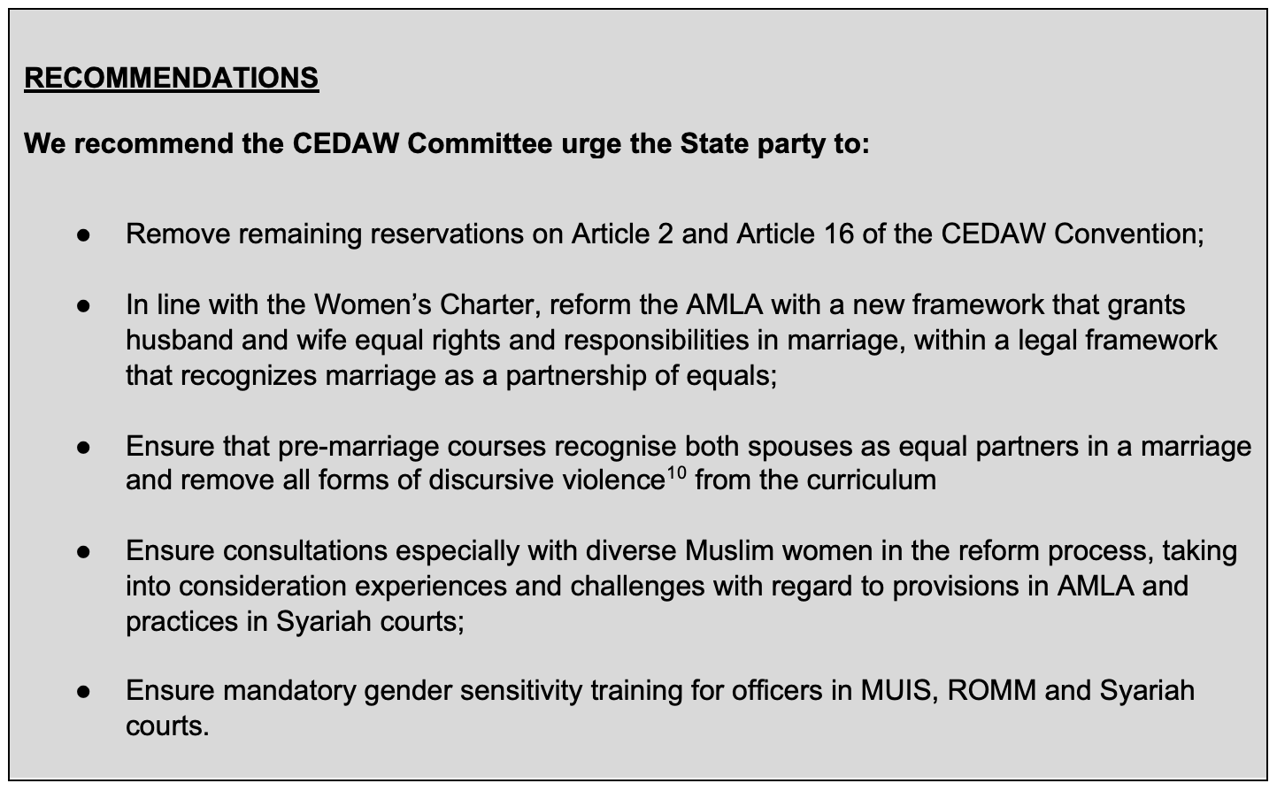

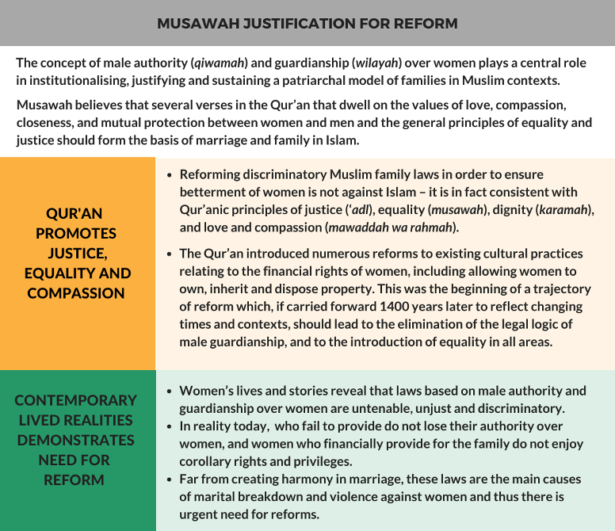

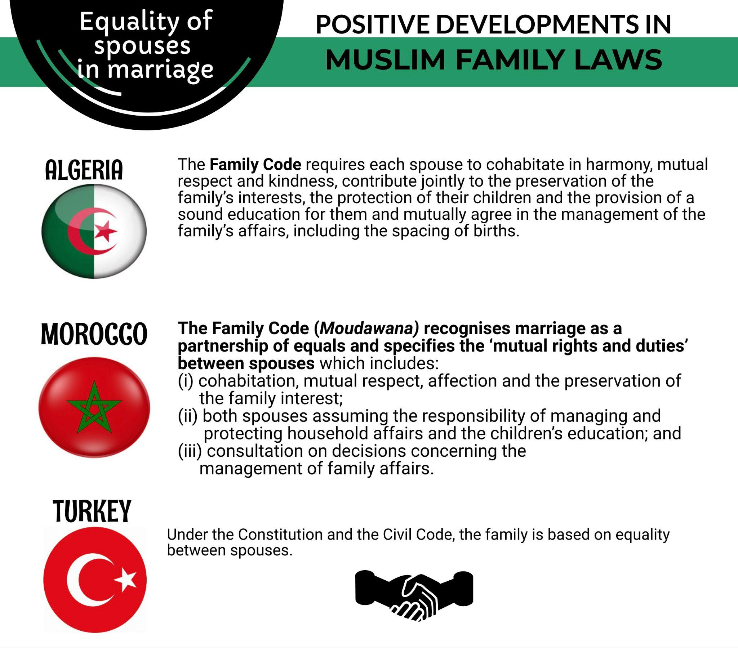

Women’s Consent and Capacity to Enter into Marriages

Regardless of their age, both prospective brides and grooms must consent to the marriage. However a Muslim prospective bride still requires the consent of a male guardian (wali) to enter into marriage.
When a woman does not have a wali, a Kadi may act as guardian in the absence of one. In addition, if the guardian of a prospective bride opposes the marriage on grounds that the Kadi considers to be unreasonable, the Kadi may solemnize the marriage.
The requirement of the consent of a wali regardless of the age of the bride denies women full autonomy and rights as an individual to enter into a marriage out of her own free will and choice.

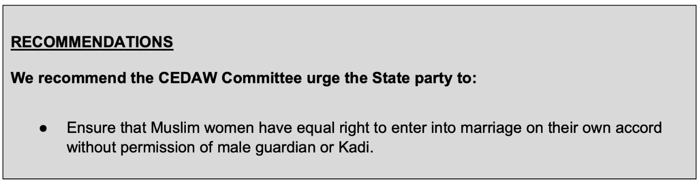
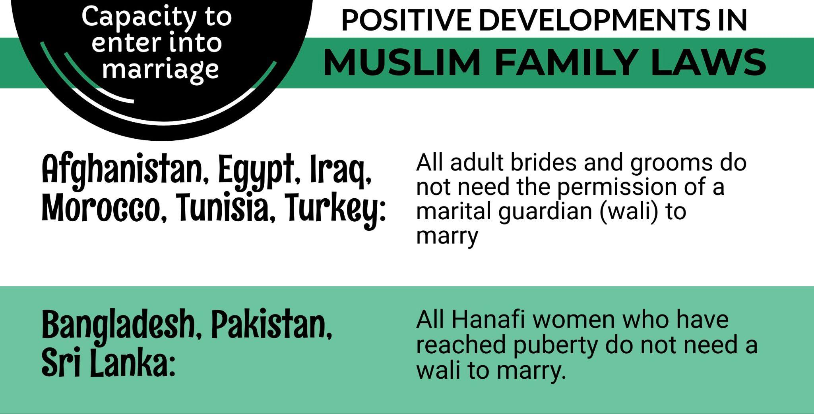

Early and Child Marriages

The minimum legal age for marriage is 18 years for Muslim females and males. However, Section 96(5) of AMLA provides that a Kadi may authorize the marriage of a girl below 18 years but has attained the age of puberty. The law does not stipulate an absolute minimum age below which a marriage may not be authorized.
In paragraph 128 of the state’s Replies to List of Issues, the government stated that “such marriages are rare” and that “the number has declined from 12 (0.2%) in 2017 to 5 (0.08%) in 2021” under AMLA and “from 11 (0.05%) in 2017 to 1 (0.005%) in 2021” under Women’s Charter.
Since the numbers are low and declining, raising the minimum age of marriage for girls to 18 years, without any exceptions, will ensure that the law prevents the few cases that may occur regardless of the circumstances.
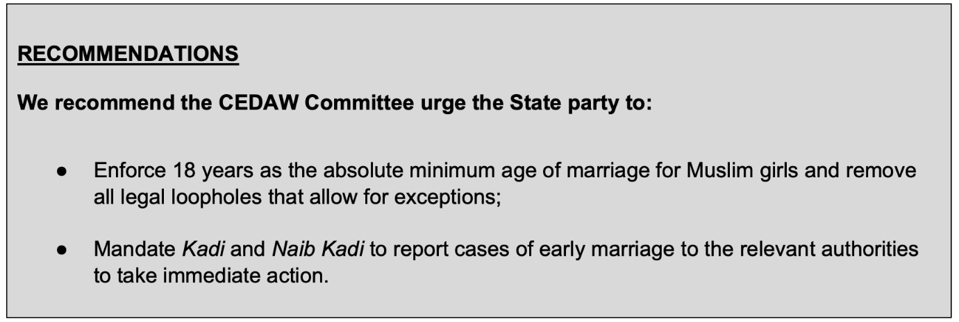
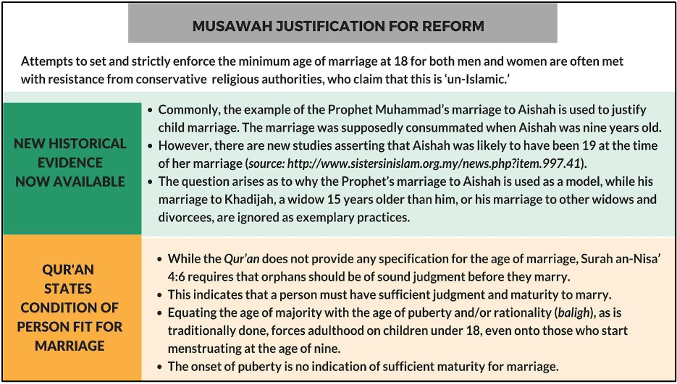
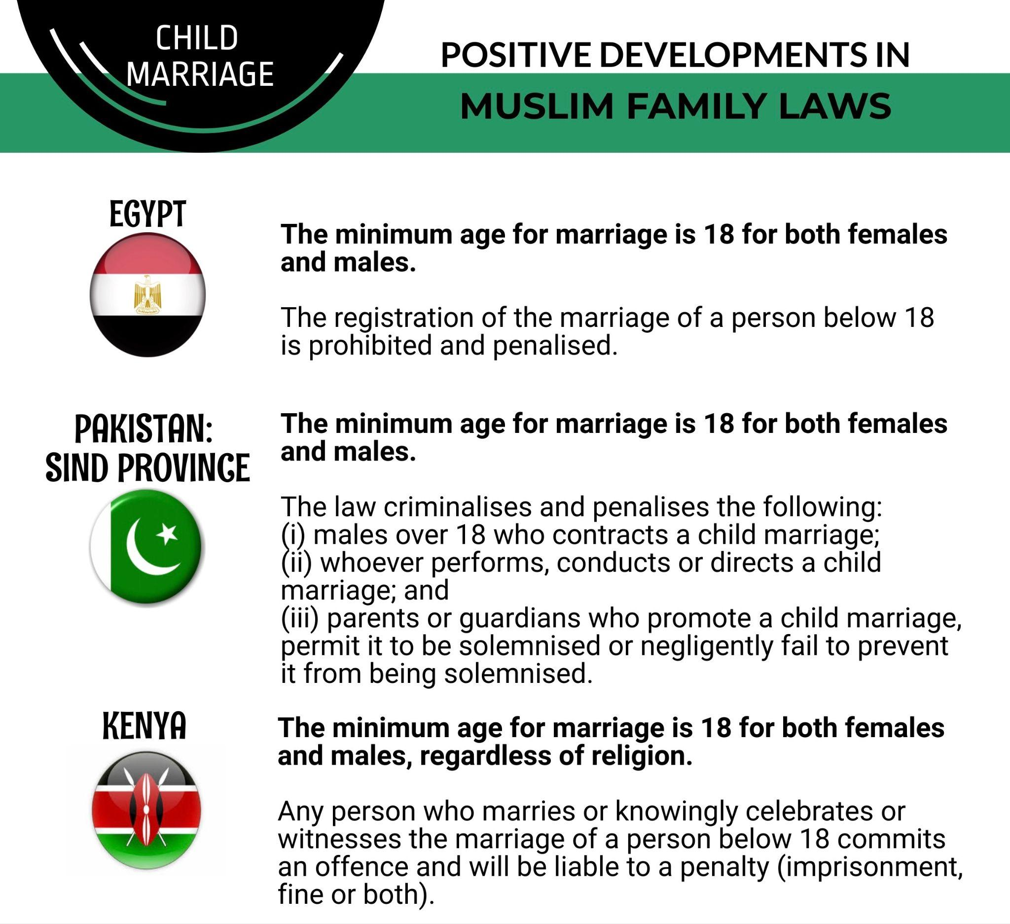

Polygamy

Polygamy is a criminal offence for non-Muslims in Singapore. But as per the AMLA, a Muslim man may marry up to four wives at one time. He is required by law to seek the permission of the Kadi to enter into a polygamous marriage. As per procedure, the Kadi must hold an inquiry and may require the prospective groom, the prospective wife and her wali, the existing wife or wives as well as any other relevant person to attend the inquiry and give any evidence. The Kadi considers certain conditions, such as financial capacity and reasons of husband, prior to authorizing the marriage:
Based on official data, polygamous marriages are rare and have decreased from 0.4% in 2010 to 0.18% of Muslim marriages in 2020.
However, according to local women’s groups, illegal and unregistered polygamous marriages are common especially across national borders. Despite the need to get approval for subsequent marriages, Singaporean Muslim men bypass this procedure by marrying Muslim women from other countries such as Indonesia or Thailand, where approval is not needed. These non-registered marriages leave Muslim women and their children in highly vulnerable situations socially, financially and psychologically and there are little or no consequences on men.
Such transnational polygamous marriages also have an effect on the second wife, who is often a foreigner, and the children of the marriage. According to local legal practitioners, individuals who have entered into polygamous marriages abroad and subsequently seek recognition of their marriage under Singaporean law often encounter unsuccessful outcomes. While that is justifiable, in such instances, the second wife’s ability to obtain rights in relation to entrance and length of stay in Singapore may be limited. This, in turn, impacts the family's daily life, separates children from one parent for extended periods, and challenges the husband's ability to treat his wives fairly, especially if they reside in different countries. More public education must be done by the State to highlight the adverse effects of being in a marriage that is not recognized under Singapore law.
According to information on the ground, there are some civil society programmes that seek to raise awareness among prospective brides to add a term in their marriage contracts that if their husbands marry a second wife without their permission, they are entitled to seek divorce in accordance with their marriage contracts. However, this means that wives who do not want to be in plural marriages, have little choice other than divorce to object to her husband’s decision to take a subsequent wife.
The declining rate of polygamous marriages indicates that more Muslim couples are refraining from plural marriages and/or the practice is losing social acceptance. Given the low rate of the practice and the negative impacts that polygamy has on Muslim women and children, Singapore is in an opportune position to eliminate the practice of polygamy completely.
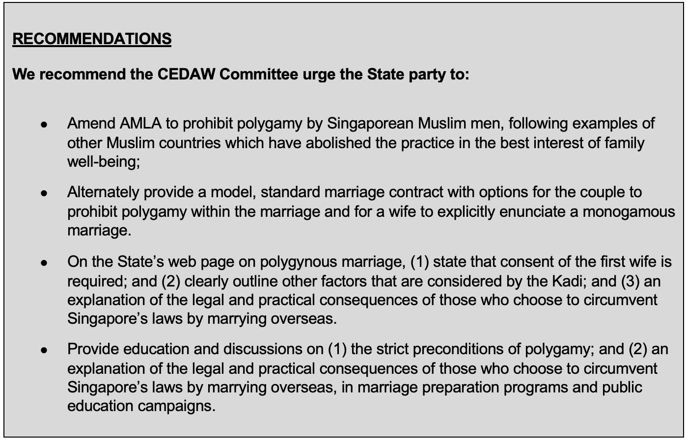
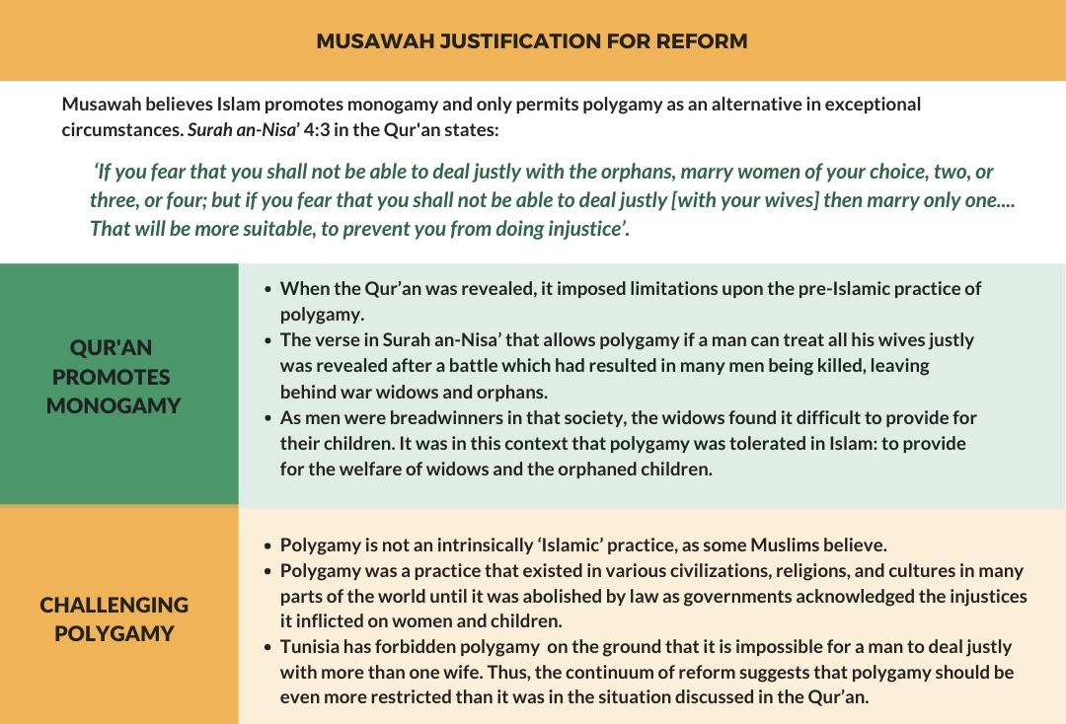

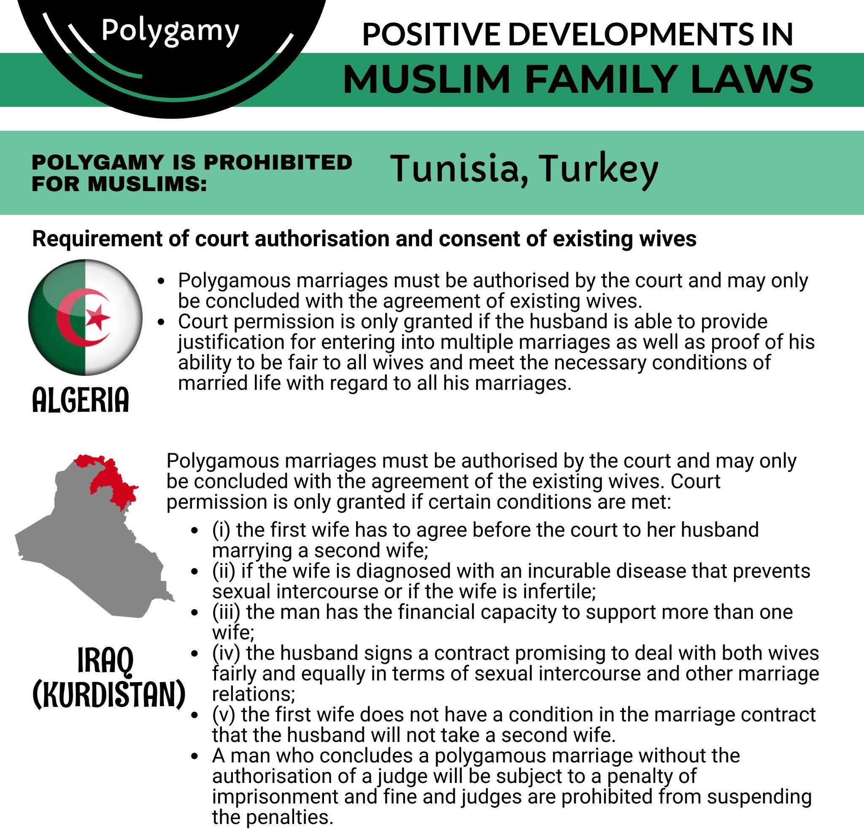

Divorce Rights

AMLA provides for four different mechanisms for divorce, which differ on the basis of gender. While husbands are entitled to unilateral repudiation (talak) without conditions, a wife can only divorce based on certain conditions. The four main types of divorce are as follows:
- Unilateral repudiation (talak or talaq)
Under Section 102(5) of AMLA, a husband may unilaterally repudiate the marriage without conditions or reasons.
- Conditional divorce (cerai taklik)
According to Section 48 of AMLA, a Muslim woman may apply for a cerai taklik divorce only when any of the conditions stipulated in the taklik (marriage contract) at time of or after her marriage is violated.
- Judicial divorce (fasakh)
The AMLA gives valid grounds for seeking a judicial divorce by a wife. These include: (a) failure to provide maintenance for more than three months; (b) insanity or incurable or severe illness; (c) continuing impotence; (d) imprisonment of more than three years; (e) failure to perform his marital obligations with his wife for more than one year without reasonable cause. In addition, a wife may seek divorce on the basis that her husband treats her with cruelty, which includes assault, adultery and failure to maintain (among other conditions).
In all judicial divorce cases initiated by women, including those based on a husband’s purported cruel treatment, a wife’s testimony alone is insufficient to prove grounds for divorce. Both conditional and judicial divorces require some form of admissible evidence to be produced by women. In paragraph 135 of the state’s Replies to List of Issues that “the standard of proof is the same regardless of whether the divorce applicant is the husband or the wife” is untrue. Men who are seeking divorce based on the pronouncement of talak only has to provide evidence of such pronouncement, while in cases where talak has not been pronounced, women have to furnish further evidence to satisfy the grounds listed under fasakh or taklik, and procure two witnesses.
- Redemptive divorce (khul’)
A wife may seek redemptive divorce (khul’), whereby she is granted a divorce in exchange for a mutually-agreed compensation to be paid to the husband. If the husband refuses the divorce, the court will appoint a panel of two arbitrators (hakam) to reconcile the couple. If the reconciliation process fails, the wife will be granted a divorce.
- Overall procedural issues
According to local legal practitioners, the process is set out such that in cases where parties are seeking an amicable divorce, the Syariah divorce process is one that provides a speedy and fair outcome. However, if parties are going through an acrimonious divorce, there are many stages in which parties have made attempts to delay proceedings.
Local advocates have shared anecdotal cases of men who delay proceedings by making excuses about being unable to file their documents on the Syariah Court portal, being unable to find legal representation, needing more time to prepare their financial documents, etc., leading to the postponement of mediation sessions and Pre-Trial Conferences for over 6 months. The State, in paragraph 136 of its Replies to List of Issues, stated that “Muslim men are also required to maintain their ex-wives during the iddah (waiting period before a divorced woman may marry another man) and obliged to provide mutaah (a consolatory gift), and repay any outstanding marriage expenses and emas kahwin (compulsory marriage gift).'' However, these men, who know that their wives are seeking a quick divorce to avoid stress and financial burden, use the time factor as a bargaining chip to get their wives to agree to waive nafkah iddah, mutaah, and other claims relating to the matrimonial assets.
Additionally, while the State, in paragraph 137 of its Replies to List of Issues, stated that both men and women are entitled to make ancillary claims, it is untrue that both are at an equal position. Based on anecdotal evidence, a disproportionately higher number of men compared to women, have taken advantage of the court’s lax enforcement mechanisms, to ignore deadlines, delay proceedings for as long as possible, and pressure their wives to agree to certain terms.
These issues are exacerbated by the understaffed status of the Syariah Court. There are only three mediators, two registrars, three Presidents, and one Senior President currently serving at the Syariah Court. Local legal practitioners have cited concerns over long postponements of 3 months each time an adjournment is granted at mediation or at a hearing due to the availability of the mediators, registrars and presidents. Such delays affect access to justice and have disproportionate impacts on women who are often the primary caretakers of children, and who may have difficulty in finding and maintaining employment while going through protracted divorce proceedings.
- Recent amendments to the AMLA
There have been several amendments to the AMLA, however two areas that have continued to lead to duplicity in proceedings and have had a disproportionate impact on Muslim women: (1) claim for child maintenance; and (2) claim for financial relief pursuant to foreign divorces.
- Child maintenance
Minister for Muslim Affairs, Masagos Zulkifli, stated that, “We are amending section 35 of the AMLA to clarify that the Syariah Court’s jurisdiction includes maintenance of children on divorce or nullification of marriage, which has always been part of section 52(3) of AMLA.”
In practice, while the Syariah Court has powers to make orders on maintenance of minor children, the Syariah Court has not done so. Instead, pursuant to the conclusion of the divorce at the Syariah Court, the parent who has custody of the child must then make an application for maintenance at the Family Justice Court.
While there is no presumption at law or common practice, oftentimes mothers are awarded care and control and would have to apply to the Family Justice Court for maintenance for the child pursuant to the grant of the divorce at the Syariah Court. This involves additional time, effort and financial resources, and affects access to justice.
- Financial relief pursuant to foreign divorce
In the case of TMO v TMP [2017] SGCA, the Singapore Court of Appeal held that in a case where a foreign court issued the decree of Muslim divorce, the Syariah Court had no jurisdiction to exercise its powers under Section 52(3) of the AMLA, including its powers to make orders relating to the division of matrimonial assets. However, the Singapore High Court had residual jurisdiction to make such orders.
The effect of TMO v TMP was that Muslim claimants must go to the Syariah Court to make a claim for maintenance for the wife (nafkah iddah or nafkah mutaah), and must make another claim to the High Court to claim for other forms of financial relief related to matrimonial property, maintenance of the children, and other related matters.
When this issue was raised during the debate on the AMLA bill, Minister Masagos merely reiterated that there is no legal vacuum as claimants can go to the civil court for financial relief if Syariah Court cannot make certain orders. However, requiring claimants to go to two different courts for a matter arising from the same divorce disregards the time and costs involved. Furthermore, anecdotal evidence suggests that Muslim women are often the ones who bear the burden of making a claim for financial relief in Singapore as they are often the ones who will stand to gain if they are able to claim for a just and equitable share of the matrimonial assets that are located in Singapore.

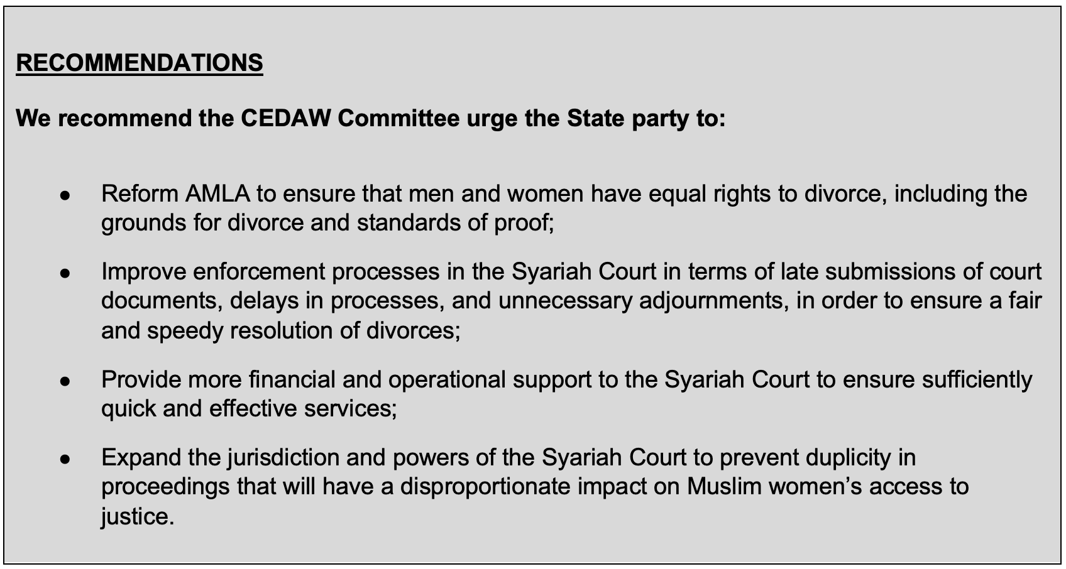

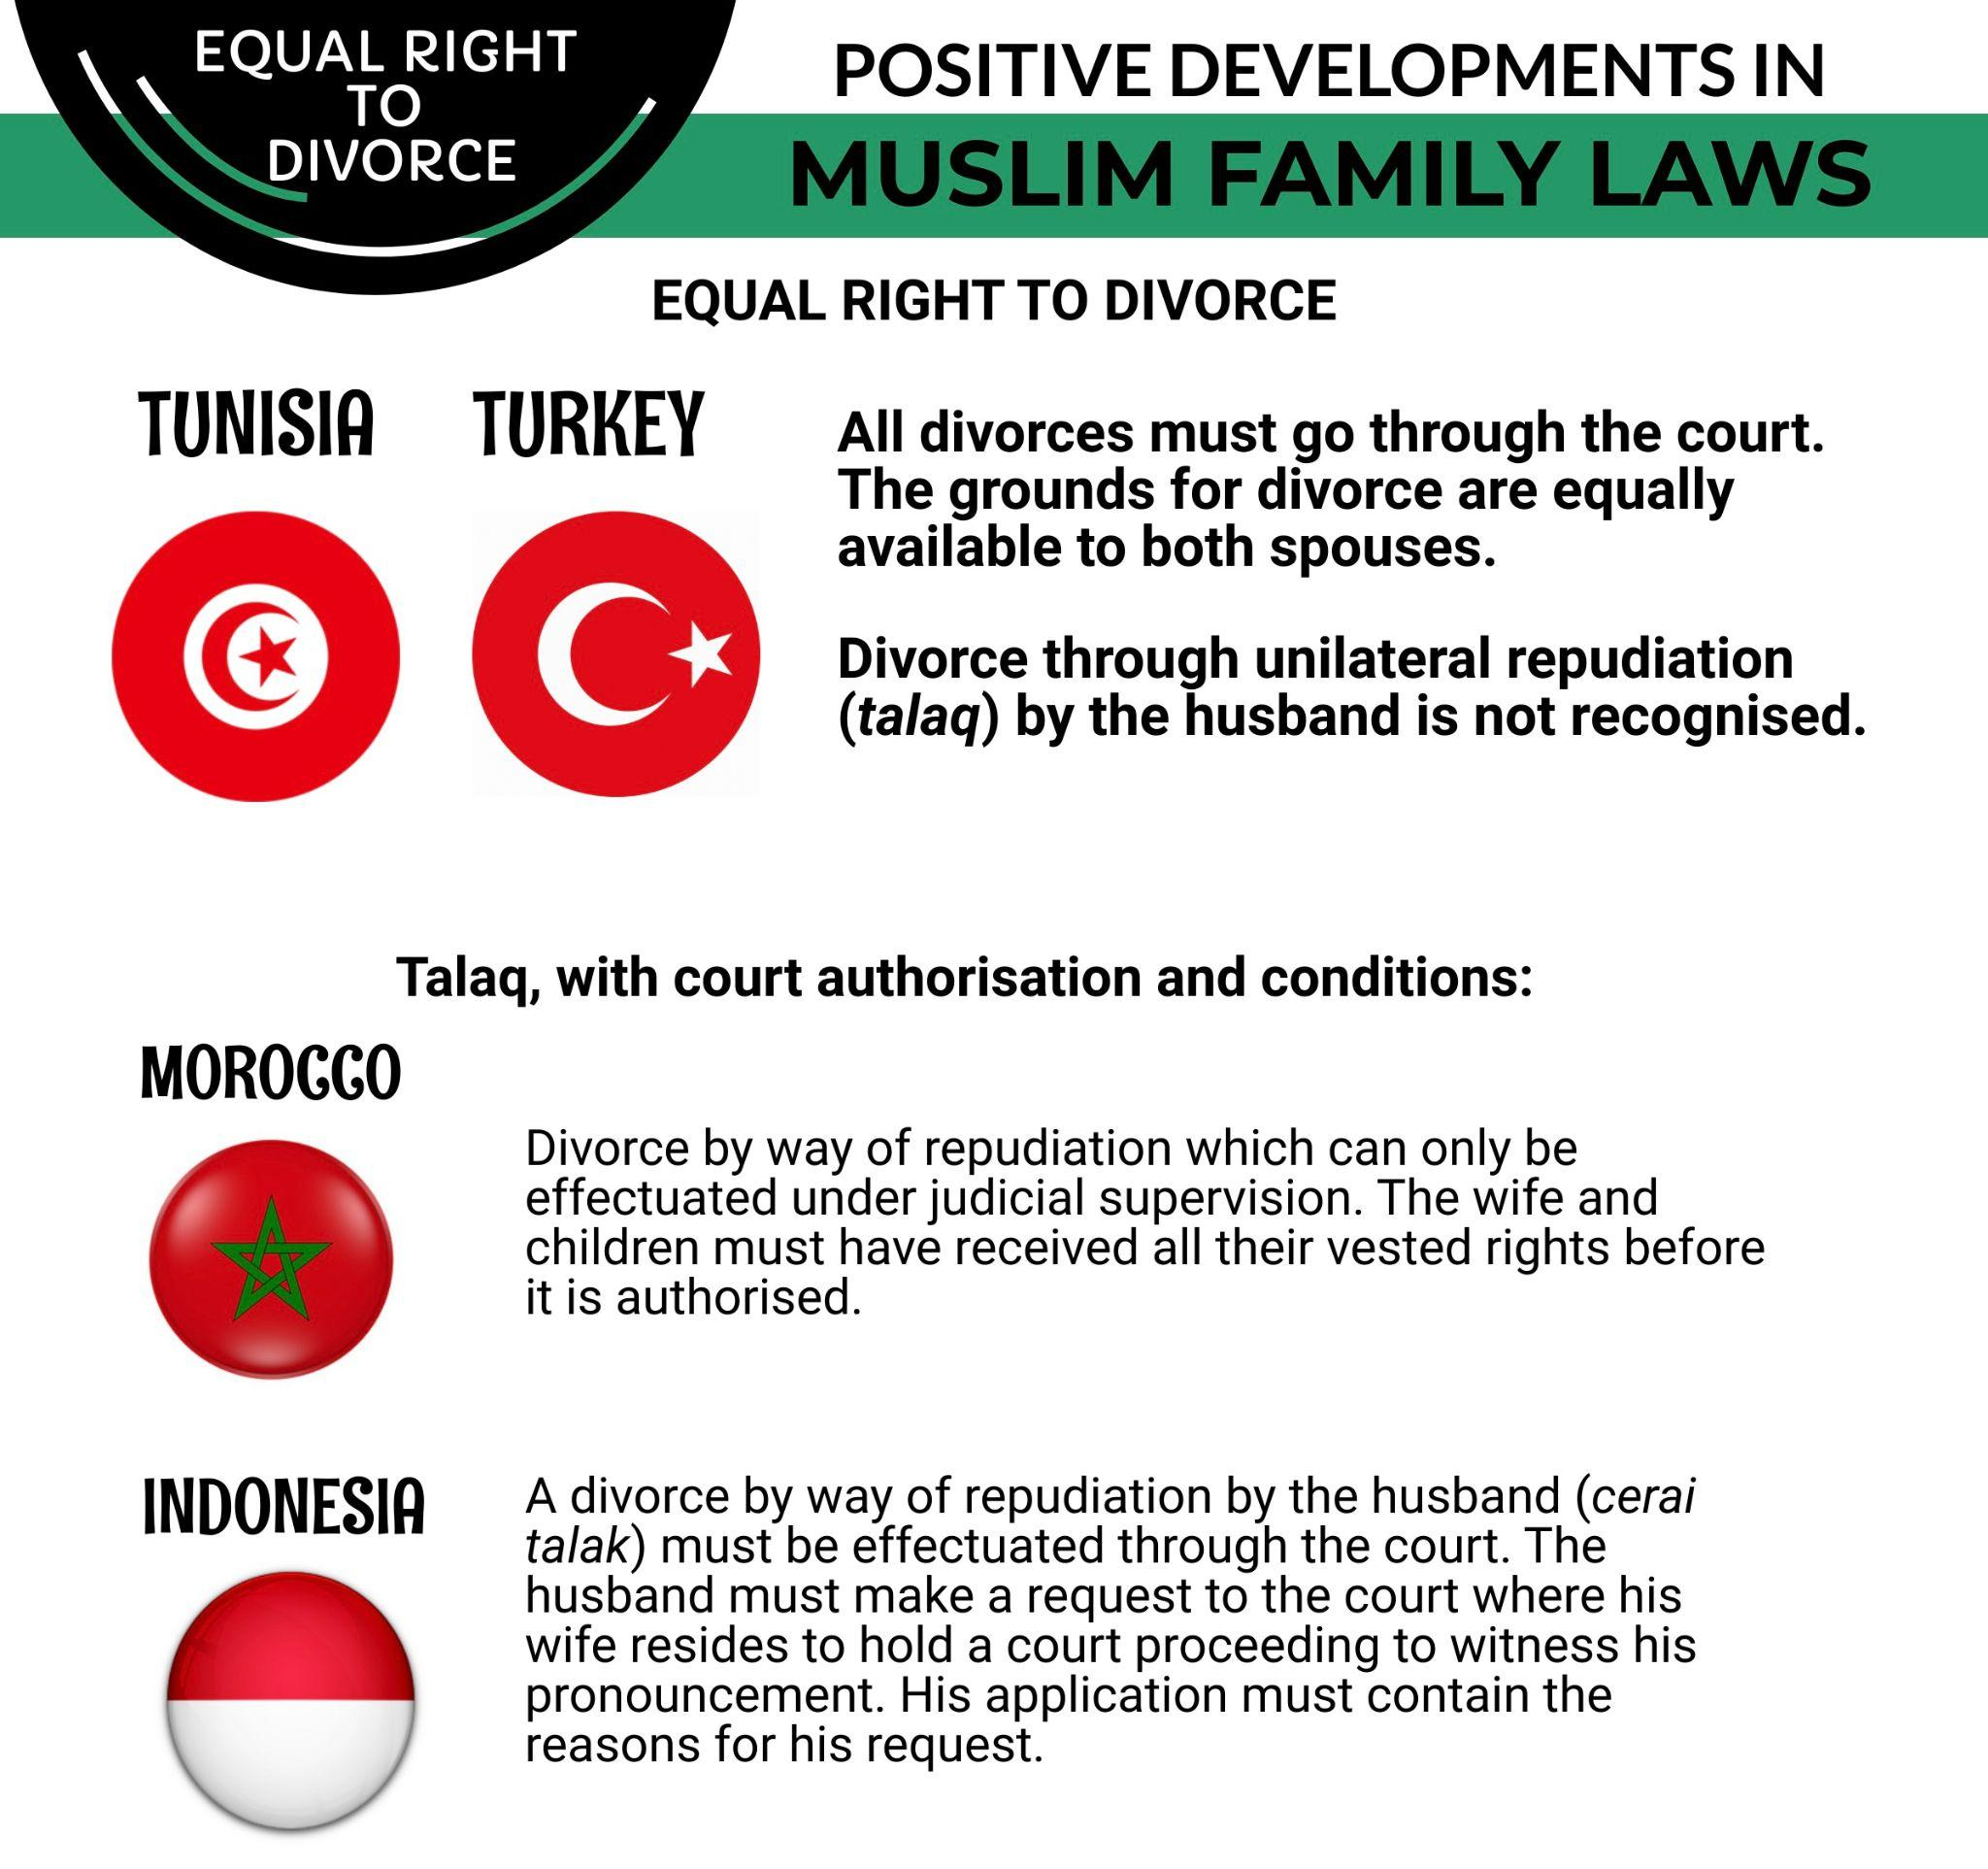

Inheritance Rights

In Singapore, the inheritance rights governing distribution of estates of Muslims are based on Muslim inheritance law (faraid) only. The provisions with regard to division of assets are unequal to men and women. In many instances, for example in the cases involving widows and widowers as well as siblings, a woman is entitled to half the share of a man.
The Singapore government responded to the Committee’s List of Issues that they have issued several “fatwas (religious rulings) over the years”.
However, the issuance of the MUIS fatwas do not address the discrimination that female family members face with regard to inheritance. According to one of the fatwas issued by MUIS, Muslims can make a gift (hibah) of property or assets in favour of their spouse or children, including daughters while still alive. However, after death it can be distributed only with the consent of the heirs regardless of the nomination, and is likely to benefit male heirs more than female heirs.
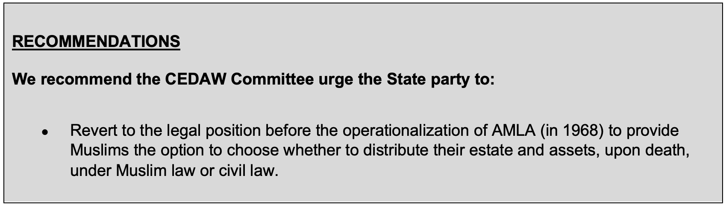
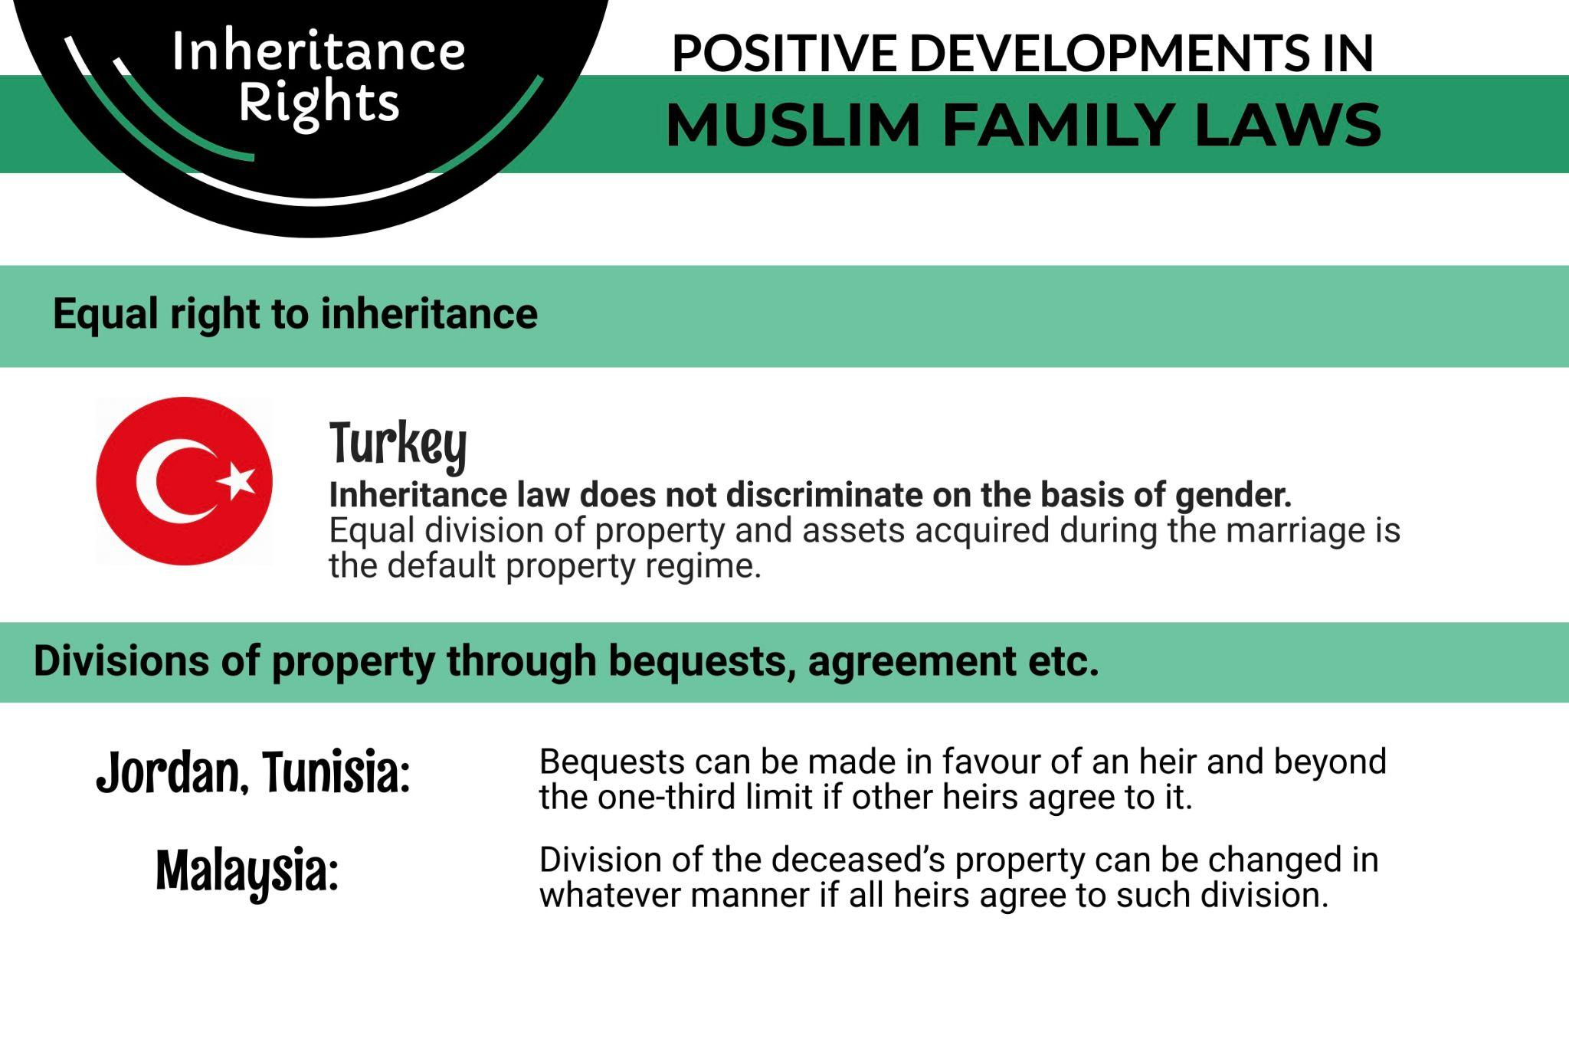

Ahmad Nizam bin Abbas, “The Islamic Legal System in Singapore”, (Pacific Rim Law &amp; Policy Journal, 21:1, 2012), p. 166, https://digital.law.washington.edu/dspace-law/bitstream/handle/1773.1/1097/21PRPLJ163.pdf?sequence=1
Article 12 of Singapore’s Constitution (1963), Gender equality is not specifically mentioned in the article. http://statutes.agc.gov.sg/aol/download/0/0/pdf/binaryFile/pdfFile.pdf?CompId:f112e119-f024-4c49-9ac3-d4e0e94ebc85
Article 12(3) of Singapore’s Constitution (1963); Ahmad Nizam bin Abbas, “The Islamic Legal System in Singapore”, (Pacific Rim Law &amp; Policy Journal, 21:1, 2012), p. 163, https://digital.law.washington.edu/dspace-law/bitstream/handle/1773.1/1097/21PRPLJ163.pdf?sequence=1
Section 3(4) of the Women’s Charter (1961), http://statutes.agc.gov.sg/aol/download/0/0/pdf/binaryFile/pdfFile.pdf?CompId:f970e7b1-2a7b-49ec-b760-061d1a85888c
United Nations Treaty Collection Website, https://treaties.un.org/Pages/ViewDetails.aspx?src=TREATY&amp;mtdsg_no=IV-8&amp;chapter=4&amp;clang=_en
Women’s Charter (1961), http://statutes.agc.gov.sg/aol/download/0/0/pdf/binaryFile/pdfFile.pdf?CompId:f970e7b1-2a7b-49ec-b760-061d1a85888c
Administration of Muslim Law Act (1966) (Hereinafter “AMLA”), http://statutes.agc.gov.sg/aol/download/0/0/pdf/binaryFile/pdfFile.pdf?CompId:da899b47-f141-4218-a27a-99ed1aee6ce1
List of Kadi/Naib Kadi, marriage.gov.sg, https://www.marriage.gov.sg/muslim/kadi-list
(i) Maintenance for children during a marriage (s68 WC: https://sso.agc.gov.sg/Act/WC1961?ProvIds=pr68-#pr68-); custody, care and control, access of child during a marriage (section 5 of the guardianship of infants act: https://sso.agc.gov.sg/Act/GIA1934?WholeDoc=1); division of matrimonial property pursuant to a foreign divorce (Chapter 4A of WC: https://sso.agc.gov.sg/Act/WC1961?ProvIds=P110-P44A_121A-#P110-P44A_121A-); (iii) maintenance for wife and children during marriage (s69 of WC, https://sso.agc.gov.sg/Act/WC1961?ProvIds=P18-#pr69-); (iv) maintenance for child(ren) pending matrimonial proceedings or pursuant to divorce (s127 of WC, https://sso.agc.gov.sg/Act/WC1961?ProvIds=pr127-#pr127-)
Section 95, AMLA (1966)
Section 95(1)(c), AMLA (1966)
Section 96(4), AMLA (1966)
Section 96(5), AMLA (1966)
Singapore Reply to the List of Issues on Singapore’s Sixth Periodic Report (2023), Paras 128, 130, https://tbinternet.ohchr.org/_layouts/15/treatybodyexternal/Download.aspx?symbolno=CEDAW%2FC%2FSGP%2FRQ%2F6&Lang=en
Section 96(3), AMLA (1966), Rule 5 of the Muslim Marriage and Divorce Rules, http://statutes.agc.gov.sg/aol/download/0/0/pdf/binaryFile/pdfFile.pdf?CompId:3b0d2473-a95f-4655-8521-f90e3d76a1d5
Section 95(3), AMLA (1966), Rule 5 of the Marriage and Divorce Rules.
Marriage.gov, “Polygynous marriage process”, https://www.marriage.gov.sg/muslim/marriage-process-polygynous
Singapore State party report, U.N. Doc. CEDAW/C/SGP/6 (2021), para 223,https://tbinternet.ohchr.org/_layouts/15/treatybodyexternal/Download.aspx?symbolno=CEDAW%2FC%2FSGP%2F6&Lang=en
SaSa meeting 17 April 2016 organized by AWARE: ‘Single and Single Again; A safe space for Malay women who are not or have never been married’
Seminar on “Rethinking the Muslim Marriage Contract” co-organized by AWARE, the National University of Singapore’s Department of Malay Studies and the Faculty of Arts and Social Sciences (Religion Cluster) and the Leftwrite Centre LLP held on 14 April 2012 at the National University of Singapore with speakers including Kyai Haji Hussien Muhammad, Dr Ziba Mir-Hosseini and Halijah Mohamad, http://www.aware.org.sg/2012/07/rethinking-the-muslim-marriage-contract/
Section 102(5), 130(2), AMLA (1966)
Section 49(4), AMLA (1966)
Sections 47(4)-47(5), 50, AMLA (1966)
Spouse and Child Maintenance, Emerald Law, https://emeraldlaw.com.sg/syariah-maintenance/
TMO v TMP [2017] SGCA, https://www.elitigation.sg/gd/s/2017_SGCA_14
Supporting the long-term socio-religious development of our Muslim community, Ministry of Culture, Community and Youth Singapore, (2024), https://www.mccy.gov.sg/about-us/news-and-resources/parliamentary-matters/2024/Feb/Supporting-the-long-term-socio-religious-development-of-our-Muslim-community
Sections 111, 112, AMLA (1966)
Islamic Religious Council of Singapore, “Fatwa on CPF Nomination (2010)”, https://www.muis.gov.sg/officeofthemufti/Fatwa/CPF-Nomination

