PUBLIC ASSOCIATION FOR ASSISTANCE TO FREE ECONOMY

Parallel information on right to adequate housing to the United Nations Committee on Economic, Social and Cultural Rights in relation to the third periodic Report of AZERBAİJAN (E/C.12/AZE/3)
50th Session (29 April-17 May 2013)

Submitted by: Public Association for Assistance to Free Economy (PAAFE)

Baku 2013
Introduction

Public Association for Assistance to Free Economy (hereinafter PAAFE) was established on January, 2004 and was registered at the Ministry of Justice on May 26, 2006. PAAFE is non-governmental, non-profit organization. The mission of the organization is providing economic freedom and better management.
Organization works in the following directions:
1) Free trade and mobility of people;
2) Transparency and accountability of the government;
3) Property rights;
4) Economic diversification;
Upon these directions, the organization implements researches, monitoring, conducts public awareness and advocacy campaign, organizes public discussions, and trainings for improvement knowledge and skills of Civil Society Institutes, young researchers and human right defenders.
The main target groups and decision makers upon these activities are civil society members, expert community, owners, young researchers and human right defenders. Based on these monitoring and researches, they prepare and publish reports, political and positional documents and present recommendations for the government, parliament members, international organization, and Civil Society. TV and radio programs, short video-tracks, infographics, and messages assigned for social networks are the most preferred ways for public awareness. It is given priority to stakeholder cooperation for effective implementations of advocacy campaign. The main stakeholders that we cooperate with are parliament members, international organizations, research centers, ombudsman administration and local and international civil society networks.

Contacts
Chairman: Zohrab Ismayil
Address: 2nd Alatava 9, 3rd floor, Baku Azerbaijan, AZ1102
Telephone: +99412 431 4612; (fax) +99412 431 4614
Email: zohrab@freeeconomy.az
Web: www.freeeconomy.az

Introduction

As a result of the oil boom and increasing oil revenues in Azerbaijan, it’s government engaged in a wide-reaching program of urban renewal and started significant infrastructure projects in the capital Baku since 2005. Although until 2008 infrastructure projects such as building of roads, bridges and footbridges constituted the majority of such projects, fundamental reconstruction of parks, state owned administrative buildings, as well as construction of new administrative buildings emerged during the last few years. In the course of this program, the authorities have illegally expropriated hundreds of properties, primarily apartments and homes, to be demolished to make way for parks, roads or luxury residential buildings. In some cases, the authorities have forcibly evicted homeowners, often without warning, in order to demolish their homes. After decisions on expropriation, it is often refused to provide owners with fair compensation based on the market values. Once the demolition is started, owners and their families are being forcibly evicted from their home.

Since 2010, the situation of property rights protection in Azerbaijan has been in the focus of democratic countries and international bodies of rights protection. The 2010 US State Department Report on Human Rights in Azerbaijan outlines violations of property rights too. In February 29, 2012, Human Right Watch released a report titled “They Took Everything from Me” regarding the property rights protection in Azerbaijan. The report looked into the forceful destruction of private real estates in Baku over the recent years and proposed recommendations to the government.
The legal basis for protection of property rights is rather appropriate in Azerbaijan and reflects its international obligations on the right. The constitution protects property from expropriation except by court decision and provides that property owners must be fairly compensated based on the value of the property. Despite that, during the years of 2009-2012, there were 3930 cases of forceful demolition of private apartments and business premises of citizens with the interference of government authorities in Baku. It is also believed that a rather high number of cases of forcefully demolished properties remain unreported. In some cases, citizens whose houses and business related properties are demolished with the interference of government authorities do not inform media and NGOs about it. There is information about public plans to demolish 50.000 houses by Baku City Executive Authority and 35.000 houses by SOCAR for its oil extraction purposes. In the regions, violations of property rights in most cases occur during the expropriation of property for state needs; expropriation of land shares, sometimes private houses for constructions of roads and water pipes are the most common grounds. The problem of adequate compensation often leads most of the cases.
This parallel information is based on PAAFE’s reports and monitoring findings on forced evictions and illegal house demolitions in Baku. Parallel information presents summary of statistics and comprehensive information on forced evictions carried out in Baku during 2009-2012 years. Two full reports added to this information as annex.

Article 11 – The right to an adequate standard of living
  - The right to adequate housing

- Article 11 of the ICESCR recognizes that all people have the right to adequate housing, which includes a right to live somewhere in security, peace and dignity. But evidenced by the statistics and reports on forced evictions and illegal house demolitions, Government failed to ensure respect to right to adequate housing of all members of society. According to the statistics and reports of PAACE, over 3930 private houses compulsorily demolished during 2009-2012 years in Baku.

- So, during the years of 2009-2012 there were 3930 cases of forceful demolition of private apartments and business premises of citizens with the interference of government authorities in Baku. But, it is supposed that the number of forcefully demolished immovable properties is more than this. That is because, in some cases citizens whose houses and business related properties are demolished with the interference of government authorities do not inform media and NGOs about this. Moreover, demolitions are going on in many areas. As examples to this we can show the demolitions going on in Bayil around Krasin square, Dilara Aliyeva, Suleyman Rahimov, Shamil Azizbeyov streets and at Ramstore Circle.

- The Government’s Replies to the List of Issues in relating to 11th article of Covenant completely do not reflect real situation. The government omits information regarding the forced evictions that carried out last 5 years and illegal nature compulsory purchase due to renovation purposes. Because Law on The Law on Purchase of Land for State Needs does not allow government compulsorily purchase private property due to construction or enhancement of parks or roads having non state importance. PAAFE regretfully notes that replies of government are unrelated to the list of issues and questions. It must be seen as avoidance to provide a faithful response about statistics and official information about forced evictions that have been carried out during last 5 years in Baku.

- PAAFE also worryingly notes that government budget policy will allow continuing realization of state investment projects for beatufication of Baku city during next years.

- PAAFE’s report presents the findings and statistics of process of eminent domain.

  - Number of immovable property compulsorily demolished in Baku during 2009-2012

Areas | Apartments and Business Premises
Khutor | 510
Around H.Aliyev Center | 244
Beshmertebe - H.Aliyev palace | 2524
Flag Square | 281
Neftchiler avenue | 88
Azadlıq avenue | 235
Ramstore Circle | 31
Zaqulba settlement | 17
Total | 3930

- PAAFE also notes that one of the main reasons behind the violation of right to adequate housing is inability to ensure rule of law, dependence of courts on executive structures, politically motivated decisions. Attention is brought to the lack of independence of the judicial system of Azerbaijan, and the cases of corruption in the court system in a number of international reports.

CASE STUDIES

It was possible to get 4 decrees accompanied with the violation of the right to housing as well as right to property in 2011. These are:

- The order 71 of the Baku City EA made on 15 February 2011 (concerned with destruction of buildings in the State Flag Square)
- The order 76 of the Baku City EA made on 16 February 2011 (Destruction of buildings under the pretext of Winter Boulevard)
- The order 188 of the Nasimi District EA made on 22 April 2011 (Destruction of buildings in the Ramstore area)
- The order 243 of the Baku City EA made on 31 May 2011 (Destruction of buildings in the State Flag Square)
- The order 71 of the Baku City EA made on 15 February 2011 (concerned with destruction of buildings and forced evictions in the State Flag Square)

As it is seen from the order 71 (Picture 1) of the Head of the Baku City Exucitive Authority made on 15 February 2011, the main reason for destroying of the building at A.Guliyev 5 address “...is the necessity to expand the territory of the State Flag Square Complex, renovation of the surroundings and the expansion of the territory of the National Park until the State Flag Square Complex in accordance with the General Plan of Baku.”

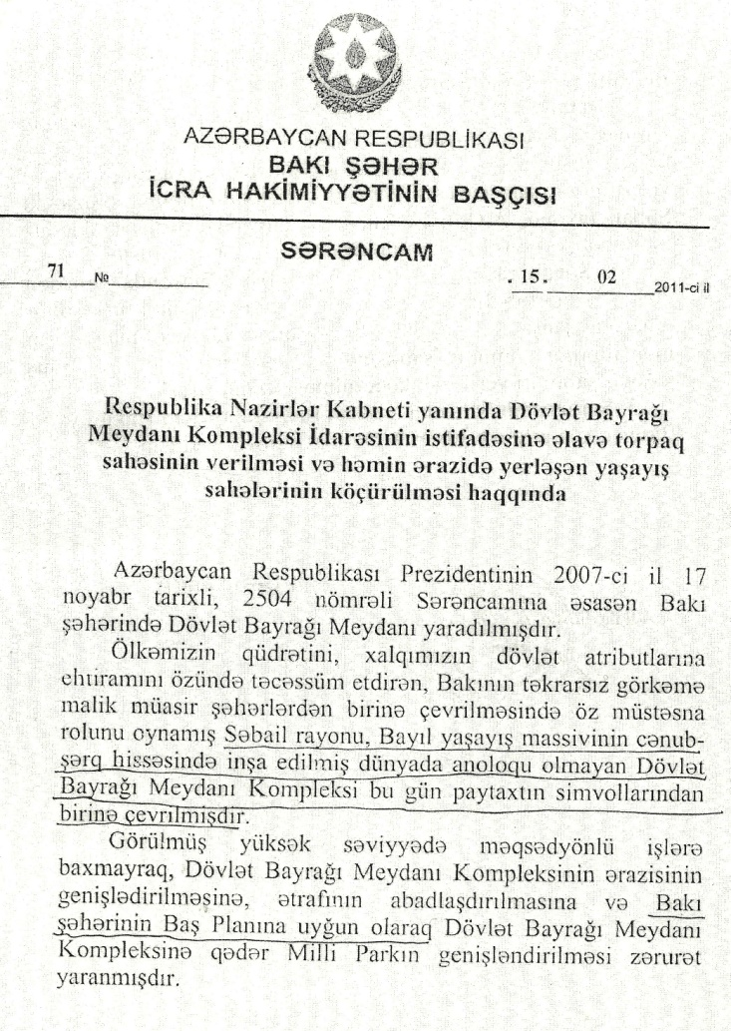
Picture 1. The order 71 of the Head of the Baku City EA made on 15 February 2011

Whereas, such “necessity” cannot be considered legal or grounded, because according to the paragraph 1 of the article 13 of the Constitution, property is inviolable in the Republic of Azerbaijan and is protected by the state.

According to the article 29 of the Constitution, right to property, including the right to private property is protected by law: “....Nobody shall be deprived of his/her property without the decision of law court. Total confiscation of the property is not permitted. Alienation of the property for state or public needs is permitted only after preliminary fair compensation of its cost”. According to the article 43 of the Constitution, nobody can be deprived of his home illegally.
Besides, according to the article 203.5 of the Civil Code, the alienation of the property owned by natural and legal persons for state and public needs permitted only after preliminary fair compensation of its cost.
But as one can see, according to the order 71 of the Head of the Baku City EA made on 15 February 2011, destruction of the residential and the non-residential spaces owned by the claimant was carried out in order to widen those territories and carry out renovation there.
According to the decree of the president made on 25 August 2000 concerning the application of the law on the Approval, entering into force of the Civil Code and legal regulation issues concerned with this, the authorities of “the relevant state structure” implied in the article 157.9 of the Code is not of the Baku CEA, but of the Cabinet of Ministers.
Along with that, according to the presidential decree 355 made on 24 November 2010 on the Establishment of a Department on the State Flag Square Complex affiliated to the Cabinet of Ministers, the determination and approval of the limits of the territory of the State Flag Square Complex within a month was assigned to the Cabinet of Ministers.
The 9 floor building situated at the A.Guliyev 5 address is facing the Flag Square. In the order 71 of the Head of the Baku City EA made on 15 February 2011 it is noted that, this building shall be moved in order to carry out the “renovation and greening works” in the Flag Square complex. There is neither a signature, nor a stamp in the notifications given to the inhabitants of the building concerned with the destruction and the enforcement displacement. İt only mentions “Displacement commission” at the end of the notification. No address was mentioned aither.

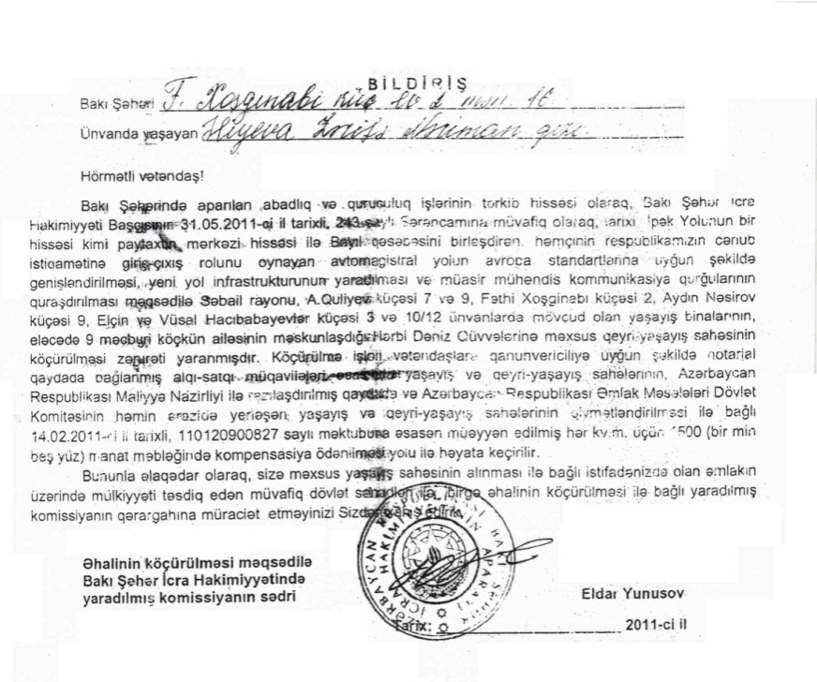
Picture 2. Notification disseminated among owners regarding the order 243 of the Baku City Executive Authority made on 31 May 2011

Along with that, people living in that territory received official notifications of the Baku City EA approved by its stamp, which says, “...As a part of the renovation and construction works held in Baku, in accordance with the order 243 of the Head of the Baku City Executive Authority made on 31.05.2011, it is necessary to resettle the buildings at the Sabail District, Agil Guliyev 7 and 9, Fathi Khoshginabi 2, Aydin Nasirov 6, Elchin and Vusal Hajibabayes 3 and 10/12, along with the non-residential spaces owned by the Naval Forces inhabited by 9 IDP families for the purpose of creation of the new road infrastructure and the modern engineering communication construction and widening of the highway connecting a part of the downtown with Bayil settlement as a part of the historical Silk Way, and playing the role of the entrance and the exit to the South of the country, in accordance with the European standards .

...With respect to this we recommend you to appeal to the headquarters of the commission established regarding the resettlement of the people together with the relevant state documents proving your ownership over the property you are using regarding the purchase of the territory owned by you” (Picture 2).

The order 188 of the Nasimi District EA made on 22 April 2011 (Destruction of buildings in the Ramstore area)

Execution of the aformentioned order resulted in the destruction of 5 floor buildings at Ahad Guliyev street (former 10th factory street) of the Nasimi district and the eviction of the inhabitants. Starting from the early 2011, the representatives of the Baku City EA notified the inhabitants, that the buildings in the aforementioned territory will be demolished for the purpose of a park construction and that the inhabitants would be forcefully resettled (Picture 3). After the continuous pressure the majority of the owners were forced to accept the compensation offered and consequently, leave the residences.

The order 76 of the Baku City EA made on 16 February 2011 (Destruction of buildings under the pretext of Winter Boulevard)

According to the Report of PAAFE on Situation with Property Rights in Azerbaijan released in 2011, this decree was considered legally ungrounded. It should be noted that, destructions concerned with this decree continued along Mirzagha Aliyev street in 2012 as well. On 9 March 2012 apartments in the building 231 were started to be destroyed without offering of any compensation to the inhabitants and/or signing of contracts with them. Preceedingly, on August 11, 2011 the office of the Institute for Peace and Democracy situated at Shamsi Badalbayli 38 was demolished illegally.

The order 243 of the Baku City EA made on 31 May 2011 (Destruction of buildings in the State Flag Square)
The order 243 of the Head of the Baku City EA made on 31 May 2011 determined that, the buildings situated on Agil Guliyev 7 and 9, Fathi Khoshginabi 2, Aydin Nasirov 6, Elchin and Vusal Hajibabayevs 3 and 10/12, along with the non-residential space owned by the Naval Forces inhabited by 9 IDP families shall be demolished and the population shall be moved.

The order consisted of 5 provisions: (1) 1500 AZN (determined by the Ministry of Finance and the State Committee on Property Issues) shall be paid for each square meter after the eviction of A.Guliyev 7 and 9, F.Khoshginabi 2, A.Nasirov 6, E.V.Hajibabayev 3 and 10/12 and 9 IDP families inhabiting the non-residential spaces owned by the Naval Forces; (2) The Baku City Housing Communal Production Union is determined as a client structure concerned with the emptying of the residential and the non-residential spaces and of the territory, where the destruction works will be carried out; (3) Establishment of a Commission for carrying out of moving of residential and non-residential territories mentioned in the order in accordance with law and for the solution of of disputes; (4) Assigning the authority of signing of contracts between citizens and the Baku CEA to the deputy head of the Office of head of the Baku CEA Zulfali Ismayilov; (5) The value of residential and non-residential spaces shall be transferred from the account of the Baku City Housing Communal Production Union to the deposit account of a notary after the signing of contracts.

As one can see from the text of the order, the Baku City EA has established the commission to ensure moving of residential and non-residential spaces. Employees of various committees and commissions and other structures of the Baku City EA were included to this commission. One of the 6 instructions given by the president to the Cabinet of Ministers in his ordinance on application of the law on Alienation of Lands for State Needs made on May 24, 2010 was the presentation of suggestions to the president regarding the resettlement plan and the resettlement instruction implied in the article 41.2 of the law on Alienation of Lands for State Needs within 3 months. But long time after the signing of the aforementioned ordinance (whereas the Instruction was supposed to be prepared within three months) the Cabinet of Ministers approved the Rule on Preparation of Resettlement Plan and Resettlement Instruction on February 24, 2012 at last. Unfortunately the approved resettlement Plan has not being applied so far during resettlement of the citizens. The established commission attached to the Baku CEA has not prepared any resettlement plan regarding the resettlement of the residential and the non-residential spaces under the power of the decree 243, neither has informed the citizens beforehand their resettlement plan for to provide them time for the necessary preparation before they will be required to leave the territory during the resettlement, , nor they have been informed of their participation in its implementation.

RECOMMENDATIONS

For tackle forced evictions and illegal house demolitions government of Azerbaijan shall take the following steps:

- The right to adequate housing should be fully integrated into all policies, projects and activities concerning housing, in particular those designed by government;

- It is important to stop any destruction works in the city until the Baku City General Plan and the Regional Development Plan is approved;
- It should be considered to increase the amount of compensation since the amount offered in compensation for damages to the citizens is not adequate to the damage occurring to them;
- The appeals and the complaints of citizens regarding destruction of their private property real estate without a court decision shall be reviewed and thoroughly investigated;

- To ensure efficient management of fast continuing construction works in Baku and in order to ensure the inviolability of private property Cabinet of Minister shall speed up the development of new Chief Plan of Baku and involvement of civil society in this process;
- To prevent the abuse of the definition of ‘government’s needs’, to improve the relevant legislation in order to bring the government programs in accordance with the government’s needs;
- To minimize the violation of property rights in the processes of eviction Baku CEA shall notify the population about the evictions in advance, publicize the Orders made for these purposes, determine the amounts of compensations and ensure transparency in the processes of payment of such compensations.
- Azerbaijan ratified the International Convention on Economic, Social and Cultural Rights on August 13, 1992. Along with that, Azerbaijan also has international obligations prohibiting forceful eviction and destruction of houses under the jurisdiction of the European Court as a party to the European Convention on Human Rights since April 15, 2002. The state shall observe its international obligations concerned with the effective resettlement and reintegration policy in the context of the respect to justice and human rights during the forced evictions;

Annexes

Map and Statistics of violation of property rights in Baku
http://freeeconomy.az/wp-content/uploads/2013/03/Map-and-Statistics-of-violation-of-property-rights-in-Baku.pdf

Annex-1 “On condition of right to property in 2011-2012 in Azerbaijan” is added to this supplementary information.

http://www.state.gov/j/drl/rls/hrrpt/2010/eur/154413.htm
http://www.hrw.org/reports/2012/02/29/they-took-everything-me-0
CESCR, General Comment No 4: The Right to Adequate Housing (Article 11), UN Doc HRI/GEN/1/Rev.5 (2001) 22
Map and Statistics of violation of property rights in Baku”
Information regarding to 2012 covers January and March.
http://www.business-anti-corruption.com/country-profiles/europe-central-asia/azerbaijan/
http://youtu.be/4d6W1OT1U8s
http://www.azadliq.org/content/article/24294298.html
http://cabmin.gov.az/?/az/pressreliz/view/626/

