BRIEFING ON EGYPT FOR THE COMMITTEE ON THE RIGHTS OF THE CHILD, SESSION 96 PRE-SESSIONAL WORKING GROUP- SEPT. 2023
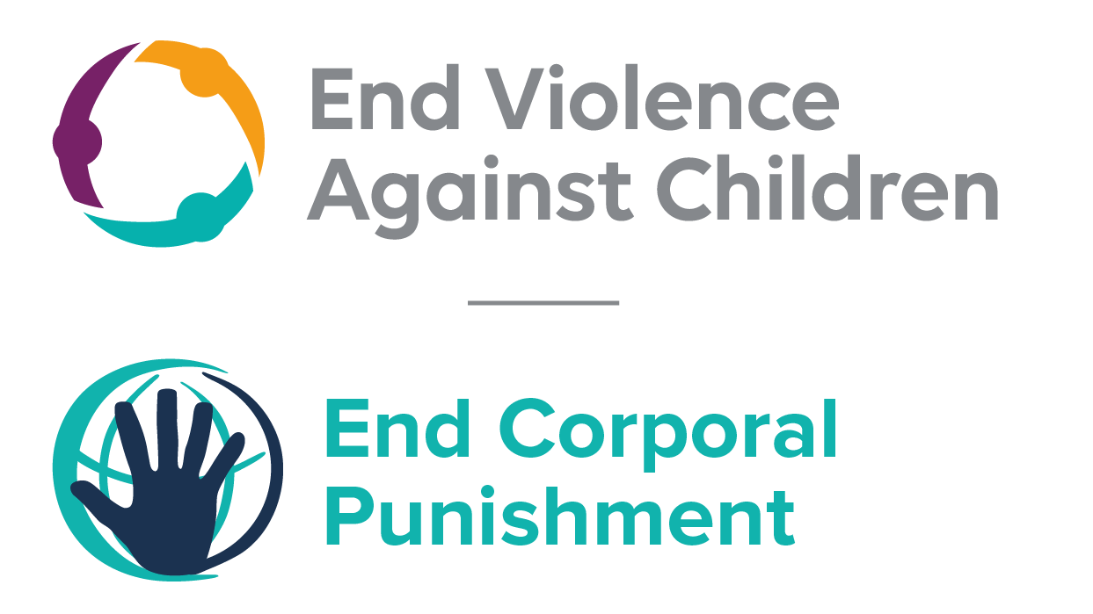
The Global Partnership to End Violence Against Children, June 2023

This briefing describes the legality of corporal punishment of children in Egypt. In light of the Committee’s General Comment No. 8 on “The rights of the child to protection from corporal punishment of children and other cruel or degrading forms of punishment”, its repeated recommendations on the issue and the importance of eradicating this form of violence given by the UN Secretary General’s Study on Violence against Children. Considering the recommendations to prohibit all corporal punishment made during the Universal Periodic Review in 2019, as well as the global commitment to ending all violence against children in the context of the 2030 Agenda for Sustainable Development, we hope the Committee will:
• in its List of Issues for Egypt, raise the issue of corporal punishment of children, in particular asking what steps are being taken to enact a legislation to explicitly prohibit corporal punishment of children in all settings; and,
• in its concluding observations on the fifth- sixth report of Egypt, recommend that a legislation is enacted as a matter of priority to explicitly prohibit corporal punishment of children, in all settings including the home and repeal all provisions allowing the use corporal punishment by adults.

Summary of necessary legal reform to achieve full prohibition
Prohibition is still to be achieved in the home, alternative care settings, day care and possibly schools; prohibition in penal institutions requires confirmation.
Article 7bis of the Child Law confirms the “right to discipline” of parents and carers, and legal provisions against violence and abuse are not interpreted as prohibiting corporal punishment. This article should be repealed and prohibition enacted of all corporal punishment of children by parents and others with parental authority.
Alternative care settings – Prohibition needs to be enacted in legislation that is applicable to all alternative care settings (foster care, institutions, places of safety, emergency care, etc).
Day care – Corporal punishment should be prohibited in all early childhood care (nurseries, crèches, kindergartens, preschools, family centres, etc) and all day care for older children (day centres, after-school childcare, childminding, etc).
Schools – The ministerial directive against corporal punishment in schools must be confirmed in legislation, which should clearly prohibit all corporal punishment in all education settings, public and private.
Penal institutions – Corporal punishment is prohibited in prisons; prohibition is required that it is also prohibited in social welfare institutions.

- Current legality of corporal punishment in Egypt
  - Home: Corporal punishment is lawful in the home. Act No. 126 2008 amended the Children’s Act 1996 to strengthen legal protection for children’s rights, including protection from harm. Article 1 of the amended Act states that the State shall guarantee as a minimum requirement the same rights provided for in the Convention on the Rights of the Child and other relevant international instruments applicable in Egypt. However, efforts to introduce full prohibition of corporal punishment of children into the law were unsuccessful. Article 3 states that the law shall ensure “the right of the child to life survival, and development in a supportive family environment, to enjoy various preventive measures, and to be protected from all forms of violence, or injury, or physical, mental or sexual abuse, or negligence, or negligent treatment, or any other forms of maltreatment or exploitation”. But article 7bis confirms parents/carers’ “right to discipline”, stating: “With due consideration to the duties and rights of the person who is responsible for the care of the child, and his right to discipline him through legitimate means, it is prohibited to intentionally expose the child to any illegitimate physical abuse or harmful practice.” Provisions against violence and abuse in the Children’s Act, the Criminal Code 1937 and the Constitution 2012 are not interpreted as prohibiting all corporal punishment of children.

1.2 Alternative care settings: Corporal punishment is lawful in alternative care settings under the “right to discipline” in article 7bis of the Children’s Act (see under “Home”).

  - Day care: Corporal punishment is lawful in early childhood care and in day care for older children under the “right to discipline” in article 7bis of the Children’s Act (see under “Home”).

  - Schools: A ministerial directive of 17 November 1998 states that corporal punishment should not be used in schools but there appears to be no explicit prohibition of corporal punishment in law. The National Council for Childhood and Motherhood has called for the ministerial directive to be confirmed in law, but to our knowledge this has not yet been achieved. A 2014 decree “absolutely prohibit[s]” physical punishment or verbal abuse of students subject to penalties under the “Rules Organizing the Disciplinary Responsibility of Civil Servants.” A 2016 decree states that corporal punishment is not an approved disciplinary measure that school staff may take to deal with student “infractions” such as tardiness, not wearing a uniform, and alarmingly, “harming national unity or incitement against the nation.” We have been unable to examine the text of Decree 287/2016 on school discipline.
  - Penal institutions: Corporal punishment is unlawful as a disciplinary measure in prisons. The provision for flogging prisoners in Law No. 396 1956 was repealed by Law No. 152 2002. Under article 42 of the Children’s Act any person arrested or detained “shall be treated in the manner concomitant with the preservation of his dignity” and “no physical or moral harm is to be inflicted upon him”. Article 40 of the Code of Criminal Procedure states that any person detained “shall be treated in a manner that preserves his human dignity, he should not be harmed physically or mentally”. Article 36 of the Constitution 2012 states: “Anyone who has been arrested, jailed, or restricted in his freedom in any form is entitled to being treated in a way that respects his dignity. He must not be tortured, threatened, or degraded. He must not be harmed physically or mentally.” However, we have been unable to ascertain the legality of corporal punishment in social welfare institutions, in which children below 16 years convicted of crime may be detained. The Human Rights Association for the Assistance of Prisoners has documented flogging of juveniles in social care institutions.
  - Sentence for crime: Corporal punishment is unlawful as a sentence for crime. It is not a permitted sentence for children between the ages of 7 and 15 years under the Children’s Act 1996 (art. 101). Children between 15 and 18 receive reduced penal sentences, and these do not include corporal punishment.

Recommendations by human rights treaty bodies and during the UPR

  - CRC: On two occasions, the Committee on the Rights of the Child has recommended to Egypt that legislation be enacted to explicitly prohibit corporal punishment in all settings: in its concluding observations on the state party’s second report in 2001, and on the third-fourth report in 2011.

  - ACERWC: In 2009, in its concluding observation on the state party’s initial report, the African Committee of Experts on the Rights and Welfare of the Child recommended that the Government take the necessary measures to abolish the practice of corporal punishment.

  - UPR: At the third cycle of the Universal Periodic Review of Egypt in 2019, two recommendations to adopt legislation to explicitly prohibiting corporal punishment were issued. The Government later partially supported the first one, stating that the “law prohibits the application of corporal punishment to children in all settings”. It supported the second one, stating that “in all cases, the imposition of corporal punishment upon children is prohibited by law. Moreover, Law No. 152 of 2001 abolished the punishment of whipping, being the last corporal punishment that existed hitherto.”

Ministerial Decree no. 264, issued May 20, 2014, Annex, articles 5, 10, on file with Human Rights Watch.
Ministerial Decree no. 287, issued on September 19, 2016, second Annex, on file with Human Rights Watch.
Detention and Detainees in Egypt 2003: Sixth Annual Report on the Condition of Prisons and Detention Centres
21 February 2001, CRC/C/15/Add.145, Concluding observations on second report, paras. 37 and 38
15 July 2011, CRC/C/EGY/CO/3-4, Concluding observations on third/fourth report, paras. 57 and 59
November 2009, Concluding observations on initial report, recommendation 10
9 March 2020, A/HRC/43/16/Add.1, Report of the Working Group: Addendum

