Assessment of Economic and Social Rights Fulfilment in Peru
Submission from the Human Rights Measurement Initiative to the United Nations Committee on Economic, Social and Cultural Rights for the 77th Pre-Sessional Working Group Geneva, February 2025.
I. Reporting Organisation
1. The Human Rights Measurement Initiative (HRMI) measures the human rights performance of countries, including Peru. HRMI is an independent, not-for-profit NGO with a primary base of operations in New Zealand, and a second base in the United States at the University of Georgia’s Center for the Study of Global Issues (GLOBIS).
II. Assessment Methodology
2. HRMI uses the award-winning and peer-reviewed SERF Index methodology to measure the fulfilment of economic and social rights (ESR).
3. This methodology uses bellwether indicator data from international organisations—such as the World Health Organization and UNICEF—and compares each country’s achievement to what other countries at the same level of income have achieved. In this way, HRMI measures progressive realisation of economic and social rights (ESRs) as defined in the International Covenant on Economic, Social, and Cultural Rights (ICESCR). A country’s income-adjusted HRMI score is a measure of how well its government is converting its resources into good human rights outcomes for its people.
4. HRMI supplements these scores with qualitative information sourced by a confidential survey of on-the-ground human rights experts, such as NGO researchers, journalists, and human rights lawyers and advocates. For more details on HRMI’s methodology, please refer to the resources on our website. All HRMI’s data are published annually on the Rights Tracker and are freely available for non-commercial use under a Creative Commons License. HRMI’s Rights Tracker is a certified Digital Public Good with the Digital Public Good Alliance.
III. Overview of Economic and Social Rights Fulfilment in Peru
5. HRMI’s most recent ESR scores for Peru measure its achievement as of 2021 and show room for improvement. They are shown in the graph below.

6. Peru’s scores for 2021 are as follows:
▪ Overall Quality of Life score = 82.7%
▪ Right to education = 79.5% (bad)
▪ Right to food = 87.3% (fair)
▪ Right to health = 83.3% (bad)
▪ Right to housing = 76.1% (bad)
▪ Right to work = 87.4% (fair)
7. These scores fall in the ‘bad’ and ‘fair’ ranges, with no headline scores in the ‘very bad range, but none reaching the ‘good’ range.
8. Peru scores 82.7% on Quality of Life when scored against the 'Income adjusted' benchmark. This score takes into account Peru’s resources and how well it is using them to make sure its people's Quality of Life rights are fulfilled.
9. This score tells us that Peru is only doing 82.7% of what should be possible right now with the resources it has. This score may seem positive, however, since anything less than 100% indicates that a country is not meeting its current duty under international human rights law, our assessment is that Peru has a long way to go to meet its immediate economic and social rights duty.
10. Compared with other countries in the Americas, Peru is performing lower than average on Quality of Life rights.
IV. Right to Education
11. HRMI defines the right to education in accordance with ICESCR Article 13 and CESCR General Comments 11 and 13. In the case of low- and middle-income countries, such as Peru, HRMI further breaks down the right to education into three areas of measurement: primary school enrolment, secondary school enrolment, and quality of education. Our scores show challenges in the secondary education area and significant challenges in the quality education area.
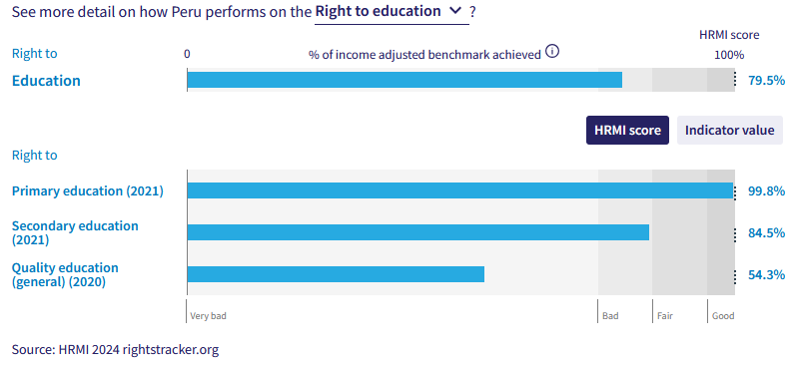
12. Peru ranks as the top within the Americas and is 8th in the world in terms of primary education enrolment, achieving 99.8% of what is possible with their available resources. Peru has held an excellent HRMI score for an extended period across two decades and has shown recent growth following a dip in score over the 2015-2019 period.
13. Peru’s secondary education score has varied over the previous two decades. Peru sits above average at 13th of 35 countries in the Americas for secondary education enrolment. However, their HRMI score reached a peak of 87.7% in 2011 but has since decreased to 84.5% in 2021. The current HRMI score of 84.5% falls into the ‘bad’ range.
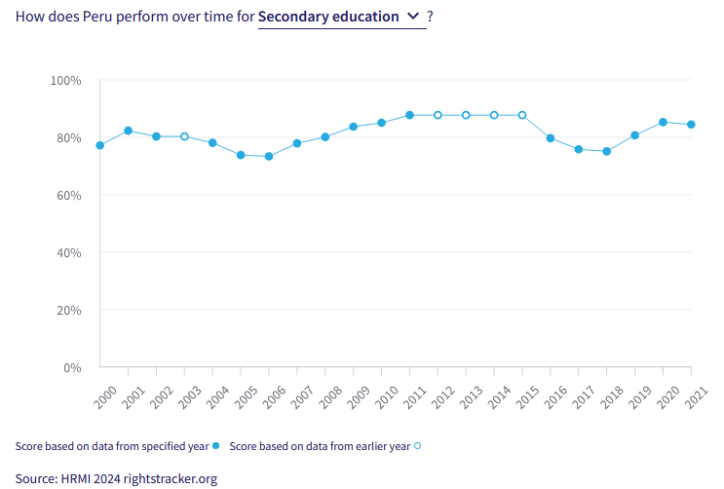
14. The quality education score is in the ‘very bad’ range. Peru is achieving only 55.3% of what we calculate ought to be possible in terms of quality of education. However, some recovery has been made over the 2018-2021 period.
V. Right to Food
15. HRMI defines the right to food in accordance with ICESCR Article 11 and CESCR General Comment 12. For low- and middle-income countries, such as Peru, HRMI first uses a bellwether indicator of how many children are growing well (are not stunted). Peru’s score for the right to food is 87.3% and falls in the ‘fair’ range. This means that Peru is doing 87.3% of what ought to be possible to ensure the right to sufficient healthy food for its people. This score draws on indicator data on child stunting rates published by the UNICEF-WHO-World Bank: Joint child malnutrition (JME) database.
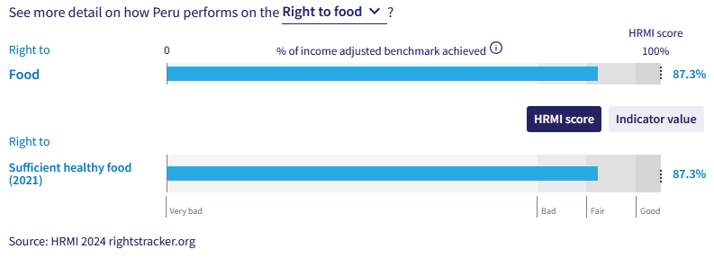
16. Peru is currently achieving 87.3% of what is possible regarding the right to sufficient healthy food. Whilst this score is still within the ‘fair’ range, Peru has made continued improvement over the past two decades. In 2000, the HRMI score for the right to food was only 61.6%.
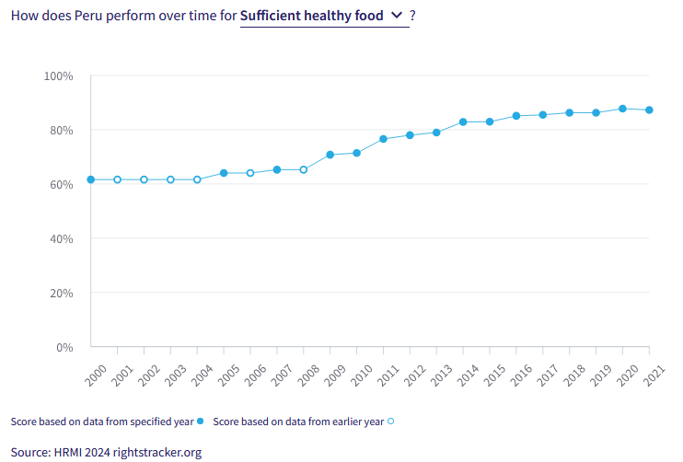
VI. Right to Health

17. HRMI defines the right to health in accordance with ICESCR Article 12.1 and CESCR General Comment 14. In the case of low- and middle-income countries, such as Peru, HRMI uses three indicators to measure the country’s achievement in child health, adult health, and reproductive health. Peru is currently allocating a ‘good’ score 96.9% of its available resources to child health, yet the HRMI score for adult health lies in the ‘bad’ range and reproductive health in the ‘very bad’ range.
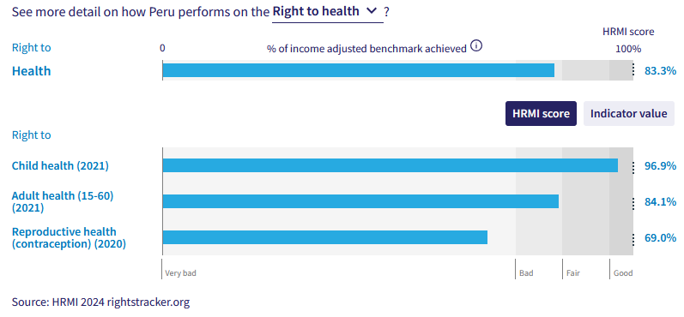
18. The overall right to health has a HRMI score of 83.3% and sits within the ‘bad’ range. Over the past two decades, the right to health has steadily remained at this benchmark. However, there has been a decline over the 2020-2021 period.

19. Peru currently holds a 69.0% score for the right to reproductive health, indicating that it is inefficiently turning its resources into good outcomes for its people. Peru has been sitting around this score for the past two decades, gradually rising from an all-time low HRMI score of 61.7% in 2005 to 69.0% over 15 years.

20. Child health scores have increased gradually for Peru over the course of two decades. The HRMI score has risen from a ‘fair’ score of 91.6% in 2000 to a ‘good’ score of 96.9% in 2021 and an all-time high of 97.1% in 2020. This score places Peru slightly above average when compared with other counties in the Americas.

21. Over the period of 2000-2019 adult health as incrementally increased from 88.1% to 92.7% which was within the ‘fair’ range. However, over 2020 and 2021, this score has fallen, probably reflecting death rates during the Covid-19 pandemic.

22. Peru is currently on track to achieving full progressive realisation of child health rights and is close to meeting its immediate human rights obligations under international law. However, significant further progress will be required to realise the rights to reproductive and adult health.

VII. Right to Housing

23. HRMI defines the right to housing in accordance with ICESCR Article 11.1 and CESCR General Comment 4. In the case of low- and middle-income countries, such as Peru, HRMI uses an assessment standard that measures the right to water on premises and ‘basic’ sanitation (each household having its own improved toilet facilities). For basic sanitation, Peru has a score within the ‘bad’ range, and for water, its score is sitting within in the ‘fair’ range. The overall HRMI score for the right to housing is 76.1%, falling within the ‘bad’ range.

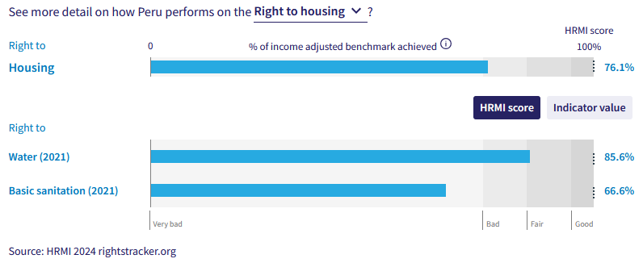
24. In Peru, 87.1% of households have water on premises as of 2021. Given what other countries with the same level of income have shown to be possible, these statistics lead to a HRMI score of 85.6% for the right to water. However, the HRMI score has risen slowly from 76.5% in 2000 to the current score of 85.6% in 2021. More people in Peru would have access to these necessities if Peru used the maximum available resources towards progressive realisation of these rights.

25. There have been minor improvements regarding basic sanitation over the past two decades. Peru was only achieving 59.7% of what was possible in 2000, which has now gradually risen to 66.6% in 2021. This score places Peru 5th from the bottom of the 40 assessed countries in the Americas, which demonstrates Peru is performing far lower than average and is far from meeting their immediate human rights requirements under international law.

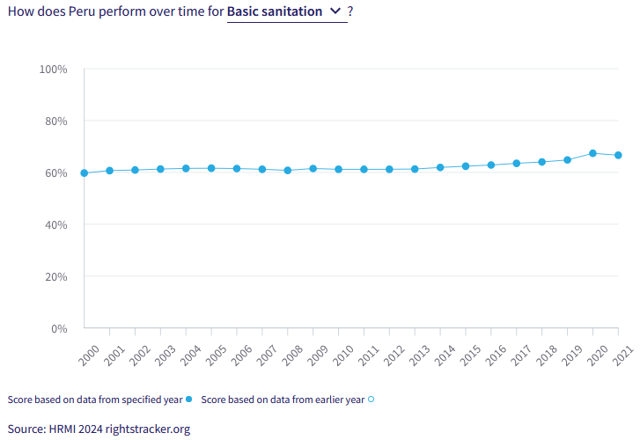
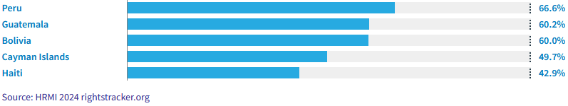Caption: HRMI Rights Tracker, income adjusted benchmarks – Americas, right to basic sanitation, bottom 5 countries

VIII. Right to Work and Social Security

26. HRMI measures the right to work in accordance with ICESCR Articles 6 and 7. For low and middle-income countries, such as Peru, HRMI measures the right to work and social security using a subsistence income indicator. According to the World Bank PovcalNet in 2021, in Peru, the percentage of people who were not absolutely poor was 89.8%, leading to a ‘fair’ HRMI score of 87.4%, indicating that Peru still has way to go to meet its immediate obligations for the right to work.
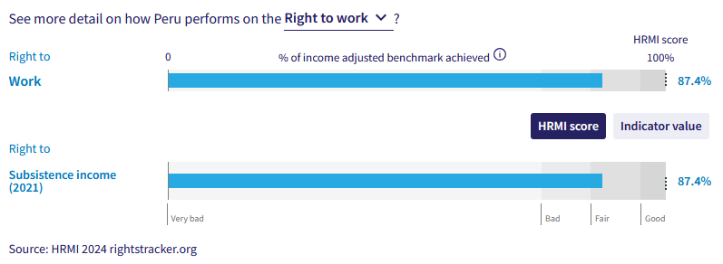
27. Over the course of the last two decades, Peru has had a consistent increase regarding this right. Peru reached a peak score of 87.9% in 2019 increasing from a HRMI score of 67.6% in 2000. This score saw a minor decrease in 2020 down to 79.7% before rising again to its current score of 87.4% in 2021.
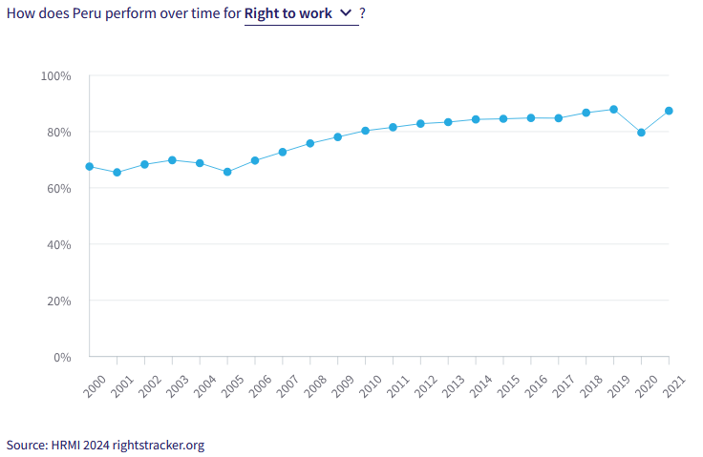
X. Concluding Remarks

28. Peru’s best HRMI score are for primary school enrolment, where it is a world leader, and child health.

29. Peru’s most concerning scores are for quality of education; reproductive health; and basic sanitation. For these rights, Peru needs to make large changes in order to meet its obligations; but our analysis is that it has the resources to do much better immediately.

30. Peru has improved its scores significantly for the right to food and the right to work.

28. HRMI respectfully submits its data and findings on the fulfilment of economic and social rights in Peru. We hope that this Submission will serve as a useful resource to the Committee on Economic, Social and Cultural Rights for drafting specific and meaningful questions to Peru during the CESCR’s 77th Pre-Sessional Working Group.

Prepared by:
Thalia Kehoe Rowden
Sarah Bakewell
Regan Joyce
Sam Turner

Visit HRMI’s website to learn more about our mission and work, https://humanrightsmeasurement.org/.
This content represents the opinions of the Human Rights Measurements Initiative. It carries no endorsement of the University of Georgia.
See HRMI’s methodology for measuring economic and social rights: https://humanrightsmeasurement.org/methodology and https://rightstracker.org/page/methodology.
Ibid
Ibid
HRMI 2024 Rights Tracker, https://rightstracker.org/
See Human Rights Measurement Initiative (HRMI) Digital Public Good Certificate, https://app.digitalpublicgoods.net/a/11781 The Digital Public Goods Alliance is endorsed by the UN Secretary General’s “Roadmap for Digital Cooperation,” https://www.un.org/en/content/digital-cooperationroadmap/assets/pdf/Roadmap_for_Digital_Cooperation_EN.pdf. It defines digital public goods as: “open source software, open data, open AI models, open standards and open content that adhere to privacy and other applicable laws and best practices, do no harm, and help attain the SDGs,” https://digitalpublicgoods.net/standard/.
HRMI 2024 Rights Tracker, https://rightstracker.org/country/PER?tab=report-esr
The labels on the country charts of good, fair, bad, and very bad are used to give a general indication of how to understand the scores. HRMI’s income adjusted Quality of Life scores can be broadly interpreted as showing the percentage of the country’s obligation it has met, compared to what the best performing countries have achieved at each income level. A country scoring below 75% with a label of “Very bad” is failing to put in place the kinds of structures and policies that help people claim the right concerned, but the structures and policies in place most likely prevent many people from claiming their rights. See HRMI’s methodology for measuring human rights, https://rightstracker.org/page/methodology.
HRMI 2024 Rights Tracker, https://rightstracker.org/country/PER?tab=report-esr&qolFdScore=hrmi
HRMI 2024 Rights Tracker, https://rightstracker.org/metric/esr?region=americas
HRMI 2024 Rights Tracker, https://rightstracker.org/metric/education.
HRMI 2024 Rights Tracker, https://rightstracker.org/country/PER?tab=report-esr
HRMI 2024 Rights Tracker, https://rightstracker.org/metric/tot-sec-enrol?tab=report-esr
HRMI 2024 Rights Tracker, https://rightstracker.org/country/PER?tab=report-esr
HRMI 2024 Rights Tracker, https://rightstracker.org/country/PER?tab=report-esr
HRMI 2024 Rights Tracker, https://rightstracker.org/metric/not-stunted.
HRMI 2024 Rights Tracker, https://rightstracker.org/country/PER?tab=report-esr&as=core
HRMI 2024 Rights Tracker, https://rightstracker.org/country/PER?tab=report-esr&as=core
Ibid
HRMI 2024 Rights Tracker, https://rightstracker.org/metric/contraception?tab=report-esr
Ibid
HRMI 2024 Rights Tracker, https://rightstracker.org/metric/under-5-survival?tab=report-esr
HRMI 2024 Rights Tracker, https://rightstracker.org/country/PER?tab=report-esr
HRMI 2024 Rights Tracker, https://rightstracker.org/country/PER?tab=report-esr
Ibid
Ibid
HRMI 2024 Rights Tracker, https://rightstracker.org/country/PER?tab=report-esr&qolFdScore=hrmi

