INTERNATIONAL CONVENTION ON THE ELIMINATION OF ALL FORMS OF RACIAL DISCRIMINATION

THE ALTERNATIVE (thematic) REPORT TO COMBINED TWELFTH TO FOURTEENTH PERIODIC REPORTS OF THE REPUBLIC OF ARMENİA SUBMITTED TO THE COMMITTEE ON THE ELIMINATION OF RACIAL DISCRIMINATION (CERD)

This alternative (thematic) report is submitted to the UN Committee on the Elimination of All Forms of Racial Discrimination and is dedicated to the cases of Armenia's violation of rights stipulated on the Articles 2-7 of the UN Convention on the Elimination of All Forms of Racial Discrimination. The report had been prepared jointly with the Citizens' Labour Rights Protection League and the Human Rights Education and Research Public Association


Citizens' Labour Rights Protection League
Baku AZ1006, N.Narimanov str., 11/16
Azerbaijan
Telephone: +(994 12) 5104271;
Mobile: +(994 50) 314 49 15
e-mail: sahib.mammadov@gmail.com ; office@labourrights-az.org
http://labourrights-az.org/en


Human Rights Education and Research Public Association
Azerbaijan, Baku, S.Orujov Street, building 1, aprtm.21
Email:hrtrpa@gmail.com

Information about the NGOs that submitted the report:
The Citizens' Labour Rights Protection League (CLRPL) is a non-governmental organization operating in Azerbaijan and was founded in 1997. The mission of the NGO is the protection of human rights. For this purpose, the organization monitors various fields of human rights, prepares reports, and conducts strategic litigation. CLRPL has been cooperating with UN treaty and charter bodies for many years. It mainly prepares and presents alternative (shadow, thematic) reports to relevant UN Committees related to periodic reports of Azerbaijan. The number of different alternative reports submitted by CLRPL to UN committees on Azerbaijan is as follows: 3 alternative reports to the Human Rights Committee, 3 alternative reports to the Committee on Economic, Social and Cultural Rights, 1 alternative report to the Committee on the Rights of Persons with Disabilities, 2 alternative reports to the Committee on the Elimination of Discrimination against Women, 2 alternative reports to the Committee for the Protection of Migrant Workers and Their Family Members, 1 alternative report to the Committee on the Elimination of Racial Discrimination (short report). The NGO submitted several alternative reports on Armenia to the relevant UN Committees. CLRPL also prepared counter-information to Azerbaijan's 1st and 4th cycle reports on the Universal Periodic Review (UPR) procedure. http://labourrights-az.org/en/

The Human Rights Education and Research Public Association is a partner of the Citizens' Labour Rights Protection League (CLRPL) and participates in the joint preparation of alternative reports. It was founded in 2010. Its main activity is to carry out educational activities in the field of universal human rights and freedoms and conduct research in this field.

1.Brief historical information
The State of Armenia, which declared its independence in 1918, was formed in the territories inhabited by various peoples, mainly Turks (Azerbaijani), Armenians, Kurds, and partially Russians. This new state was ethnically diverse 100 years ago, but now it is the most monoethnic state in the world. Thus, up to 99% of the country's population are Armenians. Unfortunately, in the report submitted to the "Committee for the Elimination of Racial Discrimination", the State of Armenia did not mention the policy and activities of its racial discrimination. On the contrary, the State of Armenia devoted a significant part of its report to the neighboring state, and also included false, unsourced and untrue information in the periodic report. Thus, the State of Armenia did not provide information in the report about the activities it should implement in the reporting period under the UN Convention on the Elimination of All Forms of Racial Discrimination, and about its legal and practical activities related to the Committee's previous notes, remarks and recommendations¹. Instead, the State of Armenia submitted a report that did not comply with the Committee's regulations by providing false and unsourced information about the territories it had occupied and effectively controlled for 30 years.
İn 1918 77.5% of the population in the territory of the Armenia were Azerbaijanis (Azerbaijani Turks) and 22.5% were Armenians, but in 2022, the number of Azerbaijanis living in Armenia is 0%. During 1918-1991, there were 3 forced deportations of Azerbaijanis from the territory of Armenia. These are deportations in 1918-1920, 1948-1953 and 1988-1991. These deportations were forced displacements that resulted in the deaths of many people. During the periods between these deportations, a large part of the population voluntarily left the territory of Armenia as a result of policies against Azerbaijanis, racism, prohibition of the use of the mother tongue and etc. After the last forced deportation, there are no Azerbaijanis (Azerbaijani Turks) in the territory of the State of Armenia. During the last deportations that took place in 1988-1991, 250,336 Azerbaijanis from 22 districts (40,928 families from 172 Azerbaijani settlements, 89 Azerbaijani-Armenian mixed settlements) were forcibly deported from their territories. Some of them were killed, wounded, and died in snow storms on the roads. Also, as a result of the war started against Azerbaijan, Armenia took control of the former Nagorno-Karabakh Autonomous Province and 7 surrounding districts and forcibly deported more than 700,000 non-Armenian people living in those territories.
The Republic of Armenia, which declares racial, national and religious discrimination as the main direction of its policy, violated the laws of war and took hostages of the civilian population in the territories under its control, and also deported the non-Armenian civilian population from the territories.
In 1992-2020, no civilian population of Azerbaijani origin lived in the territories of Azerbaijan under the effective control of Armenia. All residential and non-residential buildings, infrastructure were destroyed and fauna and flora were degraded in the territories where Azerbaijanis were deported.
Until the beginning of the 1990s, there were 2625 monuments in the territories occupied by Armenia for 30 years. A total of 706 monuments, including 11 monuments of international importance, 240 monuments of national importance and 455 monuments of local importance, were protected by the state.
After the liberation of the territories, it was recorded that 40,000 museum heritage, more than 900 historical and cultural monuments, 403 historical-religious places, 67 mosques, 144 temples, and 192 shrines were destroyed or looted in those territories.
During the occupation, 927 libraries with 4.6 million book collections, 808 cultural palaces, clubs and culture houses, 85 music and art schools, 22 museums and museum branches with a collection of more than 100,000 exhibits, 4 art galleries, 4 theaters, 2 concert institutions, 8 cultural and recreational parks, including one of the oldest settlements in the world - Azikh cave (Fuzuli region), Shusha State Historical-Architecture Reserve were destroyed.
Between 1992 and 2020, hundreds of gold-seeking gangs operated in the cemeteries of the occupied territories. Since most of the local population used gold teeth, the graves in this area were dug up and the teeth of the corpses were removed. For this purpose, hundreds of cemeteries were destroyed in areas where 700,000 people lived. Currently, the identification process is ongoing. On the Armenian side, these grave digging works were called "gold fever" ironically.
At the same time, thousands of historical, cultural, and architecturally important monuments in the territory of Armenia were completely destroyed, and some of these monuments were reconstructed and presented either as Armenian monuments or as monuments belonging to other nations. Although 310 mosques were registered in the territory of Iravan governorate at the beginning of the 20th century, in 1915 the number of mosques in the territory of Iravan and Zangezur governorates increased to 391, of which 382 were Shia and 9 were Sunni mosques. Starting from 1918, all these mosques were destroyed by the Armenians. Armenians took over 234 schools, 214 libraries, 268 cultural institutions, 235 health centers, 112 kindergartens, and 152 households in the territories where Azerbaijanis were forcibly deported in 1988-1991. 223 cemeteries, 49 mosques, 68 historical-architectural monuments were gradually destroyed by the Armenian authorities over time. In general, more than 5,000 cultural monuments were consciously and plannedly destroyed by Armenians, and all toponyms were Armenianized. Currently, only the Blue Mosque is active on the territory of Armenia, and several mosques in the regions have partially survived. Blue Mosque is presented to foreign guests as a "Persian" mosque.
Toponomic names and acronyms have been completely changed. More than 1000 toponomic names were changed during 1924-1988. 57 settlements were renamed in 2006 and 21 in 2007.
All the mentioned happened as a result of religious, national and racial hatred and discrimination.
2.About the first part of the periodic report of the Republic of Armenia
As mentioned, Armenia occupied 20% of the territory of Azerbaijan during 1990-1994. The former Nagorno-Karabakh Autonomous Province inhabited by the Armenian population was one of the occupied territories, and this territory was a small part of the total occupied territories. The information mentioned in the first part (paragraph 4) of the “Issues worth attention of the Committee. Manifestations of racism and extreme hatred towards Armenians” part of the periodic report submitted by the State of Armenia is not true. The Second Karabakh War, which began on September 27, 2020, took place as a result of a pre-planned military operation by the Armenian armed forces. The war was started by Armenia in accordance with the "New war for new territories" doctrine³ announced by the Minister of Defense of Armenia, David Tonyan, in March 2019 in New York, USA. The war resulted in the defeat of the Armenian armed forces and ended with a ceasefire agreement⁴ on November 10, 2020. According to paragraph 5 of the report, the opinions claimed by Armenia regarding the participation of mercenaries and Turkish Armed Forces in the war have not been confirmed by any evidence. On the contrary, Armenia involved mercenaries from Lebanon and other countries into the war, and during the war, some of such mercenaries were captured by Azerbaijan.
The territories called "Nagorno-Karabakh Republic" or "Artsakh Republic" and 7 administrative territories around it were occupied by the Armed Forces of the Republic of Armenia in 1990-1993 (the 366th military unit of the former USSR participated in a number of operations). 4 resolutions of the UN Security Council have been adopted regarding the immediate withdrawal of Armenian Armed Forces from this territories.
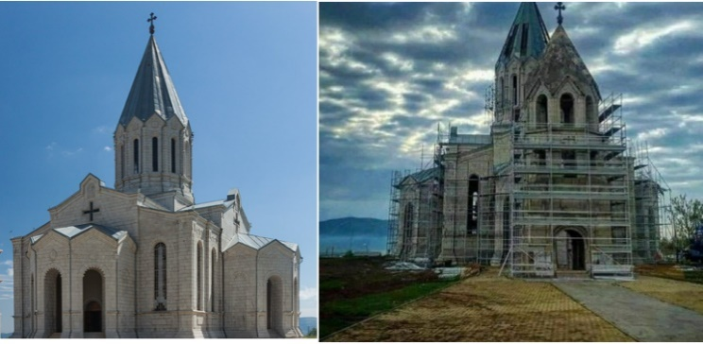
For the first time in history, the Armenian people declared a state called Armenia in 1918. The former Nagorno-Karabakh Autonomous Province, which was occupied by Armenia and was under the de facto administration of Armenia until November 2020, is historical territory of Azerbaijan and became part of the Russian Empire with the 1805 Treaty of Kurakchay.
The occupation of the territories by the Armed Forces of the Republic of Armenia and the management (effective control) of the territories by Armenia are also indicated in the "Case of Chiragov and others v. Armenia"⁵ decision adopted by the Grand Chamber of the European Court of Human Rights on December 12, 2017.
The Prime Minister of the Republic of Armenia Nikol Pashinyan mentioned these words in his speech at the opening of the "All-Armenian Sports Games" organized in the occupied territories: “Thus, Armenian capital has a homeland, because its owners have a homeland - Armenia, and Artsakh is Armenia, and that is all”.
The information provided in subsections 8, 9 and 10 of the first part of the periodical report of Armenia is not true. During the period of military operations, the population of Armenian origin living in the territories (before the military operations and during the military operations, only the population of Armenian origin lived in the territories) temporarily left the territories. However, after the agreement of November 10, 2020, they returned to their homes with the help of Russian Military Forces (the so-called Peacekeeping Forces) and are currently living in those territories.
However, Armenia maintained a 12,000-strong military presence in the areas under the jurisdiction of the Russian peacekeeping forces (known as peacekeeping forces), despite Azerbaijan's demands for their withdrawal. This Armenian military contingent refused to leave the sovereign territories of Azerbaijan. Furthermore, weapons were illegally transported to this army via the Lachin Corridor. Additionally, natural resources, including non-ferrous metal ore, were transported to Armenia from these areas, which were inhabited by Armenians.
In response, Azerbaijan closed the Lachin Corridor to prevent the illegal transportation of military cargo into its territory and the smuggling of non-ferrous metal ores to Armenia. However, the route remained open for the transportation of passengers and civilian goods.
During the anti-terror operations on September 19, 2023, Azerbaijan appealed to the local population, however, most of them moved to Armenia. Although Armenian sources reported the number of emigrants as 100,000 and some sources as 120,000, in reality, significantly fewer people crossed the border and immigrated to Armenia. Among them, 12,000 were members of the Armenian military units, and approximately 24,000-30,000 were family members of these soldiers who had never lived in these territories and whose permanent residence was in Armenia. Additionally, up to half of the displaced population consisted of individuals of Armenian origin who had been illegally resettled in these territories from various countries (including Lebanon and Syria) and Armenia during the period when these areas were under Armenian control. Armenia had encouraged this illegal settlement at that time, providing subsidies to those moving to these areas. After the territories were liberated, these individuals had no option to remain and thus had to leave the territories of Azerbaijan.
Those who lived in the territories before January 1, 1992, and their children born after January 1, 1992, have the right to restore their citizenship of the Republic of Azerbaijan (citizenship in Azerbaijan is determined based on jus sanguinis). However, the majority of that population left the territories after September 19, 2023, and moved to Armenia voluntarily. This occurred despite the state of Azerbaijan guaranteeing their safety and the preservation of their identity, as well as their right to use their language, practice their religion, and maintain their cultural heritage by all means.
There are mainly two reasons why the majority of the population of Armenian origin, who had the right to stay and regain their citizenship, moved to Armenia voluntarily: The first reason is that, unfortunately, a part of that population once collaborated with the Armenian military in deporting Azerbaijanis, seizing their property, burning their houses, taking them hostage, and committing mass killings. Therefore, they voluntarily left the territories, fearing accusations of war crimes. Despite Azerbaijan's official statements that those who did not commit war crimes but cooperated with the separatist authorities (collaborators) would not be prosecuted, some of them moved to Armenia. The Azerbaijani authorities created a free "hotline" system and offered them a chance to return. A portion of the Armenian population that lived in the area did not leave at all, and a small number of them returned. However, the possibility of return remains for Armenians and their children who lived in the territories of Azerbaijan until the beginning of January 1992. Additionally, persons of Armenian origin who have established relationships (marriage, etc.) with these people have the opportunity to obtain citizenship later by going through the naturalization process.
The exception is the city of Shusha and the settlement of Hadrut. In the city of Shusha, the population of Armenian origin was slightly more than 1% until the First Karabakh War. After the Armenian Armed Forces occupied Shusha, the population of Armenian origin was moved there from Syria, Lebanon and Armenia. These population left the territories during the Second Karabakh War, and after the liberation of these territories by the Azerbaijani Armed Forces, they did not return to their homes. The only reason why they don't want to return to this territory is that these people don't want to accept Azerbaijani citizenship or the Armenian authorities apply repression against people who will accept citizenship. 750 local Armenians who died during the war were soldiers fighting against Azerbaijan within the Armenian Armed Forces. All those who died from the civilian population are civilians who were involved in military operations but were not soldiers, and their number is 3 times less than the number in the report.
The information provided in subsections 11-13 of the report is not true. During the military operations, the "Gazanchi Church" in the city of Shusha, which was restored in 1868 on the site of the ancient Zoroastrian temple and turned into an Armenian church, suffered minor damage. Currently, that church is being restored in its previous form by Azerbaijan and will be presented for the use of the population of Armenian origin.
The restoration works are being carried out under the supervision of international organizations and foreign embassies, and all available photos and video materials of the original form of the church are used.
In paragraph 16 of the report, Armenia refers to the 1954 Hague Convention "On the Protection of Cultural Monuments" and condemns the destruction of museums by Azerbaijan, including the "Shusha Carpet Museum" and 7 other museums, and accuses Azerbaijan of violating the requirements of the Hague Convention. In fact Armenia is presenting now the museums of Azerbaijan which had been left there when Shusha was occupied by armenian armed forces as museum that belongs to armenian people on its periodical review, including the museums established based on azerbaijani carpets which had been armenianized. When the city of Shusha was occupied by the Armed forces of Armenia on May 8, 1992, slightly more than 1% of the population of that city was Armenian, and there was no museum belonging to the Armenian people in the city. The "Gazanchi Church", which later became an Armenian church, existed as an unused building (the Soviet Union was an atheist state and religious buildings were not used for religious purposes).
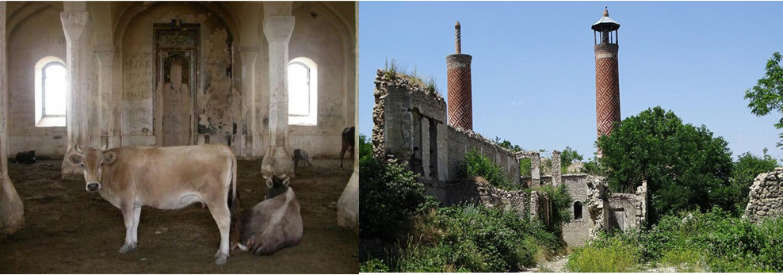
63 of the 67 Muslim mosques (13 in Shusha, 5 in Aghdam, 16 in Fuzuli, 12 in Zangilan, 5 in Jabrayil, 8 in Gubadli, 8 in Lachin) were completely destroyed and 4 were partially destroyed in the territory controlled by Armenia for 30 years. The Govhar Agha mosque mentioned in Armenia's report was partially restored with the funds of the Islamic Republic of Iran and was presented as a Persian mosque. By presenting the religious monument belonging to Azerbaijan as a Persian-Iranian culture, Armenia has violated the requirements of the Hague Convention. After partially destroying the mosque in Aghdam, the Armenians kept pigs and cattle in that mosque for the purpose of supplying meat for the Armenian soldiers.
Armenian Armed Forces used mosques in Aghdam and Shusha to keep cattle.
Regarding sub-paragraphs 18, 19 and 20 of the report:
Until September 2023, monuments of historical significance to the Armenian people within areas inhabited by Armenian-origin populations were primarily under the jurisdiction of the Russian armed forces, known as peacekeeping forces. However, the Russian armed forces have since departed from territory of Azerbaijan and returned to Russia. Following September 2023, all monuments deemed to be historical and cultural heritage have been registered and safeguarded by the Ministry of Culture of the Republic of Azerbaijan, categorized according to their respective purposes (religious, cultural, etc.).
The demolition exclusively targeted statues portraying Bolshevik-Leninist figures and monuments constructed within the past three decades to commemorate soldiers accused of war crimes, lauded as heroes by Armenia.
This is just a part of the fake campaign used by Armenia for propaganda purposes. Azerbaijan has invited UNESCO, a specialized agency of the UN, to inspect the territories that have been under the effective control of Armenia for 30 years. So far, UNESCO has not accepted this proposal, citing a lack of specialist resources. UNESCO has planned to inspect only a few areas. From this point of view, the opinion that the Azerbaijani side obstructs the inspection of UNESCO is wrong.
Most of the information included in the report by the State of Armenia about "The Military Trophy Park" is not true. There are such open-air museums in many countries of the world. During the ongoing Russian-Ukrainian war, such exhibitions were organized in Kiev, Moscow, Prague and other cities for the purpose of displaying military trophies and destroyed military equipment. The wax figures of the soldiers were temporarily exhibited in order to show the battle scenes, and the aim was not to insult the soldiers of the Armenian Army. Currently, those stand boards have been canceled.

Paragraph 21 of the report states that Armenia complies with the principles of the convention. However, in the last 10 years, especially in the past 30 years, the ethnic composition of Armenia has been completely changed and Armenia has become the most monoethnic country in the world. Currently, the composition of the population in Armenia consists of 98.1% - Armenians, 1.1% - Yazidi Kurds, 0.7% - others.
There are many reports about the difficult situation of Yazidi Kurdish women. Women have been deprived of the right to study in their native language. However, in 1934, there were 45 Kurdish schools in Armenia. Currently, there are no such schools. The official media of Armenia and the textbooks of Armenia carry out total anti-Azerbaijani and anti-Turkish propaganda and create hatred and revenge. Armenia organizes special hate classes and exercises for children.
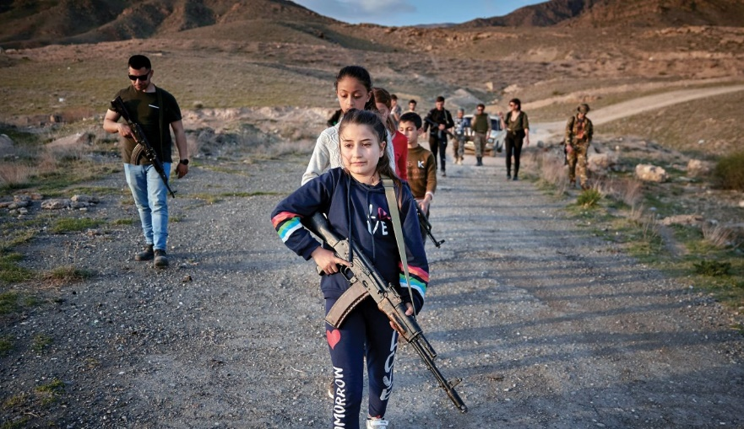
Armenia violates the international norms it supports and organizes "hate lessons" for children by sending them to military camps. They also prepare children for battles against Azerbaijan by involving them in military training.
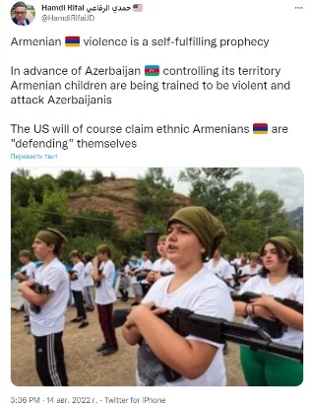
Armenia violates the requirements of Article 38 of the 1989 UN Convention on the Rights of the Child⁸, "Optional Protocol on the Involvement of Children in Armed Conflicts”⁹, as well as UN General Assembly Declaration No. 3318 "On the protection of children and women in emergencies and military conflicts"¹⁰ dated December 14, 1974 and involves children in military training. At the same time, the process of "brainwashing of children" and teaching them hatred is going on in those military trainings.
One such camp was organized by a US citizen of Armenian origin.
Journalist Neil Hauer of the prestigious Washington Examiner magazine of USA published an interview about it. . The interview shows that a person named Aram, a veteran of the US Air Force, founded a school called "Phoenix" in the Armenian settlement of Armash (Ararat region), where children are given military training and ideological preparation classes. The interview shows that, apart from Aram, other military instructors of Armenian origin and foreigners were involved in the school. These instructors are Armenian specialists from Libya, France, Russia and Syria. Most of them were participants in the Karabakh war.
Turkish media⁹ and social networks also gave detailed comments about this school.
In general, in Armenia, school children are brought up with hatred towards Azerbaijanis (Turks) and they are taught to use weapons in order to kill Azerbaijanis in the future.
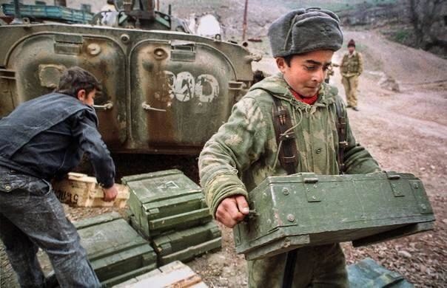
Parallel to the education of patriotism in Armenian schools, there is an "education" of hatred for the people of the neighboring country. All textbooks contain ideas that create hatred for the neighboring nation and insult the neighboring nation. Numerous videos prepared by the state and non-state institutions of Armenia and posted on social networks are aimed at educating Armenian children on patriotism (in fact, this is hatred). In these videos, children are taught that Azerbaijanis are the enemy and their goal is to kill the Armenian people.

Many years ago, the Ministry of Defense of Armenia, the Ministry of Education of Armenia and the racist volunteer organization "Erkrapa" signed a joint memorandum, and the memorandum aimed to increase military and patriotic education in schools. The memorandum was signed by Seyran Ohanyan, the Minister of Defense of Armenia, Armen Ashotyan, the Minister of Education, and General Manvel Girgoryan, a participant in the First Karabakh War, and the head of the racist volunteer organization called "Erkrapa". The last person participated in the mass killing of civilians during the war. He was a participant in the Khojaly genocide and was famous for torturing hostages, and was later prosecuted.
Numerous videos are shared on Armenian Telegram channels about raising children with hatred and involving them in military training. The video shared by Telegram channels with a YouTube link shows the use of weapons by Armenian children who currently live in the territory of responsibility of the Russian Peacekeepers.
3.Persecution by Armenia of Armenians who want to restore Azerbaijani citizenship and call for reconciliation with the people of Azerbaijan
After the Second Karabakh War, the attempts of the persons of Armenian origin living in the territory of responsibility of the Russian Military Contingent (so-called Peacekeeping Forces) in the Karabakh territory of Azerbaijan to restore the Azerbaijani citizenship¹² and enter the jurisdiction of the Azerbaijani administrative system are prevented by Armenia and a fictitious governing body created by Armenia, which continue de facto administration in those territories. Such people are persecuted and criminal proceedings are initiated against them for treason, espionage and etc. In general, calls for reconciliation with the Azerbaijani people by Armenians living in Armenia, including well-known Armenian figures, are blocked by the Armenian authorities with repressive methods. For example, in August 2022, a criminal case was initiated against two citizens of Armenia who appealed to the President of the Republic of Azerbaijan via video, under the articles of treason and espionage (418.1 and 424.1) of the Criminal Code of the Republic of Armenia. One of those people stated in his video that he wishes to restore the Azerbaijani citizenship and live under the jurisdiction of the State of Azerbaijan in the city of Khankendi, Karabakh.
Currently, Armenians living in Armenia or in the area of responsibility of the Russian Military in the Karabakh region of Azerbaijan are immediately persecuted for any positive opinion they say about Azerbaijan. These people are accused of "treason", "espionage" and other crimes and arrested.
4.Media and textbooks
There are calls of hatred against the Azerbaijani (Turkish) people in Armenian media and media organizations founded by people of Armenian origin in other countries and in the textbooks of Armenian schools. These media and textbooks contain the calls for creation of an image of the enemy and revenge, and this systematic hate propaganda is in the main directions of Armenian state policy.
Voskanapat.info, the main ideological mouthpiece of Armenianism, publishes numerous humiliating articles every day. For example: “If before the turks of Caucasia (meaning Azerbaijanis) were presented as intimidation as much developed and better fighters, as well as much civilized neighbors, the situation had been changeda after long years of brain washing of Caucasus turks. Now they have become the conglomerat ethnos of nomadic tribes and zombi, fear from terrible armenians made them as primitive savages under the influence of armenofobia venom..
Another online mass media from armenia is insulting people of azerbaijan issuing the article titled “Sheep is an animal very close to azerbaijanis”. Or on news.am portal which is one of the leading media institutions in Armenia was broadcasted the article with the title “The mass media of Azerbaijan has admited that azerbajani poeple are relatives of sheeps”.
In Armenia, the gravest insult is often considered to be the term "Turk." It's used as a derogatory slur, with individuals hurling it at each other as a means of insult. Those who engage in negotiations, peace efforts, or reconciliation with Azerbaijan are swiftly labeled as "Turks," deemed enemies in the eyes of Armenian nationalists and the opposition. Presently, even Prime Minister Pashinyan is facing this accusation, with Armenian nationalists and the opposition branding him as a "Turk," which is viewed as the ultimate form of insult.
Samvel Tadevosyan, a notable figure in Armenia known for his racist views, emphasized the severity of the term "Turk" in an interview with the online newspaper hraparak.am about Pashinyan, who declared that he recognizes the territorial integrity of Azerbaijan. He stated that being called a "Turk" is deeply offensive to Armenians, suggesting that it represents the pinnacle of insult. Tadevosyan remarked, "If you call me a 'Turk,' I take offense... But the most egregious insult of all is when they label you as a 'Turk.' If an individual with such moral standing is not offended by being called a 'Turk,' then the matter becomes even more significant.".
School textbooks in the Republic of Armenia (those textbooks are also used by Armenian schoolchildren living in the area of responsibility of the Russian Military Forces in the Karabakh territory of Azerbaijan) are based on propaganda of hatred for the Azerbaijani (Turkish) people. Even the textbooks of natural sciences (mathematics, physics, chemistry, geography, etc.) include lessons on hatred, claims against the territories of neighboring countries, and the importance of taking revenge on the enemy.

5.Burning houses and damaging the environment
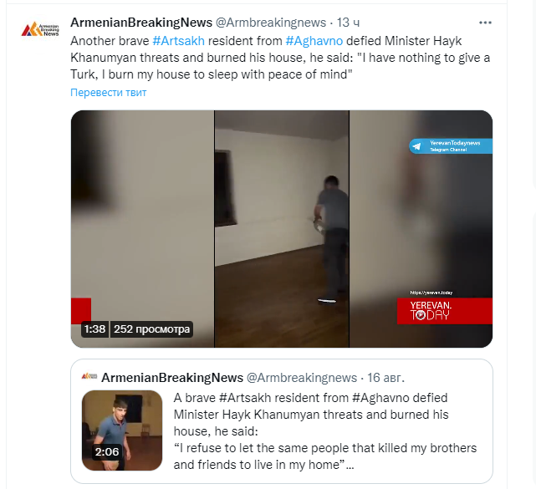
According to the terms of the ceasefire agreement on November 10, 2020, people who lived illegally in the territories controlled by Armenia for the past 30 years left the territories. When they left the territories, they burned the occupied houses belonging to Azerbaijanis, caused massive damage to the environment and burned forests. Thousands of mines brought from Armenia were buried in these areas during migration. All of these activities were encouraged and supported by the Armenian authorities. The Armenian media presented the people who burned houses and damaged the environment as heroes.
Armenians, who occupied the houses of Azerbaijanis 30 years ago and now refuse to accept Azerbaijani citizenship, are massively burning houses that do not belong to them. They say: "I have nothing to give to Turks. I burn my house so I can sleep peacefully." https://twitter.com/Armbreakingnews/status/1560026767175389186
6.Using anti-personnel mines as a weapon of revenge
Armenia has placed thousands of anti-personnel and anti-tank mines in the territories of Azerbaijan, which it occupied and effectively controlled for 30 years.
After the war that started on September 27, 2020 and ended with the signing of the ceasefire agreement on November 10, 2020, more than 10,000 square kilometers of territory have been liberated. Currently, there are thousands of mines and unexploded ordnance in those areas. Despite the efforts of international mediators, the Republic of Armenia refuses to provide a map of mined areas. Several maps presented by Armenia can show the location of mines in small areas with 15-20% accuracy at best. According to the terms of the signed ceasefire agreement, the Armenian Armed Forces had to leave Agdam region by November 20, 2020, Kalbajar region by November 15, 2020, and Lachin region by December 1, 2020, and return these areas to the jurisdiction of the Republic of Azerbaijan. From the humanitarian point of view, that period was extended by 10 days. However, Armenians who lived in these areas illegally for 30 years burned the houses they lived in but belonged to Azerbaijanis. In addition, the Armenian Armed Forces used this period to bury mines on a large scale. As a result, additional thousands of mines were buried in Agdam, Kalbajar and Lachin regions. The production dates of the mines prove that the mines were buried in a short period of time. In comparison with the mines produced in 2020 in Armenia it is possible to identify the mines which were hidden much before.
According to the ceasefire agreement, the 5 km wide Lachin corridor was to be handed over to Azerbaijan after the construction of an alternative road. After the alternative road was ready in August 2022, the Armenians who left the area burned forests and houses, destroyed the infrastructure and buried thousands of new mines in the areas.
It should be noted that all the mines discovered in this area were produced in Armenia in 2021.
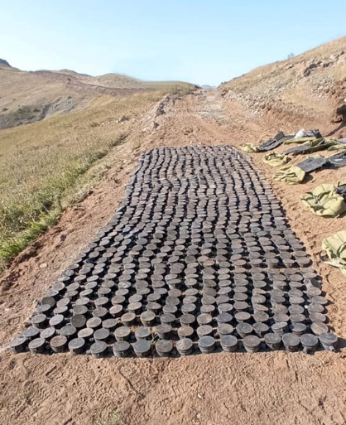
Armenia does not have any military or defense purpose for burying mines. These mines were buried by the instructions of the political and military authorities of Armenia to kill the population of Azerbaijani origin. Since November 2020, 67 people have been killed and 272 injured in the liberated territories as a result of mine explosions. In total, the number of victims is 237 people. The total number of victims is more than 341 people.
During the last 30 years, that is, until the Second Karabakh War, the number of people who died as a result of mine explosions in Azerbaijan was close to 4,000.Armenia does not hide its racial hatred by using anti-personnel mines against the people of Azerbaijan.
7.Excavation of graves for gold prospecting
According to preliminary research conducted in the liberated territories after the Second Karabakh War, hundreds of cemeteries were destroyed in the territories where more than 700,000 Azerbaijanis lived. In the investigations carried out so far, the facts of the destruction of more than 70,000 graves during the occupation have been recorded. Special gold-seeking gangs from Armenia collected gold teeth from graves using technical equipment. Since the use of gold teeth was popular among the people who lived in these areas, Armenians destroyed the graves for gold teeth. On the Armenian side, these grave digging works were called "gold fever" ironically.

8.Mass burial sites
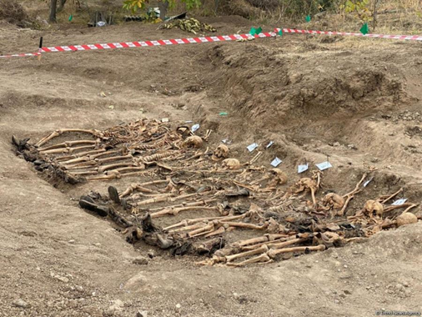
Following the liberation of territories under Armenian control for over three decades, 13 mass burial sites were uncovered. These sites revealed harrowing scenes, predominantly consisting of women, elderly individuals, children, and captured Azerbaijani soldiers. Tragically, these innocent individuals had been taken hostage by the Armenian military and institutions, subjected to brutal acts of violence, and then callously buried in large pits dug for this purpose. The remains of at least 107 individuals were unearthed across these mass grave sites: 28 in Dashalti village of Shusha district, 12 in Farrukh village of Khojaly district, 27 in Edilli village of Khojavend district, 9 in Yukhari Seyid Ahmadli village of Fuzuli district, and 31 in a prison area in Shusha city. Similar mass graves were also discovered in Bashlibel, Khojaly, and other areas. Through meticulous excavation, exhumation, autopsy, and identification processes, many of these remains were identified as local Azerbaijanis who had been taken hostage and murdered out of racial animosity. However, it's crucial to note that the individuals found in these mass graves represent only a fraction of the total number of captives whose fate remains unknown. Armenia, regrettably, continues to withhold official information regarding all captured Azerbaijanis.
On February 23, 2024, a mass grave was discovered in Khojaly district. Human remains belonging to at least 4 individuals were found, including one minor, believed to be 4-5 years old. Tragically, these victims bore signs of torture, their hands bound with ropes, indicating a cruel fate. It's been estimated that they were buried over 25 years ago.
In total, from 2021 to March 2024, 16 mass graves have been uncovered, revealing the remains of over 600 individuals.
9.Recommendations
İt has to be presented to the attention of the governement of Armenia that they had taken the obligation on “submitting the report on legislative, court, administrative or any other measures that had been taken” in line with the requirement of the Article 9 of the Convention. In this regard, the periodic report should include legal, legislative, administrative and other measures aimed at preventing racial discrimination in Armenia.
The State of Armenia should stop its propaganda of hatred and enmity against neighboring nations using media and textbooks. Textbooks should be revised and serious changes should be made in the media policy;
Lists of cultural, religious and architectural buildings destroyed on the territory of Armenia and belonging to the Azerbaijani people should be published. Also, the affiliation of the buildings that have been reconstructed and Armenianized or shown as belonging to other nations should be determined. The long-standing racist policy in this field should be stopped.
Armenia, which has become a monoethnic state, should start legal and practical activities that allow Azerbaijani refugees to return to the territories where they historically lived in the territories of Armenia.
The Armenian authorities should provide information to Azerbaijan about the 4,496 people (according to the International Committee of the Red Cross's calculations¹⁸), most of whom were civilians, including children, women and the elderly, who were taken hostage during the First Karabakh War. Armenia should also submit to Azerbaijan the map of the mass graves of Azerbaijanis who were subjected to extrajudicial punishments;
The State of Armenia should submit to Azerbaijan the maps of more than one million anti-personnel and anti-tank mines buried in the territories of Azerbaijan;
The Armenian authorities should stop the repression against the Armenians who want to reconcile with the Azerbaijani people. Armenia should show tolerance towards other initiatives aimed at the reconciliation of nations and stop repressive measures aimed at preventing such initiatives.

V.A Kuluyeva. S. 119. MDTA f.290, siy.2, iş 747, vər.6
Aziz Alakbarli. The 1988 genocide of West Azerbaijanis, Baku, 2008. p 9-55
http://www.un.org/en/ga/search/view_doc.asp?symbol=S/RES/822(1993) http://www.un.org/en/ga/search/view_doc.asp?symbol=S/RES/853(1993) http://www.un.org/en/ga/search/view_doc.asp?symbol=S/RES/874(1993) http://www.un.org/en/ga/search/view_doc.asp?symbol=S/RES/884(1993)
http://www.virtualkarabakh.az/en/post-item/32/52/kurakchay-treaty.html
https://www.primeminister.am/en/Artsakh-visits/item/2019/08/05/Nikol-Pashinyan-visit-to-Artsakh/
https://turan.az/ext/news/2021/5/free/politics_news/en/3766.htm
Source: http://www.indexmundi.com/armenia/demographics_profile.html
https://www.washingtonexaminer.com/politics/inside-the-world-of-private-war
https://daytube.az/embed/99968 https://daytube.az/embed/99969
https://vestikavkaza.ru/news/skoncalsa-eks-deputat-parlamenta-armenii-manvel-grigoran.html https://www.e-huquq.az/en/news/world/21339.html
https://www.youtube.com/watch?v=LlikoXpS9D4&t=5s
https://voskanapat.info/?p=28457&l=ru https://arka.am/ru/news/politics/v_armenii_vozbudili_ugolovnoe_delo_v_otnoshenii_dvoikh_grazhdan_prosivshikh_grazhdanstvo_azerbaydzha/
https://pandukht.livejournal.com/1563171.html
http://nv.am/barany-vesma-blizkie-azerbajdzhantsam-zhivotnye/
https://news.am/rus/news/218809.html
https://hraparak.am/post/cf64b651f386a6ad5882f10a06a1a97f
https://vestikavkaza.ru/news/v-mid-azerbajdzana-prokommentirovali-podzogi-lesov-v-lacinskom-koridore.html
https://mod.gov.az/en/news/more-than-900-anti-personnel-mines-were-detected-in-the-lachin-direction-41396.html https://vestikavkaza.ru/news/minoborony-azerbajdzana-soobsilo-o-minnom-pole-sozdannom-armanskimi-nvf.html

