NGO Thematic Alternative Report on the Rights of Migrant Children
to the UN Committee on the Elimination of Racial Discrimination (CERD)

Republic of Korea

115th Session | 29 April – 30 April 2025

State Party: Republic of Korea
Treaty covered by report: CERD
Category of Reports NGO

Submitted by:

Network for the Rights of Children and Youth with Migrant Background
Duroo – Association for Public Interest Law
Dongcheon Foundation
Migrant Center Friend
Migration and Human Rights Institute
Yongsan Nanum House, the Anglican Church of Korea

1. Background

According to the State party’s immigration statistics as of December 2023, the number of migrant children and adolescents under the age of 20 in the State party is approximately 210,000, making up 8% of the total migrant population. However, this figure excludes undocumented children or those born in the State party who have not been registered as foreign residents. Experts estimate that at least 10,000 to 20,000 undocumented migrant children remain unrecorded in official statistics. The lack of accurate statistics indicates the absence of nationwide state efforts to assess their conditions and highlights the State party's indifference to policy-making and budgeting for the protection and support of migrant children.

The Republic of Korea is a State Party to the Convention on the Elimination of Racial Discrimination (CERD) and the Convention on the Rights of the Child (CRC), both of which emphasize the principle of non-discrimination for all children. Nevertheless, migrant children in the State party are excluded from or face restrictions in accessing child protection, support, and welfare under domestic laws and policies solely due to their nationality. Even policies intended for all children are, in practice, implemented only for citizens of the State party. Undocumented migrant children, in particular, are excluded from even the limited protection and support provided to registered migrant children, are labeled as "illegal immigrants," and are consequently deprived of fundamental rights.

Two comprehensive bills seeking to guarantee migrant children's rights were proposed in 2010 and 2014. These bills included provisions ensuring birth registration, childcare, education, and healthcare rights for migrant children. Additionally, they proposed granting humanitarian residence permits to undocumented migrant children. However, neither bill advanced to a vote before the end of the legislative term. Additional bills proposed in 2022 and 2023, intended to ensure birth registration for children of migrants who are born in Korea, also expired without enactment. An amendment proposed to extend the Child Welfare Act to migrant children likewise failed.

The failure of legislative efforts to protect migrant children's rights is largely due to rising anti-immigrant sentiment and xenophobia, with certain xenophobic groups actively opposing legislative initiatives both online and offline. The State party interprets these views as prevailing public opinion, hindering the enactment or amendment of relevant laws. Although the State party has claimed that current laws adequately protect migrant children's rights, various fact-finding investigations and human rights reports have repeatedly disproven these assertions. This report aims to examine the realities faced by migrant children in the State party, including their lack of rights to birth registration, childcare, education, healthcare, and social security, as well as the issues faced by undocumented migrant children, such as immigration status, migration detention, and the limitations of the current laws and regulations.

2. Universal Birth Registration

The State party has claimed that it has prepared a draft Bill on Birth Registration of Foreign Children (tentative title) to enable the registration of children who are not Korean nationals and that it has coordinated discussions with relevant ministries under the leadership of the Ministry of Justice. However, after the bill—initially promoted by the Ministry of Justice and introduced by a National Assembly member—was discarded due to the expiration of the 21st National Assembly’s term, no further efforts or measures by the government have been made public.
According to an audit conducted by the Board of Audit and Inspection of Korea on the Ministry of Health and Welfare in June 2023, between 2015 and 2022, more than 6,000 children born in hospitals were never registered at birth. The government conducted an investigation into this issue. Still, it only included 2,236 children of Korean nationality, whose parents are legally required to register the children. In comparison, 4,000 foreign children, who are not subject to mandatory birth registration under Korean law, were excluded from the investigation.
However, the exclusion of approximately 4,000 migrant children from the government’s focused investigation highlights significant constraints on the exercise of the right to birth registration for migrant children born in the ROK. Refugees, humanitarian stay permit holders, and asylum seekers often face difficulties in reporting their children's births to the government of their home country, which may have been the source of their persecution. As a result, these children often remain unregistered at birth in any country. Children who are not registered at birth essentially become stateless, and there have been cases of refugee children who were still unregistered by the age of 16. For children of undocumented migrants, it is often impossible to register their births at the embassies of their parents' home country due to various legal and logistical barriers. As the ROK government pressures labor-exporting countries to reduce the number of undocumented migrants, these countries sometimes impose conditions such as verifying immigration status when registering the child's birth at the diplomatic office, or even requiring the parents to return to their home country for registration. The government prohibits these children from obtaining alien registration on the grounds of their unregistered stay. With birth registration restricted both in the ROK and at the diplomatic offices of the parents' home countries, these children are left with no forms of identification at all.
Following the audit report by the Board of Audit and Inspection, the government conducted a focused investigation into unregistered Korean children and subsequently passed an amendment to the Family Relationship Registration Act, which had been pending in the National Assembly for years. This amendment introduced a birth notification system, requiring medical institutions to report child births to the government. However, since the current birth registration system applies only to Korean nationals, the new birth notification system likewise does not cover foreign children. Confusion has arisen in practice with no measures to address this gap.

Suggested Recommendations
1. The State party should explicitly recognize both the obligation and the right of birth registration to all foreigners, regardless of their own or their legal or social status, or nationality.
2. The State party should introduce the 'universal birth registration system', ensuring that all children born in the State are registered immediately after birth and given a name.

3. Right to Childcare

Free childcare and education for infants and young children are provided under the Child Care Act and the Early Childhood Education Act, regardless of household income. Additionally, since the enactment of the Child Allowance Act in 2018, the government has expanded the eligibility criteria and increased the payment amount for child allowances, highlighting low birth rates as a national concern. However, these benefits are limited to children with Korean nationality. Children without Korean nationality are not eligible to receive childcare allowances for home care, childcare subsidies for daycare centers, kindergarten tuition support, or child allowances from the central government.
In May 2019, the NHRCK recommended that the Ministry of Health and Welfare(MOHW) amend relevant laws and guidelines to ensure that all infants and young children, including migrant children, have the right to childcare. However, the MOHW rejected the recommendation, stating that expanding support for migrant children requires further social discussion and consideration of national financial conditions. Similarly, in July 2023, the NHRCK recommended that the Ministry of Education(MOE) expand kindergarten tuition support to prevent discrimination against migrant children, but the MOE did not provide a concrete implementation plan.
Nevertheless, in 2018, Ansan City in Gyeonggi Province became the first to provide childcare subsidies for migrant children aged 3 to 5 attending daycare centers. Since then, some local governments have provided partial childcare subsidies, and a few provincial and municipal education offices have offered kindergarten tuition support for children with foreign nationality. However, such supports are also limited to migrant children with legal residency status, and the amount of financial aid varies depending on the local government. As a result, parents of migrant children who cannot afford daycare costs often leave their children unattended at home while working, take them to unsafe workplaces, or leave them in the care of unverified individuals, exposing them to inadequate childcare environments.
Migrant children are also frequently denied admission to daycare centers. Under the current system, even if a migrant child lacks documents such as an alien registration card, passport, or birth certificate, they are still eligible for registration in the childcare information system. However, due to insufficient awareness of this policy, many daycare administrators still refuse admission if these documents are not provided. Additionally, some childcare institutions reject migrant children due to reasons such as skin color, foreign nationality, limited proficiency in the Korean language, visa status, or resistance from Korean parents.
Meanwhile, individuals with F-6(marriage immigrant) status can invite their parents or close relatives (within the fourth degree of kinship) to South Korea to support child-rearing for their children. In contrast, other migrant residents are not allowed to invite family members for childcare support, even if they are raising a child born outside of marriage to a Korean national. Single-parent migrant families, in particular, often face difficulties as they do not qualify for childcare subsidies while also needing to work. As a result, some send their children to their home country to be cared for by relatives and bring them back to South Korea once they reach school age.
Ultimately, the lack of childcare support results in migrant children being raised in unsafe and inadequate environments in South Korean society, struggling to achieve age-appropriate language and social development, or experiencing instability due to frequent moves between their parents’ home countries. In response, the UN Committee on the Rights of the Child recommended in 2019 that the South Korean government amend the Infant Care Act to ensure equal access to childcare facilities and financial support for all children, regardless of nationality. However, this recommendation has not been implemented.

Suggested Recommendations:
1. The State Party must provide childcare support to all children without discrimination, regardless of the child’s or parents’ nationality, residency status, or marital status.
2. The State Party must take measures to prevent daycare centers from rejecting the admission of migrant children based on discrimination and prejudice.

4. Right to Education

The current Framework Act on Education restricts compulsory education to "citizens," thereby excluding migrant children. Migrant children can apply for school admission or transfer under a special provision of the Education Act's Enforcement Decree. However, because no legal provisions prohibit schools from rejecting migrant children or guarantee their right to enroll, school principals have the discretion to deny admission, making it difficult to challenge such decisions.
In the ROK, policies to ensure the right to education for migrant children remain inadequate, leading to a concentration of these children in certain regions and schools. As a result, schools and areas experiencing a rapid increase in migrant students struggle with shortages of staff and resources. On the other hand, regions with few or no migrant children often lack the experience and capacity to support them effectively. This situation has led to schools across the country avoiding the enrollment and transfer of migrant children, reinforcing the stigma that they are "difficult students" to handle.
Additionally, although the State party report states that undocumented migrant children are granted school enrollment, schools often impose inconsistent or excessive documentation requirements, making it practically difficult for them to transfer or enroll. In particular, aside from the very few children who manage to obtain residency status by meeting strict requirements, the majority of undocumented migrant children still attend school without legal status. Even if enrolled, these children are denied essential services like financial aid, school banking, and online registration. They are also barred from academic competitions and, in principle, university admission, further excluding undocumented migrant children from public education.
The State party report claiming that migrant children receive equal educational support is also inaccurate. For example, in 2020, during the COVID-19 pandemic, the government decided to provide a special childcare and remote learning support grant but limited eligibility to children who were citizens. When teachers and civil society groups raised concerns about the exclusion of migrant children and filed a petition with the NHRCK, the government announced that the subsidy would be provided to all children without discrimination. However, it ultimately evaded responsibility by leaving the matter to individual local governments.
Support and policies to ensure the practical right to education and social integration of migrant children are also severely lacking. According to the State party report, over the past 10 years, approximately 13,000 migrant-background youth have participated in the Rainbow School program, and about 1,000 have received career education. However, considering that the Seoul Metropolitan Government and the MOE estimate the number of migrant-background youth at around 200,000 and mid-to-late-arrival youth at approximately 10,000 to 30,000, it is evident that the current level of support is highly insufficient. In particular, the government has completely cut the Rainbow School program's budget of 740 million KRW for 2025. Additionally, the budget for "Educational Activity Support for Low-Income Multicultural Children" has been reduced by approximately 1.2 billion KRW while also narrowing the scope of beneficiaries. These cuts indicate a broader reduction in financial support for ensuring migrant children's right to education. Also, the State party report states that efforts are continuously being made to foster understanding through "multicultural education." However, this so-called "multicultural education" remains highly superficial and fails to enhance sensitivity to cultural diversity or promote social integration. Furthermore, many local governments focus solely on providing Korean language education or temporary support measures rather than implementing policies that genuinely integrate migrant children into society. In fact, in 2025, the Seoul Metropolitan Office of Education transferred the responsibility for supporting migrant children from the department handling civic education to the department responsible for welfare support, significantly reducing its educational functions, budget, and personnel.
As a result, these conditions further reinforce exclusion and discrimination against migrant children. Rather than nurturing them as members of society, they are treated as temporary students who will eventually leave South Korea. This fundamentally violates their right to education in a serious way.

Suggested Recommendations:
1. The State party should expand the scope of compulsory education under the Framework Act on Education to include all children, regardless of nationality or residency status, rather than limiting it to "citizens."
2. The State party should revise relevant laws and regulations to ensure that school principals cannot refuse the admission or transfer of migrant children. Additionally, it must actively and continuously inform public educational offers and the public that no child, including undocumented children or those with incomplete documentation, should be denied or face delays in admission, transfer, or advancement to higher education.
3. The State party should ensure that migrant children are not subjected to discrimination in any education-related services, regardless of their social status.
4. The State party should reverse budget cuts for support programs aimed at helping migrant children adapt to school and expand support for their integration into the public education system.
5. Instead of one-time, superficial multicultural education, the State party should mandate cultural diversity sensitivity education to reduce exclusion and discrimination against migrant children and promote their inclusion as members of society.

5. Right to Health

Since July 2019, migrants are mandatorily required to enroll in the National Health Insurance (NHI) program. Nonetheless, over 40% of migrants in the State party remained uninsured as of late 2022, including undocumented migrants, individuals with G-1(Miscellaneous) visas, excluding those with humanitarian stay permits and their families, migrants who do not qualify for employee NHI subscriptions but have resided in the State party for less than six months, and individuals with deferred departure status.

Discriminatory policies for regional NHI-subscribed migrants frequently result in disproportionately high premiums relative to their income and assets. Additionally, restrictive household-unit definitions require family members to enroll separately, which leads to the non-payment of NHI premiums. Migrants with overdue premiums lose NHI benefits until full payment. Migrants without access to NHI benefits often delay seeking timely medical care due to high costs, resulting in aggravated health conditions.
Many migrant children also remain unable to enroll in NHI. This includes children of uninsured parents, such as undocumented migrants; children who must enroll as regional NHI subscribers but have not yet completed six months of residency since their entry or re-entry into the territory of the State party; children born in the State party to insured parents but unable to register as dependents or household members due to delays in birth registration and/or foreigner registration processes. Children without health insurance inevitably face excessive medical costs when seeking healthcare.
The Ministry of Health and Welfare operates the "Medical Expenses Support Program," targeting undocumented migrant workers, asylum seekers, and their children under 18 who cannot enroll in NHI. However, due to budget constraints and stringent eligibility criteria, only a small fraction of uninsured migrant children receive assistance from this program. Additionally, some medical institutions apply foreigner-specific Medical Fee even to migrant children without NHI, further increasing their financial burden.
In some cases, migrant children must independently enroll in NHI due to mandatory insurance obligations tied to their visa status. This particularly affects those without parents or whose parents’ visa status disqualifies them from NHI coverage. Furthermore, in situations involving siblings, migrant regional enrollees are not permitted to register their siblings under a single household; thus, each minor sibling must individually enroll as a separate household head. Unlike Korean minors who are exempted from paying NHI premiums when their income and assets fall below a certain threshold, minors with foreign nationalities are not afforded the same exemption. Although migrant minors pay the minimum monthly premium established by the Ministry of Health and Welfare—lower than the previous year's average premium required from adult migrants—this nevertheless poses a considerable financial burden for minors with no income, particularly for siblings who must individually enroll as separate household heads.
In January 2019, CERD expressed concerns about discriminatory practices of the NHI toward migrants and recommended the State party to ensure all migrant children to be covered by health insurance, regardless of their parents' NHI enrollment, and apply the same health insurance premiums to migrants as to Korean nationals. However, these recommendations remain unimplemented.
Children who are nationals of the State party and who are separated from their parents or experiencing financial hardship may be eligible for medical benefits under the national medical assistance program. However, the State party's social security system largely excludes non-nationals, including children, with few exceptions. Migrant children experiencing economic hardship thus remain ineligible for exemptions from NHI premiums and are excluded from medical assistance programs, thereby facing significant risks to their right to health.

Suggested Recommendations:
1.The State party should guarantee universal access to National Health Insurance for all migrant children, regardless of their parents' immigration status or NHI enrollment. In this case, NHI premiums for migrant children should be determined based on the same criteria as for children with Korean nationality, the scope of family members who can be grouped as a regional NHI household should be expanded, and NHI benefits should be provided up to six months, just as they are for Korean nationals, even in cases of non-payment of premiums.
2. The State party should amend the National Basic Living Security Act and the Medical Benefit Act to enable migrant children from economically marginalized households to qualify for medical assistance programs.
3. The State party should increase funding for the Medical Expenses Support Program, ensuring that undocumented migrant children and children seeking asylum have access to medical services without financial barriers.

6. Right to Protection, Support, and Social Security

Social security, which is fundamental for dignified life, must be universally guaranteed without discrimination under international human rights treaties, including CERD. However, the State party’s laws restrict social security rights exclusively to its nationals. Among social security programs, social insurance—funded through contributions from subscribers—is accessible to non-nationals residing in the State party. However, as seen in the national health insurance system, such programs frequently impose discriminatory restrictions based on nationality or immigration status, or apply different standards than those for nationals of the State party. Conversely, public assistance and social services funded through taxation remain largely inaccessible to most non-nationals, with eligibility restricted to certain visa categories.
The exclusion of migrant children ”equi’Ing social protection from public assistance is particularly problematic. Children without a guardian, those who have suffered abuse by their guardian, or those whose guardian lacks caregiving capacity are typically entitled to protection—including migrant children. However, issues arise when such children enter childcare facilities or shelters for child abuse victims: while children who are nationals of the State party receive support, including living expenses and medical assistance under the National Basic Living Security System, migrant children do not receive equivalent support.
In 2019, the Ministry of Health and Welfare revised its “Guidelines for Child-related Programs,” requiring local governments to provide living expenses from local budgets for foreign children placed in institutional care. However, this measure unintentionally led local governments to refuse admission of migrant children in need of protection into local care facilities, citing financial burdens. Additionally, although further financial assistance beyond basic living expenses can, de jure, be provided through decisions made by the “Child Welfare Deliberation Committees” at the city, provincial, or district levels, in practice these committees either do not convene at all or merely confirm support after the fact. Thus, there is effectively no responsible entity actively discussing and implementing necessary support measures for migrant children in institutional care.
The situation facing migrant child”en w’th disabilities is particularly serious. In the State party, most disability welfare services are exclusively available to individuals officially registered as persons with disabilities. However, the Act on Welfare of Persons with Disabilities strictly limits disability registration eligibility for non-nationals to recognized refugees, marriage migrants, migrants of Korean descent, and permanent residents only. Furthermore, the law includes a provision allowing national and local authorities to restrict welfare support for registered non-national persons with disabilities based on budgetary considerations. Consequently, migrant children with disabilities face significant barriers to obtaining disability registration and, even when registered, remain excluded from various welfare programs, such as disability allowances, childcare support, medical expense assistance for persons with disabilities, reduced NHI premiums for regional enrollee, developmental rehabilitation services, and personal assistance for persons with disabilities.
In preparation for the 2019 review of the State party’s implementation of the Convention on the Rights of the Child, the Ministry of Health and Welfare organized a dialogue with civil society organizations. During this dialogue, civil society representatives questioned whether migrant children with disabilities should be allowed to register as persons with disabilities regardless of their immigration status and receive essential disability welfare services. In response, the Ministry stated that allowing disability registration exclusively for migrant children without regard to their immigration status could undermine equity with migrants of other age groups. This position prioritizes a rigid notion of equity between adults and children, disregarding the critical impact that appropriate rehabilitation, education, and training during childhood have on the future quality of life of migrant children with disabilities.
It Is appropriate for the State party to provide social security to children requiring special protection. In 2019, the CERD recommended that the State party review its social security policies to ensure all persons living in its territory, irrespective of their national origin, receive basic social support. Similarly, in 2019, the CRC urged the State party to remove legislative and practical barriers to ensure that all migrant children—including those without guardians and those with disabilities—have access to financial and housing support, and protection and support services in case of abuse, on an equal basis with children who are nationals of the State party. Furthermore, in 2022, the CRPD recommended that the State party ensure all persons with disabilities, irrespective of their citizenship or residency status, have access to habilitation and rehabilitation on the basis of their individual requirements. However, these recommendations have yet to be implemented.

Suggested Recommendations:
1. The State party should revise its laws and policies to ensure that all migrant children, including those requiring special protection and those with disabilities, have equal access to social security—including livelihood support, housing, healthcare, education, and other essential protection and support services—irrespective of their nationality or immigration status, and on equal terms with children who are nationals of the State party.
2. The State party should improve data collection on migrant children and allocate adequate budgetary resources for their social security, protection, and support.

7. Right to Residence

Currently, there are no accurate statistics on undocumented migrant children in South Korea. Their presence can only be confirmed if they have a record of entering the country, or if they were previously registered as foreigners but overstayed their visas and have been counted in immigration statistics. The Ministry of Justice has revealed that, as of the end of January 2025, there were 3,434 “illegal” foreigners under the age of 18. However, civil society estimates that at least 10,000 to 20,000 unregistered migrant children are living in the country. This indicates that there is no true understanding of the situation, highlighting that the starting point of policy design and the guarantee of rights is flawed.
According to the guidelines of the Ministry of Justice, undocumented migrant children are granted a reprieve from deportation until they graduate from high school; however, once they graduate, they become subject to deportation. Nevertheless, unless their right to stay is guaranteed, the basic rights of migrant children - such as the right to health, education, and family unity- will not be protected. In 2019, the CERD recommended that the Korean government take positive measures to guarantee the right to employment, education, and access to medical care for immigrants, including migrant children. In the same year, the CRC and, in 2020, the NHRCK recommended that “a system be established to grant residency status to undocumented migrant children”. As a result, the Ministry of Justice began implementing a measure to grant residence status to undocumented migrant children, adolescents and youth in April 2021, but this was a temporary measure only. Initially, it was set to last until March 31, 2025, but due to continued demands from civil society, it was announced on March 20, 2025, that the measure would be extended until March 31, 2028. In the country report submitted in 2022, the State Party emphasized the implementation of the policy of granting temporary residence status as a measure to protect the right to stay for migrant children. However, this is far from the establishment of a sustainable legal framework recommended by the CERD, CRC, and the NHRCK.
In particular, many children are unable to apply for temporary residency under the current conditions. For example, undocumented migrant children who have not been registered and therefore do not have birth certificates, passports or family relationship certificates will face difficulties when applying for residency. In addition, the requirement that children can only apply for residency if they are enrolled in elementary, middle or high school, or have graduated from high school, excludes those who have had to interrupt their studies due to their undocumented status. When a child applies for residency, the parent must obtain temporary residency on the condition that the child will either graduate from high school or leave the country when they become an adult. However, the fine that must be paid at the time of application is 9 million won per parent. These conditions serve as a significant barrier for undocumented migrant children, adolescents and youth applying for residency. Therefore, if measures to grant residency status to undocumented migrant children are to be enacted into law, it is essential to supplement the policy by simplifying the application process, easing the application requirements, and reducing the financial burden on parents.
On the other hand, if a child reaches adulthood and chooses to leave the country, they will be fined a minimum of 2 million won and a maximum of 30 million won, depending on the length of their undocumented stay. If the fine is not paid upon departure, re-entry will be restricted; even if it is paid, the individual will be subject to long-term entry restrictions. Most undocumented migrant children who have grown up in Korea have lived in the country for more than seven years without being registered, meaning that when they leave the country as adults, they are required to pay fines that can amount to tens of millions of won. It is an inhumane act to impose excessive fines on children who had no choice but to live in the country without being registered and to restrict their re-entry, regardless of their own decisions. This also goes against the principles of Article 2 (prohibition of discrimination) and Article 3 (best interests) of the CRC.
In addition, registered immigrant children who are not of Korean descent usually hold a status of residence tied to their parents' status. This status can only be extended while they are minors, and once they reach adulthood, they must apply for independent residency status. Currently, the only way for immigrant children and adolescents who have grown up in Korea and graduated from high school to change their status of residence is to enroll in university and obtain a college student (D-2) visa. However, there are cases where immigrant children, who have delayed school entry and remain in high school as they reach adulthood, cannot extend their stay because their residency status is tied to their parents as a minor, resulting in the loss of their status..
Currently, there is no individual residency status that allows foreign-national migrant children to settle and live stably in Korea after they reach adulthood, except for those with Korean nationality (F-4) or permanent resident (F-5) status. To settle in Korea, they must go through the following procedures to change their status of residence. Since only permanent residency (F-5) holders can apply for naturalization, with the exception of some immigrants such as marriage immigrants, it is essential to acquire permanent residency (F-5) status in order to settle in Korea.
Study Abroad  (D-2)  2-4 years | → | Specialized Human Resources (E-7)  3 years or more | → | Residence  (F-2)  3 years or more | → | Permanent Residence  (F-5) | → | Naturalization

To change their status of residence, individuals must meet criteria related to age, education, Korean language ability, income, and other factors. However, the income requirements for changing one's status are particularly high. For example, the income threshold is 70% or more of the previous year's GNI for professional human resources (E-7) status and 80% or more of the previous year's GNI for residential status (F-2). Specifically, the income requirement for applying for permanent residency (F-5) status is extremely high, double the previous year's GNI. If an individual fails to meet these criteria due to age or income, they may be unable to maintain or change their status of residence, preventing them from settling down. As a result, they could be forced to leave the country involuntarily or fall into an unregistered status.
The Korean government has started to use this challenging stage of changing one's status of residence as a solution to the issue of declining population in Korean society. A prominent example of this is the “Regional Specialization Visa Project”, which began as a trial in 2022 and became a full-fledged system in 2024. This program aims to address population decline and the risk of regional extinction in rural areas. It allows individuals to bypass the typical work visa status and directly apply for residential (F-2-R) status, provided they have lived in a designated area for at least five years. The Ministry of Justice is guiding local governments to encourage those who have grown up as migrant children and are now young adults or adolescents to apply for permanent residency (F-5) within five years, provided that they obtain a regionally specialized residence (F-2-R) visa. This visa will allow them to apply for permanent residence under relaxed conditions.
However, the regional specialization visa program essentially leverages the urgency migrant children, adolescents, and young adults feel about settling in Korea to force migration to specific regions. It instrumentalizes migrant children without addressing the fundamental issues of high industrial disaster risks and inadequate infrastructure, which are the main factors that contribute to the decline of local populations. This policy limits the right to freedom of movement and settlement for children and families, and turns it into a policy tool. In fact, in November 2024, a tragic incident occurred involving a 32-year-old young man who had lived in Korea as an undocumented migrant for 25 years. After obtaining a temporary residency to attend university, he moved to Gimje in Jeollabuk-do to obtain regional specialized residence (F-2-R) status after graduation. Tragically, eight months after getting a job, he died in an industrial accident.

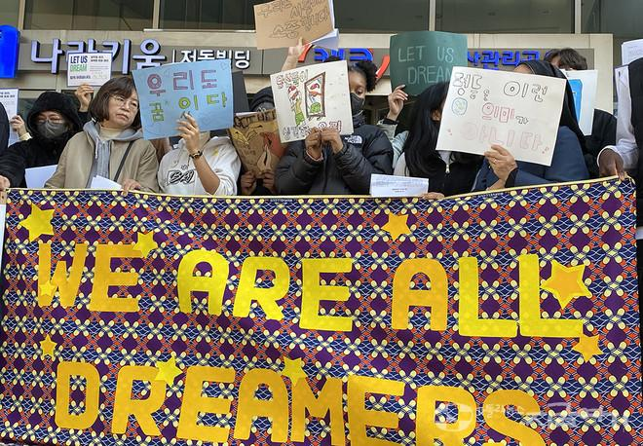  On November 16, 2024, a press conference was held in front of the NHRCK by children and young people of migrant backgrounds. They held pickets and banners that they made by themselves, and called for the Ministry of Justice to legislate the granting of residency to undocumented migrant children, rather than taking provisional measures. | 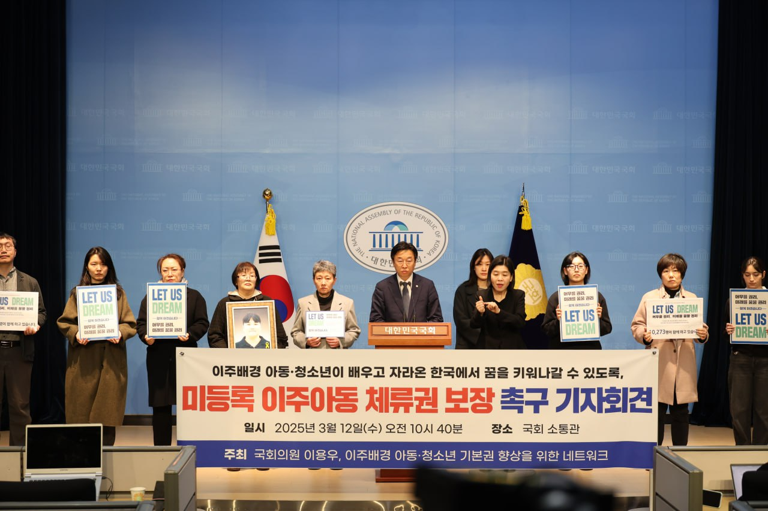  On March 12, 2025, a press conference was held at the National Assembly Communication Center to demand the legalization of the residency status of undocumented migrant children. At this press conference, the results of the “Let Us Dream” campaign to legalize the residency status of undocumented immigrant children, which was participated in by 10,273 citizens, were announced.

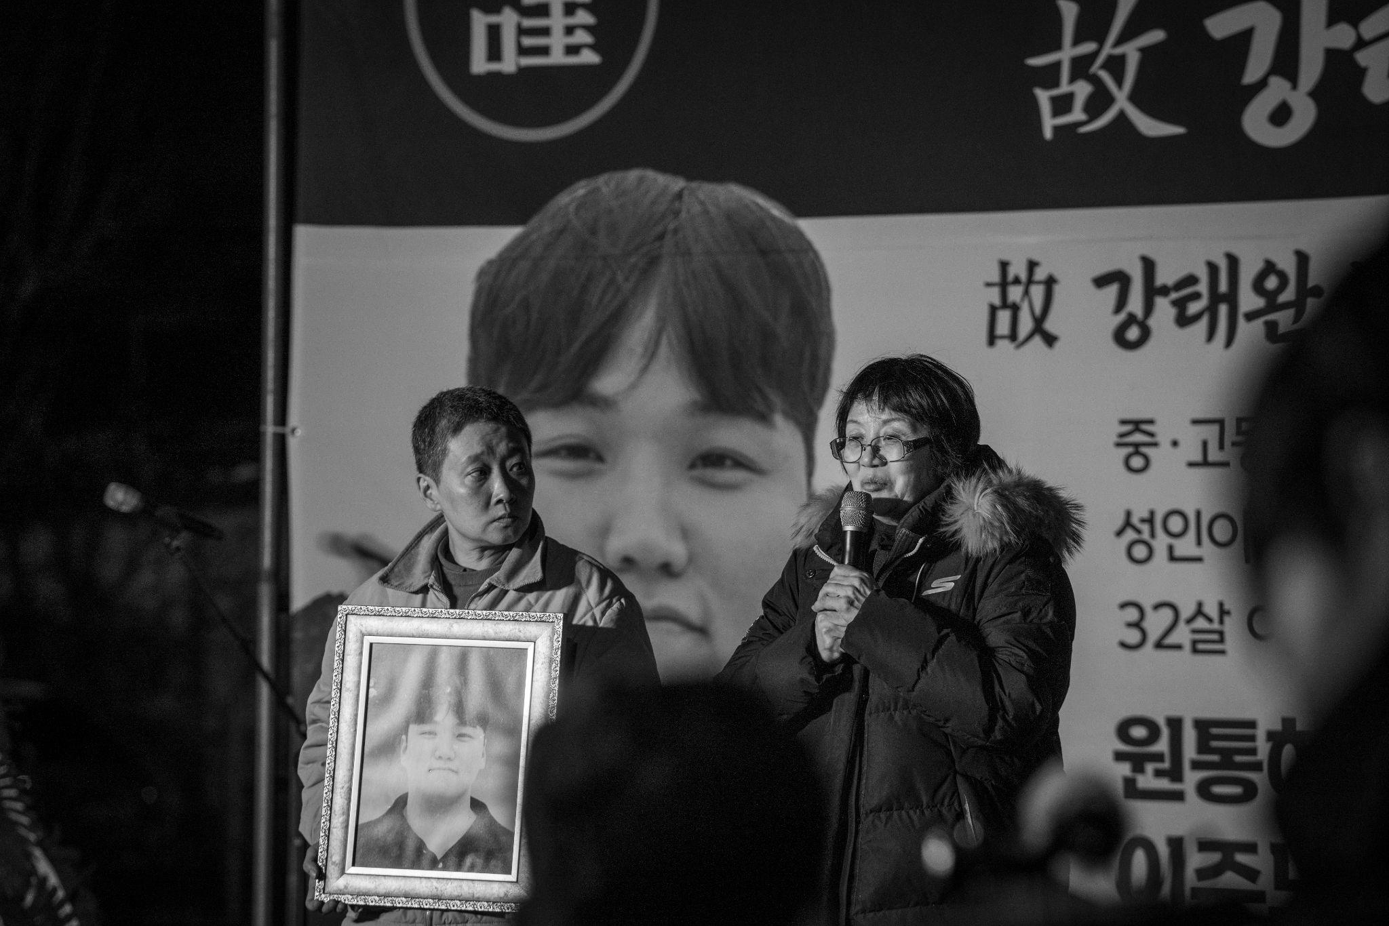
Kang Tae-wan, who immigrated to South Korea from Mongolia at the age of 5 to join his mother, lived as an undocumented immigrant for 25 years. He obtained legal status through a temporary relief measure by the Ministry of Justice, and later changed his status to regionally specialized residence (F-2-R) after studying abroad (D-2). He died in a workplace accident 8 months after joining a company in Gimje, Jeollabuk-do. The funeral was delayed for 35 days because the company he worked for refused to meet the bereaved family's demands for an official apology and measures to prevent a recurrence. The photo shows the bereaved mother speaking at a rally held in front of the company responsible for the industrial accident on December 5, 2024.

Suggested Recommendations:
1. The State party should legislate measures to grant residence status to undocumented migrant children and guarantee their stable stay even after they graduate from high school.
2. The State party should exempt undocumented migrant children from fines and allow their re-entry if they choose to leave the country upon reaching adulthood.
3. The State party should guarantee that minors with residence status accompanying their parents will have their residence status extended or changed if they remain enrolled in school after reaching adulthood.
4. To ensure the domestic settlement of long-term migrant children, the State party should establish a new, gradual status of residence that allows them to acquire permanent residency or naturalization with relaxed requirements upon reaching adulthood. In particular, the State party should not require a regionally specific status of residence as a condition for settlement.

8. Immigration Detention of Children

Migrant Children whose parents or who are themselves undocumented in the State party are constantly exposed to the threat of crackdown, detention and deportation. Among these threats, the enforcement, which is labeled as “protection” in the Immigration Act but is actually “detention”, has a deeply negative effect on migrant children’s physical and psychological health and development. Most migrant children are detained illegally or arbitrarily. The CERD recommended in 2019 that the State party “avoid the detention of children/minors and amend the Immigration Act to include provisions related to the best interests of the child.” The Committee on the Rights of the Child made a similar recommendation in the same year, adding that the state should provide “non-custodial solutions”.
Nonetheless, 300 migrant children under the age of 14 and 118 children between the ages of 14 and 18 were detained under the Immigration Act from 2019 to August 2024. The Enforcement Rule of Foreigners Protection excludes children under the age of 14 from the list of individuals to be detained, but in practice, these children are also detained when their parents are sent to the detention center, with no alternative solution. Detained children are locked up for months in a facility converted from an old prison until they are deported. Even worse, they are forced to stay with other adult detainees in a cramped room barred with metal bars. Although many treaty organizations and the NHRCK have continuously urged the State party to stop detaining migrant children, the State party continues to ignore the pressing need to reform the law and policy to prohibit the detention of migrant children and establish non-custodial measures.
In 2023, a three-year-old migrant child, born prematurely in the State party and suffering from a brain disease, was detained with his father, who received a deportation and protection order. The father applied to the immigration office for permission of temporary release and requested foster care for his son at an educational institution, but both requests were denied. The child was neglected to the point of grave illness and was no longer able to digest food properly. Civil rights groups filed a complaint with the NHRCK, urging the release of the father and his son, but the immigration office took the family to the airport and forced them to take a flight out of the country. It is reported that the child still suffers from trauma of deportation, with symptoms including eating disorders and difficulty in communication.
The Immigration Act has never mentioned the detention of migrant children in over 60 years since it was established in 1963. It only references the education and special protection of migrant children in the Enforcement Rule of Foreigners Protection. The Ministry of Justice claims that the practice of detention has been minimized and replaced with the issue of deportation orders for children under the age of 18 and over 14, and that special measures are being taken to protect the rights of children under the age of 18 through the Enforcement Rule of Foreigners Protection. However, according to a survey by the Korean Bar Association, detained migrant children were not provided with the proper education or special protection mentioned in the Enforcement Rule of Foreigners Protection. Even if education and special protection were provided, the experience of detention and isolation from society would leave an irreversible mark on a migrant child during a crucial period for physical and psychological development.

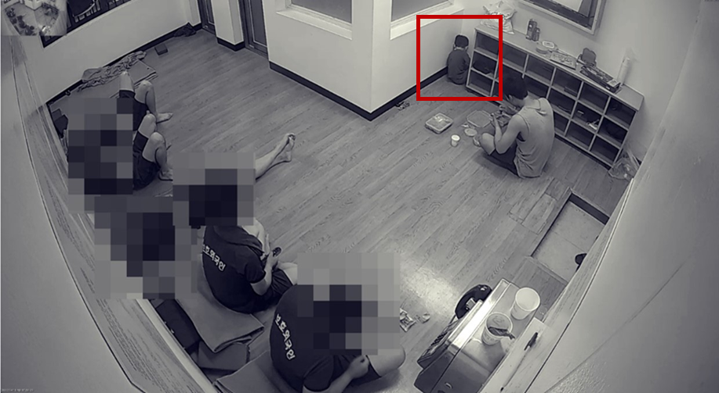
A three-year-old child, facing a wall in a corner of a small room with other adults, was spotted on a surveillance camera installed inside the Immigration Detention Center in Hwasung City in March 2023. It was clear from his posture and refusal to eat that the child was suffering from extreme stress.

Suggested Recommendations
1. The State party should implement laws and policies to prohibit the detention of migrant children.
2. The State party should take all necessary measures to prevent a migrant child from being detained in order to avoid family separation, and consider ‘the best interests of the child’ from the outset of any detention decision.

Only recognized refugee children are exceptionally eligible for support.
NHRCK, 25 August 2021. “Partial Acceptance of the Recommendation on Ensuring Migrant Children's Right to Childcare by the Ministry of Health and Welfare.”
NHRCK, 14 December 2023. “Recommendation on Providing Early Childhood Education Subsidies for Migrant Children Rejected by the Ministry of Education.”
Kim, Mi-jeong (2020), "Current Status and Support Measures for Childcare and Care of Migrant Children in Gyeonggi Province," Gyeonggi Institute for Gender Equality and Family.
Dong-A Ilbo (January 18, 2023), "A 6-Year-Old Trapped in a One-Room... Jonathan, the 'Invisible' Child." https://www.donga.com/news/Society/article/all/20220117/111282996/1
Gyeonggi Foreign Residents Human Rights Support Center (2017), "Monitoring Report on the Basic Rights of Foreign Children in Gyeonggi Province"
CRC’s Concluding observations of 2019 (CRC/C/KOR/CO/5-6, para.31(a)).
The Rainbow School is a government program aimed at supporting migrant-background youth by providing education and programs such as Korean language education and career education. It also assists their social adaptation and settlement by facilitating integration into the formal education system and offering career guidance.
The Kyunghyang shinmun (2024. 9.19.) As the number of migrant-background youth rises, the Ministry of Gender Equality and Family's budget for the Rainbow School, which supported their settlement, is slashed. https://www.khan.co.kr/article/202409191616001
On September 26, 2023, the Constitutional Court ruled that the provision of the National Health Insurance Act—which immediately restricts insurance benefits from the following month for foreign regional subscribers who default on premium payments—was unconstitutional. Consequently, on January 3, 2025, the Ministry of Health and Welfare announced a draft amendment to the Enforcement Decree of the National Health Insurance Act, adding a provision exempting foreigners with fewer than three premium payment defaults from such benefit restrictions. However, this provision does not apply to all foreigners, but exclusively to holders of visas classified as Investor(D-8), Professor(E-1), Researcher(E-3), Technical Instructor(E-4), Professional(E-5), and Resident(F-2)—groups highly unlikely to default on premium payments.
The term "Foreigner-specific Medical Fees" refers to medical charges applied to patients with foreign nationality entering the State party specifically for medical treatment, as defined by the Act on Support for Overseas Expansion of Medical Service and Attraction of International Patients. These fees are typically set between two to five times higher than the standard NHI medical fees.
While nationals of the State party living together in the same residence are grouped into a single regional insured household with insurance premiums imposed only on the household head, foreign nationals —even when residing together as family—are individually required to register as separate household heads unless they are spouses or minor children of the primary household head.
As of 2025, the minimum monthly NHI premium (based on the previous year's average premium) for migrant household heads registered as regional insured is KRW 152,790, whereas the minimum monthly premium for minor household heads is KRW 22,340.
CERD/C/KOR/CO/17-19, para. 32(a).
The National Basic Living Security System, the most prominent public assistance program, restricts eligibility among non-nationals exclusively to marriage migrants and recognized refugees. Even marriage migrants qualify only under limited conditions, such as when raising minor children with nationality of the State party or supporting lineal ascendants of their spouse who are nationals of the State party.
CERD/C/KOR/CO/17-19, para.32(b)
CRC/C/KOR/CO/5-6, para. 27(g), 36(b), 43(c)
CRPD/C/KOR/CO/2-3, para. 54.
The estimates of civil society include teenagers and young adults who have grown up as migrant children and are already adults.
CERD/C/KOR/CO/17-19, paras.29
CRC/C/KOR/CO/5-6, paras. 43-44
NHRCK (March 31, 2020) Decision Details: Human rights violations due to the lack of a system for granting residence status to undocumented migrant children who have been in the country for a long time https://case.humanrights.go.kr/dici/diciSearchView.do?search_data=c9492edff1aec0e50db253767ba9c29cf238bb7da14bd38d87dc28e723716d68
Immigration Control Act, Article 94, Item 7 https://www.law.go.kr/%EB%B2%95%EB%A0%B9/%EC%B6%9C%EC%9E%85%EA%B5%AD%EA%B4%80%EB%A6%AC%EB%B2%95/%EC%A0%9C94%EC%A1%B0
The Ministry of Justice announced that it would overhaul the relevant system so that migrant children and teenagers who have been educated and grown up in Korea after March 20, 2025, and who are over 18 years old, can apply for a job-seeking (D-10) or employment (E-7) status of residence if they wish to find employment instead of going on to university after graduating from high school. However there are age restrictions of 18 to 24 years old and the requirement of having stayed in Korea for seven years before the age of 18, so the number of eligible migrant children, teenagers, and young adults is expected to be small.
Hankyoreh (Nov. 11, 2024) “Mom, why are you crying outside the hospital... Korean life ended in death eight months after joining the company” https://www.hani.co.kr/arti/society/rights/1166921.html Hankyoreh(2025.1.8.) “May the light of Koreans’ solidarity shine on oft-forgotten migrant neighbors” https://english.hani.co.kr/arti/english_edition/english_editorials/1176984.html
Hankyoreh (Nov. 17, 2024) “The Second Kang Tae-wan” Migrant Youths “Don't Take Away Our Right to Dream” https://www.hani.co.kr/arti/society/rights/1167811.html
International News (Mar. 12, 2025) Lee Yong-woo, “Unregistered Migrant Children's Right to Stay, ‘Protection’ Not ‘Exclusion’ https://www.gukjenews.com/news/articleView.html?idxno=3221993
CERD/C/KOR/CO/17-19, para. 18.
CRC/C/KOR/CO/5-6, para. 43(a).
According to the data provided for the Ministry of Justice, there was a case where a child was detained for 196 days between 2019 and August 2024.
National Human Rights Commission of Korea, 12 April 2024, “Recommendation on Human rights violation due to the rejection of the application for temporary release of child-accompanying foreign nationals at immigration.”
Hankyoreh (13 June 2023), “[Exclusive] A sick three-year-old in a basement with no windows…The Ministry of Justice’s detention”, https://www.hani.co.kr/arti/society/society_general/1095738.html
The Enforcement Rule of Foreigners Protection article 4 (4) states that the head of the immigration office can provide education adequate for the age and capacity of migrant children or delegate the conduct of education service to an external institution.
Korean Bar Association, “Report on the Survey of Detention Centers and Departure Waiting Rooms”, 28 February 28 2023.

