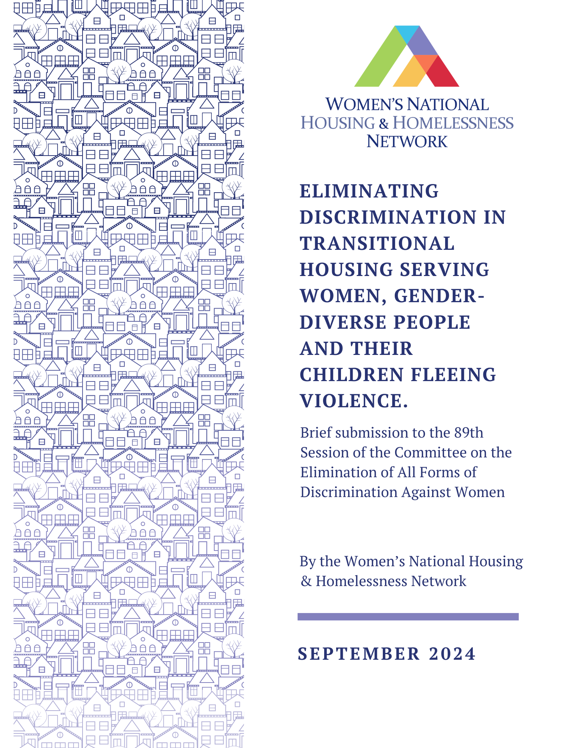
Background
- Transitional and second-stage housing are recognized as one of the most prominent housing responses for women finding respite from housing. In Canada, transitional housing and second stage housing is widely understood to, “provides temporary shelter, but can be differentiated from emergency shelters by the longer length of stay and greater intensity of support services offered to clients. Transitional housing is an intermediate step between emergency shelter and permanent housing. Support services help clients gain stability and self-sufficiency to maintain permanent housing. Stays are typically between three months and three years.”
- Research from Women’s Shelter Canada provides further clarification around the scope and scale of transitional and second stage housing in Canada, providing three key categories:
  - First stage emergency shelter/transition house: provides shorter-term shelter to women in crisis. Length of stay can be days, weeks, or months, depending on the shelter.
  - Second-stage housing/ transitional housing: provides longer-term accommodation to women who may no longer be fleeing immediate abuse but still require continued support and safety. Longer-term accommodation may be months or years, depending on the shelter.
  - Mixed facility: provides both first stage emergency shelter and longer-term second stage housing in one building under one administration.
- Based on these definitions, the research from Women’s Shelter Canada identifies that there are over 530 first stage, second stage and mixed facilities function in Canada that are “mandated to serve women and children escaping violence [and] there is no single model or governance structure for [these facilities] – they are all run individually and governed by their own boards.
- Research conducted on the impacts of transitional housing serving women, gender-diverse people and their children acknowledges that delivering services to women escaping violence often present complex challenges, which are further exacerbated by chronically underfunded services, under-paid staff that usually exhibits high turn-over tendencies, and physical infrastructure that is in need of repairs to accommodate physical accessibilities needs of the populations its serving. Despite these challenges, research recognizes that support services and safety provided by such housing offers a valuable opportunity for women to address their traumas and move towards rebuilding their lives.
- Recognizing that the ultimate purpose of transitional housing is to provide women, gender-diverse people and their children services that they need to create pathways out of violence and into stability, this submission hopes to draw attention to systemic gaps within the transitional housing system that put women and gender-diverse people in harm’s way. Ultimately addressing policy gaps and failures within transitional housing mandated to serve women and their children fleeing violence, can alleviate discrimination and harm perpetuated in women’s and gender-diverse people’s lives.
- This submission responds to CEDAW’s Concluding observations on the combined eighth and ninth periodic reports of Canada 24(e), which expresses Committee’s concern about “The lack of shelters, support services and other protective measures for women who are victims of gender--based violence, which reportedly prevents them from leaving their violent partners;” and would like to press for inquiry on Government’s progress on recommendation 25(e) which calls to “Strengthen services for women who are victims of gender—based violence, including by establishing shelters throughout the territory of the State party and ensuring the availability of psychosocial rehabilitation and reintegration programmes”;
- This submission further presents evidence to para 117 in the Report of the inquiry concerning Canada of the Committee on the Elimination of Discrimination against Women under article 8 of the Optional Protocol to the Convention on the Elimination of All Forms of Discrimination against Women, which states that, “the various initiatives notwithstanding, both government and independent sources indicate that the measures have not gone far enough to eliminate the socioeconomic disadvantage of aboriginal people. In a briefing paper prepared in 2013 by the Ministry of Aboriginal Relations and Reconciliation of British Columbia for the Committee, it was acknowledged that the existing education, employment and income gap between aboriginal and non-aboriginal Canadians went some way to explaining the high levels of domestic abuse experienced by aboriginal women and girls and that poverty was an overarching factor that forced women into homelessness and increased their vulnerability to violence.”
- This submission to the Committee on Ending all forms of Discrimination Against Women (CEDAW) hopes to identify forms of systemic discrimination perpetuated within transitional housing systems, that remain severely under research, and lead to egregious human rights violations women and gender-diverse people as they try to rebuild their lives from gender-based violence. The submission also identifies how siloed definitions of gender-based violence exclude women and gender-diverse people from receiving care through transitional and second-stage housing, leaving them to navigate the patchwork of support system while trying to keep themselves safe, and fulfilling caregiving responsibilities as mothers.
- The submission also hopes to drive attention to the egregious discrimination particularly experienced by Indigenous women, girls, Two-Spirit and gender-diverse people as they navigate transitional and second stage housing which are often not culturally appropriate and lack culturally sensitive services to meet their unique need.
Key Issue: Systemic Discrimination against Women and Gender-Diverse People Experiencing Homeless
- Based on research by Women’s Shelter Canada, a majority of transitional housing in Canada (62%) serves primarily women fleeing intimate partner violence (IPV). This means that women who are classified as homelessness are not eligible for services provided by transitional housing shelters, and thus have to rely on homelessness shelters, majority of which are not gender-specific, and put women at increased risks of violence.
- The siloing of homeless women from transitional housing services perpetuates discrimination against homelessness women and gender-diverse people in many ways. Firstly, as of 2019, 68% of homelessness shelter beds were co-ed or dedicated to men, compared to 13% dedicated to women, while many women avoid co-ed shelters due to the increased potential for violence in these spaces. When turned away from transitional housing services because they don’t meet eligibility criteria, they don’t necessarily opt for homelessness shelters. Instead, the increased risk of violence in co-ed shelters forces women to seek safety in other forms, such as “couch surfing, doubling up with other families in conditions of extreme overcrowding, [and] trading sex for temporary accommodation, and other survival strategies” that homeless women deploy have generally been categorized as indicative of “relative homelessness.” Unhoused women and gender-diverse people are more likely to experience violence, which contributes to the severity of trauma created due to homelessness among women and gender-diverse people. The lack of gender-specific homelessness response services and limited intake criteria of transitional housing leaves women experiencing homelessness with few options to find shelter and ultimately build towards housing security.
- Transitional housing, mandated to serve women, gender-diverse people and their children fleeing violence, is chronically underfunded in Canada. This means that even those who meet the eligibility requirements are at risk of being turned away if the facility is at capacity. This challenge is further complicated by the siloed eligibility criteria, which means women and gender-diverse people who fail to meet the criteria of ‘fleeing violence’ cannot access the critical safety and services infrastructure that is the most positive and significant factor of transitional housing. Studies focused on transitional housing found that the supports provided through transition houses, particularly the safety, referrals, counselling support from staff and access to basic needs within the shelter were noted as the most positive aspects of the shelter. These supports can play a critical role in providing women and gender-diverse people experiencing homelessness an environment to rehabilitate and build pathways out of homelessness.
- The impact of the siloes between homelessness shelters and those serving women and gender-diverse people fleeing violence gravely impacts Indigenous women. As articulated in the human rights claim submitted by the National Indigenous Women’s Housing Network, “silos between homelessness shelters and violence against women (VAW) shelters serving women fleeing violence create challenges for women trying to access housing supports. Experiences of homelessness and violence are intersecting, with violence being both a cause and effect of homelessness. Yet, silos between homeless shelters and VAW shelters requires women to either be attached to a ‘homeless’ status or ‘abused’ status... [sic] this can mean that if women’s homelessness is a result of poverty, evictions or any other reason in which [intimate partner] violence is not the cause of homelessness women are unable to access VAW shelters, even if homelessness is causing horrific experiences of violence in their lives. This demonstrates an egregious violation of women’s housing rights as often VAW shelters include supports that homelessness shelters don’t.”
Key Issue: Restrictive Policies, Lack of Tenant Protections and Eviction into Homelessness
- Transitional housing mandated to serve women, gender-diverse people and their children fleeing violence maintain very restrictive rules and policies to create a safe environment for children. While this is critical, it creates an environment of surveillance and high-barrier access for many women and gender-diverse people that can benefit from transitional housing and services.
- One such group prominently is women and gender-diverse people who use substances. Research on this groups notes that “Many VAW shelters maintain zero-tolerance policies regarding drug use. In fact, Newfoundland and Labrador and Nunavut mandate zero-tolerance among their shelters. Similarly, shelter policies in Alberta, Manitoba, and New Brunswick continue to link drug use to dangerous behaviour. Unsurprisingly, a 2021national survey found that, among 500 women and gender-diverse people, those who used drugs were barred from shelters at a rate that was three times higher than those who did not.”
- Best practices research from the HIV Legal Network notes that such surveillance and high barrier these rules “ignore the reality that the safety of all shelter participants, including children, and staff can be protected without such broad and stringent rules”
- Research also notes the problematic surveillance created through restrictive policies around guests, curfews barriers for women who have male children not allowed within transitional homes creating additional forms of discrimination for women and gender-diverse people. “Shelters that place inflexible limits on guests also negate women’s power and autonomy, deprive them of access to critical social and other supports, and impede their ability to generate income, including through sex work.”
- Another major challenge noted with transitional housing that can perpetuate cycles of housing insecurity for women and gender-diverse people is that “forms of housing defined as being temporary (e.g., transitional housing) do not offer residents security of tenure and protection under landlord tenant legislation, and the relationship between residents and housing providers is not a typical landlord-tenant relationship. In the case of transitional housing, women and gender-diverse persons often sign a “program agreement,” rather than a lease, which requires that they move out by a fixed end date and comply with program rules. Program rules may include participation in life-skills training, curfews, guest restrictions, and abstinence from drugs or alcohol. Their privacy may be limited, and they may be subject to room checks. Protections from eviction for failing to comply with program rules are non-existent, and there is no appeal mechanism for tenants who feel they have been unjustly exited from their unit by the housing provider. These conditions are inconsistent with the right to housing given that eviction into homelessness constitutes a violation of the right to housing under international human rights law. Preliminary research suggests that eviction from this type of housing can have severe consequences for women and gender-diverse persons who are experiencing some of the deepest forms of marginalization.”
- Research from the Centre of Public Legal Education Alberta also notes that the limited research on tenancy protections within transitional housing makes it unclear on how residents in those facilities are protected. Research noted that residents in transitional housing are handed a ‘notice to leave’ instead of an ‘evictions notice’. The lack of protections for tenants in transitional housing means that transitional housing residents do not have any accountability mechanisms available for them to seek justice. A report from The Tyee notes that “In 2020, 813 residents have been evicted from supportive housing and 285 of those tenants ended up in homeless shelters or back on the street. For 525 of those evicted tenants, it does not have information about where people ended up. BC Housing says it does not know how many of those evictions were from housing that falls under B.C.’s Residential Tenancy Act — which has specific regulations for how evictions are carried out — or transitional housing, which the act does not apply to. There are no rules around evictions from transitional housing, and it’s common for tenants to be unaware of which category their housing falls under.”
- The report also notes that “common reasons for eviction include violence, non-compliance with policies, no mental health or recovery supports, violating policies on visitors, or conflicts with staff or other residents.” One resident particularly noted being evicted for not participating in programming offered through the program at the transitional housing facility they were staying at. These no-recourse evictions further exacerbate homelessness among women and gender-diverse people trying to navigate situations of homelessness and precarity in their lives. These can lead to women and gender-diverse people ending up in cycles of homelessness, which is a failure of the goal transitional housing sets out to achieve which is to set women and gender-diverse people for housing security.
- The Human Rights claim submitted by the Women’s National Housing and Homelessness Network details how punitive rules and lack of tenancy protections leave women and gender-diverse people with little agency and no way to seek accountability in case of evictions. “An inquiry into rental housing and human rights by the Ontario Commission on Human Rights in 2008 identified similar issues in social housing, with particular policies having a disproportionately negative impact on women and women-led families. For example: “Guest policies under the Social Housing Reform Act (SHRA) were also described as having a disproportionate impact on lone mothers. Section 21(3) of the SHRA allows housing providers to establish rules for the temporary accommodation of guests in its rent-geared-to-income units. Consultees told the Commission that these rules seem to be aimed at “boyfriends” or partners whose incomes were not considered by the housing provider when calculating the subsidy amount. The Commission was told that strict enforcement of these policies can have far reaching effects on the ability of tenants to maintain their privacy and lead normal lives while at the same time maintaining their housing. If the guest is deemed to be an illegal occupant, the tenant’s subsidy can be revoked and the tenant may be evicted. The Hamilton Mountain and Community Legal Clinic provided this example: In one case at this office, a single mother of four children relied on her ex-husband to babysit while she attended the hospital with her four-year-old undergoing cancer treatment. She was repeatedly requested to provide proof that he was not staying overnight. Despite supplying affidavits and proof of his residency elsewhere, the provider removed her subsidy and brought an application to the housing tribunal to evict her family on the basis of sightings by neighbours and the superintended (sic) of his alleged overnight stays. When the so-called evidence was challenged, the matter was withdrawn, but not before serious suffering was inflicted on the entire family over the extended period.”
Recommendations
- Expand tenant protections to include transitional housing, particularly transitional housing that offer long-term stays and where tenants are paying rent.
- Ban all evictions into homelessness at transitional housing facilities
- Invest in permanent supportive housing for women and gender-diverse people experiencing homelessness and/or fleeing violence.
- Eliminate punitive policies that bar access to transitional housing for women and gender-diverse people that use substances.
- Develop low-barrier permanent supportive housing for women, gender-diverse people, and their children experiencing homelessness and/or fleeing violence.

Government of Canada, S. C. (2019, January 31). Classification of Shelter Type. 1. - Emergency shelter. https://www23.statcan.gc.ca/imdb/p3VD.pl?Function=getVD&TVD=440885&CVD=440885&CLV=0&MLV=1&D=1
October 2018 Mapping VAW shelters and transition houses: Available at: https://endvaw.ca/wp-content/uploads/2018/10/Mapping-VAW-Shelters-2018.pdf
Tutty, L.M., Nixon, K.L., & Thurston, W. (2024). "It's a Valuable Service but a Hard Place to Be:" Women's Views About Violence Against Women Shelters. Violence against women, 10778012241257244 . and https://www.theroyal.ca/sites/default/files/2020-02/VAW%20and%20MH%20Report%20final.pdf
CEDAW/C/CAN/CO/8-9 p. 7-8
CEDAW/C/OP.8/CAN/1 p. 29
Ann-Marie O’Brien MSW RSW, Emma Slaney Gose MSW RSW, Laura Crich RN MSc(c), Angel M. Foster DPhil MD AM (October 2019) “[T]here has to be a better way to deal with this”: Exploring the mental health needs of women residing in Violence Against Women shelters in Ottawa, Ontario https://www.theroyal.ca/sites/default/files/2020-02/VAW%20and%20MH%20Report%20final.pdf
Canadian Centre for Housing Rights (March 8, 2023) Canada must have a more inclusive definition of homelessness for women and gender-diverse people https://housingrightscanada.com/canada-must-have-a-more-inclusive-definition-of-homelessness-for-women-and-gender-diverse-people/
Homes for Women (October 2023) https://cwp-csp.ca/wp-content/uploads/2013/10/Housing-First-Women-Second-FINAL_Homes-for-Women_CAEH-Conf-Oct-2013.pdf p.5
Schwan et al 2020
Tutty, L. M., Nixon, K. L., & Thurston, W. (Billie). (2024). “It’s a Valuable Service but a Hard Place to Be:” Women’s Views About Violence Against Women Shelters. Violence Against Women, 0(0). https://doi.org/10.1177/10778012241257244
National Indigenous Women’s Housing Network (2022). Homeless on Homelands. p/ 42 https://womenshomelessness.ca/wp-content/uploads/Indigenous-Housing-Claim-June-15-2022.pdf
Boulanger A & Chu S (2024). Towards Access for All: Best and Promising Practices from Low-Barrier, Harm Reduction Shelters in Canada. p. 12 https://www.hivlegalnetwork.ca/site/towards-access-for-all-best-and-promising-practices-from-low-barrier-harm-reduction-shelters-in-canada/?lang=en
Boulanger A & Chu S (2024). Towards Access for All: Best and Promising Practices from Low-Barrier, Harm Reduction Shelters in Canada. p. 12 https://www.hivlegalnetwork.ca/site/towards-access-for-all-best-and-promising-practices-from-low-barrier-harm-reduction-shelters-in-canada/?lang=en
Boulanger A & Chu S (2024). Towards Access for All: Best and Promising Practices from Low-Barrier, Harm Reduction Shelters in Canada. p. 12 ﷟HYPERLINK "https://www.hivlegalnetwork.ca/site/towards-access-for-all-best-and-promising-practices-from-low-barrier-harm-reduction-shelters-in-canada/?lang=en"https://www.hivlegalnetwork.ca/site/towards-access-for-all-best-and-promising-practices-from-low-barrier-harm-reduction-shelters-in-canada/?lang=en
WNHHN (2022). The Crisis Ends with Us: Request for a Review into the Systemic Denial of the Equal Right to Housing of Women and Gender-Diverse People in Canada. P. 37-38
Gander, L. & Johansson, R. (2014). The Hidden Homeless: Residential Tenancies Issues of Victims of Domestic Violence. https://www.cplea.ca/wp-content/uploads/2015/01/FINAL-Report-The-Hidden-Homeless.2014Jun05.pdf
Denis, J (2023). https://thetyee.ca/News/2023/08/04/Supportive-Housing-Help-Tenants-Stay-Housed/
Denis, J (2023). Supportive Housing Is Meant to Help Tenants Stay Housed. It’s Not Always Working https://thetyee.ca/News/2023/08/04/Supportive-Housing-Help-Tenants-Stay-Housed/
WNHHN (2022). The Crisis Ends with Us: Request for a Review into the Systemic Denial of the Equal Right to Housing of Women and Gender-Diverse People in Canada. P. 37-38

