

Human Rights Commission of Sri Lanka

Submission by the Human Rights Commission of Sri Lanka

Review of Fifth Periodic Report of Sri Lanka under the
International Covenant on Economic, Social and Cultural Rights to the
UN Economic, Social and Cultural Rights Committee
May 2017

Independent Status of HRCSL

- The Human Rights Commission of Sri Lanka (HRCSL) established by Act No.21 of 1996 was reconstituted under the Nineteenth Amendment to the 1978 Constitution (2015) in October 2015. The Nineteenth Amendment restored the independent status of the Commission that was in effect removed by the Eighteenth Amendment (since repealed). Members of the HRCSL (as members of other independent commissions) can now be appointed by the President only upon the recommendation of the Constitution Council that comprises of Member of Parliament various political parties and also distinguished citizens. The Constitutional Council calls for nominations for membership of Commissions from professional and other civil society organizations.

- We are pleased that the composition and work of the current Commission has been commended by, among others, former UN Secretary General Ban Ki Moon, the High Commissioner for Human Rights Zeid Ra’ad Al Hussein - and also treaty bodies. The Commission is of the view that it is fully compliant with Paris Principles and plans to apply to regain ‘A’ status from the Global Alliance of National Human Rights Institutions (GANHRI).

- HRCSL is of the view that Concluding Observation 8 of CESCR (below) in response to combined periodic reports 2-4 of Sri Lanka (2010) has been addressed by Sri Lanka:
The Committee urges the State party to ensure that the National Commission on Human Rights meets the requirements of independence and autonomy set out in the principles relating to the status of national institutions for the promotion and protection of human rights (Paris Principles, General Assembly resolution 48/134)

HRCSL Commitment to Indivisibility of Rights
- HRCSL is fully committed to the concept of indivisibility of rights. That position informs all activities undertaken to discharge its mandate. The HRCSL is conferred with a relatively broad mandate under its parent statute, Act No. 21 of 1996 (ss.10 & 11). Its mandate confers powers needed to investigate and inquire into complaints relating to violations or imminent violations of fundamental rights; to make recommendations to the Government of Sri Lanka on measures that should be taken to ensure that national laws and administrative practices are in accordance with constitutionally recognized fundamental rights and international human rights norms and standards; to make recommendations to the Government on treaties on human rights that it should ratify or accede to; and to promote awareness on human rights. The Commission currently has 10 regional offices. The Commission requires its regional offices to incorporate ESC rights into their activities.

- HRCSL has established a series of thematic Sub-Committees in order to facilitate its commitment to prioritizing policy interventions, mainly on rights of marginalized communities assessed from the point of view of indivisibility of rights. The mandate of each Sub-Committee is to study pertinent issues and make recommendations for policy interventions on each theme by HRCSL. Themes covered include rights of migrant workers, plantation workers, the elderly, the disabled, gender justice, LGBTIQ Rights and education policy from a rights perspective. There is also a separate Sub-Committee on ESC Rights. Each Sub-Committee is chaired by a Commissioner/s and includes members of civil society recognized for their expertise on each theme. Interns too play an active role in the Sub-Committees. Work is ongoing and it is too early to report on outcomes.

- HRCSL is currently engaged in a program in association with the Australian Human Rights Commission on implementing regulations on accessibility rights of the disabled. Similarly, the promotion of the right to an adequate standard of mental health has received the attention of the Commission. Consultations with various stakeholders are underway with a view to formulating concrete recommendations to be made to the Government. On International Women’s Day (2017) an initiative was launched to examine the challenges facing women engaged in the informal sector with the participation of women giving leadership in related fields.

Incorporating ICESCR into Domestic Law

- HRCSL recognizes the imperative need to address the following Concluding Observation of CESCR (2010):

The Committee calls upon the State party to ensure that the Covenant enjoys full legal effects in the domestic legal order and prevails over domestic legislation in case of conflict. It also urges the State party to bring its domestic legislation in conformity with the rights contained in the Covenant. The Committee calls upon the State party to improve human rights training programmes in such a way as to ensure better knowledge, awareness and application of the Covenant and other international human rights instruments, in particular among the judiciary, law enforcement officials and other actors responsible for the implementation of the Covenant.

- HRCSL is of the view that the ongoing constitutional reform process taking place in Sri Lanka at present is an opportune moment to adopt a comprehensive Bill of Rights. Sri Lanka has a dualist legal system and has to incorporate international human rights standards via domestic legislation. The currently operative 1978 Constitution of Sri Lanka privileges civil and political rights over ESC rights. At present most economic and social rights are confined to the non-justiciable Directive Principles of State Policy (Chapter VI of Constitution).

- The unique public representations process adopted by the current constitutional reform process reported on the public demand to have economic and social rights such as the right to education and health care enshrined in a future constitution. However, a small but politically influential group has commenced an active campaign to discourage the incorporation of ESC rights as justiciable rights in the constitution, mainly on the basis that ESC rights have resource implications and an unelected judiciary should not be left to decide such issues. HRCSL is deeply concerned by such efforts that could roll back decades of work to bridge the artificial cold war inspired divide between civil and political rights and ESC rights.

- HRCSL has actively advocated the inclusion ESC rights as justiciable rights in the future Constitution of Sri Lanka. In our recommendations for constitutional reform (Annex I), the Commission endorsed an existing draft Charter of Rights that fully recognized indivisibility of rights. Further, our recommendations called for an expanded non-discrimination clause which is pivotal to the equal enjoyment of all rights including ESC rights, and also judicial review of legislation (not currently permitted).

- Additionally, HRCSL issued a public statement specifically on the need to include ESC rights as fully justiciable rights in the Constitution of Sri Lanka (Annex II). It called on the government of Sri Lanka to give leadership to recognize ESC rights as fully protected constitutional rights.

-----------------------
Annex I
Submissions by HRCSL
_______________________________________________________________________

Presented

to the Hon. Prime Minister, Hon. Speaker

&
the Public Representations Committee on Constitutional Reform
Human Rights Commission of Sri Lanka

PROPOSALS FOR CONSTITUTIONAL REFORM
Preface
The HRCSL is of the view that deepening constitutional protection of human rights requires much more than the incorporation of a substantively rich constitutional Bill of Rights into a future constitution. Two critically important dimensions that require attention in the reform process are:
- the guaranteeing of a sound system of separation of powers and checks and balances; and
- strong regulation of the public security regime

Specific Proposals
- Constitutional Principles

Foundational constitutional principles must be articulated either in the preamble to the constitution or as a substantive provision:
- Sovereignty of the people should be foundation of governance
- Transparency and accountability of governance
- Supremacy of the constitution
- Respect for pluralism, equality of dignity and inherent human rights of the people as individuals and as groups
- Respect for religious freedom of all
- Respect for social justice
- Power sharing
- Protection of the rights of future generations with special emphasis on environmental protection including protection of all animal species

- Bill of Rights:

The HRCSL endorses the Draft Charter of Rights (attached) drafted by a Sub-Committee appointed by Minister Mahinda Samarasinghe the Chair of then Inter-Ministerial Committee on Human Rights in 2006 and completed in 2009. It is endorsed subject to the following amendments and those necessitated by the repeal of the 1978 Constitution:

- Further strengthen the non-discrimination clause by adding the ground of sexual identity. The HRCSL received many representations in regard to the need to include ‘sexual orientation’, ‘sexual identity’ and ‘disability’ as prohibited grounds of discrimination. The first and the last and many other grounds such as ‘age’ and ‘maternity’ have already been included in the Draft Charter. The clause should be clearly articulated in an open manner as required by our international obligations—“…no discrimination shall be permitted on grounds such as…”
- Recognize the right to be free from enforced disappearances
- Recognize the right to legal aid or the broader right of access to justice
- Include a positive obligation of the State to introduce affirmative action measures in instances of historical injustice and underrepresentation in various sectors of public life
- Horizontal obligations of private parties for abuse of fundamental rights in appropriate situations
- Fundamental rights jurisdiction must be decentralized to appropriate regional courts to make access to justice easy
- ICCPR Act, No. 56 of 2007 must be repealed and rights therein must be incorporated into a future Bill of Rights. There must be no gradation of human rights.
- All rights guaranteed by the Bill of Rights must be entrenched. The diminution (lessening) or revocation (removal) of any of such rights should require a referendum in addition to adoption by a special majority in parliament. An alternative is to recognize a constitutional Basic Structure Doctrine that does not permit the amendment of fundamental rights.
- Interpretation of the Bill of Rights should give primacy to protection of human dignity and equal rights; should necessarily take into account the spirit and objectives of International Human Rights Law; and Directive Principles of State Policy.

- Ensure a strong system of checks and balances:

- The Constitutional Council shall consist of a majority of members from among respected citizens than of political representatives; social diversity must be represented on the Council
- Independence of the judiciary must be enhanced by strengthening the Judicial Services Commission. The JSC must have among its members respected retired justices and retired members of the official and unofficial Bar and also academics
- Providing for specific procedure by legislation for removal of judges that complies with principles of natural justice
- Ensuring judicial review of legislation is essential. Review should be with prospective (future) effect. Pre-legislative review also should be retained.

- Public Security Regime:

- Should necessarily be in line with Sri Lanka’s international human rights obligations (Article 4 of the International Covenant on Civil and Political Rights)
- A state of emergency could be declared only when the ‘life of the nation is threatened’
- Judicial review of a declaration of a State of Emergency must be guaranteed
- Similarly, judicial review of emergency regulations and emergency orders must be expressly provided for
- If a state of emergency continues for more than six consecutive months, Parliament must approve its further extension by a special majority
- The HRCSL endorses provisions in the Draft Charter of Rights (above) on derogation of rights during periods of emergency

- International Human Rights Treaties:

- The HRCSL recommends a process for human rights treaty ratification in accordance with its mandate, while recognizing that the recommendation could be of general application.
- The executive must inform Parliament of its intention to ratify international human rights treaties. Parliament must approve by resolution such ratification. Such resolution must be deemed to be an undertaking by Parliament of its intention to approve enabling legislation.
- The government must be bound to present enabling legislation within three months of ratification. If enabling legislation is not adopted within a year of ratification, courts should be authorized to give judicial recognition to the substantive rights in the ratified treaty.

- Human Rights Commission of Sri Lanka

- The Commission is set up under Act No. 21 of 1996. However, the appointment of Commissioners is dealt with under the Nineteenth Amendment to the 1978 Constitution. It is recommended that the HRCSL (as should all independent Commissions) be recognized in a future constitution as a constitutionally established body. Its powers and functions and the duty of public authorities to comply with its recommendations should be stipulated in the Constitution.

The HRCSL is currently studying its current legal framework in order to make recommendations for improvement.

- Linguistic Accessibility

- The HRCSL strongly recommends that the future Constitution be drafted and translated using simple language so as to enable the citizenry to read and access its provisions easily. It is a right of the citizens to know what their Basic Law says. That is of fundamental importance to constitution-building and in legitimizing constitutional governance.

---------------------------

The Draft Charter of Rights
The HRCSL endorses the incorporation of the attached Draft Charter of Rights into a future constitution subject to the amendments recommended and to the removal of references to the 1978 Constitution.
The Draft Charter of Rights was formulated between 2006-2009 by a Committee appointed on the initiative of Minister Mahinda Samarasinghe, then Chair of the Inter-Ministerial Committee on Human Rights. The Committee included academics specialized in human rights, civil society advocates, legal practitioners and representatives of the Legal Draftsman’s Department. Dr. Deepika Udagama, current Chairperson of the HRCSL was appointed as a member of the Committee and also served as the Chair of its Sub-Committee on Economic, Social and Cultural Rights. Dr. Jayampathy Wickramaratne, P.C. chaired the Committee.
The Committee deliberated on the framework and the substantive provisions of the Draft Charter for nearly two years, drawing from Sri Lanka’s international human rights obligations and also from comparative constitutions, in particular the Constitution of India and the Constitution of South Africa.
The Draft Charter was meant to be presented as the Eighteenth Amendment to the 1978 Constitution. The ending of the 26 year civil war in Sri Lanka in 2009 was an opportune moment for its release for public deliberations and eventual adoption. However, it was not officially released to the public for public debate and adoption by Parliament.

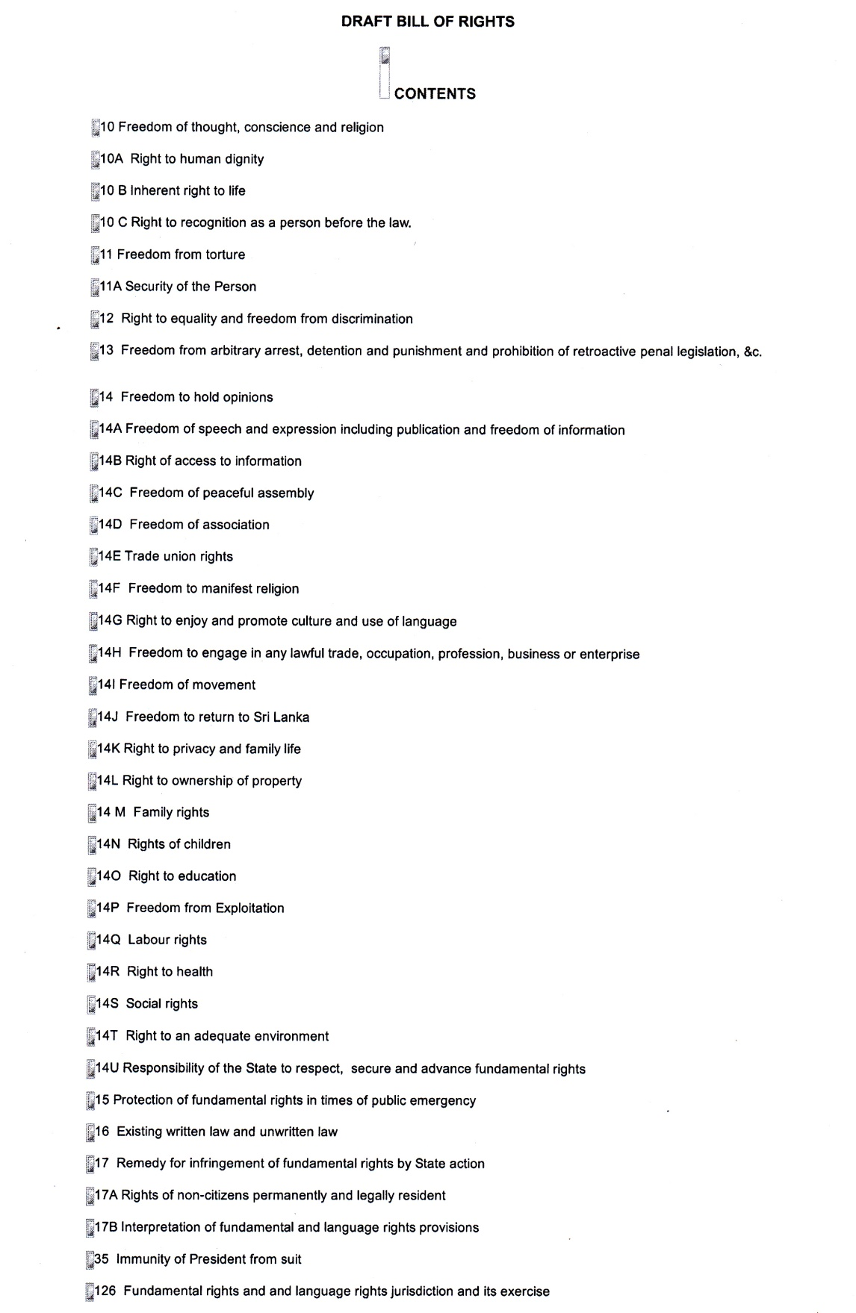
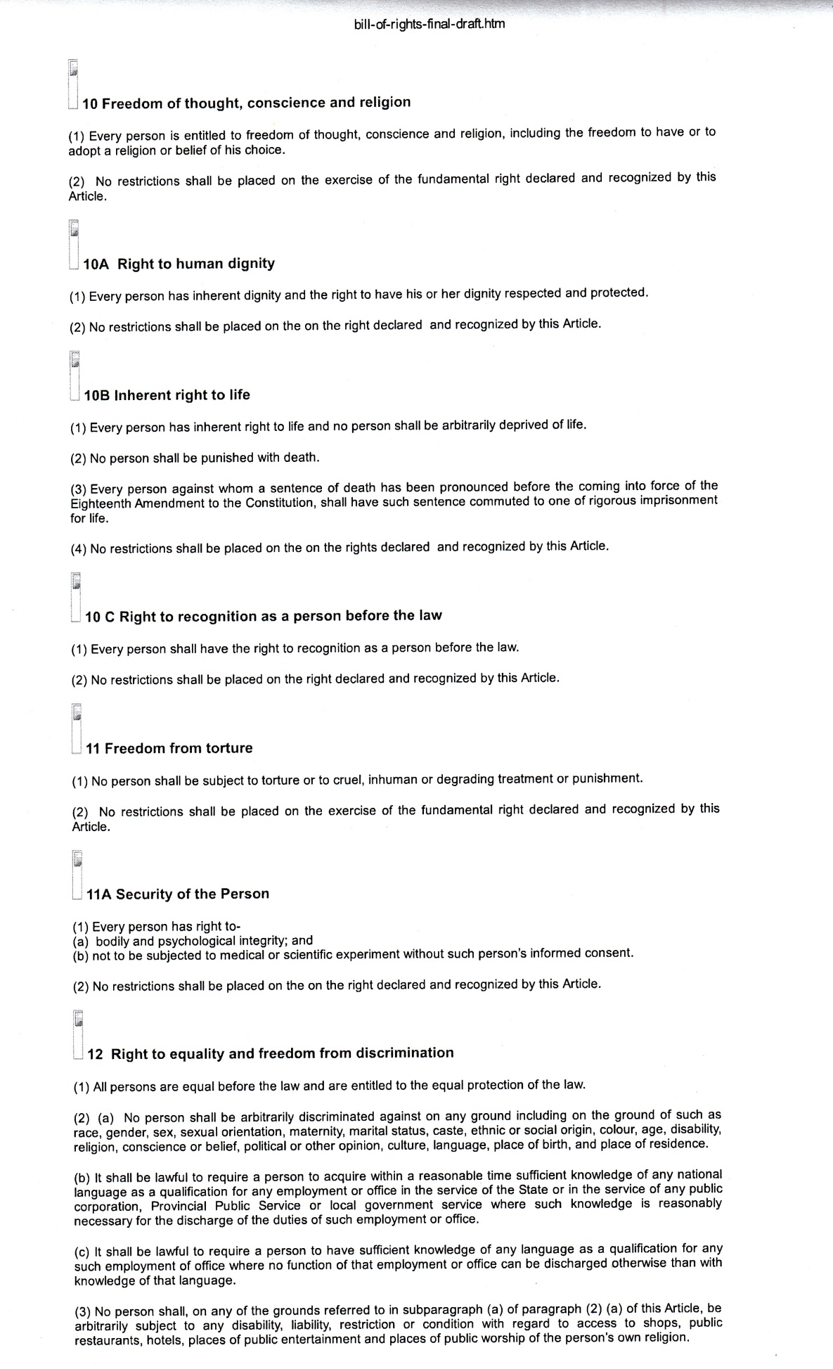
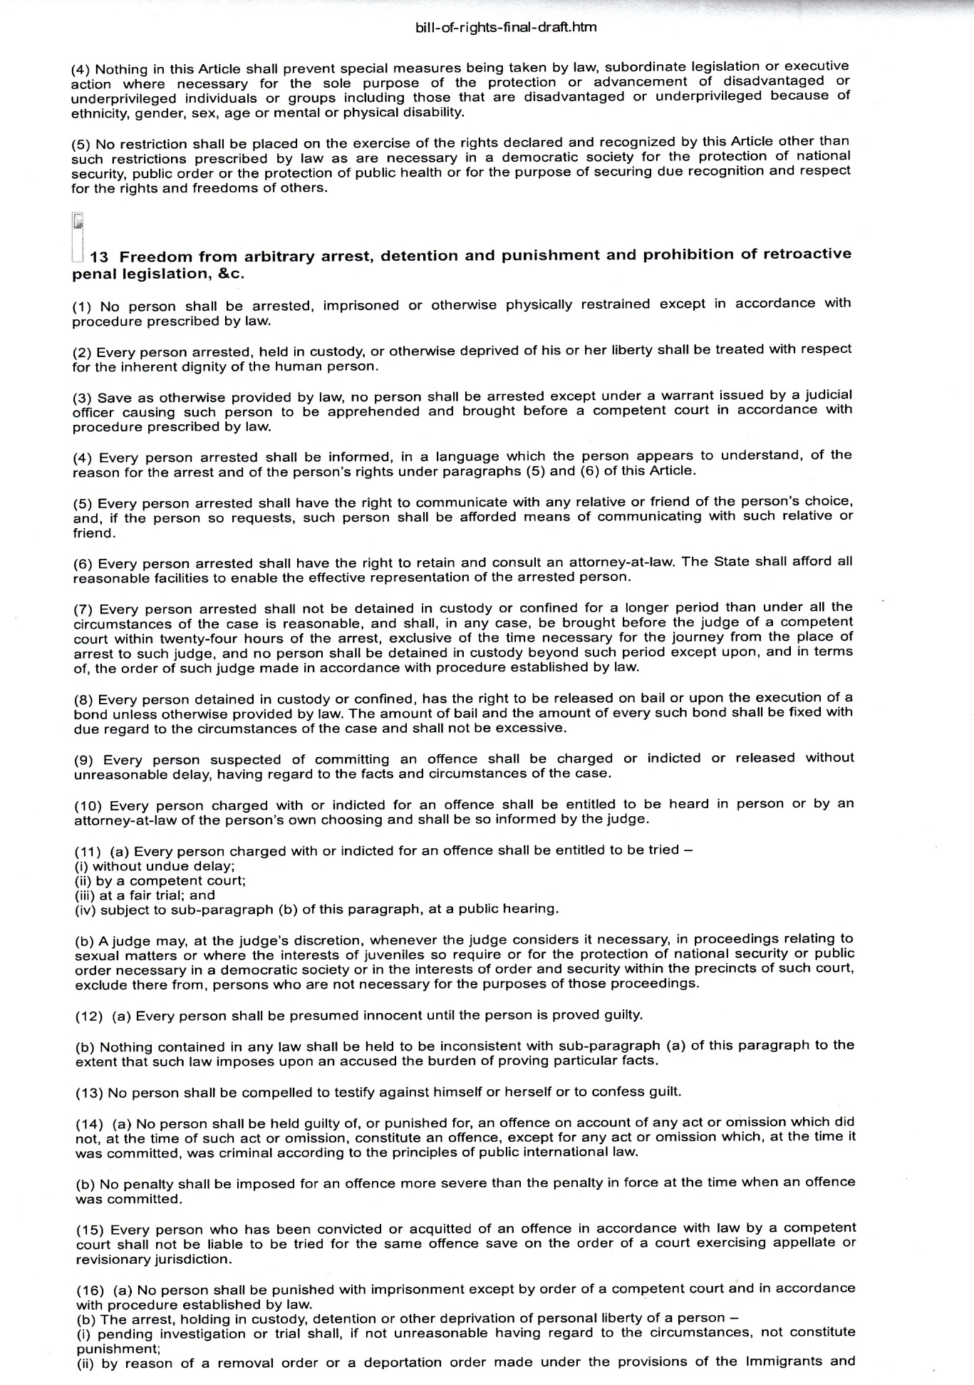
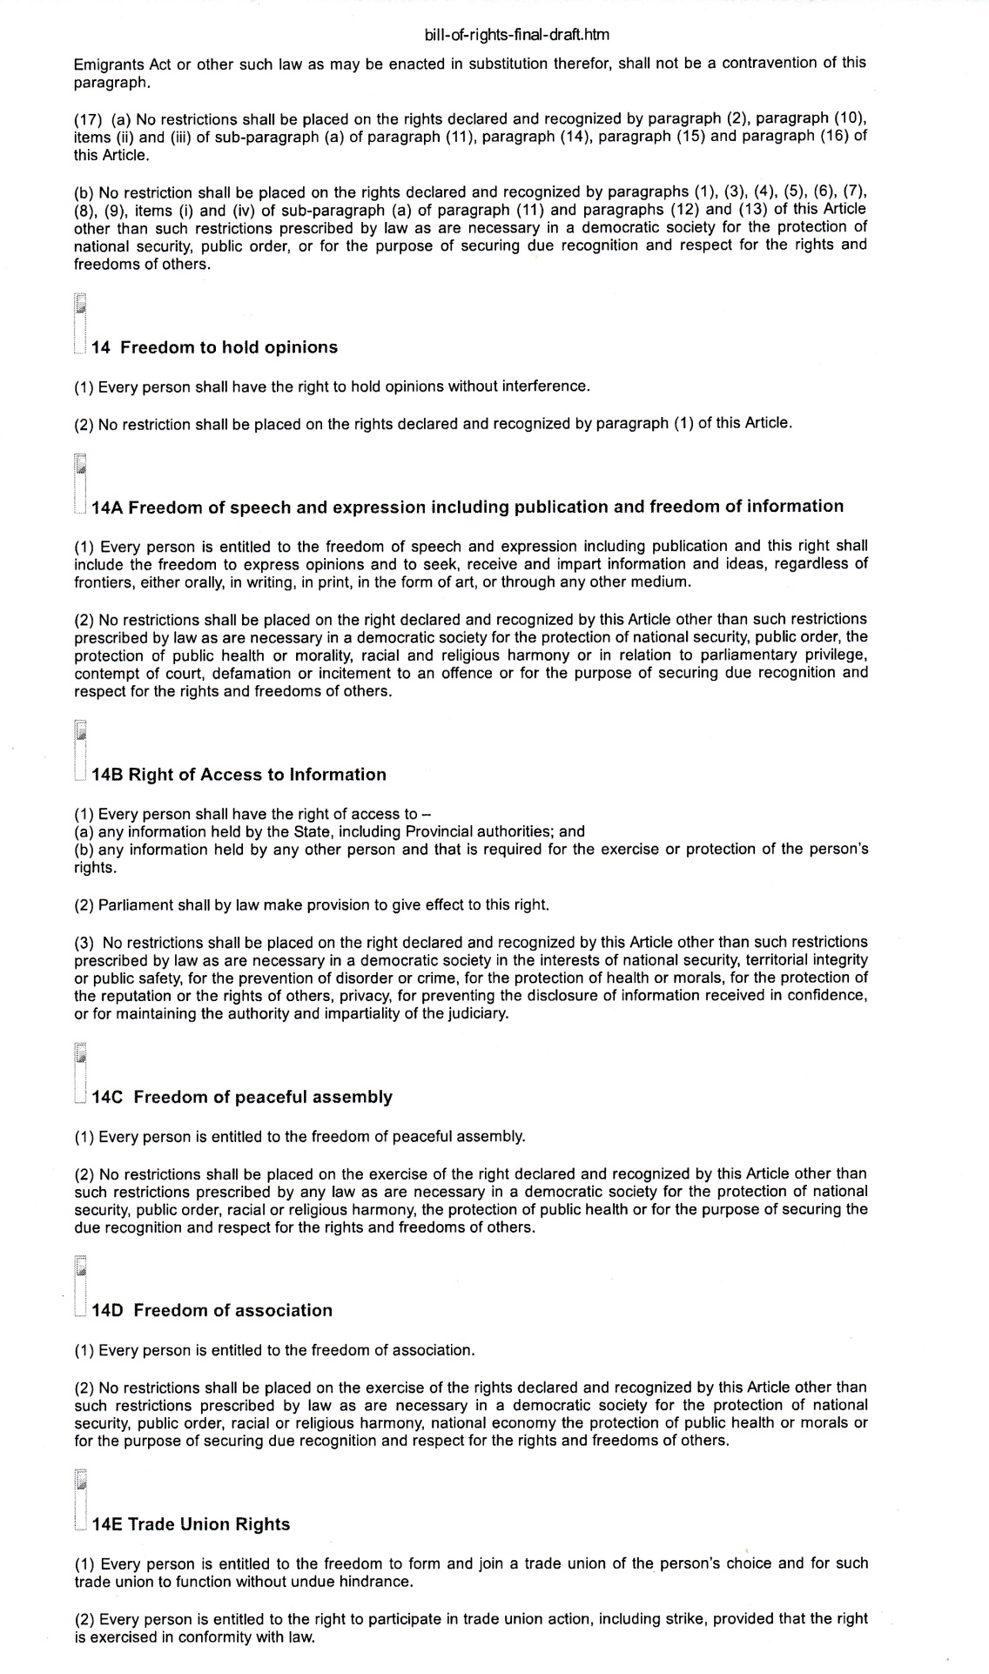
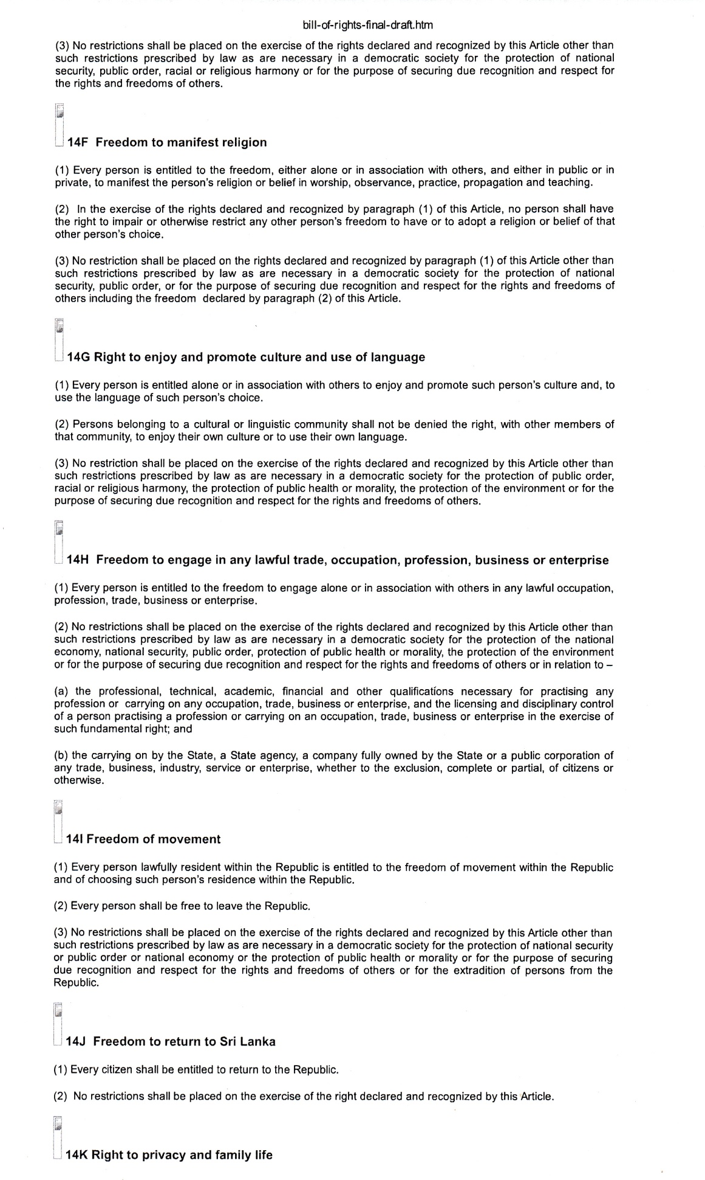
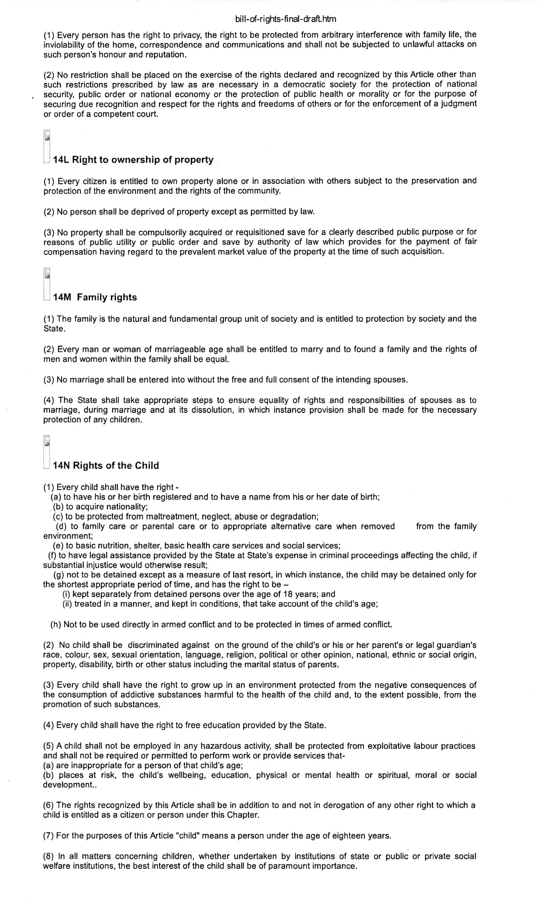
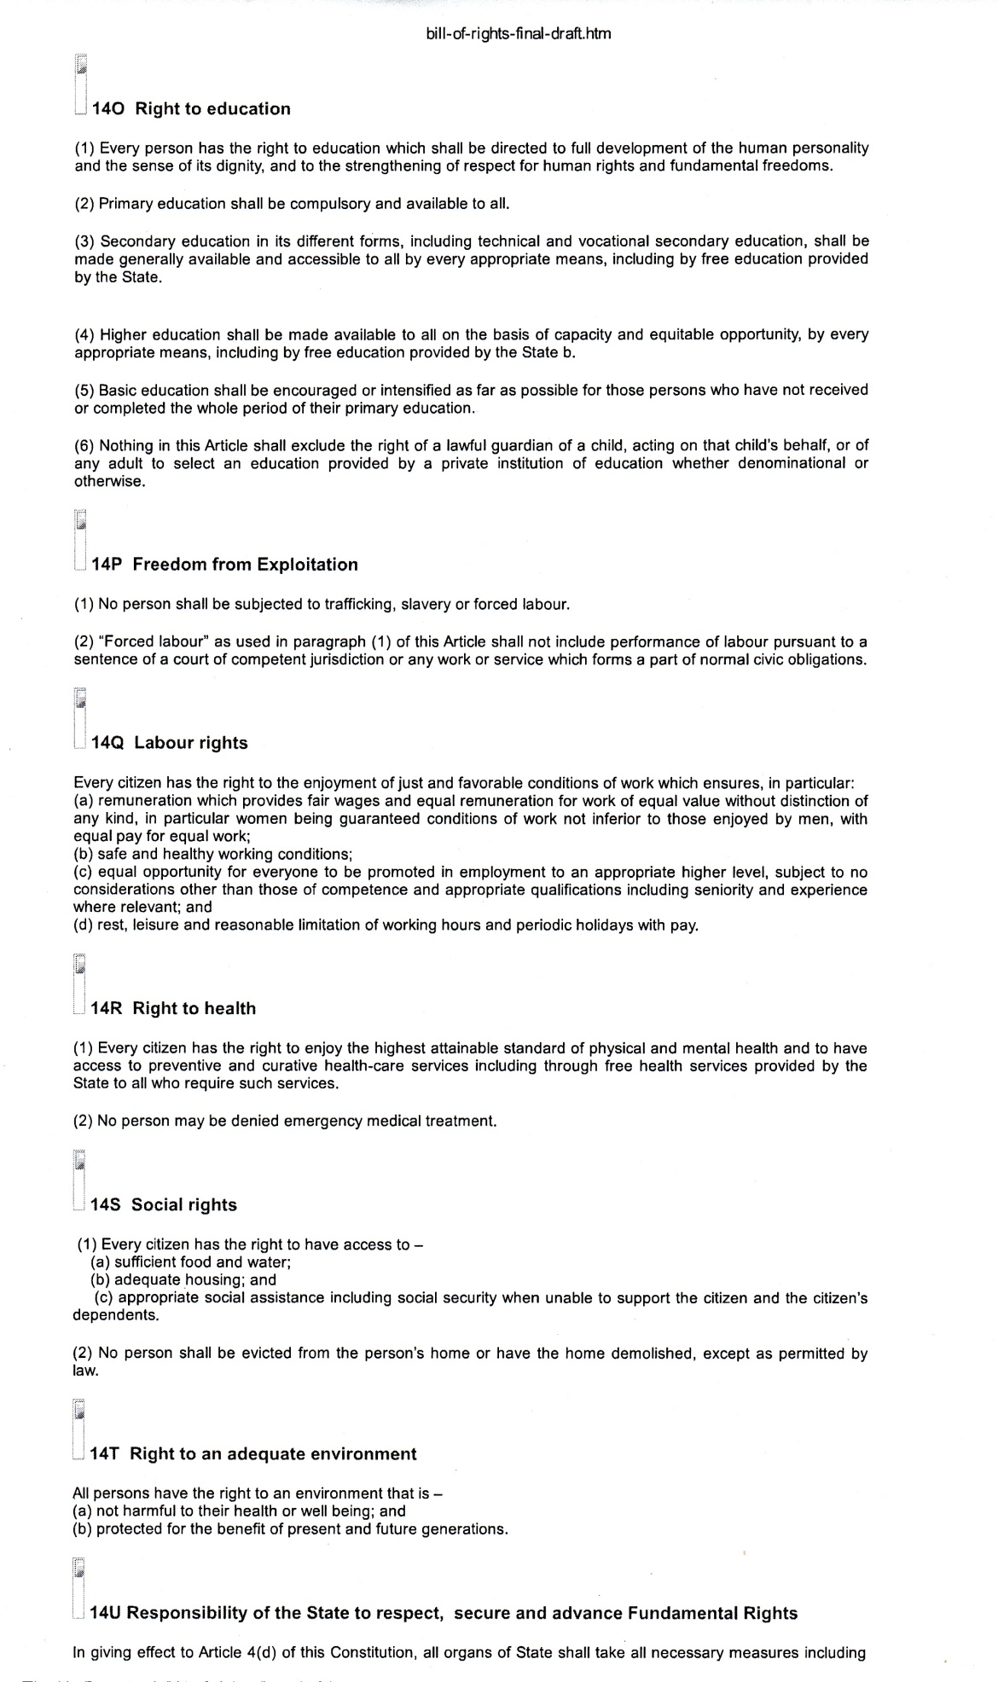
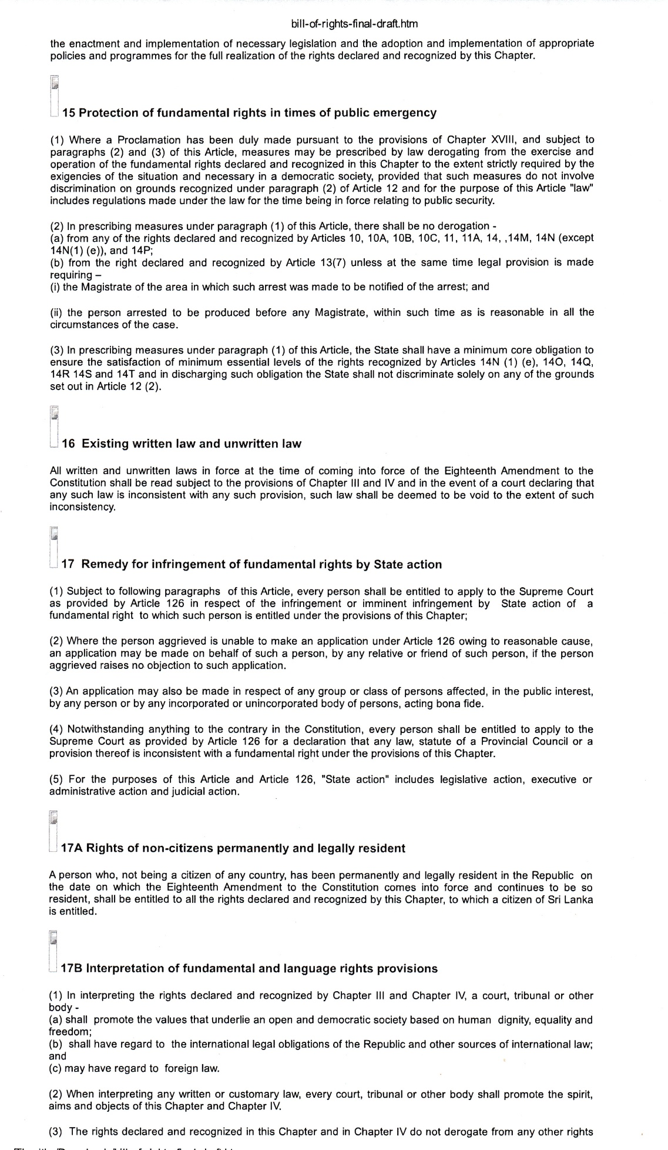

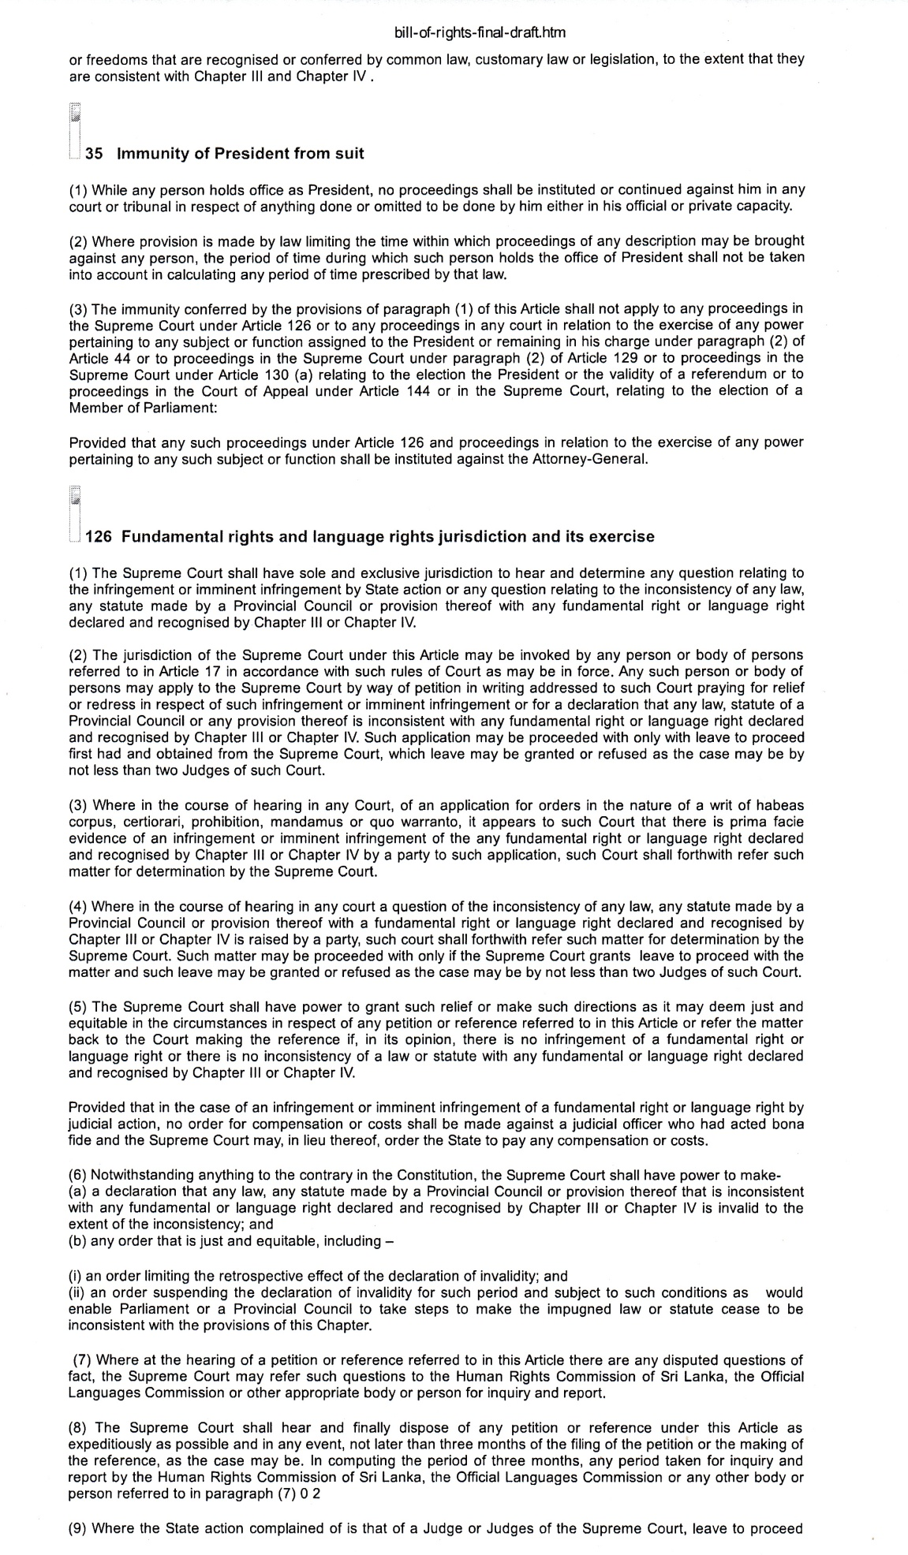

Annex II

Human Rights Commission of Sri Lanka
The Need to Incorporate Economic, Social and Cultural Rights in the Future Constitution of Sri Lanka

The Human Rights Commission of Sri Lanka (HRCSL) calls on HE the President to give leadership in calling for, and the Hon. Prime Minister and all members of the Constitutional Assembly to ensure, the incorporation of economic, social and cultural rights in the future constitutional chapter on rights as fully protected rights. The HRCSL is deeply concerned by moves by some to prevent the inclusion of such rights in violation of the principle that human rights are all inter-connected and cannot be divided. The constitution-making process must necessarily recognize the views articulated by the public in the public consultations process (2016) demanding the constitutional protection of rights such as the right to education, an adequate standard of health, housing and fair conditions of labour in the future Constitution. Failure to do so is also a violation of legal obligations undertaken by Sri Lanka, particularly under the International Covenant on Economic, Social and Cultural Rights (1966). Sri Lanka’s improving human rights record will be sullied by such a failure and would seriously undermine public confidence in the future Constitution.

The HRCSL is deeply concerned by attempts made by some quarters closely associated with the current constitution-making process to prevent the inclusion of economic, social and cultural rights (ESC rights), such as the right to education and an adequate standard of health, from the constitutional Bill of Rights as full-fledged rights for which judicial remedies are available. It has been argued that only civil and political rights should be guaranteed as full rights.
The HRCSL, the primary institution charged with the protection and promotion of human rights in the country, rejects this artificial division of human rights. It calls on the Constitutional Assembly to ensure that the people’s rights are fully guaranteed in the future Constitution. Failure to do so would seriously impede full protection of human rights and undermine the legitimacy of the new Constitution in the eyes of the public. It is the opinion of the HRCSL that such a move would also amount to a violation of international human rights obligations undertaken by Sri Lanka.
In March of this year, the HRCSL made submissions before the Public Representations Committee on its proposals for constitutional reform. The proposals were sent to the Hon. Prime Minister and the Hon. Speaker and were made available to the public in Sinhala, Tamil and English. In its proposals, the HRCSL endorsed the Draft Charter of Rights completed in 2009 for inclusion in the new constitution of Sri Lanka. The Charter, formulated by a group of experts appointed by an inter-ministerial committee guarantees not only civil and political rights but also economic, social and cultural rights as full-fledged rights capable of attracting judicial remedies.
The HRCSL proposals also emphasized the need to, among other things, recognize the promotion of social justice as a fundamental constitutional principle. It reiterated the importance of incorporating a strong system of checks and balances, including judicial review of legislation to ensure the effective protection of people’s rights. Above all, the need to recognize the principle of supremacy of the constitution was underscored.
The HRCSL proposals were made fully conscious of the unique opportunity this moment presents for Sri Lanka, especially as a post-war society, to acquire a modern constitution that addresses concerns of its people within a strong democratic State structure. This is a moment to right the wrongs of the past, and forge ahead to create a new Sri Lanka that is humane and just, as much as it is prosperous. Protection of the rights of the people in a strong and holistic manner is critical to achieving those goals. The post-conflict constitutions of South Africa, Kenya and Nepal, for example, are illustrative of such efforts. Sri Lanka too should follow suit and not miss out on this unique opportunity.
The HRCSL points to the following in that regard:
- Human rights are recognized in order for people to live in dignity realizing their full potential. As much as all aspects of human life are inter-connected, so also are human rights. It would be futile to divide rights and selectively protect only some of them. Today, the idea of indivisibility of rights is a firmly established principle recognized by the community of nations. The Vienna Declaration and Program of Action adopted by consensus by 171 States participating in the World Conference on Human Rights held in Vienna in June 1993 declares that ‘All human rights are universal, indivisible and interdependent and interrelated’.

- The unique feature of the current constitution-making process in Sri Lanka is the importance attached to public consultations. Such a process was missing in the making of the first two republican constitutions. The basis of constitution-making must be the will of the people in whom sovereignty lies. No entity is more powerful than the people in a democracy. The Constitution is for the people and must necessarily be by the people.

According to the detailed report of the Public Representations Committee on Constitutional Reform (May 2016), public representations had strongly demanded the strengthening of the existing constitutional chapter on rights by including rights such as the right to education, an adequate standard of health, housing and just conditions of work (Chapter 12). It is clear that such rights are no longer viewed by the people as welfare entitlements. They are recognized as human rights. It is worthy of note that the representations place strong emphasis on social justice in shaping the nature of the State. The demand is clearly not for cosmetic entitlements, but for full-fledged rights.

- The need to secure social justice in a post-war society cannot be emphasized more. It is the glue that could hold a fractured society together by building trust. People need to believe that the State is empathetic to their critical needs such as housing, food security, livelihoods, schooling for children and healthcare. Experiences in post-conflict societies everywhere, more recently in countries such as South Africa, Kenya, Nepal and Colombia, have proved that a constitutional commitment to social justice is needed to bring about political stability and instill credibility in governance.

- It is significant that recent public representations have referred to Sri Lanka’s international human rights obligations in articulating their demands (Report on Public Representations on Constitutional Reform (2016), Chapter 12). Reference has been made, among others, to legal obligations under the International Covenant on Economic, Social and Cultural Rights (ICESCR) which Sri Lanka ratified way back in 1980.

- States that have ratified the ICESCR are under an obligation to realize the rights through ‘progressive realization utilizing the maximum of available resources’ (Article 2). The State has to demonstrate that available resources are used maximally to realize ESC rights of the people. The State must ensure equal access to services. The State must ensure that the qualitative nature of services is commensurate with available resources. The economic development model of the State is irrelevant for those purposes. What is important is that the State discharges its obligations and demonstrates results.

Often, what is at issue is not the unavailability of resources but the failure to use available resources in a responsible and reasonable manner to realize the rights of the people. International human rights obligations compel States to utilize resources in a disciplined and accountable manner for public benefit.

- ‘Where there is a right, there is a remedy’ (ubi jus ibi remedium) is a sacred legal maxim. Critics of full recognition of ESC rights argue that canvassing such rights before courts would permit unelected judges to pronounce upon policy matters involving allocation of public resources and, therefore, should not be constitutionally recognized as rights for which judicial remedies would be available. That position is unacceptable for conceptual reasons and is also in violation of the international obligations of Sri Lanka.

Judges would not called on to initiate policy making in that regard, but are called on to review questionable policies. That is an essential feature of any functional democracy. The ICESCR obligates Sri Lanka to provide remedies, including judicial remedies, for violation of ESC rights (Committee on Economic, Social and Cultural Rights, General Comment No.9 on ‘Domestic Application of the Covenant’, E/C.12/ 1998/24 (1998) ). The UN Committee on Economic, Social and Cultural Rights, which supervises the implementation of ICESCR, has declared that it is no longer possible to deny remedies, including judicial remedies, in regard to ESC rights.

Human rights discourse at both national and international levels has moved on to new frontiers, recognizing that ESC rights as well as civil and political rights entail positive as well as negative State obligations and that the realization of all rights have financial implications for the State.

In fact, the right to vote and the right to a fair trial (civil and political rights) are two of the most expensive rights entailing the formulation and implementation of complex policies. That does not mean, therefore, such rights should be denied judicial remedies. However, skeptics argue that the right to education and right to health, for example, should not have judicial remedies as they entail both State resources and policy implications. Therefore, such matters should be left to the whims of the political branches without judicial review. The HRCSL finds such a position to be illogical and internally contradictory. As the ESC rights Committee points out, such reasoning negates the linkage between rights (indivisibility of rights) and seriously curtails the possibility of courts to protect the rights of the most vulnerable and disadvantaged in society (General Comment No. 9 (above), para 10).

- Reluctance to fully recognize ESC rights has much to do with one’s economic policy orientations. Human rights of the people cannot be contingent on the shifting vagaries of the market or official economic policy priorities that may change from time to time.

- The Responsibility of private economic actors to respect human rights is also increasingly recognized both at national and international levels. The UN Guiding Principles on Business and Human Rights (Ruggie Principles) (2011) recognize that States are obligated to enforce laws that require private business entities to respect human rights. The much respected Constitution of South Africa (1996) extends human rights obligations to private actors as well.

In Sri Lanka too public representations have been made to that effect (Report of the Public Representations Committee (2016), p 127). HRCSL proposals on constitutional reform have recommended that human rights obligations be extended to private actors. The right to property and the right to engage in an occupation of one’s choice should be balanced with obligations to larger society. Rather than be deterred by such obligations, private business entities should welcome the opportunity to earn public goodwill and credibility. Many are discovering that socially responsible business practices are good for business. It is evidenced by the 8000 + companies that have joined the UN Global Compact.

- It is also argued that full constitutional recognition of ESC rights would encroach on devolved powers. Devolution of power is not a license to violate or diminish people’s rights, but is a means to better protect rights. Recognized human rights norms recognize minimum standards that should be respected and protected by all constituent units of a State.

The world is watching the reform agenda in Sri Lanka with great anticipation, especially in regard to deepening of democratic governance and protection of human rights. Regression of the kind proposed by the critics of ESC rights would be a serious rolling back of progressive constitutional trajectories established by more recent constitutions such as those of South Africa, Kenya and Nepal. It would be a black mark against Sri Lanka’s improving human rights record. Not only should the people of Sri Lanka make use of this unique opportunity to secure a strong constitution for themselves, but also ensure that a healthy precedent is established for other countries to emulate.

Accordingly, the HRCSL calls on His Excellency the President to give leadership in this regard. We urge the Hon. Prime Minister and all members of the Constitutional Assembly to ensure that the ongoing constitutional reform process ensures the inclusion also of ESC rights in the future constitutional chapter on rights as fully protected rights capable of vindication by courts, respecting the principle of indivisibility of rights that would enable the full enjoyment of human rights by the people of Sri Lanka.

The HRCSL calls on concerned citizens and civil society organizations to step up advocacy for full constitutional recognition of all human rights so that there will be no future regrets on missed opportunities.

Dr. Deepika Udagama,
Chairperson
Human Rights Commission of Sri Lanka

Secretary-General’s remarks at event in Sri Lanka on SDG16: Sustaining Peace – Achieving the Sustainable Development Goals, 2 September 2016 at https://www.un.org/sg/en/content/sg/statement/2016-09-02/secretary-general%E2%80%99s-remarks-event-sri-lanka-sdg16-sustaining-peace-%E2%80%93
Oral update on the human rights situation in Sri Lanka by the High Commissioner to the Human Rights Council 22 March 2017 at http://www.un.org/apps/news/story.asp?NewsID=56403#.WQ3koImGNZ0; Statement by Zeid Ra’ad Al Hussein on the Situation of Sri Lanka and Myanmar, 29 June 2016 at http://www.ohchr.org/EN/NewsEvents/Pages/DisplayNews.aspx?NewsID=20218&LangID=E; Statement by UN High Commissioner for Human Rights, Zeid Al Ra’ad Hussein, at the end of his mission to Sri Lanka, 9 February 2016 at http://www.ohchr.org/EN/NewsEvents/Pages/DisplayNews.aspx?NewsID=17025&LangID=E
Committee Against Torture, Concluding Observations on Fifth Periodic Report of Sri Lanka 27 January 2017 at http://tbinternet.ohchr.org/_layouts/treatybodyexternal/Download.aspx?symbolno=CAT%2fC%2fLKA%2fCO%2f5&Lang=en ; CEDAW, Concluding observations on the eighth periodic report of Sri Lanka 3 March 2017 at http://tbinternet.ohchr.org/_layouts/treatybodyexternal/Download.aspx?symbolno=CEDAW/C/LKA/CO/8%20&Lang=En
Report of the Public Representations Committee on Constitutional Reform at http://www.yourconstitution.lk/PRCRpt/PRC_english_report-A4.pdf
‘Socio-economic rights in Sri Lanka's constitution may backfire on the poor’, Economy Next, 25 February 2017 at http://www.economynext.com/Socio_economic_rights_in_Sri_Lanka_s_constitution_may_backfire_on_the_poor-3-7428.html

