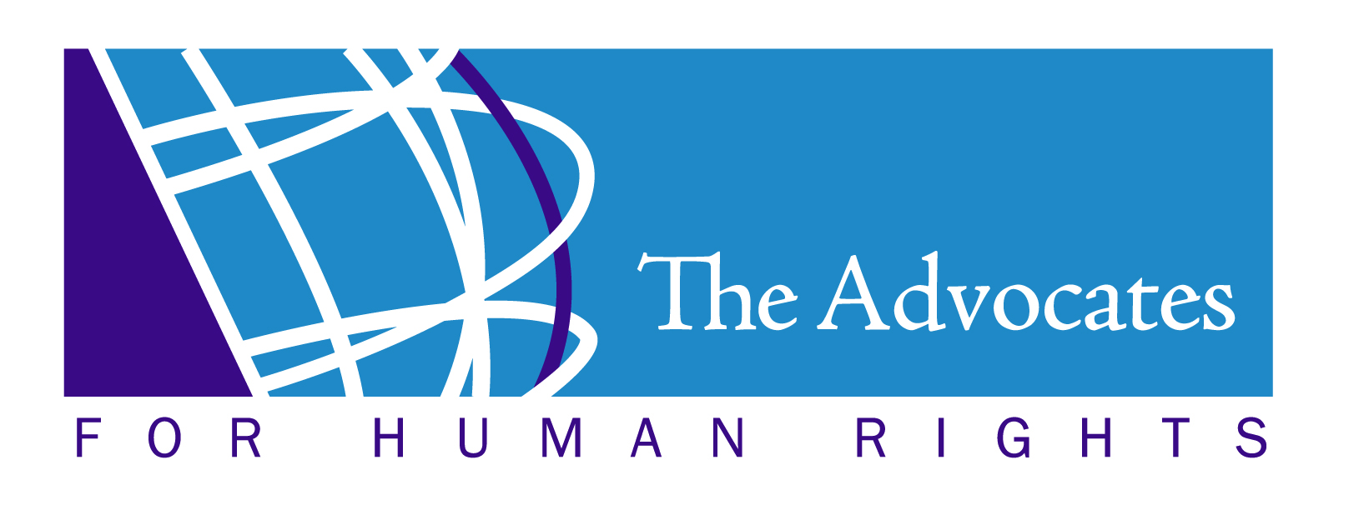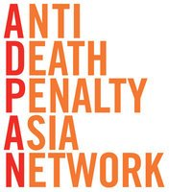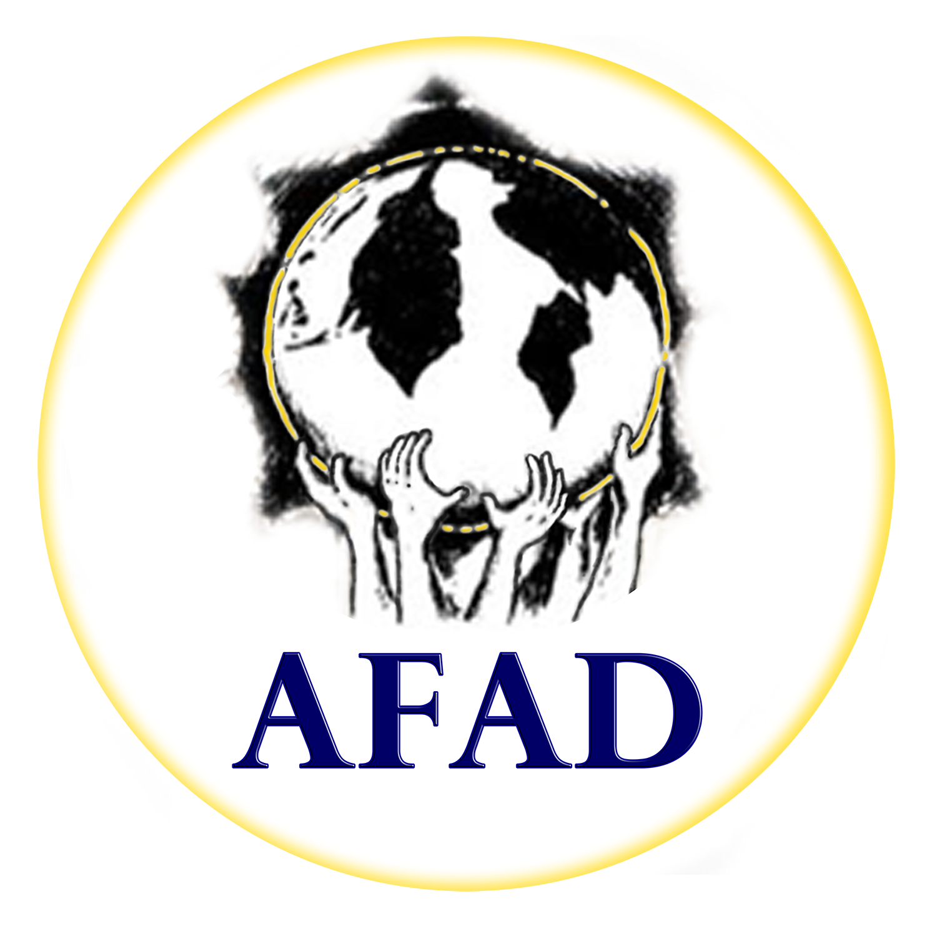





Civil Society Joint Alternative Follow-up Report on Key Recommendations Submitted one year after the UN Committee against Torture’s

Concluding Observations on the initial report of Bangladesh

25 August 2020

Joint submission by:
Advocates for Human Rights; Anti-Death Penalty Asia Network (ADPAN); Asian Federation Against Involuntary Disappearances (AFAD); Asian Legal Resource Centre (ALRC); International Federation for Human Rights (FIDH); Odhikar; Robert F. Kennedy Human Rights; and World Organisation Against Torture (OMCT)

- Introduction

- This Alternative Report is submitted to the United Nations (UN) Committee against Torture (CAT) one year following its adoption of the Concluding Observations on the initial report of Bangladesh at its 67th session on 8 August 2019. At that time, the CAT requested the Bangladesh Government to submit a follow-up report by 9 August 2020 on measures it had taken to implement the Committee’s recommendations. We note that as of this submission, the Government of Bangladesh has not yet submitted its follow-up report.

- The CAT specifically requested Bangladesh to report on progress made toward the following key recommendations on:

- Ensuring the full implementation by law enforcement authorities and magistrates of the directives issued by the High Court;
- Monitoring all places of deprivation of liberty by an independent authority and representatives of NGOs;
- Establishing a complaints mechanism for persons detained arbitrarily; and
- Ensuring that members of civil society organizations who have cooperated with the Committee in the context of the consideration of the State party’s initial report are protected from any reprisals or harassment.

- More generally, the Bangladesh Government was also invited to provide information on its plans to implement the remaining recommendations made by the CAT in its Concluding Observations, in response to reports of serious human rights abuses, including torture, enforced disappearances, the use of the death penalty, and extrajudicial killings. This abbreviated Alternative Report provides inputs from civil society organisations regarding the Bangladesh Government’s implementation of the CAT’s four recommendations for follow-up made in the Concluding Observations. The full Alternative Report on implementation of all the recommendations made by the Committee in the Concluding Observations is included as an annex to this report, and is available here: https://rfkhumanrights.org/news/civil-society-joint-alternative-follow-up-report.

- At the time of Bangladesh’s initial review in 2019, many of the civil society organisations contributing to this Alternative Report submitted a Civil Society Joint Alternative Report on Bangladesh to raise serious concerns regarding Bangladesh’s failure to implement the Convention against Torture and other Cruel, Inhuman or Degrading Treatment or Punishment (“the Convention”). The information in this report follows from this prior participation in the CAT review process, and reflects the collective efforts of these organisations to continue to monitor, document, and report on human rights abuses in Bangladesh, including those that violate the Convention.
- Follow-up on the Committee Against Torture’s Key Recommendations

- The following section details the four recommendations identified by the CAT for follow-up in its Concluding Observations on the initial report of Bangladesh, and the perspectives of civil society organisations on actions taken by the Government of Bangladesh toward implementation of those recommendations.

Key Recommendation 1: Ensure prompt and full implementation by law enforcement authorities and magistrates of the directives issued by the High Court and affirmed by the Court of Appeals in the case of Bangladesh Legal Aid and Services Trust v. Bangladesh, including through providing training and greater oversight.

- Although the Supreme Court ordered the Government to amend the relevant sections of the Code of Criminal Procedure of 1898, the Penal Code of 1860, and the Evidence Act of 1872 to ensure compliance with its ruling in the case of Bangladesh Legal Aid and Services Trust and others vs. Bangladesh and others and to ensure compliance with international human rights obligations, those changes have not been made. After hearing this case in 2003, the High Court Division of the Supreme Court of Bangladesh issued 15 directives to safeguard against abuse of the powers of arrest and interrogation in custodial detention. The Appellate Division upheld the directives of the High Court Division and added four more directives in 2016. However, the directives are yet to be implemented.

- In Bangladesh, the police generally abuse power under Sections 54 and 167 of the Code of Criminal Procedure. Section 54 empowers police to arrest anyone on suspicion without a warrant, and Section 167 permits police to take an accused into custody on remand. The plea for remand is generally accepted, and the accused is subjected to torture to extract a “confession.” According to existing law, after arresting someone without warrant, an officer has to take the person arrested before a Magistrate without any unnecessary delay. No police officer shall detain a person arrested without warrant for a period longer than 24 hours, exclusive of the time necessary for the journey from the place of arrest to the Magistrate’s Court, without any special order of a Magistrate under Section 167. However, such mandatory provisions are often violated. A Magistrate is authorised to grant remand under Section 167 of the Code of Criminal Procedure, by noting the specific reasons, if the police officer reasonably fails to complete the investigation of the relevant case within 24 hours. Time in police remand can be up to 15 days, which has long been criticised by human rights defenders.

- The rights to access to counsel immediately after arrest and thereafter, as well as the right to ensure family members are promptly informed about the time and place of a person’s arrest and detention, are still widely violated, and the directives of the Supreme Court related to these have not been implemented.

- Pretrial detentions in Bangladesh are excessively used and lengthy. Denial of bail is one of the main reasons for the abuse of pretrial detention, as well as the delay in carrying out investigations and submitting charge sheets, and delays in prosecution. As of 12 July 2020, 81 percent of the prison population was made up of pretrial detainees.

- As a measure of last resort, pretrial detention shall be used only in accordance with international standards and norms. However, there is no information on whether pretrial detention is regulated by means of legal criteria compliant with international standards.

- The Government has not taken any measures to decrease the excessive use of pretrial detention by the authorities and to increase the use of non-custodial measures in accordance with the United Nations Standard Minimum Rules for Non-custodial Measures (the Tokyo Rules).

- However, the Government has considered releasing selected prisoners, who had been jailed for minor offences or had completed most of their terms, from jails to contain the spread of COVID-19 in Bangladesh. The Government released 2,884 convicted prisoners who were serving short sentences to reduce the risk of the spread of COVID-19.

Key Recommendation 2: Ensure that all places of deprivation of liberty in the State party are monitored by an independent authority with the power to carry out unannounced visits to places of detention and speak confidentially with any individual in the facility, and that representatives of non-governmental organizations (NGOs) are also permitted to access all places of detention.

- The Bangladeshi authorities still engage in the practice of unacknowledged detention. None of the allegations of unacknowledged detention, enforced disappearance, and death in custody have been promptly and thoroughly investigated by an independent body.

- The Government has failed to ensure that all places of detention in the country are monitored by an independent authority with the power to carry out unannounced visits and speak confidentially with any individual in the facilities. Representatives of non-governmental organisations (NGOs) are not permitted to access all places of detention. A few government-sponsored non-governmental organisations (GONGOs) are registered with the National Human Rights Commission of Bangladesh (NHRC) and are authorised to visit some places of detention, mainly police stations and prisons. However, such organisations rarely visit police stations and prisons.

- The Government has not published a list of all recognised places of detention and failed to ensure that no one is held in secret or incommunicado detention anywhere in the territory of Bangladesh. There are still allegations of holding people in secret or incommunicado detention.

Key Recommendation 3: Establish a complaints mechanism for persons detained arbitrarily.

- The Government has not established a complaints mechanism for persons detained arbitrarily. Currently, the only legal remedy available to those arbitrarily detained is to file a habeas corpus petition with the High Court Division of the Supreme Court. In practice, however, this remedy is seldom granted, given the lack of independence and impartiality of the judiciary.

- Arbitrary arrests and detentions continue to be widely used by the Government to attack those expressing dissent against the ruling party. The victims of arbitrary detention include university teachers, journalists, a cartoonist, bloggers, online activists, and individuals below the age of 18. For example, on 20 June 2020, police arrested a 15-year-old for making a Facebook post allegedly defaming Prime Minister Sheikh Hasina and criticising the Government’s handling of the pandemic. Political activists, dissenters, journalists, and writers have been facing criminal cases and arbitrary detentions under the Digital Security Act (DSA) of 2018, particularly in response to their comments on the COVID-19 outbreak.

- The Government continued its crackdown on freedom of opinion and expression during the COVID-19 outbreak, targeting journalists, human rights defenders, writers, bloggers, academics, and even arresting ordinary people for speaking out about the COVID-19 pandemic, silencing those who expressed concern over the Government’s mishandling of the pandemic. The Government has enforced the repressive DSA: to muzzle freedom of expression; silence and intimidate journalists and human rights activists; and sue individuals who are critical of the Government’s response to the pandemic.

- From January to June 2020, the authorities detained 94 people under the DSA, mostly for criticising the Government in Facebook posts. Among them, 47 were detained for raising questions about the Government’s mismanagement of the COVID-19 situation and related corruption. For instance, on 6 May 2020, RAB-3 filed a case against 11 people under the DSA for allegedly spreading rumours and carrying out anti-government activities, posting anti-government messages on Facebook, providing false information about COVID-19, and publishing cartoons of various leaders. The 11 people who have been charged include: cartoonist Ahmed Kabir Kishore; Swedish-Bangladeshi journalist Tasneem Khalil; and blogger Asif Mohiuddin. Four of the 11 were arrested and sent to jail by court order. The RAB stated in the First Information Report that the men had been deliberately posting rumours against the Father of the Nation, the Liberation War, and the COVID-19 pandemic to harm the nation’s image and to create confusion among the public through social media. More broadly, the Government has also blocked access to several online news outlets, including Al Jazeera and PoribortonDotCom.

- There are a number of other draconian criminal laws still in place that contribute to the widespread use of arbitrary arrest and detention. Under the Special Power Act of 1974, persons can be “preventively detained” to prevent them from committing “any prejudicial act,” that the executive authority deems detrimental to the interests of the State, even if the individual has not yet committed such an act. It has been common for persons arrested under Section 54 of the Code of Criminal Procedure to be later charged under the Special Powers Act of 1974.

Key Recommendation 4: Ensuring that members of civil society and NGOs who have cooperated with the Committee in the context of the consideration of the State party’s initial report are protected from any reprisals or harassment, including charges of breaching the Information and Communications Technology Act, in keeping with the pledge given by the Minister of Law, Justice, and Parliamentary Affairs.

- Persecution and harassment of members of civil society and NGOs continues, despite the Committee’s recommendation to ensure protection of the members of civil society and NGOs who have cooperated with the Committee in the context of its consideration of Bangladesh’s initial report from any reprisals or harassment, including charges of breaching the Information and Communications Technology (ICT) Act of 2006. Furthermore, the Government has continued to withhold its approval for foreign funding to NGOs working in areas the NGO Affairs Bureau deemed sensitive, such as human rights, labour rights, indigenous rights, or humanitarian assistance to Rohingya refugees. For example, the Government’s crackdown on Odhikar, which began in 2013, continues. To date, the NGO Affairs Bureau (NGOAB) under the Prime Minister’s Office has not renewed Odhikar’s registration, which was submitted in 2014. In order to halt all of Odhikar’s human rights activities, the NGOAB has stopped fund clearance for all of the organisation’s projects for the last six years and completely barred approval of any new projects. Furthermore, human rights defenders associated with Odhikar have been subjected to various forms of harassment, including surveillance, due to their public positions on human rights violations. The case filed under the ICT Act against the Secretary and Director of Odhikar is still pending.

---

END OF THE REPORT

UN Committee against Torture, Concluding Observations on the Initial Report of Bangladesh, ¶ 1, UN Doc. CAT/C/BGD/CO/1 (Aug. 26, 2019), https://undocs.org/CAT/C/BGD/CO/1.
Id. at ¶ 52.
Civil Society Joint Alternative Report on Bangladesh Submitted to the Committee against Torture, 67th CAT Session (22 July – 9 August 2019), https://tbinternet.ohchr.org/Treaties/CAT/Shared%20Documents/BGD/INT_CAT_CSS_BGD_35328_E.pdf.
Bangladesh Legal Aid and Services Trust (BLAST) v. Bangladesh, Supreme Court of Bangladesh, High Court Division, Writ Petition No. 3806 of 1998 (2003), https://www.lawyersnjurists.com/lawyer_ci/case/bangladesh-legal-aid-and-services-trust-blast-and-others-vs-bangladesh-and-others-55-dlr-2003-363.
Bangladesh Legal Aid and Services Trust (BLAST) v. Bangladesh, Supreme Court of Bangladesh, Appellate Division, Civil Appeal No. 53 of 2004 (24 May 2016), http://www.humanrights.asia/wp-content/uploads/2020/07/Bangladesh-Supreme-Court-Verdict-on-Civil-Appeal-No.-53-of-2004.pdf.
Bangladesh Jail, accessed 12 July 2020, https://prison.com.bd/home.
M. Moneruzzaman, Jail Authorities Start to Release 2,884 Inmates, New Age Bangladesh (5 May 2020) https://www.newagebd.net/article/105722/jail-authorities-start-to-release-2884-inmates.
BANGLADESH: Seized State Power and Institutional Collapse Key Behind Continued Enforced Disappearances, Written Statement to the 42nd Regular Session of the UN Human Rights Council, Asian Legal Resource Centre (29 August 2019), http://alrc.asia/bangladesh-seised-state-power-and-institutional-collapse-key-behind-continued-enforced-disappearances/.
DSA Violations: Ninth Grader Lands in Juvenile Centre, The Daily Star (22 June 2020), https://www.thedailystar.net/dsa-violations-ninth-grader-lands-in-juvenile-centre-1918693.
BANGLADESH: Surge of Arbitrary Detention under Digital Security Act Leads to Deepening Crisis, Asian Human Rights Commission (13 July 2020), http://www.humanrights.asia/news/ahrc-news/AHRC-STM-014-2020/.
BANGLADESH: Surge of Arbitrary Detention under Digital Security Act Leads to Deepening Crisis, Asian Human Rights Commission (13 July 2020), http://www.humanrights.asia/news/ahrc-news/AHRC-STM-014-2020/.
The Rapid Action Battalion. The number “3” denotes the zone or area covered by a particular RAB contingent. Zone 3 is the Tikatoli/Mughbazaar area, a heavily populated zone.
Zyma Islam and Muntakim Saad, Digital Security Act: 11 Sued, Two Sent to Jail, The Daily Star (7 May 2020), https://www.thedailystar.net/frontpage/news/digital-security-act-11-sued-two-sent-jail-1900228.
BANGLADESH: Stifling Expression Using Digital Security Act Must Not Be the Norm to Address COVID-19 Pandemic, Asian Human Rights Commission and CIVICUS (11 May 2020), http://www.humanrights.asia/news/ahrc-news/AHRC-JST-002-2020/.
Zyma Islam and Muntakim Saad, Case Against 11 Under DSA: Charges Appear to Be Puzzling, The Daily Star (9 May 2020), https://www.thedailystar.net/frontpage/news/case-against-11-under-dsa-charges-appear-be-puzzling-1900915.
Id.
BANGLADESH: Muzzling Press Freedom Triggering Risks on Livelihood of Information Technology Professionals, Asian Human Rights Commission (24 Jan. 2020), http://www.humanrights.asia/news/ahrc-news/AHRC-STM-001-2020/.
U.S. Department of State, Bangladesh 2019 Human Rights Report (Feb. 2020), https://www.state.gov/reports/2019-country-reports-on-human-rights-practices/bangladesh/.
Odhikar in collaboration with the Asian Legal Resource Centre (ALRC), Asian Federation Against Involuntary Disappearances (AFAD), Asian Forum for Human Rights and Development (FORUM-ASIA), FIDH - International Federation for Human Rights, Robert F. Kennedy Human Rights, and the World Organisation Against Torture (OMCT) submitted a joint alternative report to the Committee and cooperated with the Committee in the context of its consideration of the State party’s initial report.

