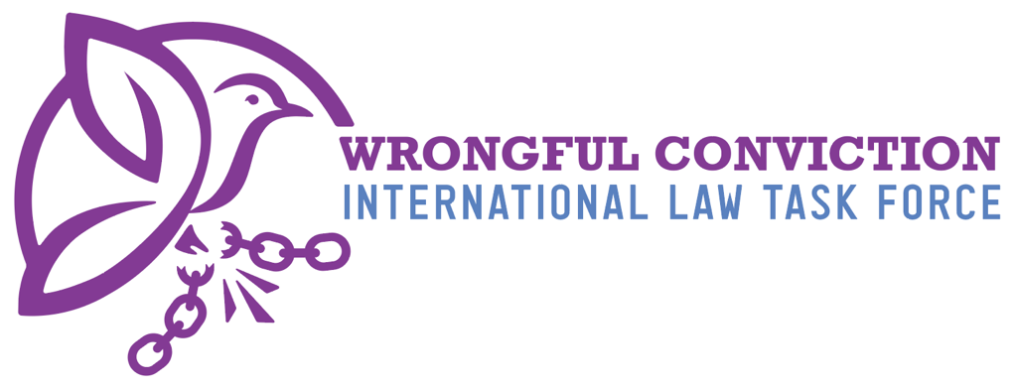

List of Issues for Belgium Prior to Reporting
United Nations Human Rights Committee
Submitted on January 5, 2026

- Authors
The Wrongful Conviction International Law Task Force (WCILTF) is a global coalition of law professors, attorneys and activists working together to fill the “Innocence Gap” in international law. The WCILTF is supported by a pro bono legal team at the international law firm Proskauer Rose (www.proskauer.com/) located in New York City.
In the past twenty-five years, wrongful conviction of the innocent has emerged as a major problem in criminal justice systems around the world. Research indicates that the problem has always existed but has only come to light in recent decades due to forensic advancements allowing for post-conviction DNA testing of crime scene evidence. Wrongful convictions occur because of human limitations in investigation and evidence collection, such as memory weaknesses and malleability (leading to misidentifications by eyewitnesses), unreliable or faulty forensic evidence, false confessions, confirmation bias or tunnel vision on behalf of investigators, inadequate defense lawyering, and many other human problems. Thus, wrongful convictions exist in all legal systems around the world, as all nations use the same types of evidence and investigation techniques regardless of the precise legal procedures employed in their courtrooms.
NGOs called “Innocence Projects” have sprung up around the globe to combat this problem, and now entire networks of innocence projects exist in Asia, Europe, North America and South America. Innocence Projects are often housed at law schools and are operated by law professors and law students. In one member state, for example, more than 3,000 innocent people have been released from prison in recent years due to the work of NGOs like Innocence Projects. Exonerations of the innocent have occurred across the globe in the past three decades.
For a brief video overview of the global problem of wrongful convictions, and the efforts of Innocence Projects to combat the problem, please view: https://youtu.be/jMATkuFaRU8?si=fO0wXGhPr-oCyhBA
As the innocence movement has developed a global presence in recent years, it has become apparent to legal scholars that an “Innocence Gap” exists in international law. The WCILTF formed to combat this problem and help fill the Innocence Gap. The WCILTF is comprised of more than twenty-five law professors and Innocence Project leaders from across Asia, Europe, North America and South America.

- Filling the Innocence Gap
Due to the relatively recent discovery of wrongful convictions, international law covenants and treaties predate awareness of this problem and thus do not speak directly to issue. In recent years, however, the United Nations Human Rights Committee (HRC) has identified key rights to the benefit of incarcerated person claiming innocence to be derived from the right to a fair trial and other existing rights. For example, in Abdiev v. Kazakhstan, 2023, the HRC stated that the right of incarcerated persons to re-open a criminal case in order to present new evidence of innocence after conviction and appeal have concluded, in order to achieve exoneration and freedom, is essential to the right to a fair trial under Article 14(1) of the ICCPR. Similarly, on October 3, 2023, in Concluding Observations on the Fifth Periodic Report of the Republic of Korea, the HRC observed that South Korea should “provide adequate legal and financial assistance to enable individuals sentenced to death to re-examine convictions on the basis of newly discovered evidence, including new DNA evidence.” Likewise, on July 25, 2024, in Concluding Observations on the Second Periodic Report of Maldives, the HRC expressed concern “about the lack of information on the existence of a procedure enabling individuals sentenced to death to seek a review of their convictions and sentences based on newly discovered evidence of their innocence, including new DNA evidence, and, if wrongfully convicted, to provide them with compensation.” The HRC recommended that Maldives take all necessary measures to ensure that “death sentence can be reviewed based on newly discovered evidence of their innocence, including new DNA evidence, adequate legal and financial assistance is provided to enable this review and, if wrongfully convicted, individuals have access to effective remedies, including compensation” para. 28(e). See Brandon Garrett, Laurence Helfer and Jayne Huckerby, Closing International Law’s Innocence Gap, S. Cal. L. Rev. 95 (2021), available at: https://papers.ssrn.com/sol3/papers.cfm?abstract_id=3803518#
- Rights of Innocent Incarcerated Persons in Belgium
Based on the research of the WCILTF, it is our belief that Belgium does provide a formal legal framework through which wrongfully convicted persons may seek to challenge their convictions based on newly discovered evidence of innocence. Belgium allows for a post-conviction revision procedure, enabling courts to reopen and reconsider cases considering compelling new facts that appear capable of demonstrating innocence. Recent reforms have attempted to modernize this system, including the introduction of an advisory commission to assist the Court of Cassation in examining whether a “new fact” exists and whether it is sufficiently persuasive to justify reopening the case.
However, despite these positive developments, significant barriers remain. The revision procedure is narrow and procedurally demanding. Belgium does not have a dedicated statutory right guaranteeing incarcerated persons access to post-conviction DNA testing of crime-scene evidence. Instead, DNA testing may only play a role indirectly within the revision process, contingent upon the willingness of authorities or courts to authorize it. Equally concerning is the absence of a comprehensive legal framework requiring biological crime-scene evidence to be preserved for future testing. While some DNA-related materials may be retained in practice, there is no clear legal obligation ensuring that potentially exonerating biological evidence remains available years after a conviction has become final.
Belgium similarly lacks a broad transparency or “sunshine law” regime permitting post-conviction access to police and prosecution files by defense attorneys, NGOs, journalists, or incarcerated individuals. Access generally depends on formal judicial processes, limiting independent review. Although Belgium’s inquisitorial system requires authorities to collect and consider exculpatory evidence prior to trial, there is no explicit equivalent to a codified “Brady rule,” and there is no strong legal mechanism guaranteeing disclosure as a separate enforceable right.
Belgium does provide compensation to individuals whose wrongful convictions are overturned, although such compensation is not automatic and must be pursued through a separate legal process. Additionally, Belgium does not mandate universal audio-visual recording of police interrogations, relying instead on optional recording and written summaries. Finally, although identification procedures employ certain safeguards, Belgium has not yet incorporated scientifically recommended protections such as mandatory double-blind or sequential line-ups.
- Questions to Belgium
- Have any post-conviction motions presenting new evidence of innocence been successfully granted by a court in Belgium, resulting in the incarcerated person’s exoneration and freedom? Have any such motions been denied by courts in Belgium? In practice, how do the revision mechanism work when new evidence of innocence is presented post-convicion?
- Does Belgium have a law allowing incarcerated persons to petition for post-conviction DNA testing of crime scene evidence to prove innocence and seek relief?
- Does Belgium have a legal procedure requiring biological evidence collected from the crime scene to be properly stored and preserved for future DNA testing?
- If so, how long must the biological evidence be preserved?
- Does Belgium have a “sunshine law” or “public records law” granting defense attorneys, NGOs, journalists or incarcerated persons access to police files and documents of an incarcerated person’s case post-conviction?
- Does Belgium have a legal standard requiring the police and prosecution to disclose to the defense pre-trial any exculpatory evidence or other information helpful to the defense or that might lead to new avenues of pre-trial investigation that might be conducted by the defense?
- If so, what is the legal standard pertaining to this disclosure requirement?
- Why does Belgium lack with respect to regulations ensuring that police identification procedures for eyewitnesses adhere to best practices devised by the scientific community, such as the double-blind eyewitness identification requirement? See https://www.ojp.gov/ncjrs/virtual-library/abstracts/double-blind-sequential-police-lineup-procedures-toward-integrated
- Are there any efforts underway in Belgium to improve the police eyewitness identification procedures to bring them up to international standards?

This document created by the following members of the WCILTF:
Mariana Raventos
LLM student, University of Cincinnati
Professor Mark Godsey
University of Cincinnati
To contact the WCILTF generally, please email:
Prof. dr. mr. G.J. Alexander Knoops. Professor Mark Godsey
Advocaat/Attorney at law University of Cincinnati College of Law
Professor Politics of International Law Director, Ohio Innocence Project
alex@knoopsadvocaten.nl markgodsey@gmail.com

