Intersex Genital Mutilation
Human Rights Violations Of Children
With Variations Of Reproductive Anatomy

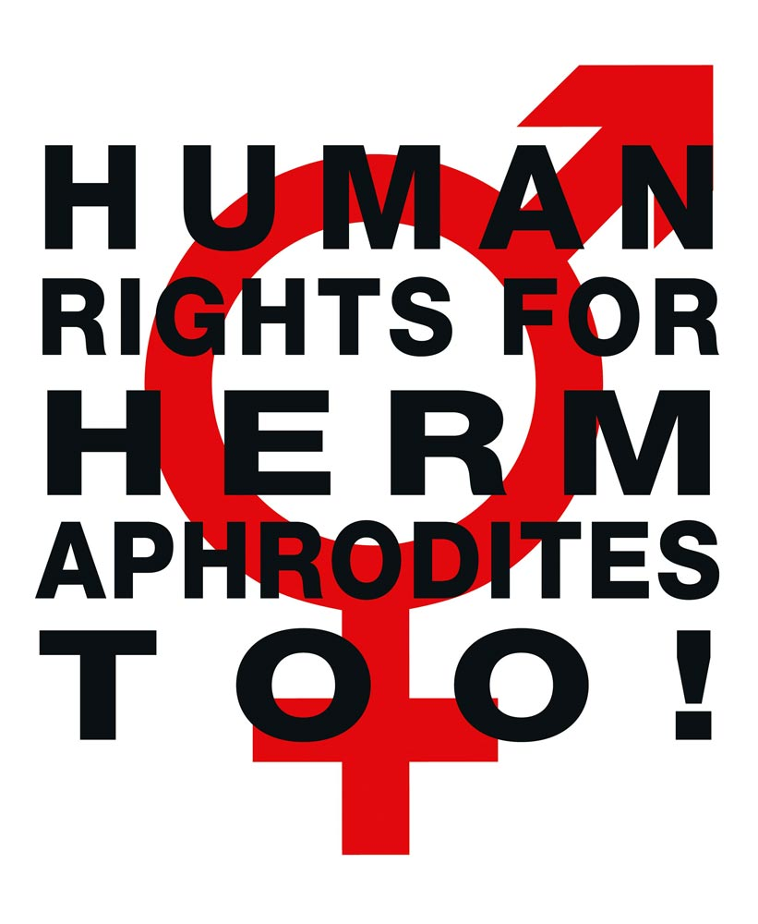

NGO Report (for Session)
to the 1st Periodic Report of Israel on the
Convention on the Rights of Persons with Disabilities
(CRPD)
Compiled by:

StopIGM.org / Zwischengeschlecht.org (International Intersex Human Rights NGO)
Markus Bauer, Daniela Truffer
Zwischengeschlecht.org
P.O.Box 1318
CH-8031 Zurich
info_at_zwischengeschlecht.org
https://Zwischengeschlecht.org/
https://StopIGM.org

August 2023

This NGO Report online:
DOCX: https://intersex.shadowreport.org/public/2023-CRPD-Israel-NGO-Intersex-StopIGM.docx
PDF: https://intersex.shadowreport.org/public/2023-CRPD-Israel-NGO-Intersex-StopIGM.pdf

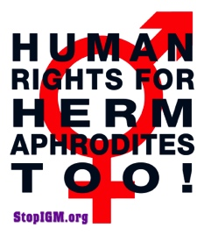
Executive Summary
Despite new 2017 Medical Guidelines issued by the Ministry of Health, all typical forms of Intersex Genital Mutilation are still practised in Israel, facilitated and paid for by the State party via the public health system. Parents and children are misinformed, kept in the dark, pressured to “consent” to harmful surgery, and denied appropriate support. Despite repeated Government pledges and calls by Israeli intersex persons, experts and allies to end harmful practices on intersex children, Israel fails to act.
Israel is thus in breach of its obligations to (a) take effective legislative, administrative, judicial or other measures to prevent involuntary, non-urgent genital surgery and other harmful medical treatment of intersex children, (b) to ensure access to justice, redress, compensation and rehabilitation for victims, and c) to provide families with intersex children with adequate psychosocial and peer support (art. 17).
This Committee has consistently recognised IGM practices to constitute a violation of the integrity of the person under the Convention in Concluding Observations.
In total, UN treaty bodies CRPD, CRC, CEDAW, CAT and CCPR have so far issued 83 Concluding Observations recognising IGM as a serious violation of non-derogable human rights, typically obliging State parties to enact legislation to (a) end the practice, (b) ensure redress and compensation and (c) access to free counselling. Also, the UN Special Rapporteurs on Torture (SRT) and on Health (SRH), the UN High Commissioner for Human Rights (UNHCHR), the World Health Organisation (WHO), the Inter-American Commission on Human Rights (IACHR), the African Commission on Human and Peoples’ Rights (ACHPR) and the Council of Europe (COE) recognise IGM as a serious violation of non-derogable human rights.
Intersex people are born with Variations of Reproductive Anatomy, including atypical genitals, atypical sex hormone producing organs, atypical response to sex hormones, atypical genetic make-up, atypical secondary sex markers. While intersex people may face several problems, in the “developed world” the most pressing are the ongoing Intersex Genital Mutilations, which present a distinct and unique issue constituting significant human rights violations.
IGM practices include non-consensual, medically unnecessary, irreversible, cosmetic genital surgeries, and/or other harmful medical procedures that would not be considered for “normal” children, without evidence of benefit for the children concerned. Typical forms of IGM include “masculinising” and “feminising”, “corrective” genital surgery, sterilising procedures, imposition of hormones, forced genital exams, vaginal dilations, medical display, involuntary human experimentation and denial of needed health care.
IGM practices cause known lifelong severe physical and mental pain and suffering, including loss or impairment of sexual sensation, painful scarring, painful intercourse, incontinence, urethral strictures, impairment or loss of reproductive capabilities, lifelong dependency of artificial hormones, significantly elevated rates of self-harming behaviour and suicidal tendencies, lifelong mental suffering and trauma, increased sexual anxieties, and less sexual activity.
For 30 years, intersex people have denounced IGM as harmful and traumatising, as western genital mutilation, as child sexual abuse and torture, and called for remedies.
This NGO Report has been compiled by StopIGM.org / Zwischengeschlecht.org, an international intersex NGO. It contains Suggested Recommendations (see p. 14).
NGO Report (for Session) to the 1st Periodic Report of Israel
on the Convention on the Rights of Persons with Disabilities (CRPD)

Table of Contents

IGM Practices in Israel

Executive Summary 3
A. Introduction 5
1. Israel: Intersex, IGM and Human Rights 5
2. About the Rapporteurs 5
3. Methodology 5
B. IGM in Israel: State-sponsored and pervasive, Gov fails to act 6
1. Overview: IGM practices in Israel: Pervasive and unchallenged 6
2. Israel’s commitment to “protect intersex children”, “ensure accountability” 6
a) UNHRC45 Statement, 01.10.2020 6
b) UNHRC48 Statement, 04.10.2021 6
3. Most Common IGM Forms advocated and perpetrated by Israel 7
a) IGM 3 – Sterilising Procedures: Castration / “Gonadectomy” / Hysterectomy 8
b) IGM 2 – “Feminising Procedures”: Clitoris Amputation/“Reduction”, “Vaginoplasty” 9
c) IGM 1 – “Masculinising Surgery”: Hypospadias “Repair” 9
d) IGM 4 – Selective Abortion, Pre-Implantation Genetic Diagnosis (PGD) 10
4. 2017 Ministry of Health Intersex Guidelines 11
5. Israel fails to effectively protect intersex children from IGM 12
6. Obstacles to redress, fair and adequate compensation 13
C. Suggested Recommendations 14
Annexe 1 – Intersex, IGM and Disability 15
1. Intersex = “Inferior”, “Abnormal”, “Deformed”; IGM = “Cure” 15
2. Intersex = Variations of Reproductive Anatomy 15
3. IGM = Involuntary, unnecessary interventions via substitute decision-making 16
4. Intersex is NOT THE SAME as LGBT 17
5. IGM is NOT a “Discrimination” Issue 18
6. IGM is NOT a “Health” Issue 18
Annexe 2 – Intersex as “Invalidity”: Historical Medical Examples 19
1916–1950s: “Intersex = bastardisation” caused by “racial mixing” 19
Baltimore and Zurich 1950: Start of systematic “genital corrections” 20
Annexe 3 – “IGM in Medical Textbooks: Current Practice” 21
IGM 1 – “Masculinising Surgery”: “Hypospadias Repair” 21
IGM 2 – “Feminising Surgery”: “Clitoral Reduction”, “Vaginoplasty” 23
IGM 3 – Sterilising Surgery: Castration / “Gonadectomy” / Hysterectomy 25
“Bad results” / “Gonadectomy, Feminising Genitoplasty” 27

A. Introduction

1. Israel: Intersex, IGM and Human Rights
Despite that the persistence of IGM practices in Israel is a matter of public record, same as the criticism and appeals by intersex persons, experts and allies, to this day the Israeli Government fails to recognise the serious human rights violations and the severe pain and suffering caused by IGM practices, let alone to “take effective legislative, administrative, judicial or other measures” to protect intersex children from harmful practices.
What’s more, Israeli IGM doctors publicly frame intersex children as not “normal” and suffering from “[s]exual malformations” and “deformities”, and to be “fix[ed]” and “correct[ed]” by IGM surgery (see below, p. 7, 8).
This Thematic NGO Report demonstrates that the current and ongoing harmful medical practices on intersex children in Israel – advocated, facilitated and perpetrated by the state funded University Hospitals, as well as private hospitals, and paid for by the State party via the public health system – constitute a serious breach of Israel’s obligations under the Convention.
2. About the Rapporteurs
This NGO report has been prepared by the international intersex NGO StopIGM.org:
- StopIGM.org / Zwischengeschlecht.org is an international intersex human rights NGO based in Switzerland, working to end IGM practices and other human rights violations perpetrated on intersex people, according to its motto, “Human Rights for Hermaphrodites, too!” According to its charter, StopIGM.org works to support persons concerned seeking redress and justice and regularly reports to relevant UN treaty bodies, often in collaboration with local intersex persons and organisations, substantially contributing to the so far 83 Treaty body Concluding Observations recognising IGM as a serious human rights violation.
In addition, the Rapporteurs would like to acknowledge the work of Israeli intersex NGO PELE (‘Rallying for intersex rights’). And we would like to acknowledge the work of Limor Meoded Danon.
3. Methodology
This thematic NGO report is based on the 2022 CRC Israel NGO Report (for LOI) by the same Rapporteurs.
B. IGM in Israel: State-sponsored and pervasive, Gov fails to act
1. Overview: IGM practices in Israel: Pervasive and unchallenged
In Israel, same as in the fellow Mediterranean countries of Malta (CRC/C/MLT/CO/3-6, paras 28-29), Greece (CRC/C/GRC/CO/4-6, para 28(c)), Cyprus (CRC/C/CYP/CO/5-6, para 25(b)), and in many more State parties, there are
- no legal protections in place to prevent IGM practices as stipulated in various UN Conventions, including CRPD,
- no legal measures in place to ensure access to redress and justice for IGM survivors,
- no legal measures in place to ensure the accountability of IGM perpetrators,
- no measures in place to ensure data collection and monitoring of IGM practices.
Despite that the persistence of IGM practices in Israel is a matter of public record, same as the criticism and appeals by intersex persons, experts and allies (see below, p. 12), to this day the Israeli Government fails to recognise the serious human rights violations and the severe pain and suffering caused by IGM practices, let alone to “take effective legislative, administrative, judicial or other measures” to effectively protect intersex children from harmful practices.
2. Israel’s commitment to “protect intersex children from violence and harmful practices”, “investigate abuses”, “ensure accountability” and “access to remedy”
a) UNHRC45 Statement, 01.10.2020
On occasion of the 45th Session of the Human Rights Council the State party supported a public statement calling to “protect […] intersex adults and children […] so that they live free from violence and harmful practices. Governments should investigate human rights violations and abuses against intersex people, ensure accountability, […] and provide victims with access to remedy.”
b) UNHRC48 Statement, 04.10.2021
On occasion of the 48th Session of the Human Rights Council the State party supported a public follow-up statement reiterating the call to end harmful practices and ensure access to justice:
“Intersex persons also need to be protected from violence and States must ensure accountability for these acts. […]
Furthermore, there is also a need to take measures to protect the autonomy of intersex children and adults and their rights to health and to physical and mental integrity so that they live free from violence and harmful practices. Medically unnecessary surgeries, hormonal treatments and other invasive or irreversible non-vital medical procedures without their free, prior, full and informed consent are harmful to the full enjoyment of the human rights of intersex persons.
We call on all member states to take measures to combat violence and discrimination against intersex persons, develop policies in close consultations with those affected, ensure accountability, reverse discriminatory laws and provide victims with access to remedy.”
3. Most Common IGM Forms advocated and perpetrated by Israel
Despite above mentioned commitments to protect intersex children, to this day, in Israel all forms of IGM practices remain widespread and ongoing, persistently advocated, prescribed and perpetrated by the state funded University Hospitals, as well as private clinics, and paid for by the State via the public health system under the oversight of the Ministry of Health.
In Israel, IGM is practiced in at least 8 large hospitals, and there are 2 main hospitals that are perceived as “DSD centres”.
Also in Israel, medically unnecessary, non-consensual and irreversible IGM practices are justified by psychosocial indications, and parents are pressured to “consent” to IGM, as interviews with IGM practitioners demonstrate:
“Prof. B, an Israeli urologist: ‘[…] they have genitalia that are neither male nor female, and society cannot accept this. […] psychologically, a girl also has to grow up . . . knowing that she is more or less normal. […] So, the goal is to fix these children between the age of six months and a year. This is the optimum age.’”
“[Y]ou want to have a boy who can urinate and feel normal around others, so we talk to the parents […]. [If they refuse, we] will tell them, ‘Listen, you are very smart parents, but it is very bad for your child. He’ll be very uncomfortable in first grade or in third ...’ The pediatrician knows much better than the inexperienced parent.” (Prof. Ziv., Israeli endocrinologist, 24.11.19)
Israeli parents also criticise this pressure to “consent” to IGM:
“Why did none of the doctors come to me and say okay, this is an aesthetic problem, and only when it actually bothers the child, […] we’ll arrive at a common understanding that if he wants to do it then it will be possible to do it?” (Suzi, mother of a baby with hypospadias, 17.2.2020)
Further, Israeli doctors justify early IGM practices by comparing them to the ritual circumcision of boys:
“Israeli urologist, Dr. Benny […]: ‘There is a reason that boys are ritually circumcized at age eight days and not eight years [in Judaism]. Really, it’s less painful and less psychologically traumatic. There’s less separation anxiety from the parents and everything that’s connected to it at older ages. There are many advantages to doing it at a young age, so today we recommend age six months to a year for [intersex] children.’”
[Note: As stressed also by the study author, this assumption of medical professionals that early surgeries are less psychologically traumatic is not empirically based. However, the pain and suffering caused by IGM is.]
Currently practiced forms of IGM in Israel include:
a) IGM 3 – Sterilising Procedures:
Castration / “Gonadectomy” / Hysterectomy /
Removal of “Discordant Reproductive Structures” / (Secondary) Sterilisation
Plus arbitrary imposition of hormones
The “Pediatric Urology” homepage of the Wilf Children’s Hospital at the Shaare Zedek Medical Center (SZMC) in Jerusalem lists under “disorders treated in the clinic”: “18. Sexual malformations in children with sexual differentiation disorders.”
And the “Urology (Pediatrics)” homepage of the “Dana-Dwek” Children’s Hospital at the Tel Aviv Sourasky Medical Center Ichilov (TASMC) “treats congenital deformities of the genitourinary tract of boys and girls. […] [It] performs surgeries to correct […] “intersex” conditions (‘hermaphrodites’).”
Accordingly, a 2018 Israeli study interviewing doctors found:
“Medical professionals from different hospitals in Israel […] reported that […] surgeries to remove internal sex organs are performed […] between the ages of six months and one year.”
Another Israeli doctor explained:
“[We did] a laparoscopy . . . We inserted a camera and looked for the testicles in the abdomen. […] I saw two – we do not call them testicles . . . two gonads. It seemed they might be strange ovaries, I don’t know, and a uterus and fallopian tubes […] we performed tests and found that he was really lacking this MIF [Müllerian inhibiting factor]. This is something fantastic in theory. Why in theory? Because we usually prefer to remove it . . .. we moved the testicles into the scrotum and removed the uterus and fallopian tubes.” (Prof. B., 25 October 2015)
b) IGM 2 – “Feminising Procedures”: Clitoris Amputation/“Reduction”,
“Vaginoplasty”, “Labiaplasty”, Dilation
The “Pediatric Urology” homepage of the Wilf Children’s Hospital at the Shaare Zedek Medical Center (SZMC) in Jerusalem lists under “disorders treated in the clinic”: “Sexual malformations in children with sexual differentiation disorders.” It further claims, “The department serves as a national referral center for children with endocrinological disorders who need sexual organ repair. This is one of the most challenging fields in reconstructive surgery and the department is among the world's leading centers for these procedures.”
And the “Urology (Pediatrics)” homepage of the “Dana-Dwek” Children’s Hospital at the Tel Aviv Sourasky Medical Center Ichilov (TASMC) “treats congenital deformities of the genitourinary tract of boys and girls. […] [It] performs surgeries to correct […] ‘intersex’ conditions (‘hermaphrodites’).”
Accordingly, a 2018 Israeli study with interviews with parents of intersex children quotes “a father of a 9-year-old girl born with 46XX CAH”: “The Dr. said it would be better to operate before she was conscious of it, before she grew up and was traumatized by it. […] But it doesn’t always work.”
And a 2021 Israeli study interviewing parents of intersex children quotes a “mother of a 12-year-old girl, with classical congenital adrenal hyperplasia” who “consented” to IGM 2 on her child due to psychosocial pressure:
“[S]he and her husband were mainly afraid of negative social responses. Their daughter first underwent surgery at the age of 11 months, but the operation did not continue as planned because the surgeon said that the baby’s body was not ready. […] At the age of 19 months, the daughter returned to the operating room, and this time her clitoris was reduced and her urethral opening and vagina were reconstructed. […] ‘We were more afraid that society wouldn’t know how to accept it. […]’”
c) IGM 1 – “Masculinising Surgery”: Hypospadias “Repair”
The “Pediatric Urology” homepage of the Wilf Children’s Hospital at the Shaare Zedek Medical Center (SZMC) in Jerusalem lists under “disorders treated in the clinic”: “Hypospadias – incomplete closure of the urethra.” It further claims, “The department is recognized as a Excellence Center for hypospadias repair.”
And the “Urology (Pediatrics)” homepage of the “Dana-Dwek” Children’s Hospital at the Tel Aviv Sourasky Medical Center Ichilov (TASMC) offers surgery to “correct” “Hypospadias – a congenital penile abnormality.”
Accordingly, a 2022 medical publication out of the Department of Urology of the Tel Aviv Sourasky Medical Center Ichilov (TASMC) and the Department of Pediatric Urology of its “Dana-Dwek” Children’s Hospital reviewing the medical records of “children who underwent hypospadias repair between 10/1999 and 12/2018” and who were circumcised previous to hypospadias “repair” noted, “mean age at surgery was 14 months (interquartile range 9,22).”
Also in Israel, hypospadias “repair” often result in severe complications leading to serious actual medical problems, and parents bitterly regret having “consented” to the unnecessary surgical “corrections”:
“The mother of a 40-year-old man born with minor hypospadias […] described how the urethral stenosis that resulted from his first surgery, at the age of 2 years, became a significant and complicated issue in her son’s life. The stenosis was treated in two additional surgeries performed when he was an adolescent, but it began to cause problems again in his adult life. […]. He required a special kit with a sterile catheter that he could use to release his urine when he could not do so himself […]. She realized that the correction had been detrimental to her son’s well-being and regretted agreeing to it in the first place. […]:
‘I don’t understand why this surgery is performed so frequently, because they [the doctors] don’t talk about urination at all, only about the psychological aspects, that the child will grow up and have a trauma. What, not being able to urinate isn’t traumatic? […] You don’t necessarily need scalpels to deal with the problem. Put them aside, why the urgency? It’s not that bad.’
A young mother of a 6-month-old baby with minor hypospadias, re-examined the doctors’ advice to agree to early corrective genital surgery. She searched on social media for adults who had experienced this surgery. […] When she went to different doctors to […] discuss her concern regarding surgical complications […] the reactions were not what she had expected:
‘They started telling me I was making problems for the boy, and in adolescence he would have problems, because that is boys’ most important organ. […] Get the boy, […] we’ll perform a two-hour surgery, after that a two-week catheter, and it’s no big deal. If worse comes to worst and the surgery isn’t successful, we’ll do another surgery, take skin from the cheek, it’s nothing. […] I know better. I’m the professor.’”
d) IGM 4 – Selective Abortion, Pre-Implantation Genetic Diagnosis (PGD)
In Israel prenatal testing of foetuses, selective abortions, and pre-implantation genetic diagnosis (PDG) is very frequent, as described in a 2018 Israeli study:
“Biomedical diagnosis in Israel is widely used before and during pregnancy in order to prevent the conception of pathological bodies or identify them as early as possible. Preimplantation genetic diagnosis testing (PGD) is offered to families with a history of various serious conditions, including some intersex conditions. It aims to prevent the conception of fetuses with a variety of intersex conditions, including congenital adrenal hyperplasia and androgen insensitivity syndrome.”
According to another 2018 study, “[i]n Israel, parents’ decision to continue a pregnancy after finding out that their embryo has an intersex condition is perceived as a rare occurrence by many professionals.” The author was able to obtain data for the number of terminations of pregnancy (TOP) due to different intersex conditions that took place between 2009 and 2014. “According to this data, approximately 50 foetuses with different intersex bodies are aborted each year.”
Similarly, a mother, reflecting on the difficult experience of her abortion, expressed her criticism of the pressure on parents to prevent diseases and disabilities, including intersex diagnoses, in Israeli society, “It’s prevention for the sake of elimination . . . not . . . for the sake of preparation.”
4. 2017 Ministry of Health Intersex Guidelines
In 2017, following eight years of intersex activists’ work with medical professionals, ethicists, feminist activists, and scholars, the Israeli Ministry of Health published a new circular on approved procedures regarding intersex and distributed it to all the hospitals in Israel. It is the first such document to include detailed information about intersex/DSD conditions for parents and patients and to address the importance of putting the patients’ needs and well-being at the centre. While such positive aspects have to be commended, including references to CRC and CRPD, there are also serious shortcomings, as unfortunately the guidelines fail to effectively prevent IGM practices:
“One of its most important statements is that a DSD condition that does not pose a danger to the patient’s life or mental or physical health does not necessarily require medical treatment, and that each case should be decided according to the specific circumstances and wishes of the patient and parents, or both. The circular does not prohibit sex assignment surgery in infancy, nor does it set a new default of non-surgery; however, it provides guidance that will hopefully give rise to informed, well thought out decision making by multiple participants.”

Another Israeli author also commends that the circular stresses the “importance of psychological support for patients and families as well as the importance of consent,” but notes that in practice there is “a lack of psychological support within hospitals that specialise in DSD/intersex bodies due to budgetary issues,” and “no social workers or psychologists participate in the decision making or support parents and patients.” Worse, where psychological support is available, it “mainly helps parents to adjust without question to medical normalisation practices.”
5. Israel fails to effectively protect intersex children from IGM
The persistence of IGM practices in Israel is a matter of public record, same as the criticism and appeals by intersex persons, experts and allies.
However, Israeli paediatric surgeons nonetheless continue to fail to adequately consider any human rights concerns.
And the Israeli government, despite recognising CRPD and CRC in the 2017 Guidelines issued by the Ministry of Health (see above p. 11-12), to this day fails to take effective legislative measures to protect intersex children from IGM practices, in particular to “explicitly prohibit by law and adequately sanction or criminalize” IGM in order to ensure “equal access to justice, including by addressing legal and practical barriers to initiating legal proceedings, such as the limitation period”.
Therefore, this situation is clearly not in line with Israel’s obligations under the Convention.
6. Obstacles to redress, fair and adequate compensation
Also in Israel the statutes of limitation prohibit survivors of early childhood IGM practices to call a court, because persons concerned often do not find out about their medical history until much later in life, and severe trauma caused by IGM practices often prohibits them to act in time once they do. So far, in Israel there was no successful case of a victim of IGM practices going to court. Currently, a first lawsuit is (slowly) underway, but a trial date is not yet known.
Conclusion, this situation is again clearly not in line with Israel’s obligations under the Convention.

C. Suggested Recommendations

The Rapporteurs respectfully suggest that, with respect to the treatment of intersex persons in Israel, the Committee includes the following measures in their recommendations to the Israeli Government:

Intersex Genital Mutilation
While welcoming the 2017 guidelines by the Ministry of Health “Diagnosis and treatment of a person with DSD/intersex”, the Committee remains seriously concerned about cases of medically unnecessary and irreversible surgery and other treatment on intersex children without their informed consent, which can cause severe suffering, and the lack of legal protections, redress and compensation in such cases.
The Committee recommends that the State party (Articles 15 and 17):
Adopt clear legislative provisions that explicitly prohibit the performance of unnecessary and irreversible medical interventions, including surgical, hormonal or other medical procedures, on intersex infants and children; provide adequate counselling and support for families of intersex children; extend the statute of limitations to enable criminal and civil remedies; and provide health care and psychosocial support to intersex persons who have been subjected to intersex genital mutilation.
Systematically collect data on the number of irreversible surgical and other procedures that are performed on intersex children, disaggregated by age, type of intervention, and geographic location.

Annexe 1 – Intersex, IGM and Disability
1. Intersex = “Inferior”, “Abnormal”, “Deformed”; IGM = “Cure”
Doctors and medical bodies, in complicity with healthcare providers and governing State bodies, have traditionally been framing and “treating” intersex variations as a form of disability in the medical definition in need to be “cured” or “corrected” surgically, often with racist, eugenic and suprematist undertones.
To this day, such harmful stereotypes and prejudices framing intersex as “inferior”, “deformed”, “disordered”, “degenerated” or a “bad omen” remain widespread and still inform the current harmful western medical practice, as well as other practices including infanticide and child abandonment. For example, in Pakistan intersex is considered a “congenital genitalia birth defect” to be “cured” by surgery “to make them normal persons again.”
Accordingly, the easier an intersex trait can be tested prenatally, the higher the selective (late term) abortion rates. Most intersex diagnoses are also listed as permissible for de-selection in State sponsored pre-implantation genetic diagnosis (PGD) guidelines, and e.g. in Switzerland IGM practices are paid for by the Federal Disability Insurance.
2. Intersex = Variations of Reproductive Anatomy
Intersex people, in the vernacular also known as hermaphrodites, or medically as persons with “Disorders” or “Differences of Sex Development (DSD)”, are people born with Variations of Reproductive Anatomy, or “atypical” sex anatomies and reproductive organs, including atypical genitals, atypical sex hormone producing organs, atypical response to sex hormones, atypical genetic make-up, atypical secondary sex markers. Many intersex forms are usually detected at birth or earlier during prenatal testing, others may only become apparent at puberty or later in life. Most intersex conditions do not represent a health problem. A known exception is the condition Congenital Adrenal Hyperplasia (CAH), which in the salt-losing form requires hormonal treatment (but no surgery). The only exceptions requiring immediate medically necessary genital surgery is if there is no urethral opening or if the urine flow is otherwise obstructed.
While intersex people may face several problems, in the “developed world” the most pressing are the ongoing Intersex Genital Mutilations, which present a distinct and unique issue constituting significant human rights violations, with 1 to 2 in 1000 newborns at risk of being submitted to non-consensual “genital correction surgery”.
3. IGM = Involuntary, unnecessary interventions via substitute decision-making
In “developed countries” with universal access to paediatric health care 1 to 2 in 1000 newborns are at risk of being submitted to medical IGM practices, i.e. non-consensual, medically unnecessary, irreversible, cosmetic genital surgeries, and/or other harmful medical treatments that would not be considered for “normal” children, practiced without evidence of benefit for the children concerned, but justified by societal and cultural prejudice, stereotypes, norms and beliefs, and often directly financed by the state via the public health system.
Typical forms of medical IGM include “feminising” or “masculinising”, “corrective” genital surgery, sterilising procedures, imposition of hormones (including prenatal “therapy”), forced genital exams, vaginal dilations, medical display, human experimentation, selective (late term) abortions and denial of needed health care.
Typically, medical IGM is performed at a very young age, with doctors advocating unnecessary surgery in the first two years of life. Consent is obtained from legal guardians via substitute decision-making, usually from parents finding themselves in a very vulnerable situation (see also p. 18).
Medical IGM is known to cause lifelong severe physical and mental pain and suffering, sometimes leading to disability, including loss or impairment of sexual sensation, poorer sexual function, painful scarring, painful intercourse, incontinence, problems with passing urine (e.g. due to urethral stenosis after surgery), increased sexual anxieties, problems with desire, less sexual activity, dissatisfaction with functional and aesthetic results, lifelong trauma and mental suffering, elevated rates of self-harming behaviour and suicidal tendencies comparable to those among women who have experienced physical or (child) sexual abuse, impairment or loss of reproductive capabilities, lifelong dependency on daily doses of artificial hormones.
From countries without universal access to paediatric health care, there are reports of infanticide of intersex children, of abandonment, of expulsion, of massive bullying preventing the persons concerned from attending school (recognised by CRC as amounting to a harmful practice), and of murder.
4. Intersex is NOT THE SAME as LGBT
Unfortunately, there are several harmful stereotypes and misconceptions about intersex still prevailing in public, including if intersex is counterfactually described as being the same as or a subset of LGBT, e.g. if intersex and/or intersex status are misrepresented as a sexual orientation (like gay or lesbian), and/or as a gender identity, as a subset of transgender, as the same as transsexuality,35F or as a form of sexual preference.
The underlying reasons for persistence of these harmful misconceptions include lack of awareness, third party groups instrumentalising intersex as a means to an end for their own agenda, and State parties trying to deflect from criticism of involuntary intersex treatments.
Intersex persons and their organisations have spoken out clearly against instrumentalising or misrepresenting intersex issues,36F maintaining that Intersex Genital Mutilations present a distinct and unique issue constituting significant human rights violations, which are different from those faced by the LGBT community, and thus need to be adequately addressed in a separate section as specific intersex issues. Also, human rights experts are increasingly warning of the harmful conflation of intersex and LGBT.
Nonetheless, the pervasiveness and persistence of these harmful misconceptions remains, in particular by State parties constantly misrepresenting intersex and IGM as sexual orientation or gender identity issues in an attempt to deflect from criticism, instead referring to e.g. “gender reassignment surgery” (i.e. voluntary procedures on transsexual or transgender persons) and “gender assignment surgery for children”, “sexual orientation and gender identity”, “civil registry” and “sexual reassignment surgery” , when asked about IGM by Treaty bodies.
5. IGM is NOT a “Discrimination” Issue
An interrelated diversionary tactic is the increasing misrepresentation by State parties of IGM as “discrimination issue” instead of a serious violation of non-derogable human rights, namely inhuman treatment and a harmful practice (see also CRPD/C/G/3, para 32), in combination with the misrepresentation of intersex human rights defenders as “fringe elements”, and their legitimate demands and criticism of such downgrading and trivialising of IGM as “extreme views”.
6. IGM is NOT a “Health” Issue
Another interrelated, alarming new trend is the increasing misrepresentation of IGM as “health issue” instead of a serious human rights violation, namely inhuman treatment and a harmful practice (see also CRPD/C/G/3, para 32), in combination with the promotion of “self-regulation” of IGM by the current perpetrators instead of effective measures to finally end the practice (as repeatedly stipulated also by this Committee).
Even worse, Health Ministries construe UN Treaty body Concluding observations falling short of explicitly recommending legislation to criminalise or adequately sanction IGM as an excuse for “self-regulation” promoting state-sponsored IGM practices to continue with impunity.
Annexe 2 – Intersex as “Invalidity”: Historical Medical Examples

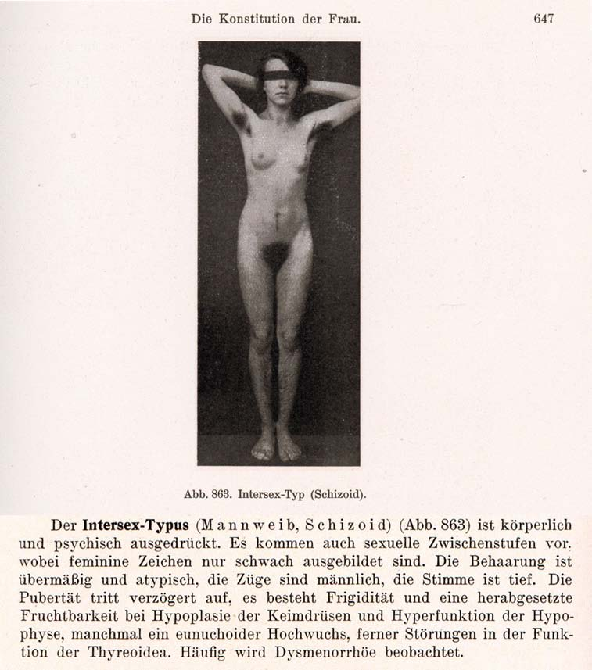
1916–1950s: “Intersex = bastardisation” caused by “racial mixing”;
racist gynaecological diagnosis “intersexual constitution”
The German geneticist Richard Goldschmidt (1878–1958) coined the terms “Intersex” and “Intersexuality” when publicising his experiments of crossbreeding “different geographic races” of gypsy moths, claiming to be able to produce “hermaphroditic” a.k.a. “intersex” specimens of any grade and shape at will, and thereafter extrapolating his findings to humans. Of Jewish descent, in 1936 Goldschmidt was forced to resign as director of the “Kaiser-Wilhelm-Institut für Biologie” in Berlin and emigrated to the United States. Despite Goldschmidt downplaying the “racial” background of his findings since the early 1930’s and later renouncing the underlying genetic theories altogether, the term “Intersex” and its “racial” implications prevailed. In 1924 the gynaecologists Paul Mathes (1871-1923, Austria) and Hans Guggisberg (180-1977, Switzerland) introduced the derived diagnosis “Intersexual Constitution” into human medicine, allegedly caused by “racial mixing”, “most frequent in Jews” and associated with “biological inferiority”, mental illnesses (see above “schizoid”), “hypertrophied clitoris” and a strict verdict “not fit for marriage.” It proved particularly popular among prominent eugenicists and Nazi doctors, including Fritz Lenz, Hans Naujoks, Lothar Gottlieb Tirala, Robert Stigler, Wilhelm Weibel, Walther Stoeckel, and kept being used in medical publications until the 1950s.
Sources: Wilhelm Weibel: Lehrbuch der Frauenheilkunde, 7th ed., Berlin/Wien 1944 p. 647 (photo), 648 (text).
Richard Goldschmidt: “Die biologischen Grundlagen der konträren Sexualität und des Hermaphroditismus beim Menschen”, in: Archiv für Rassen- und Gesellschaftsbiologie 12, 1916.
Paul Mathes, Hans Guggisberg: “Die Konstitutionstypen des Weibes, insbesondere der intersexuelle Typus”, in: Josef Halban, Ludwig Seitz: Biologie und Pathologie des Weibes. Bd.3, 1924.
Helga Satzinger: Racial Purity, Stable Genes, and Sex Difference: Gender in the Making of Genetic Concepts by Richard Goldschmidt and Fritz Lenz, 1916 to 1936. In: Heim et al. (ed.), The Kaiser Wilhelm Society under National Socialism, 2009.
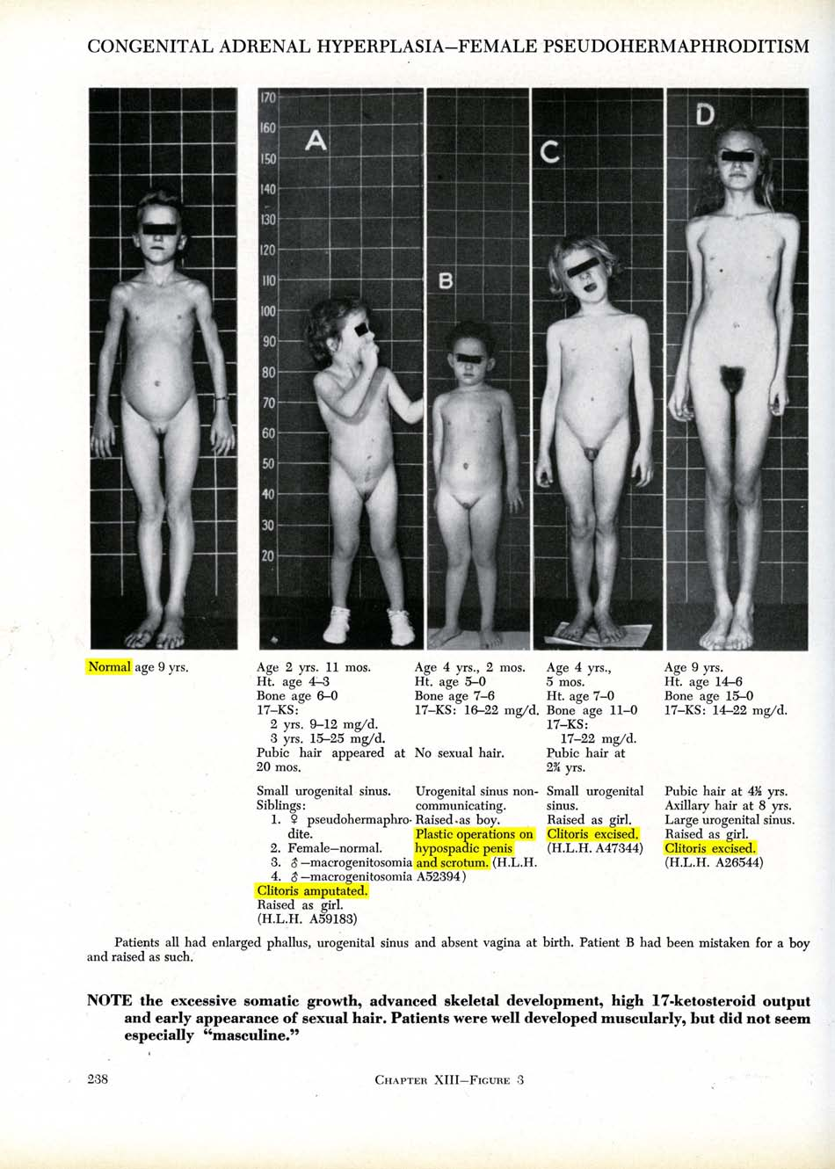
Baltimore and Zurich 1950: Start of systematic “genital corrections”
Lawson Wilkins (1894-1963), “The Father of Pediatric Endocrinology”, and teacher of the famous Swiss paediatric endocrinologist Andrea Prader in 1950, who then introduced the practice in Europe, was also the “inventor” of systematic cosmetic genital surgeries on children. As Wilkins’s monograph illustrates, in 1950 at Johns Hopkins in Baltimore, any child diagnosed “not normal” was submitted to drastic “genital corrections”, either “feminising” or “masculinising”. Often the psychologist John Money gets erroneously credited as having “invented” the systematic mutilations, however, it was Wilkins (and Prader) who started systematic surgeries; Money “only” delivered a “scientific rationale” five years after the fact.
Sources: Lawson Wilkins: The Diagnosis and Treatment of Endocrine Disorders in Childhood and Adolescence. Springfield, 1950.
Alison Redick: American History XY: The Medical Treatment of Intersex, 1916-1955, Dissertation 2004
Annexe 3 – “IGM in Medical Textbooks: Current Practice”
IGM 1 – “Masculinising Surgery”: “Hypospadias Repair”
“Hypospadias,” i.e. when the urethral opening is not on the tip of the penis, but somewhere on the underside between the tip and the scrotum, is arguably the most prevalent diagnosis for cosmetic genital surgeries. Procedures include dissection of the penis to “relocate” the urinary meatus. Very high complication rates, as well as repeated “redo procedures” — “5.8 operations (mean) along their lives … and still most of them are not satisfied with results!”
Nonetheless, clinicians recommend these surgeries without medical need explicitly “for psychological and aesthetic reasons.” Most hospitals advise early surgeries, usually “between 12 and 24 months of age.” While survivors criticise a.o. impairment or total loss of sexual sensation and painful scars, doctors still fail to provide evidence of benefit for the recipients of the surgeries.
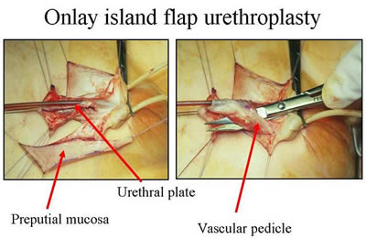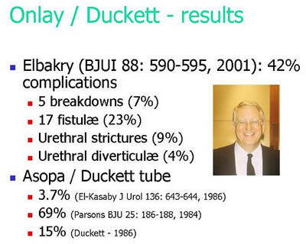
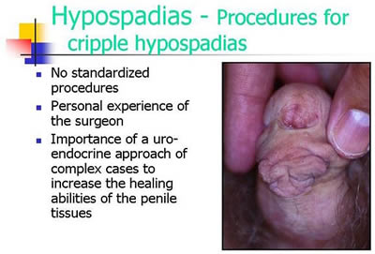
Official Diagnosis “Hypospadias Cripple”
= made a “cripple” by repeat cosmetic surgeries

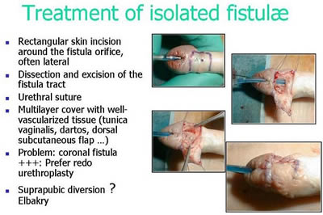
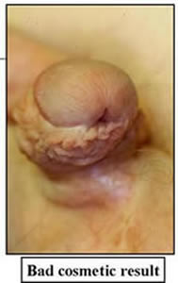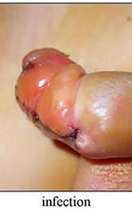
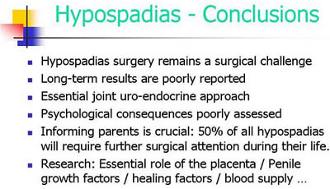
Source: Pierre Mouriquand: “Surgery of Hypospadias in 2006 - Techniques & outcomes”

IGM 2 – “Feminising Surgery”: “Clitoral Reduction”, “Vaginoplasty”
Partial amputation of clitoris, often in combination with surgically widening the vagina followed by painful dilation. “46,XX Congenital Adrenal Hyperplasia (CAH)” is arguably the second most prevalent diagnosis for cosmetic genital surgeries, and the most common for this type (further diagnoses include “46,XY Partial Androgen Insufficiency Syndrome (PAIS)” and “46,XY Leydig Cell Hypoplasia”).
Despite numerous findings of impairment and loss of sexual sensation caused by these cosmetic surgeries, and lacking evidence for benefit for survivors, current guidelines nonetheless advise surgeries “in the first 2 years of life”, most commonly “between 6 and 12 months,” and only 10.5% of surgeons recommend letting the persons concerned decide themselves later.
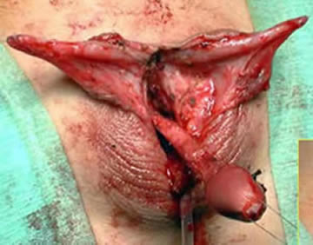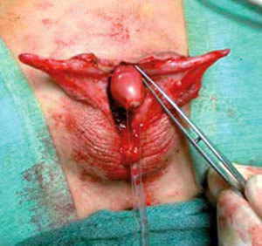
Source: Christian Radmayr: Molekulare Grundlagen und Diagnostik des Intersex, 2004
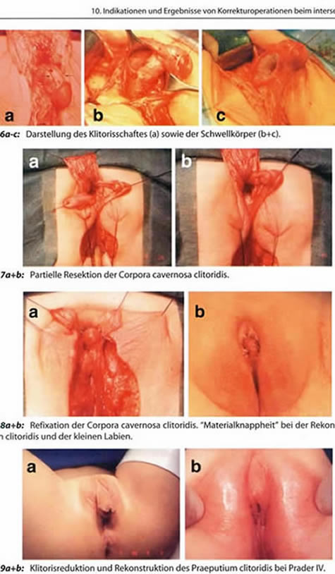
Source: Finke/Höhne: Intersexualität bei Kindern, 2008
Caption 8b: “Material shortage” [of skin] while reconstructing the praeputium clitoridis and the inner labia.
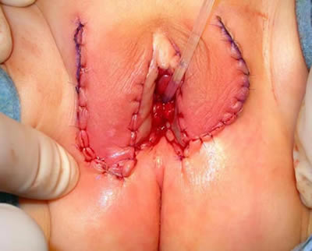
Source: Pierre Mouriquand: “Chirurgie des anomalies du développement sexuel - 2007”, at 81: “Labioplastie”
IGM 3 – Sterilising Surgery: Castration / “Gonadectomy” / Hysterectomy
Removal of healthy testicles, ovaries, or ovotestes, and other potentially fertile reproductive organs. “46,XY Complete Androgen Insufficiency Syndrome (CAIS)” is arguably the 3rd most common diagnosis for cosmetic genital surgeries, other diagnoses include “46,XY Partial Androgen Insufficiency Syndrome (PAIS)”, male-assigned persons with “46,XX Congenital Adrenal Hyperplasia (CAH)”, and other male assigned persons, who have their healthy ovaries and/or uteruses removed.
Castrations usually take place under the pretext of an allegedly blanket high risk of cancer, despite that an actual high risk which would justify immediate removal is only present in specific cases (see table below), and the admitted true reason is “better manageability.” Contrary to doctors claims, it is known that the gonads by themselves are usually healthy and “effective” hormone-producing organs, often with “complete spermatogenesis [...] suitable for cryopreservation.”
Nonetheless, clinicians still continue to recommend and perform early gonadectomies – despite all the known negative effects of castration, including depression, obesity, serious metabolic and circulatory troubles, osteoporosis, reduction of cognitive abilities, loss of libido. Plus a resulting lifelong dependency on artificial hormones (with adequate hormones often not covered by health insurance, but to be paid by the survivors out of their own purse).
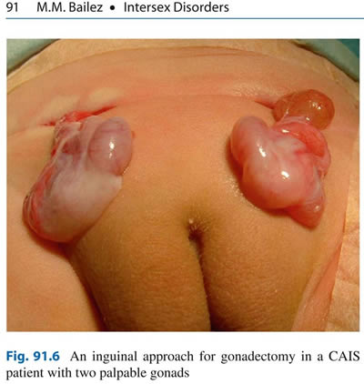
Source: Maria Marcela Bailez: “Intersex Disorders,” in: P. Puri and M. Höllwarth (eds.),
Pediatric Surgery: Diagnosis and Management, Berlin Heidelberg 2009.
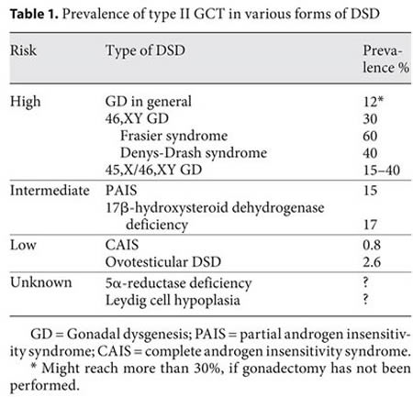
Source: J. Pleskacova, R. Hersmus, J. Wolter Oosterhuis, B.A. Setyawati, S.M. Faradz, Martine Cools, Katja P. Wolffenbuttel, J. Lebl, Stenvert L.S. Drop, Leendert H.J. Looijenga: “Tumor risk in disorders of sex development,” in: Sexual Development 2010 Sep;4(4-5):259-69.
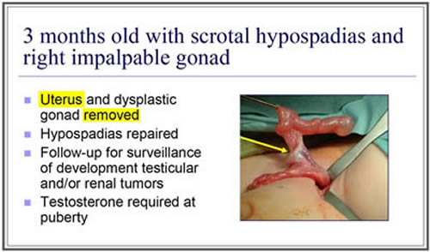
Source: J. L. Pippi Salle: “Decisions and Dilemmas in the Management
of Disorders of Sexual [sic!] Development (DSD),” 2007, at 20.
“Bad results” / “Gonadectomy, Feminising Genitoplasty”
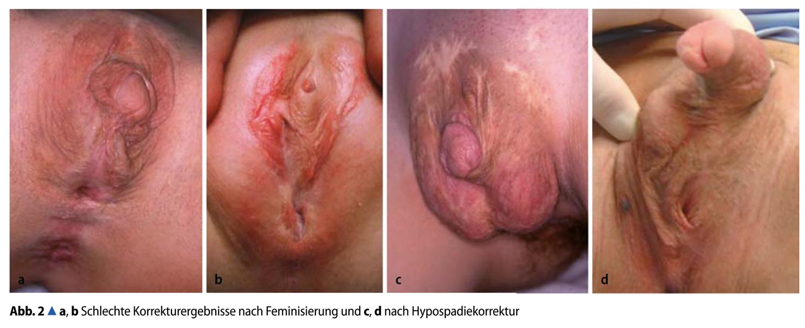
Caption: 2a,b: “Bad Results of Correction after Feminisation, and”, c,d: “after Hypospadias Repair” – Source: M. Westenfelder: “Medizinische und juristische Aspekte zur Behandlung intersexueller Differenzierungsstörungen,” Der Urologe 5 / 2011 p. 593–599.
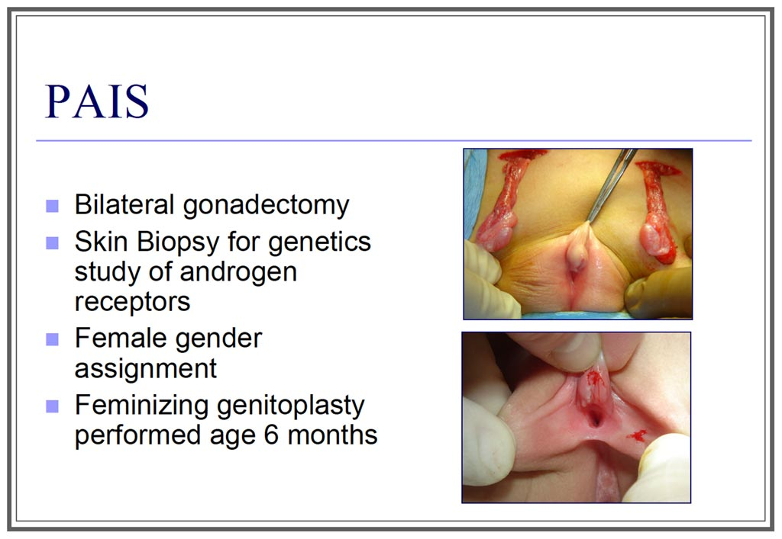
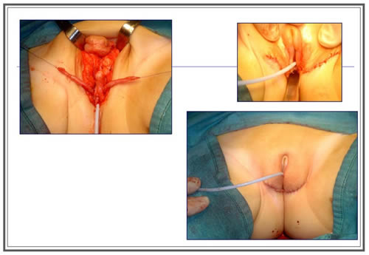
Source: J. L. Pippi Salle: “Decisions and Dilemmas in the Management
of Disorders of Sexual [sic!] Development (DSD)”, 2007, at 20.

https://Zwischengeschlecht.org/ English homepage: https://StopIGM.org
https://zwischengeschlecht.org/post/Statuten
https://intersex.shadowreport.org
https://stopigm.org/post/IAD-2016-Soon-20-UN-Reprimands-for-Intersex-Genital-Mutilations
https://www.facebook.com/119012418134853
https://medicine.biu.ac.il/en/node/2879
https://intersex.shadowreport.org/public/2022-CRC-Israel-LOI-NGO-Intersex-StopIGM.pdf
Currently we count 81 UN Treaty body Concluding Observations explicitly condemning IGM practices as a serious violation of non-derogable human rights, see: https://stopigm.org/post/IAD-2016-Soon-20-UN-Reprimands-for-Intersex-Genital-Mutilations
Statement supported by Israel (and 34 other States) during the 45th Session of the Human Rights Council on 1 October 2020, https://www.dfat.gov.au/international-relations/themes/human-rights/hrc-statements/45th-session-human-rights-council/joint-statement-led-austria-rights-intersex-persons
Statement supported by Israel (and 52 other States) during the 48th Session of the Human Rights Council on 4 October 2021, https://www.bmeia.gv.at/oev-genf/speeches/alle/2021/10/united-nations-human-rights-council-48th-session-joint-statement-on-the-human-rights-of-intersex-persons/
Limor Meoded Danon (2018), “Intersex Activists in Israel: Their Achievements and the Obstacles They Face”, J Bioeth Inq. 2018 Dec;15(4):569-578, p. 577, https://pubmed.ncbi.nlm.nih.gov/30194675/
Limor Meoded Danon (2018), “Comparing contemporary medical treatment practices aimed at intersex/DSD bodies in Israel and Germany”, Sociol Health Illn. 2019 Jan;41(1):143-164, p. 155, https://pubmed.ncbi.nlm.nih.gov/30182487/
Limor Meoded Danon (2018), “Comparing contemporary medical treatment practices aimed at intersex/DSD bodies in Israel and Germany”, Sociol Health Illn. 2019 Jan;41(1):143-164, p. 157, https://pubmed.ncbi.nlm.nih.gov/30182487/
Limor Meoded Danon (2022), “Temporal sociomedical approaches to intersex* bodies”, Hist Philos Life Sci. 2022 Jun 8;44(2):28., p. 12, https://pubmed.ncbi.nlm.nih.gov/35674937/
Ibid., p. 19
Limor Meoded Danon (2018), “Intersex Activists in Israel: Their Achievements and the Obstacles They Face”, J Bioeth Inq. 2018 Dec;15(4):569-578, p. 576-577, https://pubmed.ncbi.nlm.nih.gov/30194675/
For general information, see 2016 CEDAW NGO Report France, p. 47. https://intersex.shadowreport.org/public/2016-CEDAW-France-NGO-Zwischengeschlecht-Intersex-IGM.pdf
https://www.szmc.org.il/eng/departments/peds-urology/about/
https://www.tasmc.org.il/sites/en/Surgery/Urology/Pages/peds-urology.aspx
Limor Meoded Danon (2018), “Intersex Activists in Israel: Their Achievements and the Obstacles They Face”, J Bioeth Inq. 2018 Dec;15(4):569-578, p. 577, https://pubmed.ncbi.nlm.nih.gov/30194675/
Limor Meoded Danon (2018), “Comparing contemporary medical treatment practices aimed at intersex/DSD bodies in Israel and Germany”, Sociol Health Illn. 2019 Jan;41(1):143-164, p. 154, https://pubmed.ncbi.nlm.nih.gov/30182487/
For general information, see 2016 CEDAW NGO Report France, p. 48. https://intersex.shadowreport.org/public/2016-CEDAW-France-NGO-Zwischengeschlecht-Intersex-IGM.pdf
https://www.szmc.org.il/eng/departments/peds-urology/about/
https://www.tasmc.org.il/sites/en/Surgery/Urology/Pages/peds-urology.aspx
Limor Meoded Danon (2018), “Intersex Activists in Israel: Their Achievements and the Obstacles They Face”, J Bioeth Inq. 2018 Dec;15(4):569-578, p. 578, https://pubmed.ncbi.nlm.nih.gov/30194675/
Limor Meoded Danon (2021), “The Parental Struggle With the Israeli Genital Socialization Process”, Qualitative Health Research 2021, Vol. 31(5) 898-912, p. 904, https://pubmed.ncbi.nlm.nih.gov/33530874/
For general information, see 2016 CEDAW NGO Report France, p. 48-49. https://intersex.shadowreport.org/public/2016-CEDAW-France-NGO-Zwischengeschlecht-Intersex-IGM.pdf
https://www.szmc.org.il/eng/departments/peds-urology/about/
https://ichilov-clinic.gov.il/departments/treatment-of-children/pediatric-urology/
Haim Herzberg, Adit Dubi-Sobol, Tomer Mendelson, Reuben Ben-David, Noam Bar-Yaakov, Ziv Savin, Jacob Ben-Chaim, Yuval Bar-Yosef (2022), “Operative techniques and long-term outcomes of hypospadias repair in the absence of preputial skin after neonatal circumcision”, J Pediatr Surg. 2022 Nov;57(11):676-680, p. 676, https://pubmed.ncbi.nlm.nih.gov/35927070/
Limor Meoded Danon (2021), “The Parental Struggle With the Israeli Genital Socialization Process”, Qualitative Health Research 2021, Vol. 31(5) 898-912, p. 909, https://pubmed.ncbi.nlm.nih.gov/33530874/
See 2014 CRC Switzerland, NGO Report p. 76, https://intersex.shadowreport.org/public/2014-CRC-Swiss-NGO-Zwischengeschlecht-Intersex-IGM_v2.pdf
Limor Meoded Danon (2018), “Intersex Activists in Israel: Their Achievements and the Obstacles They Face”, J Bioeth Inq. 2018 Dec;15(4):569-578, p. 576-577, https://pubmed.ncbi.nlm.nih.gov/30194675/
Limor Meoded Danon (2018), “Comparing contemporary medical treatment practices aimed at intersex/DSD bodies in Israel and Germany”, Sociol Health Illn. 2019 Jan;41(1):143-164, p. 151-152, https://pubmed.ncbi.nlm.nih.gov/30182487/
Limor Meoded Danon (2021), “The Parental Struggle With the Israeli Genital Socialization Process”, Qualitative Health Research 2021, Vol. 31(5) 898-912, p. 903, https://pubmed.ncbi.nlm.nih.gov/33530874/
Ministry of Health, Israel. 2017. [Diagnosis and treatment of a person with DSD/intersex (official circular on procedure (in Hebrew)] March 6, 2017, https://www.health.gov.il/hozer/mr10_2017.pdf
Maayan Sudai (2017) “Changing ethical and legal norms in the management of differences of sex development”, The Lancet Diabetes & Endocrinology 5(10): 764–766, at 765, https://www.thelancet.com/journals/landia/article/PIIS2213-8587(17)30043-8/fulltext
Limor Meoded Danon (2018), “Comparing contemporary medical treatment practices aimed at intersex/DSD bodies in Israel and Germany”, Sociol Health Illn. 2019 Jan;41(1):143-164, p. 153-155, https://pubmed.ncbi.nlm.nih.gov/30182487/
Sagit Mor (2013), “From Absence to Presence: A Critique of Intersex Surgeries (Hebrew)” Mishpatim, The Hebrew University Law Review 44.1 (2013): 89-157. https://web.archive.org/web/20160121175148/http://works.bepress.com/sagitmor/10/ “Intersex surgeries in Israel are performed based on a brief medical protocol, the content of which does not begin to cover the social, medical and legal complexities surrounding it. The Article critiques the protocol for the language that it uses, its insufficient attention to the complex issues of informed consent that the subject involves, including parental consent to surgeries, and its inadequate attention to the ongoing relations between intersex people and the healthcare system. The Article suggests the moratorium approach to intersexuality as an alternative to the prevailing medical-surgical one. This approach offers to suspend the decision on surgical intervention until the intersex person is competent to make an independent decision [...].”
Intersex NGO PELE (‘Rallying for intersex rights’), https://www.facebook.com/119012418134853 “The main goals of PELE are to encourage a positive attitude towards intersex people in Israel, to change the policy of performing early irreversible surgeries on intersex babies, to increase intersex children’s bodily autonomy, and to establish support groups for parents and intersex adults. Currently, PELE focuses on producing and participating in conferences in different places in Israel and recruiting additional intersex people and parents. Using social media networks, sharing knowledge with intersex activists around the world, and raising intersex issues in different circles is the beginning of a long journey that’s purpose is to change biomedical discourse and practices in Israel.” (Limor Meoded Danon)
Yanir Dekel (2015), “Should Parents Decide the Gender of Their Intersex Children?”, https://blogs.timesofisrael.com/should-parents-decide-the-gender-of-their-intersex-children/ “A news story on Ynet about a sexual reassignment surgery that was performed in Haifa’s Ben Tzion hospital on a two-year-old kid who was born intersex sparked angry responses […] According to the Ynet article, written by Dr. Itay Gal, babies who are born intersex in Israel are going through gender reassignment surgery as early as possible in order to allow them a normal development and to prevent stigmas and damage to the mental development of the baby.”
Maayan Sudai (2017) “Changing ethical and legal norms in the management of differences of sex development”, The Lancet Diabetes & Endocrinology 5(10): 764–766, at 765, https://www.thelancet.com/journals/landia/article/PIIS2213-8587(17)30043-8/fulltext
Limor Meoded Danon (2018), “Intersex Activists in Israel: Their Achievements and the Obstacles They Face”, J Bioeth Inq. 2018 Dec;15(4):569-578, p. 576-577, https://pubmed.ncbi.nlm.nih.gov/30194675/
Globally, no survivor of early surgeries ever managed to have their case successfully heard in court. All relevant court cases resulting in damages or settlement (3 in Germany, 1 in the USA) were either about surgery of adults, or initiated by foster parents.
Personal communication
2014 CRC NGO Report, p. 52, 69, 84, http://intersex.shadowreport.org/public/2014-CRC-Swiss-NGO-Zwischengeschlecht-Intersex-IGM_v2.pdf
In the WHO “World Atlas of Birth Defects (2nd Edition)”, many intersex diagnoses are listed, including “indeterminate sex” and “hypospadias”: http://web.archive.org/web/20160305152127/http://prenatal.tv/lecturas/world%20atlas%20of%20birth%20defects.pdf
“The Racist Roots of Intersex Genital Mutilations”, http://stop.genitalmutilation.org/post/Racist-Roots-of-Intersex-Genital-Mutilations-IGM
For 500 years of “scientific” prejudice in a nutshell, see 2016 CEDAW France NGO Report, p. 7, http://intersex.shadowreport.org/public/2016-CEDAW-France-NGO-Zwischengeschlecht-Intersex-IGM.pdf
Pakistani doctors in “The Nation”, see http://stop.genitalmutilation.org/post/Pakistan-Intersex-children-birth-defects-patents-offered-surgery-to-make-them-normal-again Original source: https://www.thenews.com.pk/print/287739-100-infants-with-birth-defects-rehabilitated
For stats and references, see “Selective Intersex Abortions: XXY 74%, Indeterminate Sex 47%, Hypospadias 2%”, http://stop.genitalmutilation.org/post/Selective-Intersex-Abortions-Hypospadias-Intersex-XXY
For example in the UK, see http://guide.hfea.gov.uk/pgd/
See 2014 CRC Switzerland NGO Report, p. 76, http://intersex.shadowreport.org/public/2014-CRC-Swiss-NGO-Zwischengeschlecht-Intersex-IGM_v2.pdf
The currently still official medical terminology “Disorders of Sex Development” is strongly refused by persons concerned. See 2014 CRC NGO Report, p. 12 “Terminology”.
For references and general information, see “What are Intersex Genital Mutilations (IGM)?”, 2016 CEDAW NGO Report France, p. 45–51, http://intersex.shadowreport.org/public/2016-CEDAW-France-NGO-Zwischengeschlecht-Intersex-IGM.pdf
See “IGM Practices – Non-Consensual, Unnecessary Medical Interventions”, ibid., p. 38–47
See 2015 CRPD Germany NGO Report, p. 17, 22-23, http://intersex.shadowreport.org/public/2015-CRPD-LoI-Germany_NGO-Report_Zwischengeschlecht_Intersex-IGM.docx
For example in South Africa, see 2016 CRC South Africa NGO Report, p. 12, http://intersex.shadowreport.org/public/2016-CRC-ZA-NGO-Zwischengeschlecht-Intersex-IGM.pdf For South Africa, see also https://mg.co.za/article/2018-01-24-00-intersex-babies-killed-at-birth-because-theyre-bad-omens For example in Uganda, Kenya, Rwanda, see “Baseline Survey on intersex realities in East Africa – Specific focus on Uganda, Kenya, and Rwanda” by SIPD Uganda, relevant excerpts and source: http://stop.genitalmutilation.org/post/Africa-Intersex-Survey-Documents-Intersex-Genital-Mutilation-Infanticide-Abandonment-Expulsion-Uganda-Kenya-Rwanda ; for Uganda, see also 2015 CRC Briefing, slide 46, http://intersex.shadowreport.org/public/Zwischengeschlecht_2015-CRC-Briefing_Intersex-IGM_web.pdf For Kenya, see also http://www.bbc.com/news/world-africa-39780214
For example in Uganda, Kenya, Rwanda, see "Baseline Survey on intersex realities in East Africa – Specific focus on Uganda, Kenya, and Rwanda" by SIPD Uganda, relevant excerpts and source: http://stop.genitalmutilation.org/post/Africa-Intersex-Survey-Documents-Intersex-Genital-Mutilation-Infanticide-Abandonment-Expulsion-Uganda-Kenya-Rwanda For example in China, see 2015 Hong Kong, China NGO Report, p. 15, http://intersex.shadowreport.org/public/2015-CAT-Hong-Kong-China-NGO-BBKCI-Intersex.pdf
For example in Uganda, Kenya, Rwanda, see "Baseline Survey on intersex realities in East Africa – Specific focus on Uganda, Kenya, and Rwanda" by SIPD Uganda, relevant excerpts and source: http://stop.genitalmutilation.org/post/Africa-Intersex-Survey-Documents-Intersex-Genital-Mutilation-Infanticide-Abandonment-Expulsion-Uganda-Kenya-Rwanda
For example in Nepal (CRC/C/NPL/CO/3-5, paras 41–42), based on local testimonies, see http://stop.genitalmutilation.org/post/Denial-of-Needed-Health-Care-Intersex-in-Nepal-Pt-3
For example in Kenya, see https://76crimes.com/2015/12/23/intersex-in-kenya-held-captive-beaten-hacked-dead/
E.g. the Swiss Federal Government in 2011 in answers to parliamentary questions consistently described intersex as “True and Untrue Transsexualism”, e.g. 11.3286, http://www.parlament.ch/d/suche/seiten/geschaefte.aspx?gesch_id=20113286
For references, see 2016 CEDAW NGO Report France, p. 40, fn 49. http://intersex.shadowreport.org/public/2016-CEDAW-France-NGO-Zwischengeschlecht-Intersex-IGM.pdf
For example ACHPR Commissioner Lawrence Murugu Mute (Kenya), see http://stop.genitalmutilation.org/post/ACHPR-African-Commissioner-warns-Stop-conflating-intersex-and-LGBT
CRC73 New Zealand, http://stop.genitalmutilation.org/post/NZ-to-be-Questioned-over-Intersex-Genital-Mutilations-by-UN-Committee-on-the-Rights-of-the-Child
CCPR120 Switzerland, http://stop.genitalmutilation.org/post/Pinkwashing-of-Intersex-Genital-Mutilations-at-the-UN-CCPR120
For example Amnesty (2017), see http://stop.genitalmutilation.org/post/Amnesty-Report-fails-Intersex-Children-and-IGM-Survivors
For example FRA (2015), see Presentation OHCHR Expert Meeting (2015), slide 8, http://stop.genitalmutilation.org/public/S3_Zwischengeschlecht_UN-Expert-Meeting-2015_web.pdf
For example CEDAW (2017), see, http://stop.genitalmutilation.org/post/Major-Setback-for-Intersex-Human-Rights-at-the-UN
See e.g. Ministry of Health Chile (2016), http://stop.genitalmutilation.org/post/Circular-7-step-back-for-intersex-human-rights-in-Chile

