Comments to List of Issues and Questions prior to the submission of the 9th periodic report of Spain, CEDAW/C/ESP/QPR/9.
By the CEDAW-Istanbul-Beijing Shadow Spain Platform.
(Translated by: Beatriu Cardona, Cristina Contreras, Magaly Thill, Rosabel Agirregomezkorta)
Updated version may 2023
9-10 GENDER-BASED VIOLENCE (GbV) AGAINST WOMEN
In may 2020, only 75 of the 290 measures of the State Pact against Gender Violence 2018-2022 (PEVG) -passed on October 28th 2017- were accomplished. In some Autonomous Communities (CCAA) the funds are distorted via change/late resolution of grants, or family and/or anti-abortion expenses (Andalusia), and eliminating funding both for the associative movement and resources against violence (AADAS, CARRMM). There is also a neglect in fulfilling the measures regarding specific training for all professionals involved in the prevention, protection and psychosocial assistance to victims, which leads to many lacking the necessary skills. Moreover, a lack of transparency and delays in the publication of public spending on policies to combat gender violence is noted. In February 2021, the execution of the State Pact budget was still no accountable. Also, inter-territorial and inter-institutional coordination amongst the CCAA -which are responsible over GbV- is lacking, weakening the network of information, care and recovery for victims.
The Royal Decree-Law 9/2018, on urgent measures for the development of the PEVG modifies the Organic Law on gender-based Violence (LOVG) (art. 23) allowing to prove the condition of victim of GbV with a certificate by either social services or specialized services, without the need of criminal complaint, but its practice is irregular as it falls on the CCAA, giving rise to cases of non-compliance or/and re-victimization (as reported by CCOO-Málaga in the application of Instruction 1/2021, of February 18th, of the IAM).
The Organic Law 8/2015 amends art.1 of the LOVG to also consider children as victims, along with their mothers. Law 3/2019 to improve the situation of orphanhood of children of victims of GBV, creates the orphanage benefit but this is far from reaching the pensions for children of victims of terrorism.
The Organic Law (OL) 5/2018 reforming the Judiciary includes specific subjects in the selection tests and continuous training of the Judicial and Prosecutorial Careers, and specialization tests to access competent Courts in violence against women (VAW). However, the quantity and quality of training is not sufficient. The Courts of VAW continue to drop too many complaints about GBVAW, as recognized by the Constitutional Court (TC) in 2020, an average of 36.5% between 2015-2021; protection orders or criminal protective measures were granted in only 19% of the complaints; and convictions account for almost 22% of the complaints (table 1). Out of the 55 women victims of intimate feminicide in 2019, 11 cases (20%) had been previously reported, and only 5 had received protective measures, in one case already expired. In 2015-2019, 74.13% of the victims of intimate feminicide officially registered had not been previously reported.
The use of parental alienation syndrome (SAP) and similar figures (Parental coordinator) persists and worsens although the General Council of the Judiciary (CGPJ) and LO 8/2021 reject its implementation and urge institutions to avoid its practice. It is even imposed in GbV procedures (13.8% of the cases analyzed by Themis association of women jurists, 2021), disregarding the Istanbul Convention (art. 48.1) and the Organic Law on Comprehensive Protection Measures against GBV.
Institutional violence: defenselessness and judicial helplessness: scandalous sentences and case droppings benefiting aggressors, low control of precautionary measures and sentences, and hardly ever requested forensic risk assessment reports. Judicial persecution and conviction of the mothers victims of VAW: M.S., S.G., J.R., , Infancia Libre, S.B.B. Non-compliance of the suspension of visiting arrangements of those convicted for GBV (art. 66 LOVG, and the Civil Code art. 94 reformed in 2021): the percentage of suspensions of visiting arrangements in situations of VAW does not exceed 3% (2021). Suspension in Court it is still a minority and very dissimilar depending on the territories. Failures in due diligence: The Delegate against GbV recognizes structural coordination failures in judiciary which led to the murder of a minor under 11 in Sueca, April 2022. The Spanish State fails to comply with the CEDAW Committee (communication No. 47/2012), refusing to investigate and compensate until it is compelled by the Supreme Court.
Sexual violence: The inclusion of sexual harassment and stalking at the 2019 Macro -survey is welcomed; however, it leaves emotional/psychological violence out. One out of two women over 16 has suffered violence, with higher occurrence among migrants. 80% of women with disabilities suffer violence and have four times more risk of suffering sexual violence than other women. Between 10-20% of children (78.9% of them being girls) have suffered sexual abuse (Save the Children, 2021:3). Reports of sexual violence in the period 2013-2019 have increased by 70%, with 85% of the victims being women in 2018 (Ministry of the Interior). Detected sexual abuse in and around Children Care Homes (Balearic Islands and Madrid) though is suspected to affect all territories..Regarding cyberviolence, during 2019 there were 3,243 victimizations of minors (32.56% sexual offences). High impunity of sexual offences: In 2018, only 29% of detainees were convicted (INE), 84% of preliminary proceedings are not resolved (State Attorney General's Office), and dropping cases figures remain high. Lack of specialized centers to care for victims of sexual assault and rape open 24h/365 days: only half of the CCAA have specialized centers and equal attention even in the same province is not guaranteed leaving victims unprotected, especially those with disabilities and/or living in rural areas. Regarding violence and sexual harassment at work, there is a tendency to ignore or blame the victim (up to suiciding: V.R. 2019) despite the fact that it is compulsory to have a sexual harassment protocol. Regarding women deprived of liberty, the evaluation of their gender violence history is not included in the protocols and psychosocial and health interviews (Ombudsman, 2020).
Main concerns:
- Normalization of denial speeches in media and parliaments (F.S., VOX) which have an impact on social discourse. Growing denial of GBV among youth: 1 out of 5 teenagers and young men (15-29 years old ) believe that GbV does not exist and that it is an "ideological invention", doubling 2017 data (Youth and Gender Barometer 2021).
- Increase in sexual violence among young people: Between January-March 2021, half of the victims in Catalonia were underage.
- Growing use of chemical submission (1 in every 3) and group sex assaults (doubling those of 2019) and lack of resources, as denounced by the Hospital Clínic de Barcelona.
- Increase in vicarious violence: 3 in 2020 and 7 in 2021 (in 57% of the cases there were previous complaints).
- Low number of complaints: only 9 of the 43 women murdered in 2021 had filed a complaint against their aggressor (Ombudsman 2021).
- The legal possibility that convicted of GBV could practice as public defenders in GBV (until 2022).
- Attacks on social media, academic spaces and demonstrations on March 8th by transactivists, supported by institutional representatives.
Table 1: Table 2:
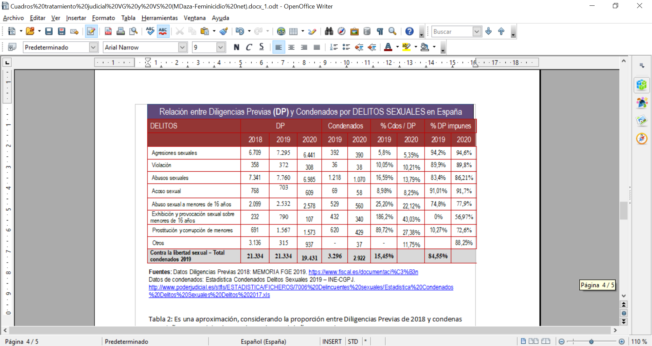
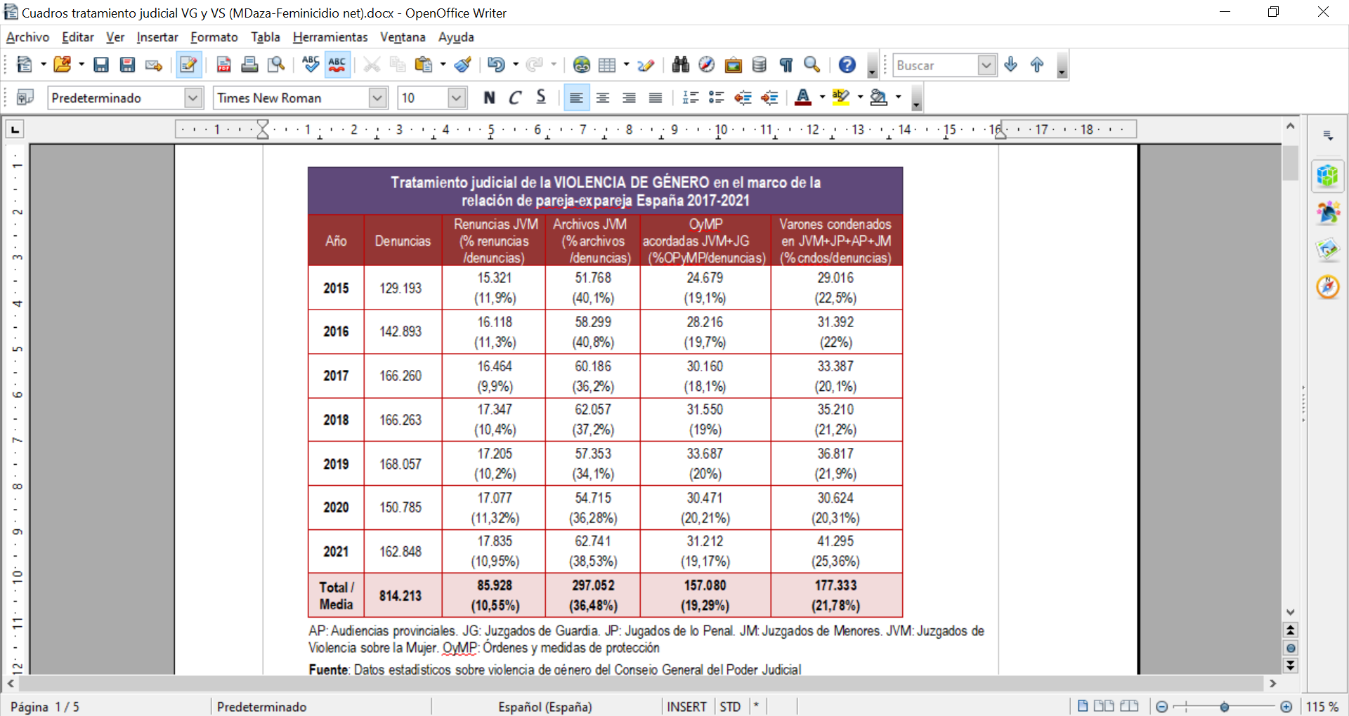
AP: Audiencias provinciales. JG: Juzgados de Guardia. JP: Jugados de lo AP: Provincial Courts. JG: Duty Courts . JP: Penal Courts . JM : Juvenile Courts . JVM: Courts of Violence against Women . OyMP : Orders and protection measures _
Source: General Council of the Judiciary.

11 &12 TRAFFICKING AND EXPLOITATION OF PROSTITUTION (art. 6)
No specific legislation has been passed, disobeying the Final Observation (para. 23), and the PEVG (Axis 8). Deficiencies in the Comprehensive Plan to Combat Trafficking of Women and Girls for Sexual Exploitation 2015-2018: Imprecise resources and budget; lack of communication and coordination with countries of victims and traffickers; absence of mention of victims with physical and/or intellectual disabilities; lack of reintegration or restoration resources and policies (GR19); Recognizing the high risk for women of decriminalizing activities linked to pimping (OL10/1995) continues not being tackled properly; there is no mandatory compliance. 41.45% of the measures were not implemented due to lack of competence and unapproved legislative reforms (confiscation of assets and proceeds of crime, witness protection law). Incomplete implementation of Law 4/2015 of the Statute of the Victim of Crime regarding the legal and social response and specific attention to victims. There is no State-based Derivation Mechanism to coordinate fast derivation between CCAA, undermining the protection, security and recovery of victims; access to resources for victims is diverse and the criteria for police action in the identification of victims are dissimilar in the territories.
Extension of the Contingency Plan to face COVID19 with additional measures for victims of sex trafficking and prostitution, though discarding their access to the Minimum Vital Subsidy. Lack of procedures and protocols to improve and monitor prevention, training, detection and care. Police and judicial interventions omit disability as a vulnerability or aggravating factor.
Lack of regulatory framework for advertising of prostitution (in social media, messaging platforms…) and investigation to address trafficking in relation to the sex industry, prostitution and pimping as stated in CEDAW/C/ESP/CO/6 Recomm. (paras.22-23). There are no effective measures to discourage the demand for prostitution (Art. 18 Directive 2011/36/EU and CEDAW RG 38, 2020, p.30). High consumption of prostitution (first European country and third worldwide, UN, 2017-2018) and one of the main trafficking destinations (EUROPOL, 2016). 90% of trafficking crimes are linked to prostitution, 32% more than the world average (Aliens Unit - Attorney General's Office, 2018) and more than 80% of women in prostitution in Spain are being forced (National Police, 2020).
Public institutions lack their own data. Data is managed by the Intelligence Center against Terrorism and Organized Crime (CITCO), linking the definition and classification of victims to legal-criminal considerations excluding women who do not report or are not recognized, thus reducing the number of victims identified by NGOs, which detected and assisted 13,317 women in 2018, 4,302 of them with evidence of sex trafficking and 9,028 victims of sexual exploitation (DGVG, 2018). Almost 100% sub- Saharan women arriving in boats are victims of trafficking (according to Prosecutor 's Office at MZC, 2016). The rate of sexual exploitation victims detected in Spain in 2019 was 0.63 per 100,000 inhabitants, 96% of them women and girls (INE). In 2020, a year in which the detection of sexual trafficking decreased, 75.21% of the previous proceedings initiated referred to these crimes compared to 19.75% for labor, 5.12% for trafficking with the purpose of committing crimes and 1.70% begging (Prosecutor Memorandum, 2021). Femicides in prostitution do not form part of the official statistics on GbV (53 murdered in 2010-2019, Femicidio.net).
Main concerns:
- Art. 177bis of the Penal Code makes it impossible to prove abusive situations.
- A broad definition of pimping has not been adopted to ensure adequate prosecution of those who exploit prostitution.
- Demand, a causal factor, is not yet tackled effectively.
- Use of digital technology to recruit vulnerable women and girls for online exploitation (2.0 pimping), and increasing paedophile demand.
- Recruitment and sexual exploitation of children in care in some CCAA.
- In the last 3 years, the victim detection protocol has been activated only 6 times (Ombudsman, 2021). In 2021, a woman remained held at Barajas airport for almost 2 months before being interviewed despite trafficking signs.
Annex 1:
INDICTMENTS FILED IN 2020
Type | Files | Victims |  |  |  |  | Defendants
Type | Files | Women |  |  | Men
Type | Files | Adults | Minors |  |  | Women |  | Men | Legal entities
Sexual | 34 | 79 | 5 | 0 |  | 55 |  | 53 | 2
Labour | 5 | 0 | 5 | 20 |  | 9 |  | 3 | 0
Mendicity | 1 | 0 | 1 | 0 |  | 1 |  | 1 | 0
Criminal Activities | 1 | 0 | 0 | 10 |  | 6 |  | 0 | 0
Source: State Prosecutor's Office, 2020 report

18-19 HEALTH, SEXUAL AND REPRODUCTIVE RIGHTS (ARTICLE 12)
The Spanish Public Health System (SNS) does not currently guarantee universal access to health care for undocumented migrants.
Deficient information and training of health personnel on sexual and reproductive health (SRH) in general, and especially on SRH for lesbian and bisexual women. Low risk perception of sexually transmitted diseases, underdiagnosis and greater difficulty in prevention measures aimed at lesbian and bisexual women (Accem, 2019).
Gender bias in health care, clinical and epidemiological research, especially during the COVID19 pandemic. Lack of knowledge and research on the different symptoms in women and men in diseases, which cause late diagnosis and treatment which is not adjusted to the anatomo-physiology of women as in Parkinson's. There are health protocols for early diagnosis and treatment in women that are not put into practice as shown by the fact that women continue to have higher morbidity and mortality, persisting a cardiovascular mortality gap. Lack of knowledge and under-diagnosis of diseases specific to women (endometriosis). In the Malaise Syndrome, women are more likely to be diagnosed with anxiety or depression, being prescribed psychotropic drugs and hypnosedatives without evaluating other possible causes or physiological diseases. Overdiagnosis of fibromyalgia and idiopathic pain without specific studies. Insufficient health care resources and training of professionals in non-pharmacological therapies. Lack of feminist perspective and neglect in the prevention, diagnosis, intervention and follow-up of Eating Disorders, which mostly affect girls and women and have a high rate of chronicity and mortality, aggravated during COVID19. Difficulty of access to public health care or follow-up after medical discharge.
Impacts of GBV: 57.3% of women have suffered some type of violence. As a result, 46.6% of women in intimate partner relationships have suffered injuries, 70% have psychological consequences and 17.5% have some kind of disability (2021).
Impact of working conditions (feminized precariousness) on physical and mental health, especially during confinement (teleworking, stress, conciliation, anxiety). The relationship of breast cancer with jobs involving exposure to chemical agents requires in-depth research.
SRH is not incorporated into affective-sexual education in the educational curriculum. Accessibility to contraceptive methods is variable, with difficulties especially for undocumented migrant women. Partial financing of hormonal methods and none for barrier methods. Irregular access to emergency contraception. Voluntary termination of pregnancy (VTP) is restricted for women under 17 and is not fully provided in the public health system: only 11.2% of VTP was performed in the public sector in 2021, 10.40% in 2015, compared to 88.26% performed in the private sector with public funding, although there are variations among regions. Access to emergency contraceptive methods or post-exposure prophylaxis is more complicated for foreigners due to language, cultural, legal barriers.They represent 33.27% of women who undergo abortion. Inadequate regulation of conscientious objection. Harassment of clinics where abortions are practiced and of women who go for VTP by anti-abortion groups. The group “Hazte Oir”, in addition to the harassment, has opened an anti-abortion center in front of a clinic in Madrid. High number of caesareans (25% of deliveries in 2018 compared to 10-15% recommended by WHO), being higher in the private sector. Infantilization and lack of scientific evidence in obstetrics and gynecology practice. Difficult access to specialized care. Spain leads the european market in assisted reproduction clinics in relation to its population, accounting for 9.8% of births in 2018. The use of these techniques for female couples through the ROPA method (Reception of Oocytes from the couple), requires marriage, excluding de facto couples, in order to proceed to the recognition of the maternity of both.
The provision of services and treatment to undocumented women with HIV/AIDS is not fully guaranteed. In overall population, 14.7% of the new cases and 56.9% of the late diagnoses are women (2018). Heterosexual transmission constitutes 82.2% of the new diagnoses and 56.1% of these are foreign women.
Irregular application of the State Protocol against female genital mutilation (MSSSI, 2015): in 2018 more than 15,000 girls were at risk. Lack of training among professionals in FGM victims care.

15- 7- 8 EDUCATION (Art.10)
The legislation is not a truly egalitarian one: Advances of the new educational law (LOMLOE) are valued but it still shows structural deficits such as: maintenance of sexist stereotypes and gender roles, distortion of affective and sexual education, and a curriculum far from a real coeducational conception and an integral feminist perspective. In 2022, LOMLOE is still undeveloped and unimplemented.
Stagnation of the right to education: Despite the commitments, universal and free Early Childhood Education (0-3 years) is still an objective to be achieved. In the 2021 General National Budget (PGE), a 202 million euros budget line was foreseen, far from the needs as at least 2,898 million euros were needed to cover 72% of this educational stage. No significant progress regarding in improving implementation at the 15-18 age group stage, being more evident in rural areas. Although a slight budget increase in the budget for education in the territories (CCAA) as a whole, it has not yet recovered to its pre-financial crisis level. Unequal attention to and compliance with state legislation on equality in public education policies by the CCAA in: specialised teacher training on equality, programmes and actions in schools to promote equality.
Early school dropout as a risk factor for girls: In 2020, Spain had one of the highest early school dropout rates in the EU-27 (8.0%), only surpassed by Bulgaria, Malta and Romania. It accounts for 20.2% among men and 11.6% in women. Between 2010-2020 the dropout rate decreased by 12 percentage points, a decrease of 43.1%, although the reduction in female dropout is smaller (in absolute terms 11 percentage points (p.p) among females and 13 p.p for males). In relative terms, the reduction compared to 2010 is greater for women (48.6% compared to 39.7%) (National Institute of Statistics-INE).
In 2020, 60.2% of the spanish population aged 16-74 years had basic digital skills (62.6% men, 58% women). Although equality in access to ICTs is being achieved in the 16-24 years age group, the historical gender digital gap has not been bridged, and it is especially serious in households earning less than 900 €: more than 40% do not have a computer and some do not even have Internet.
Limitations and restrictions in education: Measures to remove gender bias in academic choice have yet to be put in place. In implementing LOMLOE, guidance and education schemes specifically aimed at encouraging girls and women to pursue STEM (science, technology, engineering and mathematics) careers, and boys to pursue health and social care, should be developed and funded. At present, unequal attention is paid depending on each CCAA.
With the new LOMLOE, sex-segregated schools are still maintained. Insufficient measures have been developed for the elimination of gender stereotypes. On the contrary, the "gender identity" theory has penetrated schools through materials and educational activities that further reinforce sexist stereotypes and roles. Education for equal opportunities between women and men and affective-sexual education in the educational curriculum, foreseen in the LOMLOE, must be deployed and developed in the curriculum, classroom practices, chool organization and in all programs and lines of the education system.

16 y 17 DERECHOS ECONÓMICOS Y LABORALES
Royal Decree-Law 6/2019 on urgent measures to guarantee equal treatment and opportunities between women and men in employment, and its regulations approved in October 2020, are the only rules approved to correct existing structural discriminations: Greater temporality and partiality in employment, wage gap and higher unemployment rate (in 2018 women accounted for 51.86% and in 2020 52.43%) penalizing women doubly: in their working life due to low incomes and later in accessing a pension.
Wage gap remains, slowly decreasing from 22.86% (2015) to 19.50% in 2019 (INE, 2019); the gap widens as workers aged and in part-time work (96% of those working part-time were women in 2019). Decreasing gap occurs because men's wages are falling, narrowing the gap between men and women, not because of taking measures to correct it.
Besides, women are more affected by job insecurity. Women accounted for 63.9% of workers with low earnings in 2019: Firstly, women are the main occupants of jobs in the lowest valued and lowest paid sectors, and those with the highest rates of precariousness. This is mainly due to the tertiarization of female employment, concentrated in sectors such as commerce (17%), health (15.4%), education (9.9%) and hostelry (8.4%) (INE, 2020). Secondly, unpaid activities (housework and care) are undertaken by women, limiting their access to employment or interrupting their workday and professional development: women constituted 49% of the inactive population in 2020, but 93.2% of them are forced to do so to take care of dependents (EPA INE 2019). Paternity leave came into force in 2017, equalising both parents to 16 weeks in 2021. However, care remains women's responsibility: in 2019, 9 out of 10 family care leaves are requested by women (Secretary of State for Social Security).
Household and care work is 89% made up of women, migrant and spanish. Out of 630,000 women in the sector, more than a third are in the informal economy, undermining their labor rights. 45% of domestic and care workers are interns; the proportion of those who are affiliated to social security is unknown. No database of the State Public Employment Service (SEPE). Law 27/2011, which set up the "Special System" of contributions for Domestic Employees to the General Regime, has not embraced the changes demanded by domestic and care workers` associations. Changes to bring domestic workers into line with the general regime are lacking, as they are not entitled to unemployment benefits and the Wage Guarantee Fund and can be dismissed by resignation with less compensation. Domestic Employment sector is not included in the Occupational Risk Prevention Law. They are more exposed to harassment, abuse and violence, including sexual violence, in contracting households. An invisible and lowly recognized violence which increased during the pandemic. There is no Collective Bargaining Agreement regulating the special characteristics of this work. Placement and intermediation agencies act without a license and charge abusive fees to job seekers. Positive action for the creation of domestic and care workers' cooperatives is lacking. Associated employees are not consulted, nor are invited to Social Dialogue Roundtables.
In 2020, 27.2% of women were at risk of poverty or social exclusion compared to 25.6% of men. The highest levels were found among women under 16 and youth (19-29 years) (31.1% and 29.3% respectively). 49% of single-parent families are at risk of poverty, and eight out of ten single-parent households are headed by women (Spanish High Commissioner for the Fight against Child Poverty, 2021).
40.4% of women surveyed in report on sexual harassment in the workplace had experienced sexual harassment (DGVG, 2021).
Table 1: Pay gap table by autonomous community, 2019. 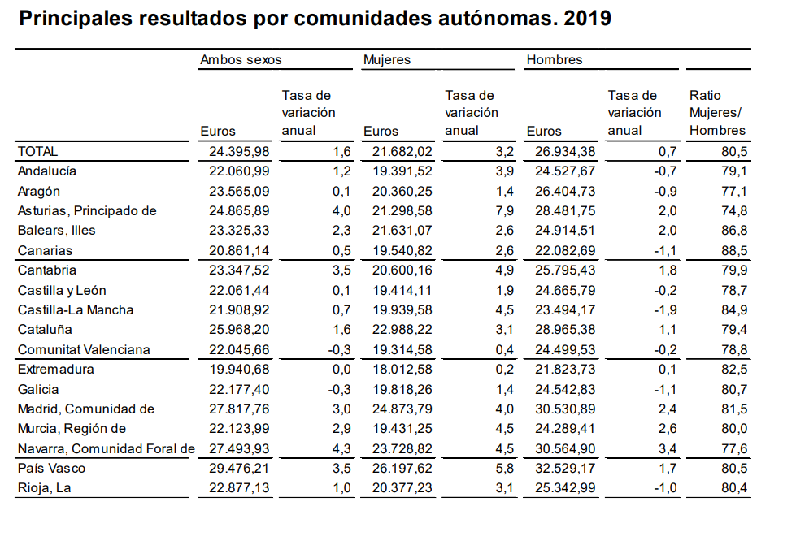
Source: Quadrennial Wage Structure Survey 2019

21 FEMALE REFUGEES AND ASYLUM-SEEKERS
Non-application of Observations No. 37 and 43 (CEDAW/C/ESP/CO/7-8, 29th of July, 2015). Pending ratification of the Convention on the Protection of the Rights of Migrant Workers. Failure to comply with the regulatory development of Act 12/2009 regulating the right of asylum and subsidiary protection (art. 46), hindering family reunification, applications made at diplomatic offices, deadlines in border procedures, humanitarian stay, protection of women in situations of special vulnerability, legal assistance and freedom of movement for asylum seekers in Ceuta and Melilla to travel to the peninsula. Failure to comply with Directives 2013/32/EU and 2013/33/EU: Refoulement at the border continues to take place without an individual gender-specific assessment (CEAR). Regarding female asylum-seekers, their needs are covered through international protection grants co-financed by the Asylum, Migration and Integration Fund (FAMI). However, if the request is rejected or the reception programme ends, they are left completely unprotected, breaching Directive 2013/33/EU (art. 15.3).
Mechanisms to identify women and girls exposed to violence in mixed movements and a more effective asylum system need to be improved. The OAR undertook a massive dismissal of interim staff in 2018 and remained understaffed with insufficient trained and experienced staff until positions were filled in 2020. These deficiencies were aggravated by the rapid increase in international protection applications: In 2017, 31,740 applications were formalized, 55,749 in 2018, while in 2019 it amounted to 118,446. In 2020 applications reduced by 25% (88,826) due to the impact of COVID-19 on the global flow of movements. Waiting times for appointments to formalise asylum applications are at an all-time high, calling for a change in the data collection procedure, as the first interview is currently carried out by state security forces who do not always have the proper training. Special mention should be made of exceptional situation affecting Ukrainian nationals who obtain immediate regularisation after passing emergency regulations (Order PCM/169/2022, and Order PCM/170/2022).
Few women are granted asylum for gender- and sexual orientation-based persecution (Law 12/2009, 30th of October) due to the difficulties of obtaining evidence and the interpretation of the prevailing circumstances in the country of origin. Official data is not disaggregated by cause, preventing us from knowing how many women are seeking asylum on the grounds of gender, trafficking, VAW or forced marriage.
Women and minors who cross the maritime border illegally are detained in police facilities and remain in cells for 72 hours for identification, though they only incur administrative fault. Meanwhile their human rights are violated. CETIS (Immigrant Temporary Stay Centres) in Ceuta and Melilla are overcrowded, reaching triple their capacity and with serious deficiencies in security and care, endangering women's integrity. Restriction on freedom of movement to the peninsula, adopted by the Secretary of State for Security (Ministry of the Interior), has been maintained despite the fact that the High Court of Justice of Andalusia and Madrid ruled its practice to be against the law.
The amendment made by Royal Decree-Law 9/2018 on urgent measures for the development of the State Pact against GbV allowing situations of GBV to be accredited independently of a complaint, has not been accompanied by the needed amendments to Art. 31bis of Organic Law 4/2000 on rights and provisional authorisation for temporary residence and work of undocumented foreign women in possession of an enabling document accrediting them as a victim of GBV.
Concerns:
- Current gender-blind, persecution-oriented legislation on foreigners is the main structural barrier to adequate assistance.
- Ensuring safe immigration, asylum and reception environments, requires resources, services and programmes addressing an intersectional & intercultural perspective, as well as a comprehensive gender perspective, which is lacking to date.

PARTICIPATION (art.7)
CEDAW recognizes women's equal participation as essential for peace and full development (art. 7, General Recomm. No. 23) and calls for specific measures (art. 3). Other international frameworks, endorsed by Spain, have further developed it: Rome Declaration SDG16+, Busan Efficiency Agenda (2011), DAC Recomm on Enabling Civil Society, 2021. This right is violated at various levels:
- Disabling environments for CSOs where the far-right (VOX) is key to political governance: Undermining and dismantling equality frameworks and structures through political agreements aimed at dismantling both equality and GBV policies as well as women's and/or feminist associations (suppression of Madrid City Council's General Directorate for Equality, early 2021). Financial strangulation of women's associations by cancelling calls for subsidies (2019, 2020 in Andalusia), and affecting actions aimed at GbV, assistance to women at risk of social exclusion, women's social participation, and advancing gender equality managed by 250 women's and feminist associations. It leaves unattended nearly 100,000 women at risk of social exclusion, trafficking and victims of GBV in a context of widespread crisis by Covid. It is worth noting that the calls for subsidies from the other departments were resolved without problems.
- Obstacles to participation, transparency and accountability: The president of the Junta, who chairs the Andalusian Council for Women`s Participation (which represents more than 2,000 andalusian associations), refused to meet the associations or give any explanation on the cancellation of the 2019 call. The CEDAW-Istanbul-Beijing (CEB) shadow Platform, which brings together more than 200 (women's, Human Rights and feminist) organizations monitoring the aforementioned frameworks, has submitted more than a dozen requests for meetings and/or information which were not unanswered by the Ministry of Equality. Feminist organizations and networks are also not accountable or informed about policies/legislative proposals and official deadlines for submitting reports (CEDAW, II National Action Plan on Women, Peace and Security monitoring report); No information is provided on exclusion in the consultation of applications for the selection of experts to the Grevio Committee. Weakening of formal spaces for the participation of women: Local, regional and national councils are legal bodies for participation, representation and political influence for CSOs in gender equality policies. Their functions include the issuing of reports prior to the elaboration of policies, budgets, grants and subsidies dependent on equality bodies.
- Attacks and harassment of women's and/or feminist associations by political parties, using the opportunity offered by parliamentary seats and the public media and going unpunished. Both the PP (Popular Party) and Cs (Citizens party) have embraced the discourse promoted by VOX on GBV and criminalizing women's associations. Sexist and xenophobic insults to female political representatives (T.R., L.B., F.H.H.), against feminists (VOX) and abolitionists (by institutional representations, Secretary of State for Equality, or even through state media (RTVE).
- Prosecution: Far-right and ultra-Catholic entities prosecute campaigns for affective-sexual education, sexual and reproductive rights, and GbV prevention. "Christian Lawyers" has reported about 20 cases in 2020, using art. 525 of the Penal Code regarding the offense of religious feelings (against activists and clinics for the right to abortion dismissed by the Supreme Court in 2020; "March of the Rebellious Cunt" trial (3 activists acquitted in 2019, 1 convicted in Malaga in November 2020). Falsely reported and falsified documents by the police against the association "Infancia Libre". Academics denounced for hate speech, boycotts and censorship (Rosario de Acuña Feminist School, July 2019; (J.G. and UIB in 2022), as well as professionals (C.L.) by the transactivist lobby.
- Discriminatory policies generating legal insecurity for women (Constitutional Court,2022).

COVID 19 IMPACT
Care work burden: During confinement, women's burden increased due to reduction or closure of services and Teleworking: Women who teleworked during the pandemic assumed 29% more caregiving responsibility than men, enduring 20% more mental fatigue and 16% more stress than men during lockdown. One in five women have lacked space, equipment, and/or privacy to work remotely. Teleworking has negatively affected disabled women employed. No institutional campaigns were carried out to promote co-responsibility until March 2021.
Job insecurity: COVID-19 initially aggravated employment inequality. In the first quarters of the pandemic, female unemployment rate increased —from 1.8 pp. up to 7.4%—more than men`s—from 1.2 pp. up to 13.4%—, as they predominated in the jobs directly affected. The nearly 600,000 domestic workers were particularly affected: 1 out of 3 lives below the poverty line, around 30% of them do not have a contract and are not eligible for temporary benefits. In 2020, the implementation of equality plans in spanish companies fell by 25% compared to 2019, and conciliation policies were reduced by 12%.
Single-parent families: Single-mother families accounted for 81% of all single-parent families in 2019. Lack of specific measures generates vulnerability. 48% of single-mother families need help to cope with the situation caused by the epidemic and 27% acknowledge that they cannot afford food expenses.
Digital divide: Replacement from face to face services by virtual services had an impact on increased risk and vulnerability, including GBV-related. Administrative issues related to Immigration and social assistance application have become even more difficult.
Health: The pandemic has impacted women due to their status as caregivers and health professionals. More than 80% of care professionals and more than 90% of home caregivers are women. In the health sector, 75% of people infected from March to June 2020 were women. Data disaggregated by sex of infected caregivers was not collected. At the end of May 2020, Ministry of Health sources reduced the publication of sex-disaggregated data, in COVID19 symptoms and associated morbidity, not complying with LO 3/2007. As a result, COVID19 cases and deaths in women were under-reported, as respiratory processes are more frequent in men and women are less hospitalised. Mortality and morbidity data, disaggregated by sex, in care homes for the elderly, were also not computed. Between May and September 2021, mortality of women over 65 years exceeded that of men. Absence of previous studies of the impact of vaccines on women. 79% of women have persistent COVID. 11 provinces reported no abortions in their territory, which implies that women had to travel for abortions, due to shortages of medicines and disruptions in supply chains or border closures.
Pandemic and migration: Undocumented migrants are excluded from contingency plans (around 200,000 women in 2019). 75% of the population assisted on an emergency basis were migrant women, usually with dependent children, as they did not have any source of income due to mobility restrictions and did not have access to government social assistance. Pandemic has led to a huge need for psychological care (social phobia, depression, suicide attempts, etc.) among the most in need migrants which is not covered by the public health system.
Recovery, Transformation and Resilience Plan: Gender equality is identified as one of the Plan`s axes. However, of the total of 26,634 million euros of European funds (Next Generation EU) included in the 2021 State Budget, only 48.6 million were managed by the Ministry of Equality. It`s worth noting that of the seven flagship initiatives in the Plan, only one (Reskill&Upskill) targets women.

CEDAW/C/ESP/CO/7-8, 29th of July 2015
Asylum and Refuge Office.
Sentence of the High Court of Justice of Andalusia, Seville (Contentious-Administrative Chamber, Section 4) No. 1177/2010, 25th of October, and the Sentence of the High Court of Justice of Madrid (Contentious-Administrative Chamber, Section 1) No. 667/2017, 29th of September.
The suppression of subsidies to the so-called "ideological NGOs" is one of the points imposed by VOX for its support in Andalusia, admitted and supported by PP and Cs (see VOX agenda, point 3).
Study on the gender impact of teleworking as a result of COVID-19. Feminist Policy Forum, 2020.
When the Joint Responsibility Plan was approved, with a budget allocation of €190 million per year for the development of actions and/or benefits aimed at facilitating family reconciliation.
Employment decreased in the second quarter of 2020 by 527,800 men and 546,200 women.
The most affected sector was Services, where women are the majority, with 816,900 fewer employed persons.
Article 30 of the Royal Decree-Law 11/2020.
Coordinator of the State Network of Single Mother Families, FAMS, May 15, 2020.
Period June 9-18, 2021: 9.5% excess mortality in women and 5.1% in men. Period 07/19-09/13 2021: 15% excess mortality in women and 14% in men.
Passed by ECOFIN on 13th July 2021.

