Assessment of CEDAW Rights Fulfilment in Solomon Islands
Submission from the Human Rights Measurement Initiative to the United Nations Committee on the Elimination of Discrimination Against Women, Pacific Technical Cooperation Session, 2025.
This submission can be made public.
I. Reporting Organisation
1. The Human Rights Measurement Initiative (HRMI) measures the human rights performance of countries, including Solomon Islands. HRMI is an independent, not-for-profit NGO with a primary base of operations in New Zealand, and a second base in the United States at the University of Georgia’s Center for the Study of Global Issues (GLOBIS).
II. Assessment Methodology
2. HRMI uses the award-winning and peer-reviewed SERF Index methodology to measure the fulfilment of economic and social rights (ESR), and an expert survey methodology to produce data on civil and political rights (CPR), and violations against a range of vulnerable groups, including women, girls, children, and single parent families.
3. Since 2019, HRMI has also produced expert survey data from Pacific countries and territories about specific human rights themes including violence against women, children, and other specific groups; the effects of the climate crisis on human rights; and Indigenous and cultural rights.
4. In 2021, HRMI produced an extra report on the effect of the Covid-19 pandemic and government responses on human rights conditions in a sample of countries, including the Solomon Islands.
5. For more details on HRMI’s methodology, please refer to the resources on our website. All HRMI’s data, including everything except the Covid-19 data discussed below, are published annually on the Rights Tracker and are freely available for non-commercial use under a Creative Commons License. HRMI’s Rights Tracker is a certified Digital Public Good with the Digital Public Good Alliance.
III. Discrimination Against Women in Economic and Social Rights in the Solomon Islands
6. HRMI’s income-adjusted Economic and Social Rights scores take into account Solomon Islands’ resources and how well it is using them to make sure its people’s rights are fulfilled. Unfortunately all the scores fall in the ‘very bad’ or ‘bad’ ranges, as shown in the graph below.

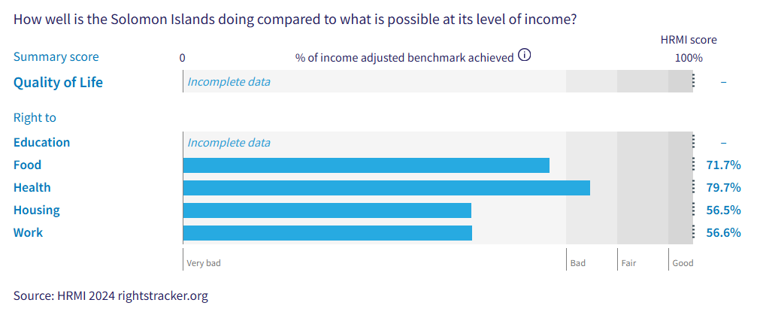
Right to education = N/A (incomplete data)
Right to food = 71.7% (very bad)
Right to health = 79.7% (bad)
Right to housing = 56.5% (very bad)
Right to work = 56.6% (very bad)
This poor performance affects women and girls in the following specific ways.
Right to Education
7. While the Solomon Islands score is in the ‘fair’ range for primary school enrolment, its score for the quality of education provided in schools falls in the ‘very bad’ range, as other countries with similar levels of income have achieved much more.
8. HRMI could not calculate a score for secondary school enrolment as the enrolment rate appears not to have been provided to UNESCO. The most recent data available is for 2006, when the HRMI score fell in the ‘very bad’ range.
Right to Health

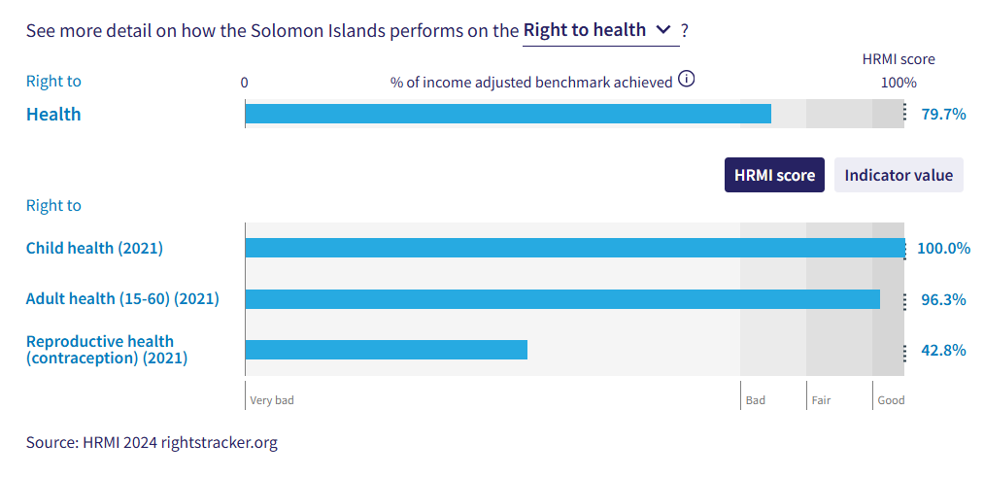
9. The Solomon Island’s score for the right to child health, based on the number of children surviving to age five, is at a full 100%, which means HRMI has not observed any country doing better for children’s health at this level of GDP per capita. In order to do better, Solomon Islands would likely need to grow its income.

10. The score for right to adult health is in the ‘good’ range, also.

11. According to human rights experts in Solomon Islands, single parent families and women and/or girls are at particular risk of having their right to health being violated.
Right to Reproductive Health
12. The Solomon Islands’ scores for reproductive health are particularly poor.

13. The Solomon Islands’ rates of modern contraceptive use (according to data published by the United Nations Population Division) are at a very low 26.3%, leading to an income-adjusted HRMI score of 42.8%, in the ‘very bad’ range. This tells us that other countries with the same level of resources as the Solomon Islands have achieved very much higher rates of modern contraceptive use.

14. There has been no overall progress in fulfilling the right to reproductive health (contraception) this century, with the current HRMI score slightly worse than the same measurement in 2000.

15. All Pacific countries have low scores on this indicator. See graph below showing HRMI’s income-adjusted right to reproductive health scores for 12 Pacific countries and territories:

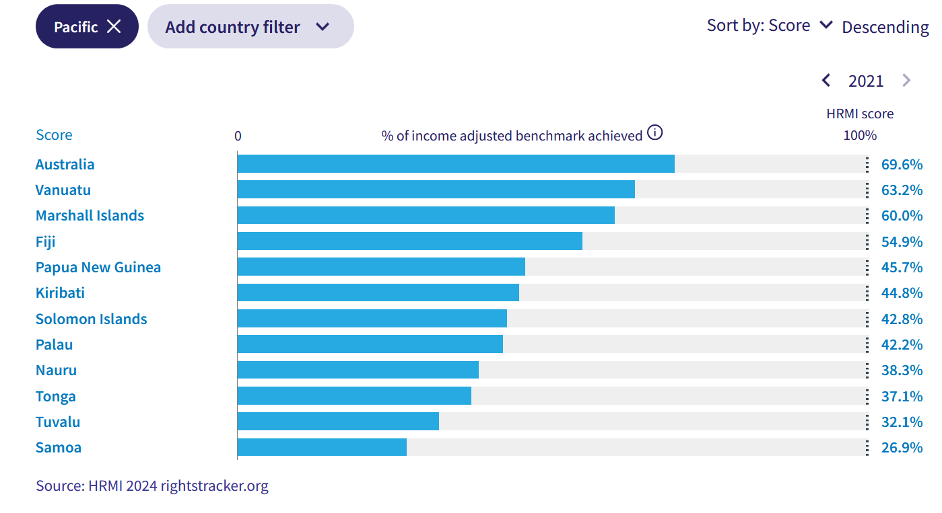

Right to housing, water, and sanitation

16. The Solomon Islands’ scores for the rights to housing, water, and sanitation are in the ‘very bad’ range, indicating substantial room for improvement.

17. Human rights experts in the Solomon Islands identified single parent families as being at particular risk of having their right to housing being violated, among many other groups.

Civil and Political Rights
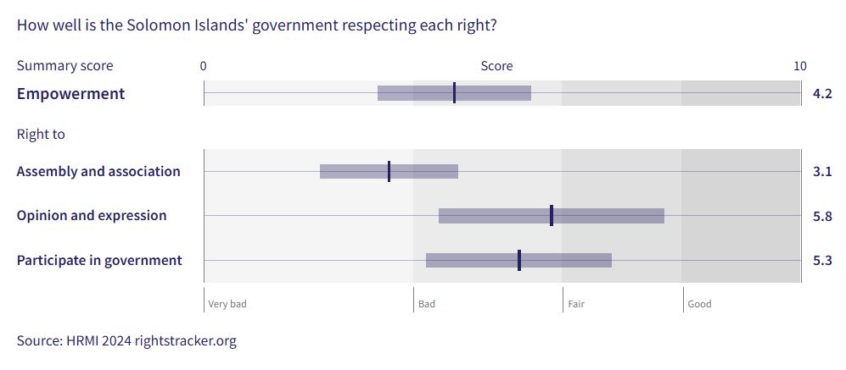

18. The Solomon Islands has good scores for protection of physical integrity rights.

19. The Solomon Islands’ scores for empowerment rights, however, are concerning, with no scores reaching the good range. The overall empowerment score of 4.2 out of 10 suggests that many people are not enjoying their civil liberties and political freedoms.

20. In all three of the empowerment rights – the rights to assembly and association, opinion and expression, and participation in government – women and/or girls have been identified as being at particular risk of rights violations.

Intersectionality

21. HRMI’s data for the Solomon Islands documents poor rights outcomes for a range of groups, including street children and homeless youth, disabled people, women and/or girls, single parent families, LGBTQIA+ people, and Indigenous people. Additionally, students, journalists, and people who engage in protests face challenges on their rights.

Covid-19

22. Covid-19 has been highlighted as a contributor towards worsening economic and social rights fulfilment in the Solomon Islands. Human rights respondents reported that worsening economic and social rights can be attributed to the Covid-19 pandemic.
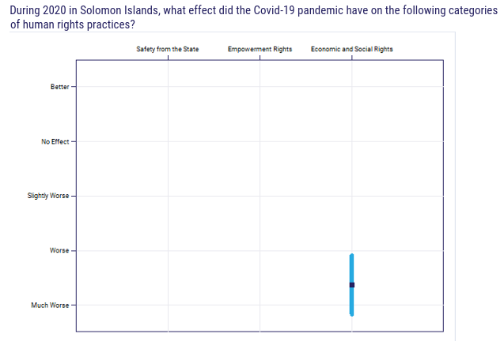

23. When asked what specific fulfilment of economic and social rights have been affected, 100% of respondents claim that education and work fulfilment have been affected. Furthermore, 66.7% of respondents claimed the fulfilment of the rights to food and health have also been affected. Half of respondents highlighted the fulfilment of the right to housing as being affected as well.
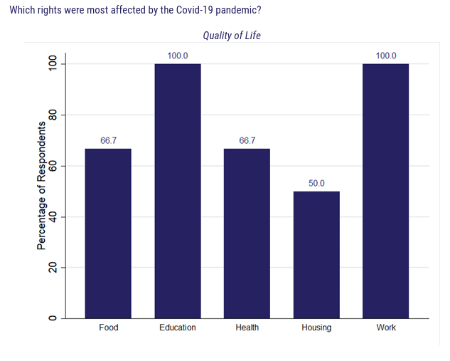

Climate Crisis

24. In 2019, in response to direct requests from Pacific human rights defenders, HRMI began producing data annually to document the effect of the climate crisis on human rights.

25. Human rights experts in the Solomon Islands reported that human rights in the country have been ‘moderately’ affected by the climate crisis.

Violence

26. Again, in response to direct requests from communities in the Pacific, HRMI has been measuring rates of violence against four specific vulnerable groups since 2019: children; people with disabilities; MVPFAFF+/LGBTQIA+ people; women.

27. The scores in the graph below show that there are significant problems with violence against all four groups in the Solomon Islands.

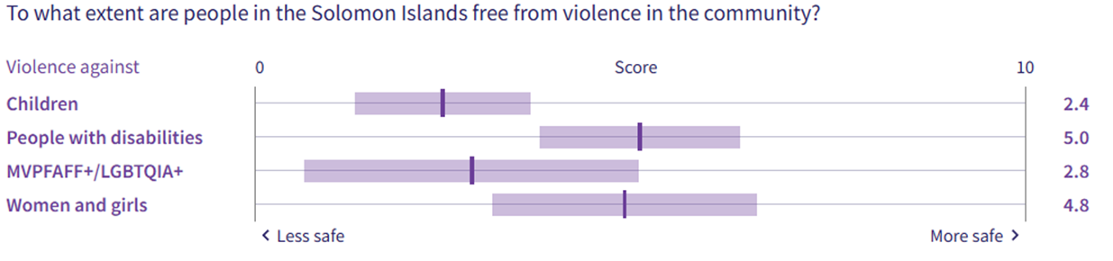

X. Concluding Remarks

28. HRMI respectfully submits its data and findings on elimination of discrimination against women in the Solomon Islands.

29. We hope that this Submission will serve as a useful resource to the Committee for drafting specific and meaningful questions to the Solomon Islands during the Pacific Technical Cooperation Session in Suva, April 2025.

Prepared by:
Thalia Kehoe Rowden
Sam Turner
Sarah Bakewell

Visit HRMI’s website to learn more about our mission and work, https://humanrightsmeasurement.org/.
This content represents the opinions of the Human Rights Measurements Initiative. It carries no endorsement of the University of Georgia.
See HRMI’s methodology for measuring economic and social rights: https://humanrightsmeasurement.org/methodology and https://rightstracker.org/page/methodology.
Ibid
HRMI 2024 Rights Tracker, https://rightstracker.org/
See Human Rights Measurement Initiative (HRMI) Digital Public Good Certificate, https://app.digitalpublicgoods.net/a/11781 The Digital Public Goods Alliance is endorsed by the UN Secretary General’s “Roadmap for Digital Cooperation,” https://www.un.org/en/content/digital-cooperationroadmap/assets/pdf/Roadmap_for_Digital_Cooperation_EN.pdf. It defines digital public goods as: “open source software, open data, open AI models, open standards and open content that adhere to privacy and other applicable laws and best practices, do no harm, and help attain the SDGs,” https://digitalpublicgoods.net/standard/.

