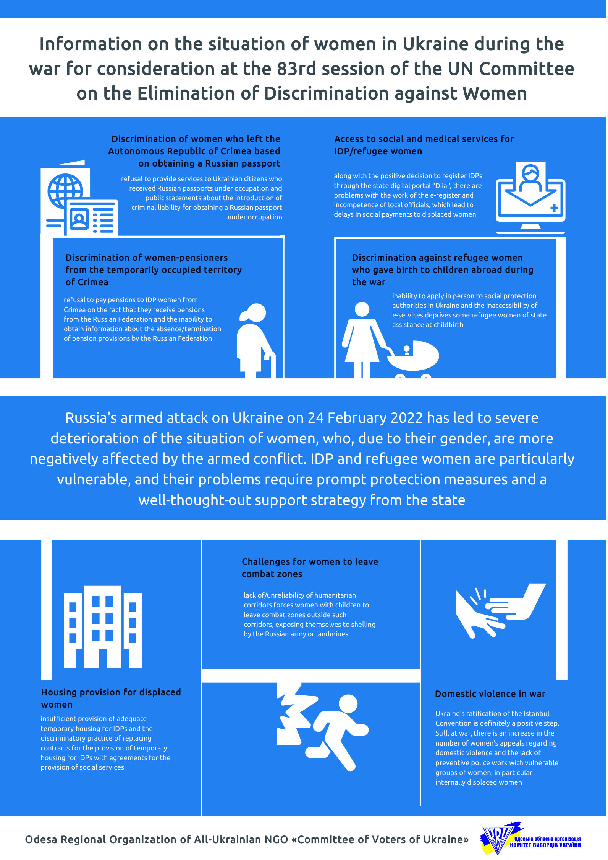

Committee on the Elimination of Discrimination against Women
Human Rights Treaties Division (HRTD)
Office of the United Nations High Commissioner for Human Rights (OHCHR)
Palais Wilson - 52, rue des Pâquis
CH-1201 Geneva
Switzerland
By E-mail: ohchr-cedaw@un.org

10 September 2022

Information on Ukraine for Consideration by the Committee on the Elimination of Discrimination against Women at its 83rd Session (10 - 28 October 2022)

Introduction

On the eve of the 83rd Session of the Committee on the Elimination of Discrimination against Women (the Committee), which will be held on 10-28 October 2022, we present our vision of the situation regarding certain aspects of women's rights during wartime for consideration of Ukraine's Ninth Periodic Report. This document is the result of research carried out by the experts of the Odesa regional organization "Committee of Voters of Ukraine" on women's rights amid the large-scale armed invasion of the Russian Federation into Ukraine and the analysis of the legal practice of the Organization on the protection of women's rights in war. The armed attack of the Russian Federation on Ukraine on 24 February 2022 led to a severe deterioration of the human rights situation in the country, in particular concerning the rights of women and girls, who, due to the gender aspect, experience a much more significant impact of the armed conflict. This document focuses on a particularly vulnerable category of women and girls who had to leave their homes and move to safer regions of Ukraine or abroad due to the armed conflict. The challenges IDP and refugee women face are crucial for the observance of their rights now and in the future and require the state to provide operational means of protection and a thought-through support strategy. The problems with the rights of IDP and refugee women, outlined below, include a general description of the situation and specific cases, the formulation of discriminatory provisions of legislation and the activities of state bodies, as well as the state's information policy.

1. Discrimination against women who left the temporarily occupied territories (in particular, the Autonomous Republic of Crimea) based on obtaining a "Russian passport" in Crimea

The reported cases indicate that Ukrainian embassies abroad refused to provide services to women because they received a Russian passport during the occupation and allegedly lost Ukrainian citizenship. The embassies' position contradicts the state approach, applied since 2014 to the occupied territories and Ukrainian citizens living there. In particular, Article 9 of the Law "On Ensuring the Rights and Freedoms of Citizens and the Legal Regime in the Temporarily Occupied Territory of Ukraine" stipulates that the documents issued by the occupying power shall have no legal consequences. Also, Ukraine's high-ranking officials have repeatedly stated that obtaining Russian passports in Crimea is forced and coercive, therefore, not recognized by Ukraine. Meanwhile, the war-related evacuation of women and children abroad from the occupied territories is not an isolated case. Displaced people may have different issues with their documents. Most such people have Russian documents in parallel with Ukrainian ones. The embassy/consulate staff's ignorance regarding the legislation regulating the rights and status of people from the occupied territories leads to violating their rights and putting people under even greater stress, given the impact of the armed conflict. Considering that under martial law, mostly women with children are allowed to travel abroad, such discriminatory attitude mainly concerns women.

The Organization conducted a strategic litigation to protect the rights of a Crimean woman who was refused a travel document for her child at the Embassy of Ukraine in Moldova. The reason was the forced acquisition of Russian passports by the parents in Crimea and the Russian birth certificate of the child born in 2017. The family decided to leave Crimea and Ukraine for security reasons. The Embassy of Ukraine, contradicting applicable legislation of Ukraine, informed the woman she had lost her Ukrainian citizenship and the state authorities would not help her. The Organization drafted and submitted a statement to a local court in Odesa to establish the birth of a child in the temporarily occupied territory. A favourable court ruling became the basis for issuing a Ukrainian birth certificate. It was then transferred to the woman in Moldova. In addition, the Organization has sent an appeal to the Embassy of Ukraine in the Republic of Moldova, providing arguments for the inadmissibility of discrimination against people from the temporarily occupied territories. The appeal also clarified the provisions of the law regarding the fact that obtaining Russian passports by citizens of Ukraine in occupied Crimea does not entail any legal consequences and responsibility. In June 2022, the woman again applied to the Embassy of Ukraine in Moldova and obtained travel documents for the children without impediments.

In this context, we would also like to draw attention to the rhetoric of some high-ranking officials regarding the residents of the temporarily occupied territories, which may indicate a dangerous tendency to depart from the previously developed approach. For example, the Minister of Reintegration of the Temporarily Occupied Territories announced the introduction of criminal liability for obtaining a Russian passport by citizens of Ukraine under occupation. The Organization published an open letter to the Minister and expressed concerns over the announced legislative initiative. The Organization also has discussed this discriminatory threat with other human rights organizations and developed a joint position/action plan to counter such discriminatory initiatives.

2. Discrimination against women-pensioners displaced from Russia-occupied Crimea

A threatening situation has arisen for displaced Ukrainian women, who previously lived in Russia-occupied Crimea and, during 2014-2022, became recipients of pensions and other types of social assistance from the Russian Pension Fund. After 24 February 2022, they moved to the Government-controlled territory of Ukraine and found themselves in a vulnerable situation. The Government of Ukraine refused to pay pensions to them because:
- They have secured pensions from the Russian Pension Fund;
- They cannot provide information that they do not receive pensions and other social benefits "at the previous place of pension receipt" from the Russian Pension Fund.
In our opinion, this discrimination results from the inconsistency and contradiction of national legislation. The Law of Ukraine as of 1 July 2021 No. 1618-IX is supposed to guarantee the pension payment to all citizens of Ukraine without exception.

Nevertheless, Crimeans, particularly those who left Crimea and became IDPs, are denied their pensions. Such discrimination and violation of the right to receive pensions from the Pension Fund of Ukraine result from the fact that the current legislation of Ukraine still contains contradictory provisions preventing the payment of pensions.

It is still prohibited to pay pensions to citizens from Crimea, if:
1) IDPs who previously lived in Crimea have Russian citizenship;
2) IDPs who previously lived in Crimea receive or received retirement payments from the Russian Pension Fund;
3) The Pension Fund of Ukraine has not received any information from the Russian Pension Fund on the payment and termination of the pension of IDPs (an impossible condition during the armed conflict);
4) The Pension Fund of Ukraine did not receive an IDP file from the Russian Pension Fund (currently impossible).

The Applicable Resolution of the Cabinet of Ministers of Ukraine as of 2 July 2014, No. 234, defines two mandatory conditions to assign a pension to IDPs who have left the territory of Crimea:
- a certificate from an authorized Russian body must be obtained certifying that the person had no assigned pension at the place of registration in Crimea, and
- a personal declaration about the lack of citizenship of the occupying state."
The Pension Fund of Ukraine still refers to these discriminatory conditions, refusing to pay pensions to citizens of Ukraine who are IDPs from Crimea.

3. Discrimination against women who gave birth abroad during the war.

Under Art. 1, 3, 10 of the Law of Ukraine "On State Assistance to Families with Children", families with children are entitled to receive state assistance upon the birth of a child, and one-time in-kind assistance "Baby Package", regardless of the family's place of residence. According to the existing procedures, all required documents shall be submitted in person by the person who claims to assign assistance.

After 24 February 2022, more than nine million citizens left Ukraine, including many pregnant women, who then gave birth or will give birth abroad, and mothers with newborn babies. Given that the applicable legislation has not been adapted to the mass departure of women abroad and staying there for an indefinite period, some of these women are or may be deprived of the opportunity to personally apply for receiving state assistance provided by law.

The option provided by legislation to submit an application and documents in electronic form does not solve the problem. This method of submitting the electronic form is available to a limited number of citizens abroad, only under the following conditions:

1) a foreign diplomatic institution of Ukraine issued the birth certificate, and the same institution entered information about the child's birth into the Unified State Demographic Register;
2) the applicant has a qualified electronic signature from a Ukrainian provider of electronic trust services.

In addition, the application can be submitted only within 12 months.

4. Access to social and medical services for IDP/refugee women

IDP women get access to social and medical services only after their registration in the new place of residence. Therefore, proper organizing of the registration process is essential. After 24 February 2022, the Government amended the IDPs registration procedure, adding a new option to register through the e-service portal Diia, which is definitely a positive step. At the same time, unfortunately, there are delays in IDPs' registration by local authorities. Only cities and district centres have access to the IDP register, while it takes a long time to enter the data at the territorial community's level. Territorial communities have different installed software "Social Community", which is not fully synchronized with the state central registry. In addition, there is still a lot of paperwork at the level of territorial communities. There is a need for a unified software product with sufficient server capacity; otherwise, IDPs will have to wait a long time for their registration and consequent assistance/healthcare.

We also detected different cases of poor competence of state/municipal officials engaged in IDP registration. For example, a woman was refused registration as an IDP because she left the temporarily occupied Crimea in 2017, before the full-scale war that began on 24 February 2022, while the occupation started in 2014. There are numerous cases of women whose social/maternity benefits were delayed.

At the same time, the Government continued securing maternity benefits despite the war, the employee's evacuation, the impossibility of the employer to form an application, and even in the case that maternity leave started after the employment contract suspension for the war period.

We would like to outline the Government's efficient step in changing the procedure for providing sick leave in connection with pregnancy and childbirth. The Ministry of Health has simplified the procedure for providing sick leave for pregnant women who had to leave the country due to the war.

It used to be only possible to commence a sick leave only during a personal appointment with a doctor. Under martial law, the Ministry of Health allowed the doctors-in-charge to make medical conclusions on temporary incapacity for work (MCTI) without a personal visit of a pregnant woman. Also, according to our monitoring data, the Ministry of Health responded quickly and effectively to the need to adapt the health care system to war conditions. It also considers the fact that people will move and, accordingly, will seek medical care outside their place of permanent residence. Thus, Ukrainians' access to primary medical care was simplified – IDPs can now be admitted to any hospital if it can provide the necessary treatment, and the family doctor's declaration is not mandatory.

5. Accommodation of IDP women.

The issue of accommodating IDPs remains pressing. Territorial communities partially cover this need by placing people in communally owned facilities; some other people are accommodated in private housing at the invitation of the owners. Unfortunately, since 2014, the local authorities have not formed a sufficient number of accommodations to provide temporary housing to displaced persons. In most cases, displaced persons – primarily women and children – are settled either in communal institutions, such as schools, kindergartens, clubs, or private houses.

We would like to outline a valuable initiative of https://dopomagai.org Private individuals created the site for a convenient search for housing by displaced persons and for posting information from owners about the possibility of accommodating IDPs. At the same time, we must emphasize the need to create safeguards for IDP women who seek accommodations through the private sector using such resources. For instance, the ads such as "a 60-year-old man will provide a room in his apartment to one 60-year-old woman" suggest that such an offer was made in bad faith.

We also detected cases when local authorities forced IDPs accommodated in social facilities to sign new agreements on social services provision, replacing their agreements on providing temporary accommodations for IDPs with contracts on social services provision. This practice is alarming as it does not meet the requirements of the Law of Ukraine "On Ensuring the Rights of Internally Displaced Persons". The newly proposed agreements impose obligations on IDPs that aggravate their situation. For example, an IDP retired woman with the first group (grave) disability has reached our Organization as she was under pressure to sign such an agreement.
The document implies compliance with the internal procedure rules, including:
- the requirement to provide medical certificates proving the absence of diseases (in particular, mental, venereal);
- the Social Centre's staff have the right to monitor compliance and implementation of the Rules by IDPs;
- IDPs have the right to leave the Centre only from 06:00 to 23:00;
- IDPs have the right to invite guests only upon the agreement of the Centre's head;
- IDPs are required to attend individual and collective events for social adaptation;
- IDPs are obliged to comply with the orders of the Centre's head and staff;
- Centre's representatives can enter the accommodation without hindrance for inspections;
- IDPs are required to make notes in a special journal about each intention to leave the Centre, indicating the time of leaving the Centre and returning;
- IDPs are obliged to take turns and serve as on-duty personnel in the common-use premises of the Centre. During their shift, IDPs are required to clean the premises and wash equipment and furniture.
These provisions significantly narrow the IDP's rights compared to what is guaranteed by the Constitution of Ukraine and the Law of Ukraine "On Ensuring the Rights and Freedoms of Internally Displaced Persons."

6. Challenges of women leaving combat zones.

One of the most dangerous moments for IDP women is the very process of their moving to a new place. Many humanitarian corridors turned out to be unreliable and unsafe. On 3 March 2022, Ukraine and Russia agreed to create humanitarian corridors for evacuating civilians and delivering humanitarian aid for the first time. Still, until now, this process has been slow and with significant limitations. It is imperative that civilians seeking protection from bombardment, including those whose homes have been destroyed, evacuate safely without threats to their lives and health. In addition, these people cannot be forced to move to the territory controlled by Russia. Ukrainian authorities have demanded routes allowing civilians to evacuate from the devastated cities, such as Mariupol, Enerhodar, Sumy, Izium, and Volnovakha, and residents of several towns near Kyiv, including Bucha, Irpin, and Hostomel, to reach the capital. But during active hostilities, people could not evacuate due to continuous Russian shelling. There are many documented cases when women and children were forced to leave temporarily occupied settlements outside the routes of humanitarian corridors and were fired on by the Russian military or got injured because of mines' explosions.

7. Issues of domestic violence during wartime.

The Organization welcomes Ukraine's ratification of the Istanbul Convention, which is an undeniably positive step in combating domestic violence. At the same time, the problem of domestic violence intensified amid a full-scale war. From 01/01/2022 to 11/07/2022, the National Police in the Odesa Region registered 5,034 complaints regarding domestic violence against 4,547 during the same period in 2021, which is 500 more cases. Another concern is the lack of disaggregated statistics on domestic violence among IDPs. Lack of knowledge of the situation regarding the spread of violence among IDP families hampers preventive measures.

RECOMMENDATIONS:

1) to train officials who work with IDPs on the current legal framework regarding their rights and status;

2) to bring Resolution No. 234 of the Cabinet of Ministers of Ukraine as of 02.07.2014, which approved the "Procedure for paying pensions and providing social services to citizens of Ukraine living in the territory of the Autonomous Republic of Crimea and the city of Sevastopol", in line with the legislation, removing the paragraphs that imply that receiving a Ukrainian pension by citizens of Ukraine depends on whether they receive a Russian pension or not;

3) to simplify the assignment of social parenting benefits for Ukrainian citizens abroad and enable foreign diplomatic institutions of Ukraine to provide relevant administrative services;

4) to enable foreign diplomatic institutions to enter information about the birth of a child to the Unified State Demographic Register, based on birth certificates issued by authorized foreign institutions;

5) amend the Law of Ukraine "On State Assistance to Families with Children", and the Procedure for Assigning and Paying State Assistance to Families with Children, approved by Resolution of the Cabinet of Ministers of Ukraine No. 1751, to ensure that parents who are currently abroad can apply to social security agencies or diplomatic institutions of Ukraine for the assigning of state benefits through a representative acting on the basis of the Power of Attorney granted by one of the parents;

6) amend the Law of Ukraine "On State Assistance to Families with Children", and the Procedure for the Appointment and Payment of State Assistance to Families with Children, approved by Resolution of the Cabinet of Ministers of Ukraine No. 1751 as f 27 December 2001, to suspend the requirement to apply for state social benefits during 12-month for the period of martial law and within 12 months after the termination of martial law, providing for the conditions for renewing the missed 12-month period;

7) to amend the Law of Ukraine "On State Assistance to Families with Children", as well as the Procedure for Assigning and Paying State Assistance to Families with Children, approved by Resolution of the Cabinet of Ministers of Ukraine No. 1751 as of 27 December 2001, to enable the parents who are currently abroad to send applications and documents certified by a notary public or a foreign diplomatic institution by post to the social security authorities for the assigning of state assistance;

8) to resume the work on forming accommodation stock for IDPs;

9) to ensure that the law enforcement agencies monitor resources/advertisements regarding the accommodation offers to IDP women, which may actually intend to violate women's rights (forced labour, sexual violence);

10) introduce separate state monitoring of domestic violence cases among IDPs to take preventive measures and provide adequate responses.

https://zakon.rada.gov.ua/laws/show/1207-18#n52
https://crimea.suspilne.media/ua/news/2449
https://izbirkom.org.ua/urlikbez/obshchestvo-19/2022/oformlennya-dokumentiv-ta-zvernennya-do-yespl-yak-gromadskij-centr-pravosuddya-vplivaye-na-dotrimannya-prav-zhinok/
https://portal.lviv.ua/news/2022/07/23/vereshchuk-pro-kryminalnu-vidpovidalnist-za-pasporty-rf-pytannia-dyskusijne-ale-napriam-vyznacheno
http://cvu.od.ua/ua/announce/vidkritiy-list-do-ministerki-z-pitan-reintegratsiyi-timchasovo-okupovanih-teritoriy-ukrayini-irini-vereschuk_1414/
https://krymsos.com/krymsos-krymchany-mozhut-oformyty-ukrayinsku-pensiyu-cherez-sud/
https://zakon.rada.gov.ua/laws/show/1618-20#Text
https://zakon.rada.gov.ua/laws/show/234-2014-%D0%BF#Text
https://zakon.rada.gov.ua/laws/show/2811-12#Text
https://zakon.rada.gov.ua/laws/show/1751-2001-%D0%BF#Text
https://www.5.ua/suspilstvo/cherez-viinu-z-ukrainy-vyikhalo-vzhe-ponad-8-mln-hromadian-oon-280594.html
https://medicine.rayon.in.ua/news/510888-v-ukraini-sprostili-protseduru-vidachi-likarnyanikh-vagitnim-yaki-viikhali-za-kordon
https://mkocubynska-gromada.gov.ua/news/1662799624/
https://vinrada.gov.ua/stvorennya-nalezhnih-umov-prozhivannya-u-centrah-rozmischennya-pereselenciv-obgovorili-golova-oblasnoi-radi-ta-predstavniki-mizhnarodnoi-organizacii-z-migracii.htm
https://dopomagai.org
https://zakon.rada.gov.ua/laws/show/1706-18#Text
https://zakon.rada.gov.ua/laws/show/254%D0%BA/96-%D0%B2%D1%80#Text
https://www.amnesty.org.ua/czyvilnym-yaki-ryatuyutsya-vid-rosijskyh-atak-mayut-garantuvaty-bezpechni-gumanitarni-korydory-amnesty-international-publikuye-novi-svidchennya-z-ukrayiny/
https://zakon.rada.gov.ua/laws/show/994_001-11#Text
http://cvu.od.ua/ua/announce/domashnye-nasilstvo-pid-chas-viyni-na-odeschini-fiksuyetsya-bilshe-vipadkiv-nij-ranishe_1429/?fbclid=IwAR0KgKFcmkXilZ1fgb619Y690yNVcDSyG2TSWbQidlMOmSnfbQtVIH2EcxI

