LIMITING ACCESS FOR WOMEN WITH DISABILITIES FROM
THE REPUBLIC OF MOLDOVA TO ECONOMIC AND ENTREPRENEURIAL ACTIVITY

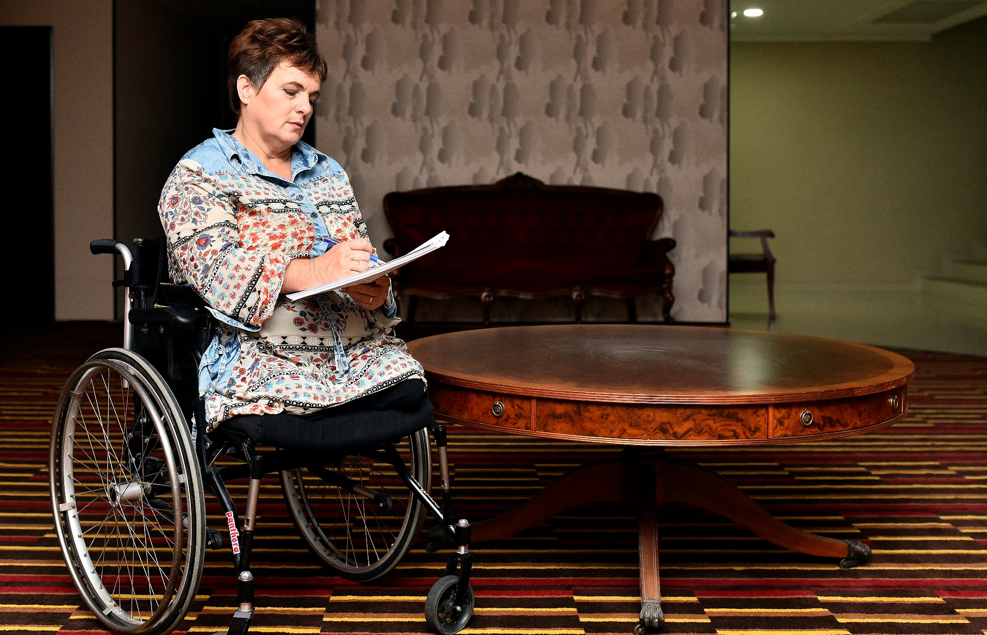

Alternative report on the implementation by the Republic of Moldova of the UN Convention on the Elimination of all Forms of Discrimination against Women in the Republic of Moldova.
Submission prepared by Association of Entrepreneurs with Disabilities of the Republic of Moldova "European skills without limits" in partnership with the Network of Women with Disabilities of the Republic of Moldova for the 75 Session CEDAW - Convention on the Elimination of All Forms of Discrimination against Women. January 2020.

Association of Entrepreneurs with Disabilities from Moldova – "European Abilities without Limits"
Contact Person: Irina Revin - president
Address: str. Socoleni 21/2, of. 2, Chisinau, Republica of Moldova, MD 2020
Phone: +(373) 60213645 E-mail: office.aefl@gmail.com
Facebook: https://www.facebook.com/AEFL.MD

January 2020

TABLE OF CONTENTS

INTRODUCTION 2
METHODOLOGY 4
RESULTS OF RESEARCH 5
RECOMMENDATIONS 6

INTRODUCTION
According to official statistics the number of persons with disabilities in the Republic of Moldova is about 184 thousand persons, of which women and girls represent 48 % of the total number of persons with disabilities.
These women with disability face considerably great difficulties in public and private spheres, such as obstacles for access to sufficient housing, healthcare, education, professional preparation and employment, and the probability of their placement to institutions of the closed type is higher. These conclusions were based on the report "Profile of Women with Disabilities" and the study "Barriers and needs of women with disabilities in the Republic of Moldova”.
Women with disability are also influenced by the unequal address at employment, promotion, payment for equal work, access to training, retraining, the credits and other productive resources, and they are almost not allowed before participation in adoption of economic and political decisions.
Promotion of gender equality and expansion of the rights and opportunities of women are is essential necessary for achievement of the internationally agreed targets in the field of development, including the Millennium development goals. Women and disabled girls are exposed to double discrimination therefore they are exposed to bigger risk of gender violence, sexual abuse, the negligent relation, improper treatment and operation. According to research held by United Nations, the world indicator of level of literacy among disabled women makes only 2 percent, and in the Republic of Moldova this percent is even lower.
Establishing the international norms and standards, the international community recognizes need for considering interests and expansion of the rights and possibilities of disabled women they could have on an equal basis all human rights and achievements of development for all, including disabled people. But in the Republic of Moldova the State too often doesn't fulfill the obligations to women and disabled girls, addressing or allowing the treatment of them as with the helpless objects of pity subject to hostility and isolation instead of giving them an opportunity to use fundamental human rights and freedoms. Moreover, politicians and strategy for women traditionally don't incorporate the disability perspective, and politicians and strategy for disabled people don't include gender issues. That is the women and the girl with disability faces discrimination and barriers because of the floor, disability and for both reasons at once. percent, and in the Republic of Moldova this percent is even lower.
On the way to education and employment with disability the way of independent and worthy life also doesn't allow women and girls to begin institutional barriers: Receiving the higher education by disabled people is interfered by multiple structural restrictions. In particular, lack of the integrated programs at high schools and whole complex of other factors, such as not tolerance of society and lack of the barrier-free environment, narrow the choice in the ambassador school and higher education for young women of people with disabilities. The circle of professions by which women with disability can receive preparation is extremely limited. The disability women's parents interfere opportunities to get an education, when family members don't want or can't incur/dedicate additional time and material expenses, or they underestimate possibilities of their children or simply have no resources necessary for development of personal and professional growth of the child. The immediate environment undoubtedly influences the vital choice of the maturing child, forming social identity of the subject, for example, marking out lines of dependence or independence, motivating or dissuade from attempts to get an education. preparation, I am extremely limited.
The general statistical analysis shows that in the woman with disability of working-age about a third of total number make. In the general contingent of the woman with disability of the woman of working specialties make 73% serving - 21%, villagers - 3%, housewives and persons without certain occupations - 3%. The general seniority before establishment of disability 53% of women had more than 25 years (according to the expert). However existence of demanded specialty and high level of training doesn't become the guarantor of the situation of stability of the woman with disability in labor market since are on special situation in the sphere of employment, having the corresponding warranties (privileges and the sparing working conditions, need to adapt jobs) which do them by "unattractive" labor source.
Their precarious situation can make them vulnerable to domestic violence, in cases where they are dependent, economically, on their partner or on a male family member. In some cases, women with disabilities have limited access to reproductive health services and may be less encouraged to access the labor market.
But just as becoming an employee is harder for Women with disability, so is becoming an entrepreneur. Barriers include a lack of access to education or training, and limited access to ICT, market information and finance. Indeed, disability women-owned SMEs with reliable funding sources are few and far between, in part because land is often required as collateral for credit in a region where disability women make up a small minority of landholders. Burdensome registration procedures combine with societal prejudice to frustrate women’s with disabilities entrepreneurial potential.
1. Improve the institutional conditions. Entrepreneurs are strongly influenced by role models and social context. It is therefore important to promote Women with disability entrepreneurs as role models and ensure that the education system is gender-neutral and does not discourage Disability women from going into STEM fields (i.e. science, technology, engineering and mathematics). Another aspect is family and tax policies, which should seek to increase Women with disability labour market participation and female entrepreneurship.
2. Improve access to entrepreneurship skills programmes. Traditional policy action that supports the acquisition of entrepreneurship skills include entrepreneurship training, coaching and mentoring programmes, and support in building entrepreneurial networks. Such programmes are often tailored to the specific barriers faced by Women with disability and delivered to women-only groups of beneficiaries.
3. Help women with disability realise the growth potential of their businesses. There is a growing emphasis in entrepreneurship policy to help women acquire and develop the skills needed to successfully launch and run businesses with high growth potential. One approach is to deliver tailored support through women with disability-only business incubator and accelerator programmes. Such incubators typically offer the usual business incubator support – premises, networking opportunities, training and workshops, etc. – but tailor them to the needs of women with disability entrepreneurs and facilitate support.

II. METHODOLOGY
This alternative report was prepared by the Association of Entrepreneurs with Disabilities of the Republic of Moldova "European Abilities without limits" in partnership with the Network of Women with Disabilities of the Republic of Moldova, which during the year 2017-2018 conducted a research under the genre "Women with disabilities - an unqualified potential for the national economy ”, with the support of the National Institute for Economic Research (INCE), the results of which are the basis of this alternative report. The research was developed by questioning 75 women with disabilities with different degrees of disability and age, who own or would like to start a business.
The questionnaire includes information:
- Business characteristic and information about the respondent;
- Setting up and developing the business: the main reasons for setting up your own business;
- Participation of other family members in business; support at the initiation stage;
- The main problems of the entrepreneur with disabilities: the general constraints of women with disabilities, including in business development; limited access to resources; problems related to state regulation;
- Support needs: from business support organizations, satisfaction with the services obtained; improving general living conditions and business development conditions;
- Cooperation with business partners and associations: membership of business associations; contribution to their activity and support from them.
Women with disabilities who already own a business (67%) or would like to file a business (35%) were asked about several regions of the country: Chisinau municipality, Balti municipality, Hâncești district, Cahul , Orhei , Stefan Voda , Criuleni, Edineț, Sangerei, Falesti,Ungheni, Drochia; of the Transnistrian region: Or. Tiraspol, or. Bender, or. Dubasari; and you have the Gagauz UTA: or. Comrat, gold. Ceadîr Lunga.

RESULTS OF RESEARCH
The most important obstacles in the development of entrepreneurial activity by women with disabilities were identified in the research:
- 100% of the women with disabilities, who participated in the questionnaires, mentioned that they had difficulty obtaining general and professional studies.
- 100% of the women with disabilities, who participated in the questionnaires, mentioned the lack of entrepreneurship support programs for women with disabilities.
- 100% of the women with disabilities, who participated in the questionnaires, mentioned the lack of knowledge related to the organization of the business and the inaccessibility of the existing programs dedicated to women's entrepreneurship.
- 97.3% of the women with disabilities, who participated in the questionnaires, mentioned the lack of special goods and services, which allow women with disabilities to be involved in work and social activities (specialized rehabilitation articles, social assistance at home, possibilities of Internet training, etc.)
- 96.0% of the women with disabilities, who participated in the questionnaires, mentioned the negative and discriminatory attitude of the society towards women with disabilities in the entrepreneurial field related to both disability and on the basis of gender (discrimination of the lending institutions that request from women with disabilities, but men with disabilities do not, or ask if the woman is supported by father or husband, etc.).
- 94.7% of the women with disabilities, who participated in the questionnaires, mentioned inaccessible infrastructure barriers (the inaccessibility of the institutions of the state in which the business is registered, the inaccessibility of the FISCale buildings in Chisinau and in regions, the lack of state electronic services dedicated to advancing the business, etc.).
Regarding the situation of entrepreneurs with disabilities in the Republic of Moldova during the research it was found:
- The strategies and policies adopted in order to facilitate, create and develop entrepreneurship activities are quite minimalist.
- There is a lack of distinct support measures for people with disabilities, especially women with disabilities.
- The incomplete and up-to-date legislative basis for the provisions and practices in the EU countries does not provide full possibilities that would favor integration in the labor market, all the more so to carry out activities on their own.
- Training and reinforcing the entrepreneurial potential of women with disabilities gives them the chance to improve their material well-being and self-realization, protecting them from financial dependence.
- In order to involve women with disabilities in entrepreneurial activities, it is necessary to support them in the SME development policy.
- When arguing the measures to support the business of women with disabilities, it is necessary to identify and take into account the specificity of their problems.

RECOMMENDATIONS
The access of women with disabilities to the economic and entrepreneurial activity contain the following:
- Design, construction and modernization of social infrastructure objects, to make them more accessible.
- Improving the possibilities for obtaining general and professional studies
- Supporting social entrepreneurship, oriented towards increasing the employment of people with disabilities, in the mirror of women with disabilities.
- Improving the possibilities for obtaining general and professional studies.
- Supporting social entrepreneurship, oriented towards increasing the employment of people with disabilities.
- Changing the attitude of the society towards people with disabilities, especially towards women with disabilities.
- Development of a state target program, which will provide for the preferential financing of the entrepreneurial activity of women with disabilities at the stage of starting the business. Providing tax and payment facilities for this group of entrepreneurs.
- Supporting the activity of business associations, which mainly meet or include entrepreneurs among women with disabilities.
- Improving the attitude of state officials, employees of commercial banks, other business support organizations towards entrepreneurs among women with disabilities.
General recommendations proposed in the framework of state support for entrepreneurs with disabilities:
- Adapting legislation and policy documents to the needs of SMEs, located in
- ownership and management of women with disabilities.
- Ensuring equal rights and expanding the possibilities of women with disabilities for
- active participation in economic, social, political and other life.
- Development of the educational system in the field of entrepreneurship, simplification of access to
- financing, improving information and consulting services.
- Development of cooperation in the field of entrepreneurship, formation of business networks.
- Expanding the dialogue between public administration bodies, the business environment and organizations
- Non-governmental organizations working in the interests of women with disabilities.
Recommendations for adapting legislation and policy documents to support small and medium-sized businesses submitted and managed by women with disabilities:
- Introduce amendments to the Law on Small and Medium Enterprises:
- Article 11. State programs for the development of SMEs The objectives of the state programs are aimed at (a) supporting young entrepreneurs ...; (b) stimulation of migrants…; (c) development of female entrepreneurship…; To add: (d) supporting entrepreneurs among people with disabilities, especially women with disabilities.
- Elaboration and adoption of the Law on family affairs:
- To provide: a special (preferential) regime for family businesses, involving people from socially vulnerable categories of the population, including persons with disabilities.
- Ensure monitoring and control over compliance with legislation.
Take in consideration that:
In the Law on Entrepreneurship and Enterprises (Chapter VI1, amendments a.2018) the concept is adopted on social entrepreneurship and in the social enterprise it refers primarily to promoting the employment of people with disabilities, but cannot motivate them to get involved. in business. In the Law on the social integration of persons with disabilities (2012), it is not assumed that I should create entrepreneurship, the concept of social integration that includes entrepreneurship.
1. Make amendments to the Law on Small and Medium Enterprises:
- Article 11. State programs for SMEs The state programmer objective is aimed at (a) supporting young entrepreneurs ...; (b) stimulation of migrants ...; (c) female entrepreneurship ...; To add: (d) supporting entrepreneurs among persons with disabilities.
2. Elaboration and adoption of laws on family affairs:
- Provide: a special (preferential) regime for family affairs, in the care are involved the socially vulnerable persons of the population, even with disabilities 3. Ensuring the monitoring and control over the legislation.
Step 1. Correct the Action Plan for the years 2018-2020 regarding the implementation of the Strategy for the development of the SME sector for the years 2012-2020.
To add to the list of support actions for young people and women, the group of people with disabilities. In particular:
◦ 3.1.1. Conduct training courses in the field of youth entrepreneurship; migrants; To add: people with disabilities..
◦ 3.2.3. Supporting actions and initiatives to promote entrepreneurship among young people. To add: also to people with disabilities ...
To organize the monitoring and control over the observance of the norms, provided for in the international conventions.
Step 2. To include in the project of the new Strategy / Program for the development of the SME sector for the years 2021+ the priority:
Developing entrepreneurship among underprivileged and under-represented population groups in entrepreneurship, which will be oriented towards supporting entrepreneurs among women, young people, old people and with disabilities.
Step 3. To reflect on the need to elaborate the Strategy for supporting persons with disabilities with a chapter intended for the development of entrepreneurship.
Recommendations for ensuring equal rights and extending the participation of women with disabilities in economic, social and political life:
1. Improve the possibilities for the development of women with disabilities in the family, which will allow them to increase their entrepreneurial potential.
2. Encouraging the economic activity of women with disabilities - in the labor market, in politics, other areas of public activity, as a premise, to contribute to the development of entrepreneurship; elimination of discrimination:
- Simplifying the physical access to the social infrastructure institutions, which allow obtaining the educational, medical and social services;
- Support the promotion of women with disabilities in management positions in the economic and political field.
3. Promoting the entrepreneurial spirit in society, with emphasis on the possibilities of involving women with disabilities in entrepreneurial activities and on their own:
- Dissemination of information regarding entrepreneurs with disabilities, their problems and successes, methods of overcoming obstacles, business development;
- The inclusion in the public television and radio programs of the broadcast cycles, oriented towards the development in society of the entrepreneurial spirit and the entrepreneurial culture.
Recommendations for developing the education system in the entrepreneurial field, simplifying access to financing, improving information and consulting services:
Development of the educational system in the field of entrepreneurship
Training of women with disabilities (as a target group) within the national program of continuous training of entrepreneurs "Efficient Business Management" (including them in the Performance Indicators);
Development of special modules and teaching methods that take into account the characteristics of entrepreneurs with disabilities.
Improving information and consulting services
Concentrated transfer of information related to the regulation, control and support of businesses, from public institutions to business associations, which bring together people with disabilities.
Develop on the web pages www.odimm.md or www.businessportal.md a section for entrepreneurs among underprivileged and underrepresented women in entrepreneurship, which will include all initiatives to support them.
Simplify access to finance
Use of the means of the Credit Guarantee Fund for entrepreneurs with disabilities (including them in Performance Indicators);
Attracting foreign financial assistance (in the form of grants or preferential loans) for the development of the business of persons with disabilities.

https://statistica.gov.md/newsview.php?l=ro&idc=168&id=4976
http://www.clinicajuridica.md/uploads/Studiu_Barierele_i_necesitile_femeilor_cu_dizabiliti_din_Republica_Moldova.pdf

