BRIEFING ON SIERRA LEONE FOR THE COMMITTEE ON THE RIGHTS F THE CHILD, SESSION 90 PRE-SESSIONAL WORKING GROUP- October 2021
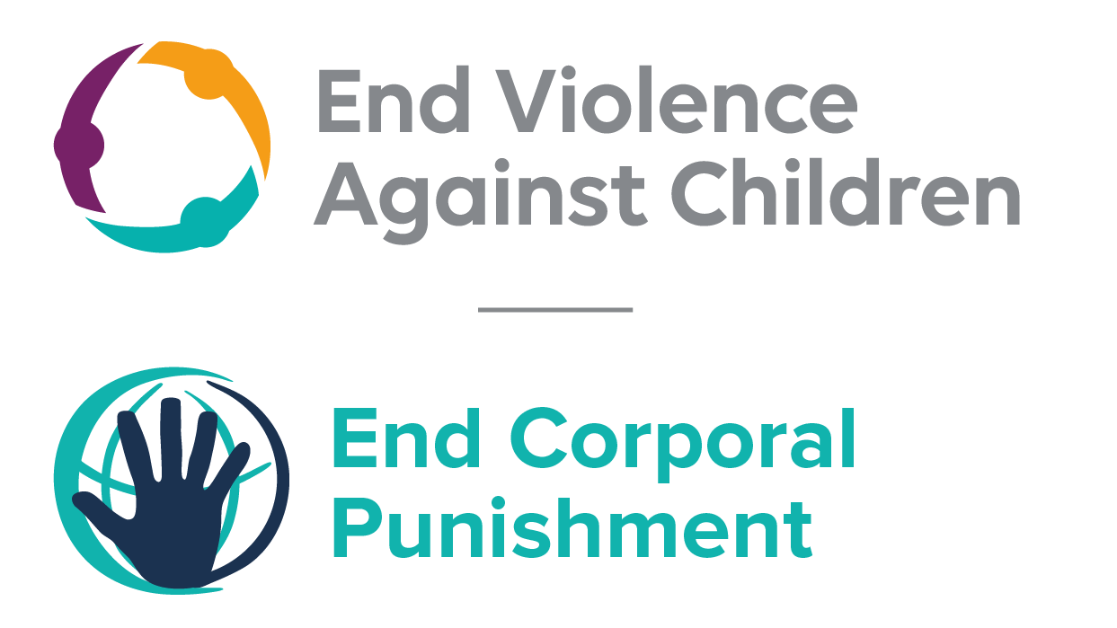
The Global Partnership to End Violence Against Children, June 2021

This briefing describes the legality of corporal punishment of children in Sierra Leone. In light of the Committee’s General Comment No. 8 on “The rights of the child to protection from corporal punishment of children and other cruel or degrading forms of punishment”, its repeated recommendations on the issue and the importance of eradicating this form of violence given by the UN Secretary General’s Study on Violence against Children. Considering the repeated recommendations made by other international and regional human rights treaty bodies to prohibit all corporal punishment and during the Universal Periodic Review of Sierra Leone in 20011 and 2016 (accepted by the Government), as well as the global commitment to ending all violence against children in the context of the 2030 Agenda for Sustainable Development, we hope the Committee will:
• in its List of Issues Prior to Reporting for Sierra Leone, raise the issue of corporal punishment of children, in particular asking what steps are being taken to enact a legislation to explicitly prohibit corporal punishment of children in all settings; and,
• in its concluding observations on the sixth-seventh report of Sierra Leone, recommend that a legislation is enacted as a matter of priority to explicitly prohibit corporal punishment of children, in all settings including the home and repeal all provisions allowing the use corporal punishment by adults.

Sierra Leone’s commitment to prohibiting corporal punishment
Sierra Leone expressed its commitment to prohibiting all corporal punishment of children by accepting the recommendations to do so made during the Universal Periodic Review of Sierra Leone in 2016.

Summary of necessary legal reform to achieve full prohibition
Prohibition is still to be achieved in the home, alternative care settings, day care and schools.
The Prevention of Cruelty to Children Act 1926 confirms the right of parents, teachers and others to “administer punishment” to a child (art. 3); the Child Rights Act 2007 confirms the concept of “reasonable” and “justifiable” correction (art. 33(2)). The near universal acceptance of a certain degree of violence in childrearing necessitates clarity in law that no degree of corporal punishment is acceptable or lawful. These articles should be repealed and prohibition of all corporal punishment should be enacted in relation to parents and all those with parental authority.
Alternative care settings – Prohibition should be enacted in legislation applicable to all alternative care settings (foster care, institutions, places of safety, emergency care, etc.).
Day care – Corporal punishment should be prohibited in all early childhood care (nurseries, crèches, kindergartens, preschools, family centres, etc.) and all day care for older children (day centres, after-school childcare, childminding, etc.).
Schools – All legal provisions authorising the use of corporal punishment in schools should be repealed and prohibition enacted in relation to all education settings, public and private.

- Current legality of corporal punishment in Sierra Leone
  - Home: states: “Nothing in this Ordinance shall be construed to take away or affect the right of any parent, teacher or other person having the lawful control or charge of a child to administer punishment to such child.” In 2004, the Sierra Leone Truth and Reconciliation Commission recommended prohibition of corporal punishment in the home and schools. Under examination by the UN Human Rights Committee in 2014, the Government stated that corporal punishment of children is unlawful under the Child Rights Act 2007. However, the Act does not repeal article 3 of the Prevention of Cruelty to Children Act 1926. Rather, it confirms the concept of “reasonable” and “justifiable” correction, stating in article 33(2): “No correction of a child is justifiable which is unreasonable in kind or in degree according to the age, physical and mental condition of the child and no correction is justifiable if the child by reason of tender age or otherwise is incapable of understanding the purpose of the correction.”

  - Provisions against violence and abuse in the Prevention of Cruelty to Children Act 1926, the Children and Young Persons Act, the Constitution 1991, the Offences Against the Person Act 1861, the Domestic Violence Act 2007 and the Child Rights Act 2007 are not interpreted as prohibiting all corporal punishment of children. The Persons with Disability Act 2011 is silent on the issue.

  - The Constitution is under review: the process was launched in July 2013 and was expected to be completed by March 2015, but the process was largely suspended during the ebola virus outbreak and is now expected to be completed by 2019/2020. As of March 2021, the constitutional reform had not been completed. The review is in part informed by the recommendations of the Truth and Reconciliation Commission, published in 2004. The Commission recommended that corporal punishment of children be prohibited in the home and schools (see extract below); it is also building on the previous constitutional review in 2008, which similarly considered the recommendations of the Truth and Reconciliation Committee but did not recommend prohibition of corporal punishment.

  - The Government reported during its Universal Periodic Review in 2016 that the newly established Children’s Commission is “pursuing the elimination of corporal punishment”. The Government accepted the recommendation made to prohibit corporal punishment of children “in all circumstances”. At the 30th session of the African Committee of Experts on the Rights and Welfare of the Child in December 2017, the Government stated that the Child Rights Act 2007 would soon be reviewed which would provide an opportunity to repeal the defence to the use of corporal punishment. The review was due to take place after the March 2019 elections. We have no further information.

  - Alternative care settings: Corporal punishment is lawful in alternative care settings under the right “to administer punishment” in article 3 of the Prevention of Cruelty to Children Act 1926 and the provisions for “reasonable” and “justifiable” correction in article 33(2) of the Child Rights Act 2007.

  - Day care: Corporal punishment is lawful in early childhood care and in day care for older children under the right “to administer punishment” in article 3 of the Prevention of Cruelty to Children Act 1926 and the provisions for “reasonable” and “justifiable” correction in article 33(2) of the Child Rights Act 2007.

  - Schools: Corporal punishment is lawful in schools under the right “to administer punishment” in article 3 of the Prevention of Cruelty to Children Act 1926 and the provisions for “reasonable” and “justifiable” correction in article 33(2) of the Child Rights Act 2007. It should reportedly be inflicted by the principal only or by female teachers on girls, but we have been unable to identify specific legislation or regulations governing how it is administered. Despite the recommendations of the Sierra Leone Truth and Reconciliation Commission to prohibit corporal punishment in schools, the Education Act 2004 is silent on the issue. In 2013, under examination by the Committee on the Elimination of Discrimination Against Women, the Government stated that legislation permitting corporal punishment in schools had been repealed in 2007 but that parents and teachers were “still entitled to use ‘reasonable’ discipline methods”.

  - Reporting to the Committee on the Rights of the Child in 2016, the Government declared that the 2009 Code of Conduct for Teachers and Other Education Personnel prohibited the use of all forms of corporal punishment in schools. Article 2.2.3 of the Code of Conduct states that “teachers and other education personnel shall establish and maintain zero tolerance for all forms of … physical and humiliating forms of punishment” and that “positive methods of corrective discipline” must be employed. Although the apparent aim of the text is to eliminate the use of corporal punishment, no explicit prohibition is included. In addition, the Code of Conduct is policy, not law. As such it is undermined by the above legislative provisions providing legal defences for the use of corporal punishment against children and does not achieve equal legal protection for children from assault in schools.

Sierra Leone endorsed the Safe to Learn call to action with the Global Partnership to End Violence Against Children in 2019: this includes a commitment to prohibit corporal punishment in schools and promote positive discipline.

  - Penal institutions: Corporal punishment is unlawful under the Correctional Services Act 2014. We are seeking to verify reports that it prohibits corporal punishment and repeals article 73 of the Prison Rules 1960 and article 57 of the Prison Ordinance 1961, which allow for corporal punishment. The Constitution 1991 states in article 20 that no person shall be subject to inhuman or degrading treatment or punishment but also states: “Nothing contained in or done under the authority of any law shall be held to be inconsistent with or in contravention of this section to the extent that the law in question authorises the infliction of any kind of punishment which was lawful immediately before the entry into force of this Constitution.”

  - Sentence for crime: Corporal punishment is unlawful as a sentence for crime under the Child Rights Act 2007, which repeals the Corporal Punishment Act 1960. There is no provision for corporal punishment as a sentence in the Local Courts Act 2011.

Recommendations by human rights treaty bodies and during the UPR
  - CAT: In its 2014 concluding observations on the state party’s initial report, the Committee Against Torture noted with concern the use of corporal punishment for prisoners as permitted by the Prison Ordinance Act of 1960 and the Prison Rules of 1961 and recommended the enactment of legislation to explicitly prohibit corporal punishment in all settings.

  - CEDAW: The Committee on the Elimination of Discrimination Against Women expressed concern about the acceptance of physical chastisement of family members recommended that the Government enact legislation on domestic violence in its concluding observations on the state party’s initial initial-fifth report in 2007. It made similar recommendation on the state party’s sixth report in 2014.

  - CRC: On three occasions, the Committee on the Rights of the Child has recommended to Sierra Leone that legislation be enacted to explicitly prohibit corporal punishment in all settings: in its concluding observations on the state party’s initial report in 2000, on the state party’s second report in 2008, and on the state party’s third-fifth report in 2016.

  - HRC: The Human Rights Committee recommended that the Government take measures to prohibit and eliminate corporal punishment of children in its concluding observations on the state party’s initial report in 2014.

  - ACERWC: The African Committee of Experts on the Rights and Welfare of the Child recommended that the Government that repeal any legal defence with a view to completely prohibit corporal punishment in all settings.

  - TRCSL: The Truth and Reconciliation Commission of Sierra Leone recommended prohibition of corporal punishment of children in all settings.
2.2 UPR: At the second cycle of the Universal Periodic Review of Sierra Leone in 2016, recommendations to adopt legislation explicitly prohibiting corporal punishment were issued and accepted by the Government.

Witness to Truth: Report of the Sierra Leone Truth & Reconciliation Commission, Vol. 2, paras. 88-93
17 March 2014, CCPR/C/SR.3040, Summary record of 3040th meeting, para. 30
www.constitutionalreview.gov.sl/site/PublicConsultation/faqs.aspx, accessed 12 November 2014
17 November 2015, A/HRC/WG.6/24/SLE/1, National report to the UPR, paras. 5, 9 and 10
Report of the Commission to Review the Constitution of Sierra Leone, 1991 (“the Peter Tucker report”), January 2008
14 April 2016, A/HRC/32/16, Report of the working group, para. 19
14 April 2016, A/HRC/32/16, Report of the working group, para. 111(77); 22 June 2016, A/HRC/32/16/Add.1, Report of the working group: Addendum, para. 9
28 February 2014, CEDAW/C/SR.1200, Summary record of 1200th meeting, para. 20
22 September 2016, CRC/C/SLE/Q/3-5/Add.1, Replies to the list of issues on third/fifth reports, para. 24
20 June 2014, CAT/C/SLE/CO/1, Concluding observations on initial report, paras. 27 and 30
21 October 2019, CRPD/C/ECU/CO/2-3, Concluding observations on second-third report, paras. 31 and 32
28 February 2014, CEDAW/C/SLE/CO/6, Concluding observations on sixth report, paras. 28 and 29
24 February 2000, CRC/C/15/Add.116, Concluding observations on initial report, paras. 34, 35, 46 and 47
20 June 2008, CRC/C/SLE/CO/2, Concluding observations on second report, paras. 35 and 36
1 November 2016, CRC/C/SLE/CO/3-5, Concluding observations on third/fifth report, para. 17
17 April 2014, CCPR/C/SLE/CO/1, Concluding observations on initial report, para. 19
[December 2017], Concluding observations on initial report, para. 20
Witness to Truth: Report of the Sierra Leone Truth & Reconciliation Commission, Vol. 2, 2004, paras. 88-93
22 June 2016, A/HRC/32/16/Add.1, Report of the working group: Addendum, para. 9

