
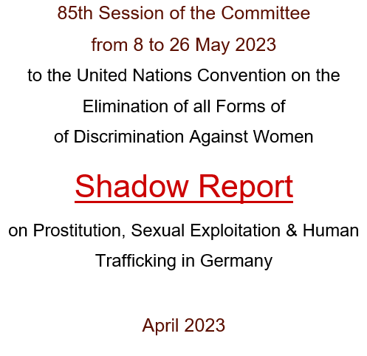

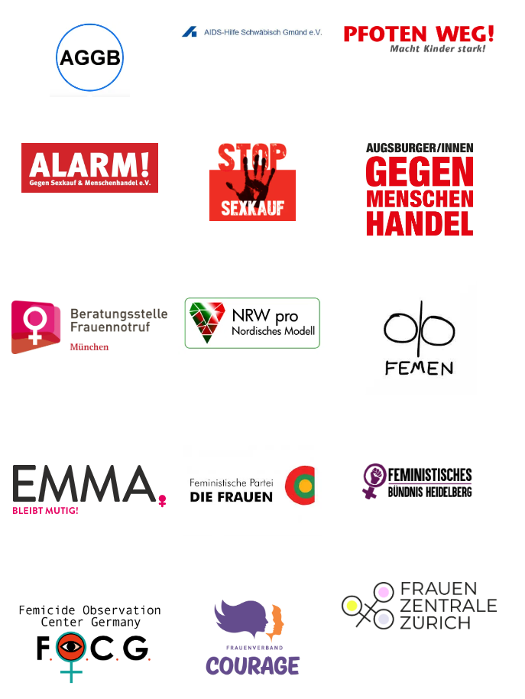

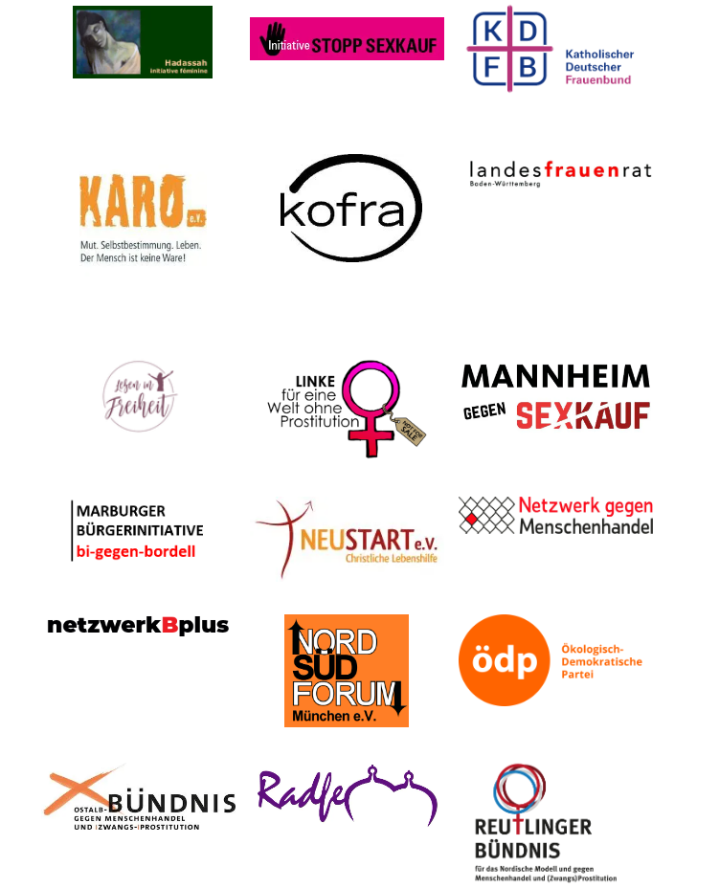
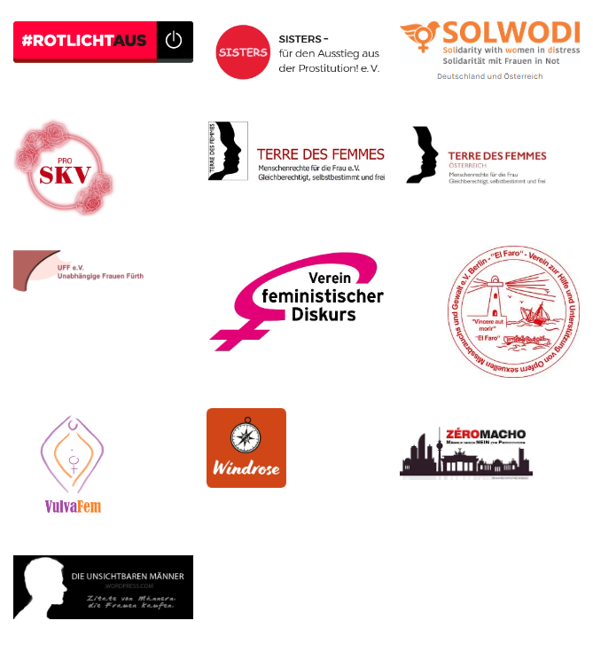

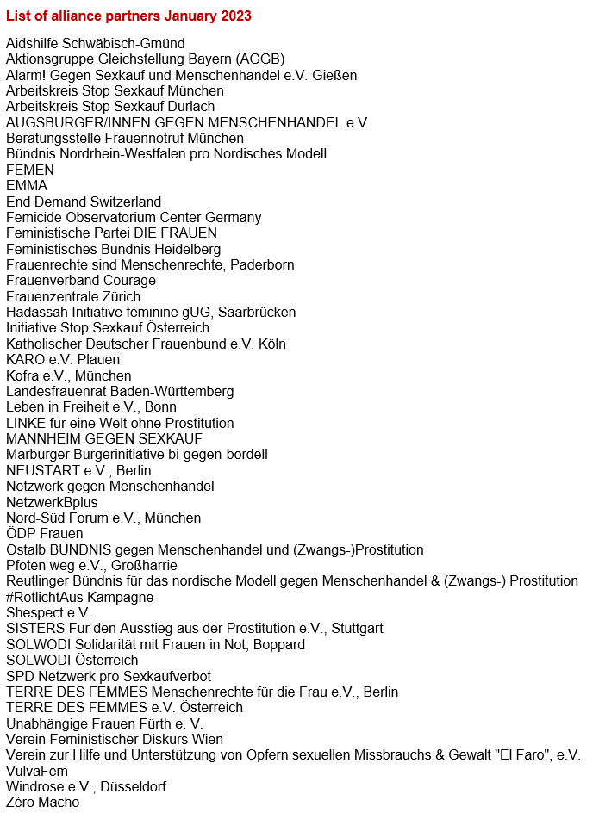

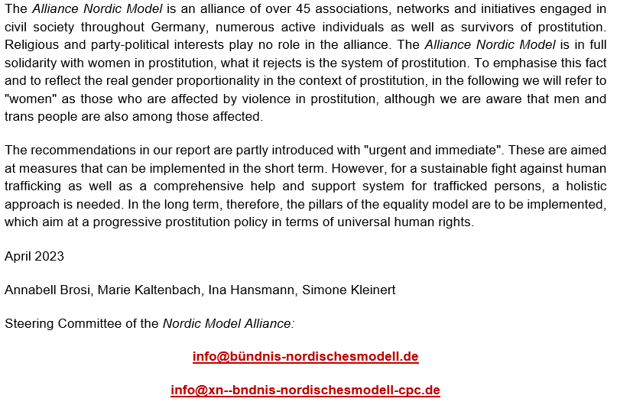

Table of contents
Introduction 2
Legislation 2
1. Prostitution as gender-based violence against women (11 LoIPR) 2
A Prosecution of violence against women in prostitution (11b) 3
B Digital violence and discrimination, sex buying webpages, John forums (11g) 4
2. Prevent demand, Art. 6, GR 38, 12 LoIPR 4
A Germany - destination country for human trafficking 5
B Prostitution premises as places of trafficking 6
(1) Prostitution premises conceal human trafficking 6
(2) Prostitution premises promote human trafficking 6
(3) Prostitution premises: Sexual exploitation without state care 7
C Human trafficking 2.0 - New ways of sexual exploitation 8
D Trafficking for the sexual exploitation of minors and young adults 8
3. Ensure prosecution of trafficking in human beings, 12b)LOIPR 10
A Lack of victim statements, low convictions, suspended sentences 10
B Victims in criminal proceedings 11
4. Identification of victims and those at risk, 12c)/d)LOIPR 12
5. Victim and vulnerable health, 12d)LOIPR 13
A Physical 13
B Psychic 13
6. Evaluation of penal provisions on trafficking in human beings, 12f)LOIPR 14
A Prosecution: poor 14
B Punishment of knowing use: ineffective 16

Introduction
This report describes the impact of German legislation in the context of prostitution. We report on the violence experienced by people in prostitution, the impact on trafficking for sexual exploitation and the health consequences for women in prostitution. Germany has 20 years of experience in trying to regulate prostitution.
One affected person describes the path Germany took in 2002 as a mistake - unworthy of human beings and exploitative. She says: "...because that makes it totally easy for the operators, the customers and everyone who earns money with it. I also don't believe that if buying sex is criminalised, it will disappear underground, because this underground already exists today."

Legislation
Since the Prostitution Act came into force in 2002, Germany has promoted human trafficking insofar as the legalisation of the prostitution market has created optimal conditions for sexual exploitation and, as a result, the demand for prostitution has increased. In 2007, the Federal Government admitted that the goals of the Prostitution Act had not been achieved. In 2017, the Act on the Regulation of the Prostitution Trade and the Protection of Persons Engaged in Prostitution - Prostitution Protection Act (Prostituiertenschutzgesetz, ProstSchG) was introduced, which was intended to regulate the prostitution market by, for example, requiring prostitutes to register or requiring prostitution premises to obtain licences. The evaluation of the penal provisions to combat human trafficking, which were reformed in 2016, has been completed. The reform has failed. The current evaluation of the Prostitution Protection Act runs until 2025. 23,743 prostitutes were registered with authorities at the end of 2021. Thus, almost 90% of an estimated 200,000 prostitutes are working in the so-called dark field. Often, prostitution premises do not have a permit.

Prostitution as gender-based violence against women (11 LoIPR)
Prostituted women experience much more violence compared to the general female population :
92% experience sexual harassment
87% physical,
82% psychological and
59% sexual violence
The very high psychological stress in this respondent group is illustrated by the finding that half of the respondents had frequent or occasional signs of depression, a quarter had suicidal thoughts, almost a third had anxiety attacks or panic attacks and about one in seven had self-harm intentions.
Overall, a high consumption of medication is visible. Thus, 67% of the women had taken painkillers, 38% sedatives, 37% sleeping pills, 34% antidepressants, 19% stimulants and 10% other psychotropic drugs in the last 5 years. Especially in the area of psychotropic drugs, this subpopulation proportionally consumed drugs two to three times more often, in some cases many times more often, than the respondents of the main survey. Drugs had been taken by 41% of the prostitutes interviewed in the last 5 years; this was stated by only 3% of the respondents of the main investigation.

Pimps provide drugs to women for pain relief, staying awake, and dealing with customers in nightclubs. Heroin and drugs are used to calm down and as painkillers, while cocaine and amphetamines help with endurance.
Our alliance partners unanimously confirm that the majority of women have experienced violence.
Prostitution is a system in which violence is inherent:
- Prostitution is part of a long patriarchal tradition of making the female body available for the benefit of men.
- The vast majority of prostituted women have suffered violence, often of a sexual nature, before entering prostitution.
- The vast majority of women experience forms of male violence (physical, verbal, sexual, psychological).
- Repeating sexual acts several times a day, mostly on young women, without physical desire, is sexual violence. Men take advantage of women's financial and social need.
- Johns in Germany have been exploiting inequality of women, their experienced violence, financial and social hardship legally and illegally for 20 years.
- Prostitution exploits multiple forms of inequality: the domination of men over women, the rich over the poor, the North over the South, majority groups over minorities.
- Discriminated minorities and migrant groups are overrepresented in prostitution in Germany as everywhere else in the world.
- The prostitution system feeds and perpetuates human trafficking for the purpose of sexual exploitation.
- Prostitution is a social obstacle on the way to a free, respectful and egalitarian society.

Prosecution of violence against women in prostitution (11b)
Germany does not ensure that violence against women in prostitution is effectively investigated, nor that perpetrators are properly punished. This is due to a flaw in the system, which basically assumes the voluntary nature of prostitutes when payment is arranged. Trafficked women report that they show no resistance when clients do not keep appointments and become violent: "I knew exactly that if I resisted, he would think it was cool and go on even more."
For various reasons, women in prostitution do not report sexual violence (lack of registration according to § 3 ProstSchG, tax evasion, lack of residence permit, prostitution in a restricted area - § 184f StGB). The decriminalisation of prostitutes and the criminalisation of clients would counteract this.

Digital violence and discrimination, sex buying webpages, John forums (11g)
Webpages for arranging sexual acts against payment treat women's bodies like a commodity that can be assembled and offer a corresponding configurator for this purpose:
Skin colour | Nationality, ethnic origin
Hair colour | Cup size
Size | Butt size
Weight | Pubic hair
Every practice can be ordered -also "AO" (without condom).
John forums are internet sites where suitors exchange information about individual women and evaluate them. Often there are extremely discriminatory, violent, insulting or objectifying descriptions that are deeply misogynistic, racist, sexist, inhuman and trivialising of violence.
Recommendations
The federal government should conduct an investigation of the free forums regarding
- criminal content and
- effects on the women and men concerned
- commission and develop a legal solution to stop such free forums.

Prevent demand, Art. 6, GR 38, 12 LoIPR
The Federal Criminal Police Office (BKA) assumes that there is a very large number of unreported cases in the area of global human trafficking to Germany. With regard to combating human trafficking for the purpose of sexual exploitation, the Prostitution Protection Act has a counterproductive effect.
Liberal prostitution legislation leads to more trafficking. "It is often assumed that legal sex for sale could reduce human trafficking because there would then be more prostitutes legally living in a country. However, our study points to the opposite," explains Axel Dreher, University of Heidelberg. "The data show that more cases of human trafficking are recorded in countries where prostitution is not prohibited by law." The researchers see one possible reason in the fact that less strict prostitution laws lead to an expansion of prostitution, which also increases the number of forced prostitutes working in that country. Germany has even chosen a path that has the opposite effect. We describe this in the following five sections (A - D).

Germany - destination country for human trafficking
The annual turnover of the prostitution industry in Germany is estimated at 14.5 billion euros per year. The vast majority of prostituted women in Germany (80-95%) are migrants, often from discriminated population groups within the European Union.
"The accession of ten Eastern European countries to the EU in 2004 and especially Romania and Bulgaria in 2007 caused hundreds of thousands of young women from these countries to flow uncontrollably into prostitution in Germany, which fundamentally changed the conditions in the milieu. Decisive factors were on the one hand the economic poverty in the home countries, the new right to freedom of movement including freedom of premises and a huge army, a veritable reservoir of girls and young women from Southeast Europe, with whom the brothels in Germany could be filled," explains Helmut Sporer, retired senior criminal councillor.
It is always the most vulnerable and discriminated against in society who are found in prostitution. Young people from the poorest regions of other countries quickly become victims of sexual exploitation when traffickers promise them a "job" in Germany.
There are stable structures of organised crime of Nigerian perpetrator groups in Germany. The statistical analysis of the Federal Situation Reports shows that the number of Nigerian suspects has continuously increased in Germany from 2015 to 2019, especially in human trafficking for sexual exploitation. In Nigeria, the traffickers' networks ensure that a forced prostitute really goes into prostitution by threatening her relatives. The traffickers do not have to fear prosecution for this. Europe's prosecutors are far away.
Sandra Schmidt, Professor of Security Agency Operations Management and Leadership Science, comments on a large-scale raid in the context of investigations against human traffickers and smugglers from Vietnam in January 2021: "Smuggling is organised crime. It is difficult to get to the actual masterminds. It is very difficult to shed light on the structures. It is inhumane and catastrophic, there is no other way to describe it. Young women who hope for a better life are simply enslaved. They become identity-less slaves in Germany."
Recommendations
- The federal legislator should look at the practical problems realistically and place prostitution and trafficking in human beings in a direct context by law.

- The federal legislator should immediately and urgently fulfil its state duty of care and replace the term "sexual service" in the Prostitution Protection Act with "prostitution", irrespective of the evaluation of the Prostitution Protection Act. Sexual service, sex work, sex worker, client, guest, etc. are misleading terms that conceal the violence in prostitution and the serious consequences for those affected.
- Federal legislators should involve the following experts: Survivors of prostitution and trafficking for sexual exploitation; organisations calling for a rethink of prostitution policy
- The federal government should set up an observatory on organised crime in the environment of prostitution, in which suspected cases are systematically recorded;
- The federal government should pursue a holistic change of direction in prostitution policy instead of pinprick policy.

Prostitution premises as places of trafficking
Prostitution premises in Germany are to a large extent involved in human trafficking and sexual exploitation or accept them recklessly or even deliberately, taking into account their own profit increase.

Prostitution premises conceal human trafficking
In 2020, according to the BKA (Federal Criminal Police Office), 291 out of a total of 465 trafficking investigations involved sexual exploitation, and every fifth trafficked person was regularly registered under the Prostitution Protection Act. Human trafficking and exploitation consequently take place within the framework of legal prostitution. These places of exploitation are licensed prostitution sites such as brothels or appointment flats. Legalising places of prostitution does not prevent trafficking in human beings and does not contribute to more effective investigations into trafficking in human beings. On the contrary, controls by law enforcement agencies are made more difficult by the basic legality of the premises.

Prostitution premises promote human trafficking
We are particularly critical here of how operators of prostitution premises design and advertise their "offer" in order to constantly generate demand, make and increase profits:
- Frequently changing "offer" of women
- young women (the more and younger the more profit)
- different types advertised along racist attributions ("exotic", "Eastern European", "Latina"...)
- different skin types ("light", "black", "brown")
- different body characteristics (bust size, hair, ...)
- different sexual practices etc.
The "Paradise Trial", which led to the convictions of an operator and his employee for aiding and abetting human trafficking in one of the "showcase brothels" in Germany, deserves special mention.

According to the presiding judge, those responsible for a brothel are criminally liable if, with their approval, traffickers and pimps send women to the brothel to engage in prostitution. Moreover, he emphasised, "A clean brothel of this size is hardly imaginable." Rudloff, as the brothel operator, admitted in court that he had not been able to get his rooms full with prostitutes working voluntarily, so he had to cooperate with rock gangs. The red-light milieu is also closely interwoven with organised crime in Germany. When the financial pressure increases, the scene offers illegal ways and means. The danger is very high that criminal networks such as rocker clubs and clans will be resorted to.

Prostitution premises: Sexual exploitation without state care
Prostitute women are not employed. Exorbitant room rents of 150€/day allow brothel operators to earn a lot of money. Brothel operators refer to the self-determination of the prostitutes. Reliable control mechanisms to prevent exploitation are not even conceivable in this concept, which is based on exploitation.
Recommendations
Federal, state and local governments should:

- Draw up transitional concepts for the abolition of prostitution premises and streets and adopt necessary legal amendments (e.g. do not designate any new areas for prostitution according to Art. 297 EC Criminal Code, do not approve any new prostitution premises).
- Allow municipalities and communities to prohibit prostitution premises in the entire city or community area, regardless of the number of inhabitants.
- Immediately and urgently prohibit advertising for prostitution premises
- Take care and intervene responsibly if there is evidence that a woman in prostitution is being influenced by a third party, even if the woman says she is acting voluntarily.

Human trafficking 2.0 - New ways of sexual exploitation
Traffickers use digital means of communication and payment. More and more, the initiation of prostitution is shifting into the digital space. The State Criminal Police Office of Lower Saxony warns against social networks: "There, the perpetrators immediately see the photos of the victims and search almost specifically as in a catalogue." The victims are getting younger and younger. Often they are filmed. Modern face apps allow perpetrators to disguise their appearance in live video (for example, gender and age).
Recommendation
- The Confederation should urgently and immediately examine what strategies are to be taken to prevent persons seen engaging in sexual acts in the digital space from being victims of trafficking for sexual exploitation, pimps and loverboys.
- The criminal investigation departments of the Laender are to set up specialised departments that specifically search Internet sites for dialogues that indicate human trafficking for sexual exploitation and child sexual abuse for money.

D Trafficking for the sexual exploitation of minors and young adults
The number of minors affected by commercial sexual exploitation is increasing every year, according to the BKA. For many victims of human trafficking, sexual exploitation begins in childhood.
Children grow up in a society where consent to sexual acts can be bought. Dealing with prostitution in Germany is a completely wrong approach if you want to prevent child sexual abuse or enable healing for those affected.
According to the BKA, every third investigated victim of human trafficking for sexual exploitation was under 21 in 2021. Franziska Kramer, officer in charge at the BKA for combating human trafficking and exploitation of minors in "forced prostitution" reports that young women from all walks of life become victims. Mostly, the traffickers, pimps and loverboys would organise the linking on the portals. "There are platforms where minors offer themselves to earn so-called pocket money. The exploitation of minors in particular has increased enormously. It has become much easier for the perpetrators. Before, they had to stand in front of the school or approach someone in the discotheque. Spend the whole evening with someone. Today they can write to 10, 20 girls at the same time via Instagram."

The BKA reports: "In the case of a good third of underage victims, the initial contact was made via the internet, especially via relevant platforms, chats, online games and social media."
The "cloak of invisibility" of German prostitution laws therefore hides not only traffickers and pimps, but also abusers.
Many of the women were not yet of age when they entered prostitution. Committed people who educate schools about the Loverboy method report that they are confronted with victims at every school.
It is difficult for the police to intervene because of the laws in place. "What should the police do if the girl says during a police check: "No, I'm just standing here waiting for someone?"
German laws trivialise the prostitution system and endanger minors and young adults.
Recommendations
- The Federal Government should immediately and urgently initiate and permanently finance comprehensive education campaigns about the lover boy method at all levels, federal, state and local. Children, parents and educators should be made aware of the loverboy method and the harmful consequences of prostitution.
- Laender and municipalities must immediately and directly oblige their schools on a permanent basis to integrate education about the new methods of lover boys into lessons at regular intervals and to offer it to guardians.
- Legislation should criminalise soliciting for prostitution by means of pretended love from the beginning of the deceptive act.
- The legislator should punish johns in general and provide for higher penalties if the victim is under 21.
- Law enforcement authorities must be better enabled to actively investigate. In the case of cybergrooming, the intention of the perpetrator is already to be punished. The penalty must be significantly higher if payment is offered for a sexual act. Perpetrators are to be punished even if they state that they were mistaken about the age.
- Relevant internet sites where minors can easily overcome the access barriers must be closed immediately and urgently.
- The federal, state and local governments should choose clear language . Terms like "young people in prostitution or child prostitution" should no longer be used from now on.

Ensure prosecution of trafficking in human beings, 12b)LOIPR
Germany has increased demand and therefore has a special obligation to ensure that cases of trafficking for sexual exploitation are prosecuted. The opposite is the case. The number of cases of human trafficking recorded annually by the Federal Criminal Police Office has been declining for years, but according to the analysis by Helmut Sporer, retired senior criminal counselor, the official case figures do not reflect reality in any way:
"If one takes a mathematical average of 300,000 prostitutes and assumes that only half of them do not work voluntarily and are therefore mostly victims, this results in a figure of 150,000 victims in prostitution. In relation to the 406 registered victims from the Situation Report 2020, this means that arithmetically just about 0.3 per cent of the victims are recognised and registered." The state is not sufficiently fulfilling its responsibility. It does not provide effective instruments against human traffickers. This means that the current system does not work.
Crimes are not reported. Investigations are very time-consuming. Judicial authorities are overburdened. Penalties are low.

Lack of victim statements, low convictions, suspended sentences
Few of those affected make a statement. They fear violence against themselves or family members, stigmatisation, re-traumatisation, publication of photos and film material by the perpetrators on the internet, repeated interrogations, long trials. Perpetrators have victims taken abroad and thus hinder police investigations. Victims who develop any victim awareness at all in the German prostitution system are prevented from contacting the police and public order offices by additional means of pressure.
Of the convicted traffickers, the majority received suspended sentences.
According to the BKA, the risk of acquittal for lack of evidence is quite high if the witnesses do not testify personally in court about what they have experienced: "Currently, it is still almost essential that victims of human trafficking also testify personally in court. Since negotiations are difficult without testimonies of trafficked persons, it may have serious consequences for the main trial if (victim) witnesses do not appear at the trial or refuse to testify in court for other reasons:
- Often, the court refuses to open the main trial due to a lack of suspicion, as important prosecution witnesses are no longer available.
- The defence lawyer can also object to the reading of the previous statement according to the Code of Criminal Procedure.
- Contradictions, for example with earlier statements to the police, can no longer be clarified.
- The court cannot form an impression about the credibility of the witness".

Victims in criminal proceedings
Victim statements are often insufficient and circumstantial evidence is not always accepted in court. Perpetrators' presence intimidates victims and their experiences of violence make it harder to qualify their testimony as credible. Law enforcement is not adequately trained to handle severe sexual violence, and dissociation is a common protective response. Dissociation is a common automatic protective mechanism of the body during sexual violence. Contradictory statements, sudden gaps in memory or attention deficit disorders are not signs of untruthfulness in victim-witnesses of this kind of violence, but a consequence of their dissociation.
The German Code of Criminal Procedure lets lawyers prolong proceedings, leading to offender-friendly deals. Victims face long waits and cannot start therapy due to credibility concerns. Even underage girls are advised against therapy during trial.
In many parts of Germany, the judiciary is working at its capacity limit. The shortcomings have been known to the government for a long time. Referring to the "Pact for a State under the Rule of Law" adopted at the beginning of 2019, the Federal Chairman Ulrich Silberbach of the German Civil Servants' Association and Collective Bargaining Union (dbb) said at the end of 2022: "The judiciary and the administration of justice are chronically overburdened".
Recommendations
The federal legislature should
- urgently and immediately decriminalise prostitutes;
- urgently and immediately repeal the punishability under § 184 f StGB for prostitutes and provide exclusively for the punishment of johns in restricted areas;
- urgently and immediately change the subjective burden of proof to objective proof, so that an accused pimp or trafficker has to provide counter-evidence for the existence of exploitation and abuse alleged by an alleged victim within the framework of existing criminal laws;
- Implement a new method of victim interviewing that corresponds to the situation of traumatised witnesses and regular training and further education for police and judicial officers;
- take appropriate account of the special situation of victim-witnesses in the Code of Criminal Procedure and, in particular, ensure that necessary therapies for victim-witnesses do not constitute an obstacle to criminal prosecution;
- Consider a higher sentence for human traffickers.

Identification of victims and those at risk, 12c)/d)LOIPR
In Germany, persons trafficked for the purpose of sexual exploitation are prevented from perceiving themselves as victims:
- because they basically move in a society where buying sex is exempt from punishment and where terms like "sex work", "clients", "sexual service" etc. prevail or where even, for example, safety is advertised, although it is known to the experts that it is sex buyers who commit additional violence against women in prostitution;
- because the boundaries between legal and illegal only exist in theory in legal texts;
- because persons trafficked for the purpose of sexual exploitation cannot identify themselves as victims or even know that they are victims under German criminal law;
- because those affected perceive prostitutes in their environment who are purely outwardly no different from them and do the same as they do themselves;
- because determining whether the offence of trafficking for sexual exploitation or forced prostitution has been committed requires years of litigation and painstaking detail work by lawyers, criminal investigators and expert witnesses. How is a trafficked person supposed to trust that justice will be done?
- because pimps/loverboys in particular use the legal situation in Germany as an argument to exploit very young victims for years: "He said that everything was normal. That is the key word: normality. Prostitution is normal and a job like any other.
- because profiteers of the sex industry claim that the number of victims of human trafficking and forced prostitution is declining or stable, although the Federal Criminal Police Office, for example, points out the high number of unreported cases every year. "I thought that prostitution is legal in Germany and therefore it can't be a bad thing," Marietta Hageney (SOLWODI Baden-Württemberg counselling centre) quotes a trafficked person and continues: "...the reality was different. She was brutally raped several times and was told what she had to do now.

Recommendations
The federal, state and local governments should
- Provide sufficient and sustainable funding for specialised counselling centres on a long-term basis, rather than on a project basis.
- Consult and promote domestic organisations of prostitution survivors so that their expertise can be used to identify victims.
- develop sensible alternative solutions to the current registration under the Prostitutes Protection Act.
- Develop concepts that make it easier for the high number of undetected victims of human trafficking for sexual exploitation in Germany to recognise themselves as trafficked persons.
- develop concrete factual evidence of coercion, violence, abuse of power, exploitation of weakness or inequality;
- Investigate situations and circumstances where, despite the absence of the above indications, exploitation and coercion to perform sexual acts could be present (e.g. in the psyche: dissociation, programming, learned helplessness, etc.).
- Train and sensitise police and judicial authorities, counselling centres so that terms such as "sex work", "clients", "sexual service" are avoided in the environment of potential trafficked persons - i.e. when dealing with prostitutes in general.
- Develop a strategically effective nationwide approach to human trafficking for sexual exploitation and implement the OSCE recommendations.

Victim and vulnerable health, 12d)LOIPR
More than 80% of prostituted women in Germany come from precarious backgrounds and do not have health or social insurance. Specialist counselling centres report on the poor health of many women for whom no official medical care is provided. Most of the prostituted women have suffered massive violence in their past and have learned to dissociate.

Physical
STIs (gonococci, chlamydia, trichomonas, condyloma, syphilis, hepatitis, HIV) due to forced condom waiving by the clients.
Tears, overstretching, fissures in the vaginal and anal area; cystitis; pelvic floor insufficiencies with urinary/ faecal incontinence;
Inflammation of the internal organs, especially the fallopian tubes;
unwanted pregnancies;
destroyed intestinal flora, thus a weakened immune system (due to frequent enemas and laxatives for the purpose of bowel evacuation, vomiting induced by oral sex practices;
mental disorders, including eating disorders;
multiple and severe pains all over the body;
Sleep disorders due to the 24/7 rhythm; stress anxiety
heavy alcohol, drug and medication use.

Psychic
Enormously high psychological stress, accompanied by disgust, shame, fear and aversion. Survival strategies are: dissociation (an emergency mechanism that leads to numbness, indifference and absence of pain), perpetrator introjection or perpetrator identification (thought and behaviour patterns of the perpetrator are adopted). Almost all women in prostitution suffer from trauma sequelae : such as complex post-traumatic stress disorder (cPTSD), (the main symptoms are: chronic overexcitement, flashbacks, avoidance behaviour, apathy, emotional numbness and general loss of interest), depression, anxiety and panic disorders, somatisation, compulsions, addictions, suicidal ideation. Furthermore, sexual disorders and relationship disorders.
Recommendations
The federal government should seek advice from doctors, trauma psychologists and therapists at hearings on prostitution.
The federal government, states and municipalities should educate society about violence in prostitution, the effects on physical and mental health and about the reenactment of sexual violence experiences in prostitution.

Evaluation of penal provisions on trafficking in human beings, 12f)LOIPR
The reformed penal provisions that came into force in 2017 are ineffective according to the evaluation of the Criminological Research Institute of Lower Saxony. For example, 83% of the investigative proceedings investigated were dropped. Only 11-14% of the offenders were convicted. Therefore, in June 2022, the justice ministers of the states held out the prospect of a further "holistic" reform of the entire regulatory area. However, due to the evaluation of the Prostitution Protection Act, for which the Ministry of Family Affairs is responsible, there is a standstill until mid-2025. Urgent "holistic reforms" to combat trafficking in human beings for the purpose of sexual exploitation can thus not be launched by the Ministry of Justice.

Prosecution: poor
Due to the legal regulation of prostitution, the investigative approaches have shifted from classical criminal law to labour law, social law or tax law. The conviction rates are low. Human traffickers do not take any risks in Germany. Police investigations in Germany's red-light districts have become more difficult since 2002. Human trafficking is a control crime. Prof. Yvette Völschow has coordinated a research project on human trafficking and interprets the low figures in the federal situation report on human trafficking as follows: "If the capacities of a personnel nature are either not there or not so strongly deployed in the area, then you don't find so many cases." Stefan Willkomm, public prosecutor's office Düsseldorf - special department of organised crime, reports the same: "It is also noticeable in other public prosecutor's offices that where certain colleagues are committed, more cases are carried out."

Since very few prostitutes are registered under the Prostitutes Protection Act, the regulatory and police authorities do not have the overview that the legislators had hoped for in order to combat human trafficking.
Law enforcement is a challenge. The procedures often require cross-border cooperation and are lengthy. The police of North Rhine-Westphalia report: "Telephone surveillance is initiated, thousands of conversations in Pidgin English or the Bini language are evaluated. Interpreter costs soon amount to over 300,000 euros." When cooperating, it must be borne in mind that corruption is sometimes very widespread in the countries of origin or people could be seriously threatened. It is therefore not expedient for German politicians to continue to block urgently needed legal reforms in the direction of the Nordic Model by pointing to a lack of cooperation in the countries of origin. It has become known that a particularly large number of victims are brought to Dresden for sexual exploitation from the region of Jambol in Bulgaria. The public prosecutor's office in Jambol confirms that the official figures are "quite low" and assumes "a much higher number of unreported cases".
The President of the State Criminal Police Office of Baden-Württemberg, Andreas Stenger, who knows the red-light scene and has himself investigated sexual exploitation for years, says that milieu-specific criminality cannot be curbed by legalising the trade: "Basically, we need the statements to get to the people behind the scenes who earn the really big money from the misery and misery of these women, and of course that has not become easier for us with the Prostitution Act."
Those affected are not recognisable and fear police and regulatory authorities. It is often not possible for aid organisations to build up relationships of trust. The women are moved from town to town and are not in one place for long.
Criminal defence lawyers specialise in human trafficking. A suspect can easily avoid a conviction due to lack of knowledge about the victim's age. A current example of criminal proceedings against human traffickers, which have been conducted at the Regional Court of Dresden for approximately two years, shows that defence lawyers are familiar with the particular difficulties of presenting evidence and are skilled in trial tactics. In November 2022, one of the two defence lawyers suddenly and unannounced resigned. The second defence lawyer requested that the proceedings be terminated and rescheduled. His client could not be adequately defended by him alone. The court should therefore, if it does not terminate the trial, repeat witness examinations from the first year. This would mean that injured parties from Bulgaria would have to be brought in again for questioning. The lawyer of another accused confirms that she still procures women. Everything is reported and legal. According to the Dresden Regional Court, her economic activities have not been restricted.
Ultimately, the aforementioned shortcomings have been confirmed in the evaluation of the penal provisions against human trafficking.

The past 20 years have shown that it is not possible to balance the interests of the prostitution industry and the fight against human trafficking for sexual exploitation. Germany turns a blind eye to its share of responsibility and does not give enough priority to combating human trafficking. There is a lack of data collection, staff and resources at law enforcement agencies.
In 2023, the networks of human trafficking in Germany are still not confronted with a suitable instrument for prevention and prosecution. Measured against the extent of the problem, the activities of the Federal Government are absolutely insufficient. There is an acute need for action, as human trafficking and sexual exploitation is not only a serious crime, but also a grave violation of human rights that must not be tolerated a day longer.

Punishment of knowing use: ineffective
Punishing a john for sexual acts against victims of trafficking for sexual exploitation or forced prostitution is theoretically possible in Germany under the conditions of Section 232a (6) of the Criminal Code (StGB). The Criminological Research Institute of Lower Saxony (KFN) evaluated the criminal provision in its version of October 2016 and found that "the risk for a john to be prosecuted for an offence under section 232 a) paragraph 6 sentence 1 StGB is close to zero." The OSCE comes to the same conclusion. "In Germany, between 2017 and 2019, there was a single investigation under Section 232a of the Criminal Code (forced prostitution), but over 330 victims were identified in the same period. “The knowing use statue is not an effective tool to reduce demand,“ says Valiant Richey, OSCE Special Representative and Co-ordinator for Combating Trafficking in Human Beings.
The evaluation of the KFN was completed in September 2021. Shortly afterwards - in October 2021 - the requirements for punishing johns were slightly tightened in para. 6. The law now also punishes recklessness. Theoretically, clients who carelessly overlook the fact that a victim is being trafficked can now also be punished. Against this tightening, two johns, supported by the Bundesverband sexuelle Dienstleistungen e.V. (BesD), filed a constitutional complaint with the Federal Constitutional Court on 2 June 2022. This is another sad low point of the negative effects of the legalisation of sex buying in Germany. The legalisation of prostitution has changed the self-image of the johns. They see themselves entitled by the prostitution laws as "customers" who "only" use a "sexual service".
So far, it has not been shown that the tightening up on "careless" overlooking has had any effect. Even the BKA writes on the recognisability of victims of human trafficking for the purpose of sexual exploitation by criminal investigators: "Whether the existence of human trafficking is recognised depends essentially on the knowledge and sensitivity of the responsible officers for the offence of human trafficking as well as on the target of the police measures. It requires a high degree of sensitivity to recognise whether a young woman or man is working as a prostitute on her own or under duress ..."

Recommendations
The federal government and the federal states should work towards
- special departments are set up at criminal justice agencies and budget plans are increased;

- the justice ministries at the federal and state levels pursue legislation modelled on the Nordic Model or the Equality Model in the fundamental reorientation of penal provisions.

Hereinafter referred to only as trafficking in human beings
Docu February 2021 "Out of prostitution - Nadine wants to get out" Minute 43:30 https://youtube.com/watch?v=Z3JLUip2t0g&si=EnSIkaIECMiOmarE
bericht-der-br- zum-prostg-broschuere-deutsch-data.pdf (bmfsfj.de) p. 80
https://www.gesetze-im-internet.de/prostschg/BJNR237210016.html
In Germany there are many different premises for prostitution (brothels, brothel flats, running houses, caravans etc.). The ProstSchG uses the generic term "prostitution premises".
See paragraph 6
https://www.destatis.de/DE/Themen/Gesellschaft-Umwelt/Soziales/Prostituiertenschutz/_inhalt.html
BMFSFJ: Living situation, security and health of women in Germany; 2004 https://www.bmfsfj.de/blob/84328/0c83aab6e685eeddc01712109bcb02b0/langfassung-studie-frauen-teil-eins-data.pdf
Dr Heike Zurhold https://www.psychologie-aktuell.com/news/aktuelle-news-psychologie/news-lesen/prostitution-kokain-und-amphetamine-erleichtern-die-sexarbeit.html
https://dieunsichtbarenmaenner.wordpress.com/tag/sex-buyer/
https://www.bka.de/SharedDocs/Downloads/DE/Publikationen/JahresberichteUndLagebilder/Menschenhandel/menschenhandelBundeslagebild2021.html - page 26
https://www.emma.de/artikel/der-ermittler-337507
https://www.uni-heidelberg.de/presse/news2013/pm20130527_prostitution.html
Ver.di trade union estimate: https://www.spiegel.de/video/mit-prostitution-werden-in-deutschland-14-5-milliarden-euro-umgesetzt-video-1286781.html
Sporer, Helmut: Der neue Deutsche Weg, Für eine Neuordnung der Prostitutionsgesetzgebung, Hanns-Seidel-Stiftung, in Aktuelle Analyse 93
http://www.cap-international.org/campaigns/parliamentarians/
Körffer, Enya, detective superintendent at the BKA, Meckenheim, Kriminalistik 2021, pp. 373-377 "Human Trafficking in the Middle of Europe" https://youtube.com/watch?v=LhgCULUw_b0&si=EnSIkaIECMiOmarE
https://www.amnesty.de/informieren/amnesty-journal/nigeria-mafia-madames-und-maedchen#:~:text=80%20percent%20of%20Nigerian%20women,the%20procedures%20last%20most%20years.
"Bild accompanies major raid against unscrupulous human traffickers" https://youtube.com/watch?v=cQWBD078o1A&si=EnSIkaIECMiOmarE https://www.hwr-berlin.de/hwr-berlin/ueber-uns/personen-von-a-bis-z/2112-sandra-schmidt/ minute 5:00
our alliance partners as well as GESTAC, Network Ella, DIAKA (https://www.ge-stac.com, https://netzwerk-ella.de; https://www.diaka.org)
BKA Bundeslagebild 2020, page 5 and 11 https://www.bka.de/SharedDocs/Downloads/DE/Publikationen/JahresberichteUndLagebilder/Menschenhandel/menschenhandelBundeslagebild2020.pdf?__blob=publicationFile&v=4
cf. BKA 2021: Bundeslagebild Menschenhandel und Ausbeutung 2020. https://www.bka.de/DE/AktuelleInformationen/StatistikenLagebilder/Lagebilder/Menschenhandel/menschenhandel_node.html
Stuttgart Regional Court, judgment of 26.02.2019 - 7 KLs 200 Js 115430/13; https://landgericht-stuttgart.justiz-bw.de/pb/,Lde/Startseite/Aktuelles/Urteil+im+_Paradise-Prozess_/?LISTPAGE=1195716 STPAGE=1195716
The "Paradise" as hell: A lawyer on the trial against the "brothel king" - FOCUS online
Minute 29:50 SWR Docu: Illegal prostitution the dangerous business with sex https://www.youtube.com/watch?v=43phPZzoydE&t=1778s
www.welt.de/vermischtes/video226584857/Loverboy-Falle-Instagram-LKA-Niedersachsen-warnt-vor-Masche-in-sozialen-Netzwerken.html
Chief Public Prosecutor Camelia Stoina from Bucharest Minute 32:30 SWR Doku: Illegal prostitution the dangerous business of sex https://www.youtube.com/watch?v=43phPZzoydE&t=1778s
Page 11 https://www.bka.de/SharedDocs/Downloads/DE/Publikationen/JahresberichteUndLagebilder/Menschenhandel/menschenhandelBundeslagebild2021.html?nn=27956
Documentary from 2021 "Via Chats into Prostitution" https://youtube.com/watch?v=k0XVrcimqL8&si=EnSIkaIECMiOmarE
https://michaela-huber.com/wp-content/uploads/2021/02/nzz-dissoziative-identitaetsstoerung_test.pdf https://www.pfoten-weg.de/motivation/ziele
https://www.bka.de/DE/Presse/Listenseite_Pressemitteilungen/2022/Presse2022/221007_BLBMenschenhandel.html#:~:text=Victims%20of%20sexual%20exploitation%20were%20with,increased%20in%20the%20reporting%20year%20strongly%20.
from minute 22:00 https://www.zdf.de/funk/ultraviolett-stories-12250/funk-missbrauch-im-netz--und-keiner-hilft-102.html
a current example from an ongoing process in Bavaria https://www.traunsteiner-tagblatt.de/region/nachrichten-aus-bayern_artikel,-zwangsprostitution-und-missbrauch-opfer-will-reden-_arid,764520.html File number: 1 KLs 8 Js 14058/21 The judge insisted on the victim testimony
More shocking quotes from john forums, researched by our alliance partner Elly Arrow: https://dieunsichtbarenmaenner.wordpress.com/tag/minderjaehrig/ https://programm.ard.de/TV/Untertitel/Nach-Uhrzeit/Alle-Sender/?sendung=281084000083447
https://liebe-ohne-zwang.de/de/ Loverboys: Between Love and Human Trafficking" February 2018 https://youtube.com/watch?v=gAmAh10byTM&si=EnSIkaIECMiOmarE
Specialist Counselling Centre in Loverboys: Between Love and Human Trafficking" February 2018 minute 20:30 https://youtube.com/watch?v=gAmAh10byTM&si=EnSIkaIECMiOmarE
https://www.terminologie.ecpat.de/leitfaden-fuer-angemessene-sprache/begriffs-check/
Kriminaloberrat (retired) Helmut Sporer in "Der neue Deutsche Weg" 2022, page 42 https://www.hss.de/publikationen/der-neue-deutsche-weg-pub2284/
Kriminaloberrat (retired) Helmut Sporer in "Der neue Deutsche Weg" 2022, page 43 https://www.hss.de/publikationen/der-neue-deutsche-weg-pub2284/
Sporer, Helmut, Augsburg senior criminal councillor (ret.), responsible for "organised crime", in https://www.emma.de/artikel/der-ermittler-337507
see previously Art. 10
See paragraph 1A
https://de.usembassy.gov/de/laenderberichte-zu-menschenhandel-2020-bundesrepublik-deutschland/ https://de.statista.com/themen/5938/menschenhandel-in-deutschland/
https://www.bka.de/DE/IhreSicherheit/RichtigesVerhalten/VerdachtDesMenschenhandels/verdachtDesMenschenhandels_node.html
Norak, Sandra: Loss of Self in Dissociation in Prostitution https://vimeo.com/354292081; Recovery of Self in Connection to Horses: A Survivor's Journey https://digitalcommons.uri.edu/dignity/vol4/iss4/6/
on 7.12.2022 https://www.dbb.de/artikel/der-rechtsstaat-darf-nicht-an-fehlendem-geld-scheitern.html
"Welcome to xxxstreet in xxx, forced prostitution, human trafficking, child prostitution- No, thank you! More fun with SAFETY" https://taz.de/Tag-gegen-Menschenhandel-am-30-Juli/!5524028/
https://www.osce.org/files/f/documents/7/f/489388_2.pdf , page 19
Thus an article by our Bünndispartner EMMA in an interview with Sandra Norak, former prostitute; https://www.emma.de/artikel/die-wuerde-des-menschen-ist-antastbar-336695
https://www.bka.de/DE/AktuelleInformationen/StatistikenLagebilder/Lagebilder/Menschenhandel/menschenhandel_node.html
"Forced Prostitution in Europe", minute 17:50, https://youtube.com/watch?v=Rc1c0CU7ETY&si=EnSIkaIECMiOmarE
https://www.ge-stac.com/ and https://netzwerk-ella.de/
Farley/Barkan, 1998 Prostitution, Violence and Posttraumatic Stress Disorder, Silbert MH, Pines AM (1981), Sexual child abuse as an antecedent to prostitution. BMFSFJ (2004): Lebenssituation, Sicherheit und Gesundheit von Frauen in Deutschland, https://www.bmfsfj.de/blob/84328/0c83aab6e685eeddc01712109bcb02b0/langfassung-studie-frauen-teil-eins-data.pdf
Abolition 2014 - For a world without prostitution: Physical harm of prostitution - report of a gynaecologist from open work; Zurhold, Heike (2003): Substance use in the lives of sex workers. Intoxication 2(1)
Huber, Michaela (2015):Trauma and prostitution from a trauma-therapeutic perspective, https://www.michaela-huber.com/files/vortraege2014/trauma-und-prostitution-aus-traumatherapeutischer-sicht.pdf
Alder, Stephan: https://bvvp.de/2020/09/07/prostitution-macht-krank/ Retrieved 23.6.2021
https://sexindustry-kills.de/doku.php?id=prostitutionmurders:de
Farley, Melissa (2003): Prostitution and the Invisibility of Harm. Women & Therapy 26(3/4): 247-280
Recently, the inadequacy of the tightening of the penal provisions on trafficking in human beings was determined by the Criminological Research Institute of Lower Saxony in an evaluation. Cf. https://kfn.de/blog/2021/11/neuer-forschungsbericht-veroeffentlicht-evaluierung-der-strafvorschriften-zur-bekaempfung-des-menschenhandels-%C2%A7%C2%A7-232-bis-233a-stgb/
https://www.justiz.bayern.de/media/pdf/top_ii.13_-_bek%C3%A4mpfung_von_menschenhandel.pdf Point 2
Federal Ministry 2007, margin note 95 : https://www.bmfsfj.de/resource/blob/84534/764b646c1afece104ab1796ad7e7cc60/prostitutionsgesetz-gutachten-1-data.pdf
https://www.uni-vechta.de/soziale-arbeit/standard-titel-2/mitglieder-soziale-arbeit/voelschow Reportage by Mitteldeutscher Rundfunk 2021 "Forced into prostitution: How women are brutally exploited in Germany." https://www.youtube.com/watch?v=tPHSPlJwlrg&t=761s Minute 18:30
"Loverboys: Between Love and Human Trafficking" February 2018 minute 6:30 https://youtube.com/watch?v=gAmAh10byTM&si=EnSIkaIECMiOmarE
https://www.destatis.de/DE/Presse/Pressemitteilungen/2022/07/PD22_277_228.html https://dserver.bundestag.de/btd/18/090/1809080.pdf
https://polizei.nrw/artikel/junge-frauen-durch-juju-zauber-gefuegig-gemacht
Human Trafficking and Prostitution, New Mafia Organisations in Europe, Minute 11 https://www.youtube.com/watch?v=re8c2WB-txI
Report by Mitteldeutscher Rundfunk 2021 "Forced into prostitution: How women are brutally exploited in Germany." https://www.youtube.com/watch?v=tPHSPlJwlrg&t=761s Minute 16:00
"Forced prostitution in Europe", minute 28:00, https://youtube.com/watch?v=Rc1c0CU7ETY&si=EnSIkaIECMiOmarE
https://www.saechsische.de/kriminalitaet/die-causa-frank-hannig-5784354.html
https://www.saechsische.de/kriminalitaet/die-causa-frank-hannig-5784354.html
Report by Mitteldeutscher Rundfunk 2021 "Forced into prostitution: How women are brutally exploited in Germany." https://www.youtube.com/watch?v=tPHSPlJwlrg&t=761s Minute 21:20
https://kfn.de/wp-content/uploads/Forschungsberichte/Bericht_Evaluierung_Strafvorschriften_Bekaempfung_Menschenhandel.pdf; page 105.
https://www.xn--bndnis-nordischesmodell-cpc.de/b%C3%BCndnistagung-2022 Page 37
https://youtu.be/r5VlDqzuy6E
https://bsd-ev.info https://www.bringt-das-in-ordnung.de/
see under "Victims and crime events": https://www.bka.de/DE/IhreSicherheit/RichtigesVerhalten/VerdachtDesMenschenhandels/verdachtDesMenschenhandels_node.html

