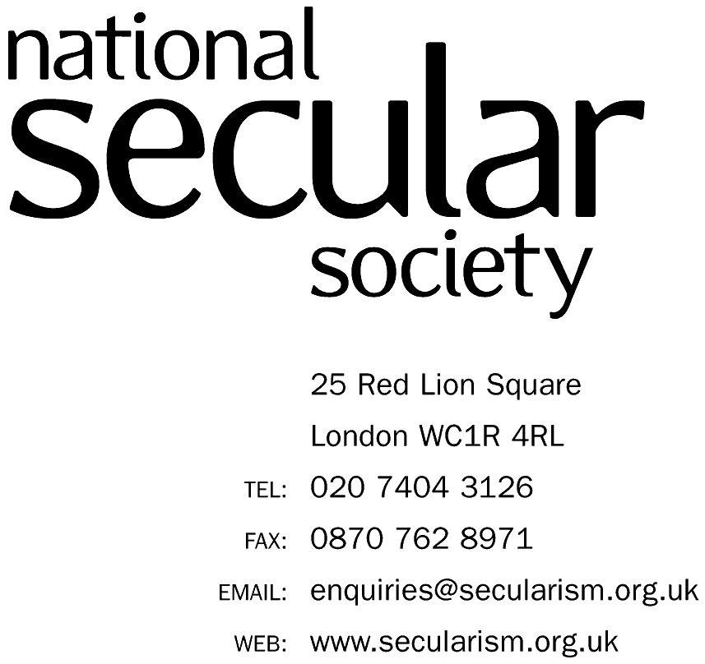


UNITED NATIONS CONVENTION ON THE RIGHTS OF THE CHILD

ALTERNATIVE REPORT ON SINGAPORE

PREPARED BY THE (UK) NATIONAL SECULAR SOCIETY

FOR THE 81st SESSION PRE-SESSIONAL WORKING GROUP

JUNE 2018

THERE IS NO TABLE OF CONTENTS AS ALL MATERIAL RELATES TO CLUSTER 4.

4 Civil Rights and Freedoms (Article 19)
Authors
- This report has been prepared by the UK National Secular Society’s (“NSS”) President, Keith Porteous Wood, and NSS Council member Josephine Macintosh, who has spoken for the NSS at the United Nations Human Rights Council (“UNHRC”). Mr Porteous Wood worked at the UNHRC and the Committee of the Rights of the Child to ensure that the Holy See was examined by the Committee, which it had not been for many years, and that the Committee had all necessary information to assist it in compiling its concluding observations.
Methodology and general approach
- The NSS works for the separation of religion and state and for equal respect for everyone's human rights so that no one is either advantaged or disadvantaged on account of their beliefs. We have been in special consultative status with the United Nations Economic and Social Council since 2016.
- Our work mentioned above relative to the Holy See, the Roman Catholic Church and elsewhere, for example with the Anglican Church, has led us to conclude that clerical abuse is much more widespread than is realised and often concealed for decades. This concealment is assisted by vows of secrecy and aggressive legal action taken by clerical organisations. We are therefore seeking to raise awareness of it and suggest ways in which it can be minimised.
- We especially commend the Committee’s recommendations previous concluding observations on Singapore as well as those on Poland, both of which are set out below, and which are especially applicable to counter institutional abuse.
- We recognise and acknowledge that much abuse (sexual and other violence by adults) against minors is familial and much also occurs in non-ecclesiastical institutional environments. Clearly, credible accusations, wherever they occur, should be pursued with the full force of the law.
- We also recognise that abuse in ecclesiastical organisations is not limited to Catholic or Christian organisations but extends across all denominations and religions in varying degrees.
- There is however extensive information about abuse in Catholic institutions, which are widespread throughout the world. We provide a summary of this in the Appendix.
- Ecclesiastical organisations are likely to disproportionately attract those intent on such abuse. The religious/spiritual power dynamic provides greater opportunities for perpetrators to abuse and conceal this. Furthermore, such organisations can often more easily conceal this abuse due to their secrecy and special position in society. They are more determined to conceal abuse in order to maintain the reputation they hold as sources of religious and moral guidance.
- The purpose of this submission is to create, in the interests of victims of such abuse, a more level playing field so that such institutions do not enjoy privileges that allow much abuse to go unpunished and victims to be denied protection, treatment and rehabilitation provided for under Articles 19, 34 and 39 of the Convention.

OUR CONCERNS
- We were encouraged that the Committee drew attention to the problem of abuse of minors in its concluding observations for the Fifty-Sixth Session for Singapore dated 2 May 2011.
- We remain convinced that mandatory reporting – if organised and resourced appropriately – is a valuable, indeed essential, tool to help reduce such endemic abuse. According to Mandate Now, a reputable organisation based in the UK:
“A recent survey of 62 nations involved 33 developed nations, and 29 developing nations. The survey found, overall, that, according to Daro, D, (ed), World Perspectives on Child Abuse, 7th ed, International Society for the Prevention of Child Abuse and Neglect, Chicago, 2006, p 26:
81.8% of the developed nations had some form of mandatory reporting;
78.6% of the developing nations had some form of mandatory reporting;
Combined, 80.3% of the nations participating had some form of mandatory reporting.”
- Attempts to introduce mandatory reporting, with criminal sanctions, have been met with demands, especially from the Roman Catholic Church (most recently in Australia and Ireland) that crimes disclosed in the confessional should be exempted. Such demands were specifically rejected by legislators in Ireland.
- Irish academic Dr Marie Keenan wrote the seminal Child Sex Abuse in the Catholic Church: Gender, Power and Organisational Structure. In it, she observed that “Receiving Confession played a role in easing the men’s conscience in coping with the moral dilemmas following episodes of abusing and provided a site of respite from guilt. … The very process of Confession itself might therefore be seen as having enabled the abuse to continue”.
- It is highly relevant to time bars/statutes of limitation that, according to the RMIT report cited in Appendix, “on average, it took more than two decades for victims to disclose”. We also note from several reports in numerous countries that convictions of alleged clerical abuse offenders have been frustrated by statutes of limitation/time bars. In the US, the Catholic Church have even openly employed lobbyists to frustrate legislative proposals for lengthened limits or (as we advocate) their removal.
- It is common for victims to be bound by the Church to secrecy/non-disclosure of any settlement or even over investigations. This contributes both to suppress public knowledge about them and facilitates the continuance of abuse perpetration with impunity.
- Even where there little or no evidence of institutional abuse, this is not conclusive proof that there is none. It often takes decades to emerge, even with free media. Under the precautionary principle and the need to protect children there seems no downside to introducing the measures we suggest, which should also serve to deter.
- Recommendations already made by the Committee in this area
We commend the Committee for the following recommendations in this area for Singapore, and those of Poland as well, listed below for convenience:
Singapore

51. The Committee recommends that the State party strengthen efforts to address the problem of child abuse by taking preventive measures, conducting public education programmes about the negative consequences of abuse and neglect, and providing adequate protection and recovery services to child victims of abuse. It also encourages the State party to establish a mandatory requirement for professionals working with children to report and take appropriate action in suspected cases of child abuse and neglect, and ensure that training is provided thereon.

65(c) Establish shelters for child victims of sexual abuse and exploitation, where children are provided with rehabilitation, recovery and social reintegration services;

70. The Committee recommends that the State party ensure, through adequate legal provisions, procedures, and regulations, that all child victims and witnesses of crimes, such as child victims of abuse, domestic violence, sexual and economic exploitation, abduction, and trafficking, as well as witnesses of such crimes, have effective access to justice and are provided with the protection stipulated in the Convention, taking fully into account the United Nations Guidelines on Justice in Matters Involving Child Victims and Witnesses of Crime, annexed to Economic and Social Council resolution 2005/20.

Poland, para 27

(a) Continue its efforts to ensure that all cases of sexual abuse of concerning children are investigated and prosecuted, including those allegedly committed by members of the Catholic clergy and representatives of other religions;

(b) That victims are adequately compensated and rehabilitated;

(c) Establish child-friendly channels for children and others to report such abuse;

(d) Protect children from further abuse by ensuring that persons convicted for abuse of children are deterred from having contact with children in their professional capacity;

(e) Put in place the necessary policies and measures to prevent the recurrence of such abuse.

OUR RECOMMENDATIONS
- The State party is asked
  - To provide supplementary and current information on the level of institutional and clerical abuse in Singapore;
  - To establish a mechanism for monitoring the level of accusations of clerical abuse in the last five years and future, including recording the year(s) in which the alleged abuse took place;
  - To indicate what action, if any, it has taken and will take and to reduce the prevalence of clerical abuse of minors in future;
  - What procedural measures it is taking to increase the future incidence of successful prosecutions for clerical abuse;
  - What measures it is taking to ensure that as many as possible of those individuals against whom there are plausible accusations are immediately suspended from their work and brought to justice;
  - To report on whether clerical victims are receiving appropriate protection, treatment and rehabilitation. Similarly, whether compensation is paid, and whether this is paid automatically under a scheme (as we recommend) and further whether it is paid conditional on non-disclosure.
  - To set out the legislative provisions for criminal and civil time bars/statutes of limitation relative to abuse and set out plans and time scales for their removal, with accusations and claims still subject to normal burdens of proof.
  - To establish whether victims are bound by the Church to secrecy/non-disclosure of any settlement or even over investigations.

- The Committee repeats its previous recommendations for Singapore and also adds those for Poland for 2015 (both shown in para 16 above)

We further suggest these be further strengthened as follows:

  - Introduce mandatory reporting of abuse in institutions with criminal sanctions, but without exemption for the confessional. Where an individual has a position of personal trust towards children and while such children are in their care, the individual has reasonable grounds for knowing or suspecting the commission of physical or sexual abuse or abuse by way of wilful neglect on such children, the State party should make it mandatory to report this to the authorities designated to protect children within seven days. If, however, the child is considered to be in danger of harm or significant harm, the matter should immediately be reported to the police. Failure to so report shall constitute a criminal offence for which there should be an appropriately serious penalty.
  - Take action to make it mandatory, including in clerical environments, for all known and suspected child sexual abusers in institutions to be removed promptly from post or from contact with children, and the matter reported urgently to regional or state authorities as described in a. above.
  - Eliminate arbitrary statutory time bars on criminal convictions and civil claims in respect of abuse of minors, which will nevertheless remain subject to the normal standards of proof and thresholds of evidence.
  - Take appropriate measures to promote protection, treatment and rehabilitation, physical and psychological recovery and social reintegration of a child victim of: any form of neglect, exploitation, or abuse; torture or any other form of cruel, inhuman or degrading treatment or punishment, as provided for in Articles 19, 34 and 39 of the Convention on the Rights of the Child.
  - Ensure that remedies for the above should mandatorily include appropriate compensation, preferably in a fair scheme which obviates victims needing to be subjected to an adversarial process.
  - Ensure that the state mandates that accusations and investigations of child abuse, or compensation, can never in future be made subject to secrecy/non-disclosure.

In conclusion we ask that the Committee considers making the combined list a standard recommendation on institutional child sexual abuse for all countries, much as it has done on corporal punishment.
---------------

APPENDIX

Abuse in Catholic institutions

- This has been researched for five years by practising Catholics Professors Desmond Cahill and Peter Wilkinson. Their Report is ‘Child Sexual Abuse in the Catholic Church: An Interpretive Review of the Literature and Public Inquiry Reports’, Centre for Global Research School of Global, Urban and Social Studies, RMIT University, Melbourne, August 2017, especially the section starting on page 273 entitled “Secrecy, silencing and denial – a mechanism for lack of transparency and accountability”. That this Report was written by “practising Catholics” … with “their continuing faith commitment to the Catholic Church” (pages 289/290) is testimony to the knowledge of the writers and that the motive of those writing the report was neither anti-clerical nor anti-Catholic.
- Our work and the RMIT report referenced above show that many of those in religious institutions and their supporters regard it as a religious duty to protect their religious institutions from scandal whatever lengths they need to go to in order to achieve this and regardless of the adverse effect on victims through for example ignoring them or even claiming they are mendacious.
- The RMIT report concludes that there is a consistent worldwide picture for the Catholic Church, placing the source of the problem at the top of the hierarchy:
“ ….These failures and deliberate attempts to cover up the abuse were enmeshed in the secrecy and secretiveness at the heart of the governance of the Catholic Church. During the twentieth century, more and more secrecy provisions were imposed, beginning with the Secret of the Holy Office imposed by Crimen Sollicitationis in 1922 and later the imposition of the Pontifical Secret on all matters and more persons associated with child sexual abuse. … the Holy See became increasingly fearful of public scandal as did the bishops. The Holy See and diocesan bishops were always fearful of scandalising the Catholic faithful…. The Holy See was always concerned that the accused priest and religious would not receive a fair trial, but it showed no concern whatsoever for the victims of the accused priests and their families.”

CRC/C/VAT/CO/2, 31 January 2014
CRC/C/SGP/CO/2-3. Available at: www2.ohchr.org/english/bodies/crc/docs/CRC.C.SGP.CO.2-3_en.doc
Mandate Now, ‘Why we exist’. Available at: http://mandatenow.org.uk/why-we-exist/
Page 287
CRC/C/SGP/CO/2-3. Available at: www2.ohchr.org/english/bodies/crc/docs/CRC.C.SGP.CO.2-3_en.doc
CRC/C/POL/CO/3-4. Available at: http://docstore.ohchr.org/SelfServices/FilesHandler.ashx?enc=6QkG1d%2FPPRiCAqhKb7yhstV3zKgaAa4TwOI5sejLPokoZ%2FHscrji1JpiYozARxzgOMaIguBQ%2BkjWOmC0Rj99HwJCrYRBPBXD%2BbyaT8wsqPcM7DUfcxPZqefjWn%2FqohtS
Available at: https://www.rmit.edu.au/content/dam/rmit/documents/news/church-abuse/child-sex-abuse-and-the-catholic-church.pdf
Available at: https://www.nytimes.com/2010/07/02/world/europe/02pope.html?ref=romancatholicchurch

