

THEMATIC REPORT ON MUSLIM FAMILY LAW AND
MUSLIM WOMEN’S RIGHTS IN
The United Arab Emirates (UAE)

82nd CEDAW Session
Geneva, Switzerland
JUNE 2022

Musawah
15 Jalan Limau Purut, Bangsar Park, 59000 Kuala Lumpur, Malaysia
Tel: +603 2083 0202 Fax: +603 2202 0303
Email: musawah@musawah.org
Website: www.musawah.org

A. INTRODUCTION
Musawah, the global movement for equality and justice in the Muslim family, submits this Thematic Report on concerns related to Muslim women’s legal equality in personal status matters, violence against women, and nationality rights for consideration by the CEDAW Committee in its review of the Government of the United Arab Emirates (UAE), reporting before the 82nd Session of the CEDAW Committee in June 2022. This is the CEDAW Committee’s third periodic engagement with the UAE. Its last full review was in 2015. The UAE acceded to CEDAW on 6 October 2004, and took reservations to articles 2 (f), 15 (2), and 16 of the Convention on the basis of Islamic Sharia, in addition to articles 9 and 29 (1).
This report highlights key legal inequalities that Muslim women face in the UAE in the personal status sphere and their resulting negative impact on women and girls, along with recommendations to address gaps. We encourage the UAE government to leverage its robust framework of diversity and inclusion to ensure full legal equality and empowerment for Muslim women in all aspects of public and private life.
We hope that the CEDAW Committee will utilize this report as a key resource during its constructive engagement with the State Party and use the recommendations, outlined in grey boxes within the text, to identify follow-up issues in its Concluding Observations.

B. BACKGROUND AND LEGAL FRAMEWORK
The United Arab Emirates is a constitutional federation of seven Emirates, which formed a union in 1971, following independence from Britain. The UAE is a Muslim-majority country, with a sizable foreign resident population. Out of an estimated total population of 9.3 million, less than one million, or 11%, are Emirati nationals. Islam is the official religion of the state, and the Constitution guarantees freedom of worship to adherents of all religions, within the limits of established customs, public order, and public morals. The vast majority of Emirati nationals are Sunni Muslims, estimated at 85%, with a sizable Shia Muslim minority. Out of the total population, Muslims comprise an estimated 76.9%, Christians 12.6%, along with communities of Hindus, Buddhists, and other faiths.
The UAE Constitution provides that equality, social justice, the provision of safety and security and equality of opportunity for all citizens form the bases of the community. Article 25 of the constitution states that “all persons shall be equal before the law,” and that there shall be no discrimination between citizens on the basis of “race, nationality, religious belief or social position.” There is no specific prohibition of gender-based discrimination in the constitution.
In terms of advancing the equality and welfare of women in society, the UAE has made strides in key indicators, such as access to education and healthcare, increasing participation in the workforce, and integration into national positions of leadership. However, discrimination against women persists in the area of personal status. The legal framework continues to treat women as subordinate to men within the family, fails to provide adequate protections from domestic violence, and contains unequal nationality laws.
The UAE Personal Status Law of 2005 governs marriage, divorce, child custody and guardianship, inheritance, and other personal status matters for UAE nationals, with the exception of non-Muslims who may opt for the applications of provisions specific to their respective religion. The Personal Status Law also applies to non-nationals, unless they ask for the laws of their own countries to be applied. Independently, Abu Dhabi enacted its own Personal Status Law for non-Muslims.

In 2019 and 2020, the UAE took several positive steps to eliminate certain provisions in the Personal Status Law. For example, it eliminated the requirement of “obedience” by a wife of her husband, replacing it with a framework of mutual respect, compassion, and good treatment, and introduced provisions to guarantee a wife’s right to complete her education. It also introduced some positive changes regarding the process of obtaining and registering a divorce. Nonetheless, the Personal Status Law continues to discriminate against women in several areas, as discussed subsequently.

Personal Status cases for Muslims are adjudicated by Sharia courts, which are part of the UAE civil court system. In each of the seven Emirates, Sharia court chambers are divided into courts of first instance and courts of appeal. Judgment of Sharia appeals chambers may, in turn, be appealed to the Court of Cassation of each Emirate, which can vacate Sharia appeals court rulings and decide on the merits of a case.

Laws that govern the protection of women from violence, including the Penal Code and the Domestic Violence Law, are adjudicated in the criminal courts of each Emirate. Matters relating to citizenship and naturalization are governed by the 1972 Nationality Law and its subsequent amendments.

C. KEY ISSUES AND RECOMMENDATIONS

Women’s Capacity to Enter into Marriage Article 16

Guardianship in Marriage

Regardless of her age, a woman must obtain the consent of a male guardian (wali) in order to enter into marriage. If the guardian does not consent to the marriage, the woman may only enter into marriage after seeking authorization of a judge. The Personal Status Law specifies the order of male relatives who may take this guardianship role, prioritizing a woman’s father, followed by a son, brother, and uncle. In all cases, a Muslim woman’s guardian must be an adult Muslim man of sound reasoning. By contrast, a man may choose his spouse freely and independently.

The law stipulates that a male guardian contracts a woman’s marriage after obtaining her consent and that a marriage contract is invalid in the absence of a woman’s guardian. Even in cases where such a marriage was consummated, the law provides that the marriage contract is annulled and the married couple are to be separated, with no mention of consulting the woman’s wishes on the matter of dissolution. The law also requires a prospective husband to be “suitably qualified to deserve the woman” at the time of contracting the marriage and authorizes a guardian to request the annulment of marriage if he subsequently discovers the husband had not been suitably qualified.

In cases where no male guardian is available or has unreasonably refused to authorize the marriage (in what is known as an ‘adhl case), a judge acts as the woman’s guardian for purposes of contracting a marriage. In practice, however, it remains socially and practically difficult for a woman to bring an ‘adhl case to court, which essentially requires a woman to challenge her male guardian, often a father or another male authority figure in her family, before going to court. If such a request was denied, the woman would have to return to her family against whom she had brought a lawsuit. Many women opt to submit to the will of their guardians for fear of social ostracization or retribution by their own families. Despite a number of successful recent cases whereby a court ruled to authorize a marriage due to a finding of ‘adhl, research indicates that such cases often face significant delays, taking up to two years in court. Moreover, the Personal Status Law does not specify on what basis a judge can accept or reject a woman’s request to get married, leaving the matter to the unfettered discretion of each individual judge.
The adverse impact on an adult woman’s ability to enter into marriage of her own free will because of a guardian’s exercise of authority, including the right to request an annulment of a marriage on the basis of unsuitability or simple unwillingness to authorize a marriage, must not be underestimated.
Forced Marriage
The Personal Status Law states that the consent of both the bride and her guardian are required in order to officiate a marriage. However, limiting a woman’s legal capacity to make independent decisions in marriage, and empowering male guardians to significantly control a woman’s marriage choices, in turn, enables the abuse of guardian powers and the coercion of women into unwanted marriages. Particularly in tribal and remote settings, women can be vulnerable to the control of their male relatives and are forced to contend with either submitting to the choices of their guardians or otherwise being prevented from entering marriages of their choosing. There is no provision in the law to enable a woman to request annulment of a marriage that was contracted under coercion, and no penalties for forcing a woman to marry against her will.

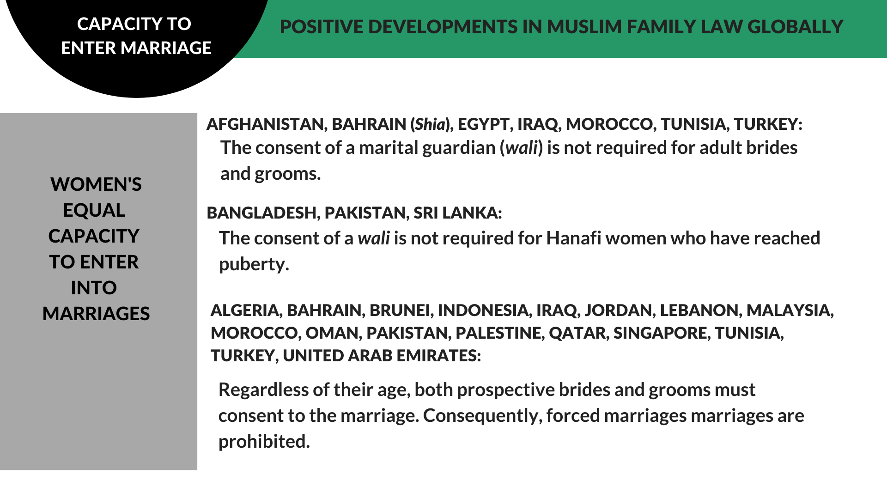

RECOMMENDATIONS
We recommend the CEDAW Committee urge the State party to:

- Amend the Personal Status Law to give adult women equal rights to enter marriage on their own accord without requiring the permission of a male guardian or judge.

- Abolish provisions that enable the annulment of a marriage contract due to the guardian’s objection.

- Enforce penalties on those who conduct, enable, or fail to prevent forced marriages.

Early and Child Marriage Article 16

The Personal Status Law establishes a minimum age of marriage of 18 years for both girls and boys, but continues to allow for judicially granted exceptions to the minimum age. The law does not specify an absolute minimum age under which marriage cannot be contracted. According to official marriage data from 2016-2021, the average marriage age of an Emirati woman is 25 years. Research points to a lack of accurate data on child marriage, and to a concern that child marriage continues to be widespread but uncaptured by official statistics.

In 2020, the UAE Council of Ministers issued guidelines with respect to evaluating petitions for marriage of children below 18 years of old. The guidelines provide for the establishment of a committee to evaluate such marriage requests by a decision of the Minister of Justice, and instructs the committee to consider all applications for marriage when the parties are below 18 but have reached puberty.

In making a decision, the guidelines instruct the committee to verify (a) that the marriage would not result harm in relation to living standards of the marriage candidates; (b) suitability in terms of age difference and comparable social and economic standing; (c) the ability of the groom to provide an adequate marital home and financial maintenance after marriage; and (d) that the marriage would not adversely affect the bride’s ability to pursue an education. The guidelines further instruct the committee to verify that the child has reached puberty and that there are no health side effects to a pregnancy at her young age (by way of a medical report), and to verify the consent of the female child and her understanding of her prospective marriage duties.

While some of the aforementioned procedures and conditions provide a degree of restriction to the practice of child marriage, we wish to express a strong concern with permitting the marriage of children, especially with no absolute minimum age limit. Young girls, in particular, are highly vulnerable to coercion and child marriage, and lack the full legal capacity to make informed decisions with respect to such a critical lifelong commitment.

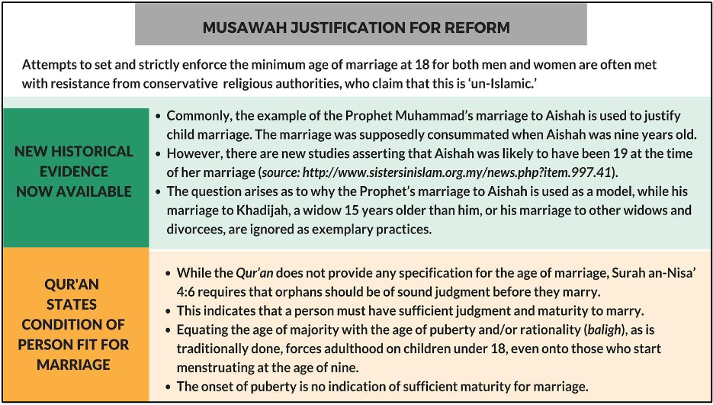

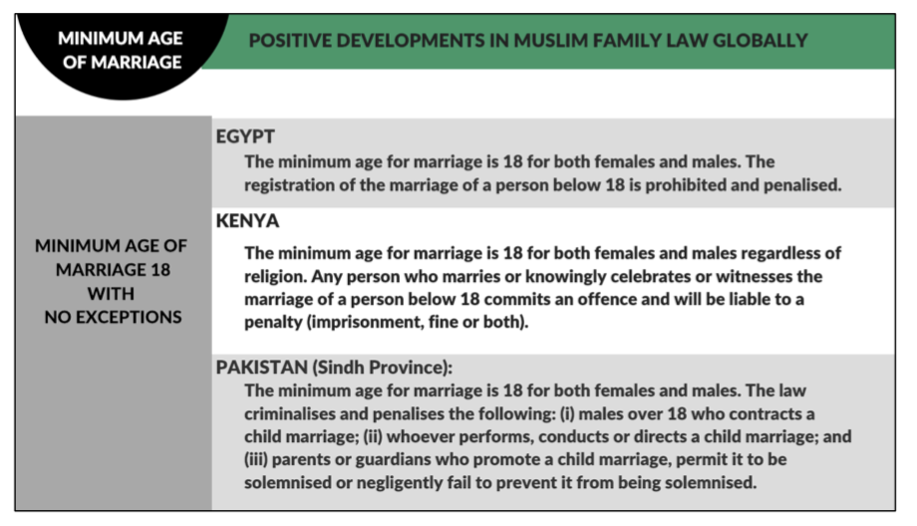

RECOMMENDATIONS
We recommend the CEDAW Committee urge the State party to:
- Establish an absolute minimum age of marriage of 18 years old, and remove exceptions that enable child marriage.

- Introduce penalties for guardians and marriage officiators who contract the marriage of a child.

- Provide targeted training programs to law enforcement officials, the judiciary, healthcare workers, and social workers to respond to reports of child marriage, and provide adequate support to victims.

Polygamy Article 16

The Personal Status Law grants a man full discretion to marry up to four wives, and does not mandate either informing an existing wife of the intention to enter subsequent marriages, nor obtaining an existing wife’s consent to alter a monogamous marriage into a polygamous one. Marrying other wives is not a valid cause for a woman to seek divorce under the Personal Status Law, unless she had included an explicit condition in the marriage contract, which requires prior consent of the husband.

The law explicitly ignores a woman’s consent to polygamous arrangements, and only offers protection in the form of encouraging a husband to treat all wives fairly. According to recent reports, the number of polygamous marriages continues to decline in the UAE. Nonetheless, polygamy continues to be practiced in a manner that harms women and causes negative consequences to the financial, psychological, and emotional wellbeing of the wives and children of polygamous unions. At an absolute minimum, the law must be reformed to make it a legal requirement for an existing wife to be informed and to consent to her husband’s subsequent marriage.

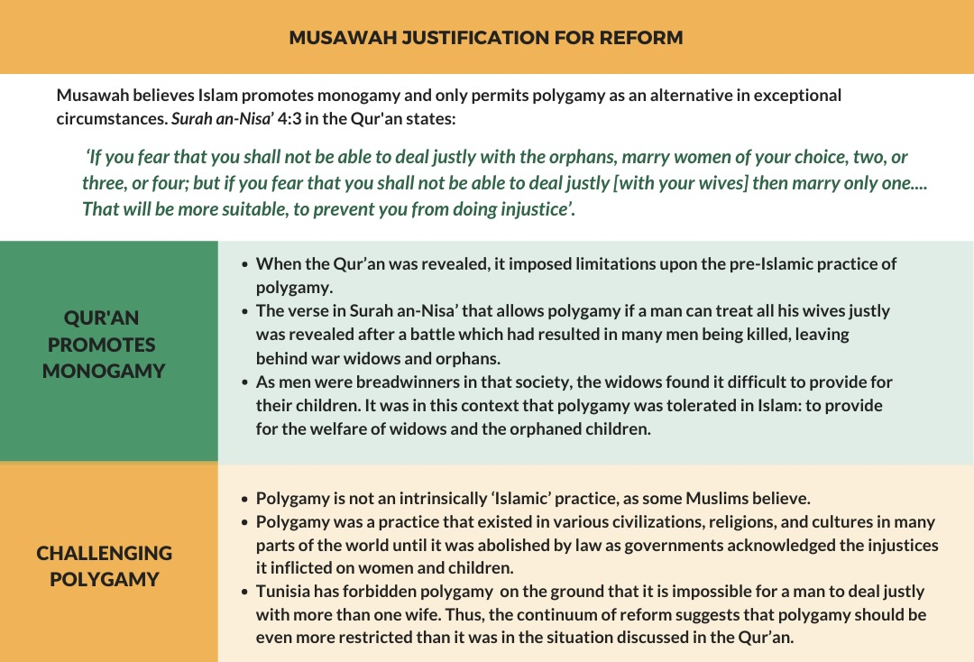

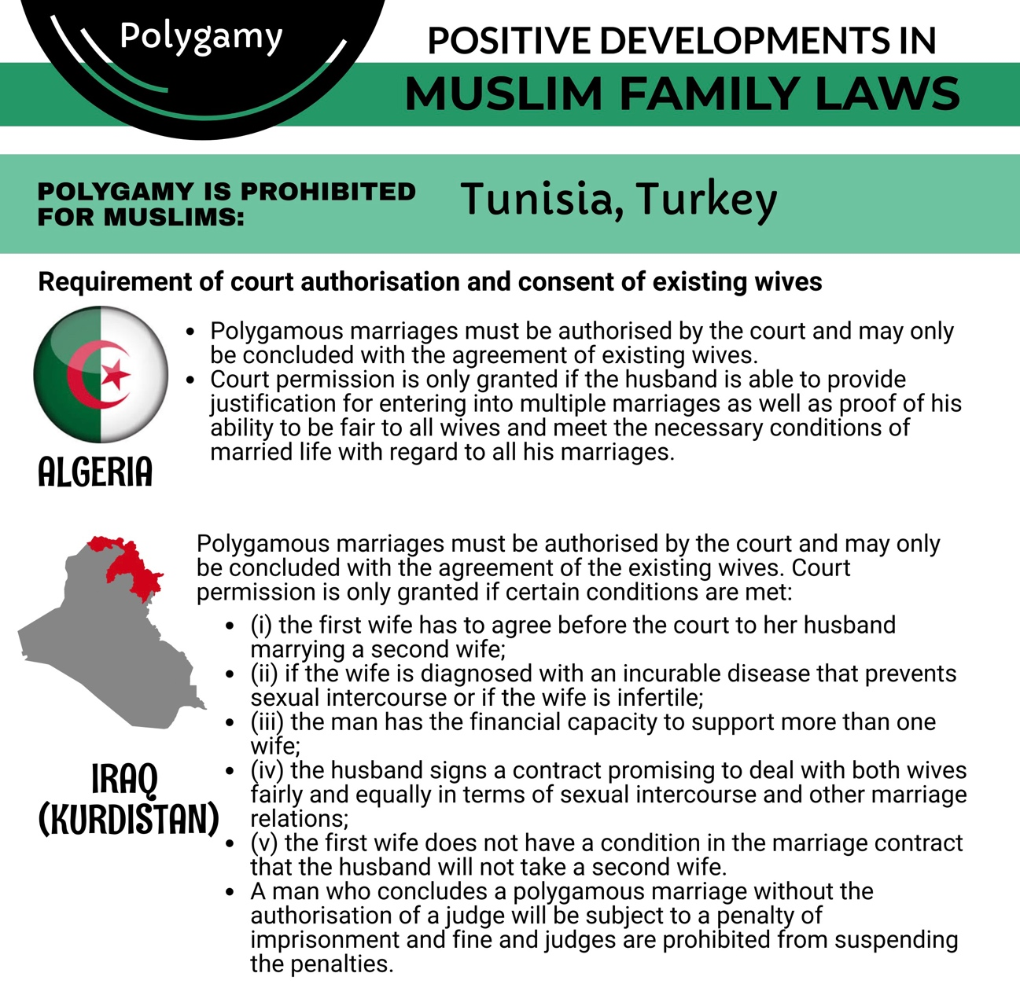

RECOMMENDATIONS
We recommend the CEDAW Committee urge the State party to:
- Introduce conditions in the Personal Status Law to restrict the practice of polygamy to minimize harm and injustice done to the wives and children, and in particular:

  - Require marriage officiators to notify a man’s existing wife at the time of contracting a subsequent marriage and to seek her consent; and

  - Include polygamy as a valid cause for judicial divorce.

Violence Against Women Articles 11-5, 16 & 19, & GR35

In 2016, the UAE amended article 53 of the Penal Code, removing spousal “discipline” as a permitted act of violence; in 2020, it repealed article 334 of the same law, which enabled lenient sentences for honor killings. In 2019, the UAE enacted the Domestic Violence Law, which enshrines certain protections for women from acts of violence within the family.

Domestic violence is defined in the law as any act or threat that one member of the family commits against another, in excess of his guardianship, maintenance, authority, or responsibility, and results in physical, psychological, sexual, or economic harm. In this definition, the law appears to offer justification for acts or threats of violence that are within a perpetrator’s “guardianship, maintenance, authority, or responsibility,” thereby significantly weakening the protection of women from violence and threats of violence within the family.

The law enables victims of domestic violence to obtain protection orders, within certain time limits. The public prosecution may issue a 30-day protection order, renewable for an additional 60 days, after which a renewal order must be issued by a competent court, for a period not to exceed six months. The law introduces fines and prison penalties for violating protection orders and for specific acts of domestic violence.

However, article 10 of the Domestic Violence Law mandates that the public prosecution offer a “reconciliation” option to victims of domestic violence. It is a strong concern that a mandated reconciliation offer in fact operates to discourage victims from seeking protection and accountability, and creates pressure to return to abusive households.

In the absence of official statistics on domestic violence, it is difficult to estimate the scale of the problem and its social harms, but anecdotal evidence points to a degree of prevalence of spousal abuse that often goes unreported or unpunished due to loopholes in the law and authorities’ reported prioritization of reconciliation and the preservation of “family unity and integration,” often at the expense of women’s safety.

Female Genital Mutilation

The UAE has not adopted legislation to criminalize female genital mutilation (FGM), despite evidence that FGM remains a prevalent practice. A recent study conducted between 2016 and 2017 revealed an FGM prevalence rate of over 41% among female participants. Over 69% percent of participants considered FGM to be a social custom, whereas only 5% considered it a religious obligation and 20% considered it a recommended act. Encouragingly, around 73% of participants were against FGM. It is critical that the legal framework is upgraded to criminalize FGM in order to deter this harmful practice.

RECOMMENDATIONS
We recommend the CEDAW Committee urge the State party to:

- Amend the definitions in the Domestic Violence Law to eliminate any loopholes that enable the use of a perpetrator’s authority over a victim as a justification for acts of domestic violence.

- Strengthen protection of domestic violence victims in the law and eliminate provisions that prioritize reconciliation over the safety of women and encourage impunity.

- Criminalize FGM, enforce strict penalties for perpetrators, and strengthen awareness-raising and educational efforts to completely eliminate this practice and its underlying justifications.

- Train law enforcement, the judiciary, healthcare workers, and social workers to respond to reports of domestic violence effectively and provide adequate support to victims of violence.

Nationality Article 9

The Nationality Law discriminates between men and women in their capacity to confer citizenship on their respective children or foreign spouses. The law enables an Emirati man to confer citizenship to his children, regardless of their mother’s nationality, at the time of birth. A foreign wife of an Emirati man may be naturalized after seven years of applying for citizenship if the couple has children, and after ten years if no children were born.

Emirati women, by contrast, lack the capacity to confer citizenship to their children at the time of birth, except in cases where the father is stateless or unknown. A 2017 amendment to the Nationality Law enables an Emirati woman to apply for citizenship for her children, after the lapse at least six years from the date of birth. An Emirati woman may not confer citizenship on her foreign husband. In all cases, no one may be naturalized without renouncing the nationality of origin.

There are no reliable statistics with respect to the number of stateless children of Emirati women. In 2019, the UAE granted citizenship to 3,354 sons and daughters of Emirati women who had applied and met the required conditions in the law in 2019. It is important that the UAE offers a more systematic and sustainable solution that eliminates the problem of statelessness of the child of Emirati women, and introduces legal equality in citizenship and naturalization.

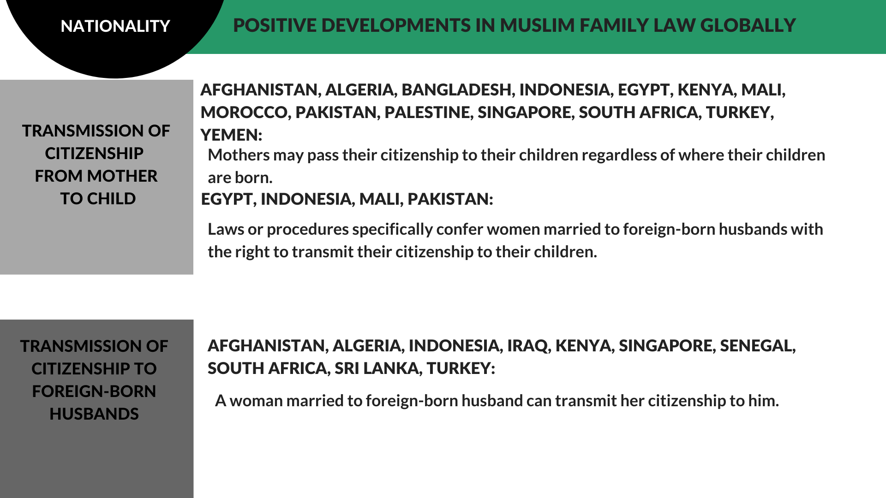

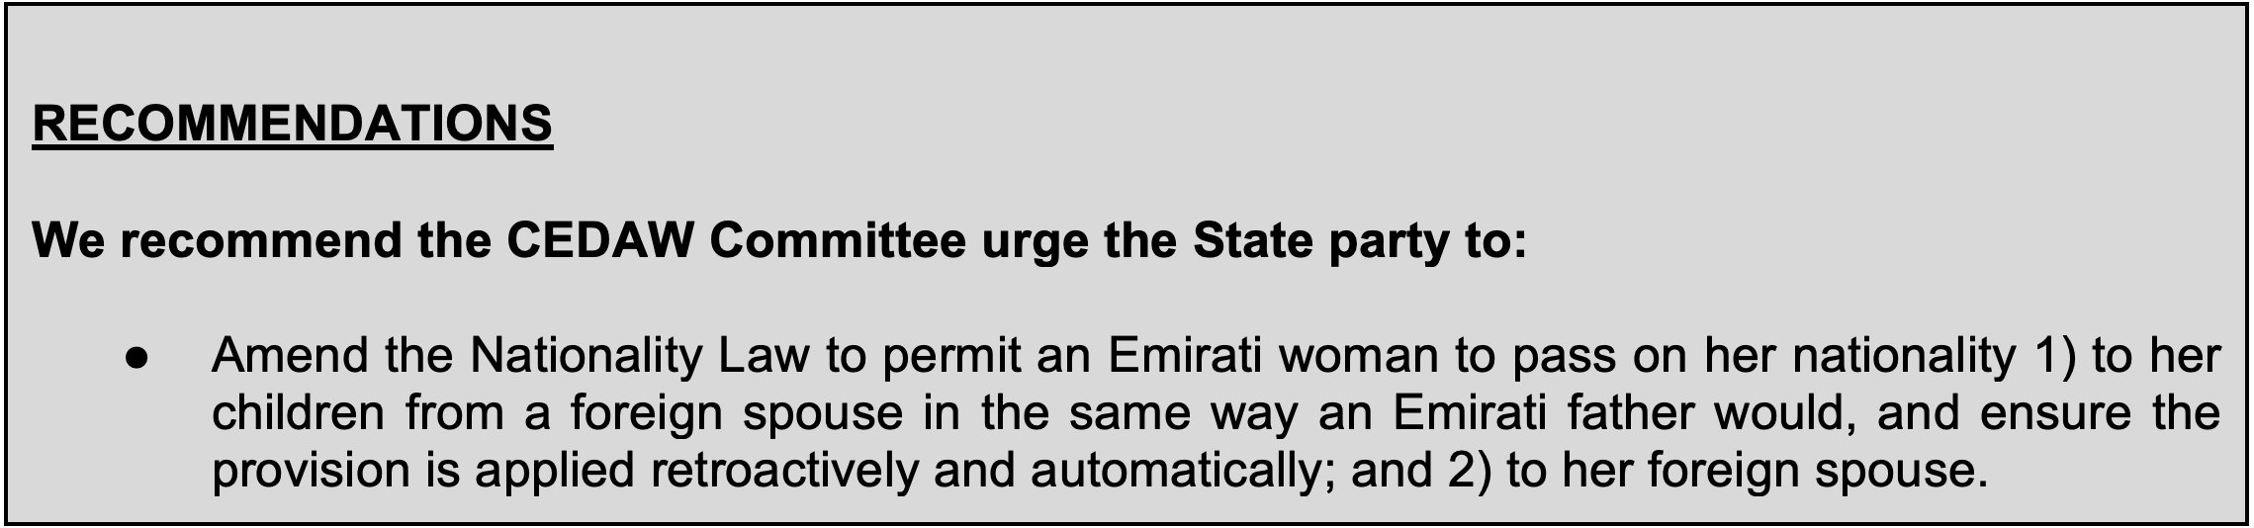

Factsheet, Official UAE Government Portal, https://u.ae/en/about-the-uae/fact-sheet.
United Arab Emirates Constitution of 1971 (hereinafter “UAE Constitution”), art. 7, https://www.constituteproject.org/constitution/United_Arab_Emirates_2004.pdf.
UAE Constitution, art. 32.
2020 Report on International Religious Freedom: UAE, US Department of State, 12 May 2021, https://www.state.gov/reports/2020-report-on-international-religious-freedom/united-arab-emirates/.
Id.
UAE Constitution, art. 14.
Id., art. 25.
See UAE State Report, paras. 102-103, Annex IV.
Federal Law No. 24, issued 19 November 2005, on Personal Status, as amended (hereinafter “Personal Status Law”), https://elaws.moj.gov.ae/UAE-MOJ_LC-En/00_PERSONAL%20STATUS/UAE-LC-En_2005-11-19_00028_Kait.html.
Id., art. 1(2).
Id., art. 1(3).
Personal Status for Non-Muslims, Official UAE Government Portal, https://u.ae/en/information-and-services/justice-safety-and-the-law/personal-status-for-non-muslims.
Personal Status Law, arts. 54-56.
Federal Judiciary, Official UAE Government Portal, https://u.ae/en/about-the-uae/the-uae-government/the-federal-judiciary.
Id; Personal Status Law, art. 13.
Federal Law No. 3 of 1987 on the Penal Code, as amended (hereinafter “Penal Code”), https://elaws.moj.gov.ae/UAE-MOJ_LC-En/00_PENALTIES%20AND%20CRIMINAL%20MEASURES/UAE-LC-En_1987-12-08_00003_Kait.html?val=EL1.
Federal Law No. 10 of 2019 on the Protection from Domestic Violence (hereinafter “Domestic Violence Law”), https://u.ae/en/about-the-uae/strategies-initiatives-and-awards/federal-governments-strategies-and-plans/family-protection-policy.
Federal Law No 17 for 1972 Concerning Nationality and Passports, as amended (hereinafter “Nationality Law”), https://icp.gov.ae/en/about-icp/laws-and-legislation/.
Personal Status Law, arts. 32-35, 39.
Id., art. 34.
Id., art. 32.
Id., art. 33.
Id., art. 39.
Id.
Id., art. 21.
Id., art. 35.
Interview with advocate, January 2020.
Id.
Id.
Personal Status Law, arts. 39, 41.
Interview with advocate, January 2020.
Personal Status Law, art. 30.
Children of the UAE, Humanium, https://www.humanium.org/en/united-arab-emirates/.
UAE Council of Ministers Decision No. 71 of 2020.
Id.
Personal Status Law, art. 20.
Id., art. 55.
“70% of polygamists in 4 emirates are non-Emiratis,” Khaleej Times, 6 June 2020, https://www.khaleejtimes.com/uae/70-of-polygamists-in-4-emirates-are-non-emiratis.
Id.
Penal Code, arts. 53, 334.
Domestic Violence Law, art. 3.
Id., arts. 6-7.
Id., arts. 8-9.
Interview with advocate, January 2020.
Prevalence, knowledge, attitude and practices of female genital mutilation and cutting (FGM/C) among United Arab Emirates population, 20 April 2020, https://bmcwomenshealth.biomedcentral.com/articles/10.1186/s12905-020-00949-z.
Id.
Id.
Nationality Law, art. 2.
Id., art. 3
Id., art. 10 Bis.
Id., art. 11.
UAE State Party Report, December 2020, U.N. Doc. CEDAW/C/ARE/4, para. 69.

