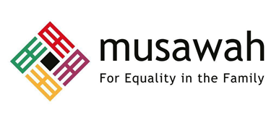

THEMATIC REPORT ON MUSLIM FAMILY LAW AND
MUSLIM WOMEN’S RIGHTS IN

YEMEN

80th CEDAW Session
18 October - 12 November 2021

Submitted by:
Musawah
15, Jalan Limau Purut, Bangsar Park, 59000 Kuala Lumpur, Malaysia
Tel: +603 2083 0202 Fax: +603 2202 0303
Email: musawah@musawah.org
Website: www.musawah.org

I. INTRODUCTION

Musawah, the global movement for equality and justice in the Muslim family, submits this Thematic Report to the CEDAW Committee in its review of the Government of Yemen, reporting before the 80th CEDAW Session in October–November 2021.

This is the CEDAW Committee’s combined seventh and eighth periodic engagement with Yemen, which acceded to CEDAW in 1984. Yemen’s last full review before the CEDAW Committee was in 2007, but the socio-economic-political situation on the ground has drastically changed since then.

This report examines Yemen’s legal framework and practices that enforce de jure and de facto discrimination against Muslim women in the following priority areas:

- Child Marriage
- Forced Marriage
- Violence Against Women
- Inheritance Rights
- Nationality Rights

The report was drafted by Shaza Loutfi in conjunction with a joint team of researchers from Musawah and the International Human Rights Clinic at Harvard Law School. Research and analysis completed prior to drafting, which forms the basis of this report, was also conducted by the International Human Rights Clinic team. We would like to thank Dr. Bilqis AbuOsba and Ghaidaa Motahar for reviewing the report and providing substantive insights on the lived realities of Yemeni Muslim women.

II. CONTEXT

Conflict
Originally destabilised by political transition in 2011, Yemen has now been in conflict for nearly seven years. Even before the war, Yemen was the poorest country in the Middle East/North Africa (MENA) and the ongoing conflict has exacerbated the country’s issues exponentially, launching one of the world’s worst humanitarian and human rights crises.

Multiple rounds of peace talks have failed, and the country has fragmented territorially and institutionally. The official government is based outside of the country, with little-to-no influence on the ground. Government-controlled areas are in practice controlled by unelected officials and armed militias. Other areas are controlled by the Houthis, in whose territory there has been a near-complete breakdown of judicial institutions; they have implemented a myriad of anti-women policies and established the Zainabiyat, tasked with enforcing restrictions on women. The Houthis also retain a firm grip on all activities within their territory, requiring both their permission and the involvement of a member of their group, leading most non-governmental organizations to implement their projects in non-Houthi-controlled areas. Houthis in some areas have instituted additional measures to control women’s movement, declaring they may not travel without an accompanying mahram, or male kin.

COVID-19 pandemic
The COVID-19 pandemic has aggravated the country’s already-dire socio-economic conditions. A routine survey by the UN’s World Food Programme showed households that were able to afford food at the start of the pandemic could no longer do so by the end of 2020, with 40% of households at poor or borderline consumption.

An accurate number of COVID-19 cases and related deaths remains unconfirmed given the country’s weak tracking infrastructure. Additionally, both the government and the Houthi rebels allegedly withhold or manipulate pandemic-related data.

The most affected by COVID-19 are the most vulnerable: internally displaced persons have disproportionately lost their unskilled jobs and been blamed for spreading the virus, and the incidents of violence against women from their families and husbands rose to 63% from the war, with many experts linking the increase to the pandemic. In Houthi-controlled areas, traditionally female-operated businesses have been forced to close while men's businesses remain open.

III. LEGAL FRAMEWORK

Overview
Yemen can be described simply as currently housing a number of separate legal systems, each corresponding to a distinct context:
- Remote or rural areas lack serious governance as the government faces challenges in implementation and enforcement there.
- Houthi-controlled areas, where the official government maintains little leverage, have their own legal structures, including for taxes and security.
- Government-controlled areas are a mixed-bag, with local authorities sometimes upholding official government policy while neglecting or contradicting them at other times.
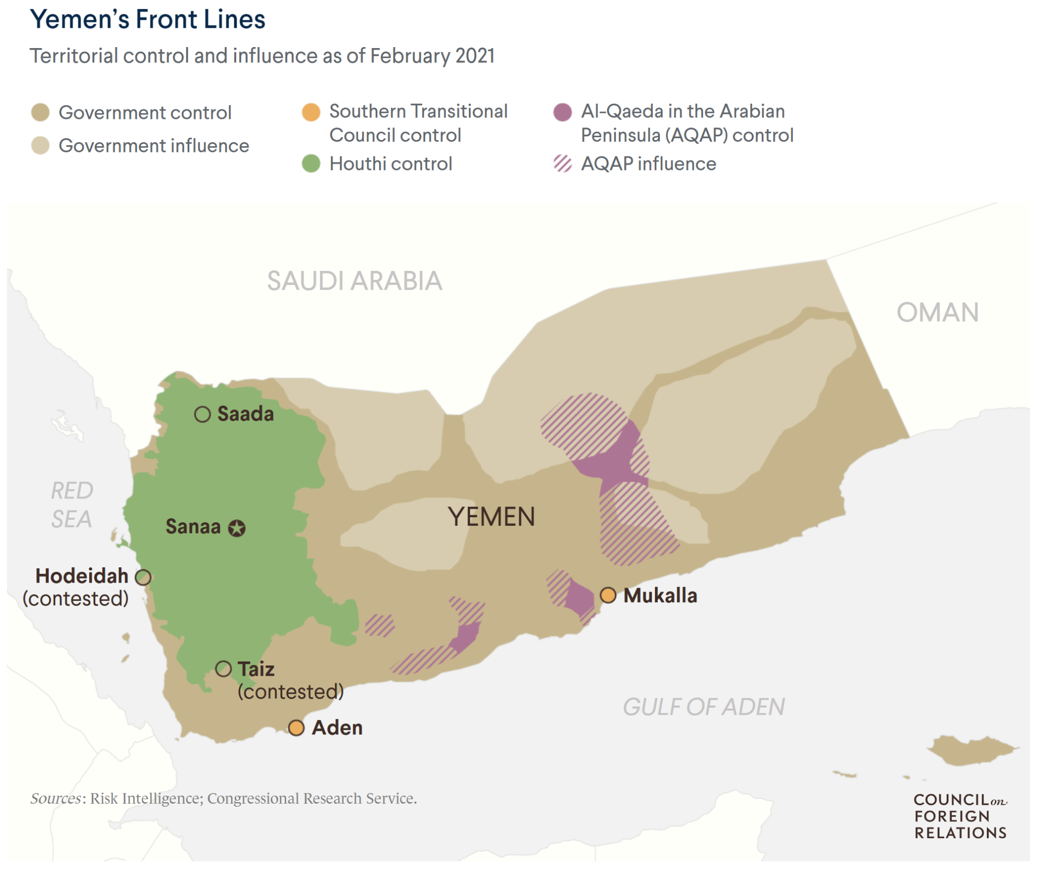

Constitution
The Yemeni constitutional provisions of equality (Article 24, 25, and 41 for example) are contradicted by other discriminatory provisions in the constitution. Article 3 states that “Islamic law is the source of all legislation,” while Article 31 denotes that, “Women are sisters of men, and their rights are according to Sharia and as stipulated by the law.” Both provisions work against women in Yemen, denigrating them to sisters rather than citizens and allowing for a wide range of interpretations under Islamic law.

A first draft of a new constitution was released in January 2015 by a drafting committee comprising 23.5% women. The draft included gender equality and non-discrimination, a quota of 30% women in government, and prohibited marriage under the age of 18 for both sexes. While there remains room for improvement, especially in guaranteeing equal rights independent of Islamic law perspectives, this draft constitution remains unratified.

Family Law
Yemen’s family law is codified as Yemen's Personal Status Law (YPSL, 1992). Despite constitutional provisions emphasising equality, the YPSL provides for a marital framework based on ‘reciprocal’ or ‘complementary’ rights (as opposed to ‘equal’ rights) between the two spouses, whereby in return for maintenance and protection from her husband, a wife is expected to obey him: a “maintenance-for-obedience” system. Provisions in the YPSL therefore discriminate against women as it is based on male authority and male guardianship, reinforcing the gender-stereotypical roles of man/husband as head of household and financial provider and woman/wife as the primary caregiver in the home. Given the political situation there is no functioning legal system through which family laws could operate.

Access to Justice
The conflict in Yemen has led to a deterioration in the access to and quality of judicial remedies. The level of this deterioration varies according to the specific area. For example, courts in Taiz and Aden have completely closed their doors, while in other areas the courts may remain open but hire unqualified judges.

Even where women can access the judicial system despite restricted movement, they face logistical obstacles. Cases can take years to be resolved, extending the time a woman must wait before she is able to access her matrimonial assets or gain custody of her children. The cost of going to court can also be prohibitive despite any legal aid programs the government supports. In Houthi-controlled areas, the judge can order a pro-bono lawyer, but this is not always implemented. Finally, outcomes so rarely work in the women’s favor that the risk of losing makes the investment of time and money unreasonable.

Given this situation, most women will choose to go to local sheikhs or leaders to help them resolve problems, including divorce, custody, and distribution of matrimonial assets. Yemeni women (both urban and rural) find it easier to access these informal actors, as they keep their doors open to the community and female members of a sheikh’s family are typically well-known and can serve as a comfortable point of contact for women. However, most often in family-related issues, a local sheikh will suggest the issue be resolved with the men in the family, rendering decisions male-centric by default.

IV. KEY ISSUES AND RECOMMENDATIONS

- CHILD MARRIAGE Article 16

There is no minimum legal age of marriage for females or males in Yemen. YPSL Article 15 only restricts the validity of a girl’s marriage (or more specifically, the act of having sex with her or moving her to the marital home) to the time she is ready for sex, broadly understood as the time of her first menstrual cycle. This narrow limitation is respected “even if she exceeds 15 years old.” Nevertheless, a marriage contract can be completed at any age. For a young boy, the YPSL states his early marriage is valid only if proven to be beneficial, though no minimum age is specified.

According to UNICEF, Yemen has the highest rate of child marriage in the Middle East. Human Rights Watch estimates that “52% of Yemeni girls are married – often to much-older men – before the age of 18, and 14% before the age of 15,” although some other estimates place these numbers considerably higher. Girls who are married at such a young age “often drop out of school, are more likely to die in childbirth, and face a higher risk of physical and sexual abuse than women who marry at 18 or later.”

Though the problem of child marriage existed prior to the war, it has been significantly exacerbated under the conflict and the related socioeconomic difficulties it has engendered, such as high unemployment and poverty rates. Since the beginning of the conflict, the rate of child marriages in Yemen has increased by three times, according to a UN report. Financial pressures are provoking many Yemeni parents into marrying off their young daughters to claim her mahr (dower). Although the bride owns the dower by law (YPSL Article 33(2)), it is often used by the family for basic needs. In this sense, child marriage in Yemen has taken on an element of sex trafficking, with reports of young brides “sold” and smuggled across the border into the Sultanate of Oman.

Similarly, child marriage is used to settle debts between families. One man was forced to marry his 9-year-old daughter to his creditor’s 27-year-old son, accepting the mahr as the loans he had borrowed. A girl was also married at age 11 to pay off $120 her father had borrowed, and another 11-year-old was married to pay back $90. Given the mounting economic pressures, the rate of child marriage has increased in more urban areas as well as rural. Key voices against child marriage include N., who became the world’s youngest divorcee at the age of 10, and D., who escaped being married off at 11 and founded a foundation to fight against child marriage.

Recent attempts at law reform

Although some judges in Yemen have invoked the “Shari‘ah clause” to invalidate child marriages based on their individual interpretations of Shari‘ah, permanent changes to the law have been rejected on the basis of Shari‘ah as well. Attempts were made to amend the laws and raise the minimum age of marriage to 18 years old, but the Yemeni parliament has failed to pass the legislation.

The Government of Yemen must move to consider positive legal developments from other Muslim countries that have raised the minimum age of marriage to 18 years, using Islamic jurisprudential evidence and various tools from Muslim legal tradition, as well as international human rights principles. A few of these are presented below:

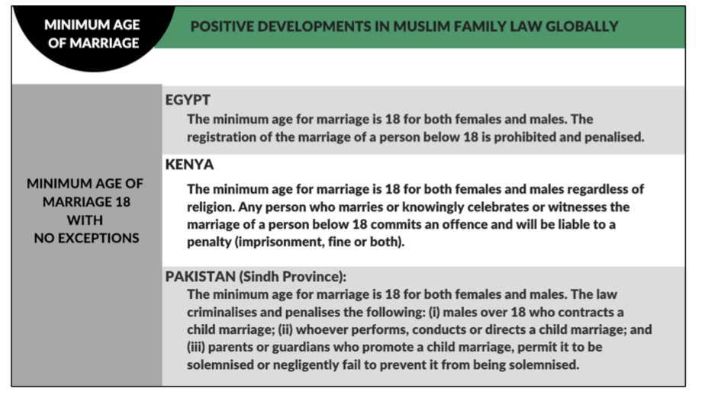
Such a move could help to unify the country’s approach to the issue and support efforts combatting child marriage already underway. Early this year in Taiz, the wedding of an 11-year-old girl to a 50-year-old man was halted after a social media hashtag campaign. Security forces—principally funded by the government—placed the girl’s father in prison to deter others intending to do the same. They also issued a circular banning underage marriage and punishing violators, while simultaneously ordering security forces to monitor for child marriages. Taiz police are credited with the first-ever intervention to stop a child marriage in Yemen in 2013. At the time, Yemen’s Ministry of Human Rights had made the issue of child marriage a priority, and in 2014 the National Dialogue Conference took decision 167 to establish the minimum age of marriage at 18 years old.

RECOMMENDATIONS
- Establish a minimum age of marriage of 18 years old.

- Amend the circular issued by the Ministry of Justice to Shari’ah officials to instruct them not to officiate any marriages of women under the age of 18 years old, rather than 17 years, and institute penalties for violators.

- Provide targeted training programs to law enforcement officials, the judiciary, healthcare workers, and social workers to respond to reports of child marriages, in order to effectively prevent such marriages where possible, prosecute those responsible, ensure effective penalties, and provide adequate support to victims.

- FORCED MARRIAGE Article 16

Child marriage often overwhelmingly coincides with forced marriage, despite YPSL Article 10 prohibiting forced marriages. Consent of a child cannot be considered valid and children lack the capacity and awareness to make marriage decisions. Often, children are lied to or remain uninformed of their fate at the time of marriage, as was the case with N., who was taken to her new husband’s house under the pretext of visiting family and was then left there. YPSL Article 23 allows for a virgin’s silence to be taken as consent, facilitating forced marriage especially where children are involved.

The issue is further compounded by the fact that the family typically takes the bride’s mahr (dower), effectively locking her into the marriage against her will, given that initiating a divorce by a woman in Yemen (using the khul’ mechanism) requires the woman to return the mahr, under YPSL Article 54. Although there are exceptions to this, such as a judge finding abuse in the marriage, practical obstacles for a child accessing courts and having her testimony perceived as credible still exist. Lack of consent also exists for older women, as they can be married off by male relatives not only without consent but without even their knowledge, by the guardianship structure set out in the law.

RECOMMENDATIONS
- Abolish the institution of male guardianship in marriage, which allows for the consent of the guardian to supersede the consent of the woman, enabling forced marriages.

- Require the clear, affirmative consent of the bride for officiating marriages in all cases.

- Enforce penalties for forced marriage and train law enforcement officials and the judiciary to respond effectively to reports of forced marriages and provide adequate protections for women who report such practices.

- VIOLENCE AGAINST WOMEN Articles 1-5, 16 & 19, & GR35

Currently, there is no general legislation for domestic violence. Article 232 of the Penal Code provides for the punishment of a man convicted of killing or seriously harming his wife upon finding her in the act of adultery; however, it is limited to up to one year’s imprisonment. Furthermore, the Penal Code does not criminalise marital rape, and YPSL Article 40(2) in fact requires a woman to provide sex to her husband, creating a significant legal gap for marital rape.

An intricate legal system that fails to criminalise certain acts of violence against women alongside rules of blood money and family pardoning means violence against women goes unpunished, contributing long-term to an environment of increasing domestic violence amid the ongoing conflict and pandemic.

This is exemplified through the story of S., whose brother killed her in front of a judge in a Sana’a courtroom. Despite significant witnesses, her brother remains free to this day. He was only requested to pay penalty blood money, which is for the victim’s family, in this case also his own. Furthermore, the victim’s immediate family may pardon the murderer, which they chose to exercise in this case as they “considered his crime an attempt to avenge his honor and reputation.” This norm is further perpetuated by the social stigma around reporting domestic abuse, which is seen as a domestic matter to be dealt with in the family, leading to lack of pathways to justice for victims, training for law enforcement authorities, and accountability from community adjudicators.

Female Genital Mutilation (FGM)

FGM is not criminalised and, in some areas in Yemen, is accepted as a cultural practice that is especially suited to curbing girls’ sexual drive and preventing shame to the family from early pregnancy. It is practiced mostly in specific areas, especially along the coast in Hodeida and Hadramaut, usually conducted in rural areas by a traditional midwife. The prevalence across Yemen can range from less than 1% to over 80% (Al-Mhrah and Hadramaut). While there had been extensive work by activists to combat its spread, the war superseded their priorities and there is now significant risk of the practice spreading to less remote areas.

In 2014, the National Dialogue Conference took decision 94 to criminalize assault on bodily integrity, including FGM. This should be made into law as soon as possible.

RECOMMENDATIONS
- Enact without delay legislation on violence against women and girls, including domestic violence, to ensure that all violence against women constitutes a criminal offence.

- Amend without delay the Penal Code to criminalise marital rape.

- Adopt legislation criminalising female genital mutilation, and strengthen awareness-raising and educational efforts, targeted at both men and women, with the support of civil society organizations and religious authorities, in order to completely eliminate this practice and its underlying justifications.

- Establish female sections in police stations and hire more female officers to deal with complaints and investigations of violence against women.

- Train law enforcement, the judiciary, healthcare workers, and social workers to respond effectively and provide adequate support to victims of violence.

- Establish government-funded shelters for victims of domestic and sexual violence across the different governorates to safely accommodate survivors and their children, and put into place a comprehensive support system in order to rehabilitate these survivors and reintegrate them into the community.

- Repeal any discriminatory penal provisions of the Penal Code to ensure that murders committed against women by their husbands or male relatives are prosecuted and punished in the same way as any other murder.

- INHERITANCE Articles 15 & 16

Article 23 of the Yemeni Constitution states that, “The right of inheritance is guaranteed according to the Islamic sharia and shall be promulgated by law.” This led to YPSL Articles 299-347, in which women and men in the same degree of relationship to a deceased are not entitled to equal shares in the estate. In many instances, a woman only receives half of the inheritance that a man with the same degree of relationship to the deceased would receive.

For Yemeni women, the most pressing concerns regarding inheritance rights are: unequal inheritance under the law, stolen or refused inheritance, and coercion into methods that keep inheritance lawfully within the family, such as forced marriage to relatives. Stolen or refused inheritance is of particularly significant concern. Protests have been documented of Yemeni women demanding their right to inheritance and sometimes turning to the courts to enforce their rights, especially where men have taken their inheritance by forging their signatures.

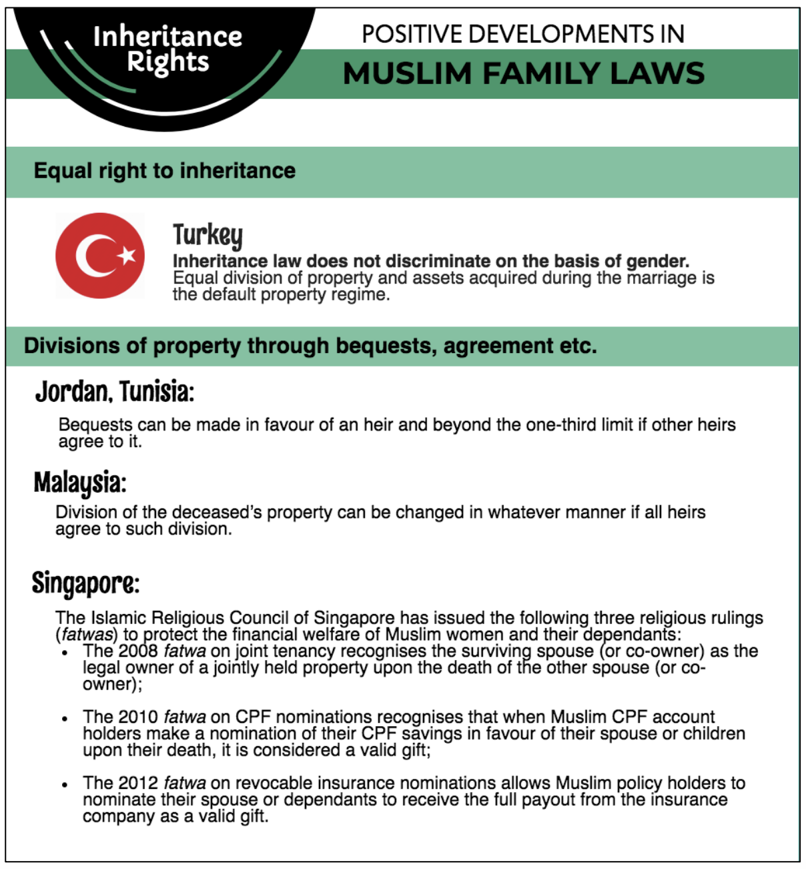

RECOMMENDATIONS
- Reform provisions on inheritance to grant inheritance on equal grounds for women and men, putting into place additional mechanisms to effectively implement the inheritance rights of women. The State may draw from progressive legislation in other Muslim contexts such as Turkey, Jordan, Tunisia, Malaysia, and Singapore.

- Ensure judicial access to and effective remedies for women whose inheritance has been forcibly taken from them, including instituting proper evidentiary standards in cases of inheritance disputes.

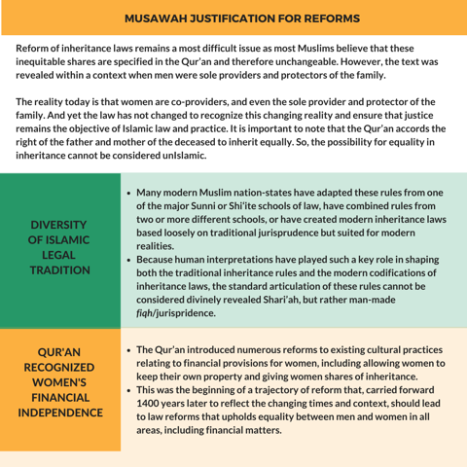

- NATIONALITY Article 9

Article 11 of the Yemeni Nationality Law outlines the conditions allowing a Yemeni man to pass his nationality to a non-Yemeni wife. However there is no such provision for a Yemeni woman to confer her nationality to a non-Yemeni husband, indirectly prohibiting the situation.

The manner in which nationality is passed to a child depends on whether Yemeni nationality will be received from the father or mother, as outlined in Article 3 of the Nationality Law. Article 3 states that “Anyone born to a Yemeni father who enjoys Yemeni Nationality” will have Yemeni nationality, whereas a mother can only pass on her nationality if the father is legally unknown, stateless, or his nationality is unknown. Furthermore, this provision was enacted in 2010 without retroactive effect, unless a request to grant citizenship is submitted within 3 years from the date of the amendment and approved by the Minister, or after a year has passed since the submission of the request. The committee formed to review these applications received only five to six cases and then stopped its work.

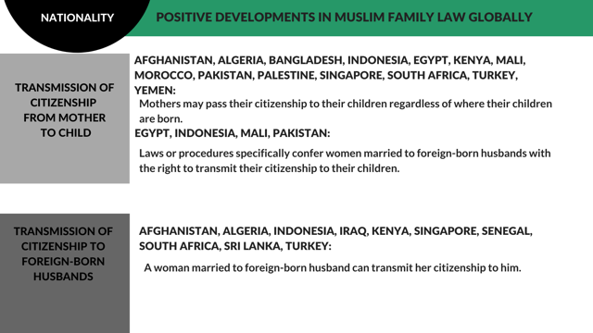

RECOMMENDATIONS
- Amend the Nationality Law to remove discrimination by permitting a Yemeni woman to pass on her nationality 1) to her children from a foreign spouse in the same way a Yemeni father would, and ensure the provision is applied retroactively and automatically; and 2) to her foreign spouse.

V. ANNEX OF SHORTENED LINKS IN FOOTNOTES

22 and 29) AlArabiya: https://tinyurl.com/rt9u8tnd
حملة توقف زفاف طفلة باليمن وتعيد زواج القاصرات للواجهة
https://www.alarabiya.net/arab-and-world/yemen/2021/01/28/%D8%AD%D9%85%D9%84%D8%A9-%D8%AA%D9%88%D9%82%D9%81-%D8%B2%D9%81%D8%A7%D9%81-%D8%B7%D9%81%D9%84%D8%A9-%D8%A8%D8%A7%D9%84%D9%8A%D9%85%D9%86-%D9%88%D8%AA%D8%B9%D9%8A%D8%AF-%D8%B2%D9%88%D8%A7%D8%AC-%D8%A7%D9%84%D9%82%D8%A7%D8%B5%D8%B1%D8%A7%D8%AA-%D9%84%D9%84%D9%88%D8%A7%D8%AC%D9%87%D8%A9

25 and 28) AlAraby: https://tinyurl.com/2vrxavt7
زواج القاصرات في اليمن.. عائلات تبيع بناتها بـ "الديون"
https://www.alaraby.co.uk/%D8%B2%D9%88%D8%A7%D8%AC-%D8%A7%D9%84%D9%82%D8%A7%D8%B5%D8%B1%D8%A7%D8%AA-%D9%81%D9%8A-%D8%A7%D9%84%D9%8A%D9%85%D9%86-%D8%B9%D8%A7%D8%A6%D9%84%D8%A7%D8%AA-%D8%AA%D8%A8%D9%8A%D8%B9-%D8%A8%D9%86%D8%A7%D8%AA%D9%87%D8%A7-%D8%A8%D9%80-%22%D8%A7%D9%84%D8%AF%D9%8A%D9%88%D9%86%22

31) The Independent Arabia: https://tinyurl.com/2m2nv3hv
الحرب تُنعش "زواج القاصرات" في اليمن
https://www.independentarabia.com/node/5556/%D8%AA%D8%AD%D9%82%D9%8A%D9%82%D8%A7%D8%AA-%D9%88%D9%85%D8%B7%D9%88%D9%84%D8%A7%D8%AA/%D8%A7%D9%84%D8%AD%D8%B1%D8%A8-%D8%AA%D9%8F%D9%86%D8%B9%D8%B4-%D8%B2%D9%88%D8%A7%D8%AC-%D8%A7%D9%84%D9%82%D8%A7%D8%B5%D8%B1%D8%A7%D8%AA-%D9%81%D9%8A-%D8%A7%D9%84%D9%8A%D9%85%D9%86

“The World Bank In Yemen: Overview,” The World Bank, Mar 25, 2021, https://www.worldbank.org/en/country/yemen/overview#.1 (“The World Bank”).
Gregory D. Johnsen, “The end of Yemen,” The Brookings Institution, March 25, 2021, https://www.brookings.edu/blog/order-from-chaos/2021/03/25/the-end-of-yemen.
“To End Yemen’s Tragic Plight, Parties Must Agree on Humanitarian Action, Nationwide Ceasefire, Special Envoy Tells Security Council,” United Nations Security Council, April 15, 2021, https://www.un.org/press/en/2021/sc14494.doc.htm (“UNSC).
A trained and armed women's military faction of the Houthis, who carry out house raids, disperse women-staged demonstrations, and arrest or detain women. See Nabil Abdullah al-Tamimi. "Houthis use all-female battalions to suppress Yemeni women." Al-Mashareq, 16 August 2018. https://almashareq.com/en_GB/articles/cnmi_am/features/2018/08/16/feature-01.
Information received from Yemeni advocate, August 2021.
The World Bank, https://www.worldbank.org/en/country/yemen/overview#1.
“Freedom in the World 2021: Yemen,” Freedom House, https://freedomhouse.org/country/yemen/freedom-world/2021 (“Freedom House”).
Freedom House, https://freedomhouse.org/country/yemen/freedom-world/2021.
Information received from Yemeni advocate, August 2021.
Ibid.
Kali Robinson, “Yemen’s Tragedy: War, Stalemate, and Suffering,” Council on Foreign Relations, February 5, 2021, https://www.cfr.org/backgrounder/yemen-crisis.
Dr, Jack Watling, “In Yemen, Competitors Lay the Ground for the Long Haul,” RUSI, June 14, 2021, https://rusi.org/explore-our-research/publications/commentary/yemen-competitors-lay-ground-long-haul
UNSC, https://www.un.org/press/en/2021/sc14494.doc.htm.
"Who Provides? Who Cares? Changing Dynamics in Muslim Families" Musawah, 2018, pp. 11-18. https://www.musawah.org/resources/who-provides-who-cares-changing-dynamics-in-muslim-families.
Information received from Yemeni, July 2021.
“Replies of Yemen to the list of issues and questions in relation to its combined seventh and eighth periodic reports,” CEDAW/C/YEM/RQ/7-8, July 14, 2020, page 7, para 28.
Information received from Yemeni advocate, July 2021.
Ghaidaa Motahar, “Gendered Security: Gender-based Violence and Women’s Access to State and Non-state Security Provision in al-Dhali’,” Yemen Policy Center, April 2020, https://www.yemenpolicy.org/gendered-security.
“Yemen: End Child Marriage,” Human Rights Watch, April 27, 2014, https://www.hrw.org/news/2014/04/27/yemen-end-child-marriage (“Human Rights Watch”).
https://raseef22.net/article/29638-early-marriage-in-yemen
Human Rights Watch, https://www.hrw.org/news/2014/04/27/yemen-end-child-marriage.
AlArabiya: https://tinyurl.com/rt9u8tnd . حملة توقف زفاف طفلة باليمن وتعيد زواج القاصرات للواجهة
http://www.nfdhr.org/news/695#.YLQJ5qhKjb1
Al Shaibany, S. and Al Wasmi, N., “Child marriage on the rise as conflict in Yemen continues”, The National, 17 April 2018, available at: https://www.thenational.ae/world/mena/child -marriage-on-the-rise-as-conflict-in-yemen-continues-1.722499.
AlAraby: https://tinyurl.com/2vrxavt7. زواج القاصرات في اليمن.. عائلات تبيع بناتها بـ "الديون"
https://arabic.cnn.com/middleeast/2014/03/08/violence-women-yemen
https://raseef22.net/article/29638-early-marriage-in-yemen
AlAraby: https://tinyurl.com/2vrxavt7.
AlArabiya: https://tinyurl.com/rt9u8tnd . حملة توقف زفاف طفلة باليمن وتعيد زواج القاصرات للواجهة
Sebastian Usher, “Yemen police 'stop child's wedding',” BBC, November 8, 2013, https://www.bbc.com/news/world-middle-east-24870526.
The Independent Arabia: https://tinyurl.com/2m2nv3hv . الحرب تُنعش "زواج القاصرات" في اليمن
Fairoz Al-Garadi, “The Case of Guardianship in Marriage in Conceptual Debates and Real Life Stories,” Al-Madaniya, October 12, 2020, https://almadaniyamag.com/2020/10/12/guardianship_in_marriage.
Information received from Yemeni advocate, August 2021.
“Female Genital Mutilation Dashboard (FGM) - Yemen,” UNFPA, https://www.unfpa.org/data/fgm/YE.
“FGM in Yemen,” 28TooMany, September 2020, https://www.28toomany.org/static/media/uploads/Country%20Research%20and%20Resources/Yemen/yemen_short_report_v1_(september_2020).pdf.
“Replies of Yemen to the list of issues and questions in relation to its combined seventh and eighth periodic reports,” CEDAW/C/YEM/RQ/7-8, July 14, 2020, page 6, para 23.
https://www.facebook.com/watch/?v=10156206556407910
Shadow report of Sisters’ Arab Forum for Human Rights/Yemeni NGOs CEDAW Coalition, submitted to the 80th Session of the CEDAW Committee, October 4, 2020, page 16.
Shadow report of Civil Alliance for Rights and Feminism, submitted to the 80th Session of the CEDAW Committee, October 2020, page 13.

