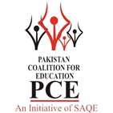
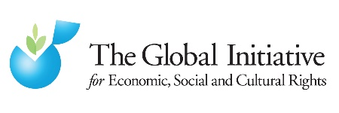
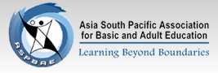

Privatised Education in Pakistan and the Right to Education: A right out of reach?

  - Alternative Report Submitted by Pakistan Coalition of Education with support of the Global Initiative for Economic, Social and Cultural Rights, Asia South Pacific Association for Basic and Adult Literacy (ASPBAE), Childs Rights Movement Pakistan (CRM), Society for Protection of the Rights of the Child (SPARC), Bonded Labour Liberation Front (BLLF), Pakistan Institute of Labour Education and Research (PILER), Pakistan Fisher folk Forum (PFF), Community Development Organization (CDO) and Workers Education and Research Organization (WERO)
  - Presented to the United Nations Committee on Economic, Cultural and Social Rights (CECSR) at its session for ICESCR
  - SUBMITTED in April 2017
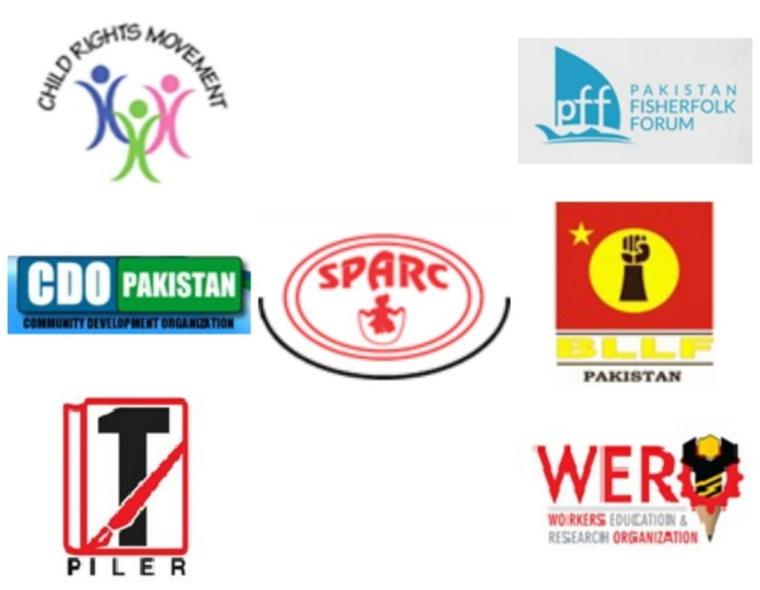

The main organisations submitting this report are:

- The Global Initiative for Economic, Social and Cultural Rights (GI-ESCR), which is an international non-governmental human rights organisation which seeks to, advance the realisation of economic, social and cultural rights throughout the world, tackling the endemic problem of global poverty through a human rights lens. It was established and it is in consultative status with the United Nations Economic and Social Council (ECOSOC). See more on http://globalinitiative-escr.org/.
- The Pakistan Coalition for Education (PCE) is a network of 200 member organizations which on the national level include local Community Based Organizations (CBOs), Non- Government Organizations (NGOs), Parents’ and Teachers Associations, civil society networks present in 65 districts. PCE is also a member of global alliances such as the Global Campaign for Education and Global partnership for Education. The coalition focuses on issues concerning education by working in close collaboration with the media including education reporters associations and representatives of relevant education departments and legislators. For more details see: http://www.pcepak.org
- Asia South Pacific Association for Basic and Adult Education (ASPBAE) is a regional association of more than 200 organizations and individuals. It works towards promoting quality education for all and transformative and liberating, life-long adult education and learning. ASPBAE is committed to ensuring that every individual receives their right to a good quality education and lifelong learning opportunities. Its members and partners work closely together to hold governments accountable for making education available, accessible, acceptable, and adaptable - free from all forms of exclusion and discrimination. For more information: http://www.aspbae.org/
- Childs’ Rights Movement Pakistan is a network of more than 200 civil society organizations and experts across Pakistan. The network is being envisioned as a civil society pressure group on issues faced by children and is striving towards the creation of an enabling environment for children through collective advocacy on child rights issues. Besides a National Secretariat, CRM Pakistan operates through seven (07) independent chapters, including chapters in all four provinces as well as in AJK, GB and FATA. See more: http://crm.com.pk/
- Society for Protection of the Rights of the Child (SPARC) is one of the leading rights based organizations working for rights of the children in Pakistan. The efforts range from general child rights issues, addressing the overall system and policy framework, with added focus on specific thematic areas of special importance to children. SPARC’s work is guided by international human rights principles and standards which are integrated at policy and program level. SPARC has consultative status with the United Nations ECOSOC (Economic and Social Council) and the United Nations Department of Public Information and is also partnered with Defence for Children International (DCI). Website: http://sparcpk.org/
- Bonded Labour Liberation Front (BLLF) is a non-governmental labour rights organization working for past 35 years to combat all forms of bonded labour from South Asia. Their work mainly concerns the eradication of bonded labour practices from economy and address related issues such as supporting the legislation of new laws and implementation of the existing laws according to bonded labour abolition system act 1992 and rules 1995, free and compulsory primary education to all children and implementation of announced minimum wage strictly. For more details: http://www.bllfpak.org/
- Pakistan Institute of Labour Education and Research (PILER) is a labour rights research organization with the main objective to education the workers in Pakistan about their economic and social rights through education, trainings and workshops. PILER is dedicated to promoting a democratic and effective labour movement for the overall advancement of a socially just and equitable society where the fundamental rights of people is respected and guaranteed. See more: http://www.piler.org.pk/

- Pakistan Fisher folk Forum (PFF) is a civil society organization working for advancement of social, economic, cultural and political rights of fisher folk and peasants in Pakistan. The PFF is a democratic organization with 70,000 memberships across the country having minimum 35% women ratio. Its struggle targets the policy issues relating to fishing rights, fish marketing & fish conservation, rehabilitation of the Indus Delta, Sustainable Fisheries Policy, abolition of Contract System over inland waters, historical fishing rights on entire water bodies for indigenous fishers, discouraging industrial fishing by deep sea trawlers & marine pollution, detention of fishermen. The PFF’s capacities and capabilities of working in the field of early warning, rescue and evacuation, emergency response and early recovery have been recognized at national and international level.

- Workers Education and Research Organization (WERO) is a civil society organization working mainly for advancement of workers’ economic and social rights through education advocacy.

Global Initiative for Economic, Social, and Cultural Rights and Pakistan Coalition for Education, August 2016.

The desk- research for this report was conducted by Pakistan Coalition of Education, with the support of GI-ESCR.

 | Contact information
Nida Mushtaq  Research Coordinator  Pakistan Coalition for Education  nida@pcepak.org  Zehra Arshad  National Coordinator  Pakistan Coalition for Education  zehra@pcepak.org | Sylvain Aubry  Right to education researcher  Global Initiative on Economic, Social And Cultural Rights  sylvain@globalinitiative-escr.org | Lucy McKernan  UN Liaison  Global Initiative for Economic, Social and Cultural Rights  lucy@globalinitiative-escr.org

KEY ISSUES ADDRESSED IN THE REPORT
This report attempts to analyse the following key issues:
- Despite the provision of law mandating the Pakistan government to provide free and compulsory primary and secondary education and its recognition as a fundamental right enshrined in Article 25-A of the Constitution, Pakistan is one of the lowest spender in education in the world and it has put in place a deliberate policy to favour private education, which has grown at an alarming rate and threatens the realisation of the right to education.
- The State has consistently failed to prioritise education spending and commit the maximum available resources to adequately finance the realisation of free and compulsory primary and secondary education. The unprecedented growth of fee-charging private education has resulted in discrimination against and stratification of some segments of society, especially children from the poorest Pakistani families, and the lack of an adequate regulatory framework and monitoring mechanisms has created an anarchic space with low quality education.
Recommended questions for Pakistan:
- What steps is the State party taking to improve and strengthen free public primary and secondary education of quality, in line with its obligations under international human rights law?
- What measures is the State taking to contain the leakages within the Education Budget and what is being done to deal with the under-spending of the Provincial Education Budgets to ensure the Right to Education?
- Given that previous reforms have failed to guarantee the realization of the right to education without discrimination, can the State Party give the timeline within which it is planning to effectively address segregation and discrimination in the education system as a matter of priority?
- How will the government concretely ensure that schools receiving public funds under PPP schemes do not practice any form of entrance selection and do not charge additional fees?
- What is the implementation status of the Islamabad Capital Private Educational Institutions (Registration and Regulation) Act 2013? As to how many school inspections have been made since 2015, and how many schools have been imposed with penalties?
- How does the State intend to monitor, regulate and evaluate the operation of private actors in education to ensure compliance with national laws and international treaties, and to ensure the right to education for all without discrimination?
Recommendations to resolve this issue:
- To institute an appropriate regulatory and monitoring framework for monitoring the enforcement of Article 25 (a) of the Constitution. The State should work together with civil society to establish an appropriate regulatory environment for the provision of education services.
- To demonstrate that private sector providers of education respect the aims and purpose of education as identified by the Convention.
- To take concrete steps to ensure that a Right to Education Law is introduced in Khyber Pakhtunkhwa and that all Provinces develop a timeframe for the introduction and implementation of legislation for the effective realisation of the right to education as sanctioned by the Constitution.
- To substantially increase the education budget and redistribute funds to strengthen the public sector and to match as a minimum the international target of 6% of GDP or 20% of the annual budget as a matter of urgent priority, and immediately make a plan to develop free public education across the country in the shortest possible time.
- To contain the governance leakages in terms of provincial budget expenditures in order to move towards effective budget utilization.
- The State is also encouraged to make an effort to make the provincial budgets allocate more budget for Non-salaried budget in order to uplift the conditions of public schools
- To conduct a rigorous and independent assessment of the impact of various public-private partnership policies in the education sector on the right to education

Privatised education in Pakistan and the right to education: A right out of reach?
  - Alternative Report submitted to the United Nations Committee on the Economic, Social and Cultural Rights (CECSR)

Contents
I. Introduction 6
II. The right to education in Pakistan 6
1. General situation of the right to education 7
III. Privatisation of education and the realisation of the right to education in Pakistan 10
1. General legal and policy framework on private actors’ involvement in education 10
2. How is Pakistan privatising education? Support of the State for the expansion of private actors’ involvement in education 11
IV. Impact of privatisation in education on the realisation of the right to education in Pakistan 17
1. Structural disparities in access to education as a result of private school expansion 17
2. Absence of regulations for private schools in Pakistan 20
V. Recommendations to the State party 26

- Pakistan signed the International Covenant on Economic, Social and Cultural Rights (“ICESCR”) on 3rd November, 2004 and ratified it on 17th April, 2008. The State Party submitted its first report (“State Report”) to the Committee on Economic, Social and Cultural Rights (“CESCR”) on 16 October 2015.

Introduction
- This alternative report to the UN Committee on the Economic, Social and Cultural Rights (CESCR) for the 61st session (29th May- 23 June) is based on a research compiled and conducted by Pakistani and international organizations on the impact of the growth of the private actors in the education system on the realization of the right to education in Pakistan. It focuses in particular on the segregation and discrimination effects of education privatisation and addresses issues of inadequate regulation and monitoring of private education providers. Privatisation in this report refers to the growth of private schools, in particular low-fee private schools. It also addresses public-private partnerships (PPP) in education, in particular when they promote privatisation and low-fee private schools.
- Privatisation in education is a growing global phenomenon threatening the right to education in many countries. An increasing body of research is examining the impact of these developments on human rights and social justice. In 2014, the UN Special Rapporteur on the right to education, Mr Kishore Singh, presented a report to the UN General Assembly which examines State responsibility in the face of the explosive growth of private education providers, in the light of States’ human rights obligations, and lays out some of the principles applicable. He further explored the issue with another report in June 2015, dealing with the regulation of private actors in education, and a report in September 2015 examining public-private partnerships.
- As this report demonstrates, this issue is also largely prevalent in Pakistan, where the government-supported growth of private actors in education is infringing upon the realization of the right to education.

The Right to Education in Pakistan
- Education has only recently been made a fundamental, justiciable and enforceable right in the Pakistan Constitution. Prior to the 2010 18th Constitutional Amendment, education was added as a Principle of Policy. The 1973 Constitution of the Islamic Republic of Pakistan only stipulated in article 37-b that the State shall “remove illiteracy and provide free and compulsory secondary education within minimal possible period”, and in article 38(d) that the State shall “provide basic necessities of life, such as food, clothing, housing, education and medical relief, for all such citizens, irrespective of sex, caste, creed or race, as are permanently or temporarily unable to earn their livelihood on account of infirmity, sickness or unemployment”. As part of the 18th Constitutional amendment, Article 25-A was added to the Chapter on “Fundamental Rights” and stipulates: “The state shall provide free and compulsory education to all children of the age five to sixteen years in such a manner as may be determined by law”.
- Although legislative and executive powers related to school education have been devolved to the provinces as part of the enactment of the 18th Amendment to the Constitution, the federal government cannot be absolved of its duty to realise the fundamental rights as provided in the constitution and international law.
- The Right to Free and Compulsory Education Act 2012 confirms the Constitutional right to free and compulsory education to all children of aged five to sixteen years and articulates how it shall be delivered. Besides, at the state level, the Islamabad Capital Territory (ICT) and Sindh province have passed legislation for the implementation of Article 25A. In 2014, both the provinces of Balochistan and Punjab Province respectively passed the Balochistan Compulsory Education Act and the Punjab Free and Compulsory Education Act 2014. In Khyber Pakhtunkhwa the Khyber Pakhtunkhwa Right of Children to Free and Compulsory Education Bill 2014 is yet to be passed.
- The National Education Policy (NEP) 2009 is the main policy intervention in Pakistan of the last two decades. It was intended as a “living document” which will remain in place for an indefinite period of time and have improvements made accordingly. NEP 2009 aimed to address the shortcomings of its predecessor, NEP 1998-2000 and rejuvenate the country’s education system by widening access to education and improving quality. One of these ways was to commit to raise the education budget up to 7% of the GDP by 2015. Other key policy actions include:
- Achieving universal and free primary education by 2015 and up to class 10 by 2025;
- Promoting equity in education with the aim to eliminate social exclusion and provision of increased opportunities to marginalized groups, particularly girls;
- Determine nation standards for education inputs, processes and outputs;
- Introduction of a common curriculum framework for public and private sectors.

General situation of the right to education
- Pakistan faces enormous education challenges. After Nigeria, Pakistan has the world’s second highest out of school population. Figures on the total number of out of school children range between 8.8 million and 25 million. Almost one in every five child of primary school age is not in school and this proportion increases at higher education levels. Balochistan province is home to the highest proportion of out of school children, followed by the Federally Administered Tribal Areas.
- Access to education varies greatly by location, gender and wealth. More than half of all out of school children are girls and children from poor households are more likely to be out of school compared to their counterparts in high-income families. According to the ASER Wealth Index (2013, 2014 and 2015), the richest quartile of the population has the highest enrolment rate (80%) while the poorest quartile has the lowest (61%). The below figure shows the percentage of children who have never been to school by location (urban/rural), gender and wealth.
Children who have never been to school by location (urban/rural), gender and wealth in 2012
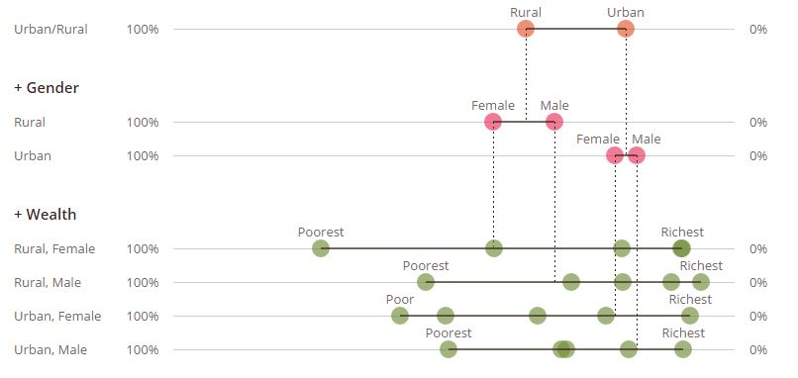
Source: UNESCO World Inequality Database on Education based on Pakistan Demographic and Health Survey 2012
- The above figure illustrates the widening gap between the children belonging from different socio-economic strata and gender. The majority of children who have never been to school are most likely to be poor girls belonging from rural areas (̃70%). It can also be seen that the gender parity in terms of choice is least in urban children.
- The educational outcomes of children who are in school are also bleak. According to ASER Pakistan data, of those children enrolled in Class 5, only 55% can read a story in Urdu/Sindhi/Pashto and 49-50% can read an English sentence or solve a two-digit division problem.
- The majority of children in rural and urban slum areas from low income families attend public schools that lack appropriate facilities, are faced with an acute shortage or absence of teachers and non-availability of suitable learning materials, such as textbooks. According to PCE survey from 2015, 26% of government primary schools do not have electricity or access to clean drinking water and 53% do not have functioning toilets.
- The current educational challenges faced by Pakistan are multidimensional. Most of these challenges are chiefly due to consistent insufficient education spending by subsequent governments. According to the Ministry of Finance’s 2014 – 2015 economic survey, Pakistan spent 2.14% of its GDP on education, falling far short of Pakistan’s longstanding target, reiterated by the current federal government, of spending 4% of GDP on education by 2018, and even more of the international target of 6%.
- It is however notable that the provinces after the 18th Amendment have allocated 20% and above of their provincial budgets to education with Khyber Pakhtunkhwa allocating the highest (25%) for the fiscal year 2015-16.
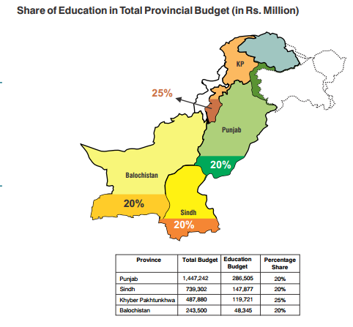
Source: ISAPS, Public Financing of Education in Pakistan Analysis of Federal, Provincial and District Budgets 2010-2016
- From the above statistics it is noteworthy to see that the provinces have allocated 20% and above of their total budgets to Education. The trend continued from last year where the provincial budgets hovered between 17-24%. However despite this increase the results have not been translated to the uplift of education system in the country. The issue of misspending has been discussed by Naviwala (2015) when she expounds on the spending dilemma in education.
- The table below shows that education spending has hovered around the 2% of GDP mark for the past decade. For the current year 2016 it is projected to hover around 2.2-2.3% of the GDP as compared to last year’s expenditure of 2.2%.
Education Expenditure as a percentage of GDP
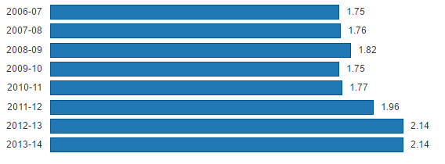
Source: Pakistan Economic Survey 2014-15
- Even taking the corrected figure from the UNESCO Institute for Statistics of 2.45% of GDP spent on education, Pakistan in 2014 ranked the third in terms of lowest spending in education in percentage of GDP, for countries for which UNESCO had data that year, behind the Bermuda and Armenia.
The 10 countries with the lowest spending in education as percentage of GDP in 2014
Country | % of GDP spend on education in 2014
- Bermuda | 1.78285
- Armenia | 2.39756
- Pakistan | 2.45459
- Sierra Leone | 2.72976
- Kazakhstan | 2.88742
- Iran (Islamic Republic of) | 3.06152
- United Republic of Tanzania | 3.48143
- Qatar | 3.52539
- China, Hong Kong Special Administrative Region | 3.57196
- Peru | 3.657
Source: UNESCO Institute of Statistics: See http://data.uis.unesco.org/ (retrieved on 16 April 2016)

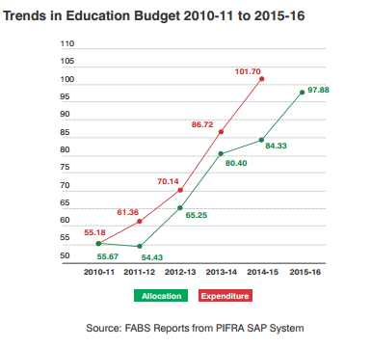
Source: ISAPS, Public Financing of Education in Pakistan Analysis of Federal, Provincial and District Budgets 2010-2016

- Pakistan’s spending on social services, which include education and health, has always come secondary to debt servicing and military expenditure. Combined these two sectors received nearly 7% of GDP in 2013-14 and each receive a higher allocation than education. Given the current education challenges, Pakistan should take immediate measures to ensure that the maximum available resources are devoted towards education as per its obligations set out under international law. If the current Sustainable Developmental Goals are to be met, the budget allocation on education would roughly need to triple.

Privatisation of education and the realisation of the right to education in Pakistan

General legal and policy framework on private actors’ involvement in education
- Based on the work analysing the situation with regards to privatisation in education in seven other countries, and following extensive consultation with education civil society organizations at the domestic, regional and international level, and with human rights and education academics and experts, a group of organisations, including the Global Initiative for Economic, Social and Cultural Rights, and the Right to Education Project, have developed the following draft analysis framework, which set out how international human rights law applies to privatisation in education, drawing in particular on articles 28 and 29 of the ICRC and article 13 of the International Covenant on Economic, Social and Cultural Rights (ICESCR). This framework aims at providing an understanding of these articles, which on one hand protect the right to free quality education without discrimination (art. 13.1 and 13.2 of the IESCR, art. 28 and 29.1 of the ICRC) and on the other hand provides some liberty for parents to choose a school of their choice (art. 13.3 and 13.4 of the ICESCR, art. 29.2 or the ICRC), under some conditions.
Private actors in education: draft human rights analysis framework
Noting the paragraphs 13 and 14 of article 13 of the ICESCR and paragraph 2 of article 29 of the ICRC on the liberty of education, when there are private actors providing education services, States must ensure that their involvement:
- Does not lead to the creation of extreme disparities in access to quality education or discrimination of any kind, and does not lead to segregation or division in societies in general or education in particular;
- Provides for a true alternative choice to quality free education, and does not replace the public system;
- Does not lead to the marketization of education such that education is no longer directed to the full development of a child's personality, talents and mental and physical abilities, but instead only to profit-making and achieving measurable outcomes - which would be contrary to the aims of education recognized in human rights law;
- Maintains the highest quality standards and is adequately regulated, both in law and in practice, with adequate inspection staffing, effective accountability mechanisms, and without corruption; and
- Is the result of a participatory policy formulation process and continues to be subject to democratic scrutiny and to the human rights principles of transparency and participation.
- The legal justification under international law and under the ICRC, for each of these dimensions has been detailed in previous reports, such as the parallel report on the Philippines submitted to the UN Committee on Economic, Social and Cultural Rights (CESCR): ‘Privatization, Commercialization and Low Government Financing in Education: Infringing on the Right to Education of Filipinos’. This report focuses on the first and the fourth areas of this framework: segregation and discrimination and the lack of regulation.

How is Pakistan privatising education? Support of the State for the expansion of private actors’ involvement in education
- Although education is mandated to be free, households bear a large part of education costs, largely resulting from low government spending on education, leakages in the system which results in misspending of the budget. According to the EFA Global Monitoring Report, about two-thirds of total expenditure on education comes from households. Meagre national education spending combined with a rapidly growing population and international pressure on the State to advance its efforts in achieving universal primary education has resulted in State support for the expansion of private education. In addition to that, the ineffective system due to leakages in budget rendering the public schools to be out of demand, Pakistan has experienced an unprecedented growth in the number of private schools. In particular, there has been a dramatic expansion of the so-called low-fee private schools in poor urban areas and rural villages over the last two decades. According to ASER data, approximately 59% of children in urban areas and 23% in rural areas were enrolled in private schools in Pakistan in 2012.
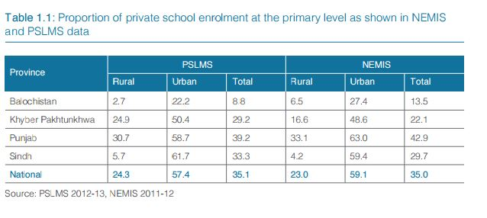
Source: Alif Ailaan, 25 million broken promises: The crisis of Pakistan’s out of school children (2014) .p.6
- The below table compares public and private school enrolment at the pre-primary, primary, lower and upper secondary levels and shows that the enrolment of children in private schools has increased at the primary level while public school enrolment has declined between 2009 and 2012.
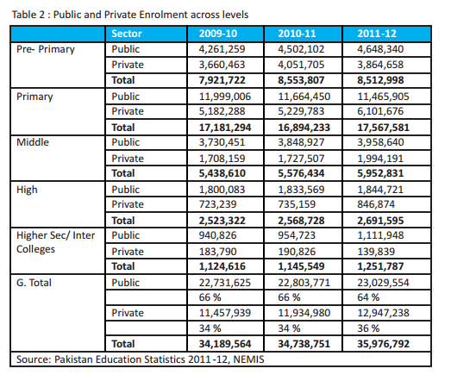
Source: National Education Management Information System 2011-2012)

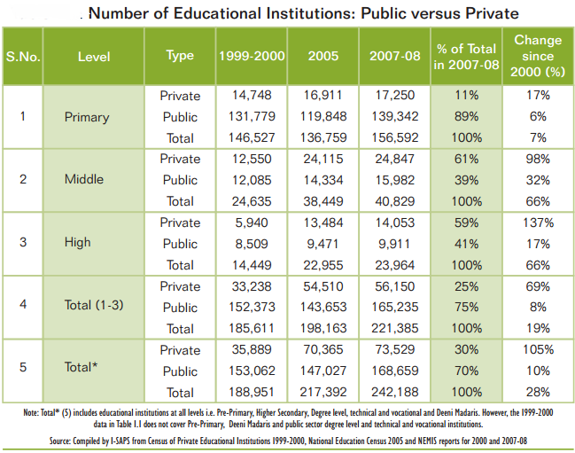
Source: I-SAPS Publication. Census of Private Schools (2007)
- Private education providers in Pakistan range from non-profit community based schools and trust schools to the more prevalent profit-making school managed by an individual or a corporation. The most prevalent private school models that can be found throughout the country are: low-fee private schools (LFPS), high fee charging schools, public private partnership schools such as the ones run by Sindh Education Foundation and the Punjab Education Foundation, non-governmental organization (NGO) run schools, schools run by madrasas and community run schools. At present, the private school system is largely composed of institutions that are for-profit, fee-based, secular, and autonomous.
- The growth of low-fee private schools has been particularly salient in recent years, notably in the Punjab Province where the government has proactively promoted the expansion of LFPSs through public private partnership modalities that are managed and financed through the Punjab Education Foundation (PEF). Established in 1991, the PEF was restructured into an independent institution in 2004, with the aim of promoting quality education through support to the private sector to provide education to the poor through public private partnerships. The foundation channels public funds to private schools through three major public private partnership initiatives including the Education Voucher Scheme, the Foundation Assisted Schools model and the New School Program. Both the World Bank and the UK Department for International Development have invested significantly in the PEF (see box below).
- Similarly, in the Sindh province, the government has turned to low-fee private schools with the aim of bolstering access to education and improve education quality at a lower cost, especially in remote areas without local public schools. The Promoting Private Schooling in Rural Sindh Project was created by the Sindh Education Foundation, a quasi-governmental agency of the Sindh provincial government, with the support of the World Bank. The program encourages private entrepreneurs to set up and operate private primary schools in underserved villages.
- A range of models that are in operation in the Sindh and Punjab Provinces, which this report includes:
  - Education Voucher Scheme (EVS): A voucher provided to parents of children who cannot afford to pay for their education in specially selected fee-charging private schools. The EVS program started in 2006 and is now functional in 17 districts of Punjab.
  - Foundation Assisted schools: Low-fee private schools that are assisted by education foundations on a per-child subsidy basis.

- Provision of education through these partnership models should remain free at the point of delivery; however, the myriad of models that these partnerships take can have differing implications for the right to education some of which are discussed in the subsequent sections.
Role of bi- and multi-lateral donors in promoting private education in Pakistan: violating the right to education?
The increased involvement of private actors in education in Pakistan has partly been driven by bi- and multi-lateral donors through various reform interventions promoted at the provincial level since the 1990s. Public Private Partnerships (PPPs) in education have been advanced in particular with donor support and have spurred the phenomenal growth of private education providers, in particular low-fee private schools.
Since its establishment in 1994, the World Bank has supported the Punjab Education Foundation (PEF), a quasi-autonomous institution of the provincial government, to promote PPPs in education. The World Bank has financed the foundations’ Education Voucher Programme with the aim of increasing access to education for the ‘poorest of the poor’. The UK Department for International Development (DFID) funds access to financing initiatives for low-fee private schools and provides significant funds for the PEFs programs to support LFPS. According to a recent report on the financing of education in Pakistan, “DFID has also established a company with functions very similar to the Sindh Education Foundation for funding public private partnership mechanisms – ones specifically focused on promoting private school establishment in low-income communities.”
In Sindh, USAID is assisting the government to implement a legal infrastructure to channel funds to private for-profit and not-for-profit actors and to implement in a charter school model in disadvantaged districts, referred to as the Education Management Organisations Model (EMO).
Through the International Development Association (IDA), the World Bank’s fund for the poorest, the Sindh government received assistance to develop and implement its Sindh Education Sector Reform Program with the aim of increasing enrolment, improving student achievement and reducing social disparities in education. This included a program offering cash subsidies to private entrepreneurs to provide primary schools in villages in remote areas without local schools.
Despite inconclusive evidence on the educational benefits of private schools, donors have invested and continue to invest substantially in the expansion of low-fee private schools and PPP programs in Pakistan. Similarly, “the evidential basis of the effectiveness of PPP is still not very clearly established, yet it is being promoted.” Most evidence demonstrating that the involvement of the private sector is a cost effective option and demonstrate a positive impact on quality has been supported by international organisations promoting these models. This is of major concern, particularly given a growing body of research evidencing the negative impacts of the growth of private actors on the right to education. An aggressive push for fee charging private providers by bi-lateral donors, such as DFID, is thus potentially a violation of States’ extra-territorial obligations, where this provision negatively affect the right to education.

- The current National Education Policy 2009 and its predecessors (1998-2010) encourage private investment in education and promote community participation and public-private partnerships to meet Pakistan’s education goals. It argues that the government alone cannot carry the burden of the whole education process at a heightened pace given the commitments made by Pakistan to the global development agendas and goals. NEP 2009 makes provision for special incentives for schools set up by the private sector, including land, tax exemptions, domestic rather than commercial rates for utilities and grants for the establishment of schools in rural or poor urban areas, provided through Education Foundations.
- Essentially, privatisation of education has been actively encouraged by the State. Public funds are increasingly diverted towards the expansion of private schools and public private partnerships in education. In the Punjab Education Sector Plan 2013-2017, PPPs are viewed as potential solutions in improving governance through “the productivity of public-private partnership and private schools can also be harnessed, under the ambit of Article 25-A” even though there is limited evidence on the efficacy of these partnerships.
- Similarly the Balochistan Education Sector Plan 2013-2017 acknowledges the mushroom growth of private schools and recommends a policy to regulate the sector however the standards are not defined. In Sindh Education Sector Plan 2014-2018, the government aims “to revive the rural economy, in part through increased engagement of the private sector actors.” Furthermore, the principal achievements of the first phase of the Sindh Education Reform Program (SERP-I) according to the Sindh provincial government were “Promoting Private Schools in Rural Sindh: Over 392 schools opened in rural/disadvantaged areas and enrolled 67,513 students”
- Such aggressive perusal of privatization policies in the sector plans of the provinces shows that the overall the provincial governments are looking to boost reach the projected targets without any due diligence towards to monitoring and evaluation mechanisms of these policies.
- The figure below depicts the increase in public financing for private education provision in three provinces – Punjab, Sindh and Balochistan – between 2007 and 2010.
Public Financing – Private Provision: Budgetary Allocations for Education foundations
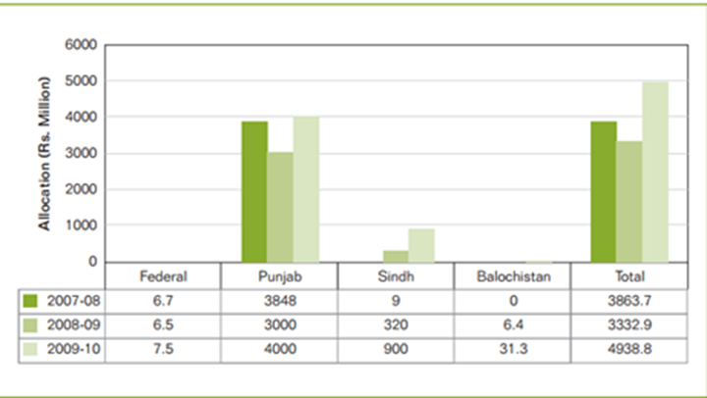
Source: I-SAPS, Public Financing of Private Education in Pakistan: Analysis of Federal and Provincial Budgets (2006).p.59

Impact of privatisation in education on the realisation of the right to education in Pakistan

Structural disparities in access to education as a result of private school expansion
- Since the passing of the 18th Constitutional amendment in 2012, the State has not been proactive in ensuring the right to education is full realised. This can be seen by the fact that one of the four provinces has failed to enact the RTE law and the other provinces did not develop implementation laws till date. Instead, the very rapid expansion of private providers across the country, actively supported by the State and donors, has produced and reproduced segregation of precisely those segments of the Pakistani society who have been targeted by these reform policies.
- In spite of the rapid growth of low-fee private schools and PPP programs targeting disadvantaged communities, it appears that these initiatives have not reached the poorest families mainly due to the cost of attending these low cost schools. These seemingly affordable fees touted by many as a solution for solving the quality or access issues in education in fact are out of reach of the poorest children of which are poor rural girls constitute as the biggest group.
- As a result of the privatisation of education in Pakistan, the education system is highly segregated by socio-economic status. According to ASER 2015 data, while 9% of children from the poorest households are enrolled in private schools, this figure raises to 38% of children from the wealthiest families, while on the other hand 87% of the poorest children go to public school, against 61% for the children from the poorest families.
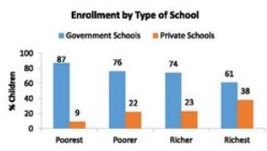
Source: ASER national report 2015, p. 19.
- In addition to tuition fees in private schools, households incur considerable non-fee expenses of schooling, including uniforms, textbooks and transportation. According to an Oxfam International report, in Pakistan, the cost of attending low-fee private schools is about one-quarter of household income, and “taking the average number of children per household into account, sending all children to school would cost 127 per cent of that household’s income.” One study estimated that non-fee expenses amount to approximately Rs. 200-400 (US $2-4) a month.
- Further segregation is created by the fact that the private schools that the poorest and the richest attend are not the same. The poorest children tend to attend low-cost private schools, which are the only ones their families can pay for, while the richest attend elite expensive private schools. Within each of these groups, further micro-segregation is created as, for instance, low-fee schools include schools with a range of fees which will create a different between the very poorest and the least poor of the poorest depending on their purchasing power.
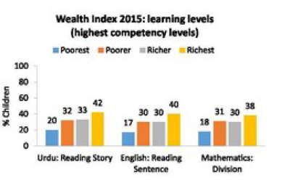
Source: ASER National Report 2015, p. 19.
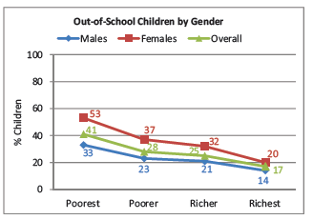
Source: ASER National report 2013, p. 19.
- Moreover, there is clear inequality of access to private schools for girls. According to Alcott and Rose (2015), in rural Pakistan, girls from the poorest households are 31% less likely than the poorest boys to attend private schools. Aslam (2009) similarly finds that access to private schools is also found to be generally lower in rural areas. This may be from the fact that there are less private institutes present in the rural areas of Pakistan (21%) as compared to 66% of the total private schools present in urban areas. This trend is a continuation of the trend from preceding years, for example from 2010/11 data, a study on private school participation in Pakistan found that: “Private school participation rates are substantially lower in rural areas than in urban areas. For example, for the 6–10 age groups, it is 13 percent in rural areas versus 43 percent in urban areas. In contrast, government school participation rates exhibit the opposite pattern. The rate is markedly higher in rural than urban areas for the 6–10 age group (50 percent versus 35 percent) and marginally higher for the 11–15 age group (48 percent versus 44 percent).” This may be due to a number of factors, including various reports that found that private schools tend to locate in urban areas and wealthier rural communities, thus limiting access for poor households.
- Instead of increasing public education spending, Pakistan has prioritised the development of partnerships with the private sector towards which it channels public funds. While acknowledging that private-public partnerships may play a positive role in education provision, they cannot be expected to resolve existing educational inequalities and instead appear to exacerbate them. LaRocque (2008) provides a valuable general outlook of PPPs in elementary education. It is concluded by him that to arrive at firm conclusions on the PPP as a revolutionary solution in terms of efficacy is premature. There is a need for more robust and rigorous studies globally to isolate the factors influencing the outcomes of PPPs on student learning outcomes. Therefore the provincial governments before aggressively pursuing the ePPPs need to assess the on ground empirical evidence in terms of gains.
- Moreover, while private schools expansion has been promoted by the State, the record of government schools has remained dismal during the past decades. The growth of private education sector has been tremendous in the recent years but its vigour has not matched the efforts made by the State especially in the post 18th amendment case where the education portfolios are devolved to the provinces and a considerable budget is allocated to the education by provinces. However these priorities are set by the respective provinces and not all provinces are equally committed towards the RTE as exemplified by the province of Khyber Pakhtunkhwa which still hasn’t passed the legislation for Right to Education Act.
- On one hand the Sindh government has been deliberately pursuing the PPP and private actors to provide education whereas on the other hand it is slowly decreasing the budget for education; Sindh government’s education spending has decreased in recent years from 40% in 2013 to 37% in 2015-2016. In Sindh, despite the expansion of low-fee private schools targeting disadvantaged communities, the out of school population in the districts of Khairpur, Jamshoro and Sanghar remains high at 30%.
- The World Bank as mentioned above has been a proponent of supporting mechanisms of privatization in various countries including Pakistan. It supports its stance on private schooling by claiming that the growth of low-cost private schools “has made them a viable alternative, even for the poor. More than a third of all children in the country are now enrolled in private schools, where tuition averages less than $5 a month in rural villages, a small fraction of average household income.” However, if the percentage of the population living below the national poverty lines are to be seen which is 22.3% of the population (living on less than $1.25), the claims of reaching the poorest are in question. This also indicates that the poorest segments are not being reached by private education service providers and that because “private schools generally do not locate in peripheral settlements suggest that the poor are geographically segregated.” Foundations like the SEF and PEF which were specifically established to reach the poorest and the marginalized have not been successful to overcome this, and as a result disadvantaged families remain concentrated in government schools or out of school.
- The voucher scheme like the one introduced by the Punjab government in 2006 as a response to the success of the Low-fee private schools was intended students who would otherwise not be able to afford an education can use vouchers of up to Pakistani Rupees 350 to attend private schools. The premise was to increase enrolments through an expansion of the voucher scheme. However, unlike schools in the private sector, the voucher scheme entails considerable administrative effort and expense to monitor learning assessments and identify deserving students and strategic school locations to receive vouchers. This ultimately raises questions in terms of its access to the poorest segments because most private schools are located in the main settlements, which are richer. Will they move to outlying settlements where the poorest children reside and at what price? The performance and fees of private schools are closely tied to their capacity to find good teachers. If such teachers are hard to find, private schools will just increase their fees to supply to the larger demand under a voucher system; if they are not allowed “top-up” fees over and above the voucher price, it’s likely they will decrease quality.
- Pedró & other (2015, UNESCO)¹⁵ unfolded the literature regarding lack of PPP evidences stated that due to diverse form of private schooling in different countries The concept of PPP has discussed widely by number of researchers and activities, there is limited but substantive evidence which favors the idea of PPP as tool of equity enhancing whereas the reasonable questions also concern that private intervention will aggravate the disparities for the poorest and socially excluded groups. Subsequently, it implies that in developing countries the governments usually lack political will and don’t have the capacity to regulate private markets.
- The phenomenal rise in the private schools is considered due to non-functionality of the public schools. Government has adopted different modalities to achieve the target of universal primary education and government has shifted interest towards PPP. The prime institute is Punjab Education Foundation (PEF), the primary purpose of PEF is to support private sector in providing education to the poor through public private partnership (PPP) (PEF annual Report, 2014). PEF budget is allocated directly from government and indirectly from DFID and World Bank for different programs; i.e. Education Voucher Scheme (EVS), Foundation assisted schools (FAS) and New school program (NSP), PEF mange its own budget and currently collaborating with 3,967 low fee private schools in whole Punjab called as partner schools
- Given the above arguments and the weak governance mechanisms especially the weak monitoring systems have resulted in situation stagnation for the poorest children; coupled with the rise of private schools this have created and further entrenched education segregation by wealth, location and gender.

Absence of regulations for private schools in Pakistan

- Of major concern in Pakistan is that the push for low-fee private education provision, by the State and bi- and multi-lateral donors, such as the World Bank and the UK Department for International Development, is done despite the absence of a State led and implemented regulatory framework for private schools.
- Right to Education Acts have been present even before the 18th Amendment such as the Punjab Compulsory Primary Education Act, 1994, the N.W.F.P Compulsory Primary Education, Act 1996, Sindh Compulsory Primary Education Ordinance 2001 and ICT Compulsory Primary Education Ordinance 2002. The legislation to regulate private market is still underway since 2001 and have revised and reviewed as i.e. NWFP Registration and functions of private educational institutions (amendments) ordinance 2002, the Sindh educational institutions (regulation and control) ordinance 2001 and amended act 2003, ICT educational institution (regulation and promotion) ordinance XXII of 2006.
- The Government has been somewhat successful to formulate a management system of the private schools in the Islamabad Capital Territory (ICT). Private Educational Institutions Regulatory Authority is working in Islamabad ICT whose main aim is to enforce of relevant rules & regulations on private education sector, for provision of quality education to the residents of Islamabad. According to official statistics (available on the website), there are 1,069 registered Private Educational Institutions (PEIs) in Islamabad Capital Territory (ICT) catering 221,125 students. However the same cannot be said about the other provinces where the majority of students study in private schools and PPP managed schools.
- The minimum requirements to open a private school in Pakistan are very low. Private institutions offering primary and secondary education do not require affiliation with a board, which means a school can be registered without being accountable for suitable permanent premises, qualified faculty, a library, and other necessary facilities. According to Fennell and Malik, “the absence of a set of regulations that would lay out the criteria that must be met by all educational institutions, whether state, Public Private Partnerships in education (ePPPs), or private providers, has proven to be a big lacuna. The consequent lack of guidance on requirements regarding salary scales for teachers, the teacher-student ratio, and the necessary physical characteristics to be deemed a registered school has meant that there are almost no entry restrictions on new providers.”
- In a study about the regulation of low-fee private schools in Islamabad, three authors point out a number of deficiencies “that have serious implications for the healthy functioning and growth of low-fee private schools”. They found that Pakistan’s Private Educational Institutions Regulatory Authority (PEIRA), which is in charge of registering, regulating and promoting private education institutions has a “cautious and complicated” relationship with low-fee private schools, involving for instance a revision of the Rules of Business in the area of fees due to the pressure from private schools. PEIRA is also supposed to be self-financed, with private schools financing monitoring and inspections themselves questioning the impartiality and consistency of the assessments.
- They also highlight the fact that the growth of private actors in education is not matched by an equivalent regulatory framework:
While recent initiatives to develop regulatory frameworks for private schools in some provinces and regions have gotten underway, such as the North West Frontier Province Registration and Functions of Private Education Institutions Ordinance (2002), the Sindh Education Institutions (Regulation and Control) Ordinance (2002), the Sindh Education Institutions (Regulation and Control) Ordinance (2001) and Amended Act (2003) and the Islamabad Capital Territory Education Institution (Regulation and Promotion) Ordinance XII (2006), the focus of educational policy at provincial level has not been on devising a regulatory framework for education, but solely on setting up private educational institutions.
- In Sindh the private schools regulated under the Sindh Private Educational Institutions (Regulation and Control) Ordinance, 2001, and Rules 2005 as well as the Sindh Right of Children to Free and Compulsory Education Act, 2013. Officials of the inspection departments revealed that many schools are operating without registration due to the fear of detailed inspection of school´s overall performance, paying taxes and hiring of the teacher less than minimum wages . There is no monitoring mechanism detailed in any Act by the province.
- In Punjab, Punjab Private Educational Institutions (Promotion and Regulation) Ordinance, 1984 has been amended into act and called as Private Educational Institutions (Promotion and Regulation) (Amendment) Act 2015. The Public private partnership Act 2014 has been passed by the Punjab Assembly in 2014 however there are many areas within the Act which needs immediate attention from the government.

The Public private partnership Act 2014
An analysis of the Public private partnership Act 2014 identifies the following sections which need attention:
- The ordinance section 2 (c) presents the definition of disadvantaged children by segregating those children´s parent whose annual income would be less than certain limit defined by government, this provision has repercussions in terms of exclusion of certain group of children which did not fall under that “specific” income basket. Which itself challenge government role in delivering quality education “to all children aged between 5 to 16 years”. There is less clear strategy for the children with special need there is no provision regarding the need of those children and integration arrangements of them in regular public education system. The ordinance lacks any information about the informal and vocational education for students who want to start their vocational education after secondary education.
- The Punjab PPP Act has missing provisions about the duties of local authorities in terms for support of private entities section 8 (3) states “government may encourage enterprises and private institutes by granting exemption or rebate in taxes and offering incentives for those who establish schools for provision of free and compulsory education”. While the explanation is important in the sense the incentives which will drive these private individuals and enterprises to run free schools and the mechanism to check that these institutes are observing the “condition of free education” and not asking for hidden fee from parents needs to be defined in clear terms
- The ordinance also makes the private school responsible to enrol and provide free education to the 10 pc of children from disadvantaged neighbourhoods. This provision is ambiguous in the sense of regulation and monitoring as to how the regulatory authority will ensure this happens without proper monitoring mechanism and will government be able to provide free textbooks to these 10 pc students in these schools? There has not been an authority defined for the protection of right of children under section (18) 2.
- Malik (2010) has assessed the working of PEF and PPP act in Punjab; The PEF Act of 2004 mandated the foundation to encourage the participation in the PPPs of everyone who has a stake in the educational system, however the PEF model has resulted in various lessons with the PPP models he states that to successfully implement the models of PPP it is mandatory to have sustainable expansion plans and governance structure as despite the early successes, program growth ground to a halt in 2008 as a result of abrupt changes in the governance and management of the PEF, there are certain issues regarding the transparency and accountability.
- He further added the main solution to PEF’s woes is to ensure that the organization consistently operates according to the statutory requirements of the PEF Act of 2004. He suggested that turning the promise of PPPs into reality on the ground requires a supportive political environment, good program design, and effective implementation which is missing as of yet.
- Naeem (2012) studied the working of PEF and found that selection of the schools criteria is ambiguous and the data used for baseline study was from 1983. Osorio and Raju (2011) assessed the effect of subsidy program in LFPS (public private partnership program administered by PEF) in Pakistan on student enrolment and school inputs.

- The lack of basic data about private schools also reflects inadequate investment in monitoring and limits the possibility for the State to regulate effectively. A study from the Institute of Social and Policy Sciences finds for instance that “a major issue that emerges from the review of the private education is the lack of data and research even about some basic characteristics of the sector. For example, policymakers do not have access to reliable knowledge about characteristics of different types of private schools” including their timely census. The last census of district wise census of the private schools was conducted in 2000 by the Former Federal Bureau of Statistics Census of Private Schools (PEIP).
- The issue is particularly acute regarding PPPs, for which regulation and monitoring are crucial. The ability of the state to regulate the partners and its capacity to put in place mechanisms for effective monitoring and sustainable exit for them is an aspect that is not part of the current discourse or debate of partnership policies in Pakistan. Contractual documents between the state and partner organizations should contain the terms of arrangement between the two parties, including the responsibilities and returns for each, expected outputs, timeline for achievement of outputs, and contingency measures in case of breach of contract. The agreements are a reflection of the clarity of policy objectives, and are one element of a clear implementation strategy for reform.
- However in Sindh and Punjab, Memorandums of Understanding (MoUs) signed between the district government and partner organization serve as management contracts that delineate the responsibilities and expectations from each of the partners. In Punjab, these MoUs do not constitute a legally binding agreement that relates to any existing policy plan for partnerships. In Sindh, until the recent amendments to the PPP Act, the MoUs did not constitute a legal agreement. The implications are multi-faceted. According to these documents, the partner organizations are volunteers with little or no obligation to deliver on the agreements being entered into.
- Stakeholder interviews with representatives of the Sindh Education Foundation (SEF) and provincial education departments corroborate that both provincial governments think of the role of the adopters to be limited to provision of basic facilities and rebuilding of depleted infrastructure. There is no provision made in the contract to leverage the capacity of non-state actors to improve quality of learning outcomes through pedagogical interventions and capacity building of teachers and school leaders.
- Quality of private schools thus questioned, due to the lack of effective regulation by the government. Economically, there exists a detrimental market failure in the form of information asymmetry; households usually do not have enough information to decide amongst schools on the basis of quality education. The fee levels are synonymous with the quality of education provided. Yet, statistics collected by ASER in 2015 in rural areas show that private schools’ facilities are similar to those of public schools, and tend to have less trained teachers.

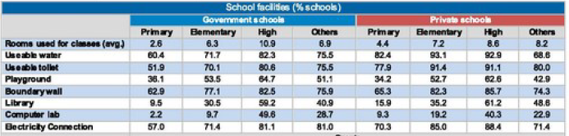
Source: ASER Annual Report 2015, p. 76.

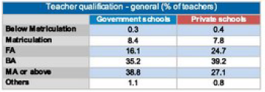
Source: ASER Annual Report 2015, p. 76.

Recommendations to the State party
48. Pakistan faces several intersecting economic and social challenges. In light of these challenges, education has a fundamental and instrumental role to play to support the development of the country and ensure the long-term realisation of all human rights. It is therefore highly regrettable that the government makes little efforts to realise the right to education, evidenced by the third lowest spending on education worldwide and an explicit policy of relying on the private sector to provide education. This approach not only creates discrimination and is not matched by adequate regulation, which infringed the right to education, but it also undermines the realisation of all human rights in Pakistan.
49. Based on the above analysis, we suggest to ask the State Party the following questions:
- What steps is the State party taking to strengthen a free public primary and secondary school system of quality, in line with its obligations under international human rights law?
- What steps is the State party taking, as a matter of priority, to effectively continued segregation and discrimination of the most disadvantaged children in the education system?
- How will the State concretely ensure that private schools receiving public funds under existing public private partnership schemes do not do not charge fees and other expenses where this leads to segregation and exclusion of poor families?
- Why has the State not done any human rights assessment of the impact of its policies of public-private partnerships in education?
- How does the State intend to monitor, regulate and evaluate the operation of private actors in education to ensure compliance with national laws and international treaties, and to ensure the right to education for all without discrimination?
- What steps are being taken by the State to allocate sufficient financial resources towards public education as a matter of priority?
- What steps is the State taking to ensure that provisions are made for effective introduction and implementation of laws and policies in its Provinces for the realisation of the right to education as sanctioned by Article 25A of the Constitution?

50. Given the questions above, we make the following recommendations to Pakistan:
- To substantially increase the education budget and redistribute funds to strengthen the public sector and to match as a minimum the international target of 6% of GDP or 20% of the annual budget as a matter of urgent priority, and immediately make a plan to develop free public education across the country in the shortest possible time.
- To take all necessary measures, to avoid any direct or indirect harmful impact of the private education sector and to ensure that the private sector contributes to the fulfilment of the right to education for all in Pakistan, and immediately set out a plan to effectively regulate the private schools.
- To institute an appropriate regulatory and monitoring framework for monitoring the enforcement of Article 25-(A) of the Constitution. Both the private education sector and the State have a responsibility to work together to ensure that all education providers are meeting minimum norms and standards as laid out by the State within a human rights framework. The State should work together with civil society to establish an appropriate regulatory environment for the provision of education services.
• To ensure it has the necessary human and regulatory capacities to ensure the effective implementation of the existing regulations with regard to provision of education by private providers, and halt further development of private education until the State has developed more comprehensive regulations and human capacities to adequately monitor private schools.
• To take concrete steps to ensure that all Provinces develop a timeframe for the introduction and implementation of legislation for the effective realisation of the right to education as sanctioned by the Constitution.
• To conduct a rigorous and independent assessment of the impact of various public-private partnership policies in the education sector on the right to education
• To regularly collect and make publically available data on private school fees and social diversity amongst the pupils attending private and public schools, so as to be able to transparently identify and understand inequalities.
• To revise the National Education Policy given the contextual shift in the post 18th Amendment thereby focusing on improving the quality of public education in Pakistan by among other things immediately increasing financial investment in the public education sector.

Singh, K. Report of the UN Special Rapporteur on the Right to Education, A/69/402, 24 September 2014 http://daccess-dds-ny.un.org/doc/UNDOC/GEN/N14/546/82/PDF/N1454682.pdf?OpenElement
Ibid.
Singh, K. Report of the Special Rapporteur on the right to education, Kishore Singh - Public Private Partnerships and the right to education, A/70/342, 26 August 2015 http://www.un.org/en/ga/search/view_doc.asp?symbol=A/70/342
For more information, see Pakistan Coalition for Education, “Legislation on Right to Education in Pakistan: A Critical review” (April 2015), available from http://www.pcepak.org/en/phocadownload/Demo/RTE-final-.pdf
PAK CONST. art. XXXVII, sec. b.
PAK CONST. art. XXXVII, sec. d.
See: http://rtepakistan.org/wp-content/uploads/2012/12/Act_2012_Right_to_Free_and_Compulsory_Education_National_Assembly_Secretariat_Islamabad.pdf
See: http://rtepakistan.org/wp-content/uploads/2012/12/The_Sindh_Right_of_Children_to_Free_and_Compulsory_Education_Act_2013.pdf
See: http://rtepakistan.org/wp-content/uploads/2014/07/The_Balochistan_Compulsory_Education_Act_2014.pdf
See: http://punjablaws.gov.pk/laws/2580.html
See the status of RTE in Khyber Pakhtunkwa: http://rtepakistan.org/legislation/kpk/
Ministry of Education, Government of Pakistan (2009) National Education Policy 2009 http://www.aserpakistan.org/document/learning_resources/2014/National%20Education%20Policy%202009.pdf [Retrieved 4 February 2016]
Alif Ailaan (2014) 25 million broken promises: the crisis of Pakistan's out of school children. Islamabad: Alif Ailaan. http://bit.ly/1FkolZ0 [Retrieved 28 January 2016]
Ibid.
Ibid.
ASER national report 2015 (2015) Available at: http://www.aserpakistan.org/document/aser/2015/reports/national/ASER_National_Report_2015.pdf (Accessed 8 April 2016)
According to UNESCO these figures represent the percentage of children aged 3-6 years above primary school entrance age who have never been to school.
ASER national report 2015 (2015) Available at: http://www.aserpakistan.org/document/aser/2015/reports/national/ASER_National_Report_2015.pdf (Accessed 8 April 2016).
Ministry of Education, Trainings and Standards in Higher Education Academy of Educational Planning and Management, Pakistan (June 2014). Pakistan Education for All Review Report 2015 http://unesdoc.unesco.org/images/0022/002297/229718E.pdf [Retrieved 8 April 2016]
Jabbar, S., Khizer, S., & Mushtaq, N. (2015). Do Schools Get Money? Islamabad: Pakistan Coalition for Education.
Government of Pakistan (2013) Pakistan Economic Survey 2014- 15: Education. Ministry of Finance http://www.finance.gov.pk/survey/chapters_15/10_Education.pdf [Retrieved 7 April 2016]
Ibid., p. 174.
Figure taken from: http://i-saps.org/upload/report_publications/docs/1461768887.pdf
(Jabbar, Khizer, & Mushtaq, 2015)
See Ministry of Finance Pakistan Economic Survey 2015-16 http://www.finance.gov.pk/survey/chapters_16/10_Education.pdf
Graph copied from: http://www.datastories.pk/with-only-2-1pc-of-the-gdp-pakistan-spends-lowest-on-education-in-south-asia/
Data from http://data.uis.unesco.org/.
Figure taken from: http://i-saps.org/upload/report_publications/docs/1461768887.pdf
Malik, R. and Rose, P. (2015)Financing Education in Pakistan: Opportunities for Action. Country Case study for the Oslo Summit on Education for Development Country report prepared for the Oslo Summit on July 6-7, 2015. http://bit.ly/1KfBx3F. [Retrieved 7 April 2016]
Ibid.
http://globalinitiative-escr.org/advocacy/privatisation-in-education-research-initiative/international-advocacy-on-privatisation-in-education/
See on http://bit.ly/1oFpW3V
In addition to fees, these costs typically include daily transport, uniforms, meals, and textbooks.
EFA Global Monitoring Report. (2012, October). Retrieved April 14, 2016, from UNESCO.org: http://en.unesco.org/gem-report/sites/gem-report/files/EDUCATION_IN_PAKISTAN__A_FACT_SHEET.pdf
Naviwala, N. (2015). Pakistan's Education Crisis: The Real Story. Washington D.C.: Wilson Centre.
UNESCO (2015) Education for All Global Monitoring Report: Achievements and Challenges. UNESCO: Paris.
Pakistan’s population is estimated at approximately 180.71 million in 2011 with an average growth rate of 2%.
Institute of Social and Policy Studies (2010) Private Sector Education in Pakistan: Mapping and Musing I-SAPS: Islamabad. http://bit.ly/1qxhLJ5 [Retrieved 7 April 2016]
Andrabi, Das, & Khwaja, Private Schooling: Limits and Possibilites, 2005
Alif Ailaan. 2014. 25 million broken promises: the crisis of Pakistan’s out-of-school children. Islamabad: Alif Ailaan. Pp.6.
Save the Children (2002) Private Sector Involvement in Education: A perspective from Nepal and Pakistan
Malik, R. and Rose, P. (2015) Financing Education in Pakistan: Opportunities for Action. Country Case study for the Oslo Summit on Education for Development Country report prepared for the Oslo Summit on July 6-7, 2015. http://bit.ly/1KfBx3F. [Retrieved 7 April 2016]
Barber, S. M. (2013). The Good News from Pakistan. London: Reform.
According to its websites, the Foundation’s mission is “the promotion of quality education through Public-Private Partnership, encouraging and supporting the efforts of private sector through technical and financial assistance, innovating and developing new instruments to champion wider educational opportunities at affordable cost to the poor.”
Malik, R. and Rose, P. (2015) Financing Education in Pakistan: Opportunities for Action. Country Case study for the Oslo Summit on Education for Development Country report prepared for the Oslo Summit on July 6-7, 2015. http://bit.ly/1KfBx3F [Retrieved 7 April 2016]
Ibid.
Pakistan Coalition for Education (2015) Public Private Partnerships and Public Education in Pakistan: Can PPPs benefit public education? http://pcepak.org/en/phocadownload/userupload/Public%20Private%20Partnership%20in%20Education.pdf
See this UKAID and DFID summary of literature on PPPs in Pakistan from 2011 “Helpdesk Report: Public Private Partnerships in Education (Pakistan)”: http://www.a-id.org/pdf/helpdesk-report-public-private-partnerships-in-education-pakistan.pdf See also: Andrabi, T., Das, J., Khwaja, A.I., Vishwanath, T. and Zajonc, T. (2008). Pakistan Learning and Educational Achievements in Punjab Schools (LEAPS): Insights to inform the education policy debate. See also: Andrabi,T., Das, J., and Khwaja A.I. (2006) “A Dime a Day: The Possibilities and Limits of Private Schooling in Pakistan” World Bank Policy Research Paper No. 4066.
See various country reports here: http://globalinitiative-escr.org/advocacy/privatisation-in-education-research-initiative/international-advocacy-on-privatisation-in-education/
See Right to Education Project and others, “Parallel report to the CESCR on the United Kingdom” (November 2015), available from http://bit.ly/1hDObw5.
UNESCO. (2010). Secondary education regional information base: Country Profile. Bangkok: UNESCO Asia and Pacific Regional Bureau for Education.
See Punjab Sector Plan 2013-2017: http://aserpakistan.org/document/learning_resources/2014/Sector_Plans/Punjab%20Sector%20Plan%202013-2017.pdf
Bano, M. 2008. Public-Private Partnerships (PPPs) as ‘anchor’ of educational reforms: lessons from Pakistan. Background paper prepared for the Education for All Global Monitoring Report 2009/ED/EFA/MRT/PI/12.
See Balochistan Sector Plan 2013-2017 at http://aserpakistan.org/document/learning_resources/2014/Sector_Plans/Balochistan%20Sector%20Plan%202013-2017.pdf
See Draft Rules of business not in place by the provinces as highlighted by the Right to Education Pakistan: http://rtepakistan.org/draft-rules-of-business/
Oxfam International (2014) “Working For the Many: Public Services Fight Inequality” https://www.oxfam.org/sites/www.oxfam.org/files/bp182-public-services-fight-inequality-030414-en.pdf [Retrieved 8 April 2016]
Fennell, S. (2013) “Low-fee private schools in Pakistan: A blessing or a bane?” in Srivastava, P. (2013) Low-fee Private Schooling: Aggravating equity or mitigating disadvantage? Symposium Books
Jamil, B. R., Javaid, K., & Rangaraju, B. (2012). Investigating dimensions of the privatization of public education in South Asia. PERI.
Ibid.
Alcott, B. M. and Rose, P. M. (2015) “Schools and learning in rural India and Pakistan: Who goes where, and how much are they learning?” Prospects, 45(2): 345-363
See: http://library.aepam.edu.pk/Books/Pakistan%20Education%20Statistics%202014-15.pdf
Nguyen, Q.T. and D. Raju (2015) “Private school participation in Pakistan” The Lahore Journal of Economics 20(1): 1-46.
Ibid.
Jabbar, S., Khizer, S., & Mushtaq, N. (2015). Do Schools Get Money? Islamabad: Pakistan Coalition for Education.
ASER (2015) Annual Status of Education Report Lahore: South Asian Forum for Education Development (SAFED)
Teachers Hold the Key to Student Learning: Pakistan Education Sector Review. (2014, October 29). Retrieved April 12, 2016, from The World Bank: http://www.worldbank.org/en/news/feature/2014/10/29/teachers-hold-key-student-learning-education-review
Pakistan Data. (2015). Retrieved April 12, 2016, from The World Bank: http://data.worldbank.org/country/pakistan
Mundy & Menashy, 2012; Malik, et al., 2015
Habib, M. (2013). Education in Pakistan’s Punjab: Outcomes and Interventions. The Lahore Journal of Economics, 21-48.
Nguyen, Q. T., & Raju, D. (2015). Private School Participation in Pakistan. The Lahore Journal of Economics, 1-46.
Khwaja, A. A. (2007). Learning and Educational Achievement in Punjab Schools (LEAPS).
Malik, R. and Rose, P. (2015) Financing Education in Pakistan: Opportunities for Action. Country Case study for the Oslo Summit on Education for Development Country report prepared for the Oslo Summit on July 6-7, 2015. http://bit.ly/1KfBx3F. [Retrieved 7 April 2016].
Humayun, S., Shahzad, R., & Cunningham, R. (2013). Regulating low-fee private schools in Islamabad: a study in policy and practice. Low fee Private Schooling: Aggravating Equity or Mitigating Disadvantage. Oxford: Oxford Studies in Comparative Education
For details of act, http://www.peira.gov.pk/Downloads/Doc1.pdf The Punjab Private Educational Institutions (Promotion and Regulation) (Amendment) Bill 2015, Bill No. 46 of 2015
Haider, M. S. (2015, December 26). Why isn’t the standard of education in Pakistan’s private schools regulated? Retrieved April 13, 2016, from Express Tribune: http://blogs.tribune.com.pk/story/29386/why-isnt-the-standard-of-education-in-pakistans-private-schools-regulated/
Fennell, S. and R. Malik (2016) “Donors, Private Actors, and Contracts: Recasting the Making and Ownership of Education Policy in Pakistan” in Verger, A., Lubienksi, C. and G. Steiner-Khamsi (Eds.) (2016).The World Yearbook of Education 2016: The Global Education Industry. New York: Routledge.
Humayun S, Shahzad, R and Cunningham, R (2013) Regulating low-fee private schools in Islamabad: a study in policy and practice. In: Srivastava P (ed.) Low-fee private schooling: aggravating equity or mitigating disadvantage? Oxford: Symposium, p. 195.
Ibid, p. 184.
See The Express Tribune news post: http://tribune.com.pk/story/956851/private-school-fees-dcs-tardiness-turns-meeting-into-fish-market/
The Punjab PPP Act 2014, can be accessed here: http://ppp.punjab.gov.pk/sites/ppp.pitb.gov.pk/files/Punjab%20PPP%20Act%20(IX%20OF%202014).doc.pdf
Malik, A. B. (2010). Public-private partnerships in Education: Lessons learned from the Punjab Education Foundation (Vol. 309). Asian Development Bank.
Malik, A. B. (2010). Public-private partnerships in Education: Lessons learned from the Punjab Education Foundation (Vol. 309). Asian Development Bank.
Naeem, Muhammad (2012). “Public Private Partnerships for education provision in Pakistan: How does Punjab Education Foundation address equity?” Conference on Globalization, Regionalization and Privatization in and of Education in Asia.
Barrera-Osorio, Felipe, and Dhushyanth, Raju. 2011. Evaluating Public Per-Student Subsidies to Low-Cost Private Schools: Regression-Discontinuity Evidence from Pakistan. World Bank Policy Research Working Paper 5638.
Institute of Social and Policy Sciences, “Private Sector Education in Pakistan: Mapping and Musing” (2010), available from http://www.aserpakistan.org/document/learning_resources/2014/Private_Tuitions/Private%20Sector%20Education%20Report-I-SAPS%20(1).pdf
See on Pakistan Bureau of Statistics webpage: http://www.pbs.gov.pk/content/census-private-educational-institutions-pakistan-1999-2000
Malik, R., Bari, F., Muzzafar, I., Mashhood, T., Mansoor, M., & Ali, A. (2015). Partnerships for Management in Education: Evidence from Punjab and Sindh. Lahore: Institute for Development and Economic Alternatives.
Ibid.

