Parallel report to the
Committee on the Elimination of Discrimination Against Women

February 2021

- Introduction
Sounds of the Silenced (“SOS”) appreciates this opportunity to submit a parallel report to the Committee on the Elimination of Discrimination Against Women (“the Committee”), for Hong Kong, China (“Hong Kong”)’s upcoming review under the Convention on the Elimination of All Forms of Discrimination against Women (“CEDAW”).

SOS’s submission focuses on various forms of violence against women arising from the 2019 Hong Kong pro-democracy protests

- Violence against women
As stipulated by the Committee in general recommendation No. 19 and 35, gender-based violence against women constitutes discrimination against women under Article 1 and engages all obligations under CEDAW.

Police brutality was prevalent in the course of the 2019 protests. Examples include the inappropriate use of live ammunition, the aiming of kinetic impact projectiles at people’s upper bodies or heads, the excessive use of force during arrests, such as beating and pepper spraying subdued protesters, and abuse in detention.

Against this backdrop of police violence, there are alarming reports of sexual and gender-based violence against women arising from the protests. A survey conducted by the Association Concerning Sexual Violence Against Women in August - September 2019 documented 194 cases of sexual violence reported by 67 respondents (58 women and 9 men). These acts range from rape, sexual assault, unwelcome bodily contact, threats of rape and sexual assault, sexually charged verbal abuse, frisk search and/or strip search conducted by a police officer of the opposite sex and leering. Perpetrators identified by the respondents include police officers, pro-government supporters and passers-by.

2.1 Verbal abuse, smear campaign and online abuse
Female protesters were regularly subjected to gendered and sexually charged verbal abuse by police officers and pro-government actors. Slurs frequently used against women include “fucking cunt (臭閪)”, “fucking whore(臭雞)” and “bitch”. There are reports that police officers used vulgar language, including rape threats, to insult and intimidate people. A woman reported that police officers called her a “fucking whore” and threatened her by saying that “I wouldn’t rape a thing like you (要姦都唔會姦呢啲)”. Kex Leung, a student activist, stated that officers told him they were exhausted from working overtime, and that it was “normal” for police officers to want to have sex with female protesters.

In September 2019, government adviser Fanny Law claimed on a radio programme that young women - dubbed “angels” - were “mislead into offering free sex” and “providing comfort” to protesters. These allegations were not supported by evidence. Discourse about female protesters being tricked into offering sex relegates women to their sexuality and diminishes their political agency. In any event, safe and consensual sex between adults should not be stigmatised.

Regrettably, this sexist narrative persisted, with pro-government actors and media outlets attacking women associated with the protests on the basis of their sex, gender and appearance. For instance, women were targeted with sexist and misogynistic abuse online. Examples include:
- A photograph of a young woman holding a banner that read “I am a secondary school student” was doctored to read “I am not wearing any underwear”.
- A photograph of activist Ho Ka Yau being apprehended by police officers was doctored to show her nipples.
- A photograph of several schoolgirls running with a flag with a protest slogan was doctored so that the flag reads ““HIV test / Free Free Free / First come, first served"
- Journalist Laurel Chor reported receiving a constant barrage of abuse in her social media accounts, including the use of words such as whore, prostitute and bitch.
- Journalist Vicky Xu recieved rape threats on her social media accounts.

2.2 Improper use of frisk search and strip search
Women alleged that they were subjected to humiliating and degrading frisk search and strip search by male and female police officers. We highlight a few examples below:

Two police officers were filmed stopping a woman for a pat-down at the Tai Wai metro station. The woman alleged that she requested the search be conducted by female officers, but this was ignored, and the male officers thrusted her against a wall aggressively, causing bruising to her legs.
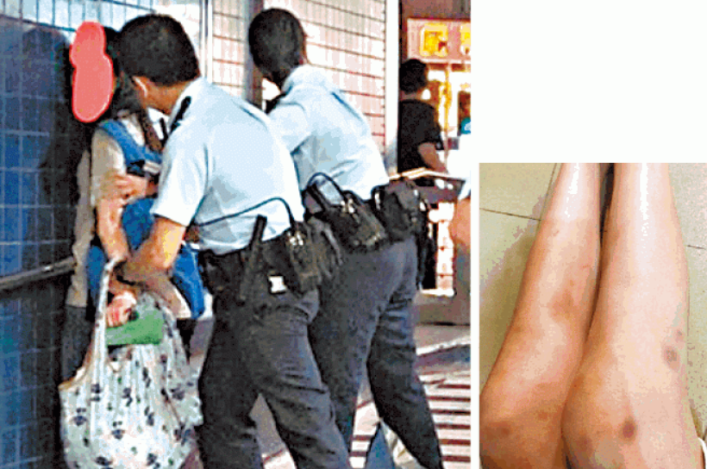
A woman alleged that she was frisk searched by two male officers. Source: Apple Daily

Chan was on a public bus when police officers flagged it down and searched all passengers. After a female officer conducted a frisk search on Chan, she was instructed to remove her dress for another search in public where other police officers and passengers were present. Chan removed her dress as instructed, but the officer did not conduct a second search on her. It is noteworthy that Chan filed a complaint to the Complaints Against Police Office (“CAPO”), but her complaint was not substantiated by CAPO, which found no misconduct on the part of the police officer. See section 3 below for a discussion of the ineffectiveness of the police complaints mechanism.

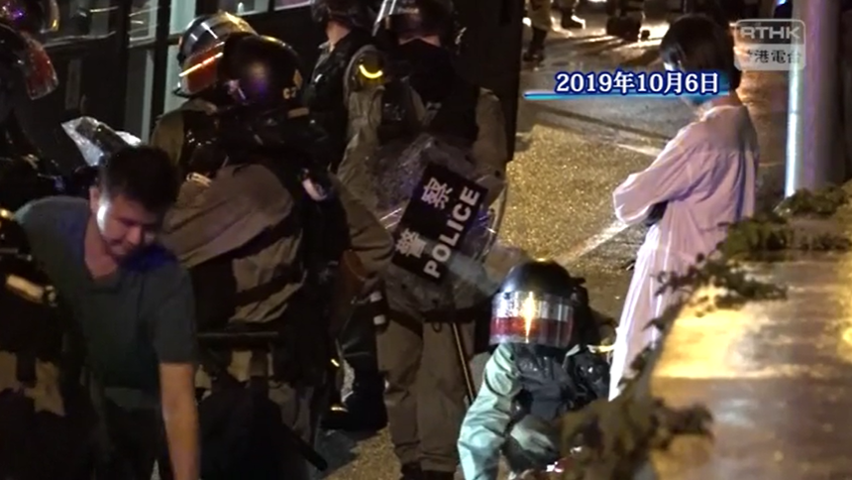
Chan (in white) being told to remove her dress for a search in public. Source: RTHK

Lui alleged that two female officers used strip search - involving the removal of underwear - to humiliate her. She was ordered to squat and rise three times. An officer patted her thighs with a pen and instructed her to open her legs wider. When Lui tried to cover her private parts, the officer hit her hand with a pen. The other female officer observed her strip search “with a kind of enjoyment, glancing at me up and down”. Lui further alleged that 10 male officers were standing outside the room where she was being searched.

Three women - Lau, Lee and Leung alleged that they were strip searched by female police officers at the Kowloon Magistrates’ Court. The strip searches involve complete removal of their underwear. They questioned the necessity of the searches, as prior to being brought to court they were detained in police custody and had already been searched.
2.3 Mistreatment of pregnant women
A three months pregnant woman, Chiu, was among those injured in the 21 July 2019 Yuen Long attack, in which pro-government mobs indiscriminately attacked passers-by at a train station.

Chiu was injured during the Yuen Long attack. Source: Stand News

In September 2020, a seven to eight months pregnant woman was pushed to the ground and pepper-sprayed by the police as they attempted to disburse a protest.
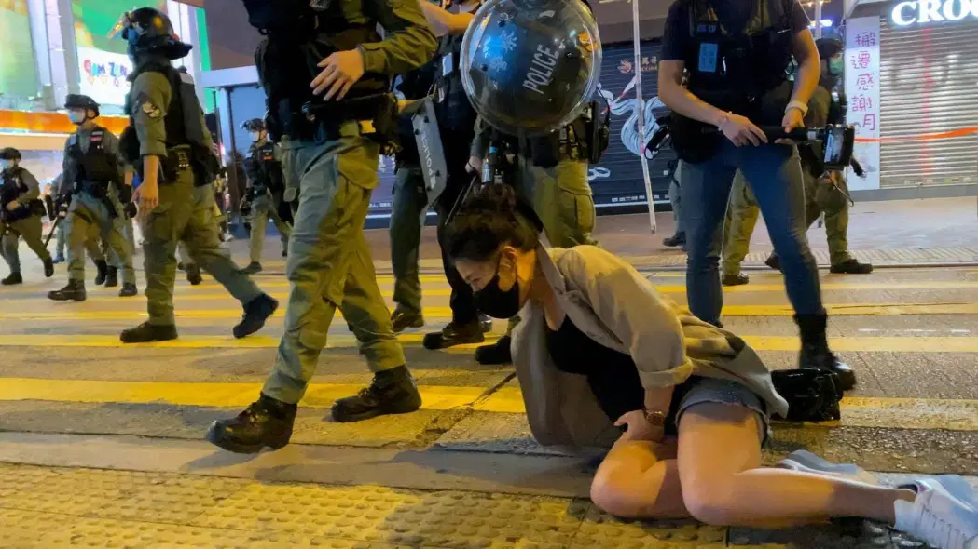
Source: Studio Incendo

In an incident unrelated to the 2019 protest, a seven months pregnant woman, Lau, alleged that she was pushed to the ground and dragged by police officers, which resulted in the premature birth of her child. She was initially stopped by the police who were enforcing covid-19 lockdown rules.

2.4 Sexual assault allegations
Multiple women accused police officers of sexual assault during their arrest or whilst they were detained in police custody. In addition to the improper use of strip search, these women alleged police officers of slapping their breasts and exposing their underwear during arrests.

“C” was filmed being lifted off the ground by a group of male officers during her arrest, exposing her crotch. In a subsequent interview, she said that she was kicked and beaten by batons after her apprehension. An officer then instructed other officers to carry her away. She was wearing a dress at the time and requested officers to let her walk. Instead she was lifted off the ground by several male officers, who scolded her and called her a bitch (八婆).
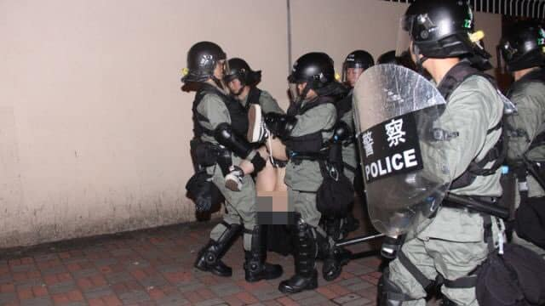
Police officers exposing C’s crotch during her arrest. Source: Apple Daily

A woman alleged that, during her arrest, a male police officer dragged her along by pulling her backpack and clothing, causing her top to be lifted and her brassiere exposed. She also felt that the officer’s hand moved from her waist to her hip once.

Ng accused a male officer of hitting her breast whilst she was detained at the Kwai Chung Police Station.

K, a 17-year-old woman, accused a female officer of squeezing her breast several times and verbally harassing her. K also claimed that a female officer placed her head close to her chest and crotch during a strip search, and repeatedly denied her requests to use the bathroom for more than an hour.

Lung accused male officers of touching her breasts whilst she was detained. She also alleged that female officers observed her whilst she used the bathroom, and would not let her close the cubicle door.

2.5 Rape allegations
X alleged that she was gang raped by police officers in Tsuen Wan Police Station in September 2019 and had to undergo an abortion.

Following the abortion, X consented to police obtaining fetal DNA to identify her assailant. However, after X filed a complaint to the Complaints Against Police Office on 22 October 2019, the police obtained a search warrant to obtain X’s medical records from her private doctor, including records pre-dating the alleged gang-rape, without X’s consent. The police warrant was eventually suspended by a court.

Alarmingly, subsequent to X’s allegation becoming public in November 2019, the police force attempted to publicly discredit her. Details of her case were leaked online, and there are reports that Chief Superintendent of the Public Relations Division of the police force, Tse Chung-chung, told selected media outlets that X was “a little mental”. In January 2020, the Commissioner of Police, Chris Tang, stated at a public district council meeting that X’s case was inconsistent with video footage from the time of the alleged incident and that the force was investigating X for attempting to mislead the police. In May 2020, Tang again stated that X was facing arrest for making a false statement.

X’s former legal representative, Vidler & Co. Solicitors criticised the police for an apparent breach of the sub judice rule:

“She has made no public comment about the case and has not sought publicity in any way… Unfortunately, the police investigating Ms X’s case appear to have systematically worked to discredit her and to undermine her complaint… Ms X considers that any attempt by police to publicly discredit a rape victim and adversely comment on evidence in an on-going investigation is despicable and offensive. Such attempts should be condemned in the strongest terms.”

X has since left Hong Kong, citing her disappointment at the police force’s handling of her case and the force’s repeated attempts to undermine her case.

- Police impunity
The lack of any effective mechanism to investigate police misconduct means that acts of police brutality, including acts involving sexual and gender-based violence, are committed with impunity. The experiences of Chan (See Section 2.2) and X (See Section 2.5) in trying to lodge complaints with the police force are a case in point. This lack of accountability violates CEDAW Article 2(c), as it deprives survivors of violence of redress and protection.
The existing two-tier police complaints mechanism is neither effective nor independent. Complaints are investigated by the police department through the Complaints Against Police Office (“CAPO”); the Independent Police Complaint Council (“IPCC”), whose members are appointed by the Chief Executive, only has advisory and oversight powers to monitor the activities of CAPO. UN treaty bodies, including the Human Rights Committee and the Committee against Torture have long criticised the lack of any effective accountability mechanism.
In May 2020, the IPCC produced a “thematic study” on the protests. SOS stresses that the IPCC’s report is not an independent investigation into allegations of police misconduct, and multiple human rights organisations have criticised the report as a whitewashing attempt. In this regard, Clifford Stott, an academic who withdrew from the IPCC’s probe citing institutional inadequacies of the IPCC, published a research paper arguing that the police’s indiscriminate use of force, the absence of accountability and the Government’s denial of responsibility contributed to the escalation of the protests.
The police force said that it does not maintain statistics on complaints relating to acts of sexual harassment and assault committing by police officers while carrying out their duties.
The statutory body responsible for enforcing Hong Kong’s anti-discrimination laws, the Equal Opportunities Commission (“EOC”), reported that it received two sexual harassment complaints against police officers in 2019, and more than 300 inquiries related to sex discrimination by police officers. It should be noted the organisations supporting victims of sexual violence have long criticised the EOC for its ineffective and oftentimes retraumatising complaints handling mechanism

- Suggested list of issues and questions for Hong Kong
Please comment on reports that the Hong Kong Police Force deployed various forms of sexual and gender based violence against protesters, including verbal abuse, sexual assault and the abuse of strip search.
Please comment on reports that pro-government actors, including the Hong Kong Police Force, deployed sexist and misogynistic smear campaigns to attack women participating in the 2019 protests.

Please provide information on the number of cases in which body searches were conducted on female arrested persons, disaggregated by year, age, location of the search, the justification used to perform the search, and the level of body searches (non-removal of clothing, removal of outer clothing, removal of underwear etc.)

Please provide information on guidelines regulating the use of frisk search and strip search by police officers and law enforcement officers. Please provide information on training provided to police officers and other law enforcement officers on gender sensitivity and the prevention of gender and sexual based violence.

Please provide information on measures taken to investigate incidents of violence against women committed by police officers and law enforcement officers in the course of law enforcement activities. Please provide the number of complaints relating to sexual and gender- based violence brought to the CAPO and/or IPCC against police and law enforcement officials, and the outcome of these complaints.

See for example, Haley Willis and Ainara Tiefenthaler, “Hong Kong Police Shot a Protester at Point-Blank Range. We Break Down What Happened.” The New York Times (1 October 2019). Available at: https://www.nytimes.com/video/world/asia/100000006745719/hong-kong-protester-shot.html ;Kris Cheng, “Hong Kong protester shot by police with live round in critical condition” Hong Kong Free Press (11 November 2019). Available at: https://hongkongfp.com/2019/11/11/breaking-hong-kong-police-shoot-protester-live-round-sai-wan-ho/
See for example, All-Party Parliamentary Group for Hong Kong, “The Shrinking Safe Space for Humanitarian Aid Workers in Hong Kong: Inquiry into Violations of Human Rights and Humanitarian Principles by the Hong Kong Police Force” (August 2020) (“APPG Inquiry Report”) at pp.15-16. Available at: https://www.hkinquiry.org/ and Amnesty International, “Hong Kong: Police should exercise restraint to avoid escalating violence” (August 2019). Available at: https://www.amnesty.org/en/latest/news/2019/08/hong-kong-police-should-exercise-restraint-avoid-escalating-violence/
See for example, APPG Inquiry Report at p.16 and Amnesty International, “Hong Kong: Arbitrary arrests, brutal beatings and torture in police detention revealed” (September 2019). Available at: https://www.amnesty.org/en/latest/news/2019/09/hong-kong-arbitrary-arrests-brutal-beatings-and-torture-in-police-detention-revealed/
See for example, Amnesty International, (n 2).
Association Concerning Sexual Violence Against Women, “Independent Inquiry into Recent Clashes and Procedural Reform on Evidence Collection Urgently Required as Sexual Crime Victims’ Confidence in Reporting Plummets” (November 2019). Available at: https://rainlily.org.hk/eng/news/2019/11/release
“防暴搜少女身辱罵「臭雞」”, Apple Daily (17 November 2019). Available at: https://hk.appledaily.com/local/20191117/K6ZPGNTGKIW6SX6W57KZ2VC44M/
“【831 太子站】被捕女事主：警署內被男警碰胸 女警觀看如廁 站內有人被打至暈倒”, Stand News (4 September 2019). Available at: https://www.thestandnews.com/politics/831-%E5%A4%AA%E5%AD%90%E7%AB%99-%E8%A2%AB%E6%8D%95%E5%A5%B3%E4%BA%8B%E4%B8%BB-%E8%AD%A6%E7%BD%B2%E5%85%A7%E8%A2%AB%E7%94%B7%E8%AD%A6%E7%A2%B0%E8%83%B8-%E5%A5%B3%E8%AD%A6%E8%A7%80%E7%9C%8B%E5%A6%82%E5%BB%81-%E7%AB%99%E5%85%A7%E6%9C%89%E4%BA%BA%E8%A2%AB%E6%89%93%E8%87%B3%E6%9A%88%E5%80%92/
Almen Chui, “Govt adviser slammed for claim girls offer sex to protesters”, Asia Times (10 September 2019). Available at: https://asiatimes.com/2019/09/govt-adviser-slammed-for-claim-girls-offer-sex-to-protesters/
Rose Troup Beuchana, “Rape threats, body-shaming and doctored photos: Hong Kong women protesters facing troll army”, Hong Kong Free Press (2 September 2019). Available at: https://hongkongfp.com/2019/09/02/rape-threats-body-shaming-doctored-photos-hong-kong-women-protesters-facing-troll-army
“This photo has been doctored to rid the flag of the original pro-democracy message”, AFP Fact Check (30 October 2019). Available at: https://factcheck.afp.com/photo-has-been-doctored-rid-flag-original-pro-democracy-message
“大圍兩男警違例搜女途人身”, Apple Daily (3 September 2019). Available at: ttps://hk.news.appledaily.com/local/daily/article/20190903/20761241
Kris Cheng, “Hong Kong police accused of indecent assault after protester strip searched days after arrest”, Hong Kong Free Press (23 August 2019). Available at: https://hongkongfp.com/2019/08/23/hong-kong-police-accused-metoo-assault-protester-strip-searched-days-arrest/
“8‧11女示威者稱遭庭警全裸搜身 辯方：律政司促暫勿索取法院CCTV”, Ming Pao (24 October 2019). Available at: https://news.mingpao.com/pns/%E8%A6%81%E8%81%9E/article/20191024/s00001/1571853854812/8-11%E5%A5%B3%E7%A4%BA%E5%A8%81%E8%80%85%E7%A8%B1%E9%81%AD%E5%BA%AD%E8%AD%A6%E5%85%A8%E8%A3%B8%E6%90%9C%E8%BA%AB-%E8%BE%AF%E6%96%B9-%E5%BE%8B%E6%94%BF%E5%8F%B8%E4%BF%83%E6%9A%AB%E5%8B%BF%E7%B4%A2%E5%8F%96%E6%B3%95%E9%99%A2cctv
Lily Kuo & Verna Yu, “'Where were the police?' Hong Kong outcry after masked thugs launch attack”, The Guardian (22 July 2019). Available at: https://www.theguardian.com/world/2019/jul/22/where-were-the-police-hong-kong-outcry-after-masked-thugs-launch-attack
“【元朗襲擊】明報：白裙傷者是孕婦 檢查胎兒平安 懷孕不足三個月無通知醫院”, Stand News (23 July 2019). Available at: https://www.thestandnews.com/politics/%E5%85%83%E6%9C%97%E8%A5%B2%E6%93%8A-%E6%98%8E%E5%A0%B1-%E7%99%BD%E8%A3%99%E5%82%B7%E8%80%85%E6%98%AF%E5%AD%95%E5%A9%A6-%E6%AA%A2%E6%9F%A5%E8%83%8E%E5%85%92%E5%B9%B3%E5%AE%89-%E6%87%B7%E5%AD%95%E4%B8%8D%E8%B6%B3%E4%B8%89%E5%80%8B%E6%9C%88%E7%84%A1%E9%80%9A%E7%9F%A5%E9%86%AB%E9%99%A2/
Rachel Wong, “Video: Pregnant woman ‘pepper-sprayed and pushed to ground’ by Hong Kong police during Mong Kok demo”, Hong Kong Free Press (1 September 2020). Available at: https://hongkongfp.com/2020/09/01/video-pregnant-woman-pepper-sprayed-and-pushed-to-ground-by-hong-kong-police-during-mong-kok-demo/
Ibid
“Woman files complaint over ‘aggressive policing’”, RTHK (10 February 2021). Available at: https://news.rthk.hk/rthk/en/component/k2/1575114-20210210.htm
Kris Cheng, “Hong Kong police fire tear gas following protest against treatment of female protester”, Hong Kong Free Press (5 August 2019). Available at: https://hongkongfp.com/2019/08/05/hong-kong-police-fire-tear-gas-following-protest-treatment-female-protester/ and “被走光天水圍少女： 警羞辱我 仲二度傷害我”, Apple Daily (10 August 2019). Available at: https://hk.appledaily.com/local/20190810/JNHV3DWDD2IMFFIPWCHPO5F3DE/
Ibid.
APPG Inquiry Report, p. 42.
Kris Cheng, “‘I am not the only one’: Hong Kong student removes mask and accuses police of sexual assault”, Hong Kong Free Press (11 October 2019). Available at: https://hongkongfp.com/2019/10/11/i-not-one-hong-kong-student-removes-mask-accuses-police-sexual-assault/
Rachel Wong, “Teen accuses Hong Kong police of sexual assault during protest arrest”, Hong Kong Free press (23 June 2020). Available at: https://hongkongfp.com/2020/06/23/teen-accuses-hong-kong-police-of-sexual-assault-after-protest-arrest/
See n7 above.
Holmes Chan, “Woman files complaint against Hong Kong police over alleged rape in station”, Hong Kong Free Press (9 November 2019). Available at: https://hongkongfp.com/2019/11/09/woman-files-complaint-hong-kong-police-alleged-rape-station/
Jennifer Creepy, “‘Grossly unprofessional’: Lawyers slam Hong Kong police for ‘privacy breach’ after woman accuses officers of gang rape”, Hong Kong Free Press (12 November 2019). Available at: https://hongkongfp.com/2019/11/12/grossly-unprofessional-lawyers-slam-hong-kong-police-privacy-breach-woman-accuses-officers-gang-rape/
“Sexual violence against Hong Kong protesters – what’s going on?”, Amnesty International (20 December 2019). Available at: https://www.amnesty.org/en/latest/news/2019/12/sexual-violence-against-hong-kong-protesters/
Jennifer Creepy, “Hong Kong police chief tried to ‘publicly discredit’ woman accusing officers of gang rape – lawyers”, Hong Kong Free Press (20 January 2020). Available at: https://hongkongfp.com/2020/01/20/hong-kong-police-chief-tried-publicly-discredit-woman-accusing-officers-gang-rape-lawyers/
Jennifer Creepy, “Hong Kong woman who accused officers of gang rape defends claim after police chief says she must be arrested for lying”, Hong Kong Free Press, (13 May 2020). Available at: https://hongkongfp.com/2020/05/13/hong-kong-woman-who-accused-officers-of-gang-rape-defends-claim-after-police-chief-says-she-must-be-arrested-for-lying/
“Criminal Investigation into Allegation of Rape inside Tsuen Wan Police Station”, Vidler & Co. Solicitors (11 November 2019). Available at: https://www.facebook.com/permalink.php?story_fbid=10157000716531491&id=112018101490
Ibid.
Human Rights Committee, Concluding observations on the third periodic report of China with respect to HKSAR, China, CCPR/C/CHN-HKG/CO/3 (29 April 2013) at [12]. Available at: https://undocs.org/CCPR/C/CHN-HKG/CO/3 and Committee against Torture, , Concluding observations on the fifth periodic report of China with respect to HKSAR, China, CAT/C/CHN-HKG/CO/5 (3 February 2016) at [8] - [9]. Available at: https://undocs.org/CAT/C/CHN-HKG/CO/5
Independent Police Complaints Council, “A Thematic Study by the IPCC on the Public Order Events arising from the Fugitive Offenders Bill since June 2019 and the Police Actions in Response” (May 2020) (“IPCC Report”). Available at: https://www.ipcc.gov.hk/en/public_communications/ipcc_thematic_study_report.html . See also: Rachel Wong, “‘Absurd, preposterous, whitewash’: Reactions pour in as Hong Kong police watchdog clears force of wrongdoing”, Hong Kong Free Press (15 May 2020). Available at: https://hongkongfp.com/2020/05/15/absurd-preposterous-whitewash-reactions-pour-in-as-hong-kong-police-watchdog-clears-force-of-wrongdoing/
Rhoda Kwan, “Hong Kong police played pivotal role in radicalising protests in build-up to Poly-U siege, policing expert report says”, Hong Kong Free Press (19 November 2020). Available at: https://hongkongfp.com/2020/11/19/hong-kong-police-played-pivotal-role-in-radicalising-protests-in-build-up-to-poly-u-seige-policing-expert-report-says/
https://www.info.gov.hk/gia/general/202007/08/P2020070800679.htm?fontSize=1
https://www.info.gov.hk/gia/general/202007/08/P2020070800679.htm and https://www.scmp.com/news/hong-kong/law-and-crime/article/3033188/hong-kongs-equal-opportunities-commission-gets-300
See for example, Rainlily, “Submission on "An outline of the topics to be covered in the fourth report of the Hong Kong Special Administrative Region under the Convention on the Elimination of All Forms of Discrimination against Women"”. Available at: https://static1.squarespace.com/static/5c1315a22487fdee2f0aefc2/t/5c52cd76c2241b2891a3fa14/1548930427236/CEDAW+RAINLILY+ENG.pdf

