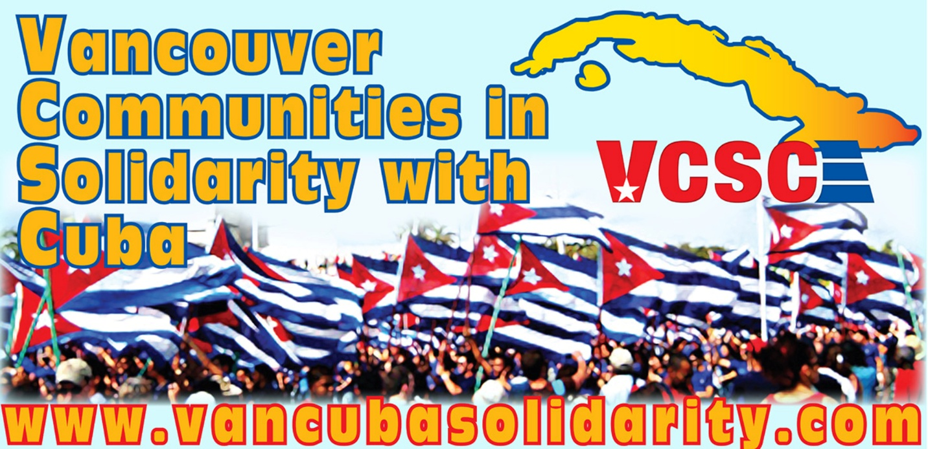

March 22, 2026

Report from Vancouver Communities in Solidarity with Cuba (VCSC) to the to 117th Session of the Committee on the Elimination of Racial Discrimination (CERD)

Who are we?
Vancouver Communities in Solidarity with Cuba (VCSC) formed in May 2004 in Vancouver, Canada to oppose new measures by the Bush administration to strengthen the U.S. blockade on Cuba. For over 21 years we have been working with groups around the world, including in Cuba, to educate, organize, and mobilize against the negative impacts of the United States’ unilateral coercive measures against Cuba, which are a huge infringement on the human rights’ of Cubans. We have also sent several delegations to Cuba meeting with Cuban’s from diverse communities, ethnicities and racial backgrounds, as well as hosted Cuban guests on speaking and musical tours across Canada.

Cuba working towards the elimination of racial discrimination
Discussing and celebrating the plurality of Cuba’s racial identities is a big part of life across the island of Cuba. Cuban’s of African descent, Cuban’s of Taino and Indigenous descent, Cuban’s of Chinese descent, Cuban’s of European descent, and the mix of other racial backgrounds are a part of how Cuban’s recognize their history, present, and future.

In visits to Cuba members of our organization have been impressed by Havana’s China town, as well as the celebration of Afro-Cuban culture everywhere from community centers to concert halls, from street art to museums. In 2025 Canada’s Calixto Garcia Brigade travelled to Eastern Cuba to learn about Cuba’s Indigenous people and make connections with Indigenous people visiting Cuba from Canada.

In its goal to work towards the elimination of racial discrimination, Cuba’s government is working to strengthen the lessons and curriculum about Cuba’s African heritage and the history of anti-racist struggles in schools. In discussing the complexities of racial history in Cuba they hope to avoid the oversimplification of Cuban history.

An example of an initiative to combat racial discrimination is the program “Color Cubano” (Cuban Colour). According to an article by Dr. C. Emilia Rebeca Hernández Mezonet, Director of Training and Development at Cuba’s National Institute of Sports, Physical Education and Recreation, “The Council of Ministers approved the National Program against Racism and Racial Discrimination, “Cuban Color.” The measure, promoted by President Miguel Díaz-Canel Bermúdez, involves 18 agencies of the Central State Administration and an equal number of civil society organizations, including the National Institute of Sports, Physical Education and Recreation (INDER).”

In December 2025 according to UNESCO, “The Casa de África Museum in Old Havana hosted the presentation of the educational game ‘African Diaspora’, an innovative proposal for schools and communities that invites players to discover characters, places, traditions and historical episodes of Africa and its descendants in the Caribbean. The game was developed through a collaboration of artists, researchers and teachers from Cuba, the Dominican Republic and Venezuela, under UNESCO’s General History of Africa (GHA) project.”

According to CubaVision journalist, Adianez Salles, “Casa de África is also a place with a community focus, with its own classroom space so that children can learn from an early age about African culture and the good relations between the largest of the Antilles and that continent that embraces us from the other side of the world.” These are all important initiatives that Cuba is building to promote racial understanding in Afro-Cubans and non-Afro-Cubans alike.

Learning about the challenges of eliminating racial discrimination
We have previously hosted tours with Afro-Cuban artists across Canada, including the hip hop group Obsesion de Cuba and singer-song writer, Gerardo Alfonso. Each have taken the opportunity to celebrate the dynamism of life in Cuba through performing their art in Canada. All have expressed how the U.S. blockade on Cuba makes working as an artist a challenge in Cuba - access to equipment and resources are very challenging. At the same time, they feel grateful for the institutional support they have received in Cuba and their ability to earn a living as artists and community builders.

Through their music and intellectual work these Cuban artists’ express the challenges faced by the Afro-Cuban community in Cuba today. For example, the difficulty of finding toys and art in Cuba that reflect the black experience in a respectful and empowering way for children. This is something Obsesion sings about in their song “Los Pelos.” This anti-racist message is reflected in their lyrics and music video released in 2010 which won Cuba’s Premio Lucas (national music video awards) for best hip hop video that year. While the song highlights a difficulty faced by the Afro-Cuban community, their video and prize demonstrate that there are spaces to debate, discuss, and push for changes.

Obsesion has another song called “Calle G” about the statue of former Cuban President José Miguel Gómez on Havana’s Avenida de los Presidentes. They spoke out about the racism of former President José Miguel Gómez and their perspective on why his statue should be torn down. El Tipo Este of Obsesion says in the song, “I am not sure what that statue is doing there, after we made a revolution here.”

The controversy around the legacy and racism of this former Cuban president is explained by the Contested Histories Initiative of the Europe for Citizens Programme of the European Union, “José Miguel Gómez was a celebrated military general who led Cuban forces during the wars of independence against Spain in the 19th century and served as Cuba’s second president between 1909 and 1913. The monument was first inaugurated in 1936. The statue has consistently been a source of contention. It was taken down in 1959 after the Cuban revolution, restored in 1999 and, more recently, underwent renovation in 2020. The statue has come under increasing scrutiny due to Gómez’s involvement in suppressing AfroCuban rebels who rose against the Cuban Government in 1912. The violence perpetrated by the government forces is estimated to have led to between 3000-6000 deaths, leading to accusations of ethnic cleansing against Gómez. However, this is highly contentious, and his place in Cuban national history has been defended.”

The legacy of José Miguel Gómez statues in Cuba continues to be debated in Cuba. In June 2023 lightening struck a different statue of Jose Miguel Gomez in Remedios. A journalist for Cubahora.cu, Mauricio Escuela Orozco wrote, “The lightning strike that hit the top of the obelisk was seen as a kind of belated historical judgment that reignited the gossip, analyses, and revisions […] José Miguel Gómez is remembered for his racism, the blatant corruption during his administration, the way national politics became a farce, and, ultimately, the dictatorial nature of his rule.”

This is just a small example of the ongoing debate over the legacy of one Cuban President, meant to illustrate how the struggle to eliminate racial discrimination in Cuba is alive and dynamic, with people from many walks of life participating. All levels of government, various institutions, artists, community organizers, journalists, etc. are all engaging in how deepening the country’s understanding of its Afro-Cuban roots and Afro-Cuban communities today is crucial in working towards the important goal of the elimination of racial discrimination.

The U.S. blockade and threats of war put at risk Cuba’s achievements
On January 29, 2026 after 64 years of U.S. embargo and blockade on Cuba, the U.S. government has decided to further strangle the countries’ economy. The executive order from the Trump administration declares a “National Emergency” calling the Cuban government “an unusual and extraordinary threat.” It further states that the U.S. government will impose tariffs on “any other country that directly or indirectly sells or otherwise provides any oil to Cuba” in order to 'protect' itself.

This puts all vulnerable people in Cuba at risk, as oil is needed to generate electricity and pump clean water. Fuel shortages in Cuba are impacting access to healthcare, schools, food, and other crucial institutions. Marta Hurtado, spokesperson for the UN Office of the High Commissioner for Human Rights, spoke out about the impact of the oil blockade on Cuba. She explained, “In Cuba, more than 80% of water pumping equipment depends on electricity and power cuts are undermining access to safer water, sanitation, and hygiene. The fuel shortage has disrupted the rationing system and the regulated basic food basket and has affected social protection networks, school feeding, maternity homes, and nursing homes with the most vulnerable groups being disproportionately impacted.” The U.S. blockade and siege on Cuba can only have a negative impact on Cuba’s ability to work towards ending racial discrimination.

Most recently on March 16, U.S. President Trump said of Cuba, “I mean, whether I free it, take it. Think I can do anything I want with it. You want to know the truth.” U.S. President Trump is not only threatening the sovereignty of Cuba, but to try to upend the work being done in Cuba towards building a more just and equitable society for oppressed and marginalized people. President Trumps’ dangerous threat of war and violence will only worsen the situation for those who are most likely to face different forms of social discrimination.

One important task of the world community is to stand against war and sanctions, which impact the ability of all people to go about their daily lives. Cuba deserves to continue working to develop its own path towards the elimination of racial discrimination – which is a goal no country in the world has successfully achieved – but one that we must all strive towards, and a goal that Cuba is working valiantly towards.

Thank you to the CERD for receiving this report.

Sincerely,

Tamara Hansen
Coordinator of Vancouver Communities in Solidarity with Cuba (VCSC)
(Member of the Canadian Network on Cuba-CNC)
Web: http://www.vancubasolidarity.com
Email: vancubasolidarity@gmail.com
Twitter / X: https://x.com/VanCuba_VCSC
Facebook: https://www.facebook.com/vancubasolidarity

From “Deporte e igualdad en Cuba: políticas públicas contra la discriminación racial” https://www.jit.cu/NewsDetails.aspx?idnoticia=1108733#:~:text=POL%C3%8DTICAS%20P%C3%9ABLICAS%20EN%20ACCI%C3%93N:%20EL,alcance%20el%2045%2C11%20%25
Ibid.
From “UNESCO presents the educational game ‘African Diaspora’ in Cuba to promote new ways of teaching African history” https://www.unesco.org/en/articles/unesco-presents-educational-game-african-diaspora-cuba-promote-new-ways-teaching-african-history
From “Museo Casa de África: espacio para promover la cultura de ese continente en Cuba” https://www.youtube.com/watch?v=-5wNiaJoMTo&t=5s
“Los Pelos” is here: https://www.youtube.com/watch?v=vs8hCanPwUg&list=RDvs8hCanPwUg&start_radio=1
The song is explained by the artist here: https://www.youtube.com/watch?v=9biOioKjf8A&list=RD9biOioKjf8A&start_radio=1
Ibid.
From The Contested Histories Initiative, ”José Miguel Gómez Statue in Cuba”, Contested Histories Case Study #281 (June 2022), https://contestedhistories.org/wp-content/uploads/Cuba-Jose%CC%81-Miguel-Go%CC%81mez-Statue-in-La-Havana.pdf
From the article, “El traidor, el héroe y el rayo enviado por los dioses” https://www.cubahora.cu/cultura/el-traidor-el-heroe-y-el-rayo-enviado-por-los-dioses
From “Addressing Threats To The United States By The Government Of Cuba” https://www.whitehouse.gov/presidential-actions/2026/01/addressing-threats-to-the-united-states-by-the-government-of-cuba/
Ibid.
From “UN Warns U.S. Oil Blockade Has Severe Impact on Cubans’ Human Rights” https://www.youtube.com/watch?v=dqjSmpCqS9o
From “Trump says he can do 'anything I want' with Cuba” https://www.theglobeandmail.com/business/article-trump-says-he-can-do-anything-i-want-with-cuba/

