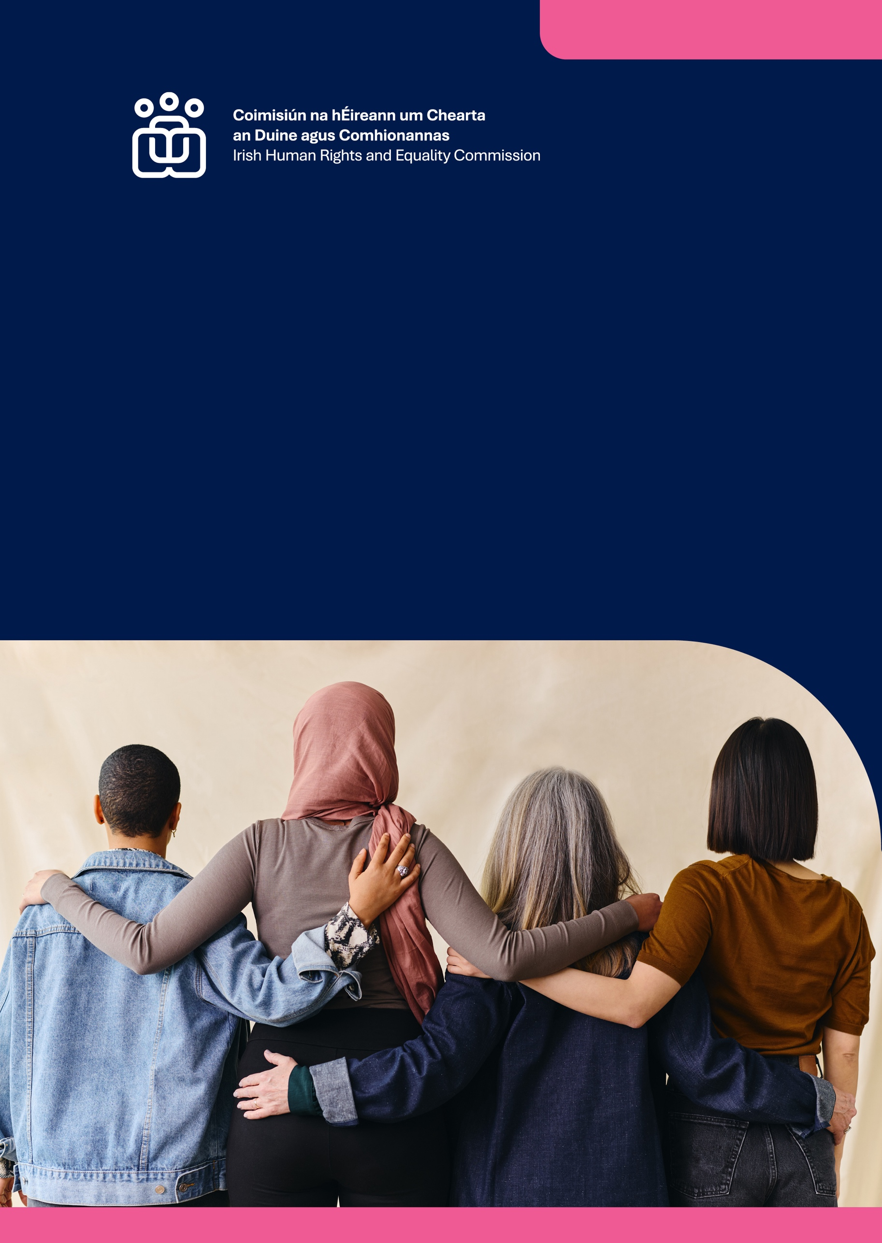

International Report

National Rapporteur

National Rapporteur

National Rapporteur

Ireland and the International Convention on the Elimination of All Forms of Discrimination
Against Women 2025

Submission to the Committee on the Elimination of Discrimination against Women on Ireland’s eighth periodic report
Published by the Irish Human Rights and Equality Commission.
Copyright © Irish Human Rights and Equality Commission 2025
The Irish Human Rights and Equality Commission was established under statute on 1 November 2014 to protect and promote human rights and equality in Ireland, to promote a culture of respect for human rights, equality and intercultural understanding, to promote understanding and awareness of the importance of human rights and equality, and to work towards the elimination of human rights abuses and discrimination.

Contents
Introduction 3
National Human Rights Institution and National Equality Body 3
Civil society 4
General observations on the implementation of CEDAW 4
Reservations 4
Data collection 4
Constitutional reform 4
Equality legislation 5
Island of Ireland 5
COVID-19 5
National machinery for the advancement of women 5
National policies 5
Public Sector Equality and Human Rights Duty (PSEHRD) 6
Stereotypes 6
Stereotypes in education 6
Stereotypes in media 6
Hate-speech targeted towards women and girls 7
Access to justice 7
Violations of women’s rights 7
Women’s rights in the justice system 8
Domestic, sexual and gender-based violence (DSGBV) 8
Trafficking and exploitation of prostitution 9
Participation in political and public life 9
Participation in politics 9
Participation in public and private leadership 10
Education 10
Education for ethnic minority women and girls 10
Relationships and Sexuality Education (RSE) 10
Employment 11
Access to decent work 11
Gender pay and pension gaps 11
Sexual harassment in the workplace 11
Childcare and parental leave 11
Health 12
Access to healthcare 12
Abortion services 12
Maternal health 12
Mental health 12
Economic empowerment 13
Equality budgeting 13
Business and human rights 13
Taxation 13
Access to social protection 13
Poverty and social exclusion 14
Housing 14
Child maintenance 14
Climate change and disaster risk reduction 14
Disadvantaged groups of women 15
Rural women 15
Traveller and Roma women 15
Women in detention 15
Disabled women and girls 16

Introduction
The Irish Human Rights and Equality Commission is Ireland’s ‘A’ status National Human Rights Institution and National Equality Body. We welcome this opportunity to provide our parallel report to inform the Committee’s review of Ireland’s implementation of CEDAW. Our report follows our 2023 submission to the Committee to inform its List of Issues. Our submission adopts an intersectional approach and is informed by the expertise and on-the-ground insights of civil society, including holding a Civil Society Forum. We are providing an additional submission which provides further detail on the issues raised in this parallel report. This report follows the structure of the Committee’s List of Issues and details our recommendations to the State to ensure structural, sustainable, and transformative change for women and girls in Ireland.

National Human Rights Institution and National Equality Body
We have a significantly expanded mandate, which has not been matched by annual budgetary increases to adequately resource their delivery. The EU Directives on Standards for Equality Bodies (EU Directives), to be transposed by June 2026, have introduced a legal requirement on EU Member States to provide multi-mandate bodies with adequate human, technical and financial resources. The State, as part of its full and ambitious transposition of the EU Directives, should engage in multi-annual budgetary planning and allocation at a level that ensures the effective discharge of all of our statutory functions.

Civil society
Women’s and girls’ civil society organisations continue to be key drivers of gender equality and social progress. The State must provide core multi-annual funding to civil society and ensure an enabling environment for advocacy, participation and leadership.

General observations on the implementation of CEDAW

Reservations
The State should constructively engage with the Committee on the removal of reservations to Articles 11(1), 13(a) ,16(1)(d) and 16(1)(f), and on fully transposing the rights under CEDAW into domestic legal order.

Data collection
The State’s collection and use of disaggregated equality data is essential for the development, implementation and monitoring of international standards, legislation and policies concerning women and girls. The State must prioritise the publication and implementation of its National Equality Data Strategy, which has been subject to numerous delays, strengthen the legislative basis for the collection, use and reporting of data, and ambitiously transpose the EU Directives Article on ‘Data collection and access to equality data’.

Constitutional reform
The State finally held referendums in March 2024 to reform Ireland’s Constitution to remove gender stereotypes, recognise the value of care, and recognise a more inclusive understanding of family. The proposed reforms were not passed by the public. Identified factors in the failed reforms include a short timeframe, vague wording, poor communication with the public, and not imposing any enforceable obligations on the State to support the provision of care in the wider community. The State should commission an independent evaluation of the referendums and publish a plan to implement the legislative and policy recommendations of the Citizens’ Assembly on Gender Equality and the Parliamentary Committee on Gender Equality.

Equality legislation
We have engaged extensively with the review of the Equality Acts. The slow pace and extent of proposed reform is deeply concerning. The State must prioritise modernisation of Ireland’s equality legislation, including provision for intersectional discrimination in the Equality Acts and repealing section 14 of the Equal Status Acts. The State should publish an analysis of the relevance to Irish Law of the Court of Justice of the European Union judgment in Deldits and any required legislative and policy changes.

Island of Ireland
There is a risk of a divergence in gender equality rights, on pay transparency and work-life balance, on the island of Ireland after the UK left the EU. The State should make a clear commitment to ensure equivalence of rights on the island of Ireland.

COVID-19
Ireland’s response to the pandemic was not gender proofed. The delayed Covid-19 Evaluation lacks a gender lens. The Evaluation should ensure equal participation of women, adopt human rights and equality-based guidance and commit to a gender equality impact assessment. The State should identify gender-specific measures to mitigate impacts of future emergencies and embed gender equality in all preparedness planning.

National machinery for the advancement of women

National policies
Ireland has been without a National Strategy for Women and Girls (NSWG) since the previous strategy expired in 2021. The significant delay highlights the insufficient priority given to gender equality. Our assessment is that the previous NSWG failed to have a tangible impact on improving the lives of women and girls. The State should ensure the new NSWG and its action plan are underpinned by resourced implementation and accountability structures, and are revised to implement the recommendations of the Committee from this Review.

Public Sector Equality and Human Rights Duty (PSEHRD)
Section 42 of the IHREC Act 2014 requires public bodies to eliminate discrimination, promote equality, and protect human rights. Implementation of the PSEHRD remains inconsistent, with a 62% non-compliance rate with reporting obligations. Intersectional gender discrimination is frequently unaddressed. We recommend that the State should issue a circular to enhance compliance with the PSEHRD, embedding Equality and Human Rights Impact Assessments in planning and reporting, and integrating it into the NSWG. Public bodies should consult civil society, assess gendered impacts of their functions, and create participatory structures enabling input from women and girls.

Stereotypes

Stereotypes in education
The State should take active measures in the NSWG to address gender norms and stereotypes in schools, further and higher education, in line with the recommendations of the Citizens’ Assembly and the Committee on Gender Equality. Mandatory teacher training on gender equality, steps to encourage under-represented groups of women into teaching and supports for pregnant and transgender students at risk of leaving school should be adopted.

Stereotypes in media
The State must ensure that the Advertising Standards Authority of Ireland introduces best practice guidelines for gender representation, and that the Media Commission holds technology and social media companies accountable for online content.

Hate-speech targeted towards women and girls
We welcome the recent commencement of the Criminal Justice (Hate Offences) Act 2024. We note the removal of amendments relating to incitement to hatred from the proposed Bill and the ongoing concerns with the inadequate Prohibition of Incitement to Hatred Act 1989, which the State has committed to amend in the 2025 Programme for Government.
Given the emergence of a vocal far-right and the rise of misogynistic and other discriminatory hate-speech in the Irish online sphere, we are concerned regarding the lack of alignment of the 1989 Act with the Online Safety and Media Regulation Act 2022.
The State should prioritise reform of the 1989 Act including alignment with regulation of online media. The State should ensure the collection and annual publication of disaggregated data on incitement to hatred offences and hate offences.

Access to justice

Violations of women’s rights
The State is continuing to fail to provide rights-based investigations and reparations to survivors of abuse within Mother and Baby Institutions, Magdalene Laundries, schools, residential institutions and to survivors of the practice of symphysiotomy. There is a need for the State to recognise that while this abuse may have been perpetrated in the past, its response is prolonging and further inflicting violations of rights. The State must overhaul its approach to investigations and reparations to ensure independent, survivor-centred, timely investigations and effective remedies for survivors. The failures of the Farrelly Commission investigation of abuse of a disabled woman from childhood indicates the need for reform including the failure to reference the submissions of the woman’s legal team.
The State must remove the arbitrary barriers to redress within the Mother and Baby Institutions Payment Scheme, including length of stay requirements, to ensure survivors can access a full and effective remedy.
The State continues to fail to adequately implement the 2014 O’Keeffe judgment. The State must establish a new comprehensive, fair and non-discriminatory redress scheme for survivors of child sexual abuse in primary and post-primary schools before 1991/1992.

Women’s rights in the justice system
The State must prioritise reform of Civil Legal Aid and extend legal aid to equality cases in the Workplace Relations Commission. The State must undertake measures with ambitious targets to address the disproportionate disadvantages faced by women in entering the legal profession and their underrepresentation in leadership roles and in the higher tiers of the courts system.

Domestic, sexual and gender-based violence (DSGBV)
DSGBV policy is an area that has seen positive reform in recent years. We are concerned that these developments are failing to translate into tangible improvements for victims and survivors. We recommend that the independence of the statutory DSGBV agency, Cuan should be strengthened to ensure it can effectively assess the State’s measures in tackling DSGBV.
We continue to note the deficits in specialist support services for victims and survivors of DSGBV and the inadequacy of refuge accommodation. The State must significantly scale up the provision of culturally appropriate, universally designed refuge accommodation units and ensure adequate provision of specialist support services for all victims and survivors of DSGBV.
The State must urgently implement the GREVIO baseline evaluation recommendations through the Third National Strategy on Domestic, Sexual & Gender-Based Violence 2022-2026, and in the development of the new Strategy from 2026-2030.

Trafficking and exploitation of prostitution
We welcome the new National Referral Mechanism which will be established upon the commencement of Part 3 of the Criminal Law (Sexual Offences and Human Trafficking) Act 2024. Gaps remain regarding the provision of detailed assistance and supports in law. The Operational Guidelines under the Mechanism should be sufficiently robust to ensure the Mechanism is compliant with anti-trafficking obligations, including the amended EU Anti-Trafficking Directive.
Survivors’ legal needs should be prioritised, including the expansion of the Legal Aid Board’s remit and the availability of compensation. There should be a specific statutory defence for victims of trafficking where they have committed crimes as a direct consequence of them being trafficked. The capacity of gender-specific accommodation for victims should be increased.

Participation in political and public life

Participation in politics
The results of the 2024 General Elections show that only 25% of parliamentary representatives are women with 32.5% of constituencies having no women representatives. Only 21.4% of the cabinet ministers are women. Ireland is currently 99th in the world for women’s representation in national parliaments and 96th in the world for women cabinet ministers. Only one woman from an ethnic-minority background was elected to Parliament in the recent election.
Childcare, cash, confidence, culture, and candidate selection processes continue to be identified as the main barriers for women entering and remaining in politics. Supports to facilitate greater representation of women, including reflecting the diversity of women, must be focused at the local level as gender imbalances among local councillors significantly affect the candidate selection processes for general elections. The State must increase remuneration for local councillors; extend the legislative gender quota to local and Seanad elections; and implement the Committee’s General Recommendation No. 40 on 50-50 gender parity for all decision-making systems, including the political sphere, by 2030.
To address gendered online hate-speech and political violence towards women candidates, the Electoral Commission must be mandated to address discriminatory rhetoric and hate speech in political discourse including during candidate selection processes, elections and referendums.

Participation in public and private leadership
Women continue to be underrepresented in public and private sectors. The European Commission recently communicated with Ireland on its failure to fully transpose the Directive on Gender Balance on Corporate Boards. The State should introduce legislative quotas for corporate and State boards.

Education

Education for ethnic minority women and girls
Financial support to all minority ethnic groups to continue education is required including language supports, IT equipment and resourcing of community education programmes. Legislation on schools’ admissions should be amended to remove the past pupil criterion. Curricula should represent ethnic minorities’ culture and history.

Relationships and Sexuality Education (RSE)
Primary-level reform of RSE is long-awaited. The State should strengthen knowledge on LGBTQIA+ relationships, contraceptive use, fertility and pregnancy loss in the RSE curriculum at secondary level. The State should increase funding and supports for continuous teacher professional development in RSE.

Employment

Access to decent work
Barriers to the six dimensions of decent work in Ireland (access to work, adequate earnings, employee voice, security and stability, equality of opportunity, and health and safety) are heightened for women, especially structurally vulnerable women. The State should address each dimension of decent work through policy and legislation, including a statutory right to collective bargaining.

Gender pay and pension gaps
The gender pay and pension gaps are approximately 11.2% and 36%. In transposing the EU Pay Transparency Directive the State should extend the scope of organisations covered by gender pay gap reporting legislation and mandate the publication of disaggregated equality data. Ireland should introduce a Universal State Pension.

Sexual harassment in the workplace
IHREC’s Code of Practice on Sexual Harassment and Harassment at Work should inform the development of workplace policies in all sectors.

Childcare and parental leave
Childcare is one the most significant barriers to women’s employment. The State should transition to a public model of childcare by 2030. IHREC-funded research has found that a quarter of fathers take Parent’s Leave compared to two-thirds of mothers. Statutory parental entitlements should provide for longer periods of paid parental leave, be equally available to one-parent families, encourage uptake by men, and reflect the rising cost of living and caring.

Health

Access to healthcare
Ireland’s two-tier healthcare system does not provide equitable care and is not gender proofed. Despite national wealth, progress to rights-based universal healthcare is significantly delayed. The State must renew its commitment to the timely implementation of Sláintecare, including through significantly increasing public spending and gender proof its delivery.

Abortion services
Despite the introduction of the Health (Regulation of Termination of Pregnancy) Act 2018, barriers to equitable and accessible abortion services remain, including uneven geographical service distribution, mandatory wait periods, fatal foetal abnormality criteria, non-providing GPs and ‘conscientious obstructors’. A multitude of women continue to travel abroad for abortion services. The State must fully implement the recommendations of the Independent Review of the Health (Regulation of Termination of Pregnancy) Act 2018 to ensure that women have equitable, accessible, and safe abortion services in Ireland.

Maternal health
The new National Maternity Strategy must ensure equal access to maternal healthcare for all women, including structurally vulnerable women. The State should invest in intersectional targeted maternal morbidity and mortality prevention.

Mental health
The continued use of the medical model in mental healthcare prevents women with psychosocial disabilities from accessing their rights. The State must comprehensively review mental health legislation and policy, in consultation with disabled people, to align with the UNCRPD and embed a gender-sensitive approach.

Economic empowerment

Equality budgeting
The State’s approach to equality budgeting has been deficient and delayed. Gender budgeting has been inadequately developed, been encompassed in a budgeting approach including other equality groups and ‘wellbeing’, and not delivered. The State should place equality and human rights budgeting on a statutory basis with a strong focus on gender and intersectionality; and ensure the participation of civil society in budgetary processes.

Business and human rights
Ireland has been without a national action plan on business and human rights since 2020. The new plan must embed gender equality considerations into business activities both in Ireland and internationally, and implement the recommendations of the Committee on Economic, Social and Cultural Rights.

Taxation
Cliff-edges in the Irish tax system should be removed and replaced by more gradual or tapered thresholds. To reduce the tax system’s impact on gender inequalities, the State should commit to a phased move towards a fully individualised tax system.

Access to social protection
The State should adopt welfare indexation and gender, equality and poverty proof all administrative social protection criteria, application procedures, and appeals processes to ensure equal access for structurally vulnerable women. The State should undertake a programme of measures co-designed with disabled people to address the cost of disability.

Poverty and social exclusion
Women, particularly lone parents and those from low-income families, are vulnerable to the structural causes and impacts of poverty. The majority of women living in poverty today have experienced intergenerational poverty, with 4.8% of women in consistent poverty. Poverty and social exclusion are exacerbated by inadequate access to transport, education, employment, childcare, and services. The State should adopt a multidimensional national action plan to eradicate poverty addressing root causes; and ensuring the inclusion of clear and measurable targets, the allocation of adequate resources for its implementation, and effective mechanisms for coordination among national and local governments.

Housing
There is an alarming lack of progress to address the ongoing structural housing crisis, with low housing affordability and availability creating dire circumstances for many women and girls, including increased homelessness. The State should significantly scale up its supply of and investment in public and social housing to match current and future need.

Child maintenance
The late, insufficient, or non-payment of child maintenance can have a negative impact on lone parent families headed by women. Proposed reforms to the enforcement of child maintenance orders need to be prioritised for implementation, ensuring that child maintenance provides for an adequate standard of living.

Climate change and disaster risk reduction
There is a lack of State commitment to address the gendered impacts of the climate crisis despite it exacerbating socio-economic inequalities, DSGBV, and health outcomes. The State should ensure climate action and adaptation measures are gender proofed, and women and girls are included in decision-making processes.

Disadvantaged groups of women

Rural women
The State has continuously failed to improve women’s land ownership. It should prioritise its Programme for Government commitment to implement the National Women in Agriculture Action Plan including promoting female succession and addressing taxation barriers to participation.
The State must ensure gender-equality proofed investment and policy development regarding access to transport, supports and services for rural women.

Traveller and Roma women
The implementation of the National Traveller and Roma Inclusion Strategy should be adequately resourced and coordinated with the NSWG to address the structural discrimination Traveller and Roma women and girls continue to face.

Women in detention
We call for the immediate ratification of the Optional Protocol to the Convention Against Torture.
Prison overcrowding continues to worsen, and concerns persist regarding reliance on custodial sentences and deficiencies in gender-sensitive supports. We are concerned about the anticipated increased use of immigration detention due to Ireland implementing the EU Pact on Migration and Asylum. There is a need to prioritise the use of alternative non-custodial measures and minimise the use of immigration detention.
Reform of mental health and protection of liberty legislation must be prioritised following excessive State delay. There are inadequate procedural safeguards governing mental health admission and an absence of effective oversight mechanisms.

Disabled women and girls
Disabled women encounter challenges in realising their right to independent living, due to a profoundly lacking system of personal assistance, which is exacerbated by the absence of a legislative framework, insufficient budgetary allocations, and insufficient coordination. Inadequate financial supports and inadequate and/or inaccessible community-based services cause some disabled women to remain in high-risk or abusive situations. The State should actively support and resource disabled women and girls to live independently, including through delivery of person-centred financial supports, a legal right to personal assistance, and seamless and flexible services across the life cycle, informed by their will and preference.
The new national strategies for women and girls and on disability must align to realise CEDAW and UNCRPD rights.


Guthán / Phone +353 (0) 1 858 3000
Riomhpost / Email info@ihrec.ie
Idirlion / Web www.ihrec.ie
 @_ihrec
 /irishhumanrightsequality
The Irish Human Rights and Equality Commission.
16 – 22 Sráid na Faiche,
Baile Átha Cliath, D07 CR20
16 – 22 Green Street,
Dublin, D07 CR20

The Irish Human Rights and Equality Commission.
16 – 22 Sráid na Faiche,
Baile Átha Cliath, D07 CR20
16 – 22 Green Street,
Dublin, D07 CR20

The Irish Human Rights and Equality Commission.
16 – 22 Sráid na Faiche,
Baile Átha Cliath, D07 CR20
16 – 22 Green Street,
Dublin, D07 CR20

The Irish Human Rights and Equality Commission.
16 – 22 Sráid na Faiche,
Baile Átha Cliath, D07 CR20
16 – 22 Green Street,
Dublin, D07 CR20

These include our role as National Rapporteur on the Trafficking of Human Beings (2020), Independent Monitoring Mechanism under the UNCRPD (2023), the proposed co-ordinating National Preventative Mechanism body in relation to OPCAT, and as a designated Article 77 body under the EU Artificial Intelligence Act (2024).
Cliff-edge refers to ‘where benefits entitlements and other supports are withdrawn sharply as income rises or where tax and social insurance liabilities increase steeply as income rises.’

