Annexes - CERD/C/UGA/11-19

Annex 1: Ethnic Minorities
Table 1: Composition of Ethnic Minorities in Uganda
No | Ethnic Group | Male | Female | Population | %
1 | Vonoma | 1,235 | 1,378 | 2,613 | 0.01%
2 | Mening | 1,264 | 1,391 | 2,655 | 0.01%
3 | Mvuba | 1,391 | 1,488 | 2,879 | 0.01%
4 | Bahehe | 1,996 | 2,027 | 4,023 | 0.01%
5 | Ngikutio | 2,757 | 2,972 | 5,729 | 0.02%
6 | Batwa | 3,022 | 3,178 | 6200 | 0.02%
7 | Leri | 4,238 | 4,119 | 8,357 | 0.02%
8 | Nyangia | 4,751 | 4,883 | 9,634 | 0.03%
9 | Banyabutumbi | 4,972 | 5,141 | 10,113 | 0.03%
10 | Shana | 5,240 | 5,595 | 10,835 | 0.03%
11 | Gimara | 5,547 | 5,635 | 11,182 | 0.03%
12 | Ik (Teuso) | 6,845 | 7,094 | 13,939 | 0.04%
13 | Basongora | 7,960 | 7,937 | 15,897 | 0.05%
14 | Banyabindi | 8,352 | 7,979 | 16,331 | 0.05%
15 | Aliba | 9,101 | 9,195 | 18,296 | 0.05%
16 | Lendu | 9,693 | 9,226 | 18,919 | 0.06%
17 | So (Tepeth) | 11,041 | 12,381 | 23,422 | 0.07%
18 | Napore | 12,337 | 13,080 | 25,417 | 0.07%
19 | Nubi | 14,181 | 14,591 | 28,772 | 0.08%
20 | Chope | 17,202 | 17,125 | 34,327 | 0.10%
21 | Batuku | 17,378 | 17,972 | 35,350 | 0.10%
22 | Babukusu | 18,484 | 18,633 | 37,117 | 0.11%
23 | Baamba | 20,923 | 21,636 | 42,559 | 0.12%
24 | Kuku | 22,103 | 24,394 | 46,497 | 0.14%
25 | Banyala | 24,005 | 23,694 | 47,699 | 0.14%
 | Total | 236,018 | 242,744 | 478,762 | 1.40%

Source: Census Report, 2014

Table 2: Newly Introduced Ethnic Groups in the Amended Constitution (2005)
No | Minority Ethnic Group
1. | Aliba
2. | Aringa
3. | Banyabutumbi
4. | Banyaruguru
5. | Barundi
6. | Gimara
7. | Ngikutio
8. | Reli
9. | Shana

Source: Constitution of the Republic of Uganda 1995 (as amended in 2005)

Table 3: Ethnic Minorities Not Listed among Official Indigenous Groups in the Constitution
No | Minority Ethnic Group
1. | Bagangaizi
2. | Bayaga
3. | Basese
4. | Benet (Ndoroobo).
5. | Meru
6. | Mwangwar
7. | Bakingwe
8. | Banyanyanja
Source: EOC Desk Review on Ethnic Minorities, 2014

Table 4: 'Contested' Ethnic Minorities
NO | Minority Ethnic Groups (Minorities) | Districts
1. | Alur | Nebbi
2. | Kakwa | Yumbe
3. | Lugbara | Arua
4. | Luluba
5. | Ma'di | Adjumani
6. | Bagungu | Masindi and Bulisa Districts
7. | Bavuma | Buvuma District
8. | Bakonzo | Kasese
9. | Ba'amba | Kasese, Bundibugyo

Source: EOC Desk Review on Ethnic Minorities, 2014
Table 5: Categories of Vulnerable Groups in Uganda under the National Equal Opportunities Policy, 2006
Conflict Related | Demographic Categories | Poverty Related
- Refugees  - Internally displaced Persons  - War orphans  - Abductees  - Households living near conflict zones | - Asset-less widows and widowers  - Orphans and abandoned children  - Female headed households  - Child headed households  - People with disabilities [PWD]  - The chronically sick  - HIV/AIDS infected and affected persons  - Victims of domestic violence  - Ethnic minorities  - Street children | - Urban and rural poor  - Urban unemployed  - Low paid workers  - Informal sector workers  - Beggars  - Squatters  - Landless  - Normadic pastoralists  - Peasants  - Plantation workers  - Unemployed Youth

Annex 2: Equal Opportunities Commission
Table 6: Complaints Handled by the EOC since its Establishment in 2010
YEAR | MALE | FEMALE | TOTAL
2017/2018 | 210 | 180 | 390
2016/2017 | 201 | 176 | 377
2015/2016 | 162 | 102 | 264
2014/2015 | 128 | 71 | 199
2013/2014 | 59 | 47 | 106
2012/2013 | 40 | 33 | 73
2011/2012 | 28 | 25 | 53
2010/2011 | 25 | 21 | 46

Source: Fifth Annual Report on the State of Equal Opportunities in Uganda
Figure 1: Nature of Complaints Reported to the EOC in Percentage
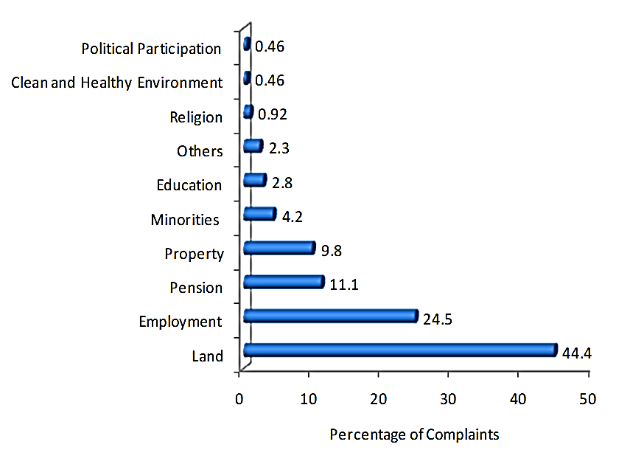
Source: Equal Opportunities Commission, 2019

Figure 2: Complaints Reported to the EOC, by Gender
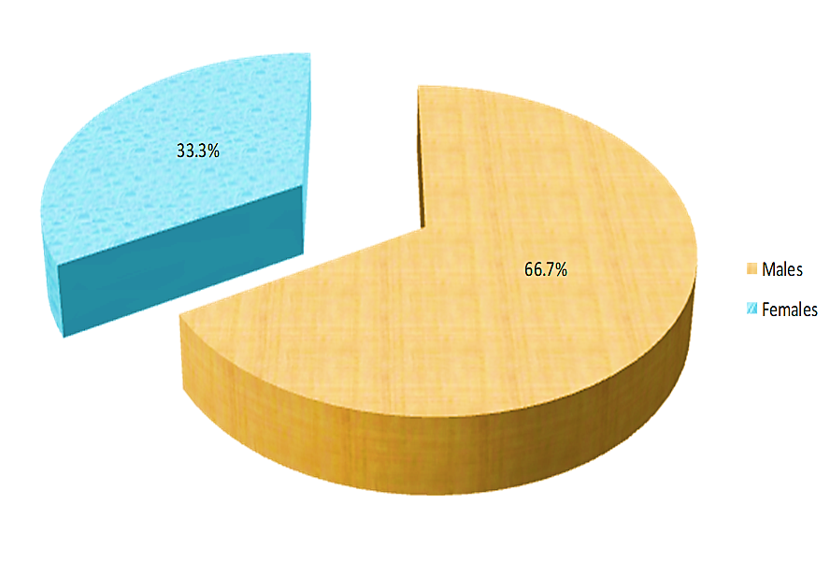
Source: Equal Opportunities Commission, 2019

Figure 3: Complaints Reported to the EOC, by Region
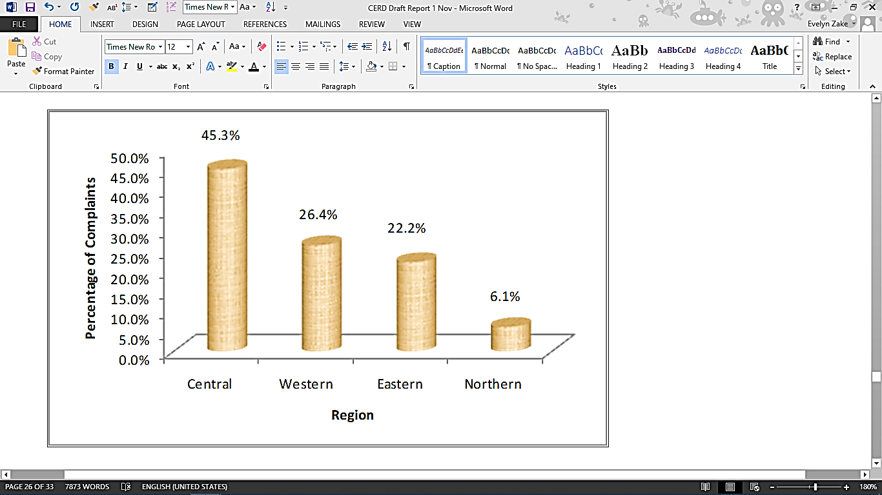
Source: Equal Opportunities Commission, 2019

Table 7: Current Status of Complaints being handled by the EOC
Status | Number of Complaints | Percentage (%)
Concluded | 44 | 20.4
Referred | 31 | 14.4
Under Hearing /  Mediation / Arbitration | 40 | 18.5
Under Investigation | 101 | 46.7
Total | 216 | 100

Source: Equal Opportunities Commission, 2018

Annex 3: Situation of the Batwa People
Figure 4: Presence of Batwa in South-Western Uganda
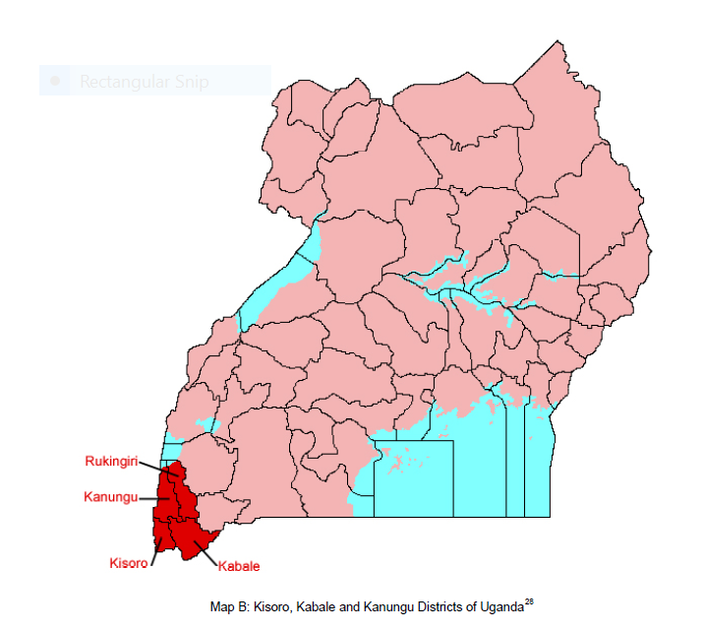
Source: Kidd, C. 2008 Development Discourse and the Batwa of South West Uganda (also see IMPP, MGLSD, 2019).

Figure 5: Educational Support Provided to Batwa Children by the BMCT Scholarship
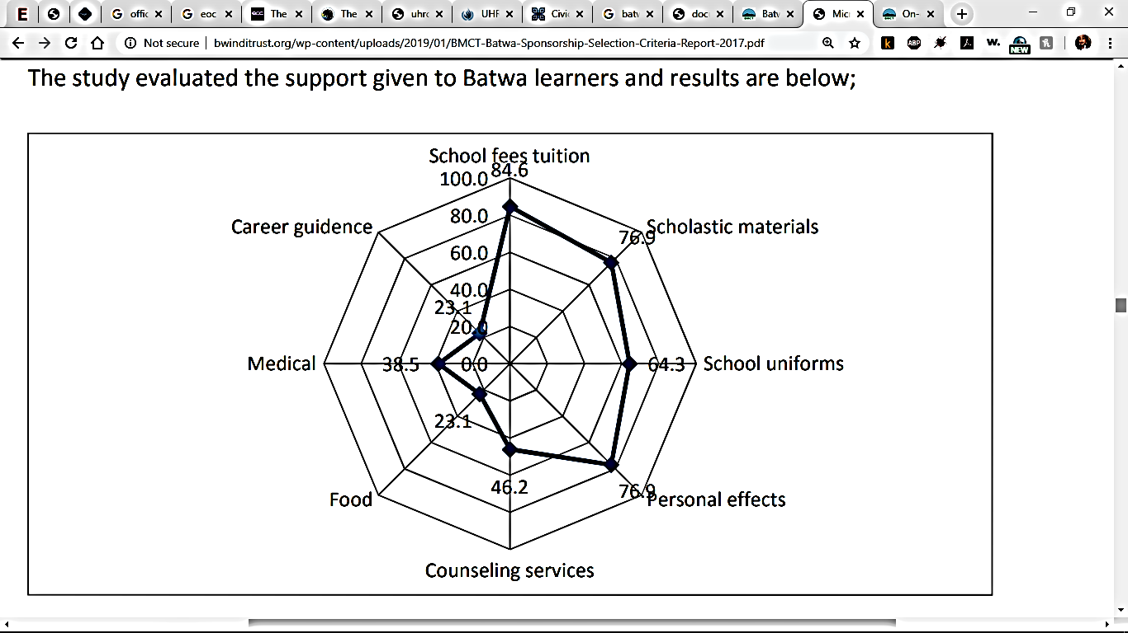
Source: BMCT 2017

Annex 4: Uganda Human Rights Commission
Figure 6: Complaints Registered by the Uganda Human Rights Commission, by Institution (2016-18)
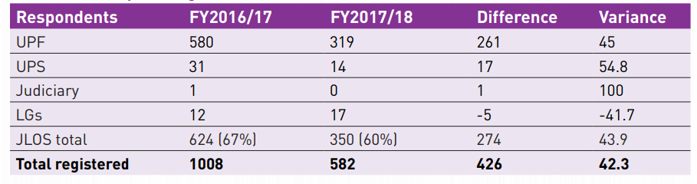
Source: UHRC (2017/18)

Figure 7: Access to Legal Aid Services Performance Indicator
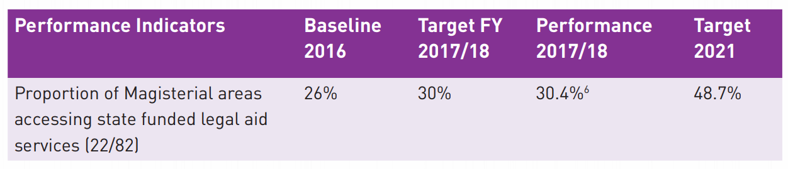
Source: JLOS Annual Report 2017/18

Annex 5: Situation of Women regarding HIV/AIDS
Figure 8: HIV Infection Rate by Gender and Residence as of 2017 (%)
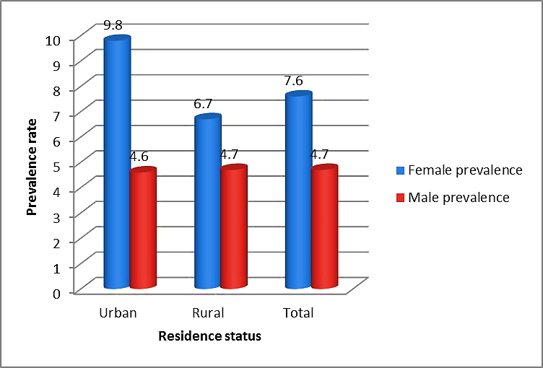
Source UPHIA 2016/17

Figure 9: HIV prevalence by Age and Sex
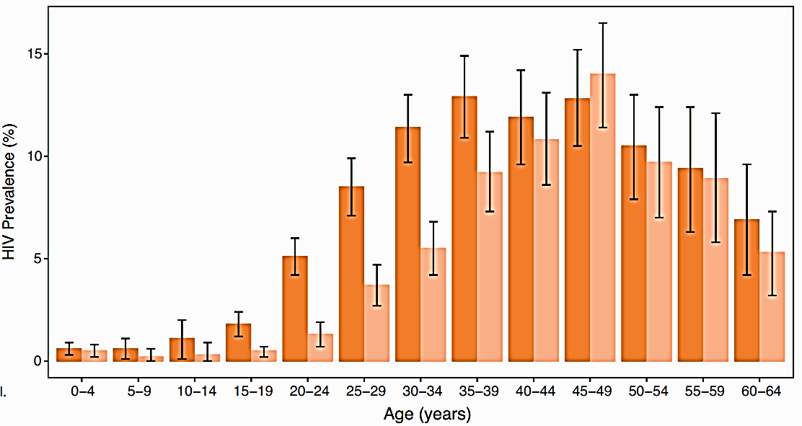
Source: UPHIA 2016/17
Figure 10: HIV Prevalence by Region
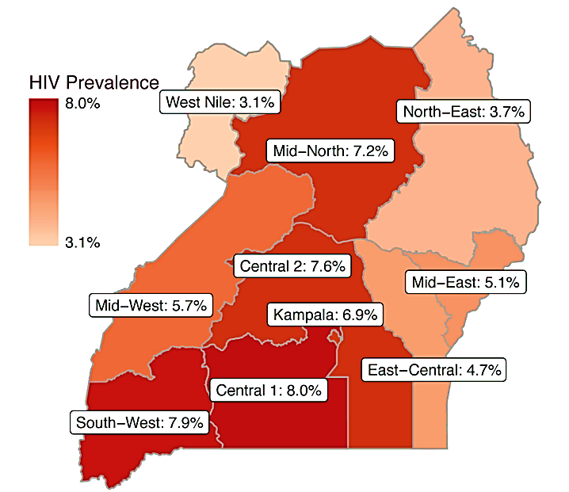

Source: UPHIA 2016/17

