O
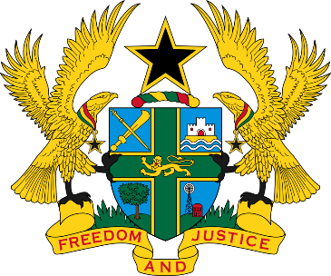
REPUBLIC OF GHANA
MINISTRY OF GENDER, CHILDREN AND SOCIAL PROTECTION

CLOSING REMARKS BY HON. DAKOA NEWMAN (MP)

MINISTER FOR GENDER, CHILDREN AND SOCIAL PROTECTION,

FOR THE DEFENCE OF GHANA’S REPORT TO THE UNITED NATIONS COMMITTEE ON THE RIGHTS OF PERSONS WITH DISABILITY
ON THE

THIRTY-FIRST SESSION ON THE RIGHTS OF PERSONS WITH DISABILITIES CONFERENCE IN GENEVA, SWITZERLAND FROM 12TH AUGUST TO 16TH SEPTEMBER,2024.

Chair, Excellencies, Distinguished Delegates, Ladies and Gentlemen
- On behalf of the His Excellency the President, Nana Addo-Dankwa Akufo Addo and the people of the Republic of Ghana, we express our sincere gratitude for the opportunity to discuss Ghana’s progress in realizing the rights of persons with disabilities. Your insightful questions and guidance have been invaluable as we strive to create a more inclusive society.
- We acknowledge the challenges that remain and reaffirm our unwavering commitment to addressing them. The Government of Ghana believes that the inclusion and empowerment of persons with disabilities are essential for building a just and prosperous nation.
- We have made significant strides in inclusive education, providing accessible curricula and training teachers to support students with disabilities. Additionally, we are committed to creating an accessible built environment and ensuring inclusive information services.
- To empower persons with disabilities economically, we are expanding vocational training, promoting entrepreneurship, and implementing inclusive workplace policies. Rehabilitation services are also being expanded to help individuals reach their full potential.
- We believe that persons with disabilities should be active participants in shaping their future. To this end, we are strengthening their involvement in public life through capacity building, advocacy training, and representation in decision-making processes.
- While we have made progress, we recognize the gaps that persist. We are committed to aligning our laws with the UN Convention on the Rights of Persons with Disabilities (UNCRPD) and accelerating the implementation of government projects and programs to support this vulnerable group.
- We will continue to collaborate with civil society organizations, persons with disabilities, and international partners to create effective and inclusive policies. We view this engagement as a crucial step towards a more inclusive Ghana and welcome continued dialogue and collaboration. In the words of the American Author and Disability Rights Advocate, Helen Adams Keller and I quote, ‘Alone we can do so little; together we can do so much" end of quote’
- Chair, we eagerly await your recommendations on our initial report to guide our national agenda for persons with disabilities. We extend our sincere appreciation to our development partners, NGOs, CSOs, and the Ghana Federation of Disabilities for their invaluable contributions to building an inclusive society. Your dedication to the rights of persons with disabilities is commendable.
- We are grateful for your kind co-operation.
- Thank you for the opportunity to share our experiences with this august Committee.

