Punjab
Expenditure Statement for Financial Year 2024-25 Child Protection & Welfare Bureau
Detail Object | Allocated Budget | 1st Quarter  Released Budget | 2nd Quarter  Budget | Total Budget Released
Total Salary | 586,068,000 | 175,827,000 | 117,215,000 | 293,042,000
Other than Salary | 412,514,000 | 103,135,000 | 82,502,000 | 185,637,000
Total | 998,582,000 | 278,962,000 | 199,717,000 | 478,679,000

Budget Detail of Child Protection & Welfare Bureau for the Financial Year 2023-24.
Summary of Budget F.Y 2023-24 of Child Protection & Welfare Bureau
Sr.NO | Detail Object | Revised Budget Estimate | Released Budget | Expenditure | Budget Saving
1 | Total Salary | 558,241,000 | 557,785,089 | 557,235,305 | 549,784
2 | None Salary | 612,400,000 | 611,794,546 | 607,988,440 | 3,806,107
 | Total | 1,170,641,000 | 1,169,579,635 | 1,165,223,745 | 4,355,891

Budget Detail of Child Protection & Welfare Bureau for the Financial Year 2022-23.
Budget Detail of Child Protection & Welfare Bureau for The Financial Year 2022-23
Sr. No | Item Description | Allocation | Final Total Released Budget | Expenditure | Balance
1 | Total Salary | 474,750,000 | 461,056,000 | 451,292,000 | 404,257,806
2 | Total non-salary | 309,141,000 | 428,021,000 | 437,785,000 | 38,996,516
 | Grand Total | 783,891,000 | 889,077,000 | 889,077,000 | 443,254,322

Balochistan

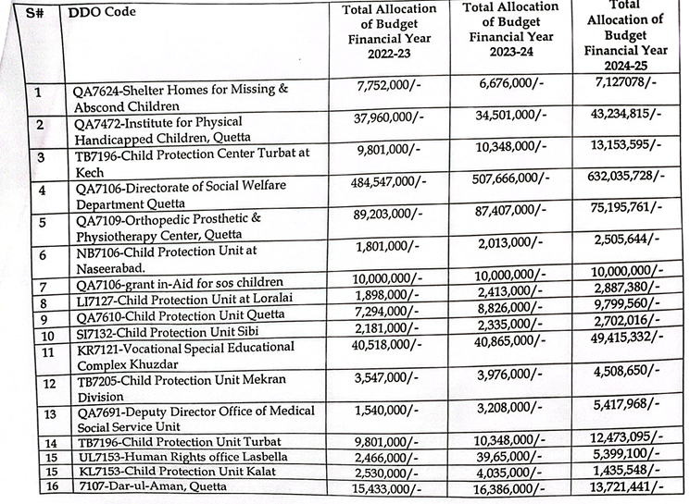

Sindh
Budget Allocation FY 2024 - 25 for Social Sectors, particularly Education, Health, and Social Protection
for Children in Marginalized and Disadvantaged Situations
 |  |  |  | Rs. in Million
S.No | Sector | Development Budget | Non-Development Budget | Total Budget Allocation
1 | Education
 | Primary Education |  | 136,224.0 | 136,224.0
 | Middle /Elementary Education | 23,051.5 | 36,145.7 | 59,197.2
 | Secondary Education | 18,021.7 | 68,521.2 | 86,543.0
2 | Health |  |  | -
 | Mother & Child Health |  | 1,181.1 | 1,181.1
 | Nutrition and Other Hygiene Programme |  | 4.6 | 4.6
 | Expanded Programme of Immunization(EPI) |  | 8,550.4 | 8,550.4
 | Rural Health Centres |  | 9,616.3 | 9,616.3
 | Basic Health Units/Dispensaries/Clinics |  | 11,690.4 | 11,690.4
 | Nursing and Convalescent Home Services |  | 13,962.3 | 13,962.3
 | Other Hospitals | 10,078.3 |  | 10,078.3
 | District Headquarter Hospitals |  | 1,656.8 | 1,656.8
 | Tehsil Headquarters Hospitals |  | 15,543.2 | 15,543.2
 | General Hospital Services |  | 126,371.0 | 126,371.0
3 | Women Development |  |  | -
 | Activities for Out of School Children |  | 20.0 | 20.0
 | Poor Women & Children, Karachi |  | 62.0 | 62.0
 |  |  |  | -
4 | Jails |  |  | -
 | Juvenile Jail Hyderabad |  | 119.7 | 119.7
 | Youthful Offender and Industrial School Karachi |  | 129.0 | 129.0
 | Central Prison II Sukkur (Juvenile) |  | 105.7 | 105.7
 |  |  |  | -
5 | Social Welfare Department |  |  | -
 | Establishment & Strengthening of Darul Atfal & Rehabilitation of Street Children through Civil Society Organization, Korangi | 20.5 |  | 20.5
 | Pakistan Sweet Home Karachi |  | 36.0 | 36.0
 | Sindh Child Protection Authority, Karachi |  | 150.0 | 150.0
 | Sindh Child Protection Authority, Karachi(Estt. of Lost & Found Children Centers) |  | 50.0 | 50.0
 |  |  |  | -
6 | Culture |  |  | -
 | Construction of Children Library & Book Shop and Provision Allied Facilities at Dargah Hazrat Allama Mian Ghulam Muhammad Mahesar at Kamal Dero Taluka Gambat District Khairpur |  | 40.0 | 40.0
 |  |  |  | -
7 | Sports & Youth Affairs |  |  | -
 | Development schemes | 5,211.1 |  | 5,211.1
 | Sports Activities for Street Children |  | 50.0 | 50.0
 |  |  |  | -
8 | Works & Services (Maintenance and Repair) |  |  | -
 | Residential Buildings Dar-ul-Aman & Dar-ul-Atfal |  | 187.5 | 187.5
 | M&R of Women & Children Jail |  | 56.7 | 56.7
9 | Social Protection Department | 14,180.0 | 12,260.3 | 26,440.3
 | Grand Total | 70,563.1 | 442,733.9 | 513,297.1

