
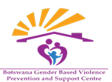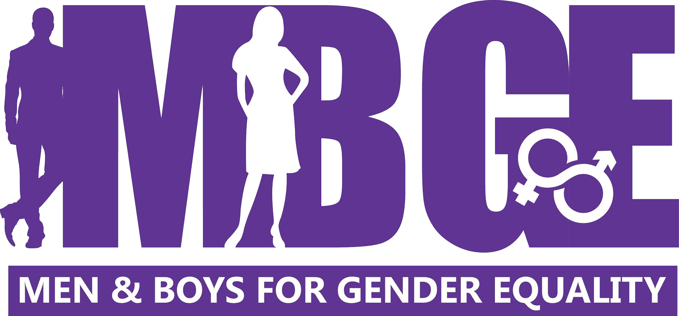

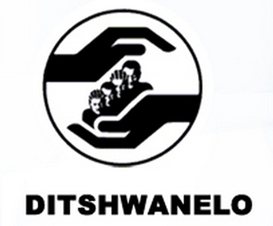
Committee on the Elimination of Discrimination against Women (CEDAW)
Human Rights Treaties Division (HRTD)
Office of the United Nations High Commissioner for Human Rights (OHCHR)
Palais Wilson - 52, rue des Paquis
CH-1201 Geneva, Switzerland

19th May 2025
Information on Botswana for consideration by the Committee on the Elimination of Discrimination against Women at its 91st session (16 June - 4 July 2025)

Introduction
- We respectfully present this report to supplement the 5th periodic report submitted by The Republic of Botswana scheduled for review by the Committee on the Elimination of Discrimination against Women ("the Committee") during its 91st session (16 June - 4 July 2025). This report is submitted jointly by Equality Now, Botswana Gender Based Violence Prevention and Support Centre, Men and Boys for Gender Equality and Ditschwanelo - the Botswana Centre for Human Rights. The submission highlights issues relating to sexual and gender-based violence and child marriage in Botswana.

- Equality Now is an international human rights organization that has been working to protect and promote the rights of all women and girls worldwide since 1992, including through our network of individuals and organizations in every region. Ending sexual violence, ending sexual exploitation, ending harmful practices, and achieving legal equality are the main areas of Equality Now’s work.
- Botswana Gender Based Violence Prevention and Support Centre is a non governmental organization working towards the prevention and response to gender-based violence in Botswana. Established in 1998, the organization works in the community to raise GBV awareness and provide psychosocial support services to GBV survivors. The organization is one of two NGOs providing safe shelter services in Botswana.
- Men and Boys for Gender Equality (MBGE), established in October 2013 and officially registered with the Registrar of Societies, is a recognized Non-Governmental Organization in Botswana. Its focus is implementing gender transformative measures involving men and boys to combat violence against women and children, prevent HIV transmission, and reduce alcohol consumption through active participation in sexual and reproductive health matters. MBGE primarily engages with men and boys through various means such as support groups, involving expectant fathers in sharing experiences and knowledge about childbirth and childcare, peer education, training sessions, and interactive discussions known as "blue couch sessions." Recognizing that every man will have familial roles, including being a father or a brother, MBGE aims to foster emotional expression among males as a means to decrease gender-based violence associated with men and boys. Moreover, by encouraging men to take on additional parenting responsibilities, MBGE promotes family support and well-being.
- DITSHWANELO – The Botswana Centre for Human Rights was established in 1993 and since then has remained the only organisation in Botswana dealing with varied aspects of human rights. DITSHWANELO works to advocate for changes in laws, policies and practices, and to raise public awareness of rights and responsibilities. They also provide paralegal services to those earning less than the minimum wage of P600.00 (UK pounds 60/US $85) per month. They work in partnership with other rights-focused organisations in Botswana, such as those focusing on gender equality, freedom of expression and information, children and youth, and indigenous peoples. Complementing the work of their partners, they focus on issues least supported by others, including those of domestic workers.
- This submission highlights the persistent issues of child marriage and gender-based violence in Botswana. It focuses on Botswana’s obligations under the Convention on the Elimination of All Forms of Discrimination Against Women (CEDAW), particularly emphasizing Articles 3, 5(a), and 16(2). Article 3 requires states to take all appropriate measures, including legislative action, in the political, social, economic, and cultural fields to ensure the full development and advancement of women, enabling them to exercise and enjoy human rights and fundamental freedoms on an equal basis with men. Article 5(a) obliges states to modify the social and cultural patterns of conduct of men and women to eliminate prejudices and customary practices based on the idea of the inferiority or superiority of either sex or on stereotyped gender roles. Additionally, Article 16(2) asserts that child marriage shall have no legal effect and requires states to establish a minimum age for marriage.
- Despite these obligations, child marriage persists, particularly under customary practices, while genderbased violence and gender inequality remain widespread. Therefore, this submission highlights existing legal gaps, insufficient enforcement of laws, a lack of comprehensive data collection and the need for urgent reforms to bring Botswana’s legal and policy framework in full compliance with CEDAW and to protect the rights of women and girls.
Previous concluding observations
- In the Concluding observations on the fourth periodic report of Botswana, the Committee was concerned about the persistence of harmful practices, including child marriage, and deep-rooted stereotypes regarding the roles and responsibilities of men and women in the family and the community. Hence, the Committee recommended that the Government of Botswana implement awareness-raising campaigns targeting families and communities on the harmful effects of child marriage on the health and development of girls and its criminal nature.
- In the combined concluding observations on the initial, second and third report of Botswana, the Committee urged Botswana to be more proactive and to put in place without delay a comprehensive strategy, including clear goals and timetables, to modify or eliminate negative cultural practices and stereotypes that are harmful to and discriminate against women, and to promote women’s full enjoyment of their human rights. Additionally, the Committee called upon Botswana to put in place a comprehensive system of data collection, including measurable indicators to assess trends in the situation of women and progress towards women’s de facto equality over time. Furthermore, it also urged Botswana to extend the Marriage Act to customary and religious marriages, so as to address entrenched customary laws which impair gender equality and lead to gender discrimination in the family.
- Previously, the Committee has been concerned about the high prevalence of gender-based violence against women and the toleration of domestic violence. According to the United Nations Population Fund (UNFPA), it is reported that over 67% of women in Botswana have experienced physical and sexual violence in their lifetime. This is over double the global average , caused by deep-rooted patriarchal attitudes,
Issues
Child marriage
Legal Framework and Gaps in Implementation
10. Botswana’s legal framework outlawing child marriage include the Children’s Act and the Marriage Act (amended in 2001), both of which establish 18 as the minimum age of marriage. However, this age restriction does not apply to customary and religious marriages, thus creating a loophole that allows child marriage to persist. Child marriage is still prevalent in Botswana. While Botswana has legal frameworks that prohibit child marriage such as the Children’s Act of 2009 and the Marriage Act, prosecutions specifically under these laws for child marriage are extremely rare or not publicly documented. The few cases of child marriage that do arise are typically handled through customary law or resolved informally at the family or community level, meaning they rarely reach the courts. Lack of reporting is a major issue: cases often go unreported due to family complicity, fear of stigma, or lack of awareness about the law, particularly in rural areas. Victims themselves may not recognize their rights or may be coerced into silence.
Lack of Enforcement and Data Collection
11. Botswana’s lack of data on child marriage cases allows violations to go unreported, creating an environment where the practice persists with impunity. The absence of official, nation-wide data on the prevalence of child marriage further complicates efforts to address the issue, as authorities may perceive child marriage as isolated incidents rather than a widespread problem.
Customary and Religious Marriages as a Loophole
12. Child marriage is most prevalent among the Bazezuru, Basarwa, and parts of the Kgalagadi communities. These marriages are often conducted under customary law, which is not effectively monitored. Many customary unions are not formally registered, despite this being a requirement in the law, making it difficult to track cases and hold perpetrators accountable. This speaks to the CEDAW Committee’s previous concerns that Botswana has failed to extend the protections of the Marriage Act to customary and religious marriages.
Marriage and Family Relations
12. In May 2024, Equality Now published the “Gender Inequality in Family Laws in Africa: An Overview of Key Trends in Select Countries Report.” In the case of Botswana, the report demonstrates the following issues of concern:
13.1: Lack of Recognition of Same-Sex Marriage: Marriage in Botswana remains reserved for heterosexual couples. Same-sex partners cannot conclude marriages, civil unions, or form permanent life partnerships. As a result, these partners do not enjoy equal protection of the law. However, the High Court in 2019 decriminalised same-sex sexual relations and the Court of Appeal confirmed this decision in 2021. Notably, the High Court held that the word “sex” in Section 3 of the Constitution should be interpreted to include sexual orientation, effectively creating a constitutional imperative to protect persons from discrimination on the grounds of sexual orientation. Botswana should, therefore, amend the Marriage Act to recognize same-sex marriage.
13.2: Lack of Recognition of Cohabiting Partners: Botswana has no legislative provision for cohabiting partners and the common law offers minimal protection for partners after dissolution of those partnerships. In order to obtain a share of joint property or the profits of joint enterprises after dissolution of the partnership, such partners must satisfy stringent standards of proof. In many neighbouring countries, permanent life partnerships or domestic partnerships have been established by legislation or precedent to protect the rights of such partners, and in particular, the rights of vulnerable women who might otherwise be left destitute after dissolution of such a partnership. It is imperative for Botswana to consider similar measures as its neighbouring countries.
Gender-based violence
Pervasive systemic drivers of gender-based violence in Botswana
14. Gender-based violence (GBV) in Botswana is driven by entrenched systemic factors that continue to undermine the rights and safety of women and girls. Patriarchal social norms and deeply rooted gender inequality promote male dominance and female subordination, reinforcing unequal power relations and legitimizing violence. The normalization of violence within families and communities—often perpetuated through cultural beliefs and socialization—further contributes to its widespread acceptance. Economic inequality, including women’s dependence on men, high unemployment, and poverty, increases vulnerability to abuse and limits access to justice or support. Additionally, a culture of silence, stigma, and fear of social repercussions discourages survivors from reporting GBV incidents, resulting in significant underreporting and impunity for perpetrators.
Lack of GBV data management systems
15. Botswana lacks the most recent or updated official statistics on GBV. Botswana's national demographic survey and related studies indicate a significant lack of official statistics on gender-based violence (GBV). While some data exists, it is often limited in scope and may not fully reflect the extent of the issue. The absence of official data further complicates efforts to address the issue, and which may comprise resource allocation for response programs.
Challenges in enforcing gender-based violence legal reforms
16. Botswana has undertaken several legal and programmatic initiatives to address gender-based violence (GBV), including intimate partner violence (IPV). A notable milestone was the enactment of the Domestic Violence Act in 2008, which provided a comprehensive legal framework for responding to IPV, including provisions for protection orders to safeguard victims/survivors. The National Strategy to End Gender-Based Violence (2016–2020) further emphasized the need for a coordinated, multisectoral approach to GBV, with a strong focus on IPV. In 2021, key legislative reforms, including amendments to the Penal Code and the enactment of the Sex Offenders Registry Act, introduced stricter penalties for perpetrators in an effort to strengthen deterrence and accountability.
However, despite these advancements, implementation gaps persist. Survivors continue to face limited access to safe shelters and there is a lack of rehabilitation programs for perpetrators. Chronic underfunding, reliance on customary courts and informal mediation, and prolonged prosecution processes undermine justice and protection. Survivors frequently withdraw cases due to stigma, pressure from families or communities, and a lack of confidence in the legal system, contributing to low conviction rates. Moreover, the effectiveness of the Sex Offenders Registry is curtailed by underreporting, case withdrawals, and limited public accessibility, reducing its potential as a preventive tool.
Recommendations
17. While Botswana has made international commitments to combat child marriage, gender-based violence and gender inequality generally under CEDAW, gaps in enforcement, legal loopholes, and lack of data continue to undermine progress. Urgent action is needed to close these gaps and protect women and girls. We therefore request the Committee to urge Botswana to take concrete legislative and policy measures to fulfill its obligations under the Convention through the following recommendations:
- Amend the Marriage Act to explicitly prohibit all marriages under 18 without exceptions, including for customary and religious marriages, and ensure strict enforcement.
- Amend Section 15 of the Constitution that provides for the protection from non-discrimination, as recommended in the Committee’s previous concluding observations, to ensure non-discrimination with respect to adoption, marriage, divorce, burial, devolution of property on death or other matters of personal law.
- Strengthen data collection mechanisms by implementing a national registry for all marriages, including those conducted under customary law.
- Enhance prosecution and accountability by training registry officers, law enforcement and judicial officers to recognize, prevent, and penalize child marriages.
- Expand awareness campaigns targeting communities where child marriage is prevalent to shift social norms and encourage reporting.
- Ensure access to education and health services for girls vulnerable to or affected by child marriage, including measures to reintegrate married girls into school;
- Ensure that the law recognizes same-sex marriage drawing on existing progressive jurisprudence;
- Recognise and regulate cohabitation relationships outside of marriage in order to protect the rights of vulnerable women;
- Strengthen the national gender machinery towards effective coordination and management of GBV response. This should include increased financing and budgetary allocation for gender-based violence prevention and response including for reform and implementation of laws, policies and multi-sectoral national action plans in domestic resources across sectors.
- Strengthening and implementation of laws and policies in both public and private sectors and reinforcement of related accountability and redress mechanisms to enhance rule of law and ensure access to justice for survivors of gender-based violence. This could be considerably enhanced if the Gender Commission of Botswana is recognized by law not by policy to be able to effectively perform its mandate and ensure accountability.
- Establishment of a National GBV database for an holistic approach to GBV reporting that meets all data quality dimensions. This will help improve the production, availability, accessibility and use of quality data and statistics on gender-based violence, disaggregated by sex, disability, age, race, ethnicity, sexual orientation, gender identity, migrant status, geographic location, and other socio-economic dimensions to support development, adoption, reform and implementation of legislation and policies to address violence against women and girls in all their diversity.

Africa meets against child marriage :: Mmegi Online
Concluding observations of the Committee on the Elimination of Discrimination against Women <CEDAW/C/BOT/CO/3: Concluding observations of the Committee on the Elimination of Discrimination against Women | OHCHR >
Concluding observations of the Committee on the Elimination of Discrimination against Women<CEDAW/C/BWA/CO/4: Concluding observations on the fourth periodic report of Botswana | OHCHR>
UNFPA ‘Gender Based Violence’ https://botswana.unfpa.org/en/topics/gender-based-violence accessed on 28 April 2023
Ibid
Ibid

