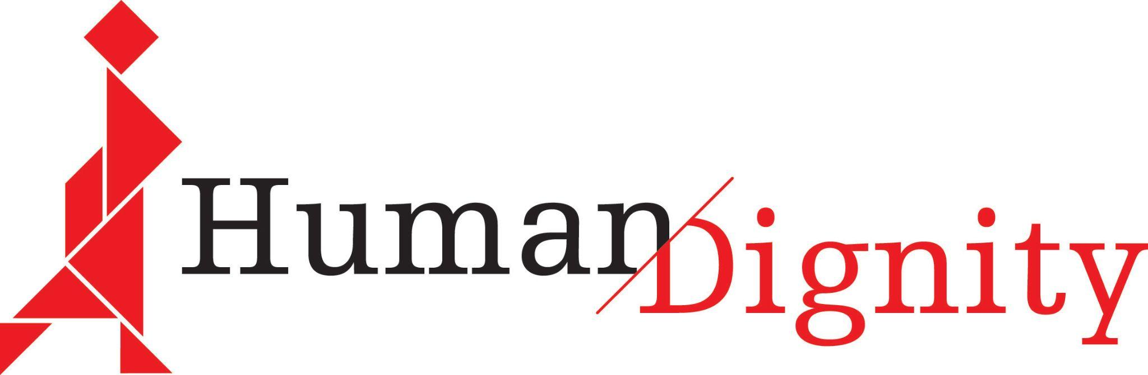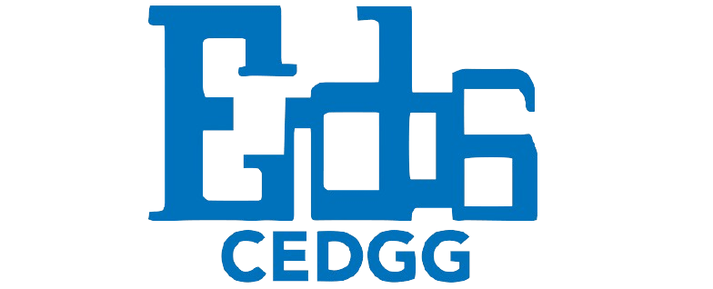

The impact of climate change on women’s right to health in Lake Baringo, Rift Valley, Kenya

Human Dignity
Centre for Enhancing Democracy and Good Governance
Human Rights, Economic Development and Globalization Law Clinic at Sciences Po Paris

January 2025

TABLE OF CONTENTS

I. Introduction 3
II. Legal and factual background 4
A. National framework guaranteeing the right to health and environmental rights in Kenya 4
B. Overview of climate change effects in Lake Baringo 6
III. The effects of climate change in Lake Baringo on women's right to health 7
A. The inaccessibility and unavailability of reproductive/maternal healthcare due to flooding 7
B. The failure to tackle displacement due to flooding 10
C. The inadequate governmental response to increased gender-based and sexual violence 11
D. The failure to address the risk to women’s health posed by malaria and dengue 13
E. The lack of effective governmental action on increasing animal attacks 14

Introduction

1. This report aims to provide information to the Committee on Economic, Social and Cultural Rights for its review of Kenya’s sixth Periodic report; in particular, on the Kenyan government's assessment, mitigation and adaptation to the impacts of climate change on economic, social and cultural rights including the right to health.

2. This submission analyses the Kenyan government's response to the impact of climate change on women's right to health around Lake Baringo in the Rift Valley Province in the west-central region of Kenya. It asserts that this response has not been sufficiently effective and targeted and highlights the issues on which the government should take further action: reproductive and maternal health facilities, gender-based violence, malaria rates, animal attacks displacement and animal attacks.

Submitting organisations

3. Human Dignity
Human Dignity is a non-profit association working for the respect, protection and realisation of economic, social and cultural rights in sub-Saharan Africa.
Its mission is to advocate for and defend the full range of economic, social, cultural, and environmental rights for all - by empowering a broad range of actors in transforming the lives of people and their communities through the fulfilment of human rights.
4. Centre for Enhancing Democracy and Good Governance (CEDGG)
The CEDGG is a non-political advocacy civil society organisation which works to empower vulnerable and marginalized citizens to claim their rights in local development and governance processes. Founded in 1995 by human rights defenders from the Endorois community in the (formerly) Baringo District, Kenya.
5. Sciences Po HEDG (Human Rights, Economic Development and Globalization) Law School Clinic
The HEDG Clinic is a program in the Law School Clinic at Sciences Po, Paris, in which master’s students complete clinic work on behalf of a partner on an issue relating to the promotion, protection and realization of human rights, the responsibility of actors in globalization and economic development, and sustainable and equitable development.
Methodology
6. This report was written as a collaboration between Human Dignity and students in the HEDG (Human Rights, Economic Development and Globalization) Law School Clinic at Sciences Po Paris, with notable contributions from Kenyan CSOs; in particular, the Centre for Enhancing Democracy and Good Governance.

7. The information contained in this submission consists of data collected from interviews with CSOs in Kenya, in addition to academic, CSOs and governmental sources from the period 2020-2024. The interviewed CSOs were the Centre for Enhancing Democracy and Good Governance, Let Girls Learn Initiative (LGLI), Indigenous Women and Girls Initiative (IWGI), Baringo Women and Youth Organisation (BWYO).

Legal and factual background

A. National framework guaranteeing the right to health and environmental rights in Kenya
8. Kenyan law guarantees an extensive series of human rights, reflecting an advanced legal system. Unfortunately, these laws are not currently being upheld by State authorities with regard to the impact of climate change on women’s right to health in the Lake Baringo region.

9. In Article 43(a), Kenya’s constitution ensures the right to health, “which includes the right to health care services, including reproductive health care”. Since 2010, Article 42 of the Kenyan Constitution states that:
42. Every person has the right to a clean and healthy environment, which includes the right— (a) to have the environment protected for the benefit of present and future generations through legislative and other measures, particularly those contemplated in Article 69; and (b) to have obligations relating to the environment fulfilled under Article 70.
10. Subsequently, the 5th Chapter of the Constitution elaborates on provisions relating to the safeguarding of land and environment. A corpus of legislation at the national and county levels has developed from this Chapter. Most notably, the 2016 Climate Change Act seeks to mainstream climate change resilience and creates the National Climate Change Council as an overarching coordinating body to institutionalise responses to climate change. Other important laws and policies include the Environmental and Management Coordination Act, at the national level, and, at the local level, the Baringo County Social Protection Policy 2021, Baringo Disaster Risk Management Policy, Baringo County Climate Change Regulation 2023, the County Climate Change Action Plan 2022-2027 and the County Participatory Climate Change Vulnerability Risk Assessment (PCRA) report.

11. Regarding the right to health, there are several significant laws and policies based on the constitutional provisions. Among them, the Primary Health Care Act (2023) establishes Primary Care Networks and formalizes the role of community health promoters within the public service system, the Social Health Insurance Act creates a framework for managing social health insurance and establishes new health insurance funds and the Kenya Health Policy 2014–2030 emphasises collaboration with non-state actors and outlines quality assurance mechanisms such as licensing, inspections, and accreditation.

12. These instruments provide for one of the strategic objectives of Kenya’s Health Ministry in 2030: universal health coverage. Recently, Kenyan authorities have announced that this scheme will continue to sponsor the Linda Mama program, one of Kenya’s most successful policies to ensure maternal and reproductive health for women. Although this is a significant decision, the counties play a crucial role in advancing these policies, due to Kenya’s devolved government structure. More recently, the Council of Governors agreed on a financial procedure manual to pay for universal health coverage, which is still to be proven successful.

13. Nevertheless, as will be discussed below, the constitutional framework and the national laws have not succeeded in creating an effective health system in the Lake Baringo area with the ability to address the needs of the population, particularly women and girls. Moreover, the facilities and services which are in place are not robust or resilient enough to guarantee the right to health of women in the area, especially in the face of floods which have affected the Lake.

B. Overview of climate change effects in Lake Baringo

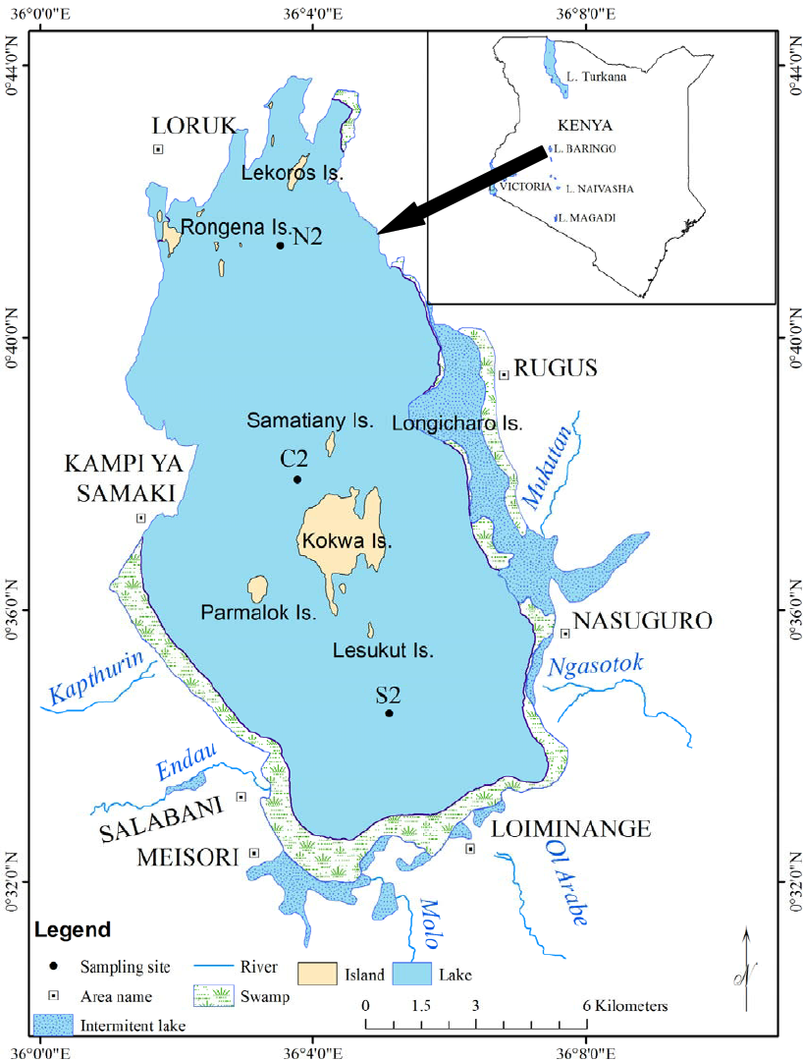
Figure 1

14. Lake Baringo is a freshwater lake in the Great Rift Valley in Kenya and is located within Baringo County, one of Kenya's 47 counties or units of devolved government under the 2010 Constitution.
Over the past decade, the water levels of Lake Baringo have risen 12 metres, causing the lake to double in size since 2010 and claiming 139.98 km² of riparian land as of 2021. A 2021 report by the government of Kenya concluded that heavy rainfall linked to climate change was the primary cause of this rapid enlargement.
15. The increased rainfall and the lake's expansion have caused significant issues for the surrounding communities:
- Contamination and loss of water sources and soil erosion.
- Rising water levels leading to stronger currents, submerged hazards, and less stable conditions for fishing, thus increasing the risks for fishers.
- The loss of arable land and livestock due to flooding, causing a disruption of the food supply.
- The increased presence of crocodiles, hippopotamuses and venomous snakes near residential areas and schools, leading to a rise in animal attacks.
- The submersion of homes and destruction of infrastructure.
- Displacement of entire villages, particularly indigenous communities such as the Endorois and the Ilchamus.
- Increased risk of infectious diseases during heavy rain periods.
- Increased conflicts due to competition for limited resources.
16. These events have affected thousands of people living around the lake, but they have had a disproportionate effect on women and girls, who have faced reduced access to reproductive healthcare services, increasing incidences of gender-based violence, and a heightened exposure to animal threats due to their distinctive roles in the family and community, as illustrated by the interviews carried out for this report. The following sections will analyse five key issues which pose significant challenges to the right to health of women in Lake Baringo.

The effects of climate change in Lake Baringo on women's right to health

A. The inaccessibility and unavailability of reproductive/maternal healthcare due to flooding

17. Lake Baringo’s water levels have consistently risen since 2010, as the rainfall in the area has increased by around 30% in the last decade. This has put communities around the Lake at a considerable risk, especially in its southern region. Climate experts warn that, if these trends, powered by hydro-climate patterns disrupted by global warming, continue, Lake Baringo and Lake Bogoria could merge, creating significant environmental damage.

18. According to United Nations Office for the Coordination of Humanitarian Affairs (OCHA), in 2024, between 5,000 and 20,000 people were affected by heavy rains and around 7,000 people were displaced by the floodings, with 11 camps installed in Baringo County to accommodate these people. Heavy rains and flooding have affected an area of at least 108.57km.² This is taking a significant toll on the lives of the communities in the area.

19. This issue has greatly affected the way in which communities living around Lake Baringo exercise their right to health, especially with regard to the availability of health facilities. According to the Centre for Enhancing Democracy and Good Governance, one particular health facility was affected: Kampi Samaki Health Centre on the western side of Lake Baringo (see map below). This has had a large ripple effect, as the facility was the main referral point for Kokwo Dispensary (on Kokwo Island), Meisori Dispensary and Salabani Dispensary. The Kenyan health care system is organized at six levels. Dispensaries, at the first level, provide basic medical care and are usually operated by nurses who treat minor ailments and provide basic maternal healthcare services. County health centres, in the second level of the healthcare system, also provide primary care, including more advanced reproductive/maternal healthcare. Thus, the reduced functioning of Kampi Samaki Health Centre affects several communities living around Lake Baringo by disrupting the services provided to them.

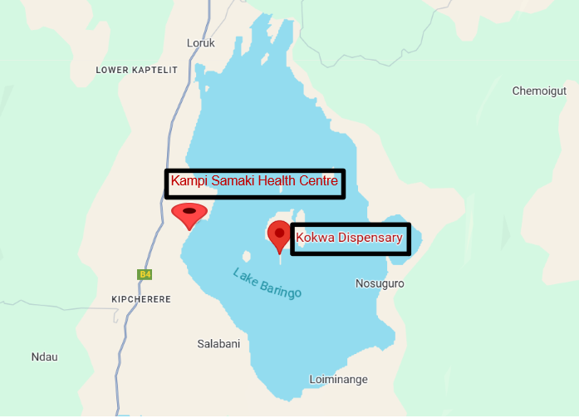

20. Kampi Samaki Health centre had been partially reconstructed at the end of 2024. However, according to the information received, only 1 staff member has been deployed and is offering only outpatient services. Before the flooding, Kampi Samaki was operating as a fully-fledged health centre. As such, it had 5 medical staff and 1 subordinate staff member. As of December 2024, the facility was yet to be connected to electricity and thus relies on the snake park for the refrigeration of vaccines in order to sustain its child immunization service. Communities are advocating for the reconstruction of the maternity wing at Kampi Samaki Health centre as a matter of urgency. Additionally, Kokwo Dispensary has been relocated twice during previous floods, losing key infrastructure including its maternity wing.

21. The reduced availability of health services has had a significant toll on women, especially those going through pregnancies, as services have become less accessible both physically and financially. At present, women in Baringo County are forced to travel to Marigat, 20km away, to access the nearest health centre for advanced maternal health services. For this journey, most of them must hire a vehicle or motorbike, which is expensive, costing approximately 1500 Kenyan shillings (11 euros) for a one-way trip, which represents almost 10% of the monthly minimum wage (15201 Kenyan shillings or 112 euros).

22. This impact of floodings, in limiting the accessibility of health facilities for Baringo women, threatens to reverse Kenya’s progress in encouraging maternal and reproductive health. It may also reinforce geographical inequalities experienced by the female population of this county. Even before the damage to health infrastructure, only 83% of women had facility births in Baringo, below Kenya’s average of 90%.

23. Moreover, Baringo county was already behind other regions in Kenya in providing sexual and reproductive health for local women, a trend which may be worsened by the effects of floods on health facilities. For example, only 49% of women in Baringo aged 15-49 had a live birth with at least 4 antenatal visits, as opposed to the 66% national average. Similarly, only 48% of currently married women in Baringo use modern forms of contraception, far below the 57% national average. Additionally, as of 2021, 'it is notable that Baringo County records 488 deaths per 100,000 births. This means Baringo County had a higher maternal mortality rate than the country level aggregate (374 deaths per 100,000 live births)', even before last year's floods. As such, if the consequences of these disasters are not promptly and effectively addressed, Baringo women will be placed in a condition of enhanced vulnerability, which may have devastating consequences for their right to health.

24. Overall, the floods, which have affected everyday life around the Lake this year and over the past decade, are now creating additional barriers for women's access to health care services. These issues threaten women's effective exercise of their right to health, by making hospitals and clinics in the county less readily available and both physically and financially inaccessible. The failure to fully restore health infrastructure such as the Kampi Samaki health centre also indicates that local and national authorities are not fulfilling their obligations to:
- Realise the right to health pursuant to Article 42 of the Constitution;
- Mainstream climate change resilience and prevention into Baringo’s health system, as stated in 2016 Climate Change Act and the county’s Climate Change Regulation and Action Plan.

25. Recommendations for the government of Kenya:
- Restore health services to their pre-flooding state, including rebuilding and restaffing health facilities. Restoration plans should include a climate-sensitive assessment of the projects, such that health facilities can withstand the effects of heavy rain and floods.
- Implement concrete measures to reduce the financial and logistical burden upon women who are currently forced to travel to distant health facilities to access medical care in the short term.
These measures could include government investment in transportation for either the users (subsidised costs) or the staff (subsidised wages). The State provision of vans for patients travelling to faraway health clinics or dispensaries could be an effective immediate solution. Another option is to collaborate with local transportation providers and provide a sufficient number of subsidised motorcycle and boat vouchers to women to use in case of emergency. Mobile clinics could also be temporarily introduced in order to reduce the need to travel for health treatment.
- Establish a working group of health professionals, climate scientists and community members to assess the risk to the 28 health centres of Baringo County in the face of heavy rains and floods, especially those in close proximity to Lake Baringo. Subsequently, create a climate change adaptation plan for the County’s health system, so that it can continue to provide care in unfavourable weather conditions.
- Invest in the training of more community health workers in basic health service provision to decrease the need to travel for basic services.
- Develop a telehealth and SMS-based system for women to contact when they need guidance in emergency situations.
- Provide emergency reproductive, maternal and newborn care kits to be stored at flood-resilient locations to reduce the need for long-distance travel for supplies.

B. The failure to tackle displacement due to flooding
26. The indigenous Ilchamus community of over 30,000 people have suffered mass displacement due to the flooding of the lake, with at least 150 households living in a camp in Kiwanja Ndege in northeastern Kenya. BWYO testified as to the impacts of this traumatic displacement upon the mental health of the Ilchamus community, and described the living conditions of women in temporary camps as follows: 'They stay in poorly ventilated units with no heat regulation, leading to dehydration, general poor health status with frail bodies [...], exposure to mosquitoes leading to serious malaria.' A report by the CSO Climate Change Refugees also describes how living conditions in camps exacerbate issues of gender-based violence.

27. With regard to the issue of mass displacement, the Committee’s list of issues requested that Kenya 'provide information on the progress made in improving access to sexual and reproductive health information and maternal health care, including through the universal health coverage scheme, for all women and girls [...] in settlements for refugees and internally displaced persons, regardless of age, marital status or any other grounds.' While the Kenyan government has created a contingency fund for people displaced by natural disasters, with 'the 2023 budget allocating Sh2.2 billion for resettlement purposes', this has not sufficiently resolved the issue of displacement, which is still very much ongoing.

28. Recommendations for the government of Kenya:
- Take urgent action to provide rehousing and healthcare assistance to women and other people displaced by climate change around Lake Baringo. In particular, prioritise the rehousing of displaced communities with accommodation that ensures proper ventilation, mosquito protection, and gender-sensitive facilities to reduce health risks and gender-based violence.
- To address immediate health concerns, mobile healthcare units equipped for maternal and reproductive care could be deployed along with additional medical staff.
- Strengthen disaster preparedness and resilience, including reinforcing early warning systems and ensuring that contingency plans address both housing and healthcare needs. Although the government allocated Sh2.2 billion in the 2023 budget to support people displaced by natural disasters, it is essential to ensure these funds are effectively used, with clear reporting on how they address the specific needs of women and their families.
- Involve affected communities, especially women, in designing and implementing these initiatives, in order to ensure their voices and needs are at the heart of the response.

C. The inadequate governmental response to increased gender-based and sexual violence
29. In 2022, in Baringo county, 6% of women had experienced sexual violence in the previous year and 20% had experienced physical violence in the same time period. CSOs based in the region have linked climate change to these high incidences of gender-based violence.

30. CEDGG testified that, due to the damage done to buildings and infrastructure by flooding, women are required to travel farther to access health facilities or essential resources and, as a result, are at greater risk of sexual exploitation. They have received testimonies of sexual exploitation by motorbike drivers and boat owners of women seeking transport to far-away clinics in Marigat (over 20km away from Lake Baringo) or to find firewood when their usual routes have been flooded. LGLI highlighted an increased risk of violence due to women's socially attributed role as water providers. When safe water is not locally available because of flooding, women must take transport to water sources and are asked for sexual favours in exchange.

31. Additionally, competition for increasingly scarce resources is tied to the persisting issue of bandit attacks on villages in Baringo, which may involve sexual and physical violence against women and girls.

32. BWYO attested that national governmental action on gender-based violence fails to prioritise the provision of information to all relevant stakeholders, most importantly rightsholders. According to the information they provided, the Ministry of Health 2009 National Guidelines on the Management of Sexual Violence in Kenya, which provide for the treatment and care of survivors of sexual violence, are disseminated to health workers but not the general public. This was also the case with the 2013 Multi-sectoral Standard Operating Procedures (SOPs) for Prevention of and Response to Sexual Violence in Kenya and the 2006 Sexual Offenses Act, which are not intended for use by the public, but only as procedural guidelines for professionals. In its reply to the List of Issues, the Kenyan government cited the following efforts to combat gender-based violence: National Police Service Response (POLICARE), Gender Violence Recovery Centres and Gender Desks. However, no clear account of how and in which regions these policies operate was provided.

33. Recommendations for the government of Kenya:
- Provide clear information of how the government is tackling the issue of gender-based violence, and whether the efforts mentioned above are working effectively to uphold the rights of women and girls. This should include the engagement of all stakeholders across Kenya, in the implementation of a coordinated national and regional strategy which allows for the reporting of gender-based violence, the prosecution of gender-based violence crimes and the medical treatment of those who have experienced gender-based violence.
- Provide updated disaggregated data on the issue of gender-based violence in Baringo County in order to effectively analyse the causes of the gender-based violence, the demographics it most affects, and the means of eradicating it. In particular, investigate the connection between flooding and gender-based violence in Baringo County through quantitative and qualitative analysis.
- Carry out public awareness campaigns at the national and county levels to inform women and girls about their rights and options for seeking medical treatment and reporting violence. This information should be disseminated in local languages to all rightsholders through effective means, which may include school visits by experts or media campaigns.

D. The failure to address the risk to women’s health posed by malaria and dengue

34. Floods and heavy rainfall create favourable conditions for the breeding of the Anopheles mosquitoes, which are responsible for transmitting malaria, and the Aedes mosquitoes, which spread dengue. The increased volume of water leads to more accumulation of stagnant liquids in which these mosquitoes reproduce easily. This, added to the fact that communities have been displaced and health infrastructure has been damaged, increases the vulnerability of the population. Women, especially pregnant women, are significantly vulnerable to the effects of dengue and malaria. Studies have found an increased risk among pregnant women with symptomatic dengue to deliver infants who are preterm or low birthweight, but both the amount of risk and the stability of this risk were affected by the inclusion or exclusion of miscarriages (infants born before 22 weeks of gestational age). This suggests that women who are pregnant should take extra precautions to avoid dengue infections during pregnancy, since it may cause an early delivery or the birth of a small infant.
35. Similarly, civil society organisations in the area, such as the Baringo Women and Youth Organisation have signalled an increase in the number of miscarriages related to malaria infections in women in the area, although more robust data is yet to be collected.
36. Additionally, the Centre for Enhancing Democracy and Good Governance highlighted that due to inadequate laboratory equipment and staff in health facilities in the affected locations, malaria cases go unreported and thus there is no commensurate intervention by government to prevent and treat malaria. At the time of reporting, there was no functional laboratory in Kampi Samaki Health Centre and the surrounding dispensaries (Miesori Dispensary, Ng'ambo Dispensary and Salabani Dispensary).

37. Recommendations for the government of Kenya:
- Adapt the national and county governments’ strategy to combat dengue and malaria from prevention and adaptation to addressing the root causes of these diseases and its links to the floodings of Lake Baringo.
This should include the improvement of the public infrastructure of the communities surrounding the Lake, with specific regard to drainage and landscaping to promote the flow of water, as well as enhanced disease surveillance and integrated disease management.

E. The lack of effective governmental action on increasing animal attacks
38. The increasing prevalence of crocodile, hippopotamus and snake attacks due to the expansion of Lake Baringo represents another significant impact upon women's right to health, as reported by the NGO workers interviewed for this report. When women are travelling to water sources to collect drinking water or wash clothes, they are in danger of attacks by these animals, which can grievously injure them or take their lives. This serious risk to women’s health merits the attention of State authorities, as it frequently entails life-changing or life-threatening injuries to the affected person and may, as a result, cause women to change their routines to the detriment of their health. For example, women may choose to travel to water sources of worse quality if there is a reduced risk of animal attacks at these sources.

39. Recommendations for the Baringo county government, assisted by the Kenyan government:
- Establish secure water collection zones with barriers to keep dangerous animals away, thus reducing the risk to women and children.
- Develop community-led wildlife monitoring systems, supported by local and national wildlife agencies, to track animal movements and issue timely warnings.
- Provide alternative water solutions, such as boreholes or water points in safer locations, in order to minimize the need for women to venture into hazardous areas.
- Introduce awareness programs to educate communities on safely navigating risky zones and responding to wildlife encounters.
- Strengthen wildlife management in order to mitigate human-wildlife conflicts.

List of issues in relation to the sixth periodic report of Kenya, Committee on Economic, Social and Cultural Rights E/C.12/KEN/Q/6 para 7 https://tbinternet.ohchr.org/_layouts/15/treatybodyexternal/Download.aspx?symbolno=E%2FC.12%2FKEN%2FQ%2F6&Lang=en
Art. 43 (a), The Constitution of Kenya.
Art. 42, The Constitution of Kenya.
Kenya's reply to List of Issues, E/C.12/KEN/RQ/6
Kenya's reply to List of Issues, E/C.12/KEN/RQ/6
Kenya's reply to List of Issues, E/C.12/KEN/RQ/6
Kilei, Charity. "Government Confirms Linda Mama Programme Will Continue under Social Health Authority." Eastleigh Voice. Last modified August 15, 2024. https://eastleighvoice.co.ke/health/69002/government-confirms-linda-mama-programme-will-continue-under-social-health-authority.
Kembenya, Elijah Migiro. "Figure 1" ResearchGate. Accessed January 6, 2025. https://www.researchgate.net/figure/A-map-of-Lake-Baringo-showing-the-stations-S2-C2-and-N2-sampled-during-the-study-from_fig1_266558961.
County Government of Baringo. "Lake Baringo National Park." County Government of Baringo. https://www.baringo.go.ke/!/tourism/150/lake-baringo-national-park/.
‘County Information | State Department for Devolution’, accessed 10 January 2025, https://www.devolution.go.ke/county-information.
The Danish Institute for Human Rights. "The Lake and the Case: How Human Rights Are Being Used to Hold States Accountable for the Impacts of Climate Change." https://www.humanrights.dk/case-story/lake-case-how-human-rights-are-being-used-hold-states-accountable-impacts-climate-change.
Republic of Kenya and UNDP. Rising Water Levels in Kenya’s Rift Valley Lakes, Turkwel Gorge Dam and Lake Victoria. Republic of Kenya, 2021. Accessed from https://ir-library.ku.ac.ke/items/5216a109-054f-4e6e-af2a-c78774f62d82.
Ibid.
Muia, Daniel, Michael Gicheru, Joshua Mutiso, Benson Mwangi, Lucy Kavinda, and Eunice Kairu. ‘Effects of Extreme Flooding of Lake Baringo on Livelihoods of Communities Lining around the Lake’. Advances in Applied Sociology 11, no. 8 (3 August 2021): 406, Section1; 409, Section 5.3. https://doi.org/10.4236/aasoci.2021.118036.
Tower, Amali, and Ryan Plano. "Case Study: Non-Economic Loss and Damage in Kenya." Climate Refugees. Last modified November 13, 2023. https://www.climate-refugees.org/reports/2023/11/13/loss-and-damage-case-study.
Muia, Daniel Michael Gicheru, Joshua Mutiso, Benson Mwangi, Lucy Kavinda, and Eunice Kairu. ‘Effects of Extreme Flooding of Lake Baringo on Livelihoods of Communities Lining around the Lake’. Advances in Applied Sociology 11, no. 8 (3 August 2021): 409, Section 5.3. https://doi.org/10.4236/aasoci.2021.118036.
Nyakundi, Victor, Eric Plal, and Kandu Kyeba. "The Risk of Flooding to Architecture and Infrastructure Amidst a Changing Climate in Lake Baringo, Kenya." American Journal of Climate Change 12 (January 1, 2023): 98, Section 6. https://doi.org/10.4236/ajcc.2023.121005.
Obando, J. A., Simon Onywere, Chris Shisanya, Antony Ndubi, Dan Masiga, Zephania Irura, Nicholas Mariita, and Haron Maragia. "Impact of Short-Term Flooding on Livelihoods in the Kenya Rift Valley Lakes." In Geomorphology and Society, edited by Michael Meadows and J.C. Lin, [Section 12.4.3]. Advances in Geographical and Environmental Sciences. Springer, Tokyo, 2016. https://doi.org/10.1007/978-4-431-56000-5_12.
The Danish Institute for Human Rights. "The Lake and the Case: How Human Rights Are Being Used to Hold States Accountable for the Impacts of Climate Change." https://www.humanrights.dk/case-story/lake-case-how-human-rights-are-being-used-hold-states-accountable-impacts-climate-change.https://www.humanrights.dk/case-story/lake-case-how-human-rights-are-being-used-hold-states-accountable-impacts-climate-change.
Nyakundi, Victor, Eric Plal, and Kandu Kyeba. ‘The Risk of Flooding to Architecture and Infrastructure amidst a Changing Climate in Lake Baringo, Kenya’. American Journal of Climate Change 12 (1 January 2023): pg. 85 Section 2.2 https://doi.org/10.4236/ajcc.2023.121005 International Disability Alliance. ‘The Impact of Climate Change on Indigenous Peoples with Disabilities in Baringo County, Kenya’ pg.31. https://www.internationaldisabilityalliance.org/resources/impact-climate-change-indigenous-peoples-disabilities-baringo-county-kenya.
Obando, J. A., Simon Onywere, Chris Shisanya, Antony Ndubi, Dan Masiga, Zephania Irura, Nicholas Mariita, and Haron Maragia. "Impact of Short-Term Flooding on Livelihoods in the Kenya Rift Valley Lakes." In Geomorphology and Society, edited by Michael Meadows and J.C. Lin, [193-215]. Advances in Geographical and Environmental Sciences. Springer, Tokyo, 2016. https://doi.org/10.1007/978-4-431-56000-5_12.
International Disability Alliance. "The Impact of Climate Change on Indigenous Peoples with Disabilities in Baringo County, Kenya." 2023. https://www.internationaldisabilityalliance.org/resources/impact-climate-change-indigenous-peoples-disabilities-baringo-county-kenya.
Climate Refugees. ‘“Climate Change Is Controlling Everything, Let Them Compensate Us”: Stories of Loss and Damage in Kenya’, 14 August 2023 https://www.climate-refugees.org/reports/kenya-loss-and-damage pg.22.
Obando, J. A., Simon Onywere, Chris Shisanya, Antony Ndubi, Dan Masiga, Zephania Irura, Nicholas Mariita, and Haron Maragia. "Impact of Short-Term Flooding on Livelihoods in the Kenya Rift Valley Lakes." In Geomorphology and Society, edited by Michael Meadows and J.C. Lin, [Section 12.4.2]. Advances in Geographical and Environmental Sciences. Springer, Tokyo, 2016. https://doi.org/10.1007/978-4-431-56000-5_12.
Republic of Kenya and UNDP. Rising Water Levels in Kenya’s Rift Valley Lakes, Turkwel Gorge Dam and Lake Victoria. Republic of Kenya, 2021. Accessed from https://ir-library.ku.ac.ke/items/5216a109-054f-4e6e-af2a-c78774f62d82. Pg. 30.
Ibid.
Cherono Kiplangat N., Olang L., Thumbi G., Stecher G., Herrnegger M., (submitted 08/2024) Flooding from Lake Level Upsurges: Anticipatory Flood Risk Assessment and Socio-economic Impacts in Lake Baringo, Kenya.
Republic of Kenya and UNDP. Rising Water Levels in Kenya’s Rift Valley Lakes, Turkwel Gorge Dam and Lake Victoria. Republic of Kenya, 2021. Accessed from https://ir-library.ku.ac.ke/items/5216a109-054f-4e6e-af2a-c78774f62d82.
OCHA. ” Kenya: Heavy rains and flooding update Flash Update #6”. May 17, 2024.
Cherono Kiplangat N., Olang L., Thumbi G., Stecher G., Herrnegger M., (submitted 08/2024) Flooding from Lake Level Upsurges: Anticipatory Flood Risk Assessment and Socio-economic Impacts in Lake Baringo, Kenya.
Dispensaries, county health centres, sub county hospitals, county referral hospitals, national hospitals, specialized medical centres
Primary health care systems (PRIMASYS): case study from Kenya, abridged version. Geneva: World Health Organization; 2017 pg.4. Licence: CC BY-NC-SA 3.0 IGO. https://iris.who.int/bitstream/handle/10665/341073/WHO-HIS-HSR-17.6-eng.pdf?sequence=1#:~:text=The%20Kenyan%20health%20system%20defines,referral%20hospitals%20and%20large%20private
Information provided by the Centre for Enhancing Democracy and Good Governance, as reported by the Baringo North Sub-County Health Services Coordinator.
1 Clinical Officer, 2 Nurses, 1 laboratory technician, 1 Public Health Officer and 1 general attendant
Kenya Gazette Supplement 114. Legal Notice No.125. The Labour Institutions Act (no. 12 of 2007). https://cotu-kenya.org/wp-content/uploads/2022/07/Minimum-Wage-Gazette-Notice-2022.pdf
The DHS Program. Baringo County: Kenya Demographic and Health Survey 2022. https://dhsprogram.com/pubs/pdf/GF57/GF57Baringo.pdf.
Ibid.
Ibid.
Baringo County Government. Baringo County Social Protection Policy 2021. https://www.baringo.go.ke/resource/baringo-county-social-protection-policy-2021/.
Climate Refugees, "‘Climate Change Is Controlling Everything, Let Them Compensate Us’: Stories of Loss and Damage in Kenya," last modified August 14, 2023, https://www.climate-refugees.org/reports/kenya-loss-and-damage, 22.
Ibid, 67-68.
List of issues, E/C.12/KEN/Q/6, para 31.
Kenya's reply to List of Issues, E/C.12/KEN/RQ/6, para 34.
‘Kenya DHS 2022 - County Fact Sheets (English) - Baringo’. https://dhsprogram.com/publications/publication-GF57-General-Fact-Sheets.cfm.
Chemase, Dickson, and Solomon Muhindi. ‘Banditry Implications on Socio-Economic Development in Baringo South Sub-County, Kenya’. Eastern African Journal of Humanities and Social Sciences 3, no. 2 (9 May 2024): 57–63. https://doi.org/10.58721/eajhss.v3i2.537.
Baringo Women and Youth Organisation. End Gender-Based Violence in Baringo County: Baseline Survey Report 2021. Section 1.8. 2021.
Replies of Kenya to the list of issues in relation to its sixth periodic report, Committee on Economic, Social and Cultural Rights 77th session E/C.12/KEN/RQ/6 pg.16 https://docstore.ohchr.org/SelfServices/FilesHandler.ashx?enc=4slQ6QSmlBEDzFEovLCuW2MbmIr6bjcj69OB9bDJS0hLUQ82qldWFvy7aUelt6OqB7lC%2FWd1MPfE8C2chR1oWBU1QdGyj6LZVugiR%2FR3Ebk0kFm58qcnvGu2hzApo7BD
Ross Boyce et al., ‘Severe Flooding and Malaria Transmission in the Western Ugandan Highlands: Implications for Disease Control in an Era of Global Climate Change’, The Journal of Infectious Diseases 214, no. 9 (1 November 2016): 1403–10, https://doi.org/10.1093/infdis/jiw363.
Omer A. Shaikh et al., ‘Dengue Outbreak Following Unprecedented Flooding in Pakistan’, Hygiene and Environmental Health Advances 7 (1 September 2023): 100076, https://doi.org/10.1016/j.heha.2023.100076.
Friedman EE, Dallah F, Harville EW, Myers L, Buekens P, Breart G, et al. (2014) Symptomatic Dengue Infection during Pregnancy and Infant Outcomes: A Retrospective Cohort Study. PLoS Negl Trop Dis 8(10): e3226. https://doi.org/10.1371/journal.pntd.0003226
‘Kenya’s Lake Baringo: Surviving Hippo and Crocodile Attacks’. 6 September 2023. https://www.bbc.com/news/world-africa-66707507.
AP News. ‘Climate Migration: Kenyan Woman Loses Nearly All to Lake’, 8 September 2022. https://apnews.com/article/africa-lakes-kenya-crocodiles-climate-and-environment-8ac5b87e2c23de2250e436238aba96b0.

